DESIGN AND IMPLEMENTAION OF SECONDARY SCHOOL MANAGEMENT SYSTEM

DANLADI FAUZIYA OSUZA
02200470380

DEPARTMENT OF COMPUTER SCIENCE
FACULTY OF NATURAL AND APPLIED SCIENCE
NASARAWA STATE UNIVERSITY, KEFFI
NIGERIA

OCTOBER 2024

DESIGN AND IMPLEMENTAION OF SECONDARY SCHOOL MANAGEMENT SYSTEM

BY

DANLADI FAUZIYA OSUZA
02200470380

BEING A PROJECT SUBMMITTED TO THE DEPARTMENT OF COMPUTER SCIENCE, FACULTY OF NATURAL AND APPLIED SCIENCES, NASARAWA STATE UNVERSITY, KEFFI IN PARTIAL FUFFILMENT FOR THE AWARD OF BACHELOR OF SCIENCE (B.SC) DEGREE IN COMPUTER SCIENCE.

OCTOBER 2024

DECLERATION
I declare that this project work title “Design and implementation of Secondary School management system” has been written by me and presented to the Department of Computer Sciences under the supervision of Mr. Jibrin YakubuAuwal, all quotations are indicated, and sources of information specifically acknowledged by means of references. I hereby attest to the fact that this work has not been submitted to any institution for the award of Degree.

_________________________ ___________________
DANLADI FAUZIYA OSUZA DATE
02200470380

CERTIFICATION
This is to certify that this project title “Design and implementation of School Management system” has been read and approved as having met the regulation governing the award of a degree in Computer Science in the Faculty of Natural and Applied Sciences, Nasarawa State University, Keffi.

______________________ ____________________
Mr. Jibrin Yakubu Awal Date
Project Supervisor

_______________________ ____________________
Dr. B.A Ajayi Date
Head of Department

_______________________ ____________________
Prof. Ogwueleka Francisca Nonyelum Date
External Examiner

DEDICATION

This research project is dedicated to Allah for gift of life and strength throughout this programme.

ACKNOWLEDGEMENTS
I give my profound gratitude to God Almighty Allah for his grace, love and protection over my life, which sustained me throughout the trying period in my academic pursuits.
I want to express my profound gratitude to my supervisor, Mr. Jibrin Yakubu Awal, his assistance and guidance for success of this project. I am mostly indebted to him for the combined effort and time he has sincerely devoted to the reading of the manuscriptinspite of his commitments. He has made constructive criticism and suggestion. He is indeed a source of encouragement, which directed my course in this research project. I say thank you so much may God bless you and your family.
I equal wish to express my appreciation to the Head of the Department of Computer ScienceDr. B.A Ajayi, and my lectures Dr . Gilbert I.O Aimufua,Mr. Y.Kafas,Mr, M.U. Ogah. Mr. Suleiman. Abubakar. Mr, Halilu. Bako Egga, Mr. Umar Faruk Usman, Mr. Tahir A Abdulhakim,Dr. M. A. Umar,Dr.Mbanaso Uche M, Mr. Adamu Aminu Muhammed, Dr, O. Marouf.Dr.Anyachebelu K.T, ROF. A.AObiniyi, Prof. N.V Blamah, Dr Fatima , I. M. Dr.Mrs.E.S.Alu, and all other Computer Science staff. May God bless and protect you all.
To my later Father Danladi Osuza even in death I have made you proud.
To the best mother I love you so much Suleiman Halima Osuza(Hakuri)To my Love Alhaji Garba Muhammed Rosha, I also want to appreciate my siblings Farida Suleiman Osuza, Faiza Sulieman Osuza, Firdaus Suleiman, Faisal Suleiman Osuza, Suleiman Osuza Suleiman, Fatima Ahmed Onuku, Hamza DahiruOsuza, for their inspiration moral and financial support that made my dream in academic pursuit a reality.
I want to appreciate my Uncle& Aunties Amina Sabo DIkko, Khadija Sabo Dikko, Maryam Sabo Dikko,Mulikat Sabo Dikko, HulairaOsuza, DahiruOsuza, Abubakar Osuza,ZayyitaOsuza,Zakira Sabo Dikko,Dalhatu Sabo Dikko, Usman Sabo Dikko, Adamu R Lawal, ZakiraHalilru..
I want to say a big thank you to my friends Zainab Alhassan Mahamud,ZulaihatAbdullateef, Zainab Babason,Zeenat Muhammed Ali, Safiya Aliyu Muhmmed, Fatima Umar Hassan,Halima Michal Agbadu, Usman Abubakar Habiba Bala Isaqa and course mates I really appreciate you all.

Abstract
This project focuses on the design and implementation of a secondary school management system. The system aims to improve the overall efficiency and effectiveness of school operations by streamlining administrative tasks and providing real-time information to teachers, students, and parents. The system will be designed to include features such as student and teacher management, class scheduling, grade tracking, and communication tools. Through a literature review, the current state of secondary school management systems was analysed, and the gaps in the existing systems that this project aims to fill were identified. The design of the system was based on the scope and objectives of the project and was implemented and tested for usability and effectiveness. The results of the project demonstrate that the developed system can significantly improve the efficiency and effectiveness of secondary school operations and is user-friendly. This research provides valuable insights for the development of similar systems in other schools and educational institutions.

Table of Contents
DECLERATION ii
CERTIFICATION ii
DEDICATION ii
ACKNOWLEDGEMENTS ii
Abstract ii
CHAPTER ONE 2
INTRODUCTION 2
1.1 Background to the study 2
1.2 Justification of the study 2
1.3 Statement of The Problem 2
1.4 Aim and Objectives 2
1.5 Method of Archiving the objectives 2
1.6 Significance of the study 2
1.7 Scope and limitation of the study 2
CHAPTER TWO 2
LITERATURE REVIEW 2
2.1 Introduction 2
2.2 Types of Secondary School Management Systems 2
2.1.1 School Information systems 2
2.1.2 Gradebook systems 2
2.1.3 Attendance Management systems 2
2.1.4 Learning Management systems 2
2.1.5 Finance and accounting systems in secondary schools 2
2.3 Education and the Nigeria Perspective 2
2.4 Manual Result Processing 2
2.5 The Need for Automated School Management System in Schools 2
2.6 Benefits of using School Management system 2
CHAPTER THREE 2
DESIGN AND METHODOLOGY 2
3.1 Introduction 2
3.2 Description and Analysis of the Existing System 2
3.2.2 Description of Proposed System 2
3.3 Design methodology 2
3.3.1 Software Requirements 2
3.3.2 Software Tools Used 2
3.3.3 Hardware Requirements 2
3.4 SYSTEM DEVELOPMENT APPROACH 2
3.5 Abstract Design of the System 2
CHAPTER FOUR 2
RESULT AND DISCUSSION 2
4.1 Windows Visual Studio 2
4.2 Login Panel 2
4.3 Homepage 2
4.5 Student Registration panel 2
4.6 Grading system 2
4.8 Result Computation Platform 2
CHAPTER FIVE 2
SUMMARY, CONCLUSION AND RECOMMENDATION 2
1.1 SUMMARY 2
1.2 CONCLUSION 2
5.3 RECOMMENDATION 2
REFERENCE 2
APENDIX 2

CHAPTER ONE

INTRODUCTION

Background to the study

The management of secondary schools is a complex task that involves various administrative and academic activities. The efficient and effective management of these activities is crucial for the smooth running of the school and the success of the students. However, the traditional method of managing secondary schools, which relies heavily on manual processes and paper-based systems, can be time-consuming, error-prone, and difficult to update.
To address these challenges, the use of computerized management systems has been proposed as a solution. These systems automate and streamline administrative tasks, provide real-time information, and facilitate communication between teachers, students, and parents. However, despite the potential benefits, the implementation of these systems in secondary schools has been limited.
The literature review revealed that existing secondary school management systems have limitations such as limited functionality, poor usability, and lack of integration with other systems. This project aims to address these limitations by designing and implementing a comprehensive secondary school management system that includes features such as student and teacher management, class scheduling, grade tracking, and communication tools. The system will be designed to be user-friendly and easy to use and will be evaluated for its effectiveness and usability.
This research project is important as it contributes to the development of a functional and user-friendly secondary school management system, which can improve the overall efficiency and effectiveness of school operations and provide valuable insights for the development of similar systems in other schools and educational institutions.

1.2 Justification of the study

The design and implementation of a secondary school management system is crucial for improving the overall efficiency and effectiveness of school operations. This research project will provide a comprehensive solution by automating and streamlining administrative tasks, improving the quality of education, and fostering better communication between teachers, students, and parents. Additionally, the findings of this research will contribute to the academic literature and inform the development of similar systems in other schools, ultimately benefiting the education system.

1.3 Statement of The Problem

The traditional method of managing secondary schools, which relies heavily on manual processes and paper-based systems, can be time-consuming, error-prone, and difficult to update. Existing secondary school management systems have limitations such as limited functionality, poor usability, and lack of integration with other systems. This project aims to address these limitations by designing and implementing a comprehensive and user-friendly secondary school management system.

1.4 Aim and Objectives

The aim of this project is to develop a Secondary School Management System Thus, the objectives of this study are.
- To develop a user-friendly interface for the secondary school management system
- To develop a database for the secondary school management system
- To develop algorithm for the secondary school management system
- To implement the algorithm in (iii)

1.5 Method of Archiving the objectives
The methodology used in carrying out this study is a critical study of existing record of manual secondary school management system used by schools. This includes all the traditional ways of managing student and staff records, analysing the performance and others. It shall further focus its view of those documents specifically on the school management process. The new system shall be designed based on waterfall model and implemented using C#, HTML, CSS, SQL and JavaScript, code documentation and basic guide shall be designed at the end of the program.

1.6 Significance of the study

The significance of this study in essence is improving the efficiency and effectiveness of school administration by automating various tasks such as student registration, class scheduling, and grade management. It will provide teachers and administrators with real-time data and analytics to make informed decisions and improve student outcomes, enhance communication and collaboration between teachers, administrators, and parents, promoting transparency and accountability. It will also enhance the security of student and school data by providing access controls and data encryption. It will also help in reducing the paperwork and increase accessibility and convenience for the school staff and students. Overall, the implementation of the system can greatly benefit the school community by streamlining processes, improving student outcomes, and promoting transparency and accountability.

1.7 Scope and limitation of the study

The major focus of this project is cantered on creating a web-based application, which will provide an electronic means of managing secondary school process. The transaction model and the system shall be designed targeting secondary school process data. Thus, further upgrades may be required for implementing the system in other higher institutions. However, the project work is limited to managing student and staff records, process result, fee management, parent portal to enable access result and profile of their children and provide a local search mechanism through which information can be gotten faster.

CHAPTER TWO

LITERATURE REVIEW

2.1 Introduction
Secondary school management systems are computerized systems that are used to manage and organize the administrative, academic, and financial aspects of a secondary school. They are designed to streamline school operations and improve the efficiency of school management. The use of these systems has grown in recent years, as schools have become increasingly dependent on technology to manage student data, track student performance, and communicate with parents and teachers (vandeck 2019).
This literature review aims to provide an overview of the current state of knowledge on the design and implementation of school secondary management systems. It will focus on the types of systems that are currently being used in schools, the processes and technologies used to design and develop these systems, the challenges, and best practices for implementing these systems in schools, the methods for evaluating their effectiveness, and the future directions and advancements in the field.
This review will be of use to educators, school administrators, researchers, and anyone interested in understanding the design and implementation of secondary school management systems.

2.2 Types of Secondary School Management Systems
A Study on the Implementation of a Secondary School Management System" by A. Ahmed et al (2017). This study examines the implementation of a secondary school management system in a school in Saudi Arabia and the challenges faced during the process. It also evaluates the system's effectiveness in terms of student performance and administrative efficiency.
An Analysis of the Use of Information Technology in Secondary School Management" by S. Wang et al (2019). This study examines the use of information technology in secondary school management in China, including the types of systems being used, the challenges faced during implementation, and the effectiveness of the systems in terms of student performance and administrative efficiency.
An Investigation of the Impact of a Secondary School Management System on Student Achievement" by M. Zaidi et al (2020) This study examines the impact of a secondary school management system on student achievement in Pakistan. It uses a quasi-experimental design and find a statistically significant positive relationship between the use of the system and student achievement.

2.1.1 School Information systems
School Information Systems (SIS) are computerized systems that help schools manage and organize student, teacher, and administrative data. these systems can improve efficiency and communication within schools, as well as provide valuable data for decision making. Wang et al (2019).
Pendil (2020) studies found that SIS can improve administrative tasks such as scheduling and grading and can also provide teachers with easy access to student information, allowing them to personalize instruction and better meet the needs of individual students.
Another study found that SIS can help schools track student progress and identify at-risk students early on, allowing for targeted interventions and support. Additionally, SIS can also provide valuable data for school administrators, allowing them to make data-driven decisions about resource allocation and school improvement. However, it has also been noted that there may be challenges in implementing SIS, such as resistance to change, lack of training and support, and concerns about data privacy and security.

2.1.2 Gradebook systems
A gradebook system is a software application used by teachers to record and track student grades. M. Zaidi et al (2020) have found that they can be effective tools for organizing and managing student performance data. They can also help teachers to easily communicate grades to students and parents, and to analyze student performance over time. Some studies have also found that gradebook systems can improve student motivation and engagement in the learning process. However, there are also concerns about the potential for errors and inaccuracies in gradebook systems, as well as the potential for misuse of the data collected. Overall, studies suggest that gradebook systems can be useful tools for teachers, but they should be used with caution and with proper training and support.

2.1.3 Attendance Management systems
Attendance management systems are software applications used by schools and other organizations to track and manage attendance records. Kanheil et al (2020) have found that they can be effective tools for tracking attendance in real-time, reducing manual errors, and providing easy access to attendance data. They can also help to automate attendance-related tasks such as generating reports and sending notifications. Some studies have found that attendance management systems can improve student engagement, as well as teacher productivity and administrative efficiency. However, there are also concerns about the potential for privacy violations, as well as the cost of implementing and maintaining these systems.
It's also important to note that some studies have found that the use of these systems might not always yield the desired results, for example, some studies have found that attendance management systems were not always used correctly by teachers, or that these systems were not always integrated properly into the existing systems of the school, leading to difficulties in tracking attendance.

2.1.4 Learning Management systems
A Learning Management System (LMS) is a software application for the administration, documentation, tracking, reporting, and delivery of educational courses, training programs, or learning and development programs. Literature reviews on Learning Management Systems (LMS) have found that they can be effective tools for delivering online and blended learning, tracking student progress, and providing easy access to learning materials. They can also help to automate administrative tasks, such as tracking attendance and grades, and providing feedback to students. Some studies have found that the use of LMS can improve student engagement, motivation, and learning outcomes, as well as teacher productivity and administrative efficiency.
However, there are also concerns about the potential for technology overload, lack of student autonomy, and lack of integration with existing systems. Additionally, there are concerns about the cost and time required to implement and maintain these systems, as well as the need for proper training and support for both teachers and students. Some studies have also found that the use of LMS may not always yield the desired results, for example, some studies have found that LMS were not always used correctly by teachers, or that these systems were not always integrated properly into the existing systems of the school, leading to difficulties in tracking student progress.

2.1.5 Finance and accounting systems in secondary schools
Finance and accounting systems in secondary schools are software applications used to track and manage financial transactions and budgeting. Mousa (2019) have found that they can be effective tools for managing financial transactions, tracking budget, and providing easy access to financial data. They can also help to automate financial-related tasks such as generating reports, budgeting, and managing accounts payable and receivable. Kanheil et al (2020) also found that finance and accounting systems in secondary schools can improve the financial efficiency of schools, providing accurate financial data and facilitating better decision-making.
However, there are also concerns about the potential for errors and inaccuracies in these systems, as well as the potential for misuse of the financial data collected.
Overall, studies suggest that finance and accounting systems in secondary schools can be useful tools for managing school's financial transactions, budgeting and reporting, but they should be used with caution, proper implementation and support, and in conjunction with other financial management strategies to ensure accurate and efficient financial management.

2.3 Education and the Nigeria Perspective
According to recent data, the percentage of Nigeria's budget allocated to education varies from year to year. In the 2021 budget, the education sector was allocated 7.04% of the total budget. In the 2020 budget, it was allocated 6.89%, and in the 2019 budget, it was allocated 6.64%. However, it is important to note that budget allocation does not always translate to actual spending and it's not uncommon for budgeted funds for education to be reallocated or underutilized. Additionally, the quality of education in Nigeria is still poor despite the allocation of funds, this could be due to poor infrastructure, inadequate funding, or lack of accountability.
There is no gainsaying the fact that education is very vital to the pace of social, political, and economic development of any nation. This is why most nations of the world strive to devote a sizeable proportion of their Gross National Income to developing the educational sector. Management of secondary education refers to the process of planning, organizing, directing, staffing, coordinating, and reporting on secondary education system. Secondary education in Nigeria refers to the education which children receive from the age of 9 years to 17 years plus. It is the medium level of the educational system which runs for six years, and it is aimed at identifying basic career development areas. Information gathered through the education data bank shows that it is difficult to provide an exact number of primary schools in Nigeria as the number may change over time and there may be variations in data sources. However, according to the Nigeria Bureau of Statistics, as of 2019, there were approximately 110,000 primary schools in Nigeria. These schools are spread across the 36 states and the Federal Capital Territory (FCT) and are run by different levels of government, including the federal, state, and local governments, as well as private organizations. The enrolment of students in primary schools in Nigeria is estimated to be around 15.5 million. And as of 2019, there were approximately 16,000 secondary schools in Nigeria, according to the National Bureau of Statistics. The enrolment of students in secondary schools in Nigeria is estimated to be around 7 million.
However, it's worth noting that this number may be an estimate and may not be accurate, as it's likely to change over time. Similarly, to primary schools, the quality of education in secondary schools remains a concern due to factors such as inadequate funding, poor infrastructure, and a shortage of qualified teachers.
The quality of education remains a concern due to factors such as inadequate funding, poor infrastructure, and a shortage of qualified teachers.
The teacher-to-pupil ratio in primary and secondary schools in Nigeria is relatively high compared to other countries. According to the National Bureau of Statistics, in 2019 the average teacher-to-pupil ratio in primary schools was 1:40, which means that on average, one teacher was responsible for 40 pupils. In secondary schools, the average teacher-to-pupil ratio was 1:35. This ratio is considered high, and it could affect the quality of education in Nigeria, as teachers may have difficulty giving individualized attention to each student. Additionally, a high teacher-to-pupil ratio can make it difficult for teachers to manage the class effectively and can lead to a lack of discipline and poor academic performance.
The structure of our population in Nigeria is such that about 37% of the people are within the age bracket of nine to sixteen years. According to the provisions of National Policy on Education, this is the corresponding age group for secondary education.
Obviously, the enrolment pattern in the educational system follows the pyramidal structure of the nation's population distribution. The primary level has the largest enrolment, followed by the secondary level and then the tertiary level. This enrolment structure, no doubt, depicts the structure of our social demand for the various levels of education. The secondary education level, being the bedrock of the child's career development, is a very vital aspect of the nation's educational system that deserves to be handled with great care and caution. Any error committed in the organization and management of this level of education may reverberate on other levels and thus seriously mar the lives of the people and indeed the overall development of the nation. This is one good reason why all the stakeholders must show enough concern for those issues that concern the organizing and managing of our secondary education system.
This write-up presents a humble attempt to highlight some contemporary issues and problems facing the organization and management of secondary school education in Nigeria with a view to proffering possible solutions to them.

2.4 Manual Result Processing

The current system is facing some setback and limitations on declaring examination results in academic institutions, specifically, the delay in declaring results can cause heavy losses to students and the repetition of work, data duplication, and difficulties in managing student records in the current system are highlighted as issues.
The existing system for managing students' records in the examination process involves a lot of repetition of work and data duplication, which is costly for the institution. Manual record-keeping is also tedious and time-consuming, and there is a risk of records being tampered with. This can lead to unfair practices and damage the credibility of the institution. Additionally, there are issues with improper subject registration, late release of results, inaccuracies due to manual calculations, and difficulties in retrieving records efficiently.
In most cases the data generated by academic institutions are usually created in non-delineated files for use by different departments/units within the institutions with the same data appearing on several of these files. This means that a simple change of address would have to be processed in two and probably three or four places, depending on the number of other files on which these data appears. The development of database concept is the answer to these problems where the amount.
of redundant data is reduced and the possibility that data contained on a file might be inaccurate because they were never updated. Other problems associated with course system management include improper registration, late release of students’ results, inaccuracy due to manual and tedious calculation, and retrieval difficulties/inefficiency. To proffer solution to the setback associated with manual system of result processing, an application called Student Academic Record Management System using Microsoft Access to handle the task of creating, storing, accessing and maintaining files and database records is developed.
According to him, the choice of Microsoft Access was because it is simple and easy to code and available with forms and reports. It is also accessible in terms of distribution with versions of Microsoft Office. MS Access version 2003 was chosen for the implementation.
Some previous works that have been carried out in this area to address the problem of manual result processing are the works by Moses E. Ekpenyong(2008) and that by Ukem , E. O. and Onoyom-Ita, E. O, (2011). In his work, Moses employs Microsoft Excel spread sheet program to build an Intelligent Knowledge-Based System (IKBS), making use of various programming facilities provided by that application (Excel). The central issue here is that the programming is hard coded into the cells, and cell referencing is used to monitor and track students’ performance. The system has been reported to be working fine.
However, it appears to be rather restrictive, and calls for substantial expertise in programming. Similarly, In the work by Ukem, E. O. and Onoyom-Ita, E. O, Adobe Dreamweaver an Integrated Development Environment is used to create the Graphic User Interface and to write the codes. MYSQL Server, a Relational Database Management System, is used to create database tables and data. Personal Home Page Pre-Processor (PHP) is used to communicate with and manipulate the database. This application, though tested and found to be working as expected, has however not been used widely. A computer software application is developed in Java programming language in the form of a database, employing MYSQL Relational Database Management System to facilitate the automated processing of the results .
The developed software performed well and produced expected results on completion. With it, it was possible to compute Grade Point Average and Cumulative Grade Point Average for each student based on examination scores entered. The application was successfully developed, tested, and found to be working as expected. It can store and processing students’ results with high speed and accuracy and presenting output in certain required forms. It is easy to use due to the use of a GUI rather than command line approach, reasonably secure, and enforces data integrity resulting from the use of a relational database management system. With this application, the processing of students’ results can be automated to a large extent, thereby reducing processing time and increasing accuracy.
The outlook of the work is to make the application web-enabled, which would greatly enhance its use. Users could then access the application from anywhere via the Internet, and be able to carry out their work, students with proper authorization would be able to view their results online. According to Ukem, E.O. and Ofoegbu, F. A (2012), the issue of security could also be investigated, with a view to improving it so that users would have greater peace of mind knowing that their data would not easily be compromised.

2.5 The Need for Automated School Management System in Schools

With automated school management system in secondary school, there will be lots of benefits to derive which will provides the necessary conveniences for the students, teachers and managements in the school. The benefit of computerize data compilation, information safety and security and result publication cannot be overemphasis, Atabong, T. A., Okpala, M. C., Abondem, A. L. and Essombe1, C. E. (2010) identify the following as benefit of computerize test taking, Marking and results publication:
(i) Facilitate Management: The Computerized Statistical Analysis of Data will facilitate the management to see trends in result at various levels. Management Information System (MIS) reports will facilitate the Top-Level Management to make strategic decisions in favour of the school and students.
(ii) Minimize Human Intervention: There will be lesser human intervention (as much as possible) in result processing by automating all the concerned activities.
(iii) Transparency: An automated system can provide real-time data and insights into school operations, making it easier for administrators and parents to monitor and track progress.
(iv) Improved communication: Automated systems can facilitate communication between teachers, administrators, and parents, allowing for more effective coordination and collaboration.
(v) Data security: Automated systems can provide a secure platform for storing and managing sensitive student information, reducing the risk of data breaches and unauthorized access.
(vi) Minimizes Redundancy: The use of Relational Database Management System for storage of students’ data will help in minimizing the redundancy in database in addition to maintain consistency, integrity and security of data. In an educational community, information is highly essential for correct students’ record and examination data.
(vii) Efficiency: Automating school management processes such as student registration, fee payment, and grade tracking can greatly improve efficiency and reduce the workload for administrators and teachers.
(viii) Cost savings: Automating school management processes can reduce the need for manual labour and paper-based systems, ultimately resulting in cost savings for the school.Overall, the implementation of an automated school management system in Nigerian schools can greatly improve the efficiency, transparency, communication, data security, and cost-effectiveness of school operations, ultimately leading to a better education experience for students.
Student information, if not properly created and stored, will cause many errors in usage. Nearly, every section of the educational system requires information processing.
This new system must be flexible and can be modified to suit any kind of record keeping and data processing.

2.6 Benefits of using School Management system

School management systems are increasingly being used by educational institutions to streamline administrative tasks and improve communication among teachers, parents, and administrators. These systems can provide a wide range of benefits, including improved efficiency, better data management, enhanced collaboration, and better parent engagement. Additionally, a school management system can help schools save money by reducing the need for paper records and administrative staff. In this article, we will explore the many benefits of using a school management system in more detail.

- Improved communication: A school management system can help improve communication between teachers, parents, and administrators by providing a central location for information sharing and updates.
- Increased efficiency: A school management system can automate many administrative tasks, such as scheduling, grading, and attendance tracking, which can save time and increase efficiency for teachers and administrators.
- Better data management: A school management system can help organize and track student data, such as grades, attendance, and disciplinary records, which can provide valuable insights into student performance and progress.
- Enhanced collaboration: A school management system can facilitate collaboration and resource sharing among teachers and administrators, which can lead to more effective instruction and support for students.
- Better parent engagement: A school management system can provide parents with access to their child’s grades, attendance, and other information, which can help increase their engagement in their child’s education.
- Cost savings: A school management system can help schools save money by reducing the need for paper records, and by reducing the need for administrative staff.
Conclusively, School management systems are an essential aspect of school administration and play a critical role in the smooth functioning of schools. The literature reviewed indicates that effective school management systems can lead to improved student achievement and teacher satisfaction. The use of technology in school management systems, such as software and apps, has become increasingly prevalent and offers many benefits, including improved communication and data management. However, the literature also highlights some challenges associated with

the
implementation of school management systems, such as the need for proper training and the need to balance the benefits of technology with concerns about privacy and security. Overall, the literature suggests that while school management systems can be beneficial, their implementation and use must be carefully planned and executed to ensure maximum effectiveness. The review points out the importance of future research in this area to further understand the impact of school management systems on student outcomes and to identify best practices for their use.

CHAPTER THREE

DESIGN AND METHODOLOGY

3.1 Introduction
The design and methodology used to develop and implement the proposed system shall be discussed. The design of the system will be based on a thorough analysis of the current processes and needs of the school, as well as a review of existing school management systems. The methodology used for the implementation of the system will be an Agile software development approach, which emphasizes flexibility, collaboration, and rapid iteration. This approach will allow for regular feedback from the school administration and users, ensuring that the system meets their needs and is easily adopted. Additionally, we will use a combination of software development methodologies like Waterfall, Scrum and Kanban to ensure that the system is delivered on time. This chapter will also discuss the testing and evaluation methods used to ensure the system is functional and meets the requirements of the school.

3.2 Description and Analysis of the Existing System

Results and other meaningful information about students are compiled by each teacher according to the subjects he or she handles by calculating (addition and division) each student’s Test and Exam scores. For every student in question, The teacher will add what the student scored in 1st & 2nd Test and Exam to get the total for that subject, for example in Mathematics, teacher repeats this process for the rest of subjects offered by the same student just to get all the total scores for each subject. To get the average score for this student, the teacher will further add all the total scores for each subject offered then divide by total number of subjects offered by the student.
The whole process is repeated for the remaining 29 students. After that is done, the teacher starts looking for the highest average score and the one that follows and so
onto get (1st, 2nd, 3rd, 4th ….30th positions in the class). it does not end there, the teacher later enters the record into each student “Report Card” and also creates a broad sheet called Master Sheet for all the students’ records for future references. This process of result compilation is very stressful and time consuming. Problems associated with the existing system are as follows:
i. Inaccuracy: The results produced by the manual system may not be accurate due to calculations which involve ordinary calculator and human reasoning.
ii. Lack of security of results: The results processed are stored in files. These flies are sometimes attacked by insects such as termites or another pest.
iii. Late processing of results: The short period of time available for the processing of results, makes the teachers involve in a period of very though work, because of this most of the times the results are produced late
iv. Production of ineffective results: As a result of miscalculations in the manual results processing system the results produced are ineffective.

3.2.2 Description of Proposed System
The proposed system for a secondary school management system is a comprehensive software solution that aims to automate and streamline the various administrative and academic processes of a secondary school. The system will includemodules for student registration, class scheduling, grade tracking, report card generation, and more. It will also include a secure portal for parents and students to access their child's grades, attendance records, and other important information. Additionally, the system will include a feature for teachers to manage their lesson plans, assignments, and other classroom resources. The system will be designed to be user-friendly and easy to navigate, with the ability to generate reports and analytics to help school administrators make informed decisions. The system will be implemented using the latest technology and will be scalable to meet the needs of any secondary school.

3.3 Design methodology
The design methodology used in the proposed system is parallel because parallel methods support the use of the proposed system side by side with the existing system to test for the system efficiency. Top-down approach is used as well in the design because it allows the analysis of the system to be carried out one after the other.

3.3.1 Software Requirements
- Operating system - Windows 7 or later recommended.
- Database – SQL
- Browser – chrome recommended.
- Development tools and Programming language - Hyper Text Markup Language (HTML) is used to write the whole code and develop web pages with cascading style sheet, Java script for styling work and C# for sever side scripting.

3.3.2 Software Tools Used
The whole Project is divided in two parts the front end and the back end.
FRONT END: The front end is designed using Hypertext Text Markup Language (HTML), Hypertext Pre-Processor (PHP), Cascading Style Sheet (CSS), and JavaScript
- Hypertext Text Markup Language (HTML): is the main mark-up language for creating web pages and other information that can be displayed in a web browser.
- Cascading Style Sheets (CSS): is a style sheet language used for describing the look and formatting of a document written in a mark-up language.
- JavaScript- JavaScript (JS) is a dynamic computer programming language. It is most used as part of web browsers, whose implementations allow client-side scripts to interact with the user, control the browser, communicate synchronously, and alter the document content that is displayed.
BACK END- The back end is designed using MySQL which is used to design the databases and C# whichis a server-side scripting language was used as the scripting language of the project.

3.3.3 Hardware Requirements
- Intel dual core or later
- Ram 2 GB minimum is recommended as it will provide fast reading and writing capabilities and will in turn support processing.

3.4 SYSTEM DEVELOPMENT APPROACH
The System development life cycle (SDLC) methodology may be condensed to include automated or manual, whether it is a new system, or an enhancement to existing system.
The development methods that intend to be used for the secondary school management system is the Prototype Model.

3.5 Abstract Design of the System

The abstract design of the system shows the different modules in the system in a top-down design approach where each module is further subtask until each module is broken down into a single task or specific task to be performed.

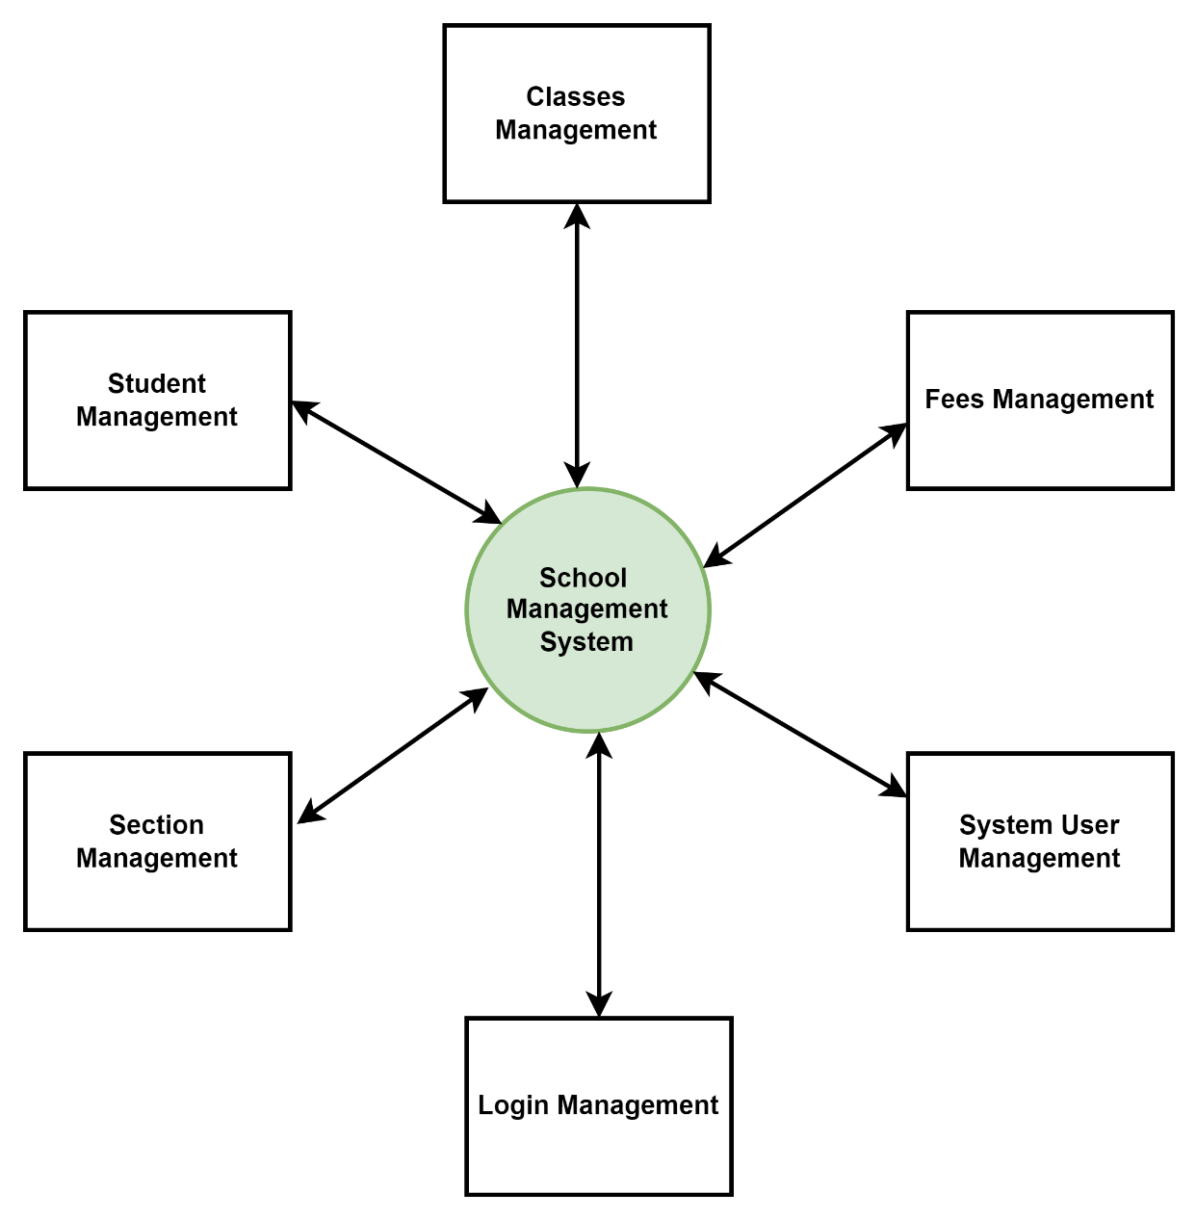
Zero Level Dataflow Diagram (0 Level DFD) Of Secondary School Management System:

It's a basic overview of the whole School Management System or process being analyzed or modeled. It's designed to be an at-a-glance view of Fees, Attendance and Subjects showing the system as a single high-level process, with its relationship to external entities of Students, Class, and Teachers. It should be easily understood by a wide audience.
- Managing all the Students
- Managing all the Class
- Managing all the Teachers
- Managing all the Timetable
- Managing all the Fees
- Managing all the Attendance
- Managing all the Subjects

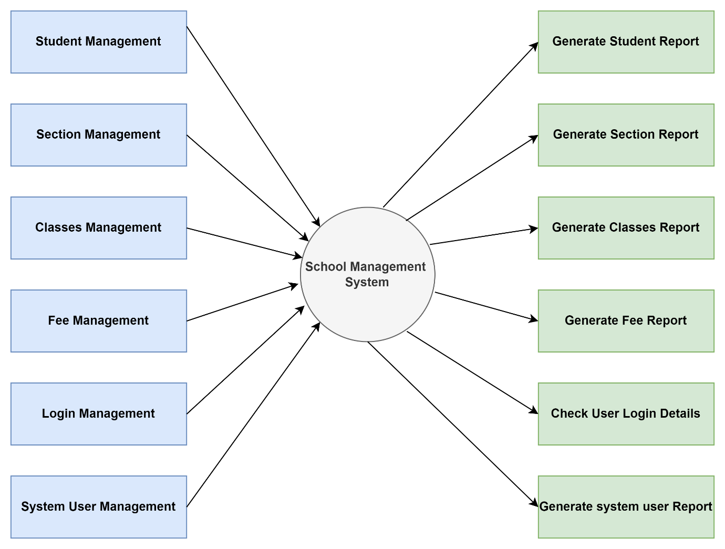
First Level Dataflow Diagram of Secondary School Management System:
First Level DFD of System shows how the system is divided into sub-systems (processes), each of which deals with one or more of the data flows to or from an external agent, and which together provide all the functionality of the School Management System as a whole. It also identifies internal data stores of Subjects,
Attendance, Fees, Timetable. Teachers that must be present in order for the school to do its job and show the flow of data between the various parts of Students, Teachers, Attendance, Subjects, Fees of the system.
- Processing Students records and generating reports of all Students.
- Processing Class records and generating reports of all Class.
- Processing Teachers records and generating reports of all Teachers.
- Processing Timetable records and generate report of all Timetable.
- Processing Fees records and generate report of all Fees.
- Processing Attendance records and generate report of all Attendance.
- Processing Subjects records and generate report of all Subjects

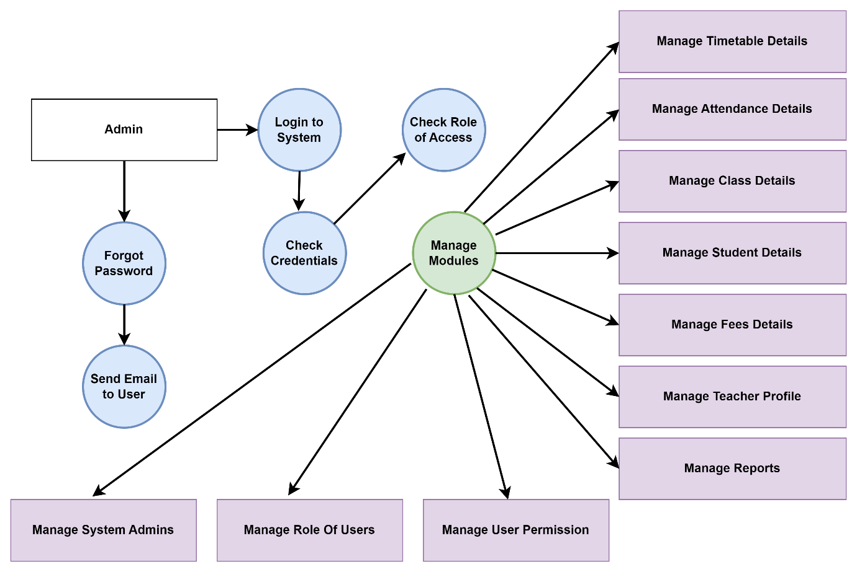
Second Level Dataflow Diagram of Secondary School Management System
DFD Level 2 then goes one step deeper into parts of Level 1 of School. It may require more functionalities of School to reach t detail about the school
Functioning. First Level DFD (1st Level) of School Management System shows how the system is divided (processes). The 2nd Level DFD contains more details of Subjects, Attendance, Fees, Timetable, Teachers, Class, Students
- Admin logins to the system and manage all the functionalities of School Management System
- Admin can add, edit, delete, and view the records of Students, Teachers, Fees, Subject
- Admin can manage all the details of Class, Timetable, Attendance
- Admin can also generate reports of Students, Class, Teachers, Timetable, Fees, Attendance
- Admin can search the details of Class, Fees, Attendance
- Admin can apply different level of filters on report of Students, Timetable, Fees
- Admin can track the detailed information of Class, Teachers Timetable, Fees

3.6 FINAL TESTING
When the system is fully implemented, it will be run on a real-world environment and test on its performance. If the performance is satisfactory, it will be applied, else amendments will be made to correct the problems. After the system has been run for daily operation, continued maintenance and administration should be carried out to handle any system errors and security issues. This will entail the pre-test, validity test, pilot and reliability test and the data survey.

CHAPTER FOUR

RESULT AND DISCUSSION

4.1 Windows Visual Studio

The Windows Visual Studio application was used in the design and development of the project. From the Windows Visual Studio interface, clicking on the File gave a drop-down menu which includes New among others and clicking on it bring a dialog box as shown in Figure 4.1
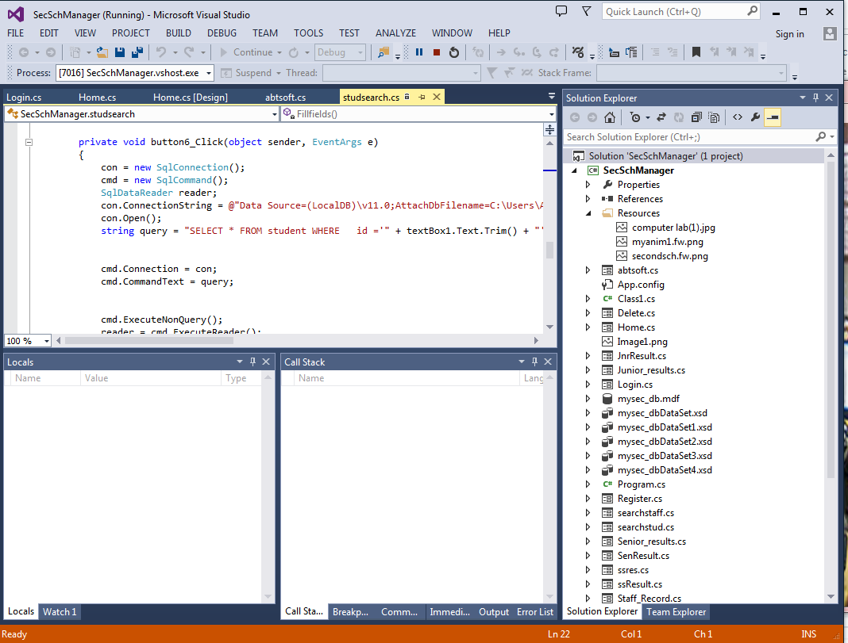
Figure 4.1: The Windows Visual Studio Interface

4.2 Login Panel
The login panel is the security gate of this application, only authorized user is allowed beyond this point. In this case, two categories of user are accepted: Administrator.
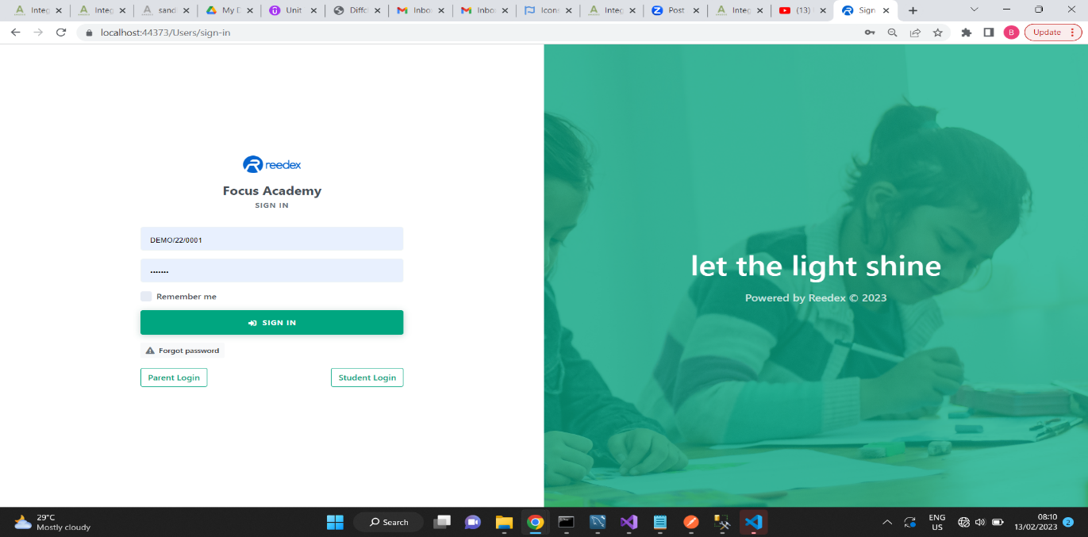

Figure 4.2 Login Panel

Student Login Panel
This platform Allows the student to login and check everything they needed to check in the school portal.

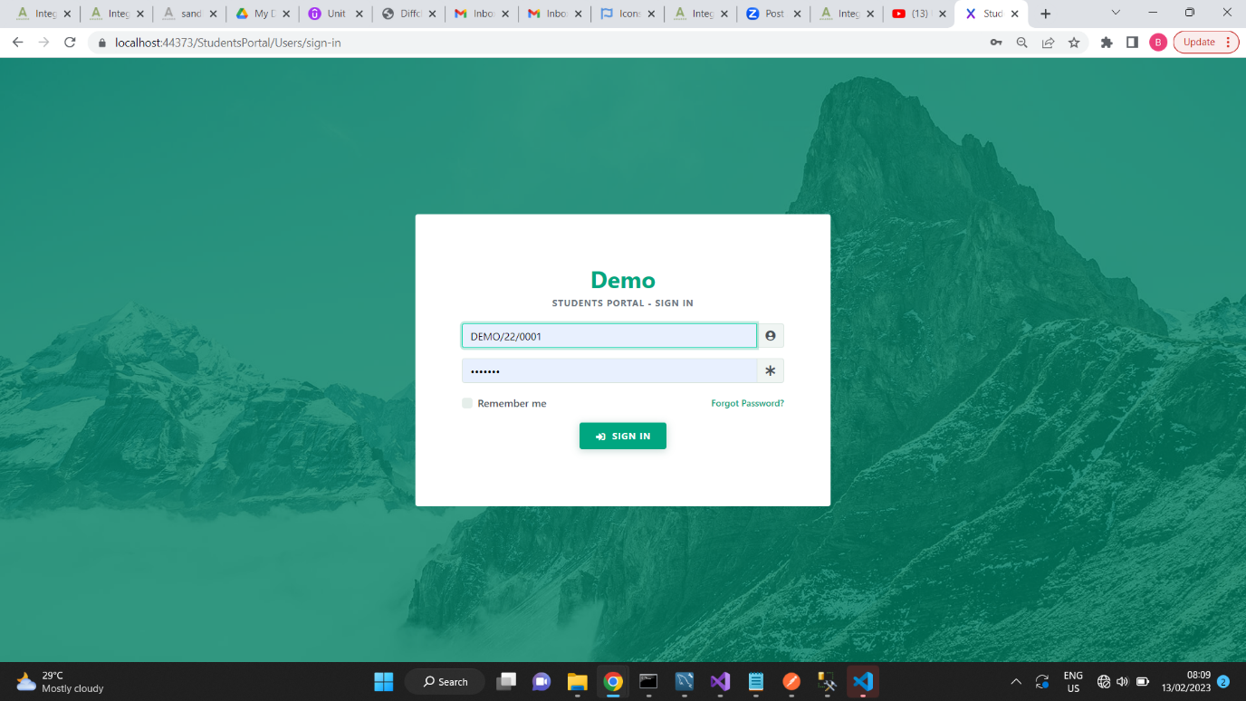

4.3 Homepage

The homepage is the next screen of the application after the credentials of the user has been confirmed. This page shows different links and navigation to various functionalities of the application.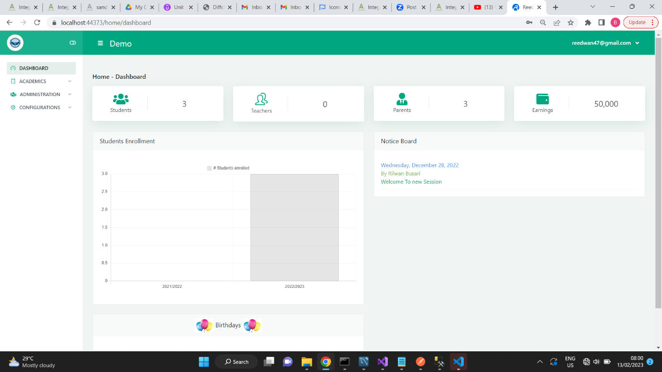 Figure 4.3 Homepage

4.5 Student Registration panel

This is a platform through which staff information can be saved.
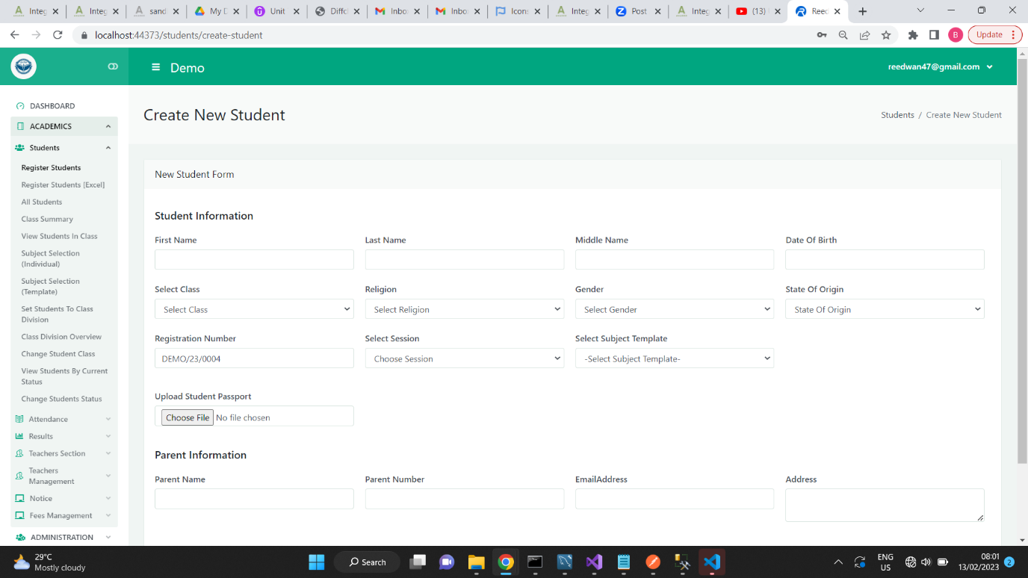 Figure 4.5 Student Registration panel

4.6 Grading system

This platform helps teachers and parent to view the school grading system.
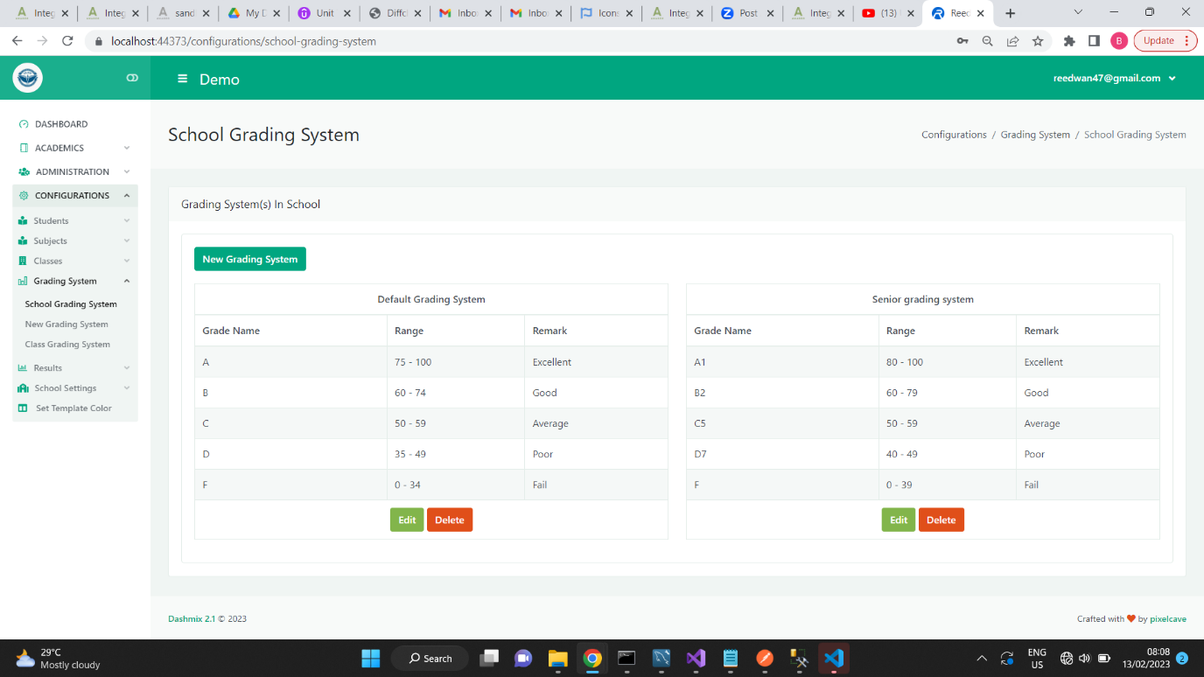

Fee Management
This section helps in managing all students school fees payment records.
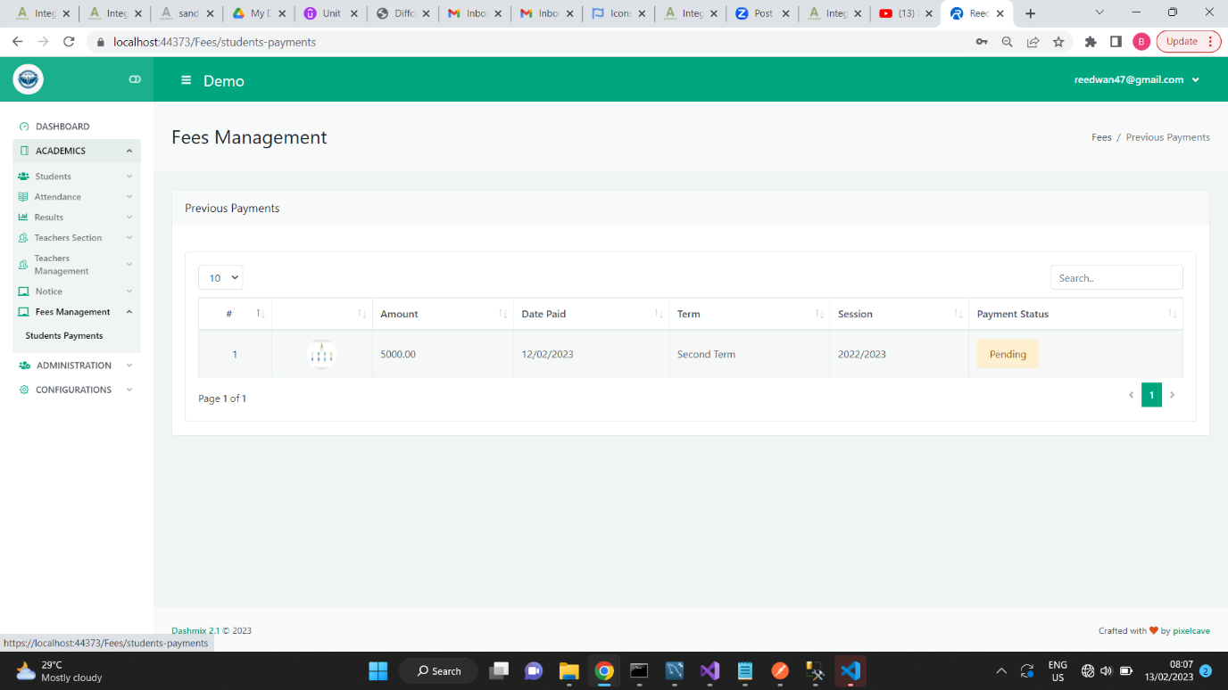
Class Overview
This platform helps in viewing and retrieving information by querying the database.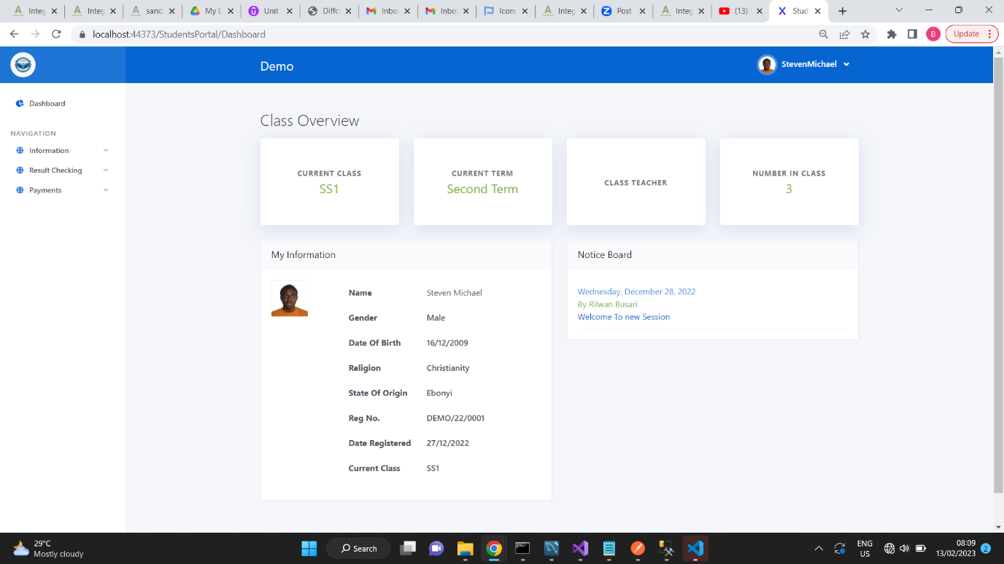
Figure 4.6 Local Search platform for staff

4.8 Result Computation Platform

This platform helps schoolteachers to process their students result and generate report sheet instantly. All subjects are loaded into the database already.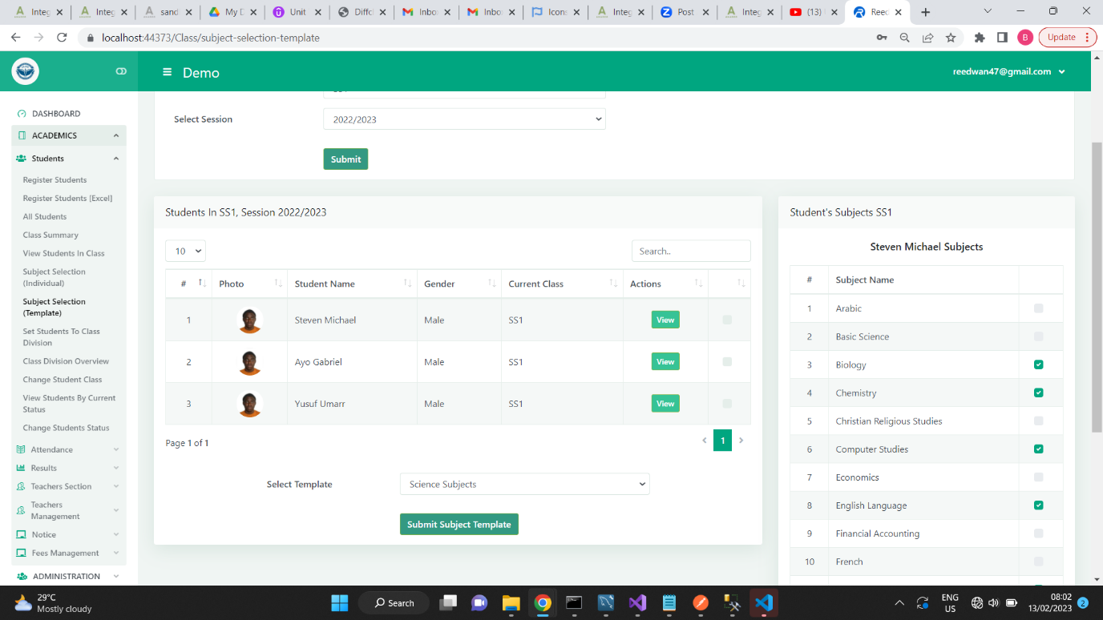
Result Summary
This platform helps schoolteachers to view their students result and generate report sheet instantly. All subjects are loaded into the database already.
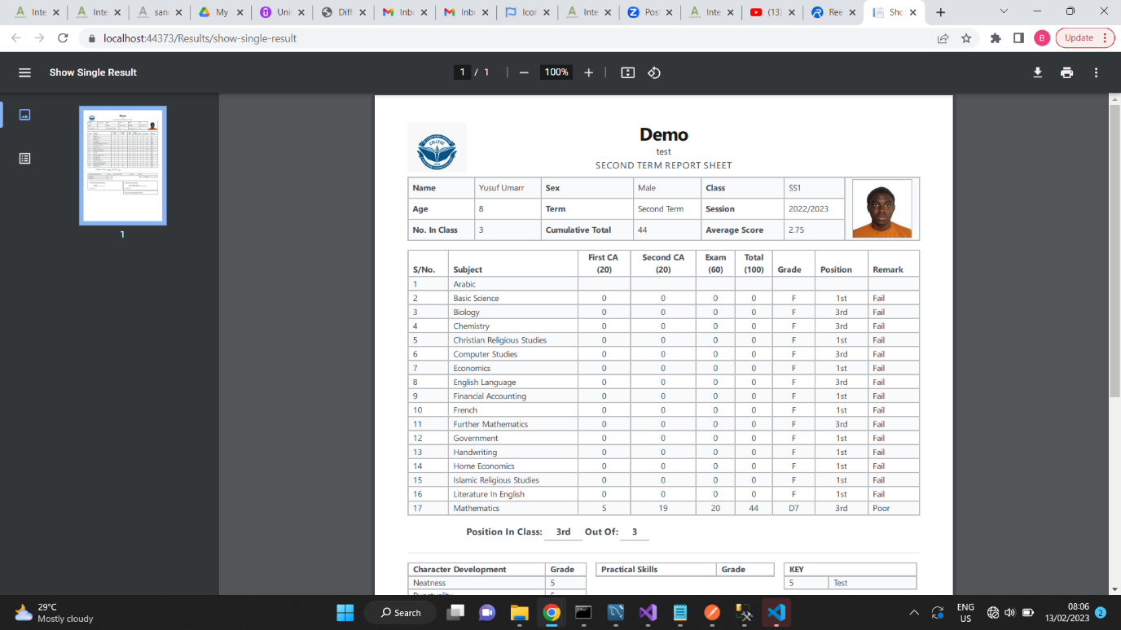
4.8 Result Computation Platform
Notice Board
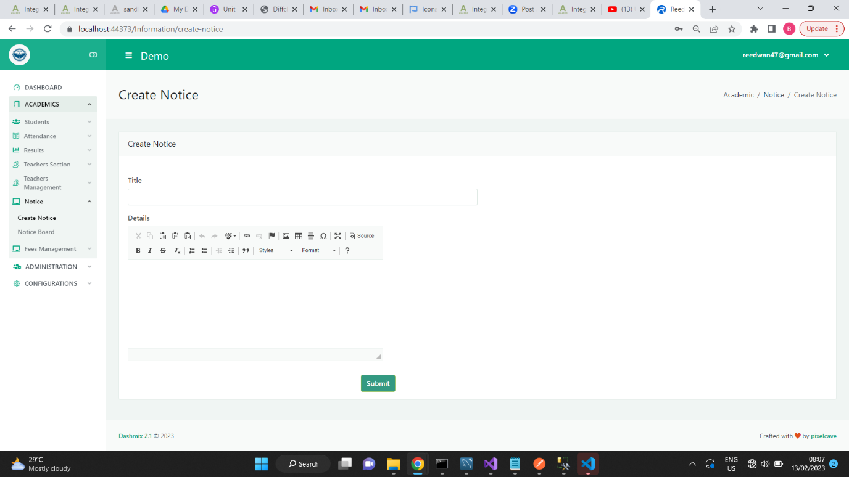 This section helps in passing information to staff, parents and the student

CHAPTER FIVE

SUMMARY, CONCLUSION AND RECOMMENDATION

SUMMARY
A secondary school management system is a software application designed to assist with the day-to-day operations of a secondary school. The system would provide an array of features to help manage student, teacher, and staff information, class schedules, student grades and attendance, as well as other administrative tasks. The system would also provide secure access to all relevant information, enabling authorized personnel to view, update, and analyze data as needed. Additionally, the system would enable easy communication between school administration, teachers, students, and parents, by providing a platform for sending notifications, announcements, and alerts. The goal of this system is to streamline school operations, increase efficiency and productivity, and provide all stakeholders with access to up-to-date information.

CONCLUSION

In this project work, the design and implementation of Secondary School Management System. This was developed to drastically reduce the stress of paperwork involved in managing a secondary school if not total eradication using a suitable Object-Oriented Programming language for its development and SQLSERVER for its database and also the local server for testing the application during the design and development stage. Tests were performed on the functionalities of the Secondary School Management System to ensure the conclusion reached is reliable and accurate.
Past works relevant to this project work system had been reviewed and information gathered had been put into effective use during this project development. The application platform had been developed and the Secondary School Management System has been created and implemented on a stand-alone system. The project has been tested on a local server to confirm its effectiveness; thus, conclusion has been made on the reliability of the project work.
The development of Secondary School Management System makes it possible for school administrators and teachers to collect and manage student without going through the stress of rigorous paperwork which is subjected to loss, damage or alterations of any kind from authorized people any time. Secondary School Management System helps remove the fear of data loss as a reliable database system was used, Security as there is monitoring from the administrator since only registered users can use the special functionalities offered on the GUI and no user will have access to more than his/her account.
This project work will enhance the E-management technology and makes it more fascinating. More so, it will help eradicate the manual way of school management which has been found over time to be less secured, time wasting and immobile, thereby encouraging individuals, institutions of learning and corporate bodies to employ or adopt the technology so that relevant information can be gotten with ease and secured reliably.

5.3 RECOMMENDATION

As it is known that a good project work must give room for improvement or paves way for further development, therefore, the just concluded project work is not an exception. There is need for further research to be carried in the future as for ways by which Secondary School Management System can be improved, which will make it a perfect replacement for Paper management. Any added knowledge or functionalities to this project work should be done by a professional in the field. Also, such functionalities must be flexible, easy to use, easy to understand, and should be within the context of improving Online Registration system in order not to lose the reliability property of the project work.

REFERENCE
Hamden, R., & Johnson, R. (2017).The impact of information and communication technology on secondary school management. Journal of Education and Practice, 8(17), 104-110.
Zohour, A. A., & Al-Harthi, A. S. (2018). Development of a secondary school management information system using object-oriented methodologies. International Journal of Information and Education Technology, 8(5), 447-451.
Al-Qahtani, S. (2015). A proposed secondary school management information system using object-oriented analysis and design. Journal of Education and Practice, 6(22), 1-7.
Tan, C. L., & Goh, D. H. (2019). Implementing a web-based secondary school management system. Journal of Education and Information Technology, 14(1), 1-7.
Stelios, P. N., & Athanasios, K. (2016). Design and implementation of a secondary school management system. Journal of Education and Technology, 11(2), 123-128.
Alkhalifah, M. (2017). A secondary school management system based on cloud computing. Journal of Education and Information Technology, 12(3), 289-295.

Al-Qahtani, S., & Al-Khalifah, M. (2018). An evaluation of the impact of secondary school management information systems on school administration. International Journal of Information and Education Technology, 8(7), 579-583.
Abdul-Razak, A., & Mustapha, A. (2017). A study of the implementation of secondary school management information systems in Nigeria. Journal of Education and Technology, 12(4), 407

APENDIX
import { useState, useEffect, useMemo } from "react";
// react-router components
import { Routes, Route, Navigate, useLocation } from "react-router-dom";
// @mui material components
import { ThemeProvider } from "@mui/material/styles";
import CssBaseline from "@mui/material/CssBaseline";
import Icon from "@mui/material/Icon";
// Material Dashboard 2 React components
import MDBox from "components/MDBox";
// Material Dashboard 2 React example components
import Sidenav from "examples/Sidenav";
import Configurator from "examples/Configurator";
// Material Dashboard 2 React themes
import theme from "assets/theme";
import themeRTL from "assets/theme/theme-rtl";
// Material Dashboard 2 React Dark Mode themes
import themeDark from "assets/theme-dark";
import themeDarkRTL from "assets/theme-dark/theme-rtl";
// RTL plugins
import rtlPlugin from "stylis-plugin-rtl";
import { CacheProvider } from "@emotion/react";
import createCache from "@emotion/cache";
// Material Dashboard 2 React routes
import routes from "routes";
// Material Dashboard 2 React contexts
import { useMaterialUIController, setMiniSidenav, setOpenConfigurator } from "context";
// Images
import brandWhite from "assets/images/logo-ct.png";
import brandDark from "assets/images/logo-ct-dark.png";
export default function App() {
const [controller, dispatch] = useMaterialUIController();
const {
miniSidenav,
direction,
layout,
openConfigurator,
sidenavColor,
transparentSidenav,
whiteSidenav,
darkMode,
} = controller;
const [onMouseEnter, setOnMouseEnter] = useState(false);
const [rtlCache, setRtlCache] = useState(null);
const { pathname } = useLocation();
// Cache for the rtl
useMemo(() => {
const cacheRtl = createCache({
key: "rtl",
stylisPlugins: [rtlPlugin],
});
setRtlCache(cacheRtl);
}, []);
// Open sidenav when mouse enter on mini sidenav
const handleOnMouseEnter = () => {
if (miniSidenav&& !onMouseEnter) {
setMiniSidenav(dispatch, false);
setOnMouseEnter(true);
}
};
// Close sidenav when mouse leave mini sidenav
const handleOnMouseLeave = () => {
if (onMouseEnter) {
setMiniSidenav(dispatch, true);
setOnMouseEnter(false);
}
};
// Change the openConfigurator state
const handleConfiguratorOpen = () =>setOpenConfigurator(dispatch, !openConfigurator);
// Setting the dir attribute for the body element
useEffect(() => {
document.body.setAttribute("dir", direction);
}, [direction]);
// Setting page scroll to 0 when changing the route
useEffect(() => {
document.documentElement.scrollTop = 0;
document.scrollingElement.scrollTop = 0;
}, [pathname]);
const getRoutes = (allRoutes) =>
allRoutes.map((route) => {
if (route.collapse) {
return getRoutes(route.collapse);
}
if (route.route) {
return ;
}
return null;
});
const configsButton = (
settings
);
return direction === "rtl" ? (
{layout === "dashboard" && (
{configsButton}
)}
{layout === "vr" &&
{getRoutes(routes)}
}
{layout === "dashboard"
{configsButton}
)}
{layout === "vr" &&
{getRoutes(routes)}
} />
);
}

