|  |
| --- |
| function setup() {  createCanvas(400, 400);  }  function draw() {  background(0, 255, 255);  } |

**Contoh 1**

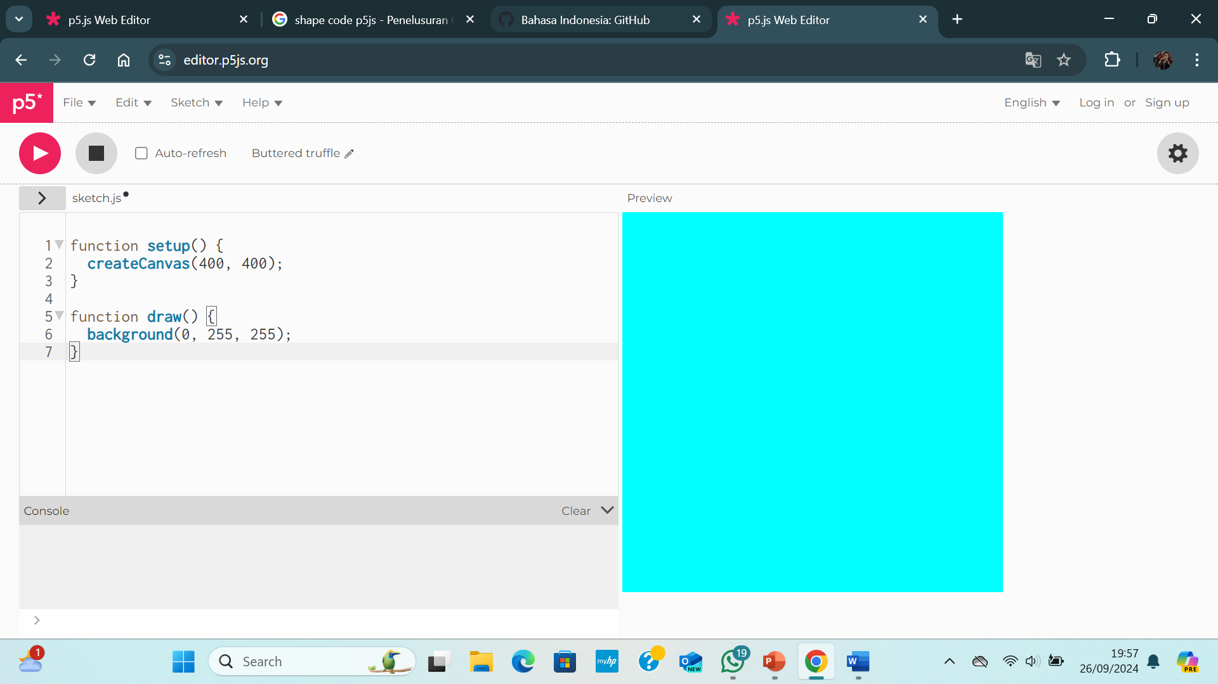

|  |
| --- |
| function setup() {  createCanvas(400, 400);  }  function draw() {  background(0, 128, 128);  } |

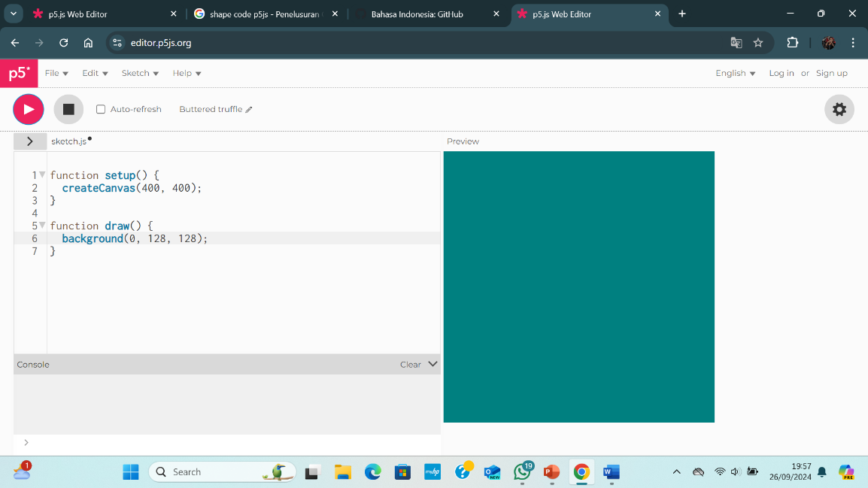

|  |
| --- |
| function setup() {  createCanvas(400, 400);  }  function draw() {  background(0, 0, 128);  } |

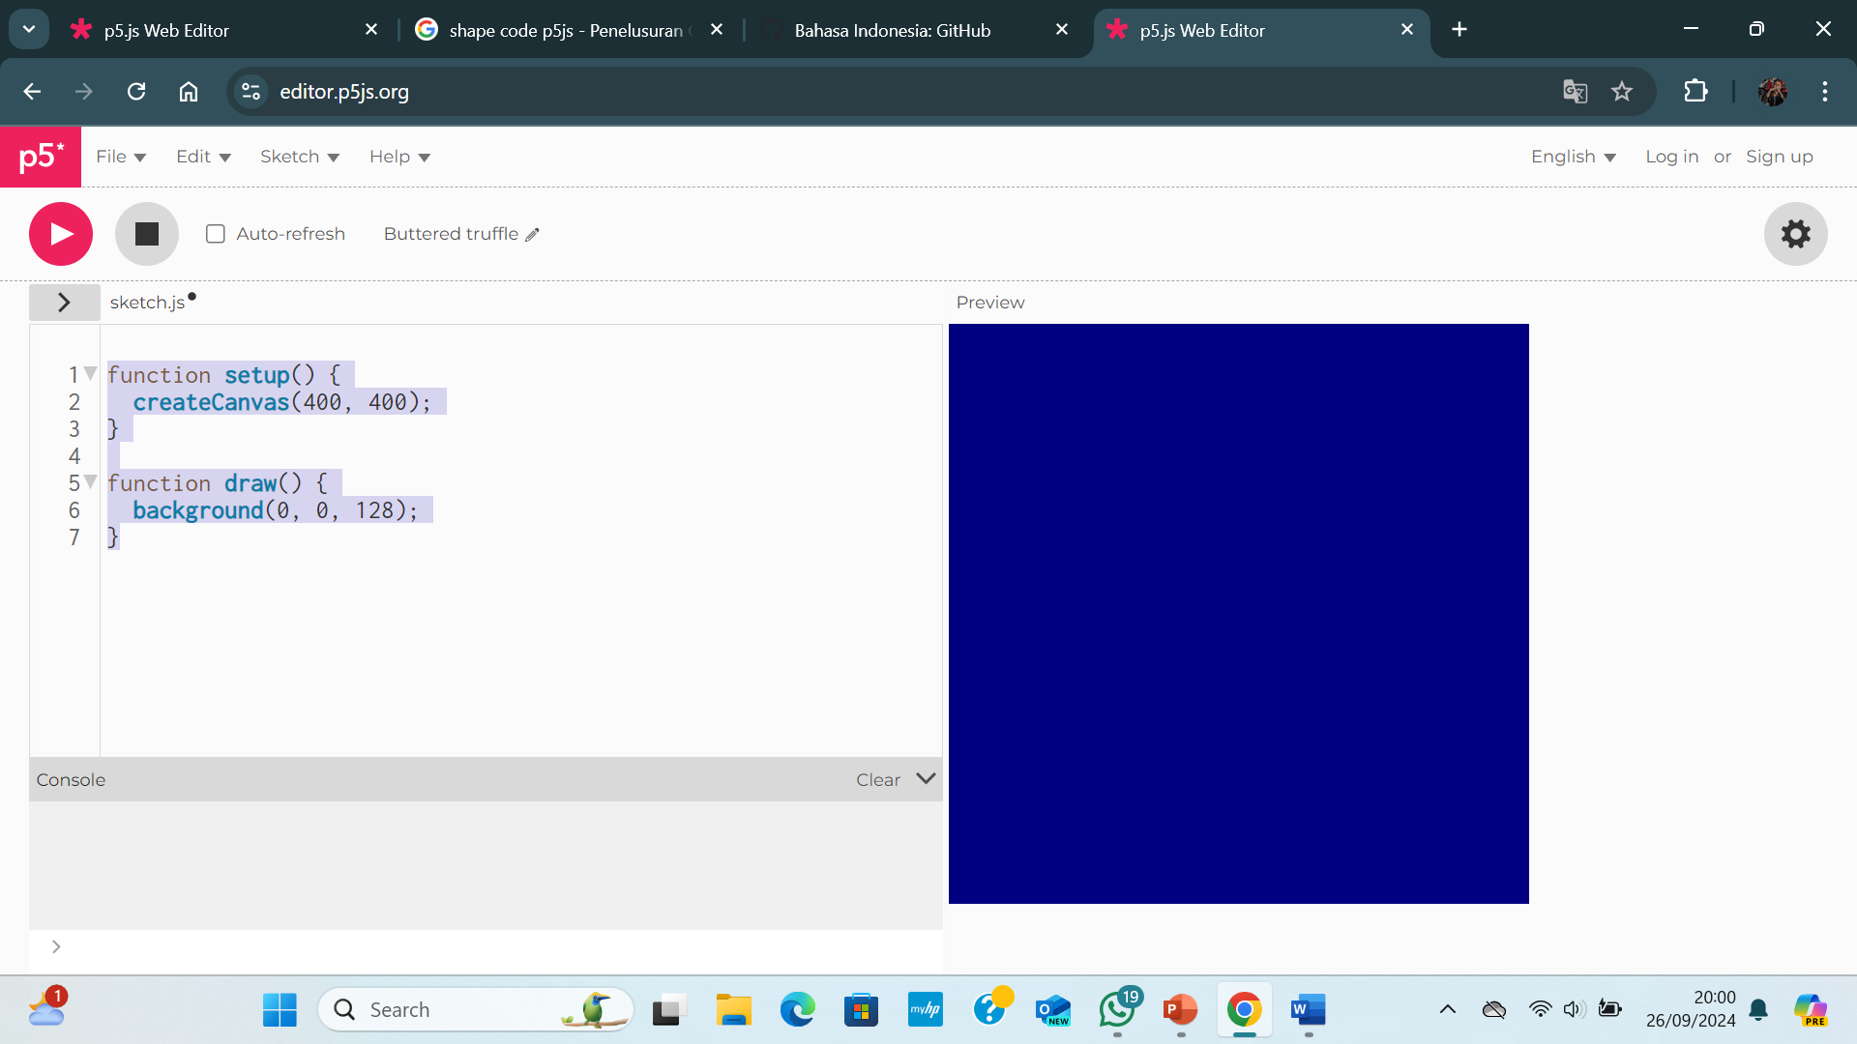

**Contoh 2**

|  |
| --- |
| function setup() {  createCanvas(400, 400);  }  function draw() {  background(220);  rect (100, 100, 100, 100)  } |

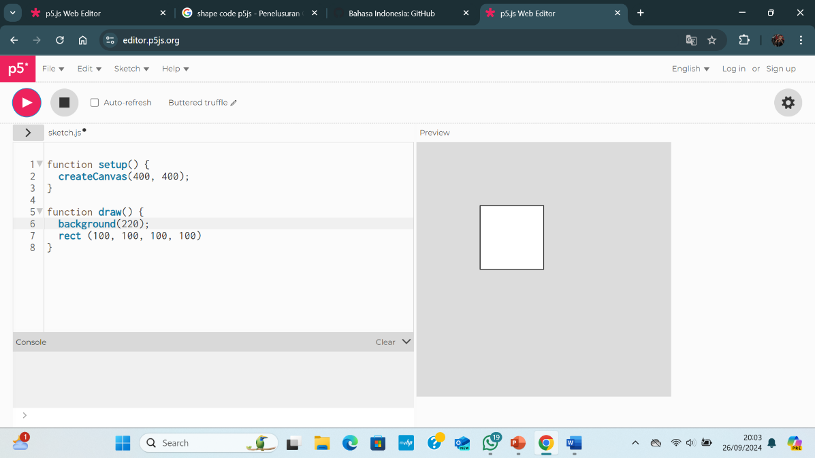

|  |
| --- |
| function setup() {  createCanvas(400, 400);  }  function draw() {  background(220);  rect (200, 200, 200, 200)  } |

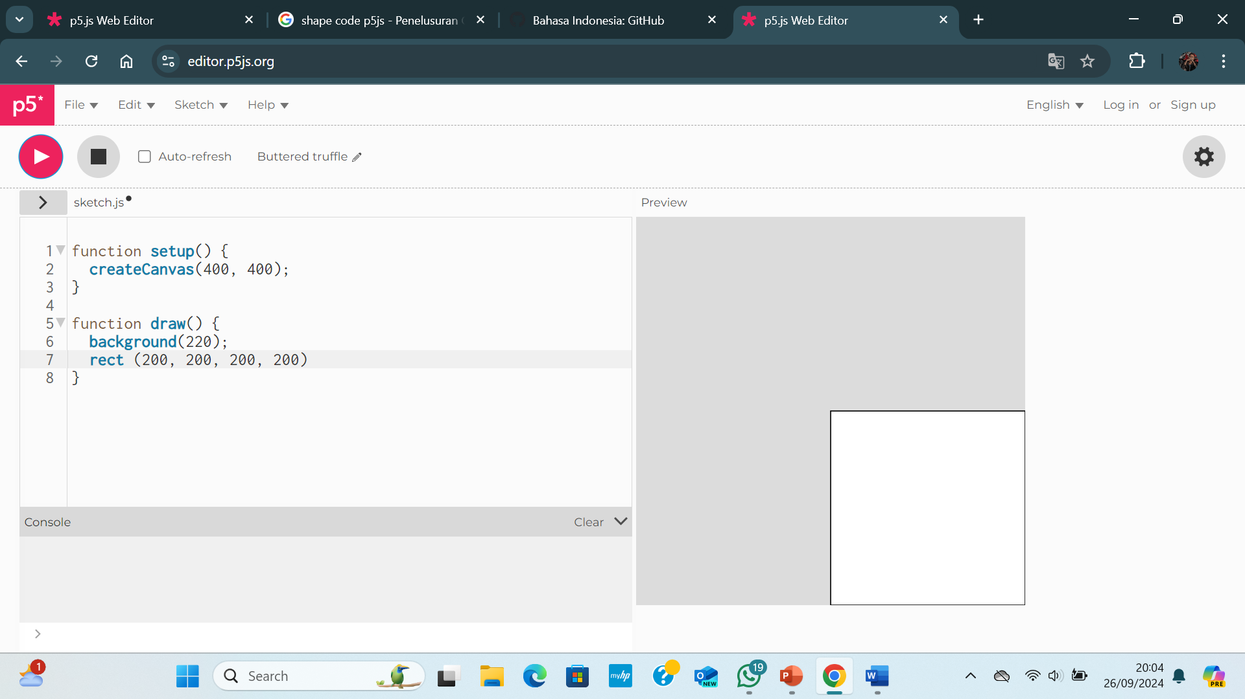

Tugas

|  |
| --- |
| function setup() {  createCanvas(640, 480);  }  function draw() {  background(123)  fill(200, 100, 150);  rect(100, 50,100,300)  } |

