
جامعة دمشق
كلية الهندسة المعلوماتية
السنة الرابعة - قسم الذكاء الصنعي
عملي مترجمات 1

إعداد:
هادي صقر
حسن مرعي
فاروق خانكان
فراس طيب

Chapter  No. | Title | Page No.
1 | INTRODUCTION | 3
2 | ARCHITECTURE OF LANGUAGE | 4
3 | LITERATURE SURVEY | 4
4 | CONTEXT FREE GRAMMAR | 4
5 | DESIGN STRATEGY (used to implement the following)  ● SYMBOL TABLE CREATION  ● ABSTRACT SYNTAX TREE  ● INTERMEDIATE CODE GENERATION  ● CODE OPTIMIZATION  ● ERROR HANDLING | 10
6 | IMPLEMENTATION DETAILS (TOOL AND DATA  STRUCTURES USED in order to implement the following):  ● SYMBOL TABLE CREATION  ● ABSTRACT SYNTAX TREE (​internal representation)  ● INTERMEDIATE CODE GENERATION  ● CODE OPTIMIZATION  ● ERROR HANDLING | 13
7 | RESULTS | 17
8 | SNAPSHOTS | 18
9 | CONCLUSIONS | 23
10 | REFERENCES/BIBLIOGRAPHY | 23

INTRODUCTION:

We have build a self-compiling mini-compiler for C++.
C++ is a general purpose programming language and widely used now a days for
competitive programming. It has imperative, object-oriented and generic
programming features.

The expected outcome of this project is generate a Symbol Table, an Abstract Syntax
Tree and Intermediate Three-Address code along with optimization.

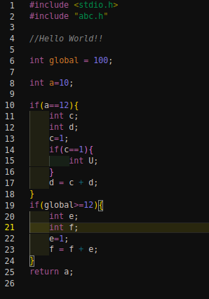
Input: Output:
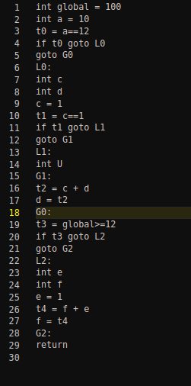

ARCHITECTURE.
The mini compiler handles most cases in the C++09 .
Features Of The Lexer.
1. Identifies and removes comments
2. Identifies various operators in the language
3. Checks for validity of the identifiers
4. Identifying numeric constants and std::string type
5. Ignores white-spaces
6. Identifies scope of variables

Syntax is handled by YACC where grammar rules are specified for the entire
language.
Semantics are handled using semantic rules for type checking while performing
operations, to ensure operations are valid.

LITERATURE SURVEY.
1. Lex & Yacc, O’Reilly, John R. Levine, Tony Mason, Doug Brown

CONTEXT FREE GRAMMAR.

P
: program
;

program
: external_declaration
| program external_declaration
;

external_declaration
: header_stmt
| global_stmt
| main_fun
;

header_stmt
: '#' T_INCLUDE '<' T_IDH '>'
| '#' T_INCLUDE T_IDH
;

global_stmt
: declaration_statement
| fun_declr
| user_defined_ds
| statement
;

main_fun
: T_TYPE T_MAIN '(' ')' compound_stmt
;

declaration_statement
: T_TYPE list_identifier ';'
;

list_identifier
: list_identifier ',' variable
| list_identifier ',' init
| init
| variable
;

variable
: T_IDENTIFIER
| T_IDENTIFIER array
;

array
: array '[' T_INTEGER_VAL ']'
| '[' T_INTEGER_VAL ']'
;

init
: var_init
| array_init
;

var_init
: T_IDENTIFIER '=' expression
;

array_init
: T_IDENTIFIER array '=' '{' values '}'
;

values
: values ',' constant
| constant
;

constant
: T_INTEGER_VAL
| T_STRING_VAL
| T_CHAR_VAL
| T_FLOAT_VAL
;

declarator
: '(' ')'
| '(' params ')'
;

fun_declr
: T_TYPE T_IDENTIFIER declarator compound_stmt
;

params_list
: T_TYPE T_IDENTIFIER
| params_list ',' T_TYPE T_IDENTIFIER
;

params
: params_list
;

compound_stmt
: start_paren end_paren
| start_paren block_item_list end_paren
;

start_paren
: '{'
;

end_paren
: '}'
;
block_item_list
: block_item
| block_item_list block_item
;

block_item
: declaration_statement
| statement
;

user_defined_ds
: class
| structure
;

class
: T_CLASS T_IDENTIFIER class_body_stmt ';'
;

structure
: T_STRUCT T_IDENTIFIER struct_body_stmt ';'
;

class_body_stmt
: start_paren end_paren
| start_paren class_mems end_paren
;

struct_body_stmt
: start_paren end_paren
| start_paren struct_mems end_paren
;

struct_mems
: struct_mem
| struct_mems struct_mem
;

class_mems
: class_mem
| class_mems class_mem
;

struct_mem
: declaration_statement
| fun_declr
;

class_mem
: T_TYPE class_var_declaration ';'
| fun_declr
| access_specifier ':'
;

class_var_declaration
: T_IDENTIFIER
| class_var_declaration ',' T_IDENTIFIER
;

access_specifier
: T_PRIVATE
| T_PUBLIC
| T_PROTECTED
;

statement
: expression_stmt
| compound_stmt
| iterative_statement
| selection_statement
| input_output_statements
| return_stmt
;

expression_stmt
: ';'
| expression ';'
;
selection_statement
: T_IF '(' expression ')' statement
| T_IF '(' expression ')' statement T_ELSE else_stmt statement
;

iterative_statement
: for_loop
| while_loop
;

for_loop
: T_FOR '(' for_assgn_stmt ';' {} expression ';' unary_exprn ')' statement
;

for_assgn_stmt
: T_TYPE for_decl_stmt
| assignment_expression
;

for_decl_stmt
: T_IDENTIFIER '=' expression
| for_decl_stmt ',' T_IDENTIFIER '=' expression
;

while_loop
: T_WHILE '(' expression ')' statement
;

return_stmt
: T_RETURN ';'
| T_RETURN expression ';'
;

expression
: assignment_expression
| simple_expression
;

assignment_expression
: T_IDENTIFIER '=' expression
| unary_exprn
;

unary_exprn
: T_ADDADD T_IDENTIFIER
| T_MINMIN T_IDENTIFIER
| postfix_expression
| T_IDENTIFIER uop_shorthd expression
;

postfix_expression
: T_IDENTIFIER T_ADDADD
| T_IDENTIFIER T_MINMIN
;

uop_shorthd
: T_ADDEQ
| T_MINEQ
| T_MULEQ
| T_DIVEQ
;

simple_expression
: additive_expression
| additive_expression relop additive_expression
| additive_expression logop additive_expression
| additive_expression bitop additive_expression
;

bitop
: T_OR
| T_AND
| T_XOR
| T_LRSHIFT
| T_LLSHIFT
;

relop
: '<'
| '>'
| T_LTEQ
| T_GTEQ
| T_NEQEQ
| T_EQEQ
;

logop
: T_OROR
| T_ANDAND
;

additive_expression
: term
| additive_expression '+' term
| additive_expression '-' term
| '+' additive_expression %prec '*'
| '-' additive_expression %prec '*'
;

term
: factor
| term '*' factor
| term '/' factor
;

factor
: '(' expression ')'
| T_IDENTIFIER
| call
| T_INTEGER_VAL
| T_FLOAT_VAL
| T_STRING_VAL
| T_CHAR_VAL
;

call
: T_IDENTIFIER '(' ')'
| T_IDENTIFIER '(' args ')'
;

args : expression
| expression ',' args
;

input_output_statements
: T_COUT T_LLSHIFT expression ';'
| T_CIN T_LRSHIFT T_IDENTIFIER ';'
;
DESIGN STRATEGIES.

SYMBOL TABLE.
The Symbol Table is used for storing variables declared and their attributes, along
with details about function calls. The Symbol table stores the size of a variable, it’s
scope and also the line numbers where the particular variable is used.
We used hash tables to implement the symbol table. The variable names were
hashed and allocated a fixed amount of space in the table. Every new scope has it’s
own symbol table, which would be destroyed once the scope would end. All symbol
tables are connected using an n-ary tree. So basically, we have implemented an n-ary
tree of hash tables. Starting with the root node which has the global symbol table.
Upon encountering a new scope, a new hash table is created as a child node of the
root node. If within the same scope another new scope is encountered a new child
node of the current scope node is created, and so on. Sibling nodes (like child nodes
on same level) have different hash tables and hence cannot access each other’s data.
But a child node can access data from it’s parent hash table.

ABSTRACT SYNTAX TREE.
The AST (Abstract Syntax Tree) is an attributed implementation of a generic tree,
which can accommodate any number of leafs and nodes and is not limited in any way.
Each node uses the same structure type and this allowed easy scaling of the project.
The leafs/nodes/sub-tree is stored in a double-ended queue, also called a dequeue.
The dequeue is available from STL of C++.

Flags for detecting if-else, for, while and declaration statements which will be used to
decide how we will push and pop the nodes/leafs in the dequeue. For each construct
we have a different function, as the method of popping and push nodes/leafs is
different is various constructs. The actions are defined as semantic rules in the yacc
file. The tree is printed in a branch-wise level-order fashion.

INTERMEDIATE CODE GENERATION.

To convert our given C language into intermediate code, we have used the SDT
scheme and made use of marker non-terminals in place of action records.
Label generation:
We have made use of stack whose elements are of type records.
Each entry to the stack is a hash table for which we have used maps.
Each of marker non-terminal will push a map record to the stack which
contains
Information of the label’s used by the statement.
temp_func()
It returns the next unused temporary variable
label_func() and global_func()
Returns the next unused label

CODE OPTIMIZATION.

We have implemented Dead Code elimination for the ICG generated. Dead codes are
pieces of code that contain temporaries that are not used further or anywhere else in
the generated ICG. We keep track of all the useful temporaries and hence when we
encounter a line which used a non-useful temporary, we can eliminate that line of
code from the ICG.

ERROR HANDLING.

We are handling syntax errors, which are generated during parsing. We are also
handling re-declaration of variables in the same scope, and are showing appropriate
error messages. We stop parsing the input on encountering these errors and display
the line number of the errors, intending the user to resolve the issue. Also handling
type mismatch errors.

IMPLEMENTATION DETAILS.

SYMBOL TABLE.
Data Structure Implementation-:

1)Structure to point to reference of each variable occurrence in program:
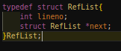
2)A single entry into the hash table :
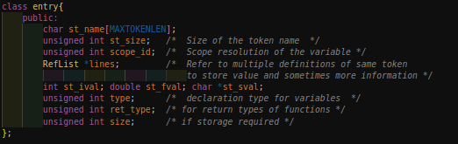
3)A Node of the n-ary tree of symbol tables:
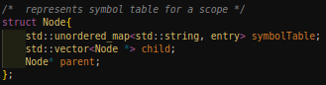
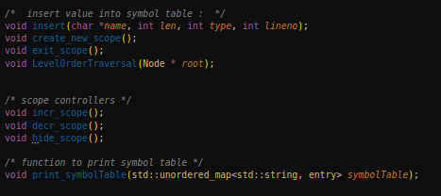
4)Functions Implemented.
ABSTRACT SYNTAX TREE.
Data Structure Implementation-:

1)Structure for each node/leaf in the AST.
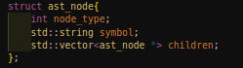
2)Syntax Tree.
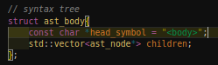
3)Double-Ended queue.
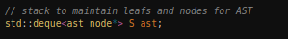
4)Functions Implemented.
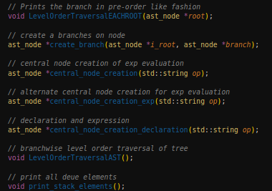

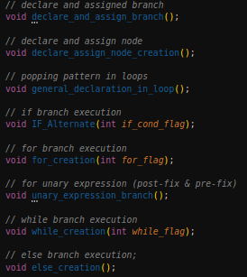

INTERMEDIATE CODE GENERATION.

Data Structure Implementation-:
-Following is the type of non-terminals used in our grammar.
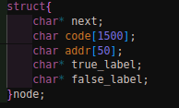
-Functions Implemented.
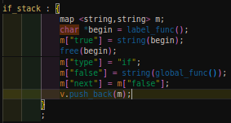
If marker non-terminal action record:

Here we can see that for the hash table key is the attribute name and its value is the
label the attribute is going to hold. In this case, we push this record before going to
the condition non-terminal.
Our stack is implemented using vector which can be seen as a generic list. The
element type of the vector used is map.

CODE OPTIMIZATION.

Data Structure Implementation-:

1)Used a vector of strings to store the input lines of ICG code one by one.
std::vector<std::string> list_of_lines;

2)List of strings after eliminating dead code is stored in :
std::vector<std::string> without_deadcode;

3)Used the following two regex to detect temporary variable or identifier
std::regex istemp("^t[0-9]*$");
std::regex isid("^[A-Za-z][A-Za-z0-9_]*$");

4)List to store the valid operators that can be used in the ICG:
char arr[][3] = {"+", "-", "*", "/", "*", "&", "|", "^", ">>", "<<", "==",
">=", "<=", "!=", ">", "<"};
std::vector<std::string> binary_operators(arr,arr+16);

5)Functions Implemented.
Void printicg(std::vector<std::string>list_of_lines,message="");
// Used to print the ICG after optimization
std::string
std::vector<std::string>remove_dead_code(std::vector<std::string>
list_of_lines);
//Used to remove dead_code from input ICG.

ERROR HANDLING.
Function to handle syntax errors, gets called automatically by yacc on encountering
syntax errors
void yyerror(const char *str)
{
printf("line no :%d %s near %s\n", yylineno, str, yytext );
}
For re-declaration check we used a flag variable declare=0, which would be set and
unset accordingly in the same scope. If it was previously set and is set again in the
same scope, we can catch the error and display appropriate error message.

RESULTS.
We were able to successfully generate the different representations of input code
written in C++ along with performing simple machine independent optimization on
intermediate code which was generated.
Shortcomings.
1. Error handling could have been done better by adding more rules.
2. More optimizations could have been implemented.
3. C++17 and namespaces not taken into consideration.

SNAPSHOTS.

Input:

Symbol Table:
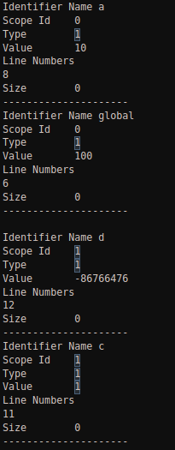
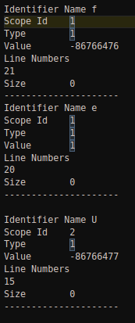

AST:
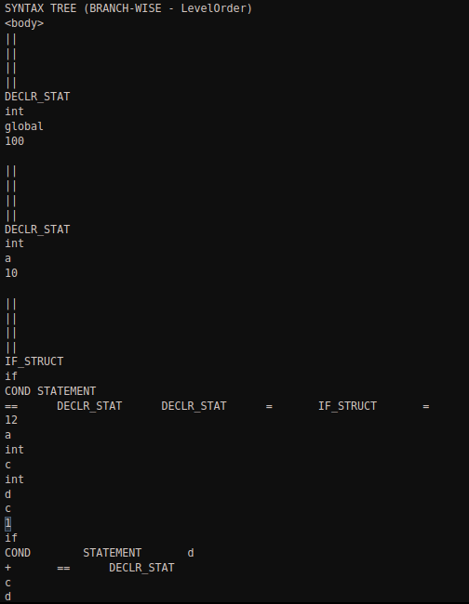

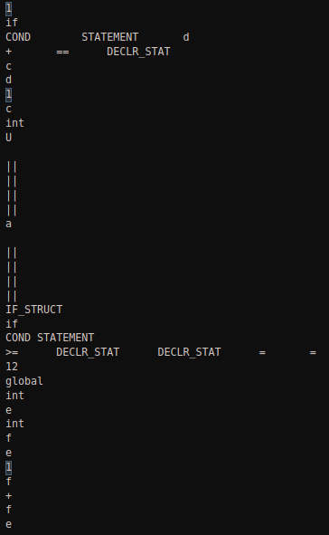

Intermediate Generate Code:
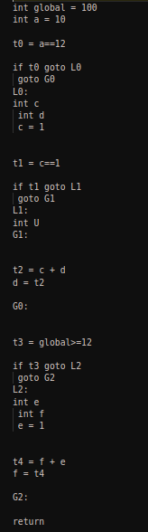

Code Optimized:
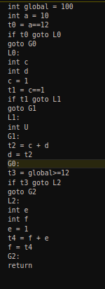

CONCLUSIONS.
By doing this project, we have gained a better insight into the phases of compiler.
YACC provided us with a better knowledge about bottom-up parser and while performing the different phases of the compiler, our code efficiency in writing code and dealing with complex data structures has significantly improved.
REFERENCES/BIBLIOGRAPHY.
Lex & Yacc, O’Reilly, John R Levine, Tony Mason, Doug Brown

