$oftware ¢orp
LevelSpot
Smart Parking Platform: Project Document
Client: Buffalo Bayou Garage Partners (BBGP)
Prepared by: Ibraheem Siddiqui, Project Manager
Version: 7.0
Date: November 5, 2026

CIS 4374 Semester Project, University of Houston. $oftware ¢orp and BBGP are fictional companies created for this course.

Revision history
Version | Date | Author | Changes
1.0 | 09/10/2026 | Ibraheem S. | Initial draft: competitive research, Vision and Scope, SRS draft with 19 use cases
2.0 | 09/17/2026 | Ibraheem S. | Work breakdown structure, estimation (story points and COCOMO check), draft schedule with Gantt chart
3.0 | 10/01/2026 | Ibraheem S. | Agile delivery plan with product backlog and sprint 1, risk register with matrix, quality gates, and communication plan
4.0 | 10/08/2026 | Ibraheem S. | Resource and cost management: staffing roster, RACI matrix, bottom-up budget with top-down cross-check, monthly cashflow, hidden costs, and first earned value report. Staffing assumption in Section 5.3 updated to match the named roster.
5.0 | 10/15/2026 | Ibraheem S. | Revisions driven by the first 9 facility surveys, which found that 6 of BBGP's 23 facilities are surface lots with no gate to read events from. Changes to the SRS assumptions and requirements, the WBS, the estimate, the schedule, the backlog and sprints, the risk register, the roster, the cost baseline, and the RACI. Tool selection, branching, and CI/CD added to Section 7.
6.0 | 10/29/2026 | Ibraheem S. | Stakeholder analysis on the power-interest grid, project charter, and team charter added as Section 11. Stakeholder table in 2.6 cross-referenced to the new analysis. Table of contents page numbers corrected; they were off by one in v5.0 because the contents listing grew onto a second page.
7.0 | 11/05/2026 | Ibraheem S. | Project closure report added as Section 14, marked internal, drafted at the design phase checkpoint (M2). Includes the October earned value reading, milestone variance against the charter baseline, lessons learned, and recommendations for future projects.

Contents
1. Research: what already exists 5
1.1 How drivers find parking in Houston today 5
1.2 Competitor review 5
1.3 Where current tools fall short 6
1.4 How LevelSpot will be different 6
2. Vision and scope 8
2.1 About $oftware ¢orp 8
2.2 How we landed the project 8
2.3 Business need 8
2.4 Vision statement 9
2.5 Business objectives 9
2.6 Stakeholders 9
2.7 Scope of release 1 10
2.8 Delivery teams 11
2.9 System context 11
3. Software requirements specification (draft) 12
3.1 Introduction 12
3.2 Overall description 12
3.3 Functional requirements 13
3.4 Non-functional requirements 14
3.5 Use cases 15
4. Work breakdown structure 24
5. Estimation 27
5.1 Story point estimates 27
5.2 Turning points into a schedule 28
5.3 COCOMO sanity check 29
5.4 Where the estimate is weakest 29
6. Schedule and timeline 30
6.1 Task schedule 30
6.2 Dependencies 31
6.3 Milestones 31
6.4 Gantt chart 32
7. Agile delivery plan and product backlog 34
7.1 How we run the project 34
7.2 Product backlog 34
7.3 Sprint 1 backlog 38
7.5 Tool selection 39
7.6 Source control and branching 39
7.7 CI/CD pipeline 40
7.8 Board 41
8. Risk management 42
8.1 Risks by category 42
8.2 Risk register 44
8.3 Risk matrix 46
8.4 Quality gates 46
9. Communication plan 48
9.1 Meeting cadence 48
9.2 Reporting methods 49
9.3 Escalation path 49
10. Resource and cost management 50
10.1 Basis of the budget 50
10.2 Roles and resource plan 50
10.3 RACI matrix 52
10.4 Bottom-up cost estimate 55
10.5 Top-down cross-check 56
10.6 Monthly cashflow 57
10.7 Hidden costs and contingency 59
10.8 Cost control and earned value 60
11. Stakeholder analysis and charters 62
11.1 Stakeholder analysis: the power-interest grid 62
11.2 Project charter 65
11.3 Team charter 67
12. Open questions for BBGP 69
13. Sources 69
14. Project closure report 71
14.1 Status of this report 71
14.2 Executive summary 71
14.3 Objectives and deliverables 71
14.4 Achievements 72
14.5 Shortfalls 73
14.6 Schedule and budget against baseline 74
14.7 Lessons learned 75
14.8 Recommendations for future projects 76
14.9 Closure checklist 77
14.10 Acknowledgments and sign-off 78

1. Research: what already exists
Before writing any requirements, we looked at the apps Houston drivers already use to find and pay for parking, and at the software garages run on behind the scenes. The point was to avoid rebuilding things that are already solved and to find the gaps worth building a product around.

1.1 How drivers find parking in Houston today
On the street, the City of Houston handles metered parking through ParkHouston pay stations and the ParkHouston app, which runs on ParkMobile. All city pay stations are pay-by-plate, so drivers don't need to leave a receipt on the dashboard. For garages and surface lots, drivers either pull in and take a ticket or book ahead through a reservation marketplace like SpotHero or ParkWhiz.
A lot of people skip all of that. They open Google Maps, pick the garage closest to where they're going, and hope there's room when they get there. That habit is really what this project is about. A garage can show up on a map and even accept an online booking, but the driver still can't tell whether a space is open right now, which level it's on, or whether their truck will fit under the entrance.

1.2 Competitor review
Table 1 summarizes the products we reviewed. Ownership in this market has changed a lot in the past two years, so the parent company is listed for each one.
Product (owner) | What it does | Strengths | Weaknesses for our use case
SpotHero (Uber announced it is acquiring SpotHero in Feb 2026) | Marketplace to book garage, lot, and valet parking ahead of time | Very large network, over 13,000 locations in 400+ cities across the US and Canada. Prepaid discounts. Booking from Apple CarPlay. | Sells inventory that operators list, not a live count of open spaces. Some user reviews mention paying more in the app than the rate posted on site.
ParkMobile / ParkHouston (Arrive, formerly EasyPark Group) | Pay by app for street meters and some garages. Official app for Houston meters. | City partner for on-street parking. Pay-by-plate. Reminders before a session expires and remote extension. | Built around paying for a session, not finding a space. No live availability for curb spaces. Garage booking only where operators opt in.
ParkWhiz (Flash) | Reservations and on-demand payment tied to Flash garage systems | License plate can act as the parking credential at supported gated garages. Event parking sold with Live Nation tickets. Bookings appear in Google Maps, Apple Maps, and Waze through Flash's demand network. | Smoothest experience requires Flash or Parkonect equipment at the garage. Garages on other hardware get a more manual setup.
Parkopedia (Arrive) | Parking location and pricing data, much of it built into in-car navigation | Broad data coverage. Already inside many vehicle navigation systems. | Availability is mostly an estimate, not a space held for the driver. Not an operator management tool.
Flash platform (operator side) | Cloud parking management: gates, LPR cameras, validation, analytics | Full hardware and software stack. Camera-based car counting. Connects operators to booking channels. | Tied closely to its own hardware. Moving a whole portfolio onto it is a big capital decision for a mid size operator.
Google Maps / Apple Maps | Where most trips start | Everyone already has it. Hands bookings off to partners. | Does not manage parking. Availability and booking depend on whichever partner feeds the data.
Table 1: Existing parking solutions reviewed

1.3 Where current tools fall short
A few patterns kept coming up while going through these products.
A reservation is not the same as a space. Most marketplaces sell a block of spaces the operator agreed to list. If the garage fills up with drive-up traffic, the app doesn't always know. The driver finds out at the gate, and the fix is a refund after the trip is already wasted.
Operators are stuck picking between two bad options. They can go all in with one hardware vendor, or they can list on several apps that each have their own portal, payout schedule, and reports. BBGP's operations team currently logs into four different portals to answer one question: how full were we last Saturday?
Nobody shows level-by-level detail. Drivers want to know which floor has room, whether the EV chargers are working, and whether accessible spaces are open. Clearance height matters a lot in Houston, where full size pickups are everywhere and some older downtown garages have low entrances.
Weather closures don't reach drivers. When heavy rain floods the street level or a basement level, garages close those floors. Drivers with reservations usually learn about it when they pull up.
The city gets very little data back. The transportation department sees meter activity, but it has almost no view into how full private garages are during a big event, which makes traffic and street closure planning harder.

1.4 How LevelSpot will be different
LevelSpot is built around live data from the garage itself. The main differences from what's on the market:
- Open space counts per level, pulled from the gate controllers, LPR cameras, and bay sensors the garage already has, and updated within seconds.
- A Spot Guarantee. A reservation holds an actual space. If the garage can't honor it, LevelSpot automatically rebooks the driver at the nearest garage with room and covers any price difference.
- Hardware neutral. An adapter layer connects to common gate and camera systems, so an operator doesn't have to replace equipment to join.
- One price shown upfront. The price in the app is the price the driver pays, fees included.
- Event mode and level closures that operators can switch on from the dashboard, with instant alerts to every affected driver.
- An anonymized occupancy feed for the city transportation department.
Competitors each cover some of this. We didn't find a single product that covers both the driver side and the operator side without requiring new gate hardware, and that is the opening LevelSpot is going after.

2. Vision and scope
This section will keep changing as the semester goes on. It captures where the project stands after kickoff.

2.1 About $oftware ¢orp
$oftware ¢orp is a software development studio based in East Downtown (EaDo) Houston. It was started in 2015 by a group of former logistics engineers and now has about 180 employees. Most of the studio's work is location based software: apps where maps, GPS, device data, and payments all have to work together.
Recent projects include a truck check-in and yard management app for a drayage company near the Port of Houston and a shuttle tracking system for a private university campus. That yard app is a big reason parking operators started paying attention to us. A garage is basically a truck yard with more rules and angrier customers.
For this project the studio has an unlimited theoretical budget. That removes a lot of the usual tradeoffs, but it does not change the fixed semester timeline, our dependence on third party services, or the security, privacy, and city rules we have to follow. Section 10 prices the project anyway, because an unlimited budget still has to be forecast and controlled.

2.2 How we landed the project
This contract came from reputation and a referral, not a cold sales pitch.
In spring 2026 two of our engineers built an open source occupancy counter through our internal "Project Garage" program. It reads gate entry and exit events and turns them into a live count per level. We demoed it at a Houston mobility meetup, and the operations director at Buffalo Bayou Garage Partners (BBGP) was in the audience. BBGP runs 23 garages and surface lots across Downtown, Midtown, EaDo, and the area around the Texas Medical Center.
A few weeks later BBGP asked around for development partners, and the drayage company we built the yard app for recommended us. The timing worked out. BBGP had a rough summer: on the World Cup match days in June and July, several of its downtown garages filled before noon, attendants were waving cars away by hand, and third party apps kept selling reservations at garages that had no room left.
BBGP released a request for proposal in July 2026. Our proposal focused on live counts and a guaranteed reservation instead of another booking marketplace. We presented to BBGP leadership in August, and the contract was signed on August 28, 2026. Kickoff with BBGP happened the first week of September.

2.3 Business need
Drivers heading to busy parts of Houston lose time circling blocks and driving between garages, which adds to congestion and makes people late. Operators have the opposite problem. BBGP's downtown garages regularly turn cars away on weekdays while its Midtown and EaDo lots sit half empty, and it has no easy way to steer drivers from one to the other or adjust prices based on demand.
BBGP needs one system that shows drivers real availability, holds spaces reliably, takes digital payments, and gives its own staff a clear view of occupancy and revenue across every facility.

2.4 Vision statement
For Houston drivers who need to park near a busy destination, LevelSpot is a mobile and web app that shows exactly where open spaces are, holds one for you, and gets you to the right entrance. Unlike reservation marketplaces that sell listed inventory, LevelSpot works from live garage data and guarantees the space. For parking operators, it is one dashboard for occupancy, pricing, and payouts that works with the equipment they already own.

2.5 Business objectives
Targets below are measured over the first 12 months after launch across BBGP facilities. Baselines will be collected during the pilot.
ID | Objective | Target
BO-1 | Cut the time drivers spend finding a space | Average time from garage entry to parked under 4 minutes
BO-2 | Move demand to underused facilities | Weekday occupancy at Midtown and EaDo lots up 15 percentage points
BO-3 | Stop selling reservations that can't be honored | Fewer than 1 in 500 reservations need a Spot Guarantee rebook
BO-4 | Shift payments to digital | 70% of BBGP parking transactions go through LevelSpot
BO-5 | Share useful data with the city | Occupancy feed live for all 23 BBGP facilities by end of pilot
Table 2: Business objectives

2.6 Stakeholders
Stakeholder | What they care about | How they are involved
Drivers and vehicle owners | Finding a space fast, knowing the real price, not getting ticketed or towed | Beta testing, in-app surveys, app store reviews
Mobile app users (frequent and monthly parkers) | Fast rebooking, saved vehicles, monthly passes | Focus group of BBGP monthly parkers
Parking facility operators (BBGP) | Occupancy, revenue, fewer staff hours at the gates | Project sponsor. Weekly review with the operations director
City of Houston transportation department | Congestion near venues, compliance with city ordinances, planning data | Quarterly briefings. Signs off on the data feed format
System administrators | Account security, user roles, uptime | BBGP IT staff plus $oftware ¢orp operations
Finance and billing personnel | Accurate payouts, refunds, reconciliation, sales tax | Monthly reconciliation reviews during the pilot
Third party payment providers | PCI compliance, fraud prevention, integration terms | Technical integration partner
Table 3: Stakeholders
Section 11.1 scores these same groups on the power-interest grid and sets how closely each one gets managed.

2.7 Scope of release 1
In scope:
- Driver registration, sign in, and saved vehicles
- Live availability map with per-level counts
- Reservations, extensions, cancellations, and the Spot Guarantee
- Digital payments (cards, Apple Pay, Google Pay), reservation history, and receipts
- Push, SMS, and email notifications
- Operator dashboard with occupancy, pricing rules, level closures, and reports
- Navigation handoff to Google Maps, Apple Maps, and Waze
- Anonymized occupancy feed for the city
- English and Spanish versions of the driver apps
Out of scope for release 1:
- Paying for street meters (the city already covers this through ParkHouston)
- Valet operations
- Paying for EV charging (LevelSpot will only show whether chargers are available)
- Buying or installing new sensors, cameras, or gates
- Parking enforcement and citations
- Cities outside the Houston metro area
Scope change, October 15. The first facility surveys found that 6 of the 23 BBGP facilities are surface lots rather than gated garages, and 2 of those have open perimeters with no single controlled entrance. Live per-space counts are not possible at those 2 without equipment nobody budgeted for. For release 1 they move to a capacity-based availability model, described in FR30, which sells against known capacity rather than a live count. The other 4 surface lots have one controlled entrance and get camera counting. Section 8 covers the risk this creates and Section 10 covers what it costs.

2.8 Delivery teams
Team | Responsible for
Mobile Application Team | iOS and Android driver apps, push notifications, CarPlay and Android Auto in a later release
Web Application Team | Driver web app and the operator dashboard
Backend/API Team | Reservation engine, pricing rules, occupancy service, city data feed API, gate vendor adapters
Mapping & Location Services Team | Map experience, geocoding, entrance-level pins, navigation handoff
Payment Integration Team | Processor integration, refunds, operator payouts, receipts
Quality Assurance & Testing Team | Test plans, device testing, load tests for event days, accessibility testing
Table 4: Development teams and responsibilities
Section 10.2 names the people in each team, with skill levels and allocations.

2.9 System context
Figure 1 shows how LevelSpot fits with its users and the outside systems it depends on. The garage equipment on the right already exists at BBGP facilities. LevelSpot reads from it but does not replace it.
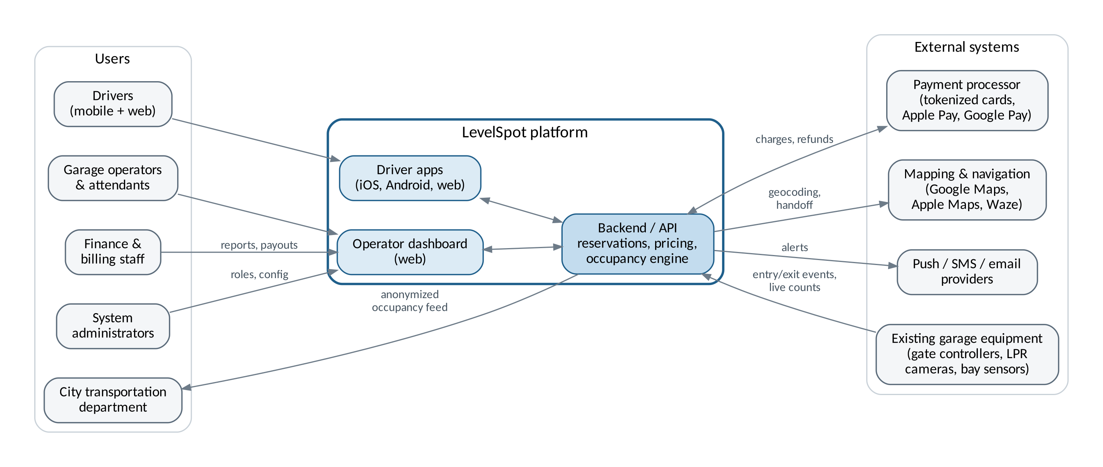
Figure 1: LevelSpot system context for release 1

3. Software requirements specification (draft)

3.1 Introduction
Purpose. This section defines the requirements for LevelSpot release 1. It is a first draft and will be expanded each week as requirement sessions with BBGP continue.
Scope. Release 1 covers the driver apps (iOS, Android, web), the operator dashboard, the backend services behind them, and integrations with payment, mapping, notification, and garage equipment vendors. Section 2.7 lists what is in and out of scope.
Definitions.
Term | Meaning
Facility | A garage or surface lot managed by an operator
Open count | Number of empty spaces in a facility or level, calculated from live gate and sensor events
Reserved buffer | Spaces an operator keeps aside for drive-up parkers. Reservations stop when the open count reaches this number.
Hold window | How long a reserved space stays held after the reservation start time. Default is 30 minutes.
Spot Guarantee | Automatic rebooking at another facility, with any price difference covered, when a reservation can't be honored
LPR | License plate recognition camera
Table 5: Definitions

3.2 Overall description
Users. Drivers (guests and registered), monthly parkers, operator managers, garage attendants, finance staff, city transportation analysts, and system administrators.
System environment. Native iOS and Android apps, a responsive driver web app, and a web-based operator dashboard. Backend services are cloud hosted on AWS across two US regions.
Constraints. The project has a fixed semester timeline. It depends on third party APIs for payments, maps, notifications, and garage equipment. Card handling must meet PCI DSS. Personal data handling must follow the Texas Data Privacy and Security Act. Pricing, signage, and data sharing must follow City of Houston parking ordinances. The apps must pass Apple App Store and Google Play review.
Assumptions, revised October 15. The original assumption here read that every BBGP facility has an internet-connected gate controller or LPR camera able to send entry and exit events. The first 9 surveys showed that is false, so it has been replaced with the following.
- Each facility falls into one of three counting classes: gate events (a networked controller with an event API), camera counting (one controlled entrance, no usable controller), or capacity model (no single controlled entrance). The class is a property of the facility, not a global assumption.
- Drivers have a smartphone with location services, or can enter a destination manually.
- BBGP gives us access to facility data and sets its own prices.
- Mapping provider licensing allows showing facility pins and handing off directions.
- BBGP staff can submit a manual count at any facility when automated counting is unavailable.
Everything downstream of the old assumption had to be revisited. FR29 through FR32 below, work package 3.7 in the WBS, and the camera counting task in the schedule all exist because of this one correction.

3.3 Functional requirements
ID | Requirement
Accounts
FR1 | The system shall allow drivers to register with an email address or mobile number and verify it with a one time code.
FR2 | The system shall allow drivers to sign in with a password or with an Apple or Google account.
FR3 | The system shall allow drivers to save vehicles with license plate, state, and height class.
FR4 | The system shall allow guest checkout using only a mobile number and license plate.
Search and map
FR5 | The system shall display facilities on an interactive map with the open count for each facility.
FR6 | The system shall show open counts per level for facilities that report level data.
FR7 | The system shall let drivers filter facilities by price, distance, clearance height, EV charging, accessible spaces, and hours.
FR8 | The system shall place each map pin at the facility's vehicle entrance, not its mailing address.
FR9 | The system shall hand off turn by turn directions to Google Maps, Apple Maps, or Waze.
Reservations
FR10 | The system shall allow drivers to reserve a space for a selected start and end time.
FR11 | The system shall hold a reserved space from the start time through the hold window.
FR12 | The system shall allow drivers to extend or cancel a reservation.
FR13 | The system shall rebook a driver through the Spot Guarantee when a facility cannot honor a reservation.
FR14 | The system shall stop selling reservations at a facility when its open count reaches the reserved buffer.
Payments and receipts
FR15 | The system shall accept payment by card, Apple Pay, and Google Pay through a PCI compliant processor.
FR16 | The system shall show the full price, including all fees and taxes, before the driver confirms.
FR17 | The system shall issue refunds automatically based on the operator's cancellation policy.
FR18 | The system shall keep reservation history and let drivers download receipts as PDF.
Notifications
FR19 | The system shall send a reminder 15 minutes before a reservation starts and 15 minutes before it ends.
FR20 | The system shall alert drivers with active or upcoming reservations when their facility or level closes.
Operator tools and administration
FR21 | The system shall provide operators a dashboard with live occupancy by facility and level.
FR22 | The system shall allow operators to set base rates, time of day rates, and event rates.
FR23 | The system shall allow operators to close a level or facility and set an expected reopening time.
FR24 | The system shall generate occupancy, revenue, and reservation reports exportable to CSV and PDF.
FR25 | The system shall allow finance users to reconcile payouts against payment processor settlements.
FR26 | The system shall allow administrators to create operator users and assign roles (manager, attendant, finance, read only).
Facility capability and fallback counting (added October 15)
FR29 | The system shall record a counting class for each facility: gate events, camera counting, or capacity model.
FR30 | For capacity model facilities, the system shall calculate availability as posted capacity minus active reservations minus a manually maintained drive-up allowance, rather than from a live count.
FR31 | The system shall show drivers an availability indicator appropriate to the facility's counting class, and shall not display an exact open count for a facility that cannot produce one.
FR32 | The system shall allow an attendant to submit a manual count for a facility or level, which overrides the calculated availability until the next automated reading or the end of that shift.
Integrations
FR27 | The system shall accept entry and exit events from supported gate controllers and LPR cameras through vendor adapters.
FR28 | The system shall publish an anonymized occupancy feed per facility for the city, refreshed every 5 minutes.
Table 6: Functional requirements

3.4 Non-functional requirements
ID | Category | Requirement
NFR1 | Performance | At gate event and camera counting facilities, open counts shown to drivers shall update within 10 seconds of a gate or sensor event. Revised October 15 to name the counting classes this applies to.
NFR2 | Performance | The map screen shall load facility pins within 2 seconds on a 4G connection.
NFR3 | Scalability | The system shall support 25,000 concurrent drivers during event peaks with reservation confirmation under 3 seconds.
NFR4 | Availability | The system shall have 99.9% monthly uptime, and 99.95% during operator-flagged event windows.
NFR5 | Resilience | If a facility loses its internet connection, the gate adapter shall keep honoring cached reservations for at least 60 minutes.
NFR6 | Security | Card numbers shall never be stored on LevelSpot servers. Only payment processor tokens are kept.
NFR7 | Security | All data shall be encrypted in transit with TLS 1.2 or higher and at rest with AES-256.
NFR8 | Security | Operator and administrator accounts shall require multi factor authentication.
NFR9 | Privacy | License plate data shall be anonymized 90 days after a reservation ends unless tied to an open billing dispute.
NFR10 | Usability | A signed in driver shall be able to complete a reservation in 4 taps or fewer from the facility screen.
NFR11 | Accessibility | Driver apps and the operator dashboard shall meet WCAG 2.2 Level AA.
NFR12 | Localization | Driver apps shall be available in English and Spanish at launch.
NFR13 | Auditability | Price changes, refunds, and role changes shall be logged with user and timestamp and kept for 2 years.
NFR14 | Accuracy | At capacity model facilities, availability shall be correct often enough that no more than 2% of reservations there need a Spot Guarantee rebook, measured monthly. Added October 15.
NFR15 | Accuracy | At camera counting facilities, the open count shall stay within 5% of a manual audit count, checked weekly during the pilot. Added October 15.
Table 7: Non-functional requirements

3.5 Use cases
The use cases below cover the main driver, operator, finance, city, and admin workflows for release 1. More will be added as requirements sessions continue.

UC-01: Register a driver account
Primary actor | Driver
Preconditions | LevelSpot app is installed. Driver does not have an account.
Main flow | 1. Driver taps Create account.  2. Driver enters a mobile number or email address.  3. System sends a 6 digit verification code.  4. Driver enters the code.  5. Driver sets a password or links an Apple or Google account.  6. System creates the account and prompts the driver to add a vehicle.
Alternate flow | 3a. Code doesn't arrive within 60 seconds: driver taps Resend (limit of 3 per hour).
Postcondition | A verified driver account exists.

UC-02: Add a vehicle
Primary actor | Driver
Preconditions | Driver is signed in.
Main flow | 1. Driver opens Vehicles and taps Add vehicle.  2. Driver enters plate number, state, and a nickname.  3. Driver picks a height class: car, SUV, full size truck, or oversized.  4. System checks the plate format for that state and saves the vehicle.
Alternate flow | 4a. Plate format doesn't match the selected state: system highlights the field and asks the driver to fix it.
Postcondition | Vehicle is saved and used for LPR entry and clearance filtering.

UC-03: Find open parking near a destination
Primary actor | Driver
Preconditions | Location access is granted or the driver types a destination.
Main flow | 1. Driver searches for a destination, for example Discovery Green.  2. System shows facilities within half a mile with their open counts.  3. Driver taps a facility.  4. System shows price for the selected time, open spaces per level, clearance height, and walking time to the destination.
Alternate flow | 2a. No facilities with open space nearby: system widens the search to 1 mile and tells the driver it did.
Postcondition | Driver sees current details for the selected facility.

UC-04: Filter facilities by vehicle needs
Primary actor | Driver
Preconditions | Search results are showing.
Main flow | 1. Driver taps Filters.  2. Driver selects EV charging, accessible spaces, or both.  3. System uses the saved vehicle's height class to hide facilities with lower clearance.  4. System refreshes the map and list.
Alternate flow | 3a. Driver has no saved vehicle: system asks for a height class once and remembers it.
Postcondition | Only facilities that fit the driver's needs are shown.

UC-05: Reserve a parking space
Primary actor | Driver
Preconditions | Driver is signed in or checking out as a guest. Facility has reservable open spaces.
Main flow | 1. Driver selects a facility and time window.  2. Driver taps Reserve.  3. System shows the total price with fees and the cancellation policy.  4. Driver confirms the vehicle and payment method.  5. Driver taps Confirm.  6. System takes payment (UC-06), holds a space, and shows the reservation with entry instructions.
Alternate flow | 5a. Open count hits the reserved buffer before the driver confirms: system explains the facility just filled up and suggests the three closest facilities with room.
Postcondition | Reservation is active and the space is removed from the sellable count.

UC-06: Pay for a reservation
Primary actor | Driver (secondary: payment processor)
Preconditions | A reservation is waiting for payment.
Main flow | 1. Driver chooses a saved card, Apple Pay, or Google Pay.  2. System sends a tokenized charge to the processor.  3. Processor approves the charge.  4. System confirms the reservation and emails a receipt.
Alternate flow | 3a. Payment is declined: system keeps the space on hold for 5 minutes and asks for another payment method.
Postcondition | Payment is captured and the receipt is stored.

UC-07: Enter and exit a garage with a reservation
Primary actor | Driver (secondary: gate controller, LPR camera)
Preconditions | Driver has an active reservation. Facility has supported gate equipment.
Main flow | 1. Driver pulls up to the entrance.  2. LPR camera reads the plate.  3. System matches the plate to the reservation and opens the gate.  4. System updates the open count.  5. At exit, the camera reads the plate, the system closes out the reservation, and the gate opens.
Alternate flow | 2a. Plate can't be read (dirty plate, bike rack, trailer hitch): driver scans the QR code in the app at the entry kiosk.  5a. Driver stayed past the end time: system charges overtime at the posted rate and adds it to the receipt.
Postcondition | Parking session is closed and the facility count is accurate.

UC-08: Extend an active reservation
Primary actor | Driver
Preconditions | Driver has an active reservation.
Main flow | 1. Driver opens the reservation from the reminder or the app.  2. Driver taps Extend and picks extra time.  3. System checks availability and shows the added cost.  4. Driver confirms.  5. System charges the difference and updates the end time.
Alternate flow | 3a. Facility is booked for an event later that evening: system offers the longest extension that is still available.
Postcondition | Reservation has a new end time.

UC-09: Cancel a reservation
Primary actor | Driver
Preconditions | Driver has an upcoming reservation.
Main flow | 1. Driver opens the reservation and taps Cancel.  2. System shows the refund amount based on the operator's policy.  3. Driver confirms.  4. System releases the space and processes the refund.
Alternate flow | 2a. Reservation is inside the no-refund window: system shows a $0 refund and lets the driver keep the reservation instead.
Postcondition | Space is back in inventory. Refund is issued if eligible.

UC-10: Rebook a driver through the Spot Guarantee
Primary actor | System (secondary: driver)
Preconditions | A driver has an active or upcoming reservation at a facility that can no longer honor it (for example, overfilled or level closed).
Main flow | 1. System detects that the facility can't honor the reservation.  2. System finds the nearest facility with open space that fits the driver's vehicle height.  3. System creates the new reservation and cancels the original.  4. System credits any price difference.  5. System sends a push notification and text with the new location and a Directions button.
Alternate flow | 2a. No facility within 1 mile has room: system gives a full refund plus an account credit and tells the driver right away.
Postcondition | Driver has a valid reservation, or a full refund and credit.

UC-11: Navigate to the facility entrance
Primary actor | Driver (secondary: mapping and navigation service)
Preconditions | Driver has a reservation.
Main flow | 1. Driver taps Directions.  2. System asks which navigation app to use and remembers the choice.  3. System sends the coordinates of the vehicle entrance.  4. Navigation app starts the route.
Alternate flow | 3a. Entrance is on a one way street: system sends an approach point so the route arrives from the correct direction.
Postcondition | Driver is routed to the correct entrance.

UC-12: View history and download a receipt
Primary actor | Driver
Preconditions | Driver is signed in and has at least one completed reservation.
Main flow | 1. Driver opens History.  2. Driver filters by date range.  3. Driver opens a reservation and taps Download receipt.  4. System generates a PDF with facility, times, plate, price, fees, and tax.
Alternate flow | 3a. Driver needs receipts for an expense report: driver selects several reservations and exports one combined PDF.
Postcondition | Receipt is downloaded.

UC-13: Monitor live occupancy
Primary actor | Operator manager
Preconditions | Manager is signed in with multi factor authentication. Facilities are connected.
Main flow | 1. Manager opens the dashboard.  2. System shows every facility with occupancy percentage and a level breakdown.  3. Manager opens one facility.  4. System shows open counts, upcoming reservations, and gate status for each lane.
Alternate flow | 4a. A gate or sensor hasn't reported for more than 2 minutes: system marks the level as Data delayed and pauses reservation sales there.
Postcondition | Manager has a current view of occupancy.

UC-14: Set event pricing
Primary actor | Operator manager
Preconditions | Manager is signed in and has pricing permission.
Main flow | 1. Manager opens Pricing.  2. Manager selects one or more facilities.  3. Manager creates an event rule with a name, date, time window, and flat rate.  4. Manager sets the reserved buffer for the event.  5. System shows a preview of the new prices.  6. Manager publishes the rule, and the system applies it to new bookings only.
Alternate flow | 5a. New rule overlaps an existing rule: system shows the conflict and asks which rule wins.
Postcondition | Event pricing is live and the change is logged.

UC-15: Close a level and alert drivers
Primary actor | Operator manager or attendant
Preconditions | User is signed in to the dashboard.
Main flow | 1. User selects a facility and level.  2. User taps Close level.  3. User picks a reason (street flooding, maintenance, event staging, other) and an expected reopening time.  4. User confirms.  5. System removes the level's spaces from availability, alerts affected drivers, and starts UC-10 for reservations it can't move to another level.
Alternate flow | 3a. Reopening time is unknown: level stays closed until someone reopens it manually.
Postcondition | Level is closed and affected drivers have been notified.

UC-16: Generate an occupancy and revenue report
Primary actor | Operator manager or finance user
Preconditions | User is signed in.
Main flow | 1. User opens Reports.  2. User chooses a report type.  3. User selects facilities and a date range.  4. System builds the report with peak hours, average occupancy, and revenue by channel.  5. User exports it as CSV or PDF.
Alternate flow | 4a. Date range is longer than 12 months: system builds the report in the background and emails a link when it's ready.
Postcondition | Report is generated and exported.

UC-17: Reconcile operator payouts
Primary actor | Finance and billing staff (secondary: payment processor)
Preconditions | User is signed in with the finance role.
Main flow | 1. User opens Payouts and selects a pay period.  2. System lists reservations, refunds, fees, and the net payout.  3. User compares the totals against the processor's settlement file.  4. User marks the period as reconciled.
Alternate flow | 3a. Totals don't match: system lists the unmatched transactions and the user opens a dispute ticket.
Postcondition | Pay period is reconciled or flagged for follow-up.

UC-18: Pull the occupancy feed for city planning
Primary actor | City transportation analyst
Preconditions | A data sharing agreement is signed and the analyst has an API key.
Main flow | 1. Analyst requests the occupancy feed from the city's traffic dashboard.  2. System returns occupancy, capacity, and a timestamp for each facility with no personal data.  3. City dashboard displays the data alongside traffic sensor data.
Alternate flow | 2a. API key has expired: system returns an authorization error with instructions to renew it through the administrator.
Postcondition | City has current anonymized occupancy data.

UC-19: Manage operator user roles
Primary actor | System administrator
Preconditions | Administrator is signed in with multi factor authentication.
Main flow | 1. Administrator opens Users and taps Invite.  2. Administrator enters an email, assigns a role, and picks which facilities the user can access.  3. System sends the invitation.  4. New user accepts, sets a password, and enrolls in multi factor authentication.
Alternate flow | 4a. Invitation isn't accepted within 7 days: it expires and the administrator can resend it.
Postcondition | User has only the permissions assigned, and the change is logged.

UC-20: Submit a manual count (added October 15)
Primary actor | Garage attendant
Preconditions | Attendant is signed in. The facility's automated counting is unavailable, or the attendant sees that the count is wrong.
Main flow | 1. Attendant opens the facility on the dashboard and taps Submit count.  2. Attendant enters open spaces for the facility or for one level.  3. System shows what the calculated availability currently is, so the attendant can see the gap.  4. Attendant confirms.  5. System overrides availability with the manual figure, marks the facility as manually counted in the driver apps, and logs who submitted it.
Alternate flow | 3a. The manual count differs from the calculated figure by more than 20%: system asks the attendant to confirm a second time and alerts the operations manager.  5a. Nobody submits a new count by end of shift: the override expires and the facility reverts to calculated availability.
Postcondition | Availability reflects what the attendant can actually see, and the override is attributable.

UC-21: Reserve at a capacity model facility (added October 15)
Primary actor | Driver
Preconditions | Driver has selected an open perimeter surface lot, which has no live count.
Main flow | 1. System shows a Likely available indicator with the time it was last confirmed, rather than a number.  2. Driver selects a time window and taps Reserve.  3. System checks posted capacity minus active reservations minus the drive-up allowance.  4. System shows the price and states plainly that this lot is not space counted and the Spot Guarantee still applies.  5. Driver confirms and pays.
Alternate flow | 3a. The calculation shows no headroom: system offers the nearest counted facility instead.
Postcondition | Reservation is active, and it is flagged internally as capacity model so the Spot Guarantee rate at that lot can be tracked against NFR14.

4. Work breakdown structure
The WBS below breaks LevelSpot into deliverables, not tasks. It goes three levels deep: level 1 is a major area of the project, level 2 is a deliverable inside that area, and level 3 is the work package a team can actually schedule and estimate. Level 3 packages are what feed the estimates in Section 5 and the schedule in Section 6.
Project management, integration work, and testing are in the WBS on purpose. Leaving them out is one of the fastest ways to underestimate a project, since they can easily be a third of the real effort.
Updated October 15. Two work packages were added after the first facility surveys: 3.7 for the facility capability model and 7.4 for surface lot camera counting. Package 7.1 also grew, because two of the surveyed sites have serial-only controllers that need a bridge to put their events on the network.
Level 1 | Level 2 and level 3 work packages | Owner
1. Project management | 1.1 Planning: charter, WBS, schedule, risk register  1.2 Stakeholder management: weekly BBGP reviews, city coordination  1.3 Status reporting: weekly stakeholder video, sprint reports | PM
2. Requirements and design | 2.1 Requirements: elicitation sessions, SRS, use case catalog  2.2 UX design: driver wireframes, dashboard wireframes, design system  2.3 Technical architecture: data model, API spec, integration architecture | PM, Web, Backend
3. Backend and API | 3.1 Accounts service: registration and verification, sign in and MFA, vehicle profiles  3.2 Occupancy service: adapter framework, event ingestion, per level count engine, data delayed detection  3.3 Reservation engine: availability and buffers, booking and holds, extend and cancel, Spot Guarantee rebooking  3.4 Pricing service: base and time of day rates, event rules, price preview API  3.5 Notification service: push, SMS, email templates  3.6 City data feed: anonymization job, public API and key management  3.7 Facility capability model (added Oct 15): counting class registry, capacity-based availability, manual count override and expiry | Backend/API
4. Payments | 4.1 Processor integration: tokenized checkout, Apple Pay and Google Pay, refunds  4.2 Receipts: PDF generation, combined export  4.3 Operator payouts: payout calculation, settlement reconciliation | Payment Integration
5. Driver applications | 5.1 iOS app: onboarding, map and search, reservation flow, active reservation screen  5.2 Android app: onboarding, map and search, reservation flow, active reservation screen  5.3 Driver web app: search and booking, history and receipts  5.4 Shared components: map component, Spanish localization, accessibility pass | Mobile, Web, Mapping
6. Operator dashboard | 6.1 Live occupancy views: portfolio view, facility and level view, gate status  6.2 Pricing management: rate editor, event rules, conflict checks  6.3 Facility control: close level workflow, driver alerts  6.4 Reporting: occupancy reports, revenue reports, CSV and PDF export  6.5 User administration: invites and roles, audit log | Web Application
7. Integrations and field work | 7.1 Gate vendor adapters: vendor A, vendor B, serial to network bridge, offline cache mode  7.2 Facility onboarding: site surveys, level mapping and clearance data, entrance geocoding  7.3 Mapping handoff: geocoding, deep links to Google Maps, Apple Maps, Waze  7.4 Surface lot counting (added Oct 15): entrance camera adapter, vehicle counting model, calibration per lot | Backend, Mapping
8. Quality assurance | 8.1 Test planning: test plan, test data sets  8.2 Functional testing: driver apps, dashboard, gate integration in the field  8.3 Non-functional testing: event day load test, security review, WCAG 2.2 AA audit  8.4 User acceptance testing with BBGP staff | QA & Testing
9. Release and operations | 9.1 Infrastructure: AWS environments, CI/CD, monitoring and alerting  9.2 App store release: App Store submission, Play Store submission  9.3 Pilot: 3 downtown garages, feedback and fixes  9.4 Full rollout: 23 facilities, attendant training, handover documents | Backend, QA, PM
Table 8: LevelSpot work breakdown structure
Figure 2 shows branch 3 drawn out as a tree, from the level 1 area down to the individual level 3 work packages. The other branches follow the same pattern.
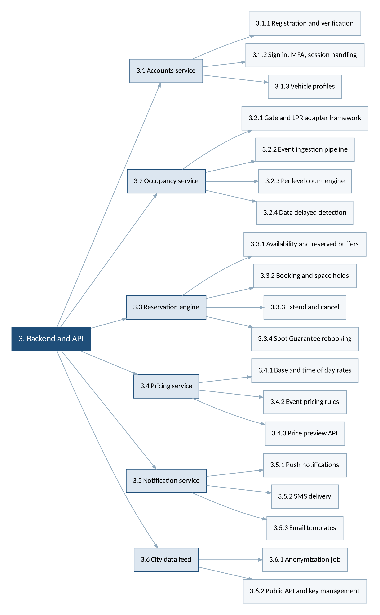
Figure 2: Level 3 decomposition of WBS branch 3, Backend and API

5. Estimation
We estimated each level 3 package with story points on the Fibonacci scale, then checked the total against a COCOMO calculation. Story points measure relative size, effort, and risk, not hours. The 89 point packages are the ones where we expect surprises, not just long hours.

5.1 Story point estimates
Story points here are rolled up to the level 2 deliverable so the table stays readable. Project management work (branch 1) is treated as ongoing overhead and is not point estimated.
WBS | Deliverable | SP | Basis for the estimate
2.1 | Requirements | 21 | Mostly elicitation sessions and writing. Similar scope to the yard app.
2.2 | UX design | 34 | Two products to design, driver app and dashboard.
2.3 | Technical architecture | 21 | Data model plus the adapter design.
3.1 | Accounts service | 34 | Standard work. Analogy: the yard app login took one sprint.
3.2 | Occupancy service | 89 | Highest risk package. Vendor formats differ and events arrive out of order.
3.3 | Reservation engine | 89 | Holds, buffers, and Spot Guarantee logic. Lots of edge cases.
3.4 | Pricing service | 34 | Rules engine with overlapping event rates.
3.5 | Notification service | 21 | Mostly integration with push and SMS providers.
3.6 | City data feed | 13 | Small API with an anonymization step.
3.7 | Facility capability model | 55 | Added Oct 15. Counting classes, capacity-based availability, manual overrides. Touches the data model, so it is bigger than it sounds.
4.1 | Processor integration | 34 | Tokenized checkout, wallets, refunds.
4.2 | Receipts | 13 | PDF generation, low risk.
4.3 | Operator payouts | 21 | Reconciliation math needs finance review.
5.1 | iOS app | 89 | Full app: onboarding through active reservation.
5.2 | Android app | 89 | Same scope as iOS, some shared logic.
5.3 | Driver web app | 55 | Smaller feature set than the mobile apps.
5.4 | Shared components | 34 | Map component, Spanish localization, accessibility pass.
6.1 | Live occupancy views | 55 | Real time updates in the browser.
6.2 | Pricing management | 34 | Editor plus conflict checking.
6.3 | Facility control | 21 | Close level workflow and alerts.
6.4 | Reporting | 34 | Charts and exports.
6.5 | User administration | 13 | Roles, invites, audit log.
7.1 | Gate vendor adapters | 89 | Raised from 55 on Oct 15. Two vendors, an offline cache mode, and a serial to network bridge the survey turned up.
7.2 | Facility onboarding | 34 | Field work at 23 sites. Effort is people and travel, not code.
7.3 | Mapping handoff | 13 | Deep links and entrance geocoding.
7.4 | Surface lot camera counting | 34 | Added Oct 15. Entrance camera adapter plus per lot calibration at 4 sites.
8.1 | Test planning | 8
8.2 | Functional testing | 55 | Includes testing at live garages, which is slow.
8.3 | Non-functional testing | 34 | Load, security, and accessibility.
8.4 | User acceptance testing | 13 | BBGP staff run their own scenarios.
9.1 | Infrastructure | 34 | Environments, CI/CD, monitoring.
9.2 | App store release | 8 | Submission and review cycles.
9.3 | Pilot | 21 | Three garages, two sprints of fixes.
9.4 | Full rollout | 34 | 23 facilities and attendant training.
Table 9: Story point estimates by deliverable
Total: 1,280 story points, up from 1,157 on October 8. The three changes above account for all of it: the facility capability model at 55, the gate adapter package going from 55 to 89, and surface lot camera counting at 34.

5.2 Turning points into a schedule
On the yard management app, one 5 person team averaged about 22 points per two week sprint. Six teams are assigned to LevelSpot, but they don't all start at once and they don't all run at full speed, so we planned on roughly 90 points per sprint across the whole project once every team is ramped up.
At 1,157 points that was about 13 sprints, or 26 weeks, against the 25 weeks the schedule allowed. Tight but workable.
Revised October 15. At 1,280 points it is 14.2 sprints, or about 28 weeks, against the same 25. The estimate no longer fits the schedule, and pretending otherwise would just move the problem to March. Three things close the gap, and all three are now in Section 6:
- The gate vendor survey is running a week ahead, which frees a week on the front end.
- Surface lot camera counting (task 8) runs in parallel with the occupancy service rather than after it, because they share no code and only the field calibration competes for the same people.
- The pilot starts at 2 garages instead of 3, which is the mitigation we already wrote down for risk R6 in week 3. Using a mitigation we planned in advance is a much better position than inventing one under pressure.
What those three do not cover, about two weeks, comes out of the milestone dates: M3, M4, and M5 all move. M6 and M8, the pilot and the rollout, hold. Those are the two dates BBGP actually cares about, so they are the two we protected.

5.3 COCOMO sanity check
Estimating the same system a second way is a cheap way to catch a bad number. LevelSpot fits the organic category in COCOMO: a known problem domain, an experienced team, and requirements we can still negotiate.
Our LOC estimate for release 1 is about 52,000 lines across the backend, apps, and dashboard, based on the yard app and the campus shuttle system.
Effort = 2.4 × (52)^1.05 = 152 person-months
The roster in Section 10.2 now names 22 people, several of them part time, which works out to 18.0 full time equivalents and about 180 person-months of capacity. It was 21 people and 174 person-months on October 8; a contract computer vision engineer was added for the surface lot work. The COCOMO number sits under that, so the effort estimate still looks reasonable.
The schedule side is where it gets interesting. COCOMO's development time formula, 2.5 × (152)^0.38, gives about 17 months with an average of 9 people. We are planning 9 months with 18 full time equivalents. COCOMO penalizes exactly that kind of compression, so this is a real flag rather than a rounding difference. We're handling it by keeping the teams working on separate parts of the WBS with clear interfaces between them, and by treating the schedule as the first thing to renegotiate if the occupancy service slips. Risk R6 in Section 8 tracks it.

5.4 Where the estimate is weakest
- Partly resolved October 15. The occupancy service and gate adapter packages depended on vendor documentation we had not seen. We have now seen it for 9 of 23 sites, and the adapter package did grow, from 55 points to 89. The remaining 14 sites are still an open exposure, and if they match the pattern of the first 9 we should expect roughly 4 more surface lots and 2 more sites needing replacement controllers.
- Facility onboarding (7.2) assumes BBGP has accurate level, capacity, and clearance data for all 23 sites. The first 9 surveys found the capacity figures off by more than 10% at 3 sites, so this is now a known problem rather than a worry.
- Surface lot camera counting (7.4) is estimated at 34 points from a vendor demo, not from our own prototype. It is the least grounded number in this table.
- App store review times are outside our control.
- Points were estimated by the leads, not by the full teams. We'll re-estimate in sprint planning, and the numbers here will move.

6. Schedule and timeline
The plan runs from kickoff on September 8, 2026 to full rollout on June 11, 2027, about 40 weeks. Work is organized in two week sprints inside the phases below.
Revised October 15. Task 8, surface lot camera counting, is new. The occupancy service gained two weeks and the reservation engine one, both from the survey findings. The pilot drops from 3 garages to 2. Milestones M3, M4, and M5 move; M6 and M8 hold.

6.1 Task schedule
Task | Start | Finish | Duration | Depends on | Notes
1. Requirements elicitation with BBGP | 09/08/26 | 09/25/26 | 2.8 wks | Start
2. SRS baseline and use case catalog | 09/14/26 | 10/02/26 | 3 wks | 1 (SS) | Runs alongside elicitation
3. UX design: driver app and dashboard | 10/05/26 | 11/06/26 | 5 wks | 2 (FS)
4. Architecture, data model, API spec | 10/05/26 | 10/30/26 | 4 wks | 2 (FS)
5. Gate vendor survey, 23 facilities | 10/05/26 | 11/13/26 | 6 wks | 2 (FS) | Running a week ahead
6. Accounts service | 11/02/26 | 12/04/26 | 5 wks | 4 (FS)
7. Occupancy service and gate adapters | 11/02/26 | 01/29/27 | 13 wks | 4, 5 (FS) | Critical path, +2 wks
8. Surface lot camera counting | 11/16/26 | 02/12/27 | 13 wks | 5 (FS) | New, from survey findings
9. Reservation engine and Spot Guarantee | 11/30/26 | 02/19/27 | 12 wks | 7 (SS) | Critical path, +1 wk
10. Pricing service | 01/04/27 | 02/05/27 | 5 wks | 9 (SS)
11. Payments and payouts | 12/07/26 | 02/05/27 | 9 wks | 6 (FS)
12. Driver apps: iOS, Android, web | 11/16/26 | 03/26/27 | 19 wks | 3 (FS) | Critical path, +1 wk
13. Operator dashboard | 01/04/27 | 03/26/27 | 12 wks | 3, 7 (FS)
14. Notifications and city data feed | 02/08/27 | 03/12/27 | 5 wks | 9 (FS)
15. Facility onboarding and level mapping | 02/01/27 | 04/16/27 | 11 wks | 5, 7 (FS)
16. QA: functional and field gate testing | 02/15/27 | 04/16/27 | 9 wks | 12 (SS) | Critical path
17. Load, security, accessibility testing | 03/15/27 | 04/23/27 | 6 wks | 13 (FS)
18. Pilot at 2 downtown garages | 04/05/27 | 05/07/27 | 5 wks | 16, 17 (FS) | Critical path, cut from 3
19. UAT with BBGP staff | 04/19/27 | 05/07/27 | 3 wks | 18 (FF) | Finishes with the pilot
20. App Store and Play Store release | 05/03/27 | 05/21/27 | 3 wks | 18 (FS)
21. Full rollout to 23 facilities, training | 05/10/27 | 06/11/27 | 5 wks | 19 (FS) | Critical path
Table 10: Draft task schedule with dependencies

6.2 Dependencies
Most tasks are finish to start, but three relationships drive the plan and are worth calling out.
- The reservation engine starts alongside the occupancy service (start to start) rather than after it. The booking logic can be built against simulated counts, and waiting for real gate data would push everything back by two months.
- QA starts alongside the driver apps (start to start) so bugs surface during development instead of in one long test phase at the end.
- UAT finishes with the pilot (finish to finish). BBGP staff test against the live pilot garages, so both wrap up on the same date.
- Surface lot camera counting (task 8) depends only on the survey, not on the occupancy service, so the two run side by side. That parallelism is what keeps the added work from pushing the pilot.
The critical path runs through the gate vendor survey, the occupancy service, the reservation engine, the driver apps, field testing, the pilot, and rollout. Anything that slips on that chain moves the June date. The occupancy service is still the piece to watch, and it got two weeks longer this week, so the float that used to sit between feature complete and the pilot is now down to about ten days.

6.3 Milestones
ID | Milestone | Date | Change since October 8
M1 | Requirements baseline approved by BBGP | 10/02/26 | Met
M2 | Design and architecture sign-off | 11/06/26
M3 | Live counts working at the test garage | 01/29/27 | Moved from 01/15. Occupancy service extended.
M4 | Driver app alpha on internal devices | 03/05/27 | Moved from 02/26. Follows M3.
M5 | Feature complete for release 1 | 03/26/27 | Moved from 03/19.
M6 | Pilot launch at 2 downtown garages | 04/05/27 | Date held. Cut from 3 garages to 2.
M7 | UAT sign-off from BBGP | 05/07/27 | Date held
M8 | Rollout complete at all 23 facilities | 06/11/27 | Date held
Table 11: Milestones

6.4 Gantt chart
Figure 3 shows the same schedule visually. Bars are grouped by phase and the diamonds along the top are the milestones from Table 11.

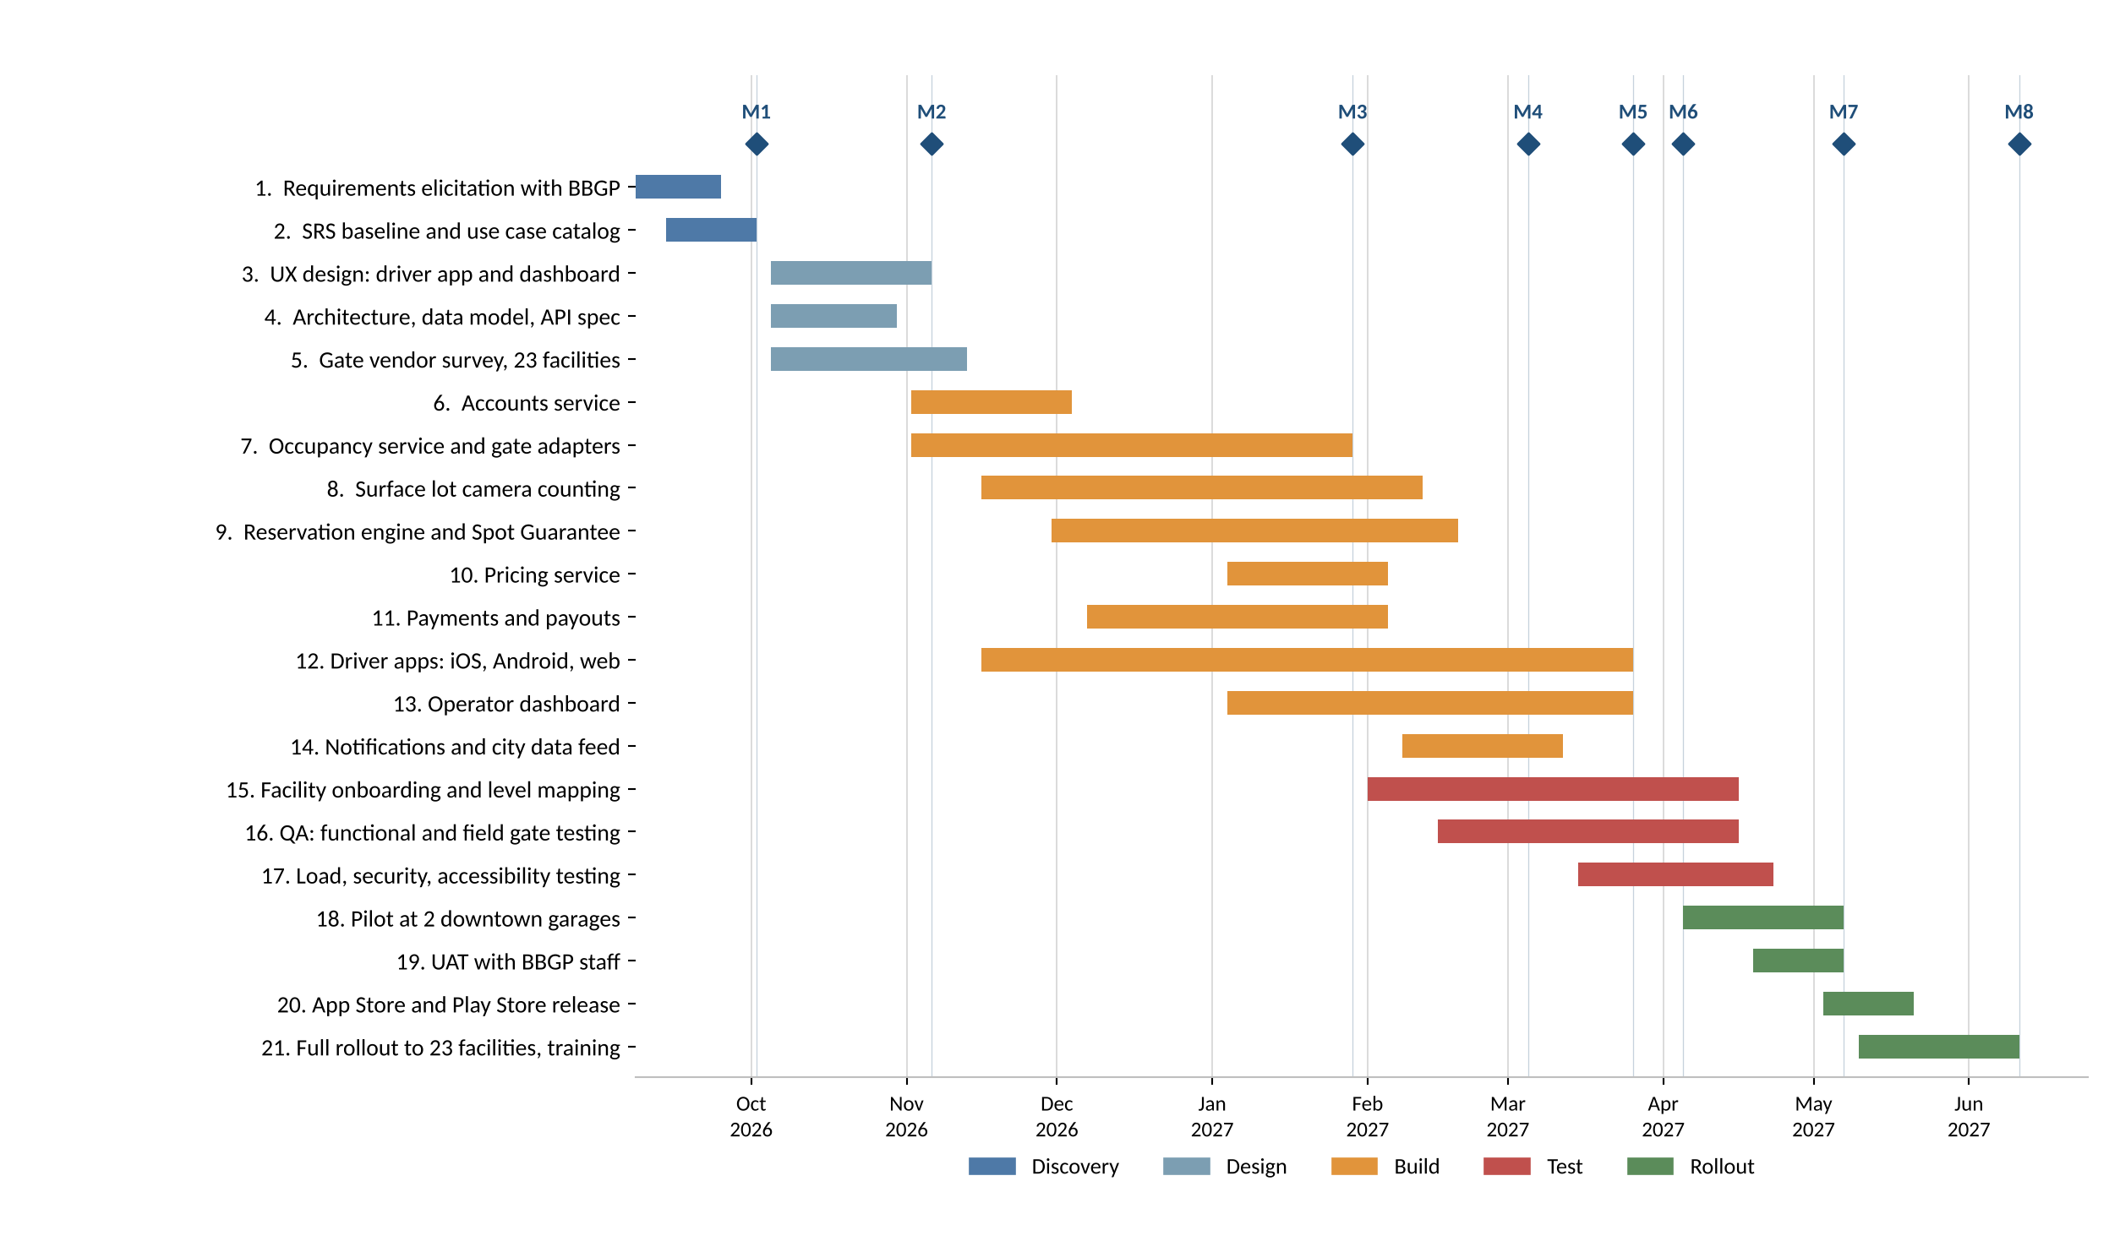
Figure 3: LevelSpot draft schedule, September 2026 to June 2027
Two scheduling notes. The Thanksgiving and December holidays fall inside the backend build, so we planned lighter sprints there instead of pretending the team is at full capacity. And the pilot starts in early April, which gives us a month of real use before the summer event season, when BBGP's garages are busiest and mistakes would be most visible.

7. Agile delivery plan and product backlog
LevelSpot runs on Scrum with two week sprints. The schedule in Section 6 is the outer frame for BBGP and the city, and the backlog below is how the teams actually work inside it. We also keep a separate Kanban board for production defects once the pilot starts, because bugs at a live garage can't wait for the next sprint boundary.

7.1 How we run the project
Element | How it works on LevelSpot
Sprint length | Two weeks, Monday start, demo on the second Friday
Product Owner | $oftware ¢orp product lead, with the BBGP operations director as the business decision maker
Scrum Master | One per delivery team, rotating every quarter
Sprint planning | Monday morning. Teams pull from the top of the backlog against their own velocity.
Daily standup | 15 minutes per team. What moved, what is next, what is blocked.
Sprint review | Working software demoed to BBGP. No slides.
Retrospective | Team only, 45 minutes, after the review
Defect workflow | Kanban board with a WIP limit of 3 per column, used from the pilot onward
Metrics | Velocity for forecasting sprints, cycle time for the defect board
Tooling | Trello through sprint 1, moving to Jira from sprint 2. Section 7.5 covers why.
Table 12: Scrum and Kanban setup

7.2 Product backlog
The backlog has 54 stories across six epics. The sixth, facility capability, was added on October 15 after the first surveys, and every story in it exists because the gate event assumption in Section 3.2 turned out to be wrong. Points use the same Fibonacci scale as Section 5. Priority uses Must, Should, Could for release 1.
Two Could stories, LS-47 (scheduled report emails) and LS-48 (driver monthly summary), were moved out of release 1 in the same session to make room. That is 10 points back, against 55 added, so it is not a rescue, just the cheapest thing available.
ID | User story | SP | Priority
Epic: Login and accounts
LS-01 | As a driver, I want to register with my phone number or email and verify it with a code so that I can book a space. | 8 | Must
LS-02 | As a driver, I want to sign in with Apple or Google so that I don't have to create another password. | 5 | Must
LS-03 | As a driver, I want to reset a forgotten password so that I can get back into my account. | 3 | Must
LS-04 | As an occasional parker, I want to book as a guest with just my phone number and plate so that I don't have to sign up. | 8 | Should
LS-05 | As an operator manager, I want to sign in with multi factor authentication so that nobody else can change my pricing. | 3 | Must
LS-06 | As a driver, I want to stay signed in on my phone and sign out of other devices so that parking is quick but still mine. | 3 | Should
Epic: Driver interface
LS-07 | As a driver, I want a map of nearby garages with open counts so that I can see where there is room right now. | 8 | Must
LS-08 | As a driver, I want a facility page showing open spaces per level so that I know which floor to drive to. | 5 | Must
LS-09 | As a truck owner, I want to filter garages by clearance height so that I don't get stuck at a low entrance. | 5 | Must
LS-10 | As a driver, I want to filter for EV charging and accessible spaces so that I only see garages that work for me. | 5 | Should
LS-11 | As a driver, I want a booking screen that shows the all-in price before I confirm so that there are no surprise fees. | 8 | Must
LS-12 | As a driver, I want an active reservation screen with my entry QR code so that I can get in if the camera misses my plate. | 5 | Must
LS-13 | As a driver, I want to extend or cancel from the reservation screen so that I can adjust without calling anyone. | 5 | Must
LS-14 | As a driver, I want a history screen where I can download receipts so that I can expense my parking. | 5 | Should
LS-15 | As a driver, I want to save my vehicles so that I don't retype my plate every time. | 3 | Must
LS-16 | As a driver, I want to switch the app to Spanish so that I can use it in my own language. | 5 | Should
Epic: Operator interface
LS-17 | As an operator manager, I want a portfolio view of all 23 facilities so that I can see the whole operation at once. | 8 | Must
LS-18 | As an operator manager, I want a facility view with live counts per level so that I can spot a filling garage early. | 8 | Must
LS-19 | As an attendant, I want to see gate lane status so that I know which lane is down before drivers tell me. | 5 | Should
LS-20 | As an operator manager, I want a pricing editor for base, time of day, and event rates so that I can price for demand. | 8 | Must
LS-21 | As an attendant, I want a close level dialog with a reason and reopening time so that flooded floors stop being sold. | 5 | Must
LS-22 | As an administrator, I want screens to invite users and assign roles so that staff only see what they should. | 5 | Must
Epic: Backend processes
LS-23 | As the system, I want to ingest entry and exit events from gate controllers and LPR cameras so that counts stay current. | 13 | Must
LS-24 | As the system, I want a count engine that tracks open spaces per level so that drivers see real availability. | 13 | Must
LS-25 | As the system, I want to detect stale sensor data and pause sales for that level so that we never sell a space we can't verify. | 8 | Must
LS-26 | As the system, I want an availability API that respects each operator's reserved buffer so that drive-up parkers still get in. | 8 | Must
LS-27 | As the system, I want to create reservations that hold a space through the hold window so that the driver's spot is really there. | 13 | Must
LS-28 | As the system, I want to process extensions, cancellations, and refund rules so that changes are handled without support calls. | 8 | Must
LS-29 | As the system, I want Spot Guarantee rebooking that finds the nearest facility and credits the difference so that a full garage isn't the driver's problem. | 13 | Must
LS-30 | As the system, I want a pricing rules engine that resolves overlapping event rates so that the right price is charged. | 8 | Must
LS-31 | As the system, I want a price preview API so that apps and the dashboard show identical prices. | 5 | Should
LS-32 | As the system, I want to charge tokenized cards and wallets through the processor so that we never store card numbers. | 13 | Must
LS-33 | As the system, I want to process refunds automatically against the operator's policy so that finance isn't doing it by hand. | 8 | Must
LS-34 | As the system, I want to calculate operator payouts per period so that BBGP gets paid accurately. | 8 | Must
LS-35 | As the system, I want one dispatch service for push, SMS, and email so that alerts go out the same way everywhere. | 8 | Must
LS-36 | As the system, I want an anonymized occupancy feed with API keys so that the city can pull data without personal information. | 8 | Should
LS-37 | As the system, I want audit logging of pricing changes, refunds, and role changes so that we can answer what happened and when. | 5 | Must
LS-38 | As the system, I want to match plates at the gate and fall back to QR codes so that entry works even when a plate can't be read. | 8 | Must
Epic: Reporting
LS-39 | As an operator manager, I want an occupancy report by facility and level so that I can plan staffing. | 8 | Must
LS-40 | As an operator manager, I want a revenue report by channel so that I can see app bookings versus drive-up. | 8 | Must
LS-41 | As an operator manager, I want peak hour analysis so that I can set event pricing from real patterns. | 5 | Should
LS-42 | As an operator manager, I want a reservation versus drive-up mix report so that I can tune the reserved buffer. | 5 | Should
LS-43 | As a project sponsor, I want a Spot Guarantee incident report so that I can see how often we fail to honor a booking. | 5 | Must
LS-44 | As a finance user, I want a payout and settlement reconciliation report so that I can close the month. | 8 | Must
LS-45 | As a finance user, I want CSV export of any report so that I can work with it in Excel. | 3 | Must
LS-46 | As an operator manager, I want PDF export with charts so that I can send a report to leadership. | 5 | Should
LS-47 | As an operator manager, I want scheduled weekly report emails so that I don't have to log in to check. | 5 | Could
LS-48 | As a driver, I want a monthly summary of what I spent on parking so that I can budget. | 5 | Could
Epic: Facility capability (added October 15 after the first surveys)
LS-49 | As the system, I want each facility to carry a counting class so that the rest of the platform knows what kind of availability it can trust. | 8 | Must
LS-50 | As an attendant, I want to submit a manual count so that drivers see what I can actually see when the sensors cannot. | 8 | Must
LS-51 | As the system, I want a capacity-based availability model for open perimeter lots so that we can still sell parking where we cannot count spaces. | 13 | Must
LS-52 | As a driver, I want the app to tell me plainly when a lot is not space counted so that I know how much to trust the availability. | 5 | Must
LS-53 | As the system, I want an entrance camera adapter that counts vehicles in and out so that surface lots with one entrance get a real count. | 13 | Must
LS-54 | As the system, I want a serial to network bridge for older gate controllers so that sites without an event API still report. | 8 | Must
Table 13: Product backlog for release 1

7.3 Sprint 1 backlog
Sprint goal: a driver can create an account and see live open counts for one test garage on a map.
Sprint 1 runs November 2 to November 13, 2026, right after design sign-off. Only three teams are on this sprint, so the committed capacity is 55 points rather than the 90 point average used in Section 5. We picked the account stories because everything else needs a signed in user, and the two occupancy stories because they sit on the critical path and we want the risk in front of us early rather than in February.
Revised October 15. LS-49, the facility capability flags, was pulled into sprint 1 and LS-37, audit logging, pushed to sprint 2. The reason is ordering, not priority: the counting class is a column on the facility record that the count engine reads, so building the count engine first would mean rewriting it two weeks later. Audit logging has no such dependency and can move without cost.
ID | Story | SP | Team
LS-00 | Sprint 1 environment setup: repos, CI pipeline, staging AWS account | 0 | Backend/API
LS-01 | Driver registration with verification code | 8 | Backend, Mobile
LS-02 | Sign in with Apple or Google | 5 | Mobile
LS-05 | Operator sign in with multi factor authentication | 3 | Web Application
LS-23 | Ingest gate and LPR events through the adapter framework | 13 | Backend/API
LS-24 | Per level count engine | 13 | Backend/API
LS-07 | Map screen with facility open counts (one test garage) | 8 | Mobile, Mapping
LS-49 | Facility capability flags on the facility record | 8 | Backend/API
Table 14: Sprint 1 backlog as revised on October 15, 58 story points committed
That takes sprint 1 to 58 points, slightly over the 55 we said we could carry. The team accepted it because LS-00, the environment setup, is zero points but real work that is already mostly done.

Sprint 2, November 16 to November 27
Sprint goal: availability is correct at all three kinds of facility, not just gated ones.
ID | Story | SP | Team
LS-25 | Stale sensor detection and sales pause | 8 | Backend/API
LS-26 | Availability API respecting reserved buffers | 8 | Backend/API
LS-51 | Capacity-based availability model for open lots | 13 | Backend/API
LS-50 | Manual count entry for attendants | 8 | Backend, Web
LS-37 | Audit logging service (moved from sprint 1) | 5 | Backend/API
LS-08 | Facility page with open spaces per level | 5 | Mobile
LS-15 | Saved vehicles | 3 | Mobile
Table 15: Sprint 2 backlog, 50 story points committed
Sprint 2 is where the survey findings actually get built. LS-53, the entrance camera adapter, is deliberately not here: the computer vision contractor starts in mid November and we would rather he shaped that story himself than inherit an estimate the rest of us guessed at.

7.5 Tool selection
We started on Trello because it takes ten minutes to set up and sprint 1 did not need anything else. Two things have changed since then. The backlog is 54 stories across six teams, and NFR13 requires an audit trail linking changes to the work that caused them. Trello does neither well, so we scored the three tools the studio would realistically use.
Criteria are weighted 1 to 5 by how much they matter on this project, and each tool is scored 1 to 5. The weighted score is the sum of weight times score, out of a possible 135.
Criterion | Weight | Jira | Trello | Azure DevOps
Links commits and pull requests to work items | 5 | 5 | 2 | 5
Scrum and Kanban in one tool | 4 | 5 | 3 | 4
Reporting: velocity, burndown, cycle time | 4 | 5 | 2 | 4
Works across 6 teams with separate boards | 4 | 5 | 2 | 4
Cost at 22 users | 3 | 3 | 5 | 4
Ramp-up time for people who have not used it | 3 | 2 | 5 | 3
CI/CD integration | 4 | 4 | 2 | 5
Weighted score out of 135 |  | 116 | 76 | 114
Table 16: Weighted decision matrix for project tracking tools
Trello loses badly and that part is not close. Jira and Azure DevOps are 2 points apart on a 135 point scale, which is well inside the noise of our own scoring, so we did not treat the matrix as having decided it. The tie-break was that our code is already in GitHub and our CI already runs there. Azure DevOps earns most of its advantage from bundling repositories and pipelines, and we would be throwing that advantage away while paying the cost of migrating repos mid-project.
So: Jira from the start of sprint 2. The migration is one afternoon because the backlog already uses stable LS- identifiers, and sprint 1 finishes on Trello rather than moving mid-sprint.
Worth saying plainly: this is a reversal. Picking Trello at kickoff was the right call for a team of three doing setup work, and it is the wrong call for 22 people who need traceability. The cost of the switch is about a day of everyone's time, which is cheaper now than it will be in February.

7.6 Source control and branching
Code lives in GitHub. The convention below exists so that a backlog item, a branch, a pull request, and a deployed change can all be traced to each other, which is what NFR13 actually requires.
Practice | Rule on LevelSpot
Branching | Short lived feature branches off main. Nothing lives longer than one sprint.
Branch naming | The backlog ID first, then a short description: LS-24-count-engine
Protected main | No direct pushes. Main is always deployable.
Commit messages | Imperative, one concern per commit, backlog ID in the body. No end-of-day dumps mixing three features.
Pull requests | Title carries the backlog ID. Jira moves the item to Done when the PR merges.
Review | One approval normally, two for payments, reservations, or gate control, matching the quality gates in Table 21.
Merge | Squash to main so the history reads as one change per backlog item.
Table 17: Source control conventions
The rule that matters most here is the one about not pushing to main. Knight Capital, in Section 8.4, started with code that reached production without going through review. Every other rule in this table is convenience; that one is the control.

7.7 CI/CD pipeline
Continuous integration runs on every push and tells us within minutes whether a change broke something. Continuous delivery takes merged code through staging to production on a path that is the same every time. Figure 4 shows the pipeline, and it is the same set of gates already listed in Table 21, drawn as a flow rather than a checklist.

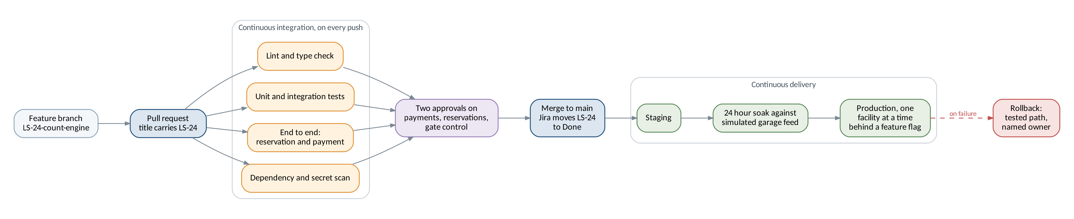
Figure 4: How a change moves from a feature branch to production
Two details are worth pointing at. The four continuous integration checks run in parallel rather than in sequence, which keeps the feedback under about six minutes, and a pull request that fails any of them cannot be approved. And production deploys go one facility at a time behind a feature flag, so a bad release reaches one garage rather than 23. The rollback path at the end is tested, not theoretical, which is the specific thing Knight Capital did not have.

7.8 Board
The board has one column per workflow state. Figure 5 shows it partway through sprint 2, after the migration described in Section 7.5. The cards carry the same LS- identifiers used in the backlog, which is what lets a branch name, a pull request, and a backlog item all point at the same thing.
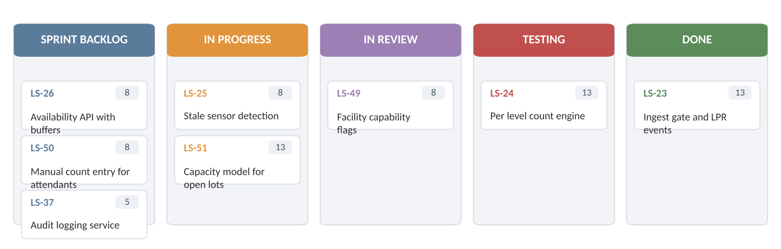
Figure 5: Sprint 2 board, mid sprint

8. Risk management
A risk is something that might happen. An issue is something that already has. This section covers risks, and anything that turns into an issue moves to the weekly status report.

8.1 Risks by category
At least four risks in each of the four categories we work with on this project.
ID | Risk
Technical
T1 | Occurred, October 13. Gate controllers or LPR cameras at some facilities have no event API, so live counts can't be read without new hardware. Now tracked as ISS-1.
T5 | Camera counting at surface lots is less accurate than gate counting, because vehicles can enter outside the camera's view.
T2 | Counts drift from reality because of tailgating at the gate, motorcycles, or miscounted levels.
T3 | Payment integration fails PCI review and has to be reworked before launch.
T4 | Event day traffic exceeds what the platform can handle, and the map or booking slows to a crawl.
Schedule
S1 | The survey of 23 facilities takes longer than the 7 weeks planned, delaying the adapter work behind it. Tracking ahead of plan as of October 15.
S5 | The remaining 14 unsurveyed facilities turn up more surprises, and the schedule absorbs a second round of rework.
S2 | Apple or Google rejects the first app submission, pushing the release date.
S3 | The occupancy service slips, and because it is on the critical path everything downstream moves with it.
S4 | Holiday weeks cut velocity more than the lighter sprint plan assumed.
Financial
F1 | Spot Guarantee price differences and credits cost more than budgeted if garages fill more often than expected.
F2 | Processing fees, refunds, and chargebacks come in higher than the per transaction model assumes.
F3 | Field work costs (travel, installation support, adapter hardware) exceed the estimate across 23 sites. Partly realized: hardware rose from $50,000 to $94,000 on October 15.
F4 | Scope grows through informal requests from BBGP without a change order, so work gets done unpaid.
People
P1 | The engineer who owns the adapter framework leaves or moves to another project, taking the context with them.
P2 | The BBGP operations director is unavailable for weeks, and decisions on buffers and policies stall.
P3 | Garage attendants resist the new workflow and keep waving drivers through manually, so counts go wrong.
P4 | The compressed 9 month schedule burns out the teams, and quality drops in the last two months.
Table 18: Identified risks by category

8.2 Risk register
Probability and impact are scored 1 to 5. The score is probability times impact, which puts anything at 15 or above in front of the sponsor every week, 8 to 14 in the monthly review, and below 8 on a watch list. The register is reviewed every sprint and rescored monthly.
Rescored October 15. R1 has been closed because it occurred; a risk that has happened is an issue, and it now sits in Table 20 as ISS-1. R6 went up to 20 and is now the top item. R11 went up on impact. R5 came down because the survey is ahead of plan. R16 and R17 are new.
ID | Risk | Category | P | I | Score | Response | Action | Owner
R5 | Facility survey runs long | Schedule | 2 | 3 | 6 | Mitigate | Rescored down Oct 15: 9 of 23 sites done in 2 of the 7 weeks allowed, so the survey is running ahead and now finishes Nov 13. | PM
R2 | Counts drift from actual occupancy | Technical | 3 | 4 | 12 | Mitigate | Daily reconciliation against attendant counts during the pilot. Alert when drift passes 5%. Keep the reserved buffer as a cushion. | Backend lead
R3 | Payment work fails PCI review | Technical | 2 | 5 | 10 | Transfer | Use a certified processor and keep tokenization on their side. Book an external review before the pilot. | Payments lead
R4 | Event day load exceeds capacity | Technical | 3 | 4 | 12 | Mitigate | Load test at 25,000 concurrent users in March. Auto scaling plus a read only fallback map if booking is saturated. | Backend lead
R6 | Critical path slips on the occupancy service | Schedule | 4 | 5 | 20 | Mitigate | Raised from 15 on Oct 15: the package grew by two weeks and the float ahead of the pilot is down to ten days. The 2 garage pilot mitigation has now been used, so it is no longer available as a second lever. | PM
R7 | App store rejection | Schedule | 2 | 3 | 6 | Mitigate | Submit a TestFlight build in March, two months before the release date, and keep the privacy labels current. | Mobile lead
R8 | Holiday velocity drop | Schedule | 3 | 3 | 9 | Accept | Sprints 4 and 5 are already planned at 60% capacity. Re-forecast in January. | Scrum Masters
R9 | Spot Guarantee costs run high | Financial | 2 | 4 | 8 | Mitigate | Cap guarantee credits per facility per day. Tune the reserved buffer by site. Track cost per rebook weekly from the pilot. | Finance
R10 | Scope creep without change orders | Financial | 3 | 4 | 12 | Avoid | Anything not in the backlog goes through a written change request signed by the BBGP sponsor. | PM
R11 | Field work costs exceed estimate | Financial | 4 | 3 | 12 | Accept | Impact raised from 2 to 3 on Oct 15. Hardware went from $50,000 to $94,000 after 9 of 23 surveys. Re-forecast again when the survey finishes on Nov 13. | PM
R12 | Key engineer leaves | People | 2 | 2 | 4 | Mitigate | Two engineers pair on the adapter framework. Architecture decisions are written down, not tribal. | Backend lead
R13 | Sponsor unavailable, decisions stall | People | 3 | 3 | 9 | Mitigate | A named backup decision maker at BBGP, and a 5 business day rule after which the PM decides and documents it. | PM
R14 | Attendants bypass the new workflow | People | 3 | 3 | 9 | Mitigate | Involve two attendants in UAT, train on site before go live, and watch for facilities with unusual manual override rates. | PM, BBGP ops
R15 | Team burnout from the compressed schedule | People | 3 | 4 | 12 | Mitigate | No crunch sprints. Track velocity and overtime in retros. Cut Could priority stories before adding hours. | Scrum Masters
R16 | Camera counting at surface lots is inaccurate | Technical | 3 | 4 | 12 | Mitigate | Added Oct 15. NFR15 sets a 5% tolerance against weekly manual audits. Calibrate per lot during onboarding and fall back to the capacity model where a lot cannot hold tolerance. | Backend lead
R17 | The remaining 14 surveys find more of the same | Schedule | 3 | 3 | 9 | Mitigate | Added Oct 15. Extrapolating the first 9 suggests roughly 4 more surface lots and 2 more replacement controllers. Survey the 3 pilot garages next so the pilot scope is certain even if the rest is not. | PM
Table 19: LevelSpot risk register
Issue log. A risk describes something that might happen. Once it happens it stops being a forecast and starts being work, so it moves here. This log is new this week because this is the first week we had one.
ID | Issue | Raised | Status | What we are doing | Owner
ISS-1 | 2 of the first 9 facilities have no gate controller that can report events, and 6 of 23 facilities are surface lots with no gate at all. The gate event assumption in Section 3.2 is wrong. | Oct 13 | Open | FR29 to FR32 added. Work packages 3.7 and 7.4 added. Camera counting for 4 lots, capacity model for 2. Baseline re-set in Section 10. | Backend lead
ISS-2 | Posted capacity figures from BBGP are off by more than 10% at 3 of the 9 surveyed facilities, which breaks the capacity model before it is built. | Oct 14 | Open | Surveyors now count spaces by hand at every site rather than taking the posted figure. BBGP asked to confirm which number is authoritative for billing. | Field ops
Table 20: Issue log

8.3 Risk matrix
Figure 6 plots the register on the probability and impact grid. Compared with last week, R1 is gone from the grid entirely, because it happened. R6 has taken its place in the top right corner, and that is the honest picture: the thing we were worried about arrived, and its main consequence is now schedule pressure on the occupancy service rather than uncertainty about whether we can count cars at all.
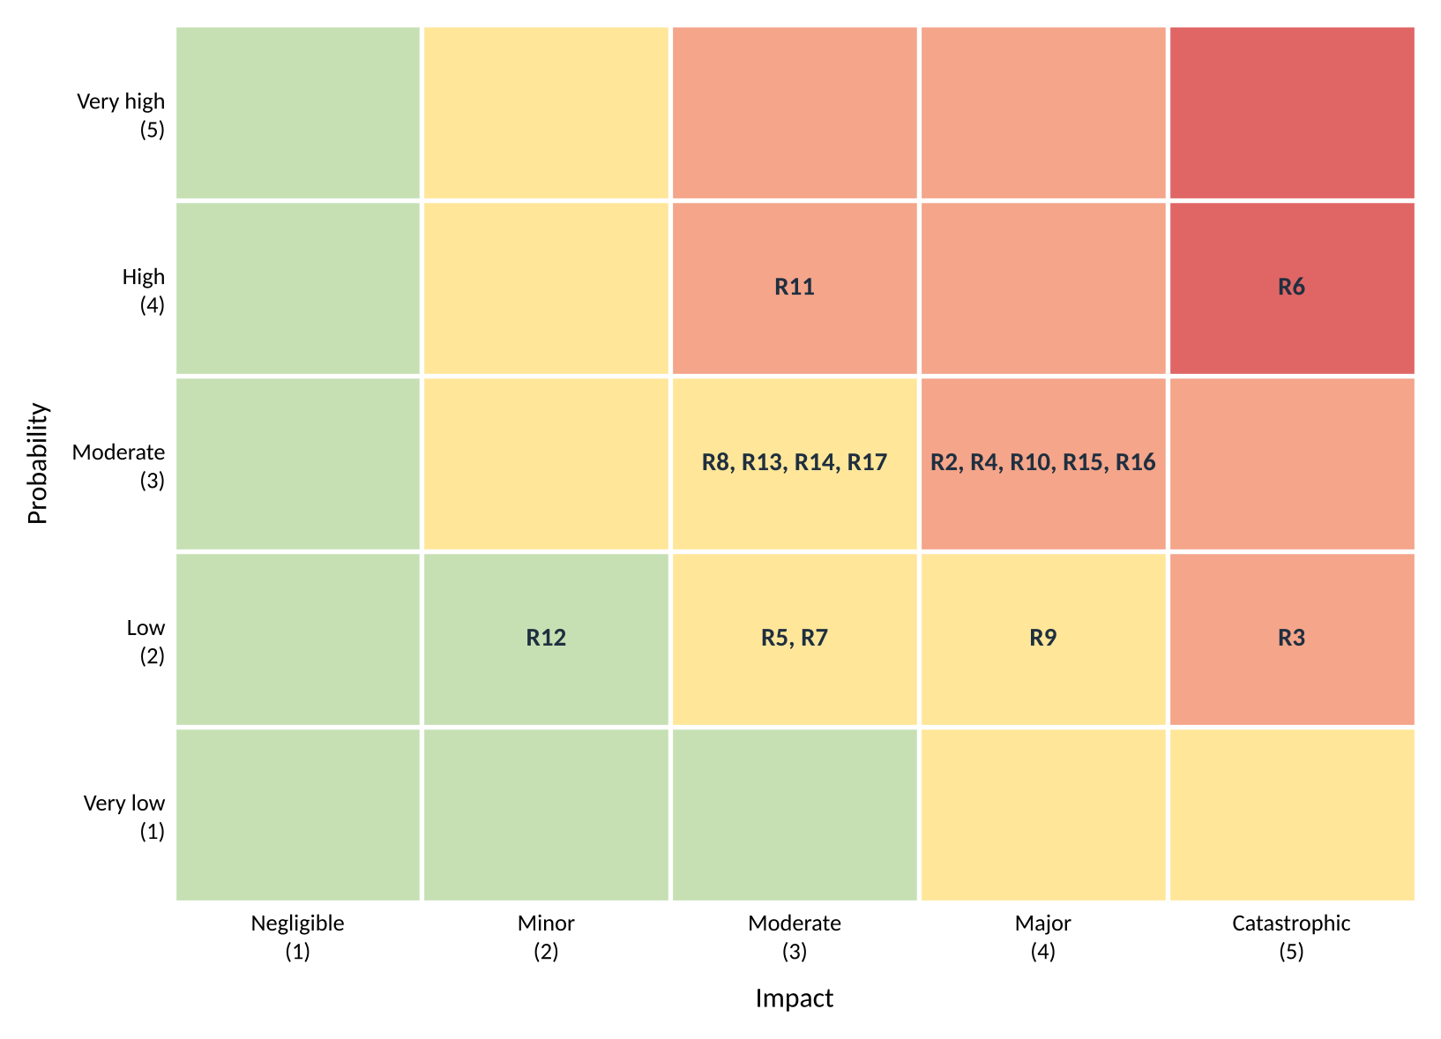
Figure 6: Probability and impact matrix for the risk register

8.4 Quality gates
Quality assurance is the process side, preventing defects. Quality control is checking the product for them. The Knight Capital failure in 2012 is the cautionary tale here: old code that was never removed got reactivated during a partial deployment, nobody had tested the production release path, and there was no rollback plan. The company lost about $440 million in half an hour.
LevelSpot touches money and physical gates, so the same class of mistake is possible. The gates we run before anything reaches production are listed below, and Figure 4 in Section 7.7 shows the same gates as the pipeline that enforces them. The table is the policy; the pipeline is how it is actually applied, which is the difference Knight Capital did not have.
Gate | What has to be true
Code review | Two approvals on anything that touches payments, reservations, or gate control
Automated tests | Unit and integration suites pass in CI. Reservation and payment paths have end to end tests.
Staging soak | New builds run against a simulated garage feed for 24 hours before release
Deployment | Feature flags, one facility at a time, never on a Friday or an event day
Rollback | Every release has a tested rollback path and a named person who can trigger it
Dead code | Unused flags and code paths are removed within one sprint, not left to be reactivated later
Table 21: Quality gates before a production release

9. Communication plan
Different audiences need different things. BBGP leadership wants metrics and dates. The teams need detail. The city needs data and a heads up before anything changes in public. The plan below sets who hears what, how often, and in what format.

9.1 Meeting cadence
Meeting | Who | Cadence | Format
Daily standup | Each delivery team | Daily, 15 minutes | In person or Slack huddle
Sprint planning | Team, Scrum Master, Product Owner | Every 2 weeks, Monday | Working session on the board
Sprint review and demo | Teams plus BBGP operations director | Every 2 weeks, Friday | Live demo of working software
Retrospective | Team only | Every 2 weeks, after the review | Facilitated discussion, actions logged
Backlog refinement | Product Owner and team leads | Weekly, Wednesday | Backlog grooming, re-estimation
Stakeholder update | BBGP leadership | Weekly, Thursday | 1 to 2 minute recorded video plus a written summary
Survey findings review | PM, Backend lead, field ops, BBGP sponsor | Weekly through Nov 13 | Added Oct 15. Walkthrough of each site surveyed that week and its counting class
Risk review | PM, team leads, BBGP sponsor | Monthly | Register walkthrough and rescoring. Open issues reviewed weekly, not monthly
Cost review | PM, finance, BBGP sponsor | Monthly | Earned value report against the baseline in Section 10
Steering committee | BBGP executives, $oftware ¢orp leadership | Monthly | Dashboard: scope, schedule, budget, top 5 risks
City briefing | Houston transportation department | Quarterly | Report plus a demo of the occupancy feed
Finance reconciliation | Finance and billing staff, Payments lead | Monthly | Payout report against processor settlements
Pilot coordination | Attendants and managers at pilot garages | Weekly during the pilot | On site walkthrough, issues logged to the Kanban board
Table 22: Meeting cadence

9.2 Reporting methods
Audience | What they get | Detail level
BBGP executives | Monthly dashboard: milestone status, budget, top risks with a red, amber, green status | High level, metrics only
BBGP operations director (sponsor) | Sprint demos, weekly video update, risk register access | Medium, decisions and tradeoffs
Delivery teams | Sprint board, burndown, defect cycle time, architecture decision records | Full detail
City transportation department | Quarterly report and the live data feed | Data and compliance
Finance and billing | Monthly reconciliation report and payout exports | Transaction level
Drivers (after launch) | Release notes in the app, service status page during incidents | Plain language
Table 23: Reporting by audience

9.3 Escalation path
A blocker that a team can't clear in one day goes to the team lead. If it isn't resolved in two business days, it goes to the PM. Anything affecting a milestone date, the budget, or a live garage goes to the BBGP sponsor the same day, and to the steering committee if it is still open after a week.
Incidents are different. Anything that stops drivers from booking, opens or locks a gate incorrectly, or charges the wrong amount gets a call, not a message, within 30 minutes, plus a status page update and a written postmortem within five business days.
Added October 15. Issues in Table 20 escalate faster than risks do. An open issue that changes scope, the baseline, or a milestone goes to the BBGP sponsor within one business day and comes with a written change request. ISS-1 followed that path: found October 13, raised with BBGP October 14, change request signed October 15, and this document re-baselined the same day.

10. Resource and cost management

10.1 Basis of the budget
Section 2.1 notes that $oftware ¢orp has an unlimited theoretical budget for this project. That is a planning convenience, not a reason to skip the numbers. BBGP signed for a fixed scope, finance still has to forecast cashflow, and no amount of money buys a shorter calendar. So this section prices the project as though the budget were real, which is the only version that helps anyone make a decision.
The estimate is bottom-up: every role is costed from hours and a rate, every non-labor item from a quantity and a unit price, and the totals roll up. Section 10.5 then checks that total against a top-down allocation, because two methods landing in the same place is better evidence than one method landing anywhere.
Rates are blended internal cost rates, not what BBGP is billed. All figures are US dollars.

10.2 Roles and resource plan
Twenty-two people work on LevelSpot across the ten months from kickoff to rollout. The six delivery teams from Table 4 are staffed below, plus the leadership and operations roles that work across all of them. A full time allocation is 1,600 hours, which is 40 weeks at 40 hours.
Changed October 15. Two changes, both from the surface lot findings. A contract computer vision engineer joins at 50% to build the entrance camera counting in work package 7.4, because nobody on the roster has done vehicle counting from video and the schedule has no room for someone to learn it. And the mapping engineer goes from 70% to 80%, since the camera work needs the same geospatial calibration he already owns. Together that is $97,600 of labor, and it is the smaller half of this week's cost increase.
Role | Name | Skill level | FTE | Hours | Rate | Cost
Project leadership (works across all teams)
Project Manager | Ibra | Senior, 8 yrs | 100% | 1,600 | $85 | $136,000
Product Owner | Marisol Vega | Senior, 10 yrs product | 60% | 960 | $90 | $86,400
Solutions Architect | Arjun Raghunathan | Principal, 14 yrs | 50% | 800 | $110 | $88,000
Senior UX Designer | Priya Anand | Senior, 9 yrs | 75% | 1,200 | $75 | $90,000
UX Designer | Tomas Herrera | Mid, 4 yrs | 50% | 800 | $55 | $44,000
Backend/API Team
Backend Lead | Nnamdi Okafor | Senior, 11 yrs | 100% | 1,600 | $95 | $152,000
Backend Engineer, occupancy | Grace Lindqvist | Senior, 7 yrs | 100% | 1,600 | $85 | $136,000
Backend Engineer, reservations | Hector Salas | Mid, 5 yrs | 100% | 1,600 | $75 | $120,000
Backend Engineer, pricing and alerts | Yusra Khan | Mid, 3 yrs | 85% | 1,360 | $70 | $95,200
Mobile Application Team
iOS Lead | Daniel Whitfield | Senior, 8 yrs | 100% | 1,600 | $85 | $136,000
iOS Developer | Amara Boateng | Mid, 4 yrs | 85% | 1,360 | $70 | $95,200
Android Lead | Jin-woo Park | Senior, 9 yrs | 100% | 1,600 | $85 | $136,000
Android Developer | Carla Jimenez | Mid, 3 yrs | 85% | 1,360 | $70 | $95,200
Web Application Team
Web Lead, operator dashboard | Sofia Ruiz | Senior, 7 yrs | 100% | 1,600 | $85 | $136,000
Web Developer | Ethan Brahms | Mid, 4 yrs | 90% | 1,440 | $70 | $100,800
Mapping & Location Services Team
Mapping Engineer | Rahul Menon | Senior, 6 yrs | 80% | 1,280 | $85 | $108,800
Payment Integration Team
Payments Engineer | Lena Fischer | Senior, 10 yrs fintech | 65% | 1,040 | $95 | $98,800
Quality Assurance & Testing Team
QA Lead | Tunde Afolabi | Senior, 8 yrs | 100% | 1,600 | $75 | $120,000
QA Engineer | Mei-Lin Chow | Mid, 3 yrs | 90% | 1,440 | $60 | $86,400
Platform and field operations
DevOps Engineer | Oscar Delgado | Senior, 7 yrs | 60% | 960 | $90 | $86,400
Field Operations Coordinator | Bianca Morales | Mid, 5 yrs | 75% | 1,200 | $45 | $54,000
Computer Vision Engineer (contract) | Oleksii Marchenko | Senior, 9 yrs | 50% | 800 | $105 | $84,000
Total | 22 people | 18.0 FTE |  | 28,800 |  | $2,285,200
Table 24: Resource plan with allocations and labor cost
Three things worth saying about this roster.
It revises the Section 5.3 assumption. That section assumed 19 people and about 175 person-months. Naming everyone moved the headcount to 21 but barely moved the capacity, because several of these roles are part time. With the two October 15 changes it is now 22 people, 28,800 hours, 18.0 full time equivalents, or 180 person-months. The COCOMO estimate of 152 person-months still sits under that.
There are no junior engineers on this project, on purpose. Most of the hard work here is integration against hardware we don't control, and the schedule is already compressed past what COCOMO says is comfortable. Junior engineers need review time that this calendar doesn't have. It costs more per hour and it is the right call, but it does concentrate knowledge in a small group, which is exactly what risk R12 is about.
The part time allocations follow the Gantt, not a spreadsheet. The architect is at 50% because the heavy design work is front loaded in October. The mapping engineer is at 80% because his work now spans both the driver apps and the surface lot calibration. The field coordinator is at 75% because the surveys and the rollout bracket the project with a quiet middle.

10.3 RACI matrix
One person accountable per activity, no exceptions. Responsible is whoever does the work, Consulted is a two way conversation before the work is done, and Informed is a one way update after. Where a role both owns and performs an activity, the cell reads A/R.
Added October 15: rows 23 and 24 for the facility capability work, row 25 for change request approval, and row 26 for the tooling standards in Section 7.6. Row 25 matters most. We re-baselined the budget this week, and before doing it we needed a written answer to who signs that off. It is BBGP, not us.

Activity | PM | PO | ARCH | UX | DEV | QA | OPS | FIELD | BBGP
1. Requirements elicitation and SRS | R | A | C | C | C | I | I | C | C
2. Vision, scope, and business objectives | C | R | I | I | I | I | I | I | A
3. UX design and design system | I | A | C | R | C | C | I | I | I
4. Technical architecture and API spec | C | C | A | C | R | C | C | I | I
5. WBS, schedule, and budget | A/R | C | C | I | C | C | I | C | C
6. Sprint planning and backlog refinement | C | A | C | C | R | C | I | I | I
7. Gate vendor survey, 23 facilities | A | I | C | I | C | I | I | R | C
8. Occupancy service and gate adapters | I | C | A | I | R | C | C | C | I
9. Reservation engine and Spot Guarantee | I | A | C | I | R | C | I | I | C
10. Driver apps (iOS, Android, web) | I | A | C | C | R | C | I | I | I
11. Operator dashboard | I | A | C | C | R | C | I | I | C
12. Payment integration and payouts | I | C | A | I | R | C | I | I | C
13. Test planning and execution | I | C | C | I | R | A | I | I | I
14. Security review and PCI assessment | C | I | A | I | R | C | C | I | I
15. Accessibility audit (WCAG 2.2 AA) | I | C | C | R | C | A | I | I | I
16. Infrastructure, CI/CD, and monitoring | I | I | A | I | C | C | R | I | I
17. Release approval and go-live decision | R | C | C | I | I | C | C | I | A
18. Pilot coordination at 3 garages | R | C | I | I | C | C | I | C | A
19. Attendant training and handover | C | I | I | I | I | I | I | R | A
20. Risk register maintenance | A/R | C | C | I | C | C | C | C | C
21. Budget tracking and EVM reporting | A/R | C | I | I | I | I | I | C | C
22. Stakeholder reporting and demos | A | R | I | I | C | I | I | I | C
23. Facility capability assessment | A | I | C | I | C | I | I | R | C
24. Surface lot camera counting design | I | C | A | I | R | C | C | C | I
25. Change request approval (scope, schedule, budget) | R | C | C | I | I | I | I | I | A
26. Tooling and source control standards | C | I | A | I | R | C | C | I | I
Table 25: RACI matrix. PM project manager, PO product owner, ARCH solutions architect, UX design, DEV delivery teams, QA quality assurance, OPS DevOps, FIELD field operations, BBGP client sponsor.
Two patterns in this matrix are deliberate. Accountability for anything the client lives with after we leave, meaning release approval, the pilot, and training, sits with BBGP rather than with us, because a go-live decision that the client did not make is a decision that gets reversed. And accountability for engineering splits between the Product Owner for scope and the Architect for technical correctness, so no deliverable ends up with two owners arguing about whose call it is.

10.4 Bottom-up cost estimate
Labor comes straight from Table 24. Everything else is costed from quantities we can point at.
Re-baselined October 15. The budget went from $3,508,880 to $3,699,780, an increase of $190,900 or 5.4%. Two lines moved: labor up $97,600 for the computer vision contractor and the extra mapping hours, and hardware up $44,000 because the survey found three more sites needing replacement controllers and six surface lots needing entrance cameras. Overhead and contingency follow those as percentages. BBGP signed the change request on October 15, which is why this is a new baseline rather than a variance against the old one.
Category | Basis | Amount
Labor | 22 people, 28,800 hours, blended rate $79.35/hour (Table 24) | $2,285,200
Overhead and benefits | 25% of labor: payroll taxes, benefits, office, admin | $571,300
Cloud infrastructure | AWS across two US regions, ramping from $1,200 to $7,000 per month | $39,700
Licenses and tools | Developer tooling and CI $18,000, design and collaboration $12,000, monitoring and logging $24,000 | $54,000
Third-party APIs | Mapping and geocoding $28,000, SMS and email $9,000, fraud screening $6,000 | $43,000
Hardware | Revised Oct 15. 31 edge gateways $20,200, 5 replacement gate controllers $45,000, 6 entrance camera kits for surface lots $14,400, device test lab $9,600, field laptops $4,800 | $94,000
Travel and field work | Site surveys and rollout support across 23 Houston facilities | $20,000
Legal and compliance | PCI review $35,000, penetration test $25,000, accessibility audit $12,000, contract and data sharing review $15,000 | $87,000
Training | Gate vendor SDK training $8,000, attendant training at 23 facilities $15,000 | $23,000
Subtotal before contingency |  | $3,217,200
Contingency | 15% of the subtotal, held against R6, R16, and the 14 unsurveyed facilities | $482,580
Total (BAC) |  | $3,699,780
Table 26: Bottom-up cost estimate
On capital versus operating costs: almost everything here is operating expense, because the project buys very little that lasts. The $50,000 of hardware is the exception, and even that is arguably BBGP's asset rather than ours once the gateways are bolted into their garages. Who capitalizes the edge hardware is an open question for their finance team, and it is in Section 11.

10.5 Top-down cross-check
A bottom-up estimate can be confidently wrong if every line is built on the same bad assumption. So we also ran it the other way: start from an envelope of what comparable 10 month platform builds have cost the studio, and allocate by the percentages $oftware ¢orp uses on fixed-price work. The envelope moves with the baseline, so this week it is $3.7 million rather than $3.5 million.
Category | Top-down % | Top-down amount | Bottom-up amount | Difference
Labor | 62% | $2,294,000 | $2,285,200 | -0.4%
Overhead and benefits | 16% | $592,000 | $571,300 | -3.5%
Direct costs | 9% | $333,000 | $360,700 | +8.3%
Contingency | 13% | $481,000 | $482,580 | +0.3%
Total | 100% | $3,700,000 | $3,699,780 | 0.0%
Table 27: Top-down allocation compared against the bottom-up detail
The totals agree almost exactly, but one category no longer does. Direct costs are 8.3% above what the standard allocation expects, where last week they were within half a percent. That gap is the hardware, and it is worth saying out loud rather than smoothing over: the percentages come from past projects that integrated with software, not with gate controllers and cameras bolted to 23 physical sites. The allocation is not wrong, LevelSpot is just not a typical project for it. If the remaining 14 surveys push direct costs past about 11% of the total, the right response is to stop using the standard allocation as a check at all rather than to keep explaining the variance away.

10.6 Monthly cashflow
Spending follows the staffing ramp. September and October are light because only the leadership, design, and architecture roles are on. November through March is the full build.
Revised October 15. November through March all went up, from the contractor and the extra hardware. December in particular jumped by $60,000, because three replacement gate controllers get ordered as soon as the survey confirms which sites need them. The peak moved too: March is now the most expensive month at $469,142, where last week it was April.
Month | Labor | Overhead | Direct costs | Contingency | Monthly total | Cumulative
Sep 2026 | $109,400 | $27,350 | $19,700 | $23,468 | $179,918 | $179,918
Oct 2026 | $153,100 | $38,275 | $19,900 | $31,691 | $242,966 | $422,884
Nov 2026 | $233,800 | $58,450 | $28,900 | $48,172 | $369,322 | $792,206
Dec 2026 | $238,800 | $59,700 | $54,900 | $53,010 | $406,410 | $1,198,616
Jan 2027 | $284,500 | $71,125 | $44,900 | $60,079 | $460,604 | $1,659,220
Feb 2027 | $284,500 | $71,125 | $15,200 | $55,624 | $426,449 | $2,085,669
Mar 2027 | $303,000 | $75,750 | $29,200 | $61,192 | $469,142 | $2,554,811
Apr 2027 | $262,500 | $65,625 | $62,000 | $58,519 | $448,644 | $3,003,455
May 2027 | $218,800 | $54,700 | $49,250 | $48,412 | $371,162 | $3,374,617
Jun 2027 | $196,800 | $49,200 | $36,750 | $42,413 | $325,163 | $3,699,780
Total | $2,285,200 | $571,300 | $360,700 | $482,580 | $3,699,780
Table 28: Budgeted monthly cashflow against the October 15 baseline
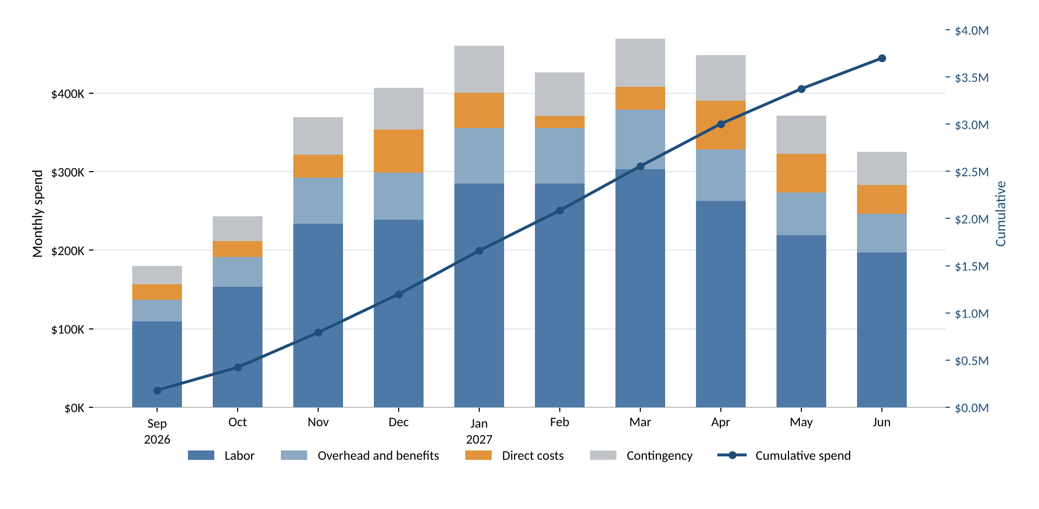
Figure 7: Monthly spend by category, with cumulative spend against the right axis
Contingency is shown spread across the months so the cashflow forecast is realistic, but it is not actually spent that way. Finance holds it centrally and releases it against a signed change request. Spreading a reserve without controlling it is how a 15% buffer quietly becomes part of the baseline by March.

10.7 Hidden costs and contingency
The line items in Table 26 are the easy part. These are the ones that get missed, and what we did about each.
Hidden cost | Why it bites | What we did about it
Cloud data egress and backups | Egress and snapshot storage are billed separately from compute and scale with map and API traffic rather than with user count. | The cloud line ramps to $7,000 a month by rollout instead of staying flat. Map tiles are cached on the device so repeat loads don't leave AWS.
Mapping API call volume | Geocoding and map loads are charged per request. At $0.005 a call, 5.6 million calls a year is $28,000, and a careless implementation geocodes on every keystroke. | $28,000 inside the API line. Entrance coordinates are geocoded once per facility and stored, not looked up per search.
SMS overage | Spot Guarantee alerts and reservation reminders go out by text, and volume spikes exactly when garages are busiest. | $9,000 for SMS and email. Push is the default channel and SMS is the fallback, which keeps per-message cost off the common path.
Per-seat license creep | Monitoring and design tools bill per seat, and seats get added quietly as teams ramp up. | Licenses are budgeted against the ramp in Table 28, not at full headcount from month 1, and seat counts are reviewed at the monthly cost review.
Technical debt | A 9 month schedule that COCOMO says should take 17 invites shortcuts, and those get paid back with interest after launch. | One sprint in four reserves capacity for cleanup, and dead code removal is a release gate in Table 21.
Gate hardware replacement | This one stopped being hidden on October 13. Some facilities have no event API at all, which turns a software integration into a hardware purchase. | Now $20,200 of edge gateways, $45,000 for five replacement controllers, and $14,400 of entrance cameras. The original $35,600 guess was low by about $44,000 against a 9 site sample.
Surface lots have no gates | The word "garages" in every early document hid the fact that 6 of 23 BBGP facilities are open lots. An event-driven design has nothing to listen to there. | Camera counting at 4 lots, a capacity model at the other 2, and FR29 through FR32 to make the difference visible to drivers. This is the most expensive assumption we got wrong.
Compliance audits | PCI review, penetration testing, and the accessibility audit are easy to leave out of an engineering budget and expensive to add late. | $87,000 as its own line, scheduled in months 7 through 9 so findings land before the pilot.
Spot Guarantee credits | Every rebook costs real money, and the cost scales with how often garages fill. | Deliberately excluded from this budget. It is an operating cost that belongs to BBGP after launch, not a build cost. Risk R9 tracks it and BO-3 caps the rate.
Table 29: Hidden costs and how the budget handles them
Contingency stays at 15%, and that deserves an explanation, because last week we said that if the survey came back clean we would cut it to 10% and hand the money back. The survey came back the other way, so the obvious move looks like raising it. We did not, for a specific reason: the costs that materialized are now known, and known costs belong in the baseline, not in a reserve. Moving them into contingency would be using the reserve to hide a scope change from the sponsor.
What the reserve still covers is the 14 facilities nobody has visited yet, plus R6 and R16. Since the subtotal grew, 15% of it is $482,580 rather than $457,680, so the reserve went up $24,900 in absolute terms without the percentage moving. When the survey finishes on November 13 the uncertainty drops sharply, and that is the point to revisit the percentage with real numbers instead of a sample of 9.

10.8 Cost control and earned value
The budget in Table 28 is the baseline. From here it only changes through a signed change request, and the monthly cost review compares actuals against it using earned value. Table 30 is the first report, at the end of month 1.
A note on the re-baseline. The figures below were measured against the original $3,508,880 baseline through September 30, and they stay that way. Restating past performance against a baseline that did not exist at the time would make the September variance disappear, which is exactly the kind of accounting that makes earned value useless. From October onward the measurement runs against the new $3,699,780 baseline, and the October report will say so.
Metric | Value | What it means
BAC | $3,508,880 | Budget at completion. The baseline in force on September 30; it is $3,699,780 from October onward
PV | $179,918 | Planned value: work scheduled through September 30
EV | $157,900 | Earned value: 4.5% of scope complete against a planned 5.1%
AC | $168,400 | Actual cost spent through September 30
SPI | 0.88 | EV / PV. Below 1, so slightly behind schedule
CPI | 0.94 | EV / AC. Below 1, so slightly over budget
EAC | $3,742,200 | BAC / CPI. Forecast total if cost performance stays where it is
ETC | $3,573,800 | EAC minus AC. Still to spend
Table 30: Earned value report at the end of month 1
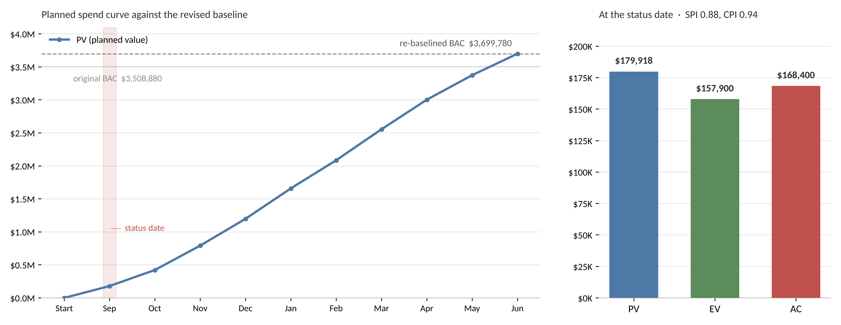
Figure 8: Planned spend curve for the project, with planned, earned, and actual value at the status date
What the numbers say. We earned 88 cents of scheduled work for every dollar planned, and 94 cents of value for every dollar spent. The cause is not mysterious: the requirements sessions with BBGP ran about a week longer than planned, which pushed design hours from September into October. That shows up as both a schedule and a cost variance in a single month.
What we are doing about it. Nothing yet, and that is a deliberate choice. One month of data on a ten month project is noise, and reacting to it would cost more than the variance. But an EAC of $3,742,200 is $233,320 over the September baseline, which is half the contingency, so it is not nothing either. The trigger we set with BBGP: re-forecast formally at the end of December, and escalate to the steering committee if CPI is still below 0.95 then.
One coincidence worth not reading too much into. The September EAC of $3,742,200 and the October baseline of $3,699,780 are within about 1% of each other, and they have nothing to do with one another. The first is a forecast from cost performance on requirements work; the second is a scope change for hardware and a contractor. Two numbers landing close together is not confirmation of either one, and treating it as confirmation is how a forecast quietly becomes a target.

11. Stakeholder analysis and charters
This section does three things the project has been running without: it scores the stakeholders by how much they can affect the outcome and how much the outcome affects them, it writes down the authority the project runs on, and it writes down how the team has agreed to work.

11.1 Stakeholder analysis: the power-interest grid
Table 3 in Section 2.6 lists who the stakeholders are. It does not say how much attention each one gets, which is the question that actually decides where a project manager's week goes. The grid below plots each group on two axes: power, meaning how much they can change the outcome, and interest, meaning how much the outcome changes things for them. Where a group lands sets how we engage with it.
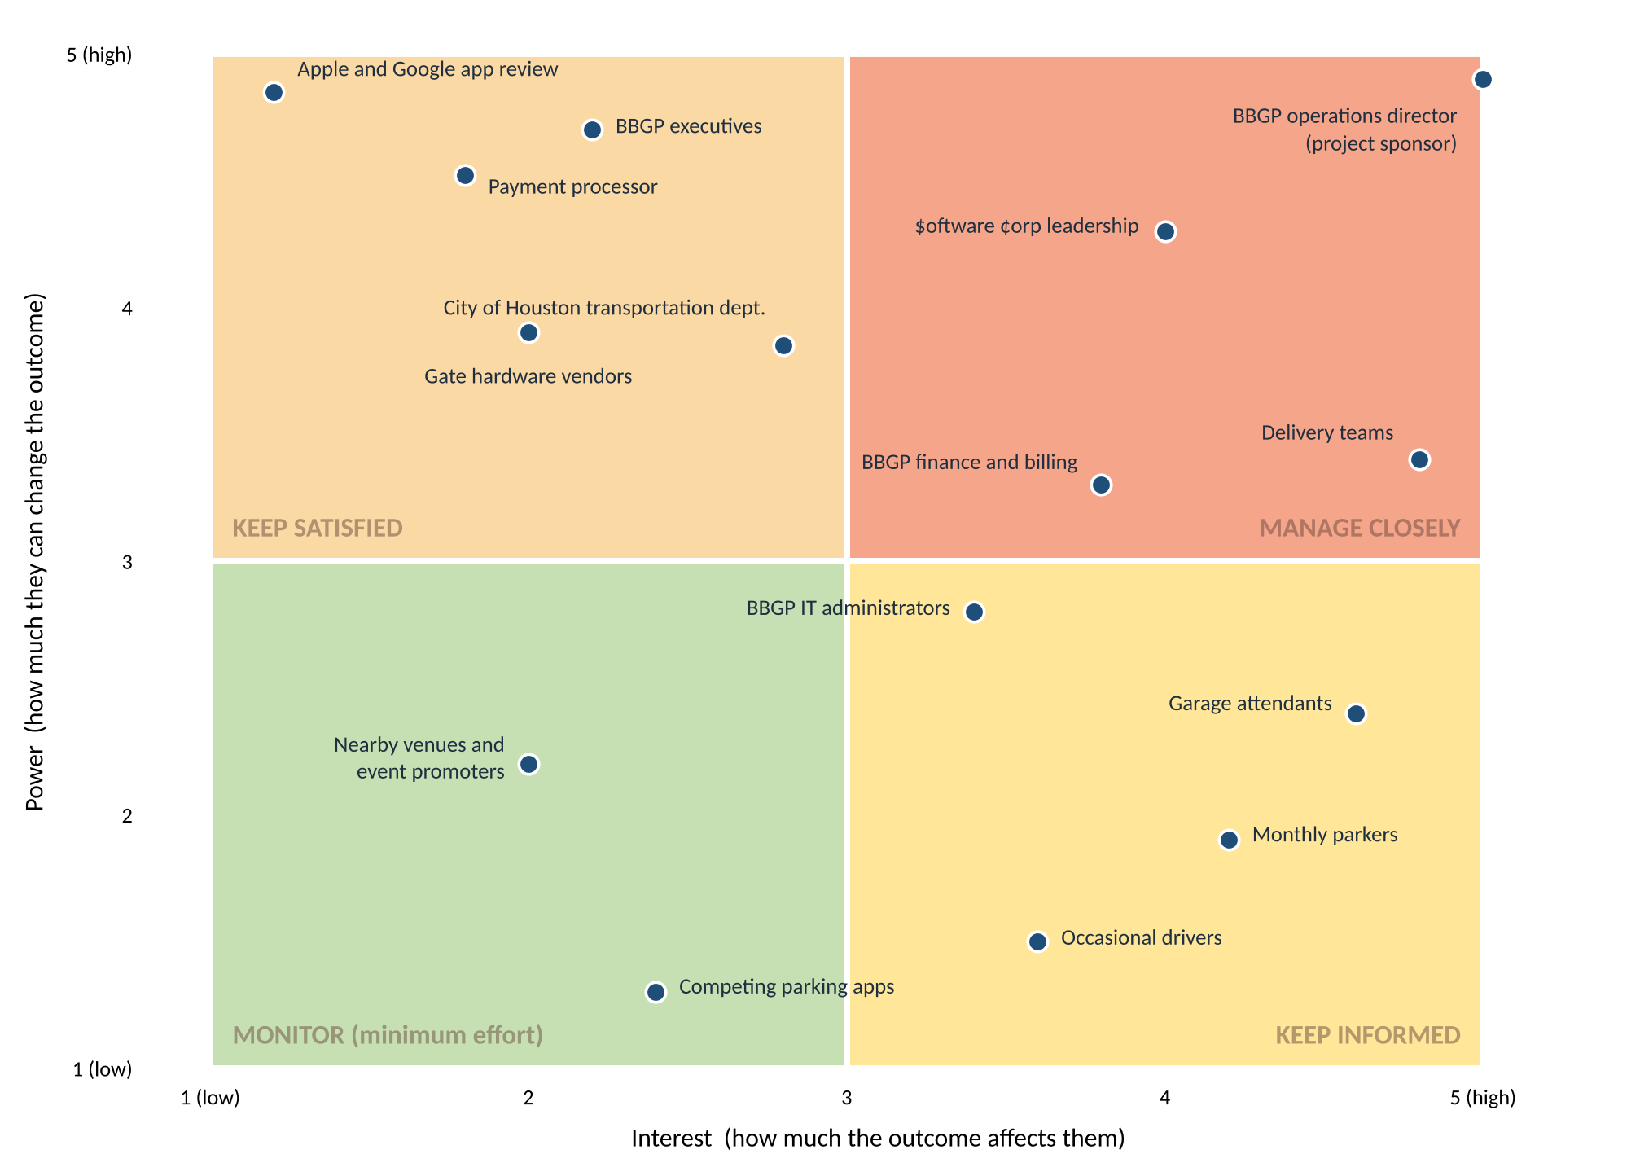
Figure 9: LevelSpot stakeholders on the power-interest grid
Stakeholder | Power | Interest | Why they sit there | How we engage
Manage closely (high power, high interest)
BBGP operations director | 5 | 5 | Project sponsor. Signs change requests and owns the go-live decision. | Weekly 1:1, sprint demos, every change request
$oftware ¢orp leadership | 4 | 4 | Carries the contract and the margin. Can reassign people. | Monthly steering committee with the budget dashboard
Delivery teams | 3 | 5 | Build it, and know first when an estimate is wrong. | Daily standup, sprint planning, retrospectives
BBGP finance and billing | 3 | 4 | Owns payout accuracy and the monthly close. | Monthly reconciliation, cost review
Keep satisfied (high power, low interest)
Apple and Google app review | 5 | 1 | Can block the May release outright. No interest in us otherwise. | Submit a TestFlight build in March, keep privacy labels current (risk R7)
BBGP executives | 5 | 2 | Fund it, and will mostly see a dashboard. | Monthly one page status, no detail unless asked
Payment processor | 5 | 2 | PCI sign-off gates the pilot. | Integration checkpoints, external review booked before the pilot
City of Houston transportation dept. | 4 | 3 | Ordinances and the data sharing agreement. | Quarterly briefing plus the occupancy feed
Gate hardware vendors | 4 | 2 | Their APIs decide whether the occupancy service works at all. | Named contact per vendor, escalation path agreed in writing
Keep informed (low power, high interest)
Garage attendants | 2 | 5 | Their daily workflow changes most. See the note below. | On-site training, two attendants in UAT, direct line during the pilot
Monthly parkers | 2 | 4 | Use it several times a week. Loudest if it breaks. | Focus group, release notes in the app
Occasional drivers | 2 | 4 | The end users the product exists for. | Beta test group, in-app surveys, status page
BBGP IT administrators | 3 | 3 | Run accounts and access after handover. | Included in design reviews for roles and security
Monitor (low power, low interest)
Nearby venues and event promoters | 2 | 2 | Benefit indirectly on event days. No role yet. | Revisit after the pilot; possible partners later
Competing parking apps | 1 | 2 | No influence over delivery. | Watch pricing and feature announcements, nothing more
Table 31: Stakeholder analysis with engagement approach

Two things the grid gets wrong if you read it literally
Garage attendants have more power than the axis says. They score 2 on power because they sign nothing and control no budget. But risk R14 is that an attendant who keeps waving cars through by hand breaks the count at their facility, and a broken count breaks the whole product at that site. Formal authority and actual influence are different things, and the grid only measures the first. So attendants get treated closer to Manage Closely than their position suggests: two of them sit in UAT, they get on-site training before go-live, and they have a direct line during the pilot.
Apple and Google are in the quietest quadrant and can still sink the date. They have no interest in LevelSpot whatsoever, which is exactly why they sit at interest 1. They also have an absolute veto over the May release. Keep Satisfied here means doing the unglamorous thing early: a TestFlight build in March, two months before we need it, so a rejection costs us a resubmission instead of the launch.
The general lesson is that the grid is a prompt for thinking, not a verdict. It is useful because it forces you to say out loud that you will spend less time on some people than others, which is a decision project managers usually make by accident.

11.2 Project charter
A project charter authorizes the project and gives the project manager the authority to spend the organization's resources on it. It normally gets written before anything else happens. Ours is reconstructed here from what was actually agreed with BBGP at kickoff on August 28, because the project document has been built in lecture order rather than project order.
Writing it down eight weeks late turned out to be more useful than writing it at the start would have been, for one reason: the project no longer matches it, and the gaps are visible.
Element | Detail
Project name | LevelSpot Smart Parking Platform, release 1
Project sponsor | Operations Director, Buffalo Bayou Garage Partners (BBGP)
Project manager | Ibra, $oftware ¢orp. Authorized to direct the assigned team, commit the approved budget, and decide technical scope within the baseline.
Charter date | August 28, 2026. Revised October 29, 2026 (see variance note below).
Business case | BBGP turns cars away at downtown garages on weekdays while its Midtown and EaDo lots sit half empty, and has no way to steer drivers between them or price for demand. Drivers circle for parking because no existing app shows whether a space is actually free. Section 1 covers why no product on the market closes both halves of that gap.
Objectives | The five business objectives in Table 2: time to parked under 4 minutes, weekday occupancy at underused lots up 15 points, fewer than 1 in 500 reservations needing a Spot Guarantee rebook, 70% of transactions digital, and the city occupancy feed live at all 23 facilities.
Scope summary | In: driver apps on iOS, Android and web; live availability; reservations with the Spot Guarantee; digital payments; the operator dashboard; the city feed; English and Spanish. Out: street meter payment, valet, EV charging payment, enforcement, and anything outside the Houston metro. Section 2.7 is authoritative.
Key deliverables | Driver applications, operator dashboard, backend and occupancy services, gate and camera integrations at 23 facilities, anonymized city occupancy feed, and operations handover with attendant training.
Milestones | M1 requirements baseline through M8 rollout complete on June 11, 2027. Table 11 carries the dates and every change to them.
Budget authority | $3,699,780 at completion, including a 15% contingency of $482,580 held centrally by finance. The PM may commit within the baseline; anything above it needs a change request signed by the sponsor.
Success criteria | All five objectives met twelve months after launch, the platform live at all 23 facilities, and BBGP staff running day-to-day operations without $oftware ¢orp involvement.
Top risks at signing | No event API at some facilities (R1, since occurred), critical path slip on the occupancy service (R6), and schedule compression against what COCOMO says this should take.
Constraints | Fixed delivery window, dependence on third party payment, mapping and gate vendors, PCI DSS, the Texas Data Privacy and Security Act, City of Houston parking ordinances, and Apple and Google store review.
Assumptions | BBGP provides facility access and sets its own prices; each facility falls into one of the three counting classes in Section 3.2; mapping licensing permits facility pins and navigation handoff.
Approval | Signed by the BBGP Operations Director and $oftware ¢orp leadership, August 28, 2026. Amendment 1 signed October 15, 2026 for the surface lot scope change and the revised budget.
Table 32: LevelSpot project charter

Variance against the charter as signed
Three things have moved since August 28, and all three went through the change request route the charter sets out rather than around it.
- Budget. Signed at $3,508,880, now $3,699,780. The surface lot findings added a contract engineer and $44,000 of hardware. Amendment signed October 15.
- Scope. The charter assumed every facility could report gate events. Two open perimeter lots now ship on a capacity model instead of live counts, which is a visible reduction in what a driver gets at those two sites.
- Pilot size. Three garages at signing, two now. This one used a mitigation that was already written down for risk R6, so it needed no new authority, but the sponsor was told in the same week.
Milestones M6 and M8, the pilot and the rollout, are unchanged from the charter. Those are the two commitments BBGP made plans around, and holding them is why the other three moved.

11.3 Team charter
The project charter says what the project is allowed to do. The team charter says how the people doing it have agreed to behave, and unlike the project charter it is not signed by anyone above the team. It was drafted by the delivery teams in the week of October 20 and is reviewed every second sprint.
Element | What the team agreed
Team purpose | Build a parking platform that tells drivers the truth about whether a space is free, and give BBGP one place to run 23 facilities. If we cannot count a lot honestly, we say so in the app rather than guessing.
Members | 22 people across six delivery teams plus project leadership and field operations. Table 24 names everyone and their allocation.
How we decide | The Product Owner decides scope, the Solutions Architect decides technical approach, the PM decides schedule and budget, and the sponsor decides anything that changes the baseline. Table 25 is the full map. If two of those conflict, the PM calls it and writes down why.
Leadership approach | Democratic by default: the people doing the work size it and choose how. Servant leadership from the leads, whose job is clearing blockers rather than assigning tasks. Authoritative only when a decision is blocking the critical path and the team is genuinely split, and when that happens the PM says out loud that it is happening and why.
Handling conflict | Collaborate first, and look for the option that actually satisfies both sides. Compromise when a decision is time-boxed and the gap is small. Escalate to the PM after two days rather than letting a disagreement sit. We do not use avoidance: an unresolved technical disagreement becomes a design flaw about three sprints later.
Meetings | Daily standup 15 minutes, sprint planning and review every two weeks, retrospective after every review, backlog refinement weekly. Table 22 has the full cadence. Anyone may decline a meeting with no agenda.
Communication norms | Decisions go in writing where the team can find them, not in a direct message. Questions in the open channel, not privately, so the answer is reusable. Reasonable response time is the same working day, and nobody is expected to answer at night or on weekends.
Definition of done | Code reviewed and approved, automated tests passing in CI, deployed to staging and soaked for 24 hours, acceptance criteria met, and the backlog item closed by the merged pull request. Table 21 has the full gate list.
Quality commitments | Two approvals on anything touching payments, reservations, or gate control. No direct pushes to main. Dead code removed within one sprint. No release on a Friday or an event day.
Sustainable pace | No crunch sprints. If a sprint is going to miss, we cut Could priority scope and tell the sponsor, rather than adding hours. Velocity and overtime are reviewed in every retrospective (risk R15).
How we treat each other | Disagree with the idea, not the person. Anyone can say they do not understand something without it counting against them. Whoever is closest to the problem has the most say in how it gets solved, regardless of title.
Charter review | Reviewed at the end of every second sprint. Any member can propose a change; it needs agreement from the team, not approval from the PM.
Table 33: LevelSpot team charter
Two entries in that table were argued about and are worth flagging. The first is the leadership approach: the leads wanted authoritative decision making available at any time, and the engineers wanted it reserved for genuine deadlock. The wording we landed on allows it, but requires the PM to say out loud that it is being used, which is a cost that keeps it rare.
The second is sustainable pace. On a schedule that COCOMO says should take seventeen months and we are running in nine, a no-crunch commitment is easy to write and hard to keep. It is in the charter because writing it down is what makes it possible to point at in February.

12. Open questions for BBGP
Updated October 15. Three questions are answered and closed, three are new, and one was rewritten because the pilot dropped from 3 garages to 2.
Answered this week:
- Which gate and LPR vendors are installed at each facility? Answered for 9 of 23. Five have a networked controller with an event API, two are serial only and need a bridge, and two have nothing usable. The remaining 14 are surveyed by November 13.
- Who covers the Spot Guarantee price difference? BBGP, as an operating cost after launch. Confirmed October 14 and reflected in Table 29.
- Who is the named backup decision maker? BBGP's Deputy Operations Manager, confirmed October 14, with the 5 business day rule from risk R13 still in force.
Still open:
- For the 2 open perimeter surface lots, what drive-up allowance should the capacity model hold back? This is the single number that decides whether FR30 works or generates Spot Guarantee rebooks all day.
- Which capacity figure is authoritative when the posted sign and our hand count disagree, which is now the case at 3 sites? This is ISS-2 and it blocks both billing and the capacity model.
- How many spaces should each facility keep as a reserved buffer for drive-up parkers?
- Does the city want the occupancy feed only through the API, or also as a regular upload to its open data portal?
- What should the default cancellation policy be for regular days versus event days?
- Is the facility list final at 23? Each additional gated site is roughly $2,200 in edge hardware, survey time, and training. A surface lot is closer to $4,600 once an entrance camera is included.
- Which 2 garages should the April pilot run at, now that it is 2 rather than 3, and can BBGP commit attendant time at those sites? Both should be gate event facilities, so the pilot tests the main path rather than the fallbacks.
- Does BBGP want surface lots in release 1 at all? Dropping the 2 capacity model lots would remove LS-51 and LS-52, about 18 points, and would take NFR14 off the table. We do not recommend it, but it is the cheapest scope cut available if the schedule tightens again.
- Does BBGP's finance team want to capitalize the edge gateway hardware on their side, or should we carry it as a project expense and bill it through?

13. Sources
Sources used for the competitive research in Section 1 and the models used elsewhere:
- Uber Technologies, "Uber to Acquire Parking App SpotHero," press release, February 2026. investor.uber.com
- CNBC, "Uber acquiring parking app SpotHero as it moves beyond ride-hailing and food delivery," February 23, 2026.
- SpotHero app listing and user reviews, Google Play Store, accessed September 2026.
- Arrive, "EasyPark Group unifies under Arrive to build the world's leading global mobility platform," June 12, 2025. arrive.com
- Parking Today, "Parking Giant EasyPark Becomes Arrive After Acquiring Rights from Flash," 2025.
- City of Houston, "ParkHouston: Download the ParkHouston App," houstontx.gov/parking
- ParkMobile, "Parking in Houston," parkmobile.io
- ParkWhiz, "ParkWhiz: On-Demand Parking Introduction," help center article, 2025.
- Flash, "Demand Network" and "Parking Technology" product pages, flashparking.com
- Parking.net, "Live Nation Taps Flash's ParkWhiz as Official Parking Provider for 41 Premier Venues," August 2024.
- Barry Boehm, Software Engineering Economics, 1981, for the COCOMO model used in Section 5.3.
- U.S. Securities and Exchange Commission, administrative proceeding against Knight Capital Americas LLC, 2013, for the case referenced in Section 8.4.
- Project Management Institute, A Guide to the Project Management Body of Knowledge (PMBOK Guide), for the earned value formulas used in Section 10.8.

14. Project closure report
INTERNAL. $oftware ¢orp only. Not for distribution to BBGP, the City of Houston, or any vendor.
This report assesses our own performance, names what we got wrong, and prices it. It exists so the next project does not repeat it. The client-facing status of the project is Sections 1 through 13.

14.1 Status of this report
LevelSpot is not finished. Rollout is scheduled for June 11, 2027, and at the date of this report the project is about 11% complete by earned value. A closure report written now cannot report final outcomes, and pretending otherwise would make every number in it useless.
So this is the closure report as a live draft. The structure is the one we will submit at close. The sections that can be filled in from eight weeks of actual delivery are filled in, and they are the ones that matter most for learning, because lessons recorded eight months after the fact are reconstructions. The sections that depend on outcomes are marked as pending and carry the measurement method rather than a result.
The natural checkpoint for this draft is M2, design and architecture sign-off, which falls on November 6. That closes the discovery and design phase, and everything in Sections 14.4 through 14.7 is drawn from it.

14.2 Executive summary
Eight weeks in, LevelSpot is behind on cost efficiency, recovering on schedule, and holding both dates the client planned around.
The defining event of the project so far was not a technical failure but a reading failure. The architecture assumed every BBGP facility had a gate that could report entry and exit events. Six of the twenty-three are surface lots with no gate at all, and the client's own request for proposal had said "garages and surface lots" since July. The field survey found it in week 6. The response took two days to authorize, cost $190,900 and two weeks of schedule, and added a whole subsystem to the design.
That is the good version of this story. The same mistake discovered during integration in February, with the occupancy service already built against gate events, would have cost a release rather than a re-baseline. The project survived it because the survey was scheduled early enough to be a test rather than a formality, and because the mitigation it forced had already been written down three weeks earlier.
What is not good is the cost trend. CPI has been 0.94 for two consecutive months. The forecast at completion is $3,942,088, which is $242,308 over an already re-baselined budget and exactly half the remaining contingency. The escalation threshold agreed with the sponsor is a December re-forecast if CPI is still below 0.95, and on current performance that conversation will happen.

14.3 Objectives and deliverables
None of the five business objectives can be measured before launch. What can be assessed now is whether each one is still coherent, and one of them is not.
ID | Objective | Status | Assessment
BO-1 | Time from garage entry to parked under 4 minutes | Not yet measurable | Needs the pilot. Baseline collection is part of the April pilot scope.
BO-2 | Weekday occupancy at Midtown and EaDo lots up 15 points | Not yet measurable | Needs 12 months post-launch. Two of the EaDo facilities are capacity model lots, so the measurement method for those is still open.
BO-3 | Fewer than 1 in 500 reservations needing a Spot Guarantee rebook | At risk | NFR14 allows a weaker 2% rate at capacity model lots. BO-3 was written before we knew those lots existed and has not been reconciled with it.
BO-4 | 70% of BBGP transactions through LevelSpot | Not yet measurable | Needs launch.
BO-5 | Occupancy feed live at all 23 facilities | On track | Feed design complete. Two lots will report capacity rather than live counts, which the city has not yet accepted in writing.
Table 34: Business objectives at the design phase checkpoint (INTERNAL)
BO-3 needs reconciling and nobody has done it. It commits to fewer than 1 in 500 reservations needing a Spot Guarantee rebook. NFR15, written in week 6, allows up to 2% at capacity model lots, which is ten times looser. Both are in the document and they contradict each other. This is the clearest example in the project of a downstream change not being chased back to the commitment it broke, and it should be closed before M3.

14.4 Achievements
Achievement | Evidence
Requirements baseline delivered on time | M1 met on October 2 with 32 functional requirements, 15 non-functional requirements, and 21 use cases.
Design and architecture closing on schedule | M2 due November 6 and tracking to date, including a data model that now carries facility counting classes it did not have in September.
The survey caught a fatal assumption in week 6 | The gate event assumption was wrong for 6 of 23 facilities. Finding it during a field survey cost $190,900 and two weeks of schedule. Finding it during integration in February would have cost a release.
Field survey running ahead of plan | 9 of 23 facilities surveyed in 2 of the 7 allocated weeks. Completion pulled forward from November 20 to November 13.
Governance held under pressure | ISS-1 was found October 13, raised with the sponsor October 14, and a signed change request re-baselined the budget October 15. Two days from discovery to authorized response.
A pre-planned mitigation was available when needed | Cutting the pilot from 3 garages to 2 was written down for risk R6 in week 3 and used in week 6 without debate or new authority.
Traceability in place before the build | Migrated to Jira with backlog identifiers carried through branch names and pull requests, which is what NFR13's audit requirement actually needs.
Table 35: Achievements through the design phase checkpoint (INTERNAL)

14.5 Shortfalls
Shortfall | Detail
A baselined assumption was never tested | "BBGP facilities have internet-connected gate controllers" sat in Section 3.2 from week 1 to week 6 without anyone verifying it. The client's own RFP said "garages and surface lots" the entire time. We read the word garages and stopped.
Budget up 5.4% at 20% elapsed | $3,508,880 to $3,699,780. The increase is defensible and was authorized, but it arrived early, which is when overruns are most predictive of more to come.
Cost efficiency below plan for two months running | CPI was 0.94 in September and 0.94 in October. The forecast overrun of $242,308 is half the contingency.
No issue log existed until week 6 | The risk register had nowhere to send a risk that had actually occurred. R1 sat as a risk for two days after it stopped being one.
A tooling decision had to be reversed | Trello was chosen at kickoff and replaced with Jira in week 6. The matrix that justified Jira could have been run in week 1 at no cost.
Client data quality was assumed, not checked | Posted capacity is wrong by more than 10% at 3 of 9 surveyed facilities. ISS-2 is still open and blocks both billing and the capacity model.
Three milestones slipped | M3 by 14 days, M4 and M5 by 7 days each.
Table 36: Shortfalls through the design phase checkpoint (INTERNAL)
Ranking these honestly: the untested assumption is the only one that was avoidable at no cost. The budget increase was the correct response to a real discovery. The tooling reversal cost a day. The missing issue log cost nothing yet. But a line of text that nobody checked for six weeks set off every other item in this table.

14.6 Schedule and budget against baseline

Schedule
Three of the eight milestones have moved, and all three sit in the middle of the plan. The two the client planned around, the April pilot and the June rollout, are unchanged from the charter.
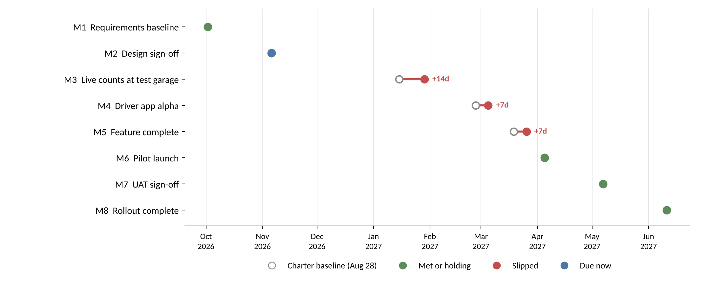
Figure 10: Charter baseline against current forecast for each milestone (INTERNAL)
Holding M6 and M8 was not free. It cost a garage off the pilot, two Could priority stories out of release 1, and the loss of the R6 mitigation, which is now spent and unavailable if the occupancy service slips again. The float between feature complete and pilot launch is down to about ten days.

Budget
Line | Charter baseline | Current | Change | Note
Total budget (BAC) | $3,508,880 | $3,699,780 | +$190,900 | Authorized by change request, October 15
Labor | $2,187,600 | $2,285,200 | +$97,600 | Contract computer vision engineer plus added mapping hours
Hardware | $50,000 | $94,000 | +$44,000 | Three more replacement controllers, six entrance cameras
Contingency | $457,680 | $482,580 | +$24,900 | Held at 15%; the percentage did not move, the base did
Spent to date (AC) | n/a | $429,500 |  | Through October 31, 11.6% of the current baseline
Forecast at completion (EAC) | n/a | $3,942,088 | +$242,308 | At current cost performance. Half the contingency.
Table 37: Budget against the charter baseline (INTERNAL)

Earned value trend
Two readings is the shortest series worth plotting, and the two disagree with each other in a useful way.
Measure | Sept 30 | Oct 31 | Reading
Planned value (PV) | $179,918 | $422,884 | Cumulative work scheduled
Earned value (EV) | $157,900 | $403,100 | Cumulative work actually completed
Actual cost (AC) | $168,400 | $429,500 | Cumulative spend
Schedule variance (SV) | -$22,018 | -$19,784 | EV minus PV. Narrowing.
Cost variance (CV) | -$10,500 | -$26,400 | EV minus AC. Widening.
SPI | 0.88 | 0.95 | Improving. The survey running ahead is most of this.
CPI | 0.94 | 0.94 | Flat. Below the 0.95 escalation threshold two months running.
Table 38: Earned value, September and October (INTERNAL)
Schedule performance improved from 0.88 to 0.95 because the survey ran ahead. Cost performance did not move. Those two facts together say the team is working faster than planned and still spending more per unit of work than planned, which is what you would expect when unplanned rework is absorbed without extending the calendar. It is also the pattern that precedes a team quietly working longer hours, which risk R15 exists to catch and which the retrospectives have not yet flagged.

14.7 Lessons learned
These are written now rather than at close because the detail is still recoverable. Each one names where in this document the evidence sits.
ID | Lesson | Where
Requirements and assumptions
L1 | An assumption nobody has tested is a risk with no entry in the register. Ours survived five weekly reviews because it was written as a statement of fact rather than as something to verify. | Section 3.2, ISS-1
L2 | The client's own words are evidence. "Garages and surface lots" was in the RFP, the contract, and our own Section 2.2 from week one. Reading documents for what they promise rather than for what they constrain is how this gets missed. | Section 2.2
Schedule and testing
L3 | Schedule the work that can invalidate the design before the design is signed off, not in parallel with the build. The survey found the problem in week 6 only because it started in week 5. Had it been sequenced after design sign-off, we would have found it in February with the occupancy service already built. | Task 5, M2
L4 | A field survey is a test, and it belongs in the test plan, not in field work. Nobody treated it as the thing that would prove or disprove the architecture, which is exactly what it turned out to be. | Section 8.1
Cost and estimation
L5 | One month of earned value is noise and two months is a signal. September alone was ignorable. September and October both at CPI 0.94 is a pattern, and the value of setting the escalation threshold in advance is that this did not become an argument. | Section 10.8
L6 | A standard cost allocation encodes the projects a firm has done before. Ours put direct costs at 9%, and this project runs at 9.8% because it bolts hardware to 23 physical sites. The allocation was not wrong, it was borrowed. | Section 10.5
Team and tooling
L7 | Choose tooling for the team at peak size. Trello was correct for three people in week 1 and wrong for twenty-two in week 6, and nothing changed between those dates except headcount, which was known at kickoff. | Section 7.5
L8 | Deciding in advance what the team will do when it is behind is worth more than the plan itself. The 2 garage pilot was agreed in week 3 and spent in week 6 with no meeting. | Risk R6
Governance and communication
L9 | Re-baseline in the open rather than absorbing a scope change into contingency. Moving $190,900 of known cost into the reserve would have kept the headline number flat and made the reserve meaningless. | Section 10.7
L10 | Open the issue log on day one alongside the risk register. A register with no issue log quietly encourages people to keep calling an event a risk after it has happened, because there is nowhere else to put it. | Section 8.2
Table 39: Lessons learned at the design phase checkpoint (INTERNAL)
If only one of these survives into the next project, it should be L3. Every other lesson here is about noticing a problem faster. L3 is about sequencing the work so the problem has to surface while it is still cheap, which is the only one that does not depend on somebody being alert.

14.8 Recommendations for future projects
ID | Recommendation | Addresses
R-1 | Add an assumption register to the SRS template, with an owner, a verification method, and a date, for every assumption. An assumption with no named verifier does not get baselined. | Prevents L1
R-2 | Put a physical-site or hardware discovery work package in the WBS ahead of design sign-off on any project that integrates with equipment, with explicit criteria for what finding would force a redesign. | Prevents L3
R-3 | Open the issue log at kickoff, in the same template as the risk register, with a documented rule for moving an item from one to the other. | Prevents L10
R-4 | Run the tooling decision matrix at kickoff against peak headcount rather than starting headcount. | Prevents L7
R-5 | For every risk scoring 15 or above, write the mitigation as a specific pre-authorized action with a named trigger, not as a description of intent. | Reinforces L8
R-6 | Validate client-supplied reference data by sampling before it is designed against. Three of nine facility capacity figures were wrong, and the capacity model depends on them. | Prevents ISS-2
R-7 | Carry direct costs as their own estimate rather than as a percentage allocation whenever a project touches physical infrastructure. | Prevents L6
R-8 | Set earned value escalation thresholds in the charter, before the first reading, so that acting or not acting on a variance is a decision made in advance rather than under pressure. | Reinforces L5
Table 40: Recommendations for future $oftware ¢orp projects (INTERNAL)
R-1 and R-2 are the two worth changing the studio templates over. The rest are good practice that a disciplined project manager would arrive at anyway; those two are structural, and this project would have gone differently with either one in place.

14.9 Closure checklist
The formal closure steps and where each one stands. Nothing here can complete before M8.
Closure step | Status | Note
Final product delivered and accepted | Not started | Due at M8, June 11, 2027
Client sign-off obtained | Not started | M7 UAT sign-off is the gate
Final budget reconciliation | Not started | Finance closes after the last payout cycle
Documentation archived | In progress | This document is version controlled in the project repository
Operations handover to BBGP | Not started | Work package 9.4, includes attendant training at 23 facilities
Final team meeting and retrospective | Not started | Scheduled for the week after M8
Lessons learned filed to the studio repository | In progress | Section 14.7 is the current draft; filed at close
Contract and vendor accounts closed | Not started | Gate vendors, payment processor, cloud accounts
Table 41: Formal closure checklist (INTERNAL)

14.10 Acknowledgments and sign-off
The field operations coordinator and the two surveyors found the issue that defined this phase, in week 6, by measuring things rather than reading about them. The backend lead rescoped a subsystem in two days without arguing about whose fault it was. Both are worth saying in writing.
This draft has no signatures because the project is not closed. At close it requires sign-off from the project manager, $oftware ¢orp leadership, and the BBGP operations director, and the client-facing version will not contain Sections 14.4, 14.5, or 14.7.
Role | Name | Signature | Date
Project manager | Ibraheem S. | pending at close
$oftware ¢orp leadership |  | pending at close
BBGP operations director (client-facing version) |  | pending at close
Table 42: Closure sign-off (INTERNAL)

