$oftware ¢orp
LevelSpot
Smart Parking Platform: Project Document
Client: Buffalo Bayou Garage Partners (BBGP)
Prepared by: Ibraheem Siddiqui, Project Manager
Version: 4.0
Date: October 8, 2026

CIS 4374 Semester Project, University of Houston. $oftware ¢orp and BBGP are fictional companies created for this course.

Revision history
Version | Date | Author | Changes
1.0 | 09/10/2026 | Ibraheem | Initial draft: competitive research, Vision and Scope, SRS draft with 19 use cases
2.0 | 09/17/2026 | Ibraheem | Work breakdown structure, estimation (story points and COCOMO check), draft schedule with Gantt chart
3.0 | 10/01/2026 | Ibraheem | Agile delivery plan with product backlog and sprint 1, risk register with matrix, quality gates, and communication plan
4.0 | 10/08/2026 | Ibraheem | Resource and cost management: staffing roster, RACI matrix, bottom-up budget with top-down cross-check, monthly cashflow, hidden costs, and first earned value report. Staffing assumption in Section 5.3 updated to match the named roster.

Contents
1. Research: what already exists 4
1.1 How drivers find parking in Houston today 4
1.2 Competitor review 4
1.3 Where current tools fall short 5
1.4 How LevelSpot will be different 5
2. Vision and scope 7
2.1 About $oftware ¢orp 7
2.2 How we landed the project 7
2.3 Business need 7
2.4 Vision statement 8
2.5 Business objectives 8
2.6 Stakeholders 8
2.7 Scope of release 1 9
2.8 Delivery teams 9
2.9 System context 10
3. Software requirements specification (draft) 11
3.1 Introduction 11
3.2 Overall description 11
3.3 Functional requirements 12
3.4 Non-functional requirements 13
3.5 Use cases 14
4. Work breakdown structure 21
5. Estimation 24
5.1 Story point estimates 24
5.2 Turning points into a schedule 25
5.3 COCOMO sanity check 25
5.4 Where the estimate is weakest 26
6. Schedule and timeline 27
6.1 Task schedule 27
6.2 Dependencies 28
6.3 Milestones 28
6.4 Gantt chart 28
7. Agile delivery plan and product backlog 30
7.1 How we run the project 30
7.2 Product backlog 30
7.3 Sprint 1 backlog 33
7.4 Board 34
8. Risk management 35
8.1 Risks by category 35
8.2 Risk register 36
8.3 Risk matrix 38
8.4 Quality gates 38
9. Communication plan 40
9.1 Meeting cadence 40
9.2 Reporting methods 40
9.3 Escalation path 41
10. Resource and cost management 42
10.1 Basis of the budget 42
10.2 Roles and resource plan 42
10.3 RACI matrix 44
10.4 Bottom-up cost estimate 47
10.5 Top-down cross-check 48
10.6 Monthly cashflow 49
10.7 Hidden costs and contingency 51
10.8 Cost control and earned value 51
11. Open questions for BBGP 53
12. Sources 53

1. Research: what already exists
Before writing any requirements, we looked at the apps Houston drivers already use to find and pay for parking, and at the software garages run on behind the scenes. The point was to avoid rebuilding things that are already solved and to find the gaps worth building a product around.

1.1 How drivers find parking in Houston today
On the street, the City of Houston handles metered parking through ParkHouston pay stations and the ParkHouston app, which runs on ParkMobile. All city pay stations are pay-by-plate, so drivers don't need to leave a receipt on the dashboard. For garages and surface lots, drivers either pull in and take a ticket or book ahead through a reservation marketplace like SpotHero or ParkWhiz.
A lot of people skip all of that. They open Google Maps, pick the garage closest to where they're going, and hope there's room when they get there. That habit is really what this project is about. A garage can show up on a map and even accept an online booking, but the driver still can't tell whether a space is open right now, which level it's on, or whether their truck will fit under the entrance.

1.2 Competitor review
Table 1 summarizes the products we reviewed. Ownership in this market has changed a lot in the past two years, so the parent company is listed for each one.
Product (owner) | What it does | Strengths | Weaknesses for our use case
SpotHero (Uber announced it is acquiring SpotHero in Feb 2026) | Marketplace to book garage, lot, and valet parking ahead of time | Very large network, over 13,000 locations in 400+ cities across the US and Canada. Prepaid discounts. Booking from Apple CarPlay. | Sells inventory that operators list, not a live count of open spaces. Some user reviews mention paying more in the app than the rate posted on site.
ParkMobile / ParkHouston (Arrive, formerly EasyPark Group) | Pay by app for street meters and some garages. Official app for Houston meters. | City partner for on-street parking. Pay-by-plate. Reminders before a session expires and remote extension. | Built around paying for a session, not finding a space. No live availability for curb spaces. Garage booking only where operators opt in.
ParkWhiz (Flash) | Reservations and on-demand payment tied to Flash garage systems | License plate can act as the parking credential at supported gated garages. Event parking sold with Live Nation tickets. Bookings appear in Google Maps, Apple Maps, and Waze through Flash's demand network. | Smoothest experience requires Flash or Parkonect equipment at the garage. Garages on other hardware get a more manual setup.
Parkopedia (Arrive) | Parking location and pricing data, much of it built into in-car navigation | Broad data coverage. Already inside many vehicle navigation systems. | Availability is mostly an estimate, not a space held for the driver. Not an operator management tool.
Flash platform (operator side) | Cloud parking management: gates, LPR cameras, validation, analytics | Full hardware and software stack. Camera-based car counting. Connects operators to booking channels. | Tied closely to its own hardware. Moving a whole portfolio onto it is a big capital decision for a mid size operator.
Google Maps / Apple Maps | Where most trips start | Everyone already has it. Hands bookings off to partners. | Does not manage parking. Availability and booking depend on whichever partner feeds the data.
Table 1: Existing parking solutions reviewed

1.3 Where current tools fall short
A few patterns kept coming up while going through these products.
A reservation is not the same as a space. Most marketplaces sell a block of spaces the operator agreed to list. If the garage fills up with drive-up traffic, the app doesn't always know. The driver finds out at the gate, and the fix is a refund after the trip is already wasted.
Operators are stuck picking between two bad options. They can go all in with one hardware vendor, or they can list on several apps that each have their own portal, payout schedule, and reports. BBGP's operations team currently logs into four different portals to answer one question: how full were we last Saturday?
Nobody shows level-by-level detail. Drivers want to know which floor has room, whether the EV chargers are working, and whether accessible spaces are open. Clearance height matters a lot in Houston, where full size pickups are everywhere and some older downtown garages have low entrances.
Weather closures don't reach drivers. When heavy rain floods the street level or a basement level, garages close those floors. Drivers with reservations usually learn about it when they pull up.
The city gets very little data back. The transportation department sees meter activity, but it has almost no view into how full private garages are during a big event, which makes traffic and street closure planning harder.

1.4 How LevelSpot will be different
LevelSpot is built around live data from the garage itself. The main differences from what's on the market:
- Open space counts per level, pulled from the gate controllers, LPR cameras, and bay sensors the garage already has, and updated within seconds.
- A Spot Guarantee. A reservation holds an actual space. If the garage can't honor it, LevelSpot automatically rebooks the driver at the nearest garage with room and covers any price difference.
- Hardware neutral. An adapter layer connects to common gate and camera systems, so an operator doesn't have to replace equipment to join.
- One price shown upfront. The price in the app is the price the driver pays, fees included.
- Event mode and level closures that operators can switch on from the dashboard, with instant alerts to every affected driver.
- An anonymized occupancy feed for the city transportation department.
Competitors each cover some of this. We didn't find a single product that covers both the driver side and the operator side without requiring new gate hardware, and that is the opening LevelSpot is going after.

2. Vision and scope
This section will keep changing as the semester goes on. It captures where the project stands after kickoff.

2.1 About $oftware ¢orp
$oftware ¢orp is a software development studio based in East Downtown (EaDo) Houston. It was started in 2015 by a group of former logistics engineers and now has about 180 employees. Most of the studio's work is location based software: apps where maps, GPS, device data, and payments all have to work together.
Recent projects include a truck check-in and yard management app for a drayage company near the Port of Houston and a shuttle tracking system for a private university campus. That yard app is a big reason parking operators started paying attention to us. A garage is basically a truck yard with more rules and angrier customers.
For this project the studio has an unlimited theoretical budget. That removes a lot of the usual tradeoffs, but it does not change the fixed semester timeline, our dependence on third party services, or the security, privacy, and city rules we have to follow. Section 10 prices the project anyway, because an unlimited budget still has to be forecast and controlled.

2.2 How we landed the project
This contract came from reputation and a referral, not a cold sales pitch.
In spring 2026 two of our engineers built an open source occupancy counter through our internal "Project Garage" program. It reads gate entry and exit events and turns them into a live count per level. We demoed it at a Houston mobility meetup, and the operations director at Buffalo Bayou Garage Partners (BBGP) was in the audience. BBGP runs 23 garages and surface lots across Downtown, Midtown, EaDo, and the area around the Texas Medical Center.
A few weeks later BBGP asked around for development partners, and the drayage company we built the yard app for recommended us. The timing worked out. BBGP had a rough summer: on the World Cup match days in June and July, several of its downtown garages filled before noon, attendants were waving cars away by hand, and third party apps kept selling reservations at garages that had no room left.
BBGP released a request for proposal in July 2026. Our proposal focused on live counts and a guaranteed reservation instead of another booking marketplace. We presented to BBGP leadership in August, and the contract was signed on August 28, 2026. Kickoff with BBGP happened the first week of September.

2.3 Business need
Drivers heading to busy parts of Houston lose time circling blocks and driving between garages, which adds to congestion and makes people late. Operators have the opposite problem. BBGP's downtown garages regularly turn cars away on weekdays while its Midtown and EaDo lots sit half empty, and it has no easy way to steer drivers from one to the other or adjust prices based on demand.
BBGP needs one system that shows drivers real availability, holds spaces reliably, takes digital payments, and gives its own staff a clear view of occupancy and revenue across every facility.

2.4 Vision statement
For Houston drivers who need to park near a busy destination, LevelSpot is a mobile and web app that shows exactly where open spaces are, holds one for you, and gets you to the right entrance. Unlike reservation marketplaces that sell listed inventory, LevelSpot works from live garage data and guarantees the space. For parking operators, it is one dashboard for occupancy, pricing, and payouts that works with the equipment they already own.

2.5 Business objectives
Targets below are measured over the first 12 months after launch across BBGP facilities. Baselines will be collected during the pilot.
ID | Objective | Target
BO-1 | Cut the time drivers spend finding a space | Average time from garage entry to parked under 4 minutes
BO-2 | Move demand to underused facilities | Weekday occupancy at Midtown and EaDo lots up 15 percentage points
BO-3 | Stop selling reservations that can't be honored | Fewer than 1 in 500 reservations need a Spot Guarantee rebook
BO-4 | Shift payments to digital | 70% of BBGP parking transactions go through LevelSpot
BO-5 | Share useful data with the city | Occupancy feed live for all 23 BBGP facilities by end of pilot
Table 2: Business objectives

2.6 Stakeholders
Stakeholder | What they care about | How they are involved
Drivers and vehicle owners | Finding a space fast, knowing the real price, not getting ticketed or towed | Beta testing, in-app surveys, app store reviews
Mobile app users (frequent and monthly parkers) | Fast rebooking, saved vehicles, monthly passes | Focus group of BBGP monthly parkers
Parking facility operators (BBGP) | Occupancy, revenue, fewer staff hours at the gates | Project sponsor. Weekly review with the operations director
City of Houston transportation department | Congestion near venues, compliance with city ordinances, planning data | Quarterly briefings. Signs off on the data feed format
System administrators | Account security, user roles, uptime | BBGP IT staff plus $oftware ¢orp operations
Finance and billing personnel | Accurate payouts, refunds, reconciliation, sales tax | Monthly reconciliation reviews during the pilot
Third party payment providers | PCI compliance, fraud prevention, integration terms | Technical integration partner
Table 3: Stakeholders

2.7 Scope of release 1
In scope:
- Driver registration, sign in, and saved vehicles
- Live availability map with per-level counts
- Reservations, extensions, cancellations, and the Spot Guarantee
- Digital payments (cards, Apple Pay, Google Pay), reservation history, and receipts
- Push, SMS, and email notifications
- Operator dashboard with occupancy, pricing rules, level closures, and reports
- Navigation handoff to Google Maps, Apple Maps, and Waze
- Anonymized occupancy feed for the city
- English and Spanish versions of the driver apps
Out of scope for release 1:
- Paying for street meters (the city already covers this through ParkHouston)
- Valet operations
- Paying for EV charging (LevelSpot will only show whether chargers are available)
- Buying or installing new sensors, cameras, or gates
- Parking enforcement and citations
- Cities outside the Houston metro area

2.8 Delivery teams
Team | Responsible for
Mobile Application Team | iOS and Android driver apps, push notifications, CarPlay and Android Auto in a later release
Web Application Team | Driver web app and the operator dashboard
Backend/API Team | Reservation engine, pricing rules, occupancy service, city data feed API, gate vendor adapters
Mapping & Location Services Team | Map experience, geocoding, entrance-level pins, navigation handoff
Payment Integration Team | Processor integration, refunds, operator payouts, receipts
Quality Assurance & Testing Team | Test plans, device testing, load tests for event days, accessibility testing
Table 4: Development teams and responsibilities
Section 10.2 names the people in each team, with skill levels and allocations.

2.9 System context
Figure 1 shows how LevelSpot fits with its users and the outside systems it depends on. The garage equipment on the right already exists at BBGP facilities. LevelSpot reads from it but does not replace it.
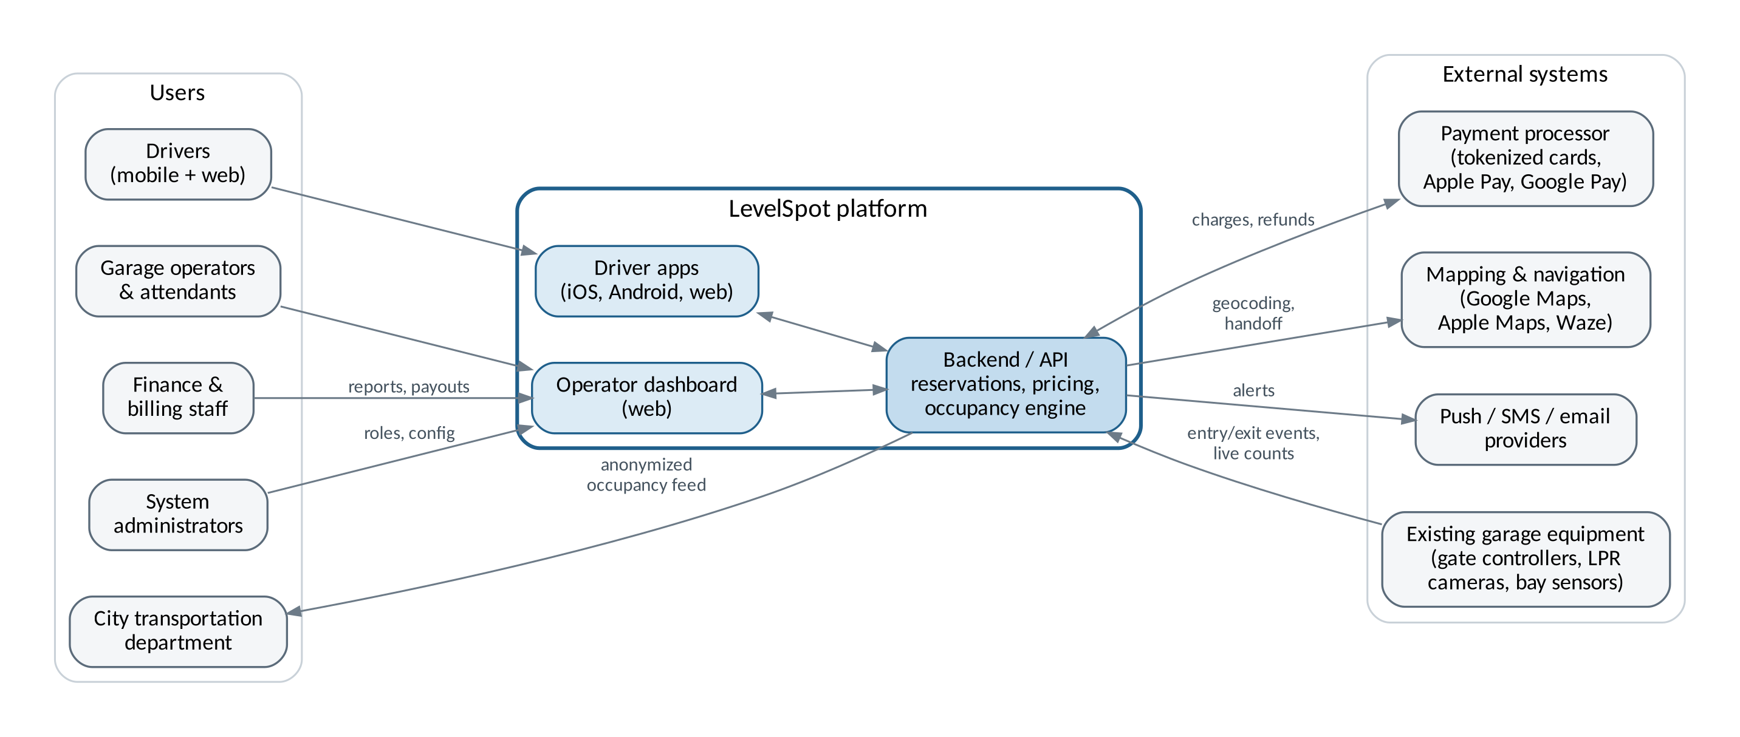
Figure 1: LevelSpot system context for release 1

3. Software requirements specification (draft)

3.1 Introduction
Purpose. This section defines the requirements for LevelSpot release 1. It is a first draft and will be expanded each week as requirement sessions with BBGP continue.
Scope. Release 1 covers the driver apps (iOS, Android, web), the operator dashboard, the backend services behind them, and integrations with payment, mapping, notification, and garage equipment vendors. Section 2.7 lists what is in and out of scope.
Definitions.
Term | Meaning
Facility | A garage or surface lot managed by an operator
Open count | Number of empty spaces in a facility or level, calculated from live gate and sensor events
Reserved buffer | Spaces an operator keeps aside for drive-up parkers. Reservations stop when the open count reaches this number.
Hold window | How long a reserved space stays held after the reservation start time. Default is 30 minutes.
Spot Guarantee | Automatic rebooking at another facility, with any price difference covered, when a reservation can't be honored
LPR | License plate recognition camera
Table 5: Definitions

3.2 Overall description
Users. Drivers (guests and registered), monthly parkers, operator managers, garage attendants, finance staff, city transportation analysts, and system administrators.
System environment. Native iOS and Android apps, a responsive driver web app, and a web-based operator dashboard. Backend services are cloud hosted on AWS across two US regions.
Constraints. The project has a fixed semester timeline. It depends on third party APIs for payments, maps, notifications, and garage equipment. Card handling must meet PCI DSS. Personal data handling must follow the Texas Data Privacy and Security Act. Pricing, signage, and data sharing must follow City of Houston parking ordinances. The apps must pass Apple App Store and Google Play review.
Assumptions. BBGP facilities have internet-connected gate controllers or LPR cameras that can send entry and exit events. Drivers have a smartphone with location services or can enter a destination manually. BBGP gives us access to facility data and sets its own prices. Mapping provider licensing allows showing facility pins and handing off directions.

3.3 Functional requirements
ID | Requirement
Accounts
FR1 | The system shall allow drivers to register with an email address or mobile number and verify it with a one time code.
FR2 | The system shall allow drivers to sign in with a password or with an Apple or Google account.
FR3 | The system shall allow drivers to save vehicles with license plate, state, and height class.
FR4 | The system shall allow guest checkout using only a mobile number and license plate.
Search and map
FR5 | The system shall display facilities on an interactive map with the open count for each facility.
FR6 | The system shall show open counts per level for facilities that report level data.
FR7 | The system shall let drivers filter facilities by price, distance, clearance height, EV charging, accessible spaces, and hours.
FR8 | The system shall place each map pin at the facility's vehicle entrance, not its mailing address.
FR9 | The system shall hand off turn by turn directions to Google Maps, Apple Maps, or Waze.
Reservations
FR10 | The system shall allow drivers to reserve a space for a selected start and end time.
FR11 | The system shall hold a reserved space from the start time through the hold window.
FR12 | The system shall allow drivers to extend or cancel a reservation.
FR13 | The system shall rebook a driver through the Spot Guarantee when a facility cannot honor a reservation.
FR14 | The system shall stop selling reservations at a facility when its open count reaches the reserved buffer.
Payments and receipts
FR15 | The system shall accept payment by card, Apple Pay, and Google Pay through a PCI compliant processor.
FR16 | The system shall show the full price, including all fees and taxes, before the driver confirms.
FR17 | The system shall issue refunds automatically based on the operator's cancellation policy.
FR18 | The system shall keep reservation history and let drivers download receipts as PDF.
Notifications
FR19 | The system shall send a reminder 15 minutes before a reservation starts and 15 minutes before it ends.
FR20 | The system shall alert drivers with active or upcoming reservations when their facility or level closes.
Operator tools and administration
FR21 | The system shall provide operators a dashboard with live occupancy by facility and level.
FR22 | The system shall allow operators to set base rates, time of day rates, and event rates.
FR23 | The system shall allow operators to close a level or facility and set an expected reopening time.
FR24 | The system shall generate occupancy, revenue, and reservation reports exportable to CSV and PDF.
FR25 | The system shall allow finance users to reconcile payouts against payment processor settlements.
FR26 | The system shall allow administrators to create operator users and assign roles (manager, attendant, finance, read only).
Integrations
FR27 | The system shall accept entry and exit events from supported gate controllers and LPR cameras through vendor adapters.
FR28 | The system shall publish an anonymized occupancy feed per facility for the city, refreshed every 5 minutes.
Table 6: Functional requirements

3.4 Non-functional requirements
ID | Category | Requirement
NFR1 | Performance | Open counts shown to drivers shall update within 10 seconds of a gate or sensor event.
NFR2 | Performance | The map screen shall load facility pins within 2 seconds on a 4G connection.
NFR3 | Scalability | The system shall support 25,000 concurrent drivers during event peaks with reservation confirmation under 3 seconds.
NFR4 | Availability | The system shall have 99.9% monthly uptime, and 99.95% during operator-flagged event windows.
NFR5 | Resilience | If a facility loses its internet connection, the gate adapter shall keep honoring cached reservations for at least 60 minutes.
NFR6 | Security | Card numbers shall never be stored on LevelSpot servers. Only payment processor tokens are kept.
NFR7 | Security | All data shall be encrypted in transit with TLS 1.2 or higher and at rest with AES-256.
NFR8 | Security | Operator and administrator accounts shall require multi factor authentication.
NFR9 | Privacy | License plate data shall be anonymized 90 days after a reservation ends unless tied to an open billing dispute.
NFR10 | Usability | A signed in driver shall be able to complete a reservation in 4 taps or fewer from the facility screen.
NFR11 | Accessibility | Driver apps and the operator dashboard shall meet WCAG 2.2 Level AA.
NFR12 | Localization | Driver apps shall be available in English and Spanish at launch.
NFR13 | Auditability | Price changes, refunds, and role changes shall be logged with user and timestamp and kept for 2 years.
Table 7: Non-functional requirements

3.5 Use cases
The use cases below cover the main driver, operator, finance, city, and admin workflows for release 1. More will be added as requirements sessions continue.

UC-01: Register a driver account
Primary actor | Driver
Preconditions | LevelSpot app is installed. Driver does not have an account.
Main flow | 1. Driver taps Create account.  2. Driver enters a mobile number or email address.  3. System sends a 6 digit verification code.  4. Driver enters the code.  5. Driver sets a password or links an Apple or Google account.  6. System creates the account and prompts the driver to add a vehicle.
Alternate flow | 3a. Code doesn't arrive within 60 seconds: driver taps Resend (limit of 3 per hour).
Postcondition | A verified driver account exists.

UC-02: Add a vehicle
Primary actor | Driver
Preconditions | Driver is signed in.
Main flow | 1. Driver opens Vehicles and taps Add vehicle.  2. Driver enters plate number, state, and a nickname.  3. Driver picks a height class: car, SUV, full size truck, or oversized.  4. System checks the plate format for that state and saves the vehicle.
Alternate flow | 4a. Plate format doesn't match the selected state: system highlights the field and asks the driver to fix it.
Postcondition | Vehicle is saved and used for LPR entry and clearance filtering.

UC-03: Find open parking near a destination
Primary actor | Driver
Preconditions | Location access is granted or the driver types a destination.
Main flow | 1. Driver searches for a destination, for example Discovery Green.  2. System shows facilities within half a mile with their open counts.  3. Driver taps a facility.  4. System shows price for the selected time, open spaces per level, clearance height, and walking time to the destination.
Alternate flow | 2a. No facilities with open space nearby: system widens the search to 1 mile and tells the driver it did.
Postcondition | Driver sees current details for the selected facility.

UC-04: Filter facilities by vehicle needs
Primary actor | Driver
Preconditions | Search results are showing.
Main flow | 1. Driver taps Filters.  2. Driver selects EV charging, accessible spaces, or both.  3. System uses the saved vehicle's height class to hide facilities with lower clearance.  4. System refreshes the map and list.
Alternate flow | 3a. Driver has no saved vehicle: system asks for a height class once and remembers it.
Postcondition | Only facilities that fit the driver's needs are shown.

UC-05: Reserve a parking space
Primary actor | Driver
Preconditions | Driver is signed in or checking out as a guest. Facility has reservable open spaces.
Main flow | 1. Driver selects a facility and time window.  2. Driver taps Reserve.  3. System shows the total price with fees and the cancellation policy.  4. Driver confirms the vehicle and payment method.  5. Driver taps Confirm.  6. System takes payment (UC-06), holds a space, and shows the reservation with entry instructions.
Alternate flow | 5a. Open count hits the reserved buffer before the driver confirms: system explains the facility just filled up and suggests the three closest facilities with room.
Postcondition | Reservation is active and the space is removed from the sellable count.

UC-06: Pay for a reservation
Primary actor | Driver (secondary: payment processor)
Preconditions | A reservation is waiting for payment.
Main flow | 1. Driver chooses a saved card, Apple Pay, or Google Pay.  2. System sends a tokenized charge to the processor.  3. Processor approves the charge.  4. System confirms the reservation and emails a receipt.
Alternate flow | 3a. Payment is declined: system keeps the space on hold for 5 minutes and asks for another payment method.
Postcondition | Payment is captured and the receipt is stored.

UC-07: Enter and exit a garage with a reservation
Primary actor | Driver (secondary: gate controller, LPR camera)
Preconditions | Driver has an active reservation. Facility has supported gate equipment.
Main flow | 1. Driver pulls up to the entrance.  2. LPR camera reads the plate.  3. System matches the plate to the reservation and opens the gate.  4. System updates the open count.  5. At exit, the camera reads the plate, the system closes out the reservation, and the gate opens.
Alternate flow | 2a. Plate can't be read (dirty plate, bike rack, trailer hitch): driver scans the QR code in the app at the entry kiosk.  5a. Driver stayed past the end time: system charges overtime at the posted rate and adds it to the receipt.
Postcondition | Parking session is closed and the facility count is accurate.

UC-08: Extend an active reservation
Primary actor | Driver
Preconditions | Driver has an active reservation.
Main flow | 1. Driver opens the reservation from the reminder or the app.  2. Driver taps Extend and picks extra time.  3. System checks availability and shows the added cost.  4. Driver confirms.  5. System charges the difference and updates the end time.
Alternate flow | 3a. Facility is booked for an event later that evening: system offers the longest extension that is still available.
Postcondition | Reservation has a new end time.

UC-09: Cancel a reservation
Primary actor | Driver
Preconditions | Driver has an upcoming reservation.
Main flow | 1. Driver opens the reservation and taps Cancel.  2. System shows the refund amount based on the operator's policy.  3. Driver confirms.  4. System releases the space and processes the refund.
Alternate flow | 2a. Reservation is inside the no-refund window: system shows a $0 refund and lets the driver keep the reservation instead.
Postcondition | Space is back in inventory. Refund is issued if eligible.

UC-10: Rebook a driver through the Spot Guarantee
Primary actor | System (secondary: driver)
Preconditions | A driver has an active or upcoming reservation at a facility that can no longer honor it (for example, overfilled or level closed).
Main flow | 1. System detects that the facility can't honor the reservation.  2. System finds the nearest facility with open space that fits the driver's vehicle height.  3. System creates the new reservation and cancels the original.  4. System credits any price difference.  5. System sends a push notification and text with the new location and a Directions button.
Alternate flow | 2a. No facility within 1 mile has room: system gives a full refund plus an account credit and tells the driver right away.
Postcondition | Driver has a valid reservation, or a full refund and credit.

UC-11: Navigate to the facility entrance
Primary actor | Driver (secondary: mapping and navigation service)
Preconditions | Driver has a reservation.
Main flow | 1. Driver taps Directions.  2. System asks which navigation app to use and remembers the choice.  3. System sends the coordinates of the vehicle entrance.  4. Navigation app starts the route.
Alternate flow | 3a. Entrance is on a one way street: system sends an approach point so the route arrives from the correct direction.
Postcondition | Driver is routed to the correct entrance.

UC-12: View history and download a receipt
Primary actor | Driver
Preconditions | Driver is signed in and has at least one completed reservation.
Main flow | 1. Driver opens History.  2. Driver filters by date range.  3. Driver opens a reservation and taps Download receipt.  4. System generates a PDF with facility, times, plate, price, fees, and tax.
Alternate flow | 3a. Driver needs receipts for an expense report: driver selects several reservations and exports one combined PDF.
Postcondition | Receipt is downloaded.

UC-13: Monitor live occupancy
Primary actor | Operator manager
Preconditions | Manager is signed in with multi factor authentication. Facilities are connected.
Main flow | 1. Manager opens the dashboard.  2. System shows every facility with occupancy percentage and a level breakdown.  3. Manager opens one facility.  4. System shows open counts, upcoming reservations, and gate status for each lane.
Alternate flow | 4a. A gate or sensor hasn't reported for more than 2 minutes: system marks the level as Data delayed and pauses reservation sales there.
Postcondition | Manager has a current view of occupancy.

UC-14: Set event pricing
Primary actor | Operator manager
Preconditions | Manager is signed in and has pricing permission.
Main flow | 1. Manager opens Pricing.  2. Manager selects one or more facilities.  3. Manager creates an event rule with a name, date, time window, and flat rate.  4. Manager sets the reserved buffer for the event.  5. System shows a preview of the new prices.  6. Manager publishes the rule, and the system applies it to new bookings only.
Alternate flow | 5a. New rule overlaps an existing rule: system shows the conflict and asks which rule wins.
Postcondition | Event pricing is live and the change is logged.

UC-15: Close a level and alert drivers
Primary actor | Operator manager or attendant
Preconditions | User is signed in to the dashboard.
Main flow | 1. User selects a facility and level.  2. User taps Close level.  3. User picks a reason (street flooding, maintenance, event staging, other) and an expected reopening time.  4. User confirms.  5. System removes the level's spaces from availability, alerts affected drivers, and starts UC-10 for reservations it can't move to another level.
Alternate flow | 3a. Reopening time is unknown: level stays closed until someone reopens it manually.
Postcondition | Level is closed and affected drivers have been notified.

UC-16: Generate an occupancy and revenue report
Primary actor | Operator manager or finance user
Preconditions | User is signed in.
Main flow | 1. User opens Reports.  2. User chooses a report type.  3. User selects facilities and a date range.  4. System builds the report with peak hours, average occupancy, and revenue by channel.  5. User exports it as CSV or PDF.
Alternate flow | 4a. Date range is longer than 12 months: system builds the report in the background and emails a link when it's ready.
Postcondition | Report is generated and exported.

UC-17: Reconcile operator payouts
Primary actor | Finance and billing staff (secondary: payment processor)
Preconditions | User is signed in with the finance role.
Main flow | 1. User opens Payouts and selects a pay period.  2. System lists reservations, refunds, fees, and the net payout.  3. User compares the totals against the processor's settlement file.  4. User marks the period as reconciled.
Alternate flow | 3a. Totals don't match: system lists the unmatched transactions and the user opens a dispute ticket.
Postcondition | Pay period is reconciled or flagged for follow-up.

UC-18: Pull the occupancy feed for city planning
Primary actor | City transportation analyst
Preconditions | A data sharing agreement is signed and the analyst has an API key.
Main flow | 1. Analyst requests the occupancy feed from the city's traffic dashboard.  2. System returns occupancy, capacity, and a timestamp for each facility with no personal data.  3. City dashboard displays the data alongside traffic sensor data.
Alternate flow | 2a. API key has expired: system returns an authorization error with instructions to renew it through the administrator.
Postcondition | City has current anonymized occupancy data.

UC-19: Manage operator user roles
Primary actor | System administrator
Preconditions | Administrator is signed in with multi factor authentication.
Main flow | 1. Administrator opens Users and taps Invite.  2. Administrator enters an email, assigns a role, and picks which facilities the user can access.  3. System sends the invitation.  4. New user accepts, sets a password, and enrolls in multi factor authentication.
Alternate flow | 4a. Invitation isn't accepted within 7 days: it expires and the administrator can resend it.
Postcondition | User has only the permissions assigned, and the change is logged.

4. Work breakdown structure
The WBS below breaks LevelSpot into deliverables, not tasks. It goes three levels deep: level 1 is a major area of the project, level 2 is a deliverable inside that area, and level 3 is the work package a team can actually schedule and estimate. Level 3 packages are what feed the estimates in Section 5 and the schedule in Section 6.
Project management, integration work, and testing are in the WBS on purpose. Leaving them out is one of the fastest ways to underestimate a project, since they can easily be a third of the real effort.
Level 1 | Level 2 and level 3 work packages | Owner
1. Project management | 1.1 Planning: charter, WBS, schedule, risk register  1.2 Stakeholder management: weekly BBGP reviews, city coordination  1.3 Status reporting: weekly stakeholder video, sprint reports | PM
2. Requirements and design | 2.1 Requirements: elicitation sessions, SRS, use case catalog  2.2 UX design: driver wireframes, dashboard wireframes, design system  2.3 Technical architecture: data model, API spec, integration architecture | PM, Web, Backend
3. Backend and API | 3.1 Accounts service: registration and verification, sign in and MFA, vehicle profiles  3.2 Occupancy service: adapter framework, event ingestion, per level count engine, data delayed detection  3.3 Reservation engine: availability and buffers, booking and holds, extend and cancel, Spot Guarantee rebooking  3.4 Pricing service: base and time of day rates, event rules, price preview API  3.5 Notification service: push, SMS, email templates  3.6 City data feed: anonymization job, public API and key management | Backend/API
4. Payments | 4.1 Processor integration: tokenized checkout, Apple Pay and Google Pay, refunds  4.2 Receipts: PDF generation, combined export  4.3 Operator payouts: payout calculation, settlement reconciliation | Payment Integration
5. Driver applications | 5.1 iOS app: onboarding, map and search, reservation flow, active reservation screen  5.2 Android app: onboarding, map and search, reservation flow, active reservation screen  5.3 Driver web app: search and booking, history and receipts  5.4 Shared components: map component, Spanish localization, accessibility pass | Mobile, Web, Mapping
6. Operator dashboard | 6.1 Live occupancy views: portfolio view, facility and level view, gate status  6.2 Pricing management: rate editor, event rules, conflict checks  6.3 Facility control: close level workflow, driver alerts  6.4 Reporting: occupancy reports, revenue reports, CSV and PDF export  6.5 User administration: invites and roles, audit log | Web Application
7. Integrations and field work | 7.1 Gate vendor adapters: vendor A, vendor B, offline cache mode  7.2 Facility onboarding: site surveys, level mapping and clearance data, entrance geocoding  7.3 Mapping handoff: geocoding, deep links to Google Maps, Apple Maps, Waze | Backend, Mapping
8. Quality assurance | 8.1 Test planning: test plan, test data sets  8.2 Functional testing: driver apps, dashboard, gate integration in the field  8.3 Non-functional testing: event day load test, security review, WCAG 2.2 AA audit  8.4 User acceptance testing with BBGP staff | QA & Testing
9. Release and operations | 9.1 Infrastructure: AWS environments, CI/CD, monitoring and alerting  9.2 App store release: App Store submission, Play Store submission  9.3 Pilot: 3 downtown garages, feedback and fixes  9.4 Full rollout: 23 facilities, attendant training, handover documents | Backend, QA, PM
Table 8: LevelSpot work breakdown structure
Figure 2 shows branch 3 drawn out as a tree, from the level 1 area down to the individual level 3 work packages. The other branches follow the same pattern.
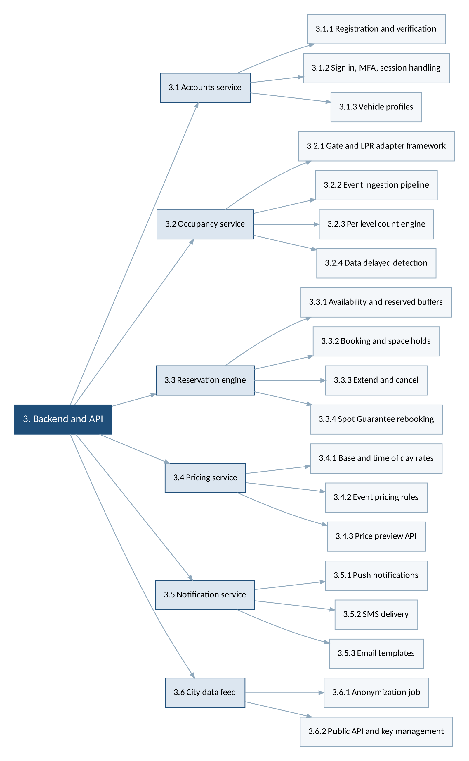
Figure 2: Level 3 decomposition of WBS branch 3, Backend and API

5. Estimation
We estimated each level 3 package with story points on the Fibonacci scale, then checked the total against a COCOMO calculation. Story points measure relative size, effort, and risk, not hours. The 89 point packages are the ones where we expect surprises, not just long hours.

5.1 Story point estimates
Story points here are rolled up to the level 2 deliverable so the table stays readable. Project management work (branch 1) is treated as ongoing overhead and is not point estimated.
WBS | Deliverable | SP | Basis for the estimate
2.1 | Requirements | 21 | Mostly elicitation sessions and writing. Similar scope to the yard app.
2.2 | UX design | 34 | Two products to design, driver app and dashboard.
2.3 | Technical architecture | 21 | Data model plus the adapter design.
3.1 | Accounts service | 34 | Standard work. Analogy: the yard app login took one sprint.
3.2 | Occupancy service | 89 | Highest risk package. Vendor formats differ and events arrive out of order.
3.3 | Reservation engine | 89 | Holds, buffers, and Spot Guarantee logic. Lots of edge cases.
3.4 | Pricing service | 34 | Rules engine with overlapping event rates.
3.5 | Notification service | 21 | Mostly integration with push and SMS providers.
3.6 | City data feed | 13 | Small API with an anonymization step.
4.1 | Processor integration | 34 | Tokenized checkout, wallets, refunds.
4.2 | Receipts | 13 | PDF generation, low risk.
4.3 | Operator payouts | 21 | Reconciliation math needs finance review.
5.1 | iOS app | 89 | Full app: onboarding through active reservation.
5.2 | Android app | 89 | Same scope as iOS, some shared logic.
5.3 | Driver web app | 55 | Smaller feature set than the mobile apps.
5.4 | Shared components | 34 | Map component, Spanish localization, accessibility pass.
6.1 | Live occupancy views | 55 | Real time updates in the browser.
6.2 | Pricing management | 34 | Editor plus conflict checking.
6.3 | Facility control | 21 | Close level workflow and alerts.
6.4 | Reporting | 34 | Charts and exports.
6.5 | User administration | 13 | Roles, invites, audit log.
7.1 | Gate vendor adapters | 55 | Two vendors plus an offline cache mode.
7.2 | Facility onboarding | 34 | Field work at 23 sites. Effort is people and travel, not code.
7.3 | Mapping handoff | 13 | Deep links and entrance geocoding.
8.1 | Test planning | 8
8.2 | Functional testing | 55 | Includes testing at live garages, which is slow.
8.3 | Non-functional testing | 34 | Load, security, and accessibility.
8.4 | User acceptance testing | 13 | BBGP staff run their own scenarios.
9.1 | Infrastructure | 34 | Environments, CI/CD, monitoring.
9.2 | App store release | 8 | Submission and review cycles.
9.3 | Pilot | 21 | Three garages, two sprints of fixes.
9.4 | Full rollout | 34 | 23 facilities and attendant training.
Table 9: Story point estimates by deliverable
Total: 1,157 story points.

5.2 Turning points into a schedule
On the yard management app, one 5 person team averaged about 22 points per two week sprint. Six teams are assigned to LevelSpot, but they don't all start at once and they don't all run at full speed, so we planned on roughly 90 points per sprint across the whole project once every team is ramped up.
1,157 points divided by 90 points per sprint is about 13 sprints, or 26 weeks of build and test work. The schedule in Section 6 allows 25 weeks between the start of backend work and the end of testing, so the two line up, with the discovery, design, and rollout phases sitting on either side of that window.

5.3 COCOMO sanity check
Estimating the same system a second way is a cheap way to catch a bad number. LevelSpot fits the organic category in COCOMO: a known problem domain, an experienced team, and requirements we can still negotiate.
Our LOC estimate for release 1 is about 52,000 lines across the backend, apps, and dashboard, based on the yard app and the campus shuttle system.
Effort = 2.4 × (52)^1.05 = 152 person-months
The roster in Section 10.2 names 21 people, several of them part time, which works out to 17.4 full time equivalents and about 174 person-months of capacity. The COCOMO number sits just under that, so the effort estimate looks reasonable.
The schedule side is where it gets interesting. COCOMO's development time formula, 2.5 × (152)^0.38, gives about 17 months with an average of 9 people. We are planning 9 months with 17 full time equivalents. COCOMO penalizes exactly that kind of compression, so this is a real flag rather than a rounding difference. We're handling it by keeping the teams working on separate parts of the WBS with clear interfaces between them, and by treating the schedule as the first thing to renegotiate if the occupancy service slips. Risk R6 in Section 8 tracks it.

5.4 Where the estimate is weakest
- The occupancy service (3.2) and the gate adapters (7.1) depend on vendor documentation we haven't seen yet. If a vendor has no event API, that package could double.
- Facility onboarding (7.2) assumes BBGP has accurate level, capacity, and clearance data for all 23 sites. They may not.
- App store review times are outside our control.
- Points were estimated by the leads, not by the full teams. We'll re-estimate in sprint planning, and the numbers here will move.

6. Schedule and timeline
The plan runs from kickoff on September 8, 2026 to full rollout on June 11, 2027, about 40 weeks. Work is organized in two week sprints inside the phases below.

6.1 Task schedule
Task | Start | Finish | Duration | Depends on | Notes
1. Requirements elicitation with BBGP | 09/08/26 | 09/25/26 | 2.8 wks | Start
2. SRS baseline and use case catalog | 09/14/26 | 10/02/26 | 3 wks | 1 (SS) | Runs alongside elicitation
3. UX design: driver app and dashboard | 10/05/26 | 11/06/26 | 5 wks | 2 (FS)
4. Architecture, data model, API spec | 10/05/26 | 10/30/26 | 4 wks | 2 (FS)
5. Gate vendor survey, 23 facilities | 10/05/26 | 11/20/26 | 7 wks | 2 (FS) | Field work, runs in parallel
6. Accounts service | 11/02/26 | 12/04/26 | 5 wks | 4 (FS)
7. Occupancy service and gate adapters | 11/02/26 | 01/15/27 | 11 wks | 4, 5 (FS) | Critical path
8. Reservation engine and Spot Guarantee | 11/30/26 | 02/12/27 | 11 wks | 7 (SS) | Critical path
9. Pricing service | 01/04/27 | 02/05/27 | 5 wks | 8 (SS)
10. Payments and payouts | 12/07/26 | 02/05/27 | 9 wks | 6 (FS)
11. Driver apps: iOS, Android, web | 11/16/26 | 03/19/27 | 18 wks | 3 (FS) | Critical path
12. Operator dashboard | 01/04/27 | 03/19/27 | 11 wks | 3, 7 (FS)
13. Notifications and city data feed | 02/08/27 | 03/12/27 | 5 wks | 8 (FS)
14. Facility onboarding and level mapping | 02/01/27 | 04/16/27 | 11 wks | 5, 7 (FS)
15. QA: functional and field gate testing | 02/15/27 | 04/16/27 | 9 wks | 11 (SS) | Critical path
16. Load, security, accessibility testing | 03/15/27 | 04/23/27 | 6 wks | 12 (FS)
17. Pilot at 3 downtown garages | 04/05/27 | 05/07/27 | 5 wks | 15, 16 (FS) | Critical path
18. UAT with BBGP staff | 04/19/27 | 05/07/27 | 3 wks | 17 (FF) | Finishes with the pilot
19. App Store and Play Store release | 05/03/27 | 05/21/27 | 3 wks | 17 (FS)
20. Full rollout to 23 facilities, training | 05/10/27 | 06/11/27 | 5 wks | 18 (FS) | Critical path
Table 10: Draft task schedule with dependencies

6.2 Dependencies
Most tasks are finish to start, but three relationships drive the plan and are worth calling out.
- The reservation engine starts alongside the occupancy service (start to start) rather than after it. The booking logic can be built against simulated counts, and waiting for real gate data would push everything back by two months.
- QA starts alongside the driver apps (start to start) so bugs surface during development instead of in one long test phase at the end.
- UAT finishes with the pilot (finish to finish). BBGP staff test against the live pilot garages, so both wrap up on the same date.
The critical path runs through the gate vendor survey, the occupancy service, the reservation engine, the driver apps, field testing, the pilot, and rollout. Anything that slips on that chain moves the June date. The occupancy service is the piece to watch: it depends on outside vendors and everything else reads from it.

6.3 Milestones
ID | Milestone | Date
M1 | Requirements baseline approved by BBGP | 10/02/26
M2 | Design and architecture sign-off | 11/06/26
M3 | Live counts working at the test garage | 01/15/27
M4 | Driver app alpha on internal devices | 02/26/27
M5 | Feature complete for release 1 | 03/19/27
M6 | Pilot launch at 3 downtown garages | 04/05/27
M7 | UAT sign-off from BBGP | 05/07/27
M8 | Rollout complete at all 23 facilities | 06/11/27
Table 11: Milestones

6.4 Gantt chart
Figure 3 shows the same schedule visually. Bars are grouped by phase and the diamonds along the top are the milestones from Table 11.

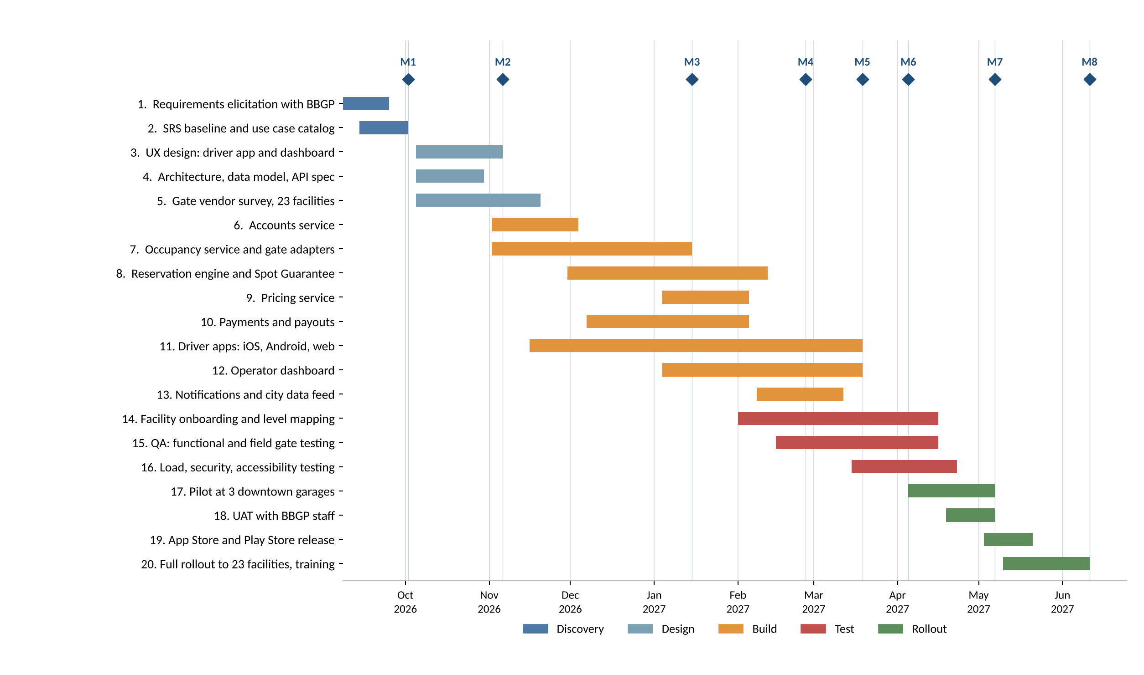
Figure 3: LevelSpot draft schedule, September 2026 to June 2027
Two scheduling notes. The Thanksgiving and December holidays fall inside the backend build, so we planned lighter sprints there instead of pretending the team is at full capacity. And the pilot starts in early April, which gives us a month of real use before the summer event season, when BBGP's garages are busiest and mistakes would be most visible.

7. Agile delivery plan and product backlog
LevelSpot runs on Scrum with two week sprints. The schedule in Section 6 is the outer frame for BBGP and the city, and the backlog below is how the teams actually work inside it. We also keep a separate Kanban board for production defects once the pilot starts, because bugs at a live garage can't wait for the next sprint boundary.

7.1 How we run the project
Element | How it works on LevelSpot
Sprint length | Two weeks, Monday start, demo on the second Friday
Product Owner | $oftware ¢orp product lead, with the BBGP operations director as the business decision maker
Scrum Master | One per delivery team, rotating every quarter
Sprint planning | Monday morning. Teams pull from the top of the backlog against their own velocity.
Daily standup | 15 minutes per team. What moved, what is next, what is blocked.
Sprint review | Working software demoed to BBGP. No slides.
Retrospective | Team only, 45 minutes, after the review
Defect workflow | Kanban board with a WIP limit of 3 per column, used from the pilot onward
Metrics | Velocity for forecasting sprints, cycle time for the defect board
Table 12: Scrum and Kanban setup

7.2 Product backlog
The backlog has 48 stories across five epics: login, driver interface, operator interface, backend processes, and reporting. Points use the same Fibonacci scale as Section 5. Priority uses Must, Should, Could for release 1.
ID | User story | SP | Priority
Epic: Login and accounts
LS-01 | As a driver, I want to register with my phone number or email and verify it with a code so that I can book a space. | 8 | Must
LS-02 | As a driver, I want to sign in with Apple or Google so that I don't have to create another password. | 5 | Must
LS-03 | As a driver, I want to reset a forgotten password so that I can get back into my account. | 3 | Must
LS-04 | As an occasional parker, I want to book as a guest with just my phone number and plate so that I don't have to sign up. | 8 | Should
LS-05 | As an operator manager, I want to sign in with multi factor authentication so that nobody else can change my pricing. | 3 | Must
LS-06 | As a driver, I want to stay signed in on my phone and sign out of other devices so that parking is quick but still mine. | 3 | Should
Epic: Driver interface
LS-07 | As a driver, I want a map of nearby garages with open counts so that I can see where there is room right now. | 8 | Must
LS-08 | As a driver, I want a facility page showing open spaces per level so that I know which floor to drive to. | 5 | Must
LS-09 | As a truck owner, I want to filter garages by clearance height so that I don't get stuck at a low entrance. | 5 | Must
LS-10 | As a driver, I want to filter for EV charging and accessible spaces so that I only see garages that work for me. | 5 | Should
LS-11 | As a driver, I want a booking screen that shows the all-in price before I confirm so that there are no surprise fees. | 8 | Must
LS-12 | As a driver, I want an active reservation screen with my entry QR code so that I can get in if the camera misses my plate. | 5 | Must
LS-13 | As a driver, I want to extend or cancel from the reservation screen so that I can adjust without calling anyone. | 5 | Must
LS-14 | As a driver, I want a history screen where I can download receipts so that I can expense my parking. | 5 | Should
LS-15 | As a driver, I want to save my vehicles so that I don't retype my plate every time. | 3 | Must
LS-16 | As a driver, I want to switch the app to Spanish so that I can use it in my own language. | 5 | Should
Epic: Operator interface
LS-17 | As an operator manager, I want a portfolio view of all 23 facilities so that I can see the whole operation at once. | 8 | Must
LS-18 | As an operator manager, I want a facility view with live counts per level so that I can spot a filling garage early. | 8 | Must
LS-19 | As an attendant, I want to see gate lane status so that I know which lane is down before drivers tell me. | 5 | Should
LS-20 | As an operator manager, I want a pricing editor for base, time of day, and event rates so that I can price for demand. | 8 | Must
LS-21 | As an attendant, I want a close level dialog with a reason and reopening time so that flooded floors stop being sold. | 5 | Must
LS-22 | As an administrator, I want screens to invite users and assign roles so that staff only see what they should. | 5 | Must
Epic: Backend processes
LS-23 | As the system, I want to ingest entry and exit events from gate controllers and LPR cameras so that counts stay current. | 13 | Must
LS-24 | As the system, I want a count engine that tracks open spaces per level so that drivers see real availability. | 13 | Must
LS-25 | As the system, I want to detect stale sensor data and pause sales for that level so that we never sell a space we can't verify. | 8 | Must
LS-26 | As the system, I want an availability API that respects each operator's reserved buffer so that drive-up parkers still get in. | 8 | Must
LS-27 | As the system, I want to create reservations that hold a space through the hold window so that the driver's spot is really there. | 13 | Must
LS-28 | As the system, I want to process extensions, cancellations, and refund rules so that changes are handled without support calls. | 8 | Must
LS-29 | As the system, I want Spot Guarantee rebooking that finds the nearest facility and credits the difference so that a full garage isn't the driver's problem. | 13 | Must
LS-30 | As the system, I want a pricing rules engine that resolves overlapping event rates so that the right price is charged. | 8 | Must
LS-31 | As the system, I want a price preview API so that apps and the dashboard show identical prices. | 5 | Should
LS-32 | As the system, I want to charge tokenized cards and wallets through the processor so that we never store card numbers. | 13 | Must
LS-33 | As the system, I want to process refunds automatically against the operator's policy so that finance isn't doing it by hand. | 8 | Must
LS-34 | As the system, I want to calculate operator payouts per period so that BBGP gets paid accurately. | 8 | Must
LS-35 | As the system, I want one dispatch service for push, SMS, and email so that alerts go out the same way everywhere. | 8 | Must
LS-36 | As the system, I want an anonymized occupancy feed with API keys so that the city can pull data without personal information. | 8 | Should
LS-37 | As the system, I want audit logging of pricing changes, refunds, and role changes so that we can answer what happened and when. | 5 | Must
LS-38 | As the system, I want to match plates at the gate and fall back to QR codes so that entry works even when a plate can't be read. | 8 | Must
Epic: Reporting
LS-39 | As an operator manager, I want an occupancy report by facility and level so that I can plan staffing. | 8 | Must
LS-40 | As an operator manager, I want a revenue report by channel so that I can see app bookings versus drive-up. | 8 | Must
LS-41 | As an operator manager, I want peak hour analysis so that I can set event pricing from real patterns. | 5 | Should
LS-42 | As an operator manager, I want a reservation versus drive-up mix report so that I can tune the reserved buffer. | 5 | Should
LS-43 | As a project sponsor, I want a Spot Guarantee incident report so that I can see how often we fail to honor a booking. | 5 | Must
LS-44 | As a finance user, I want a payout and settlement reconciliation report so that I can close the month. | 8 | Must
LS-45 | As a finance user, I want CSV export of any report so that I can work with it in Excel. | 3 | Must
LS-46 | As an operator manager, I want PDF export with charts so that I can send a report to leadership. | 5 | Should
LS-47 | As an operator manager, I want scheduled weekly report emails so that I don't have to log in to check. | 5 | Could
LS-48 | As a driver, I want a monthly summary of what I spent on parking so that I can budget. | 5 | Could
Table 13: Product backlog for release 1

7.3 Sprint 1 backlog
Sprint goal: a driver can create an account and see live open counts for one test garage on a map.
Sprint 1 runs November 2 to November 13, 2026, right after design sign-off. Only three teams are on this sprint, so the committed capacity is 55 points rather than the 90 point average used in Section 5. We picked the account stories because everything else needs a signed in user, and the two occupancy stories because they sit on the critical path and we want the risk in front of us early rather than in February.
ID | Story | SP | Team
LS-00 | Sprint 1 environment setup: repos, CI pipeline, staging AWS account | 0 | Backend/API
LS-01 | Driver registration with verification code | 8 | Backend, Mobile
LS-02 | Sign in with Apple or Google | 5 | Mobile
LS-05 | Operator sign in with multi factor authentication | 3 | Web Application
LS-23 | Ingest gate and LPR events through the adapter framework | 13 | Backend/API
LS-24 | Per level count engine | 13 | Backend/API
LS-07 | Map screen with facility open counts (one test garage) | 8 | Mobile, Mapping
LS-37 | Audit logging service | 5 | Backend/API
Table 14: Sprint 1 backlog, 55 story points committed
LS-25 (stale sensor detection) and LS-26 (availability API) are the first items in sprint 2, since both depend on the count engine landing first.

7.4 Board
The board lives in Trello with one list per workflow state. Figure 4 shows the layout partway through sprint 1.
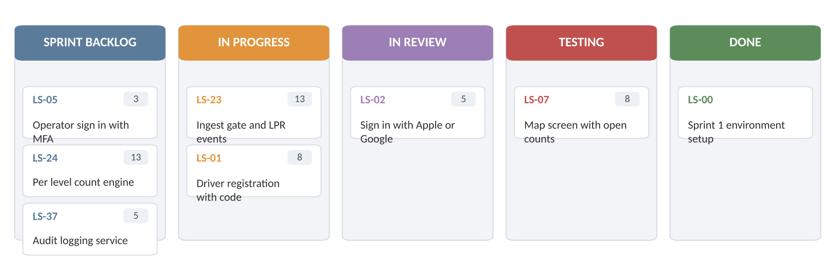
Figure 4: Sprint 1 board layout, mid sprint

8. Risk management
A risk is something that might happen. An issue is something that already has. This section covers risks, and anything that turns into an issue moves to the weekly status report.

8.1 Risks by category
At least four risks in each of the four categories we work with on this project.
ID | Risk
Technical
T1 | Gate controllers or LPR cameras at some facilities have no event API, so live counts can't be read without new hardware.
T2 | Counts drift from reality because of tailgating at the gate, motorcycles, or miscounted levels.
T3 | Payment integration fails PCI review and has to be reworked before launch.
T4 | Event day traffic exceeds what the platform can handle, and the map or booking slows to a crawl.
Schedule
S1 | The survey of 23 facilities takes longer than the 7 weeks planned, delaying the adapter work behind it.
S2 | Apple or Google rejects the first app submission, pushing the release date.
S3 | The occupancy service slips, and because it is on the critical path everything downstream moves with it.
S4 | Holiday weeks cut velocity more than the lighter sprint plan assumed.
Financial
F1 | Spot Guarantee price differences and credits cost more than budgeted if garages fill more often than expected.
F2 | Processing fees, refunds, and chargebacks come in higher than the per transaction model assumes.
F3 | Field work costs (travel, installation support, adapter hardware) exceed the estimate across 23 sites.
F4 | Scope grows through informal requests from BBGP without a change order, so work gets done unpaid.
People
P1 | The engineer who owns the adapter framework leaves or moves to another project, taking the context with them.
P2 | The BBGP operations director is unavailable for weeks, and decisions on buffers and policies stall.
P3 | Garage attendants resist the new workflow and keep waving drivers through manually, so counts go wrong.
P4 | The compressed 9 month schedule burns out the teams, and quality drops in the last two months.
Table 15: Identified risks by category

8.2 Risk register
Probability and impact are scored 1 to 5. The score is probability times impact, which puts anything at 15 or above in front of the sponsor every week, 8 to 14 in the monthly review, and below 8 on a watch list. The register is reviewed every sprint and rescored monthly.
ID | Risk | Category | P | I | Score | Response | Action | Owner
R1 | No event API at some facilities | Technical | 4 | 5 | 20 | Mitigate | Survey all 23 sites first. Build a polling adapter and a camera counting fallback. Budget for two sites needing new controllers. | Backend lead
R2 | Counts drift from actual occupancy | Technical | 3 | 4 | 12 | Mitigate | Daily reconciliation against attendant counts during the pilot. Alert when drift passes 5%. Keep the reserved buffer as a cushion. | Backend lead
R3 | Payment work fails PCI review | Technical | 2 | 5 | 10 | Transfer | Use a certified processor and keep tokenization on their side. Book an external review before the pilot. | Payments lead
R4 | Event day load exceeds capacity | Technical | 3 | 4 | 12 | Mitigate | Load test at 25,000 concurrent users in March. Auto scaling plus a read only fallback map if booking is saturated. | Backend lead
R5 | Facility survey runs long | Schedule | 4 | 3 | 12 | Mitigate | Two surveyors instead of one, starting with the three pilot garages so that work can begin before the rest is finished. | PM
R6 | Critical path slips on the occupancy service | Schedule | 3 | 5 | 15 | Mitigate | Reservation engine builds against simulated counts. Weekly critical path review. Pilot can start with 2 garages instead of 3. | PM
R7 | App store rejection | Schedule | 2 | 3 | 6 | Mitigate | Submit a TestFlight build in March, two months before the release date, and keep the privacy labels current. | Mobile lead
R8 | Holiday velocity drop | Schedule | 3 | 3 | 9 | Accept | Sprints 4 and 5 are already planned at 60% capacity. Re-forecast in January. | Scrum Masters
R9 | Spot Guarantee costs run high | Financial | 2 | 4 | 8 | Mitigate | Cap guarantee credits per facility per day. Tune the reserved buffer by site. Track cost per rebook weekly from the pilot. | Finance
R10 | Scope creep without change orders | Financial | 3 | 4 | 12 | Avoid | Anything not in the backlog goes through a written change request signed by the BBGP sponsor. | PM
R11 | Field work costs exceed estimate | Financial | 4 | 2 | 8 | Accept | Track spend per site from the first five surveys and re-forecast the rest. Budgeted at about $2,200 per facility. | PM
R12 | Key engineer leaves | People | 2 | 2 | 4 | Mitigate | Two engineers pair on the adapter framework. Architecture decisions are written down, not tribal. | Backend lead
R13 | Sponsor unavailable, decisions stall | People | 3 | 3 | 9 | Mitigate | A named backup decision maker at BBGP, and a 5 business day rule after which the PM decides and documents it. | PM
R14 | Attendants bypass the new workflow | People | 3 | 3 | 9 | Mitigate | Involve two attendants in UAT, train on site before go live, and watch for facilities with unusual manual override rates. | PM, BBGP ops
R15 | Team burnout from the compressed schedule | People | 3 | 4 | 12 | Mitigate | No crunch sprints. Track velocity and overtime in retros. Cut Could priority stories before adding hours. | Scrum Masters
Table 16: LevelSpot risk register

8.3 Risk matrix
Figure 5 plots the register on the probability and impact grid. R1 is the one that keeps me up: it is likely and it would be expensive, since live counts are the entire product. R6 sits next to it because the same work drives the critical path.
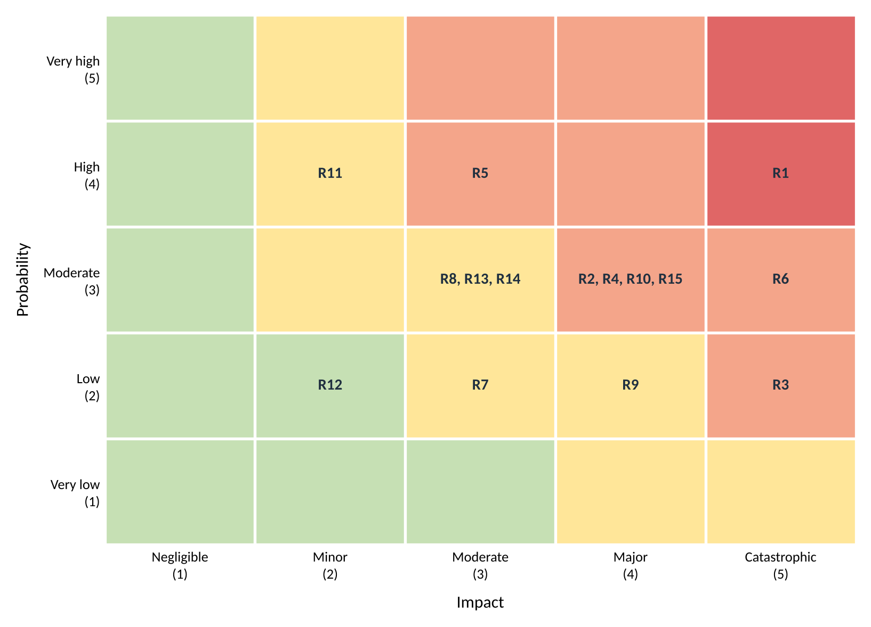
Figure 5: Probability and impact matrix for the risk register

8.4 Quality gates
Quality assurance is the process side, preventing defects. Quality control is checking the product for them. The Knight Capital failure in 2012 is the cautionary tale here: old code that was never removed got reactivated during a partial deployment, nobody had tested the production release path, and there was no rollback plan. The company lost about $440 million in half an hour.
LevelSpot touches money and physical gates, so the same class of mistake is possible. The gates we run before anything reaches production:
Gate | What has to be true
Code review | Two approvals on anything that touches payments, reservations, or gate control
Automated tests | Unit and integration suites pass in CI. Reservation and payment paths have end to end tests.
Staging soak | New builds run against a simulated garage feed for 24 hours before release
Deployment | Feature flags, one facility at a time, never on a Friday or an event day
Rollback | Every release has a tested rollback path and a named person who can trigger it
Dead code | Unused flags and code paths are removed within one sprint, not left to be reactivated later
Table 17: Quality gates before a production release

9. Communication plan
Different audiences need different things. BBGP leadership wants metrics and dates. The teams need detail. The city needs data and a heads up before anything changes in public. The plan below sets who hears what, how often, and in what format.

9.1 Meeting cadence
Meeting | Who | Cadence | Format
Daily standup | Each delivery team | Daily, 15 minutes | In person or Slack huddle
Sprint planning | Team, Scrum Master, Product Owner | Every 2 weeks, Monday | Working session on the board
Sprint review and demo | Teams plus BBGP operations director | Every 2 weeks, Friday | Live demo of working software
Retrospective | Team only | Every 2 weeks, after the review | Facilitated discussion, actions logged
Backlog refinement | Product Owner and team leads | Weekly, Wednesday | Backlog grooming, re-estimation
Stakeholder update | BBGP leadership | Weekly, Thursday | 1 to 2 minute recorded video plus a written summary
Risk review | PM, team leads, BBGP sponsor | Monthly | Register walkthrough and rescoring
Cost review | PM, finance, BBGP sponsor | Monthly | Earned value report against the baseline in Section 10
Steering committee | BBGP executives, $oftware ¢orp leadership | Monthly | Dashboard: scope, schedule, budget, top 5 risks
City briefing | Houston transportation department | Quarterly | Report plus a demo of the occupancy feed
Finance reconciliation | Finance and billing staff, Payments lead | Monthly | Payout report against processor settlements
Pilot coordination | Attendants and managers at pilot garages | Weekly during the pilot | On site walkthrough, issues logged to the Kanban board
Table 18: Meeting cadence

9.2 Reporting methods
Audience | What they get | Detail level
BBGP executives | Monthly dashboard: milestone status, budget, top risks with a red, amber, green status | High level, metrics only
BBGP operations director (sponsor) | Sprint demos, weekly video update, risk register access | Medium, decisions and tradeoffs
Delivery teams | Sprint board, burndown, defect cycle time, architecture decision records | Full detail
City transportation department | Quarterly report and the live data feed | Data and compliance
Finance and billing | Monthly reconciliation report and payout exports | Transaction level
Drivers (after launch) | Release notes in the app, service status page during incidents | Plain language
Table 19: Reporting by audience

9.3 Escalation path
A blocker that a team can't clear in one day goes to the team lead. If it isn't resolved in two business days, it goes to the PM. Anything affecting a milestone date, the budget, or a live garage goes to the BBGP sponsor the same day, and to the steering committee if it is still open after a week.
Incidents are different. Anything that stops drivers from booking, opens or locks a gate incorrectly, or charges the wrong amount gets a call, not a message, within 30 minutes, plus a status page update and a written postmortem within five business days.

10. Resource and cost management

10.1 Basis of the budget
Section 2.1 notes that $oftware ¢orp has an unlimited theoretical budget for this project. That is a planning convenience, not a reason to skip the numbers. BBGP signed for a fixed scope, finance still has to forecast cashflow, and no amount of money buys a shorter calendar. So this section prices the project as though the budget were real, which is the only version that helps anyone make a decision.
The estimate is bottom-up: every role is costed from hours and a rate, every non-labor item from a quantity and a unit price, and the totals roll up. Section 10.5 then checks that total against a top-down allocation, because two methods landing in the same place is better evidence than one method landing anywhere.
Rates are blended internal cost rates, not what BBGP is billed. All figures are US dollars.

10.2 Roles and resource plan
Twenty-one people work on LevelSpot across the ten months from kickoff to rollout. The six delivery teams from Table 4 are staffed below, plus the leadership and operations roles that work across all of them. A full time allocation is 1,600 hours, which is 40 weeks at 40 hours.
Role | Name | Skill level | FTE | Hours | Rate | Cost
Project leadership (works across all teams)
Project Manager | Ibra | Senior, 8 yrs | 100% | 1,600 | $85 | $136,000
Product Owner | Marisol Vega | Senior, 10 yrs product | 60% | 960 | $90 | $86,400
Solutions Architect | Arjun Raghunathan | Principal, 14 yrs | 50% | 800 | $110 | $88,000
Senior UX Designer | Priya Anand | Senior, 9 yrs | 75% | 1,200 | $75 | $90,000
UX Designer | Tomas Herrera | Mid, 4 yrs | 50% | 800 | $55 | $44,000
Backend/API Team
Backend Lead | Nnamdi Okafor | Senior, 11 yrs | 100% | 1,600 | $95 | $152,000
Backend Engineer, occupancy | Grace Lindqvist | Senior, 7 yrs | 100% | 1,600 | $85 | $136,000
Backend Engineer, reservations | Hector Salas | Mid, 5 yrs | 100% | 1,600 | $75 | $120,000
Backend Engineer, pricing and alerts | Yusra Khan | Mid, 3 yrs | 85% | 1,360 | $70 | $95,200
Mobile Application Team
iOS Lead | Daniel Whitfield | Senior, 8 yrs | 100% | 1,600 | $85 | $136,000
iOS Developer | Amara Boateng | Mid, 4 yrs | 85% | 1,360 | $70 | $95,200
Android Lead | Jin-woo Park | Senior, 9 yrs | 100% | 1,600 | $85 | $136,000
Android Developer | Carla Jimenez | Mid, 3 yrs | 85% | 1,360 | $70 | $95,200
Web Application Team
Web Lead, operator dashboard | Sofia Ruiz | Senior, 7 yrs | 100% | 1,600 | $85 | $136,000
Web Developer | Ethan Brahms | Mid, 4 yrs | 90% | 1,440 | $70 | $100,800
Mapping & Location Services Team
Mapping Engineer | Rahul Menon | Senior, 6 yrs | 70% | 1,120 | $85 | $95,200
Payment Integration Team
Payments Engineer | Lena Fischer | Senior, 10 yrs fintech | 65% | 1,040 | $95 | $98,800
Quality Assurance & Testing Team
QA Lead | Tunde Afolabi | Senior, 8 yrs | 100% | 1,600 | $75 | $120,000
QA Engineer | Mei-Lin Chow | Mid, 3 yrs | 90% | 1,440 | $60 | $86,400
Platform and field operations
DevOps Engineer | Oscar Delgado | Senior, 7 yrs | 60% | 960 | $90 | $86,400
Field Operations Coordinator | Bianca Morales | Mid, 5 yrs | 75% | 1,200 | $45 | $54,000
Total | 21 people | 17.4 FTE |  | 27,840 |  | $2,187,600
Table 20: Resource plan with allocations and labor cost
Three things worth saying about this roster.
It revises the Section 5.3 assumption. That section assumed 19 people and about 175 person-months. Naming everyone moved the headcount to 21 but barely moved the capacity, because five of these roles are part time. Twenty-seven thousand eight hundred and forty hours is 17.4 full time equivalents, or 174 person-months. The number that mattered for the COCOMO check held, which is reassuring; the original headcount was just the wrong way to express it.
There are no junior engineers on this project, on purpose. Most of the hard work here is integration against hardware we don't control, and the schedule is already compressed past what COCOMO says is comfortable. Junior engineers need review time that this calendar doesn't have. It costs more per hour and it is the right call, but it does concentrate knowledge in a small group, which is exactly what risk R12 is about.
The part time allocations follow the Gantt, not a spreadsheet. The architect is at 50% because the heavy design work is front loaded in October. The mapping engineer is at 70% because that work clusters around the driver apps. The field coordinator is at 75% because the surveys and the rollout bracket the project with a quiet middle.

10.3 RACI matrix
One person accountable per activity, no exceptions. Responsible is whoever does the work, Consulted is a two way conversation before the work is done, and Informed is a one way update after. Where a role both owns and performs an activity, the cell reads A/R.

Activity | PM | PO | ARCH | UX | DEV | QA | OPS | FIELD | BBGP
1. Requirements elicitation and SRS | R | A | C | C | C | I | I | C | C
2. Vision, scope, and business objectives | C | R | I | I | I | I | I | I | A
3. UX design and design system | I | A | C | R | C | C | I | I | I
4. Technical architecture and API spec | C | C | A | C | R | C | C | I | I
5. WBS, schedule, and budget | A/R | C | C | I | C | C | I | C | C
6. Sprint planning and backlog refinement | C | A | C | C | R | C | I | I | I
7. Gate vendor survey, 23 facilities | A | I | C | I | C | I | I | R | C
8. Occupancy service and gate adapters | I | C | A | I | R | C | C | C | I
9. Reservation engine and Spot Guarantee | I | A | C | I | R | C | I | I | C
10. Driver apps (iOS, Android, web) | I | A | C | C | R | C | I | I | I
11. Operator dashboard | I | A | C | C | R | C | I | I | C
12. Payment integration and payouts | I | C | A | I | R | C | I | I | C
13. Test planning and execution | I | C | C | I | R | A | I | I | I
14. Security review and PCI assessment | C | I | A | I | R | C | C | I | I
15. Accessibility audit (WCAG 2.2 AA) | I | C | C | R | C | A | I | I | I
16. Infrastructure, CI/CD, and monitoring | I | I | A | I | C | C | R | I | I
17. Release approval and go-live decision | R | C | C | I | I | C | C | I | A
18. Pilot coordination at 3 garages | R | C | I | I | C | C | I | C | A
19. Attendant training and handover | C | I | I | I | I | I | I | R | A
20. Risk register maintenance | A/R | C | C | I | C | C | C | C | C
21. Budget tracking and EVM reporting | A/R | C | I | I | I | I | I | C | C
22. Stakeholder reporting and demos | A | R | I | I | C | I | I | I | C
Table 21: RACI matrix. PM project manager, PO product owner, ARCH solutions architect, UX design, DEV delivery teams, QA quality assurance, OPS DevOps, FIELD field operations, BBGP client sponsor.
Two patterns in this matrix are deliberate. Accountability for anything the client lives with after we leave, meaning release approval, the pilot, and training, sits with BBGP rather than with us, because a go-live decision that the client did not make is a decision that gets reversed. And accountability for engineering splits between the Product Owner for scope and the Architect for technical correctness, so no deliverable ends up with two owners arguing about whose call it is.

10.4 Bottom-up cost estimate
Labor comes straight from Table 20. Everything else is costed from quantities we can point at.
Category | Basis | Amount
Labor | 21 people, 27,840 hours, blended rate $78.58/hour (Table 20) | $2,187,600
Overhead and benefits | 25% of labor: payroll taxes, benefits, office, admin | $546,900
Cloud infrastructure | AWS across two US regions, ramping from $1,200 to $7,000 per month | $39,700
Licenses and tools | Developer tooling and CI $18,000, design and collaboration $12,000, monitoring and logging $24,000 | $54,000
Third-party APIs | Mapping and geocoding $28,000, SMS and email $9,000, fraud screening $6,000 | $43,000
Hardware | 27 edge gateway units $17,600, 2 replacement gate controllers $18,000, device test lab $9,600, field laptops $4,800 | $50,000
Travel and field work | Site surveys and rollout support across 23 Houston facilities | $20,000
Legal and compliance | PCI review $35,000, penetration test $25,000, accessibility audit $12,000, contract and data sharing review $15,000 | $87,000
Training | Gate vendor SDK training $8,000, attendant training at 23 facilities $15,000 | $23,000
Subtotal before contingency |  | $3,051,200
Contingency | 15% of the subtotal, sized for the uncertainty in R1 and R6 | $457,680
Total (BAC) |  | $3,508,880
Table 22: Bottom-up cost estimate
On capital versus operating costs: almost everything here is operating expense, because the project buys very little that lasts. The $50,000 of hardware is the exception, and even that is arguably BBGP's asset rather than ours once the gateways are bolted into their garages. Who capitalizes the edge hardware is an open question for their finance team, and it is in Section 11.

10.5 Top-down cross-check
A bottom-up estimate can be confidently wrong if every line is built on the same bad assumption. So we also ran it the other way: start from a $3.5 million envelope, which is what comparable 10 month platform builds have cost the studio, and allocate by the percentages $oftware ¢orp uses on fixed-price work.
Category | Top-down % | Top-down amount | Bottom-up amount | Difference
Labor | 62% | $2,170,000 | $2,187,600 | +0.8%
Overhead and benefits | 16% | $560,000 | $546,900 | -2.3%
Direct costs | 9% | $315,000 | $316,700 | +0.5%
Contingency | 13% | $455,000 | $457,680 | +0.6%
Total | 100% | $3,500,000 | $3,508,880 | +0.3%
Table 23: Top-down allocation compared against the bottom-up detail
The two methods agree to within 0.3% overall, and no single category is off by more than 2.3%. That does not prove the estimate is right, since both methods lean on the same labor assumptions. What it does rule out is a structural mistake, like forgetting a whole category or misjudging the labor-to-everything-else ratio, which is the failure mode that actually sinks budgets.

10.6 Monthly cashflow
Spending follows the staffing ramp. September and October are light because only the leadership, design, and architecture roles are on. November through March is the full build. April is the most expensive month of the project, which surprises people: the pilot starts, and the PCI review and attendant training land at the same time.
Month | Labor | Overhead | Direct costs | Contingency | Monthly total | Cumulative
Sep 2026 | $109,400 | $27,350 | $19,700 | $23,468 | $179,918 | $179,918
Oct 2026 | $153,100 | $38,275 | $19,900 | $31,691 | $242,966 | $422,884
Nov 2026 | $218,800 | $54,700 | $26,300 | $44,970 | $344,770 | $767,654
Dec 2026 | $218,800 | $54,700 | $27,900 | $45,210 | $346,610 | $1,114,264
Jan 2027 | $262,500 | $65,625 | $30,500 | $53,794 | $412,419 | $1,526,683
Feb 2027 | $262,500 | $65,625 | $15,200 | $51,499 | $394,824 | $1,921,507
Mar 2027 | $284,400 | $71,100 | $29,200 | $57,705 | $442,405 | $2,363,912
Apr 2027 | $262,500 | $65,625 | $62,000 | $58,519 | $448,644 | $2,812,556
May 2027 | $218,800 | $54,700 | $49,250 | $48,413 | $371,163 | $3,183,719
Jun 2027 | $196,800 | $49,200 | $36,750 | $42,411 | $325,161 | $3,508,880
Total | $2,187,600 | $546,900 | $316,700 | $457,680 | $3,508,880
Table 24: Budgeted monthly cashflow, September 2026 through June 2027
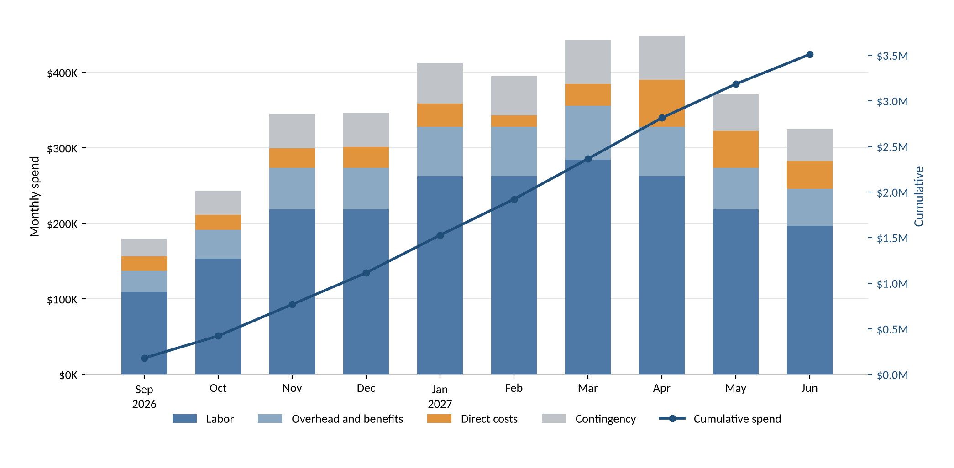
Figure 6: Monthly spend by category, with cumulative spend against the right axis
Contingency is shown spread across the months so the cashflow forecast is realistic, but it is not actually spent that way. Finance holds it centrally and releases it against a signed change request. Spreading a reserve without controlling it is how a 15% buffer quietly becomes part of the baseline by March.

10.7 Hidden costs and contingency
The line items in Table 22 are the easy part. These are the ones that get missed, and what we did about each.
Hidden cost | Why it bites | What we did about it
Cloud data egress and backups | Egress and snapshot storage are billed separately from compute and scale with map and API traffic rather than with user count. | The cloud line ramps to $7,000 a month by rollout instead of staying flat. Map tiles are cached on the device so repeat loads don't leave AWS.
Mapping API call volume | Geocoding and map loads are charged per request. At $0.005 a call, 5.6 million calls a year is $28,000, and a careless implementation geocodes on every keystroke. | $28,000 inside the API line. Entrance coordinates are geocoded once per facility and stored, not looked up per search.
SMS overage | Spot Guarantee alerts and reservation reminders go out by text, and volume spikes exactly when garages are busiest. | $9,000 for SMS and email. Push is the default channel and SMS is the fallback, which keeps per-message cost off the common path.
Per-seat license creep | Monitoring and design tools bill per seat, and seats get added quietly as teams ramp up. | Licenses are budgeted against the ramp in Table 24, not at full headcount from month 1, and seat counts are reviewed at the monthly cost review.
Technical debt | A 9 month schedule that COCOMO says should take 17 invites shortcuts, and those get paid back with interest after launch. | One sprint in four reserves capacity for cleanup, and dead code removal is a release gate in Table 17.
Gate hardware replacement | Risk R1: some facilities may have no event API at all, which turns a software integration into a hardware purchase. | $17,600 of edge gateways plus $18,000 for two replacement controllers, sized from the survey assumption.
Compliance audits | PCI review, penetration testing, and the accessibility audit are easy to leave out of an engineering budget and expensive to add late. | $87,000 as its own line, scheduled in months 7 through 9 so findings land before the pilot.
Spot Guarantee credits | Every rebook costs real money, and the cost scales with how often garages fill. | Deliberately excluded from this budget. It is an operating cost that belongs to BBGP after launch, not a build cost. Risk R9 tracks it and BO-3 caps the rate.
Table 25: Hidden costs and how the budget handles them
Contingency is set at 15%. The lecture range is 5 to 20%, and we are above the middle because two of the top risks, R1 and R6, are both unresolved and both expensive. If the facility survey comes back in November showing that every site has a usable event API, the honest move is to recommend cutting contingency to 10% and returning the difference, rather than keeping a reserve we no longer need.

10.8 Cost control and earned value
The budget in Table 24 is the baseline. From here it only changes through a signed change request, and the monthly cost review compares actuals against it using earned value. Table 26 is the first report, at the end of month 1.
Metric | Value | What it means
BAC | $3,508,880 | Budget at completion, the full baseline from Table 22
PV | $179,918 | Planned value: work scheduled through September 30
EV | $157,900 | Earned value: 4.5% of scope complete against a planned 5.1%
AC | $168,400 | Actual cost spent through September 30
SPI | 0.88 | EV / PV. Below 1, so slightly behind schedule
CPI | 0.94 | EV / AC. Below 1, so slightly over budget
EAC | $3,742,200 | BAC / CPI. Forecast total if cost performance stays where it is
ETC | $3,573,800 | EAC minus AC. Still to spend
Table 26: Earned value report at the end of month 1
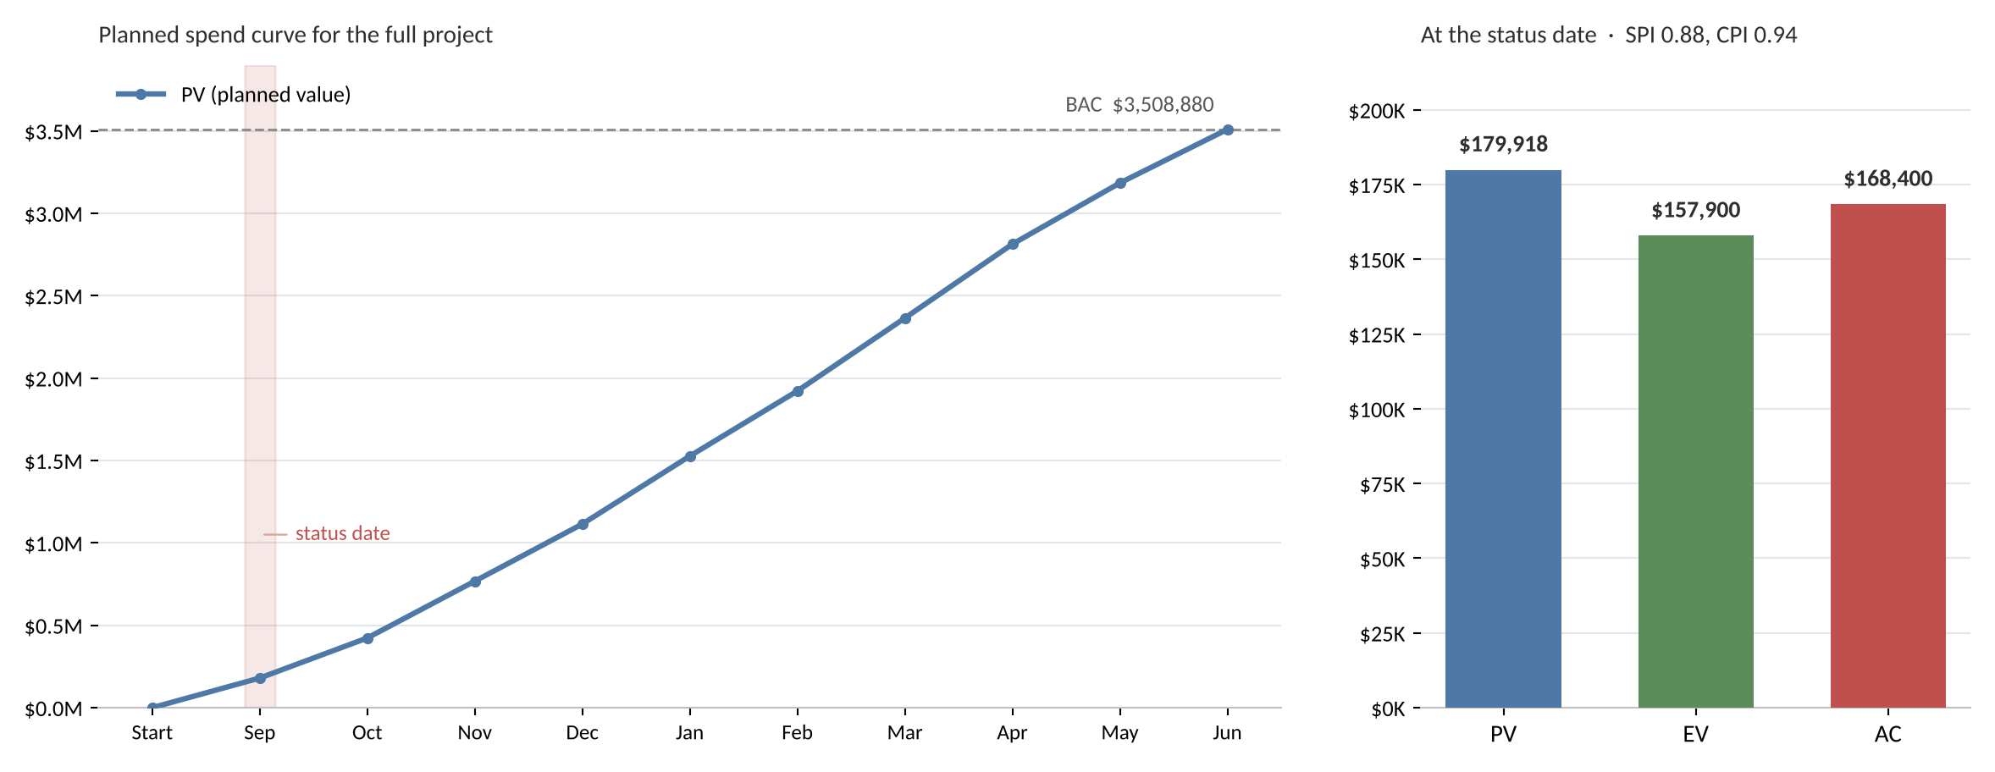
Figure 7: Planned spend curve for the project, with planned, earned, and actual value at the status date
What the numbers say. We earned 88 cents of scheduled work for every dollar planned, and 94 cents of value for every dollar spent. The cause is not mysterious: the requirements sessions with BBGP ran about a week longer than planned, which pushed design hours from September into October. That shows up as both a schedule and a cost variance in a single month.
What we are doing about it. Nothing yet, and that is a deliberate choice. One month of data on a ten month project is noise, and reacting to it would cost more than the variance. But an EAC of $3,742,200 is $233,320 over baseline, which is half the contingency, so it is not nothing either. The trigger we set with BBGP: re-forecast formally at the end of December, and escalate to the steering committee if CPI is still below 0.95 then. Reporting a number this early and then sitting on our hands is only defensible if the threshold for acting is written down in advance, which it now is.

11. Open questions for BBGP
Carried over and updated after this week's resource and cost work.
- Which gate and LPR vendors are installed at each of the 23 facilities, and do they expose entry and exit events through an API? This is the top item, since risk R1, the critical path, and the $35,600 of hardware in Table 22 all depend on the answer.
- How many spaces should each facility keep as a reserved buffer for drive-up parkers?
- When the Spot Guarantee kicks in, who covers the price difference: BBGP or the facility that takes the driver? Section 10.7 assumes this is BBGP's operating cost and not in our budget. We need that confirmed.
- Does the city want the occupancy feed only through the API, or also as a regular upload to its open data portal?
- What should the default cancellation policy be for regular days versus event days?
- Which three garages should the April pilot run at, and can BBGP commit attendant time at those sites during the pilot?
- Who is the named backup decision maker when the operations director is unavailable? The RACI in Table 21 puts BBGP accountable for release approval, the pilot, and training, so this matters more now than it did last week.
- Is the facility list final at 23? Each additional site is roughly $2,200 in edge hardware, survey time, and training, and it extends the rollout task in Table 10.
- Does BBGP's finance team want to capitalize the edge gateway hardware on their side, or should we carry it as a project expense and bill it through?

12. Sources
Sources used for the competitive research in Section 1 and the models used elsewhere:
- Uber Technologies, "Uber to Acquire Parking App SpotHero," press release, February 2026. investor.uber.com
- CNBC, "Uber acquiring parking app SpotHero as it moves beyond ride-hailing and food delivery," February 23, 2026.
- SpotHero app listing and user reviews, Google Play Store, accessed September 2026.
- Arrive, "EasyPark Group unifies under Arrive to build the world's leading global mobility platform," June 12, 2025. arrive.com
- Parking Today, "Parking Giant EasyPark Becomes Arrive After Acquiring Rights from Flash," 2025.
- City of Houston, "ParkHouston: Download the ParkHouston App," houstontx.gov/parking
- ParkMobile, "Parking in Houston," parkmobile.io
- ParkWhiz, "ParkWhiz: On-Demand Parking Introduction," help center article, 2025.
- Flash, "Demand Network" and "Parking Technology" product pages, flashparking.com
- Parking.net, "Live Nation Taps Flash's ParkWhiz as Official Parking Provider for 41 Premier Venues," August 2024.
- Barry Boehm, Software Engineering Economics, 1981, for the COCOMO model used in Section 5.3.
- U.S. Securities and Exchange Commission, administrative proceeding against Knight Capital Americas LLC, 2013, for the case referenced in Section 8.4.
- Project Management Institute, A Guide to the Project Management Body of Knowledge (PMBOK Guide), for the earned value formulas used in Section 10.8.

