CIS 4374 · Post-Mortem Analysis
The FBI's Virtual Case File
A $170 million system that was thrown away, and the replacement that proved why
Prepared by: Ibraheem Siddiqui
Course: CIS 4374, University of Houston
Date: November 5, 2026

This post-mortem covers a project not discussed in class. It is a separate document from the LevelSpot project document, as required.

1. Why this case
Most software post-mortems have the same shape: a project failed, here are the reasons, try not to do that. The reasons are usually plausible and almost never testable, because there is no version of the project that was run differently.
The FBI's Virtual Case File is the rare case that has one. The bureau tried to build a case management system, spent about $170 million over four years, and threw the result away in 2005. It then tried again, with the same mission, in the same agency, against the same requirements. The second attempt, Sentinel, spent five years going the same direction, and then in late 2010 the FBI changed who did the work and how, and finished it.
That makes this more useful than an ordinary failure story. The interesting question is not why VCF failed, which is well documented and fairly ordinary. It is what the second attempt isolates, and what it does not.

2. What was supposed to happen
By 2000 the FBI was running case work on systems built in the 1980s. Agents filed paper, and the Automated Case Support system that indexed it was old enough that searching across cases was impractical. The modernization program, Trilogy, had three parts: upgrade the network, replace the desktop hardware, and build new user applications on top.
Trilogy was originally planned as a three-year effort costing $379.8 million. By the time the Department of Justice Inspector General audited it in February 2005, total funding had reached $581.1 million.
Component | What it covered | Outcome
Information Presentation | Desktop hardware and operating software | Delivered, with cost growth
Transportation Network | Network upgrade across field offices | Delivered, with cost growth
User Applications (became VCF) | Replace the Automated Case Support system | Abandoned in April 2005 after roughly $170 million
Table 1: The three Trilogy components
The third component is the one that failed, and the September 11 attacks are a large part of why. Before 2001 the plan was to update the existing case system. After, with the bureau under pressure to show it could connect information across cases, the goal became a new case management system entirely. In December 2001 the scope expanded again, to replace all of the prior applications. Science Applications International Corporation, which had been awarded a cost-plus contract in June 2001, was now building something materially different from what it had bid.

3. What actually happened
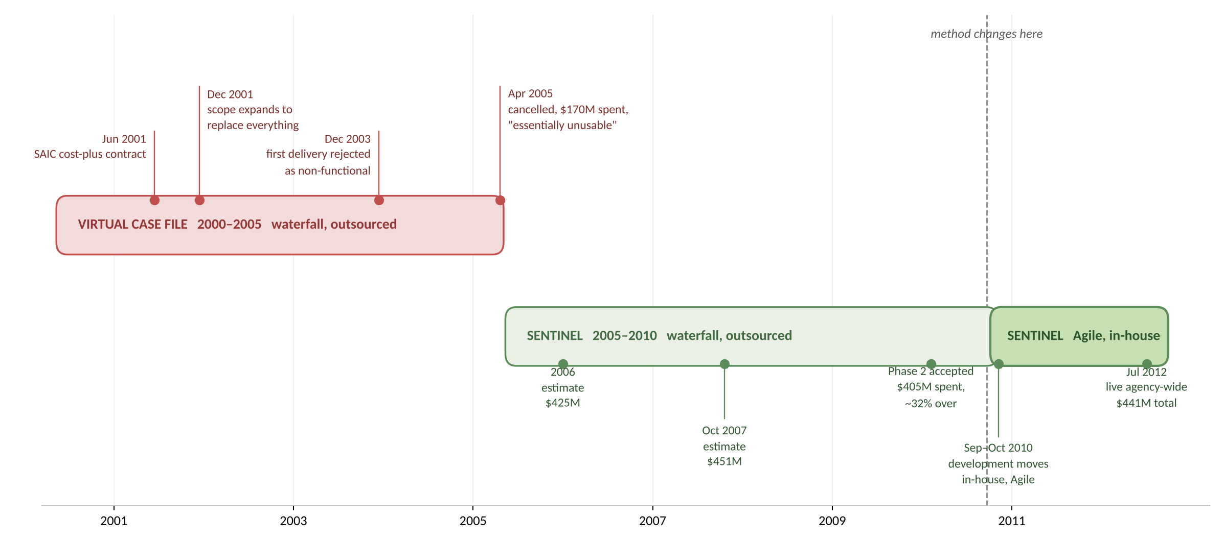
Figure 1: Virtual Case File and Sentinel, with the point where the delivery method changed
The first delivery arrived in December 2003, more than two years into development. The FBI did not accept it, because it was not functional. The schedule was revised repeatedly; two further deliveries were planned and not pursued.
In January 2005 the Aerospace Corporation delivered a 318-page independent assessment. It found the software incomplete, inadequate and poorly designed, and concluded that it was so poorly designed that it would be essentially unusable under real-world conditions. In February the Inspector General testified before the Senate. In April 2005 the FBI abandoned VCF. Of the roughly $170 million spent on it, about $104 million was a straight loss to the taxpayer.
One number is worth sitting with. By the end, the codebase had grown past 700,000 lines. None of it shipped.

4. Root causes
The Inspector General's audit and the independent assessment agree closely on the causes. They are grouped below by what a project manager could have acted on.
# | Root cause | Evidence | Who could have caught it
RC-1 | Requirements never stabilized | The IG cites "poorly defined and slowly evolving design requirements." The December 2001 scope expansion changed what was being built two years into a three-year plan. | The sponsor, by refusing scope changes without re-baselining
RC-2 | No enterprise architecture | The IG lists the absence of an enterprise architecture as a cause. There was no agreed technical structure for new work to fit into. | The architect role, which effectively did not exist
RC-3 | Management discontinuity | Three chief information officers came and went during 2003 alone. The IG cites a lack of management continuity and oversight. | The agency, by treating the role as a fixed assignment
RC-4 | Big-bang delivery | A flash cutover was planned, so nothing was usable until everything was finished. The first delivery came after more than two years and was rejected outright. | Anyone able to require incremental acceptance
RC-5 | Contract and incentive structure | A cost-plus contract awarded before the requirements settled. The IG cites contracting weaknesses among the causes of cost growth. | Contracting, by tying payment to accepted increments
RC-6 | Domain expertise gap | The assessment describes micromanagement of developers by FBI managers, many with little or no computer science training. | The agency, by staffing technical oversight technically
Table 2: Root causes of the Virtual Case File failure
RC-4 is the one that makes the others fatal. Requirements churn, architectural drift and management turnover are common on large programs and are usually survivable. What made them unsurvivable here is that nothing was delivered for more than two years, so none of those problems produced visible consequences while they were still cheap to fix. The project had no mechanism for finding out it was wrong.

5. The second attempt
Sentinel was announced in March 2005, the month before VCF was formally abandoned, with Lockheed Martin as prime contractor. It was estimated at $425 million in 2006 and revised to $451 million in October 2007. The original schedule targeted completion in December 2009.
It did not go well. By the time Phase 2 was accepted, the FBI had spent roughly $405 million, about 32 percent over budget at that point, with the system still not delivered. The schedule slipped repeatedly.
In September 2010 the FBI announced that the remaining development would be managed directly by its own Information Technology Engineering Division rather than by the contractor. Development restarted on October 18, 2010 using Scrum. Go-live began on May 29, 2012, and Sentinel was available to all users on July 1, 2012.
The FBI's July 2012 report to Congress put the total at $441 million, $10 million below available funding.

5.1 The part that usually gets left out
That last sentence is where most retellings of this story stop, and it is where a post-mortem has to be careful, because the Inspector General did not accept the figure at face value.
Claim | The qualification
Completed for $441 million, under the $451 million available | The OIG noted the figure excludes roughly $60 million for two years of operations and maintenance and roughly $30 million in FBI employee costs. The FBI disputed the operations and maintenance point, saying five years of it were funded inside the $451 million.
Agile delivered where waterfall could not | Agile adoption coincided with moving development in-house and with a reduced remaining scope. Three variables changed at once, so the method cannot be isolated as the cause.
Sentinel was a success | It was delivered. It was also about two and a half years later than its original December 2009 target, and it followed a program that had already written off $104 million.
Table 3: What the Sentinel turnaround does and does not demonstrate
A post-mortem that reports the headline and skips the footnote is advocacy, not analysis. The honest version is narrower and more useful.

5.2 What the comparison actually supports
Three things changed in late 2010: the development method, the employer of the developers, and the amount of scope remaining. Any of the three could carry the result, and no evidence here separates them.
What the comparison does support is something more specific than "Agile works." VCF ran for more than two years before producing anything the client could evaluate, and when it finally did, the answer was that the whole thing was unusable. Sentinel after October 2010 produced working increments on a scale of weeks. The variable that changed most sharply was the interval between building something and finding out whether it was right.
That reframing matters, because the interval is controllable without adopting any particular methodology. A waterfall project with quarterly working releases would have caught VCF's problems in 2002.

6. What monitoring should have caught
VCF was not unmonitored. It was audited, testified about, and reported to Congress repeatedly. It still ran for four years. The reporting measured the wrong things.
What was tracked | What it actually told anyone | What would have told the truth
Schedule against milestones | Whether dates were being met, which they were not, repeatedly, with no consequence | Working software accepted by users, counted per quarter
Spend against budget | How much had been consumed, not what had been produced for it | Earned value: cost per unit of accepted functionality
Lines of code | Output. The codebase passed 700,000 lines and none of it shipped. | Functionality demonstrated to agents in their own workflow
Contract deliverable dates | When documents were due | Whether the last increment was usable
Table 4: Monitoring that did not monitor anything useful
The general form of this failure: every metric tracked effort or time, and none tracked whether the thing worked. A project can hit all of them and still be building something nobody can use, which is precisely what happened.

7. Lessons carried into LevelSpot
The LevelSpot project document records its own lessons in Section 14.7. Four of them have a direct parallel here, which is the reason this case was chosen.
LevelSpot lesson | The VCF parallel
L3: schedule the work that can invalidate the design before design sign-off | Our facility survey found a fatal architectural assumption in week 6 and cost two weeks and $190,900. VCF's equivalent discovery arrived in year three and cost the project. Same class of mistake, different feedback interval.
L8: pre-plan the mitigation for the top risks | VCF had no fallback when the first delivery was rejected in December 2003. The schedule was simply revised. Having nothing prepared is how a bad delivery becomes two more years.
Risk R10: scope creep without change orders | The December 2001 expansion changed what was being built without re-baselining what it would cost or when it would land. LevelSpot's response to its own scope change was a signed change request in two days.
Risk R13: sponsor unavailable, decisions stall | Three CIOs in one year is the extreme version. LevelSpot's answer, a named backup decision maker and a five business day rule, exists because decisions that wait are decisions that drift.
Table 5: VCF lessons mapped to the LevelSpot project
The one that does not map cleanly is RC-6, the expertise gap. LevelSpot does not have FBI managers with no computer science background directing engineers. It does have a related exposure, which is that the client owns operational knowledge we do not, and three of the first nine facility capacity figures they supplied were wrong by more than 10 percent. The direction of the gap is reversed, and the discipline is the same: verify what the other side tells you before designing against it.

8. Conclusion
The Virtual Case File is usually taught as a requirements failure or a contracting failure, and it was both. But requirements churn and weak contracts are survivable conditions; plenty of delivered systems had them. What made this one fatal was that four years passed between starting and finding out, and by then $104 million was gone and the only honest option was to throw the work away.
The Sentinel comparison is tempting to read as proof that Agile works, and it does not prove that. Too much changed at once, and the under-budget claim carries a real qualification from the Inspector General. What it does show is narrower and harder to argue with: the FBI stopped failing at this when it shortened the time between building something and learning whether it was right.
For a project manager, that is the transferable part, because the feedback interval is a scheduling decision rather than a philosophical one. It can be shortened inside any methodology, and it costs almost nothing to shorten early.

9. Sources
- U.S. Department of Justice, Office of the Inspector General, "The Federal Bureau of Investigation's Management of the Trilogy Information Technology Modernization Project," Audit Report 05-07, February 2005. oig.justice.gov
- U.S. Department of Justice, Office of the Inspector General, "Interim Report on the Federal Bureau of Investigation's Implementation of the Sentinel Project," 2012. oversight.gov
- Federal Bureau of Investigation, report to Congress on Sentinel, July 2012, as cited in the OIG interim report.
- The Aerospace Corporation, independent assessment of the Virtual Case File, January 2005, as cited in the OIG report and contemporaneous reporting.
- "Virtual Case File," Wikipedia, used for timeline corroboration and secondary synthesis; primary figures taken from the OIG reports above.
- Knorr, Eric, "Anatomy of an IT disaster: How the FBI blew it," InfoWorld, 2005.

