|  |  |  |
| --- | --- | --- |
| INPUT | OUTPUT | PROCESSING |
| All fruits that he bought.  Their prices.  How much money does he have. | Total money that he has to pay.  His change. | Calculate the total price of each product.  Calculate the change. |

**IPO**

**PSEUDOCODE**

Start

Print “How many onions did you buy [in kg]: ”

Input O

Print “What is its price?”

Input PriceO

Print “How many apricots did you buy [in kg]: ”

Input A

Print “What is its price?”

Input PriceA

Print “How many grapes did you buy [in kg]: ”

Input G

Print “What is its price?”

Input PriceG

Print “How many tomatoes did you buy [in kg]: ”

Input T

Print “What is its price?”

Input PriceT

Total_Price = O*PriceO + A*PriceA + G*PriceG + T*PriceT

Print “Your Total Price is” Total_Price

Print “How much money do you have:”

Input Money

Change = Money – Total_Price

Print “Your Change is:” Change

End

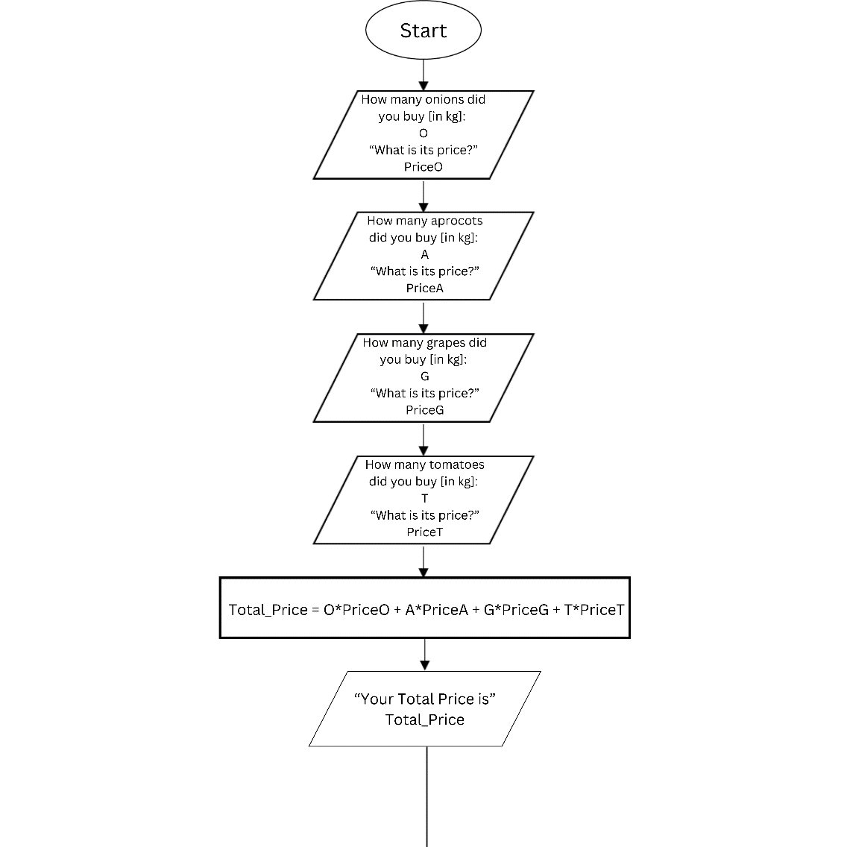**FLOWCHART**

