|  |  |  |
| --- | --- | --- |
| INPUT | OUTPUT | PROCESSING |
| All fruits that he bought.  Their prices.  How much money does he have. | Total money that he has to pay.  His change. | Calculate the total price of each product.  Calculate the change. |

**IPO**

**PSEUDOCODE**

Start

Print “input the type of plant [W for Wheat, C for Corn, R for Rice]”

Input T // assuming the correct data is entered.

Print “input the moisture %”

Input M

Print “how many hours before the last rain”

Input H

If T = W && M < 30 && H >=24

Then Print “irrigation Yes”

Else If T = C && M < 40

Then Print “irrigation Yes”

Else If T = R && M < 25

Then Print “irrigation Yes”

End If

End

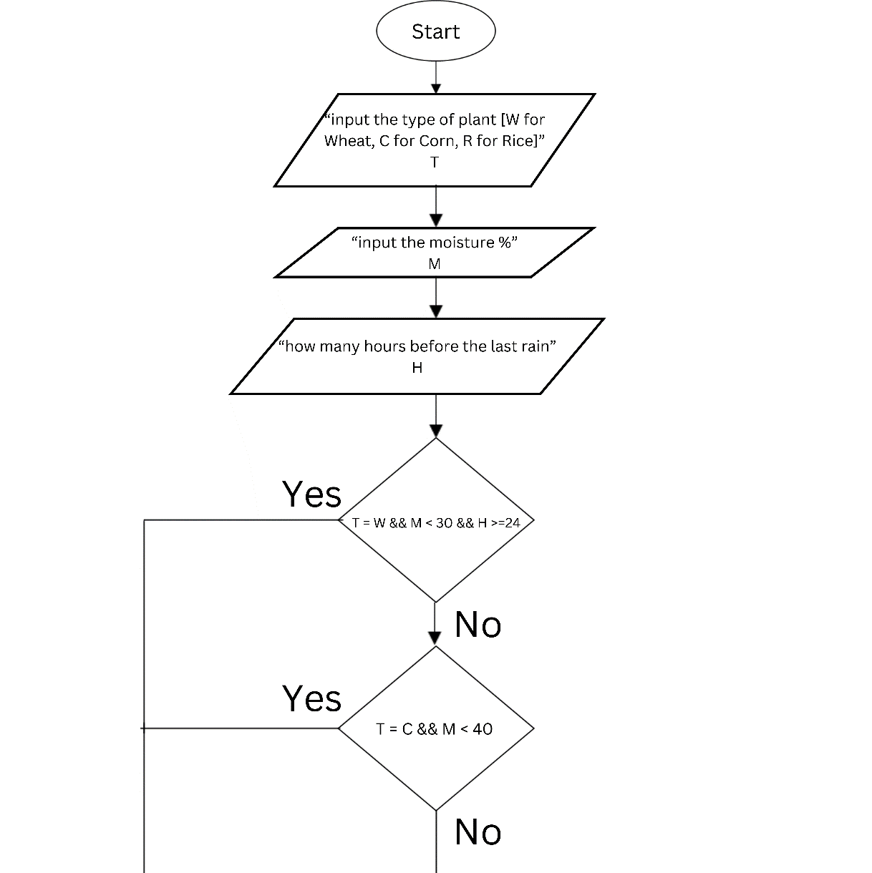**FLOWCHART**

