|  |  |  |
| --- | --- | --- |
| INPUT | OUTPUT | PROCESSING |
| Input the age, the height and the ride. | Whether they are applicable or not. | Compare the height and age requirements against the given requirements. |

**IPO**

**PSEUDOCODE**

Start

Print “input your height in inches:”

Input H

Print “input your age in years:”

Input A

Print “input your choice of ride [D for Dragon Roller Coaster, S for Sky

Swing, C for Carousal]”

Input R

If R = D && H = 48 && A = 10

Then Print “You can ride Dragon Coaster”

Else If R = S && H = 54

Then Print “You can ride Sky Swing”

Else If R = C && A = 5

Then Print “You can ride the Carousal”

Else Print “You donot meet the demands”

End If

End

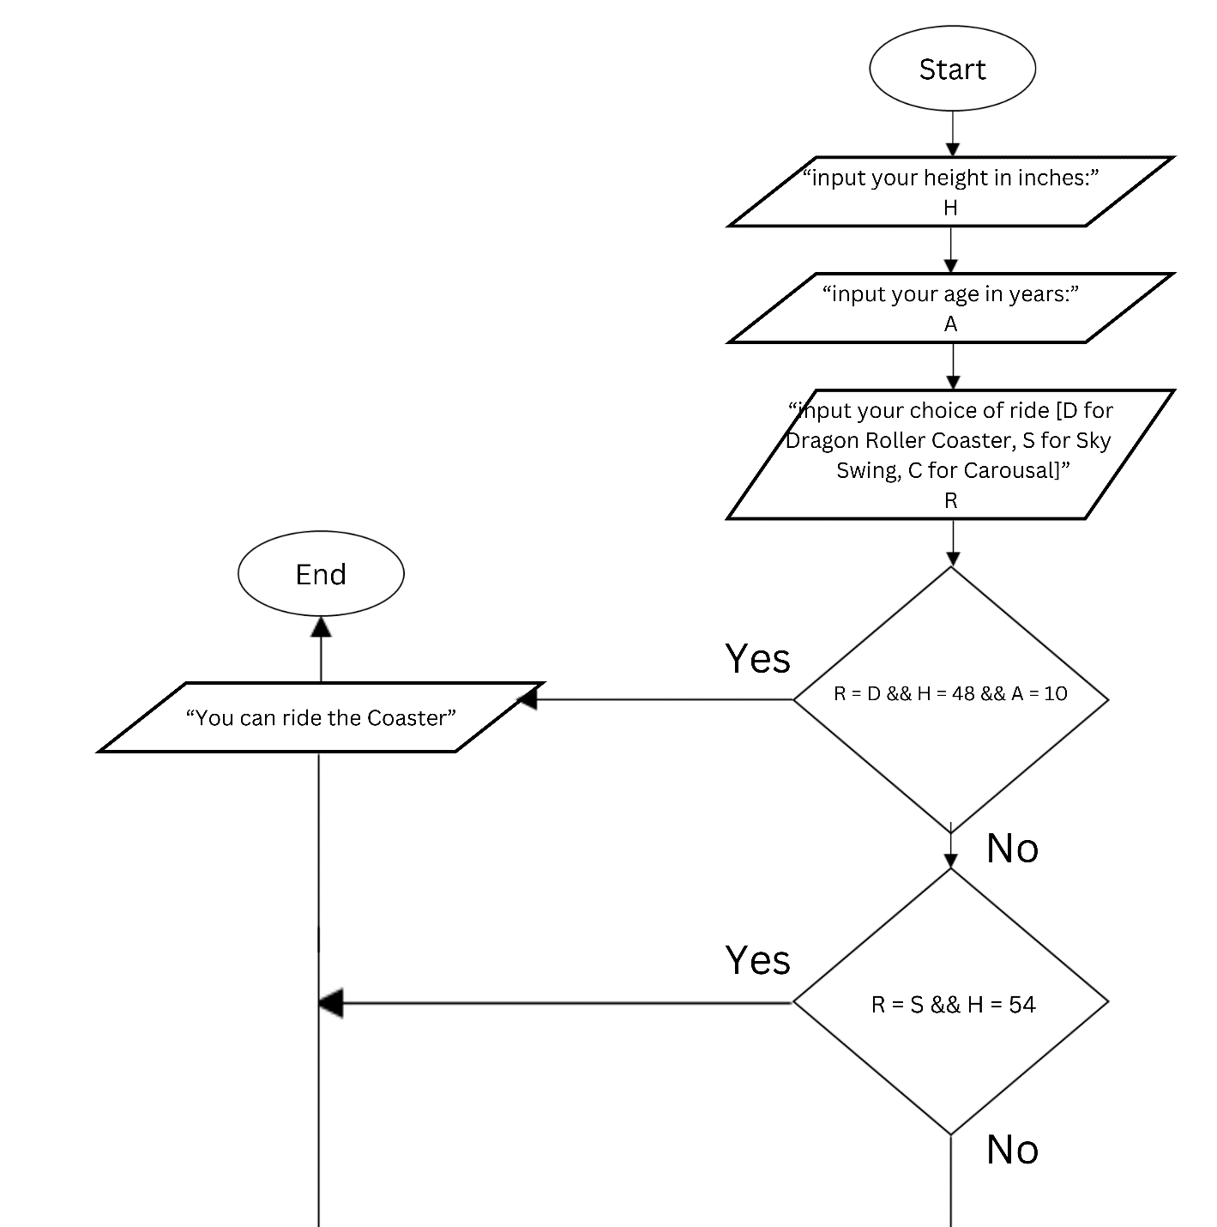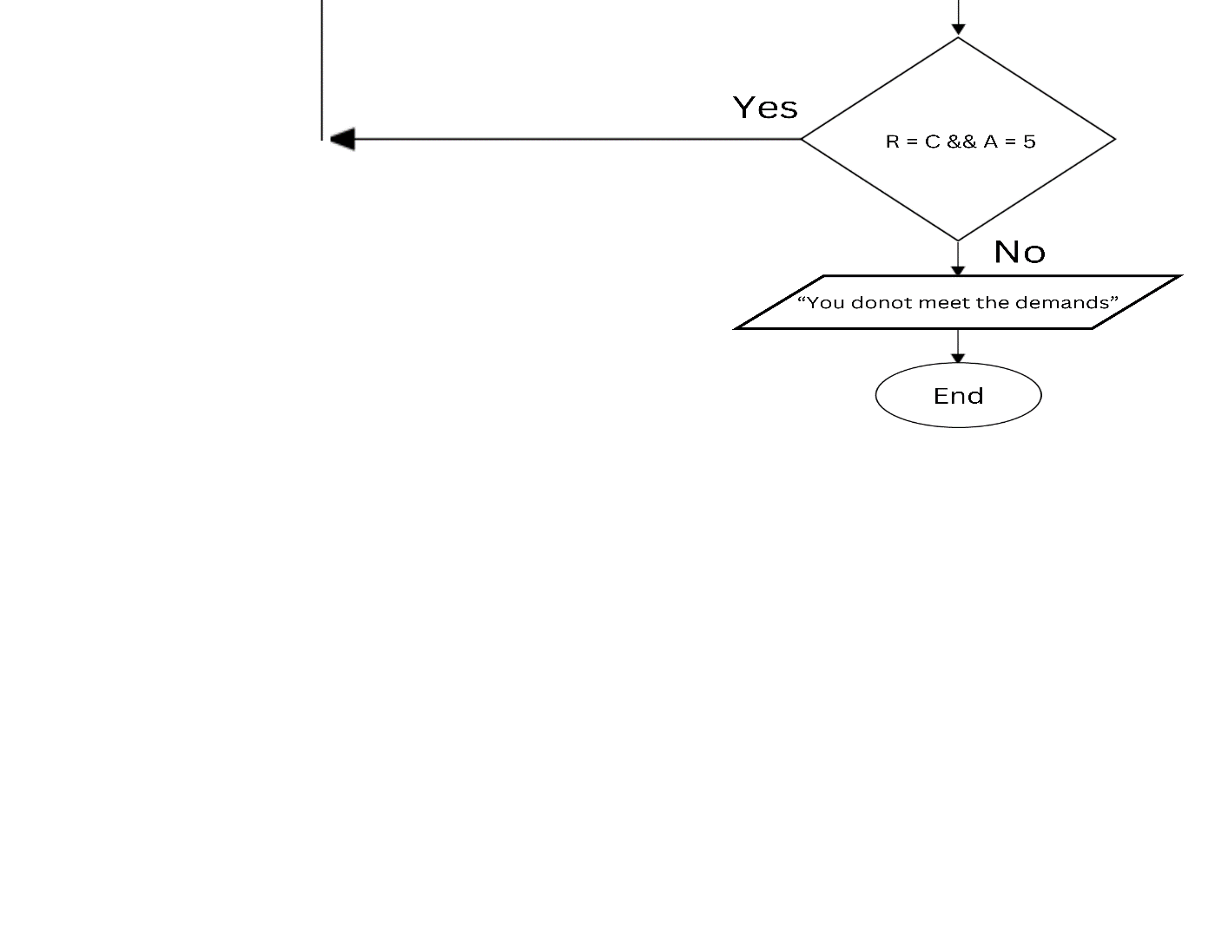**FLOWCHART**