|  |  |  |
| --- | --- | --- |
| INPUT | OUTPUT | PROCESSING |
| Input the binary code | Output the number | Compare the given number against the stored value. |

**IPO**

**PSEUDOCODE**

Start

Print “input your code”  
 Input Code

If Code = 1111110

Then Print “0”

Else If Code = 0110000

Then Print “1”

Else If Code = 1101101

Then Print “2”

Else If Code = 1111001

Then Print “3”

Else If Code = 0110011

Then Print “4”

Else If Code = 1011010

Then Print “5”

Else If Code = 1011111

Then Print “6”

Else If Code = 1110000

Then Print “7”

Else If Code = 1111111

Then Print “8”

Else If Code = 1110011

Then Print “9”

Else Print “invalid”

End If

End

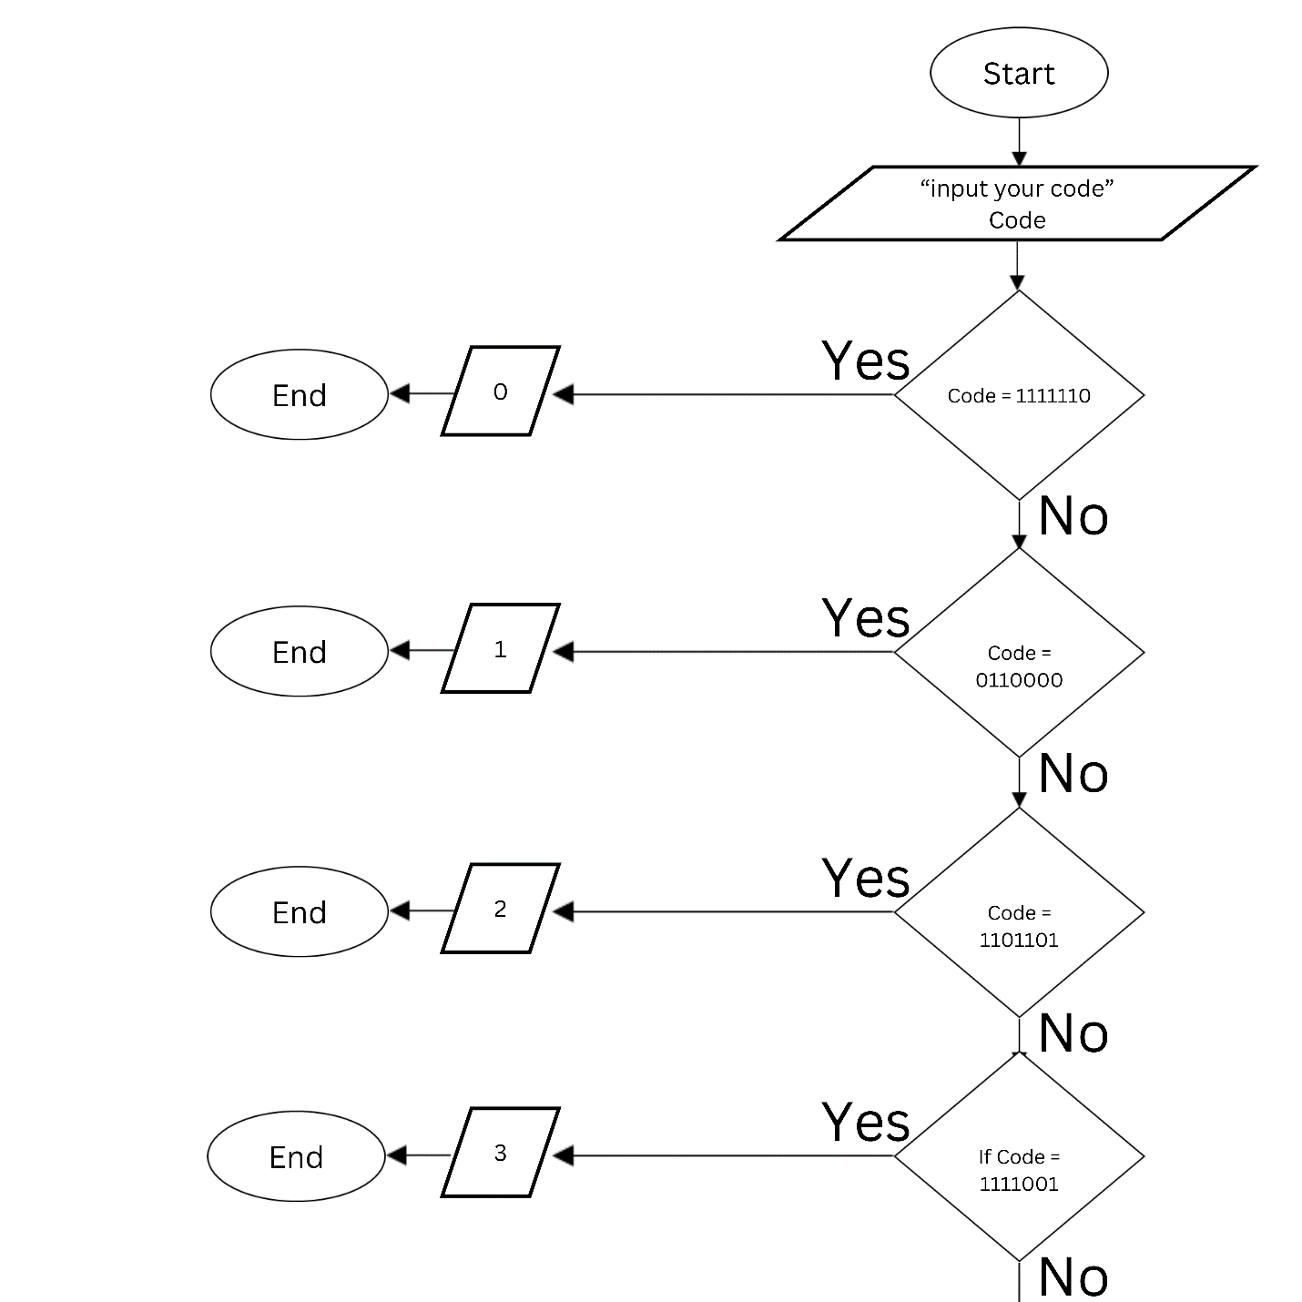**FLOWCHART**

