📚 Boon Academy
Intervention Command Center
System Architecture Diagram

A single-page visual map of every component in the system and how data flows between them — from the raw CSV files through the pipeline, into the database, and out to the Streamlit app facilitators and admins use.

System Architecture
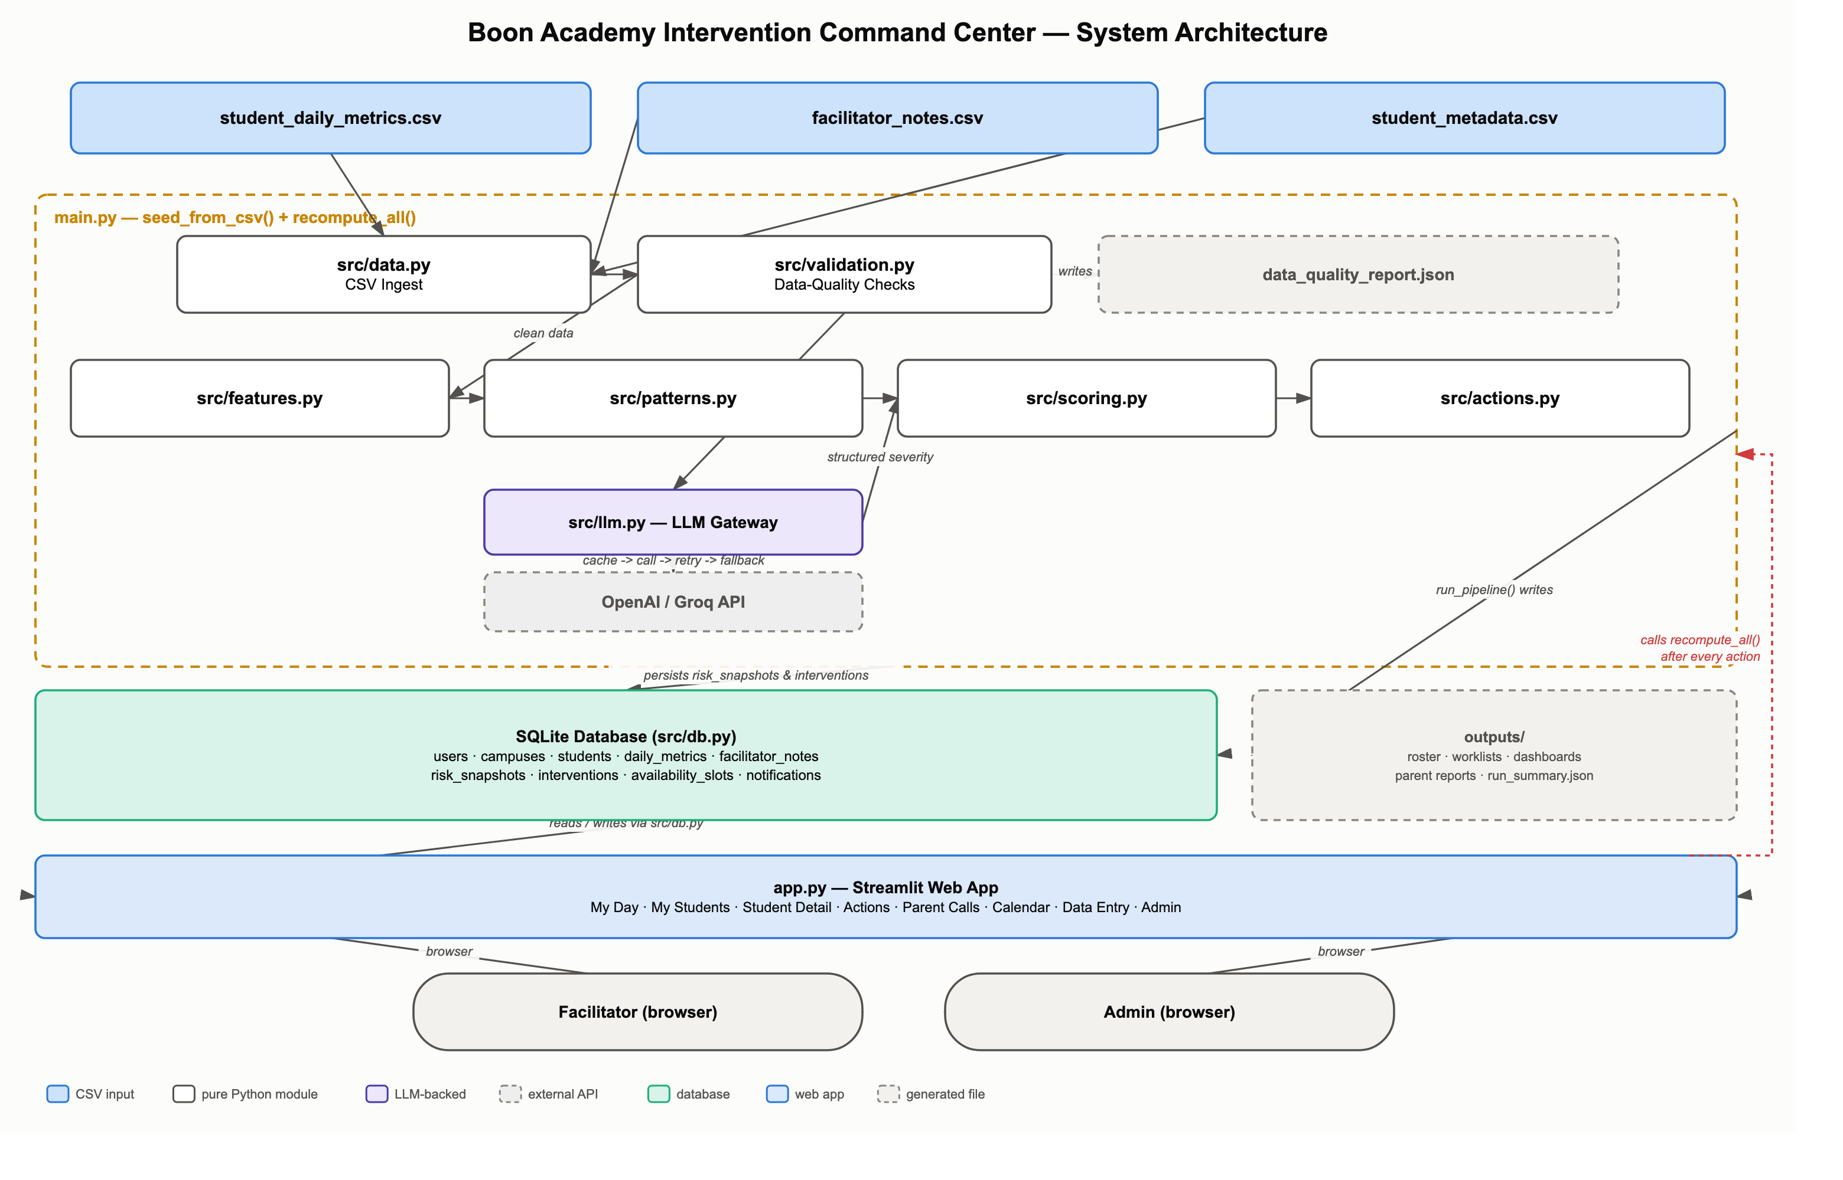
An editable version of this exact diagram is included alongside this document as docs/architecture.drawio — open it at app.diagrams.net (File → Open From → Device) or in the draw.io desktop app to move boxes, add detail, or export it in another format.

How to Read It

Shapes and colors
Shape / color | Meaning
Blue rectangle | A raw CSV input file (student_daily_metrics.csv, facilitator_notes.csv, student_metadata.csv).
White rectangle | A pure Python module in src/ — deterministic, no LLM or network calls.
Violet rectangle | src/llm.py — the one module that talks to the AI provider.
Dashed gray rectangle | A generated file/artifact, or an external system (the AI API) — not code that lives in this repository.
Green rectangle | The SQLite database — the durable state everything else reads and writes.
Light-blue wide rectangle | app.py — the Streamlit web app facilitators and admins use.
Rounded pill | A person (facilitator or admin) using a browser.
Dashed amber outline | A grouping box: everything inside it is orchestrated by main.py.
Red dashed line | The feedback loop: the live app re-triggers the same pipeline logic after every action, so nothing is ever stale.

Walking through the flow
- Three CSV files are the only input. src/data.py loads them; src/validation.py checks them for problems (missing attendance, invalid phone numbers, note-ownership mismatches, ...) and writes data_quality_report.json — flagging issues rather than silently fixing them.
- Clean data flows through src/features.py (per-student measurements) → src/patterns.py (13 deterministic behavioral rules) → src/scoring.py (the risk/priority formula) → src/actions.py (the one recommended action per student).
- Trusted facilitator notes are sent to src/llm.py, which calls the configured AI provider (OpenAI or Groq, swappable via one environment variable) with a cache → retry → deterministic-fallback path, and returns a validated severity classification back into scoring — never raw text, and never used for the numeric score itself.
- All of this is orchestrated by main.py, which persists the results (risk snapshots, recommended interventions) to the SQLite database and writes the outputs/ folder (roster, worklists, dashboards, parent reports) during a full pipeline run.
- app.py (Streamlit) reads and writes that same database, and — this is the important feedback loop shown in red — calls main.py's recompute_all() again after every single facilitator action (a note, a completed intervention, a manual metric), so the app is never running on stale numbers.
- Facilitators and admins reach the app through an ordinary browser; the app itself is the only thing they interact with directly.

