Quran Academy

Database class project 2022/2023

|  |  |  |  |  |
| --- | --- | --- | --- | --- |
| Student Name in English | Student Name in Arabic | Student ID | Section | Work percentage |
| Abbas Dweikat | عباس دويكات | 12011080 |  | 50% |
| Ibrahim Qadi | إبراهيم قاضي | 12028539 |  | 50% |
|  |  |  |  |  |

Date/time

---------------------------------------------This section is intended for the Instructor---------------------------------------

|  |  |
| --- | --- |
| **Topic** | **Mark** |
| Project Requirements and Modeling |  |
| Correctness of Database mapping |  |
| Functional Dependency and Normalization |  |
| Project Tools |  |
| Project Discussion |  |
| Project Completeness |  |
| Project Output Results or reporting (JasperReport, charts, graphs, etc.) |  |
| Project Administration and Management |  |
| Project Report |  |
| Project Idea |  |
| Project Complexity |  |
| Team work |  |
|  |  |
|  |  |
|  |  |

Abstract : 3

Introduction : 3

Project requirement : 4

All the Functional Dependency of your project 5

UML : 6

BCNF, normalization process 6

Tools used in the project : 7

discussion about GUI 8

Conclusion: 22

References: 22

# Abstract:

A simple project that talks about students memorizing the Quran.

The students and the supervisors are in the centers; each center is in a mosque, and the supervisors read and explain to the students.

Students recite what they have memorized on a set schedule, and supervisors write a mark for the students.

# Introduction:

As the number of students increases, keeping student grades and information on paper or on a single device becomes difficult.

Therefore, we turned to a database system. Where speed, accessibility, and high capabilities.

The Qur'an courses were divided into parts.

The center is located in a specific mosque.

Each center contains students and supervisors.

Students recite what they have memorized, and supervisors record students' grades

The moderators also read and explain to the students.

Our project prints grade reports for each student as well as their memorization rate and revision rate.

# Project requirement:

• The Academy is organized in centers. Each center has a unique identifier, name, address, and working days.

The database tracks two types of people:

Supervisor and students. A person can only belong to one of them. Each person has a name, unique identity, date of birth, phone number, address, and password.

• Each supervisor has several students in his group.

• Each person belongs and works for one center only.

The supervisor manages and teaches the Holy Qur’an to students.

Each student has one supervisor.

• Every student has a marks report. Each report has memorize surah, memorize range, memorize mark, review surah, review range, review mark and report date.

# 

# All the Functional Dependency of the project:

**Functional dependency of student table:**

ID -> name, birthdate, address, phone number, password, student supervisor id, student center id

Therefore, the id is the candidate key for student table.

**Functional dependency of supervisor table:**

ID -> name, birthdate, address, phone number, password, supervisor center id

Therefore, the id is the candidate key for supervisor table.

**Functional dependency of center table:**

ID -> address, working days

Therefore, the id is the candidate key for center table.

**Functional dependency of report table:**

Student id and index -> memorize surah, memorize range, memorize mark.

Student id and index -> review surah, review range, review mark.

Student id and index -> report date, supervisor id.

So student id and index are the composite candidate key for report table.

# UML model:

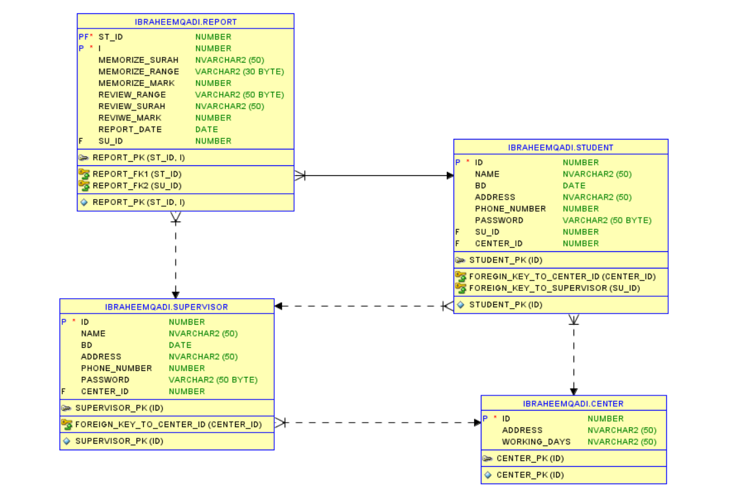

# BCNF, normalization process:

All our tables applies:

1- 1NF, each intersection of every column and row has one value.

2- 2NF, some tables do not have composite primary key, and report table applies the 2nf.

3- 3NF, because all primary keys implies all other attributes directly (no transitivity).

After we check these three rules, we can find that every determinant is a candidate key so all tables applies the BCNF.

# Tools used in the project:

1- IntelliJ IDEA 2022.2.3.

2- Draw.io.

3- Scene Builder.

4- fontawesomefx-8.2(.jar).

5- SQL Developer.

6- Data modeler oracle SQL developer.

7- Jasper soft studio and jasper Report.

# Discussion about GUI

1- Login Interface:

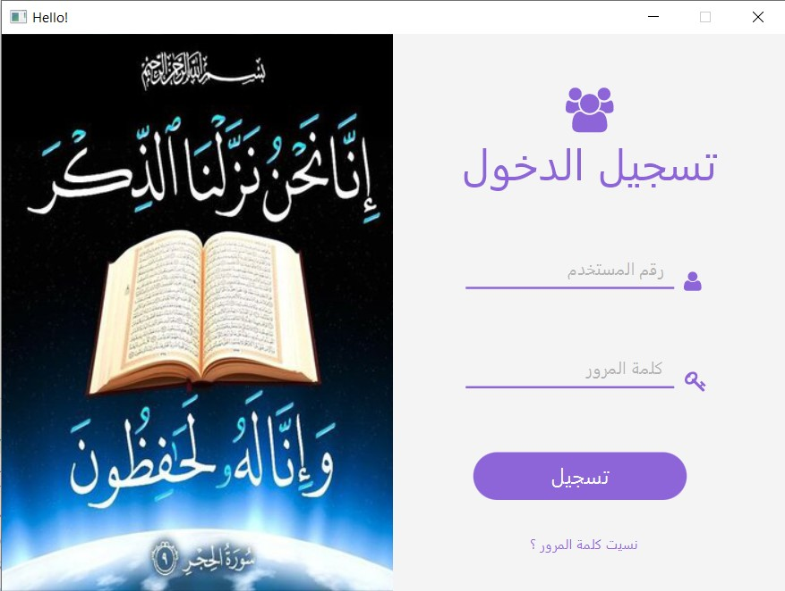The user is required to enter his ID and password.

The ID consists of four digits.

The first digit indicates if he is a supervisor or a student.

If the first digit is 1: This indicates that he is a student.

If the first digit is 2: this indicates that he is a supervisor.

There is a special case in this interface, which is admin,

Where his ID is 1234 his password is admin, and his job is to create centers, supervisors, and students (We will talk about it in detail later).When we click on the login button, it checks if the student or supervisor is actually in the database first to show its interface.

There is also another button, which is for forgetting the password. (We will talk about it in detail later)

- Forgot your password interface

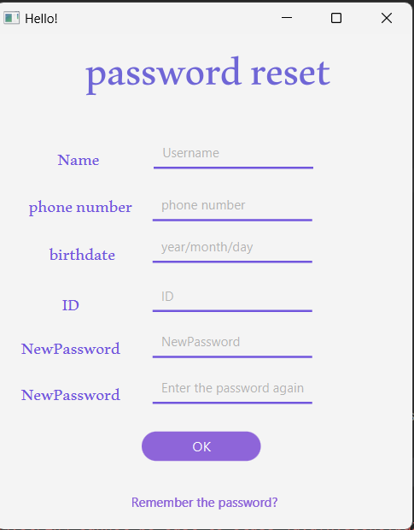

It requires the user in this interface to enter some of his information to ensure

That he is already in the database and that the information he entered is correct.

Moreover, if it is confirmed, he will enter the new password twice, in order to be able to re-enter his account again.

2- Admin interface (Only one account):

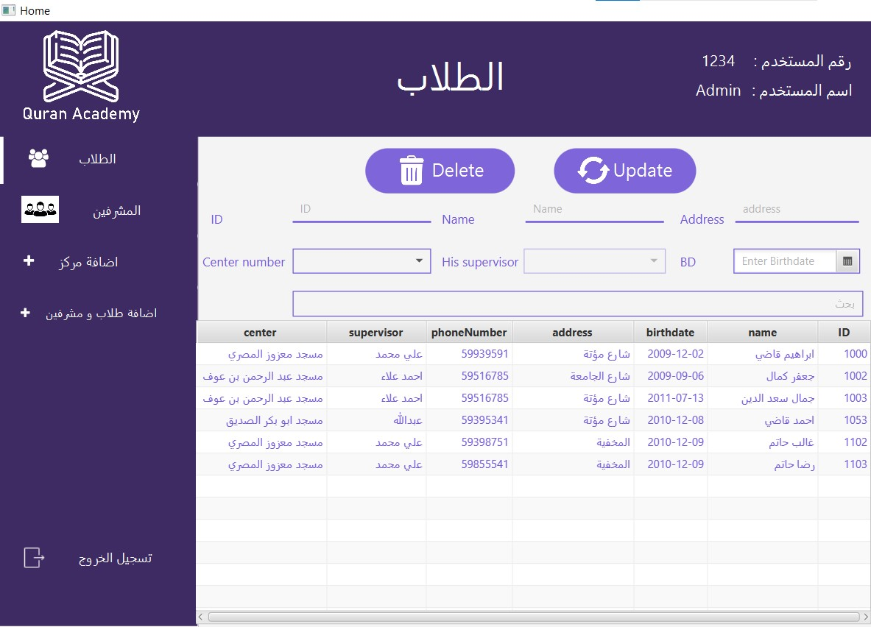

The first thing that will open in the interface is the Students page.

Where the table shows all the students present in all centers and some of their information also appears.

The administrator adds students and supervisors, deletes them, modifies their information, and creates centers.

There is an advanced search box, "Search Bar", which is used to search in the table using any attribute (see the next screen shots). For the other text fields, it used to update certain information using the student id.

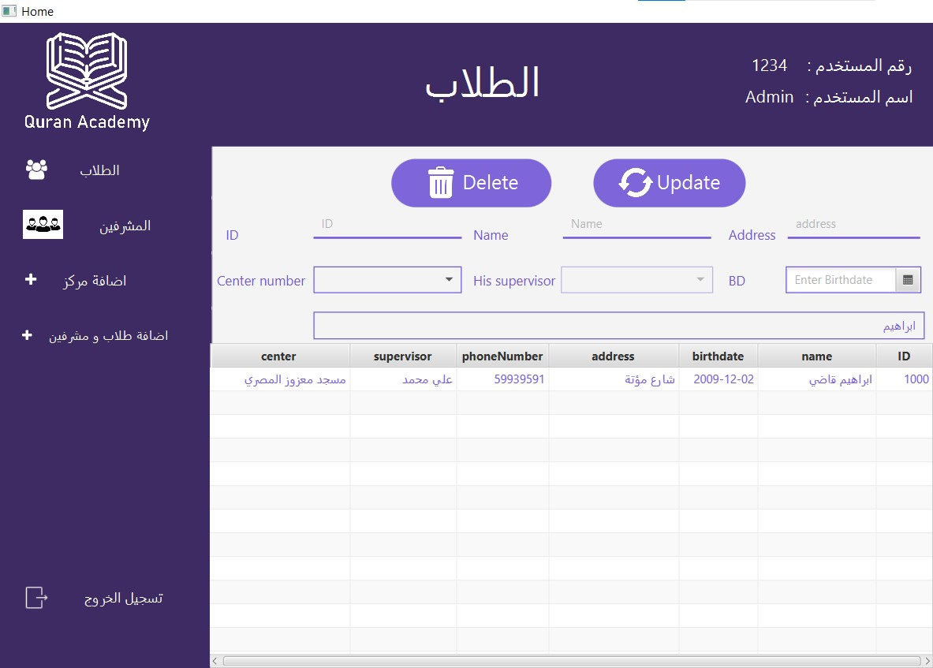

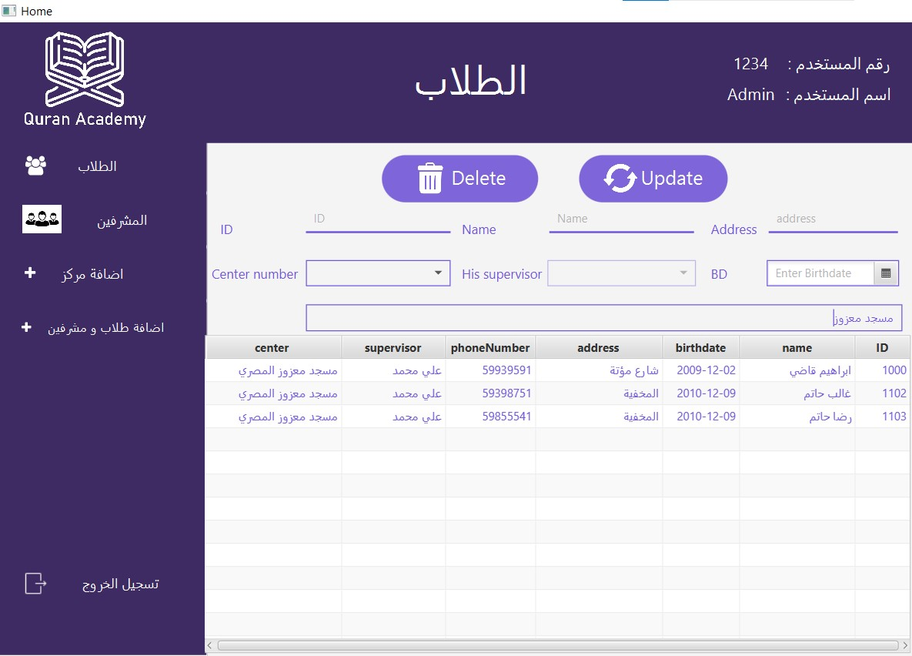

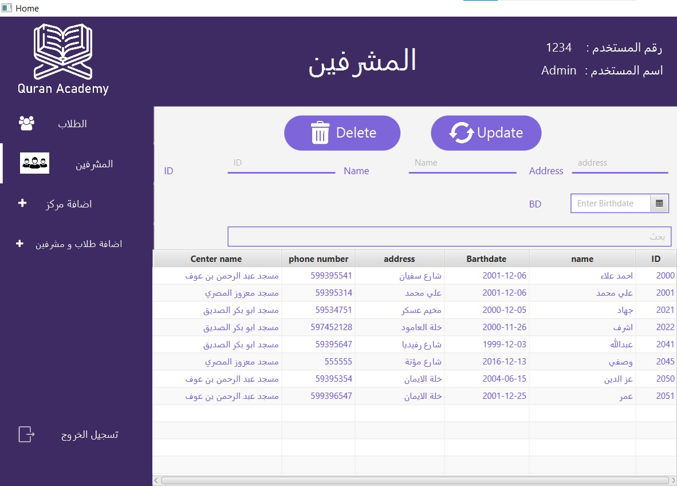

When the supervisor button is clicked, he will be taken to a screen containing a table similar to the students table.

It contains all supervisors present in all centers.

Where the administrator can change, delete and search the information of supervisors.

------------------------------------------------------------------------------------------------------------

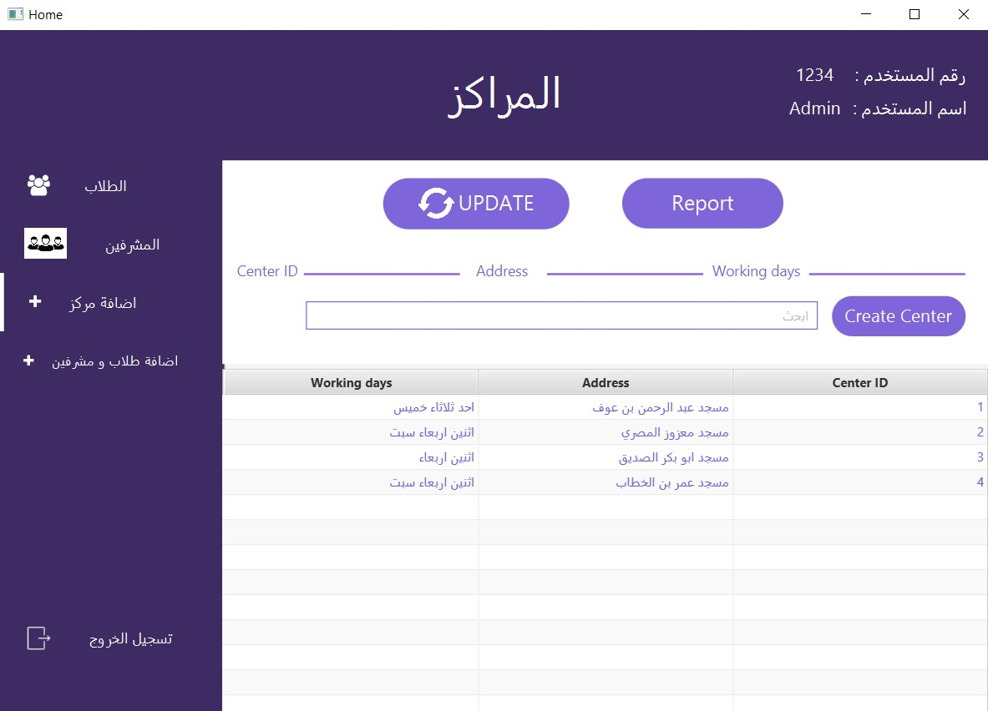

When you click the Create Center button. The center creation page will appear, which contain information about existing centers

There is an advanced search button, "Search Bar”, here the admin can create centers and search for them only.

He cannot modify or delete the center number because this will lead to some problems in the schedule of the student and the supervisor. (This is how we assumed that he could not modify and delete).

He can only modify the name of the center and its working days propriety.

------------------------------------------------------------------------------------------------------------

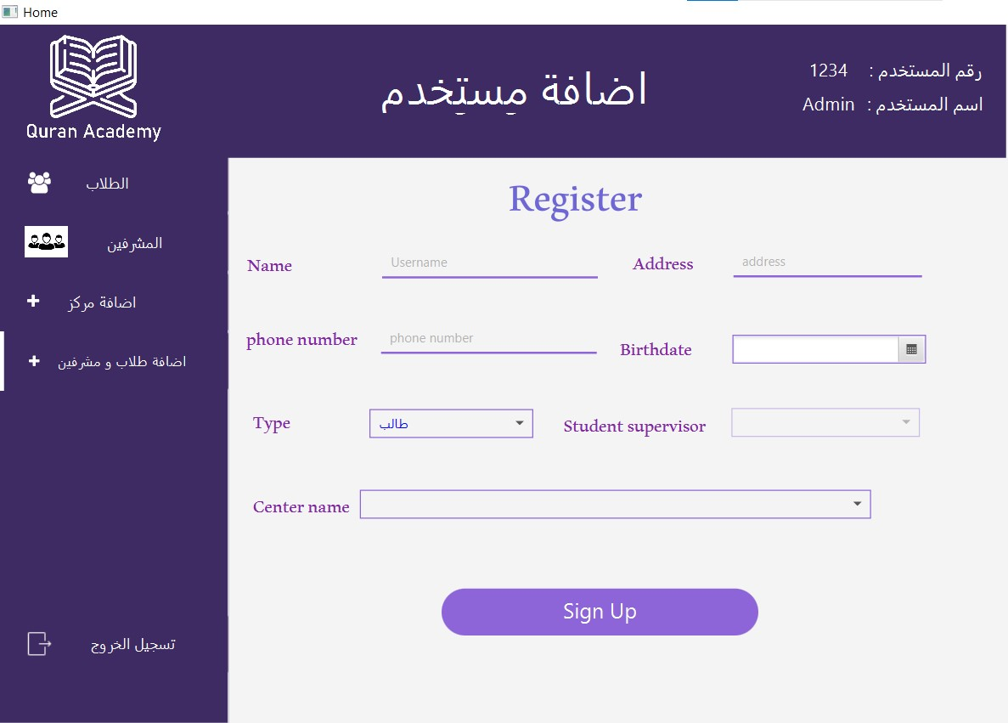

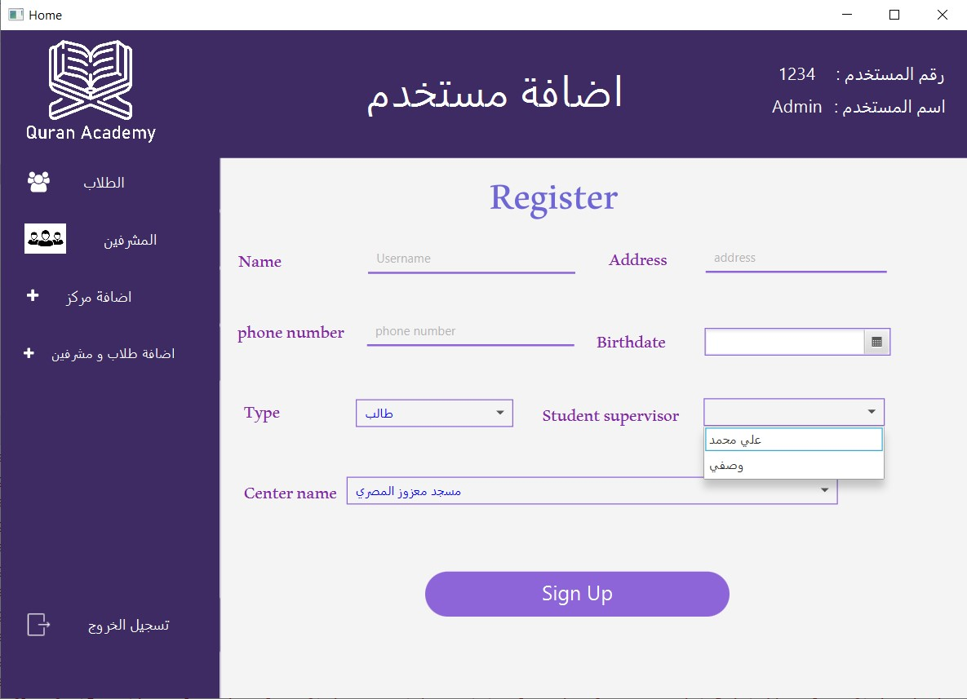

When clicking on Create students and supervisors, we go to the registration screen

It asks the admin to enter the person's information and choose the center.

The centers in the database will appear inside the combo box

When selecting a student, supervisors whose status matches the center you chose will appear in the combo box. However, if you want to create a supervisor, supervisor combo box will diapered .

When confirming all the information, you will press Register.

The id for the student well be created automatically using a sql sequence.

At first registration, the person password will be same as id, and then he can change it.

----------------------------------------------------------------------------------------------------

When you click on the logout button, you will be taken to the login screen.

------------------------------------------- finish admin GUI ------------------------------------------

2- Supervisor interfaces

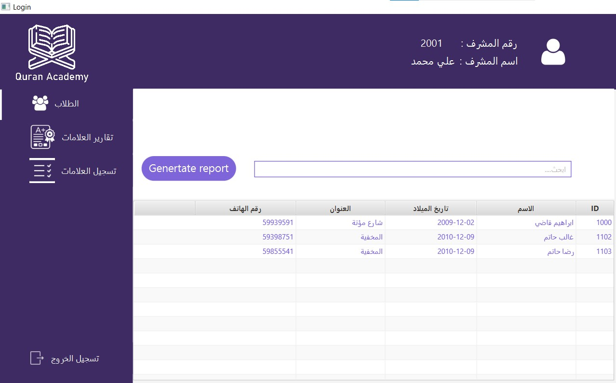

When entering the supervisor interface, only the students he supervises will appear.

He can search for them and cannot edit their information.

There is an advanced search bar supervisor can use.

When selecting a student from the table and then pressing the report button, a pdf report will generated automatically in project folder contain all data about the student and all reports for him.

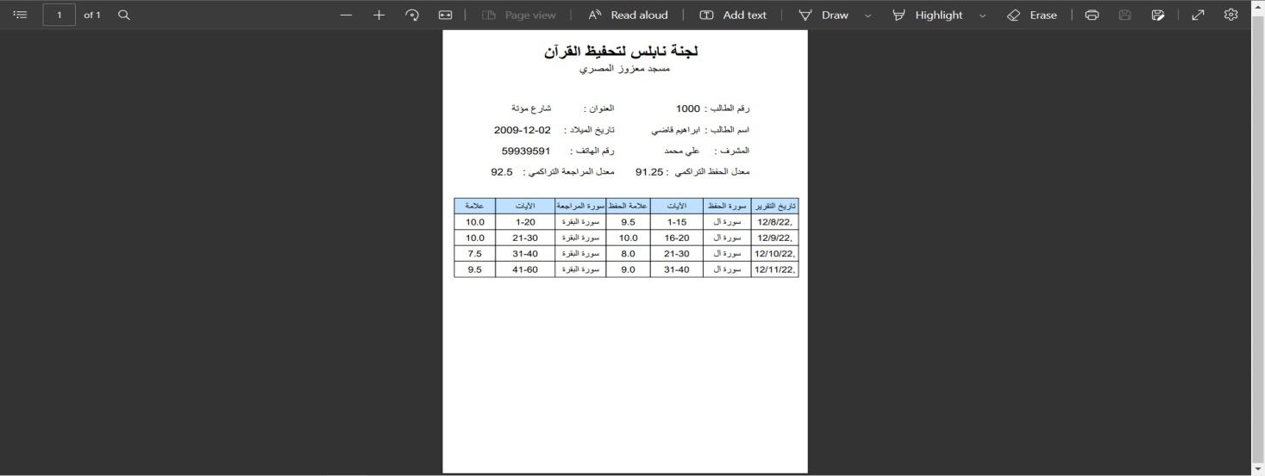

-------------------------------------------------------------------------------------------------------

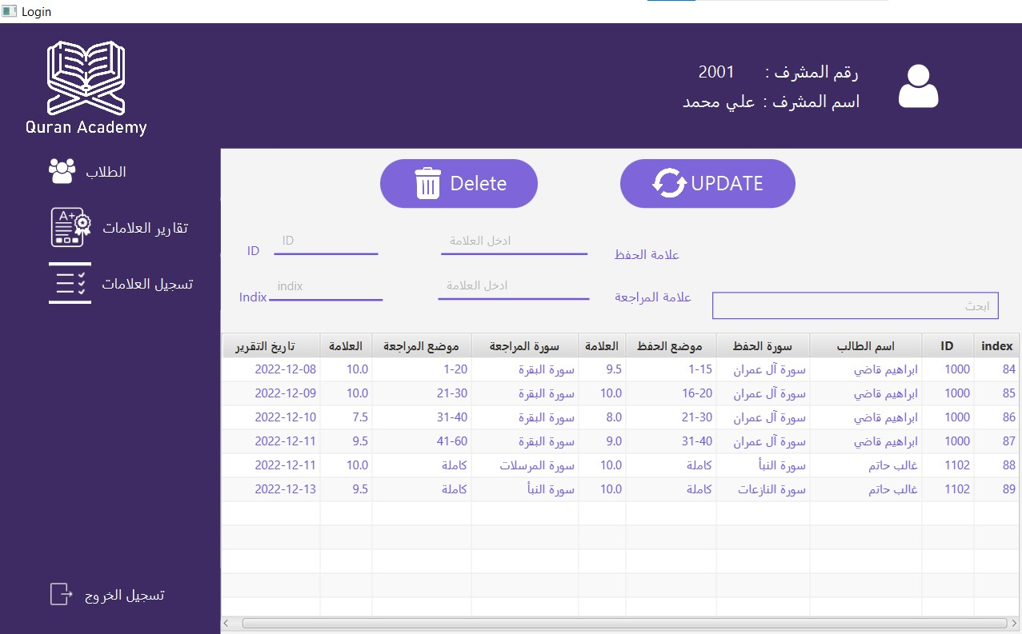

When you click on the "Report Marks" button

A table will appear showing the students' grades and information about what they have read. Supervisor can change and delete grades and search the schedule.

----------------------------------------------------------------------------------------------------------

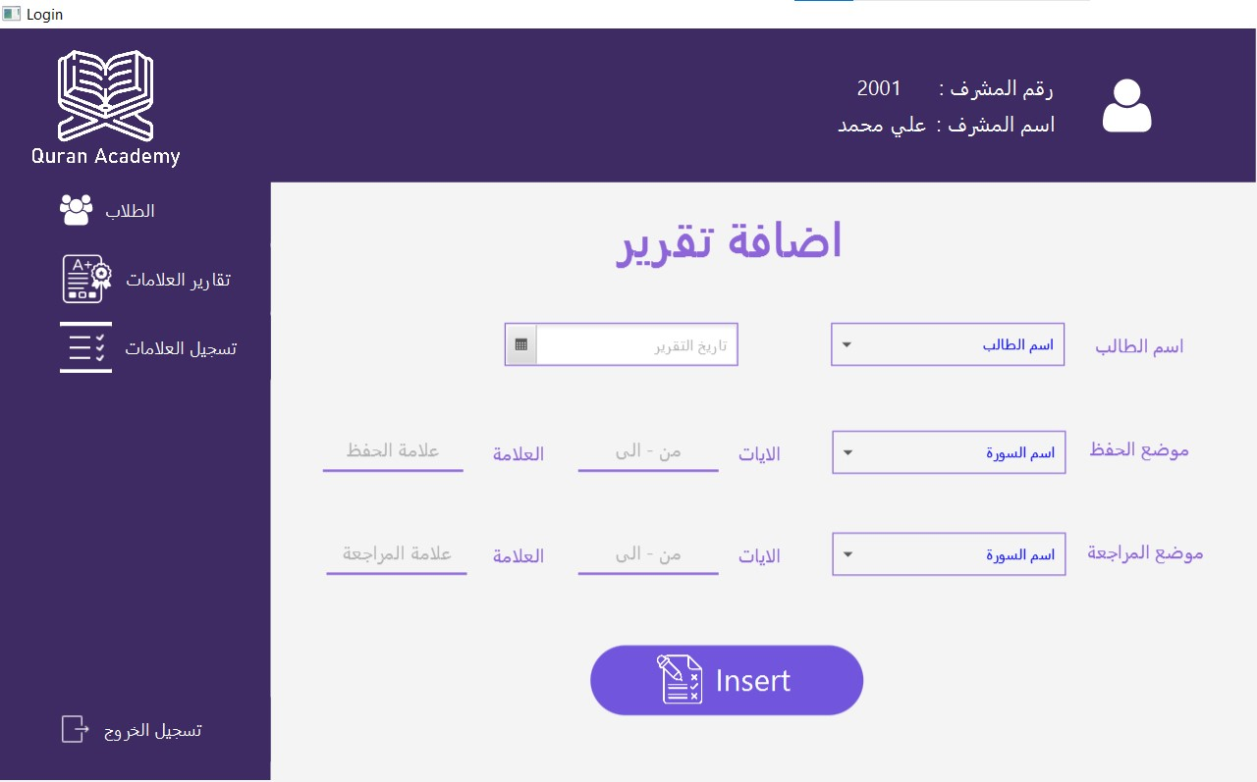

When you press the last button, you will be taken to the reports screen, as shown.

The supervisor enters the information and selects one of his students

(To make it easier to choose the name of the surah and the students, use the filter category as shown in the other image).

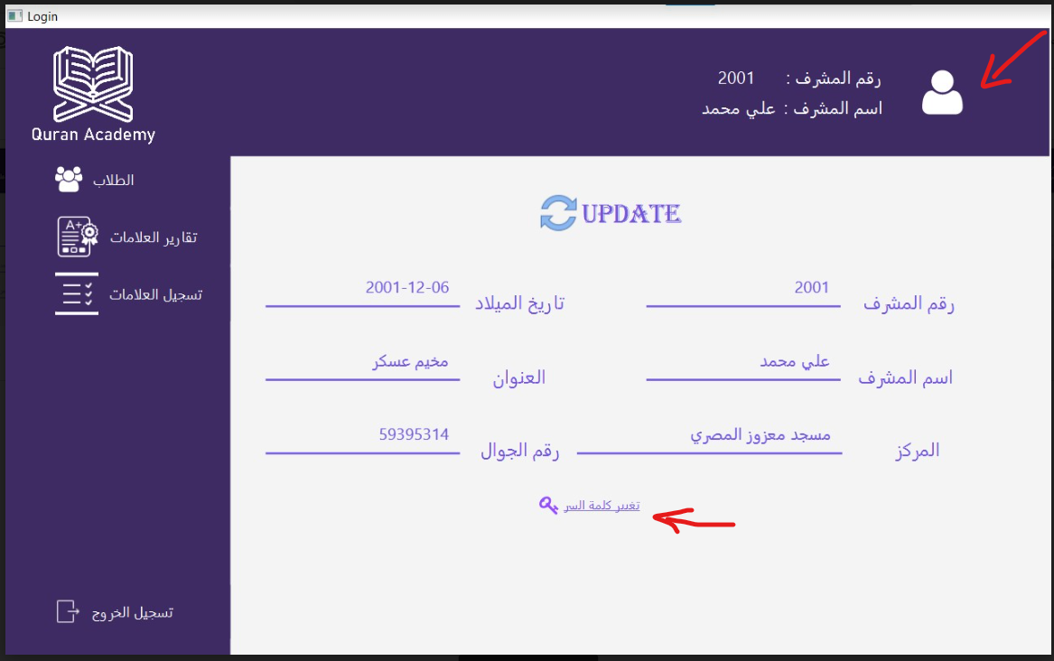

When the person button is pressed.

We go to the personal account page, which contains personal information, where the user can change his parameters (except for the personal ID).

When you click change password, the old password fields and the new fields will appear, then the change it button will appear.

----------------------------------------------------------------------------------------------------

When you click on the logout button, you will be taken to the login screen.

------------------------------------- Finish supervisor GUI ------------------------------------------

3- Student interface:

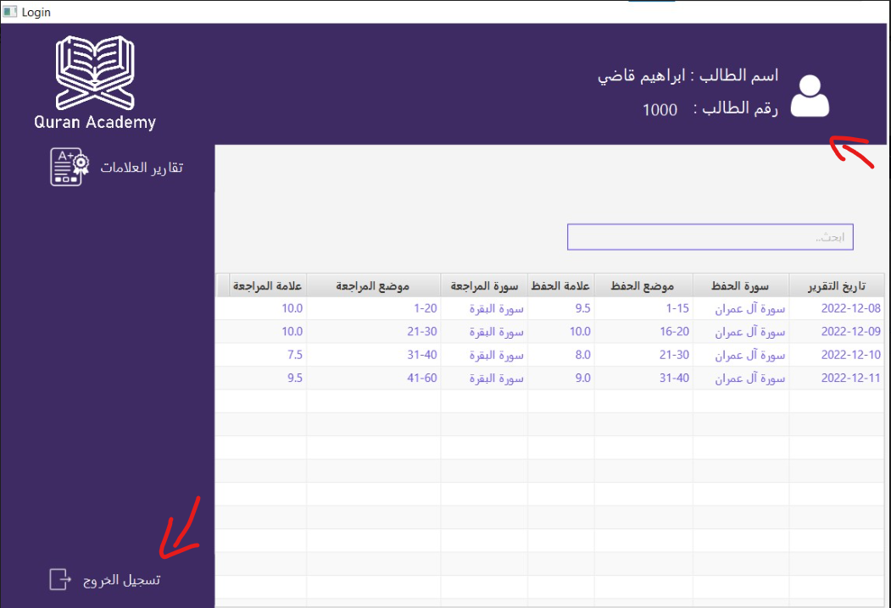

The first thing that will open in the student interface is his marks page.

A student can search for his grades and cannot edit them.

There is also a profile button as it is found in the supervisor with the same look and method of work.

----------------------------------------------------------------------------------------------------

When you click on the logout button, you will be taken to the login screen.

------------------------------------- Finish Student GUI ------------------------------------------

Edit: A report button has been added to the student interface and the supervisor interface

In the student interface, you print the student's rate.

In the supervisor's interface, you print the rates of the students he has.

---------------------------------------------- Finish GUI-------------------------------------------------

# Conclusion:

We conclude from this project the importance of learning database management, because of its great importance in terms of speed, ease of access, and high capabilities.

In this project, we were also able to learn the JavaFX language and learn a lot of other programs, so we must rely on ourselves and search for sources, and not rely on textbooks only.

# References:

<https://stackoverflow.com>

<https://www.geeksforgeeks.org>

<https://www.youtube.com/c/BroCodez>

<https://www.youtube.com/user/thenewboston>

<https://www.youtube.com/@KeepToo>

<https://www.youtube.com/@channelai1036>

<https://www.youtube.com/c/RashidCoder>