BSCS FINAL PROJECT

Autism Spectrum Disorder (ASD)



Project Advisor

Daniyal Ahmed

Presented by:
Group ID: F23CS045

L1F20BSCS0094 Ibraheem Shahzad
L1F20BSCS0661 Shoaib Akhtar
L1F20BSCS0272 Talha Maqsood

Faculty of Information Technology

University of Central Punjab
Complete System
SDP Phase IV

Autism Spectrum Disorder (ASD)
Advisor: Daniyal Ahmed

Team F23CS045
Ibraheem Shahzad | Programming and Documentation
Shoaib Akhtar | Programming
Talha Maqsood | Documentation and designing

Table of Contents
Table of Contents i
Revision History ii
Abstract iii
1. Introduction 1
1.1 Product 1
1.2 Background 1
1.3 Objective(s)/Aim(s)/Target(s) 1
1.4 Scope 1
1.5 Business Goals 2
1.6 Document Conventions 2
1.7 Miscellaneous 3
2. Technical Architecture 4
2.1 Application and Data Architecture 4
2.2 Component Interactions and Collaborations 7
2.3 Design Reuse and Design Patterns 10
2.4 Technology Architecture 10
2.5 Architecture Evaluation 11
3. Detailed/Component Design 12
3.1 Component-Component Interface 12
3.2 Component-External Entities Interface 13
3.3 Component-Human Interface 13
4. Screenshots/Prototype 14
4.1 Workflow 14
4.2 Screens 15
4.3 Additional Information 18
5. Other Design Details 18
6. Test Specification and Results 18
6.1 Test Case Specification 18
6.2 Summary of Test Results 20
7. Project Completion Status 21
8. Deployment/Installation Guide 22
9. User Manual 22
10. References 22
11. Project Summary Form 23
Appendix A: Glossary 28
Appendix B: IV & V Report 29

Revision History
Name | Date | Reason For Changes | Version

Abstract
Autism Spectrum Disorder (ASD) presents difficulties in early diagnosis, limiting appropriate treatments. This research uses deep learning to improve diagnostic accuracy and efficiency. Conventional approaches rely on subjective judgments and lack standardisation, resulting in delayed diagnosis. The research project intends to overcome this by creating a strong deep-learning model and evaluating various datasets for early ASD identification. Relying on Deep-Learning, and neuroscience, the project incorporates modal data, necessitating skill in feature extraction. The relevance lies in revolutionizing ASD diagnosis, allowing for earlier treatments and individualized assistance. A Deep Learning model for accurate ASD diagnosis is expected to be developed and validated rigorously. The findings help to refine diagnostics and better grasp the complexities of ASD.

Introduction

Product
This project is a user-friendly web-based system designed to analyze facial and neuroimages. It addresses the need for efficient image analysis in the medical field. The end product is a program that utilizes Deep Learning algorithms to process and interpret images uploaded by patients or doctors in real-time. This innovative solution simplifies the diagnostic process, providing a convenient platform for both healthcare professionals and patients.

Background
Previous efforts in the domain of Autism Spectrum Disorder (ASD) diagnosis have primarily relied on subjective clinical observations, leading to limitations in accuracy and efficiency. In comparison, our project leverages advanced technologies, including Artificial Intelligence (AI) and medical imaging, to introduce a web-based system focused on analyzing facial and neuroimages. This approach stands out by providing real-time processing and interpretation of data uploaded by patients or doctors, offering a user-friendly platform for healthcare professionals and patients. Our project aims to address the shortcomings of existing methods, contributing to a more accurate and efficient ASD diagnostic process.

Objective(s)/Aim(s)/Target(s)
The project aims to develop a user-friendly web-based system tailored for the analysis of facial and neuroimages, fostering accurate and efficient Autism Spectrum Disorder (ASD) diagnosis. Leveraging Deep Learning algorithms, the system enables real-time processing and interpretation of uploaded images, significantly enhancing diagnostic capabilities. The primary goal is to demonstrate a marked improvement in the accuracy of ASD diagnosis compared to traditional methods, emphasizing early intervention possibilities. This initiative also seeks to create a convenient and accessible platform, encouraging active participation from healthcare professionals and patients in contributing and interpreting critical medical data for ASD diagnosis. Furthermore, the project aspires to contribute to the progression of multi-modal data analysis in medical diagnostics, with a specific focus on integrating facial images and neuroimages for a more comprehensive understanding of ASD.

Scope
The scope of the proposed web-based system encompasses the comprehensive analysis of facial and neuroimages for Autism Spectrum Disorder (ASD) diagnosis. The system will accept image uploads from patients or healthcare professionals, utilizing Deep Learning algorithms to provide real-time accuracy metrics. The primary focus is on enhancing the diagnostic process for ASD by integrating facial images and neuroimages, thus contributing to a more accurate and efficient evaluation. The system's reach extends to healthcare professionals and patients, providing a user-friendly platform for uploading, processing, and interpreting critical medical data. This project aims to make a meaningful contribution to the field of medical diagnostics, particularly in the context of ASD, by addressing the limitations of traditional diagnostic methods.

Business Goals
1. Enhance Diagnostic Accuracy:
Improve the accuracy of Autism Spectrum Disorder (ASD) diagnosis through the implementation of advanced Deep Learning algorithms, contributing to better patient outcomes and treatment strategies.

2.Facilitate Early Intervention:
Provide a platform that enables early intervention by offering real-time processing and interpretation of facial and neuroimages, enhancing the potential for timely and effective therapeutic measures.

3.Improve Healthcare Accessibility:
Create a user-friendly web-based system that promotes accessibility for both healthcare professionals and patients, fostering collaborative contributions to the diagnostic process.

4. Position as an Innovative Solution:
Establish the software as an innovative and cutting-edge solution in the medical diagnostics domain, distinguishing it from traditional methods and contributing to the advancement of multi-modal data analysis.

5. Contribute to Research and Development:
Support ongoing research efforts in ASD diagnosis and multi-modal data analysis by providing a valuable tool for healthcare professionals, researchers, and patients.

6. Enhance Patient Engagement:
Foster increased engagement and understanding among patients by providing a convenient platform for them to actively participate in the diagnostic process, promoting a patient-centred approach to healthcare.

7. Compliance with Ethical Standards:
Adhere to ethical standards and patient privacy regulations to ensure the responsible and secure handling of sensitive medical data, establishing trust and credibility within the healthcare community.

8. Market Recognition:
Achieve recognition in the healthcare market as a reliable and effective tool for ASD diagnosis, fostering partnerships with healthcare institutions and professionals.

Document Conventions
- Font is “Times New Roman”
- Font size is 12.
- Heading’s BOLD “Times New Roman” in 14

Miscellaneous
N/A

Technical Architecture
The Autism Spectrum Disorder (ASD) diagnostic system is a custom-built web application designed for accurate ASD diagnosis through the analysis of facial and neuroimages. The system's technical architecture encompasses key components such as a user-friendly interface, Deep Learning module for real-time image processing, data processing module for preprocessing and model training, a database management system for storing diverse datasets, and a collaborative framework for interaction among healthcare professionals, data analysts, and administrators. Utilizing Python, React and Fast API’s the system ensures secure data handling and compatibility with neuroimaging equipment. The system is intended for internet-based operation, with hosting options ranging from secure cloud environments to local servers in healthcare institutions, adhering to privacy regulations and promoting scalability.

Application and Data Architecture
Activity Diagram
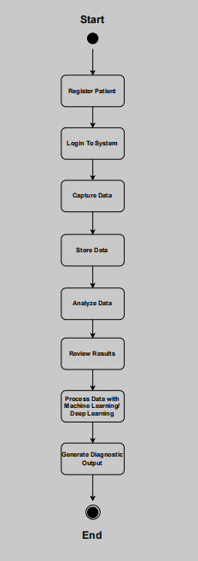

Class Diagram
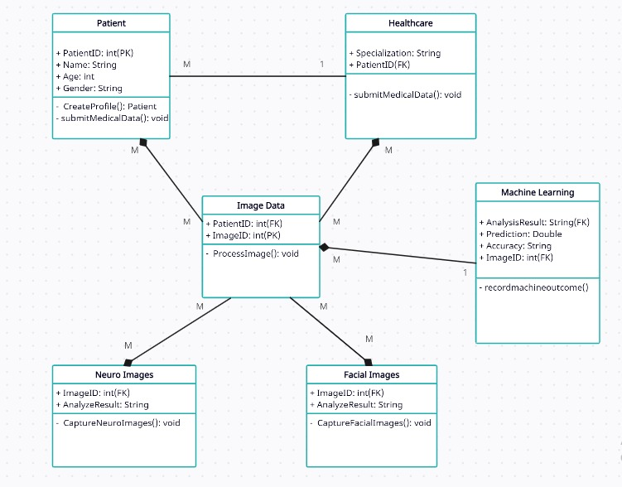

ERP Diagram

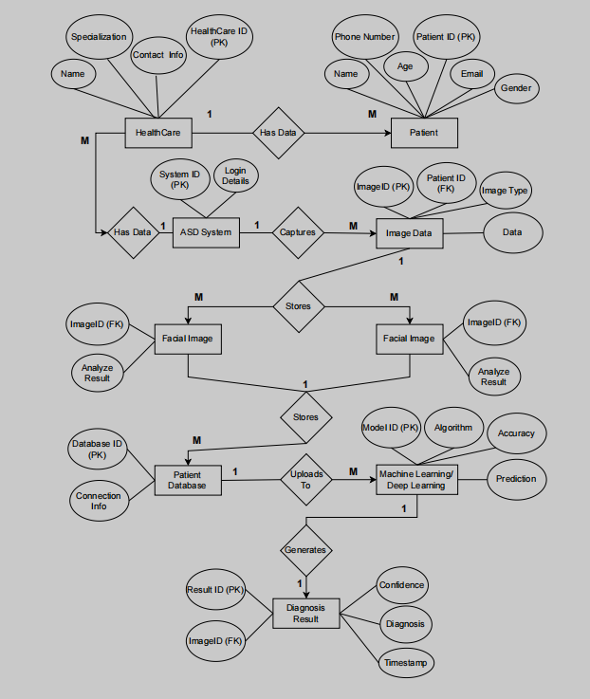

Component Interactions and Collaborations
Sequence Diagram
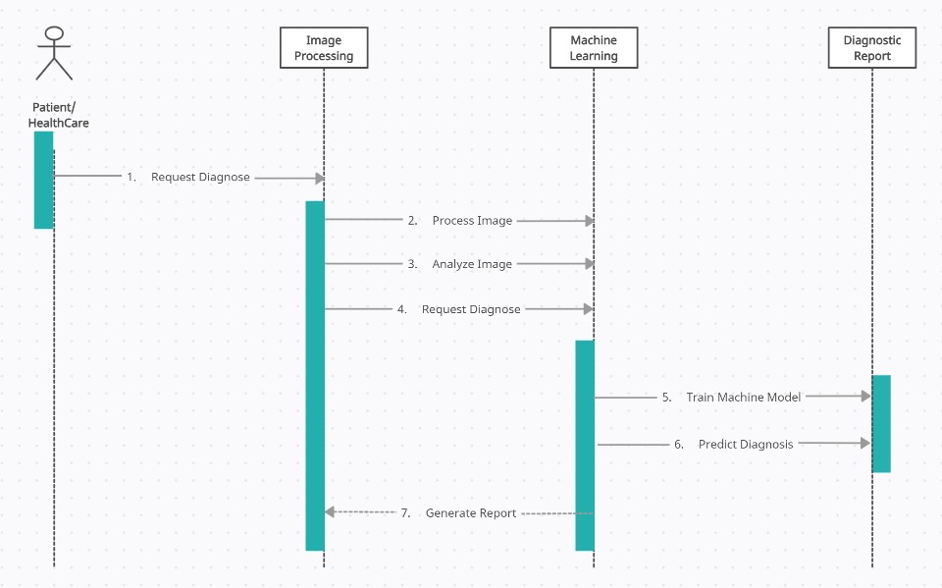

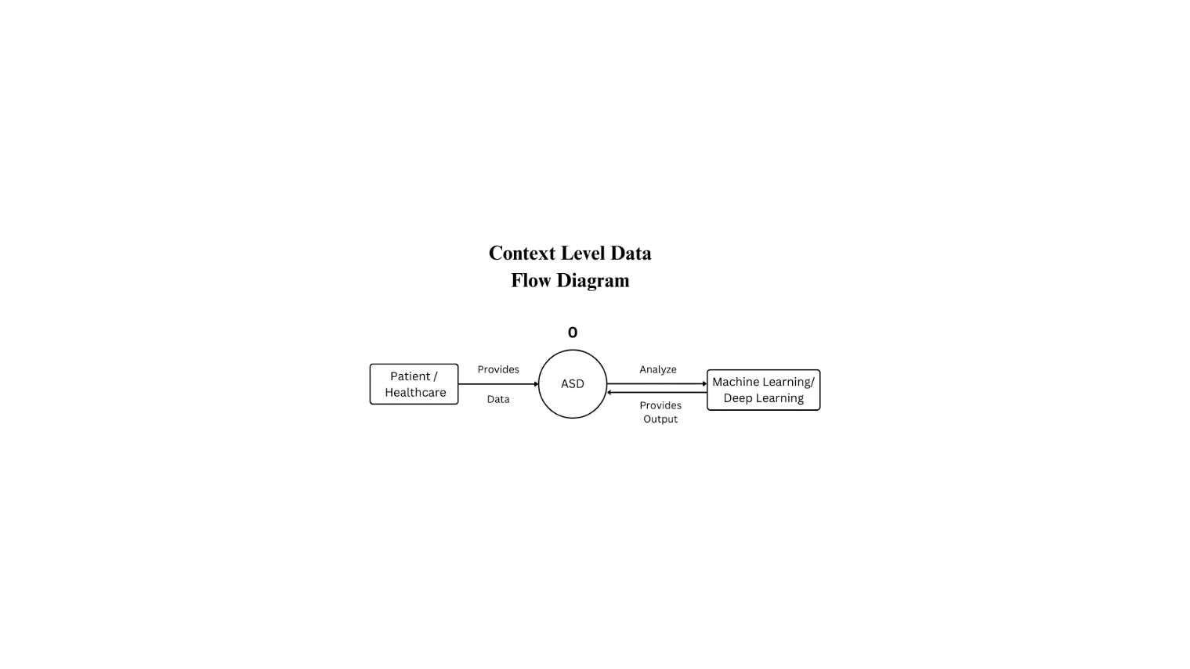
Data Flow Diagram

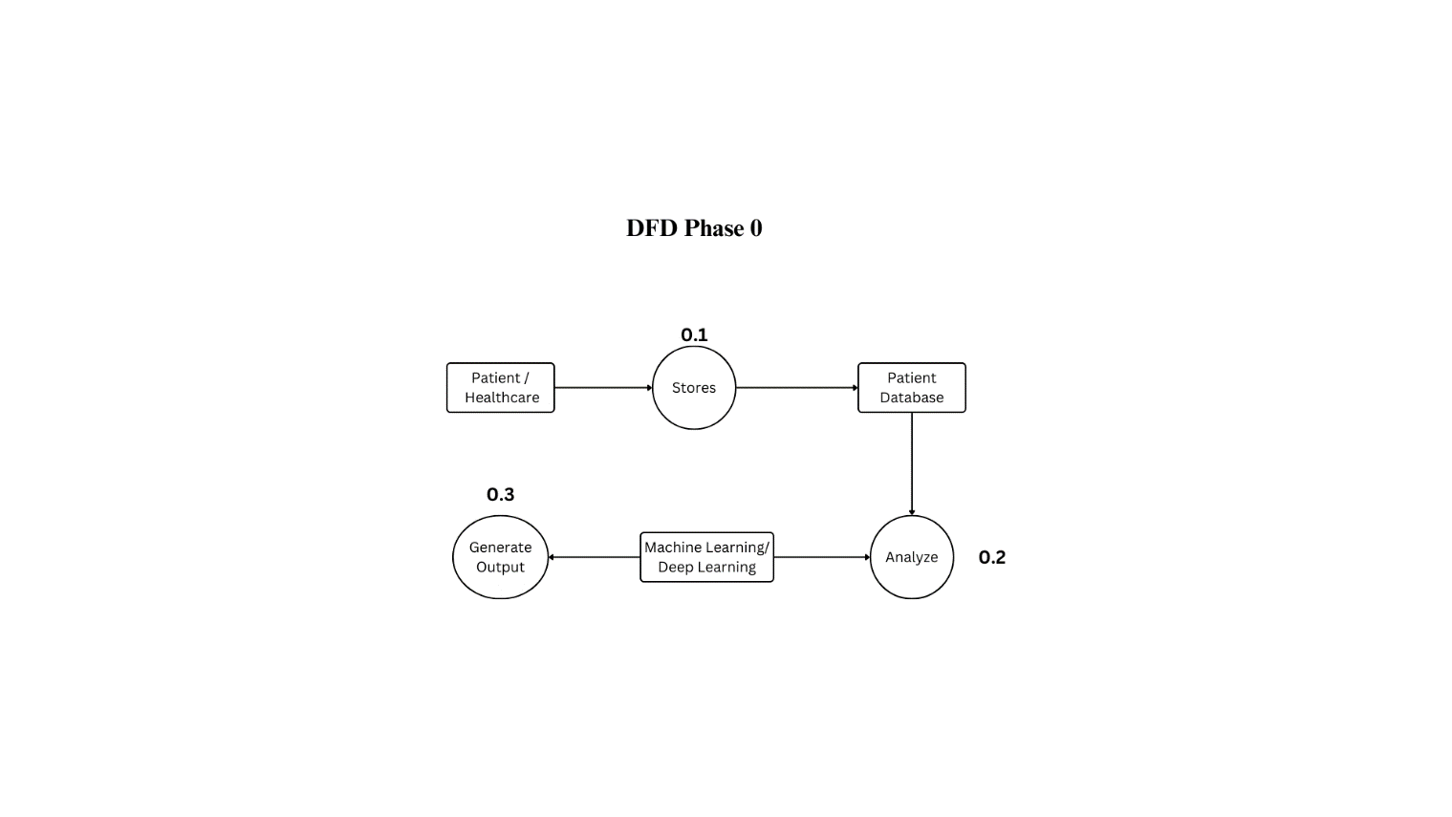

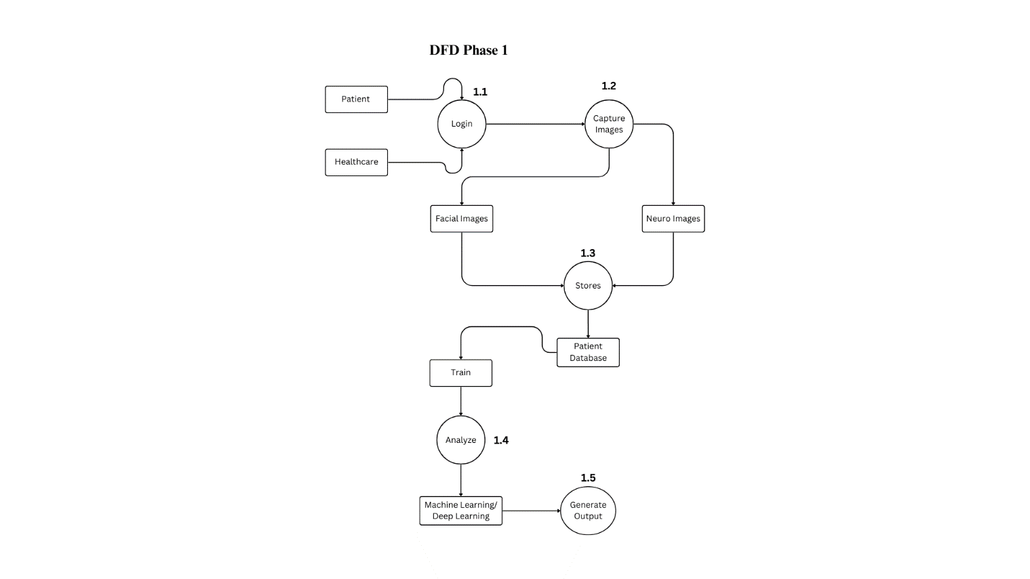

Design Reuse and Design Patterns
ASD-Specific Feature Extraction Module:

A specialized feature extraction module has been designed as a reusable component. This module extracts relevant features from both facial and neuroimages specific to ASD diagnosis. The encapsulation of this functionality allows for consistent and adaptable feature extraction strategies across different datasets.

Dynamic Algorithm Selection for ASD Assessment:

The Strategy pattern is applied to dynamically select Deep Learning algorithms for ASD assessment. Different algorithms can be seamlessly integrated and swapped based on performance metrics and the specific characteristics of the patient data. This promotes adaptability to evolving diagnostic needs and emerging research findings.

Patient Data Integration as a Factory Method:

The Factory Method pattern is applied to the integration of patient data. Different sources of data, such as facial images and neuroimaging data, can be seamlessly integrated into the system. This allows for flexibility in handling diverse datasets and accommodating new data sources as they become available.

Prototype Pattern for ASD Diagnostic System:

In the context of the Autism Spectrum Disorder (ASD) diagnostic system, the Prototype pattern is analogous to supporting the copying of existing objects without introducing dependencies on specific classes. This pattern facilitates the creation of new instances of key components, such as data processing modules or feature extraction tools, by cloning existing ones. By doing so, the system can maintain flexibility and adaptability without being tightly bound to the details of the original classes. This proves valuable in scenarios where different datasets or diagnostic algorithms may require similar functionalities but with specific variations, allowing for efficient object creation while avoiding unnecessary code dependencies.

Technology Architecture
Platform:
It will be designed to run seamlessly on servers, workstations, and computing devices following industry standards.

Connectivity Requirements:
The system will require seamless connectivity within the healthcare environment. It will be designed to operate on Local Area Networks (LANs) to ensure fast and secure communication between different components. This connectivity is essential for real-time processing and collaboration features.

Modes of Operations:
The application will support both online and batch processing modes. Real-time processing is crucial for activities such as patient assessment, while batch processing is essential for model training and continuous improvement. These modes cater to different operational needs within the healthcare ecosystem.

Database Platform:
Depending on specific requirements, the application may utilize relational databases such as MySQL for data storage. Factors like data integrity, security, and scalability will influence the choice of the database platform. The database will serve as a central repository for patient data and diagnostic information.

Programming Language:
Python will be the primary programming language for implementing Deep Learning algorithms and backend processes. Python offers flexibility, a wide range of libraries for Deep Learning, and integration capabilities. This choice aligns with industry standards and facilitates effective development.

Front-End Interface:
The user interface will be browser-based, allowing healthcare professionals and data analysts to access the application through standard web browsers. This approach enhances accessibility and eliminates the need for client-side installations. The front-end interface will provide an intuitive and user-friendly experience.

Monitoring and Maintenance:
A monitoring system will be implemented to track the performance of the ASD diagnostic system in real-world scenarios. Routine maintenance tasks, including software updates and system checks, will be scheduled to ensure optimal functionality. Proactive monitoring aims to address potential issues promptly.

Architecture Evaluation
Infrastructure/Technology Selection

- Amazon EC2 (Elastic Compute Cloud)
- Amazon S3 (Simple Storage Service)
- Python for Deep Learning
- FastAPI
- React

Reasons for Selection

FastAPI:

Performance: FastAPI provides high performance with asynchronous support, making it efficient for handling concurrent requests.
Ease of Use: User-friendly with automatic interactive API documentation generation, aiding in development and debugging.
Modern Features: Supports modern Python features, enhancing development productivity and code maintainability.
Community Support: Backed by a growing community and extensive documentation, ensuring ongoing support and resources.
Amazon EC2 (Elastic Compute Cloud):

Scalability: Allows scaling compute capacity based on demand, suitable for handling varying workloads.
Flexibility: Provides a wide range of instance types and configurations to match specific application needs.
Reliability: Offers high availability and reliability agreements with AWS.

Amazon S3 (Simple Storage Service):

Storage Scalability: Provides scalable object storage with high durability, suitable for storing and retrieving large amounts of data.
Cost-Effectiveness: Pay-as-you-go pricing model ensures cost-efficiency, especially for storage of static assets like images, videos, etc.
Integration: Seamless integration with other AWS services and ease of access through APIs.
Python for Machine Learning / Deep Learning:

Versatility: Python's extensive libraries (e.g., TensorFlow, PyTorch) support a wide range of machine learning and deep learning tasks.
Community and Ecosystem: Python has a large community of developers and researchers, with robust libraries and frameworks for AI development.
Scalability: Can leverage EC2 for scalable compute resources to train and deploy machine learning models.
React:

User Interface: Enables building interactive and responsive user interfaces for web applications.
Component-Based: Facilitates modular development, enhancing code reusability and maintainability.
Developer Experience: Rich ecosystem with a strong community, extensive libraries (like Redux for state management), and tooling (such as React Router for navigation).
Pros and Cons

FastAPI:

Pros: High performance, ease of use with automatic API documentation, modern Python features.
Cons: Fewer built-in features compared to more comprehensive frameworks like Django.
Amazon EC2:

Pros: Scalable, flexible instance configurations, high availability.
Cons: Management overhead, potential cost variability with scaling.
Amazon S3:

Pros: Highly scalable, durable storage solution, cost-effective for static assets.
Cons: Limited functionality compared to more specialized storage services for specific use cases.
Python for Machine Learning / Deep Learning:

Pros: Extensive libraries, versatile for AI tasks, large community support.
Cons: Requires computational resources for training models, potential complexity in deployment.
React:

Pros: Rich user interface development, component-based architecture, extensive ecosystem.
Cons: Initial learning curve, potential complexity in larger applications.
Alternatives

API Frameworks:

Django: Feature-rich with extensive built-in features, suitable for complex applications but heavier for smaller projects.
Flask: Lightweight and flexible, requiring more manual setup but offers simplicity and control.
Serverless Infrastructure:

AWS Lambda: Event-driven, serverless compute service ideal for microservices and event-driven architectures.
Firebase Hosting: Fully managed hosting service with CDN, suitable for static content and dynamic web applications.

Detailed/Component Design

Component-Component Interface

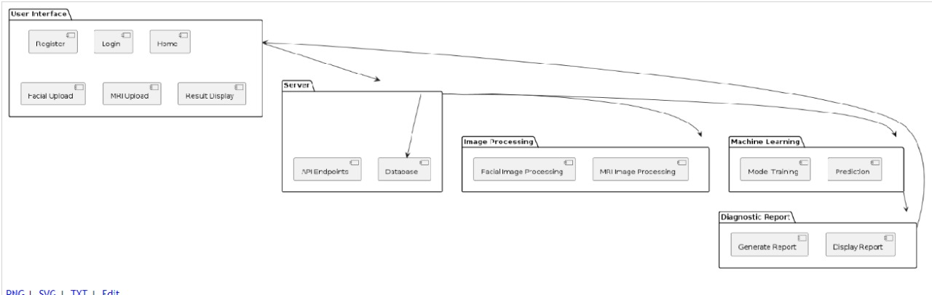

Component-External Entities Interface
N/A

Component-Human Interface

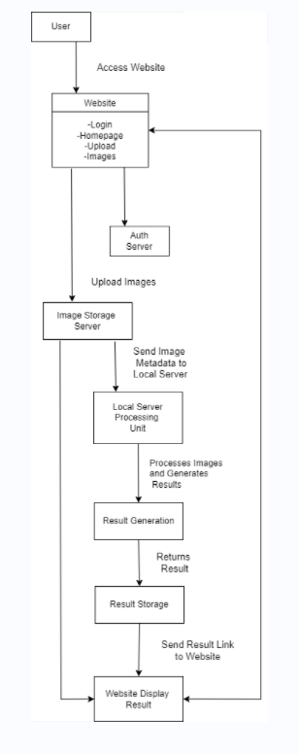

Screenshots/Prototype

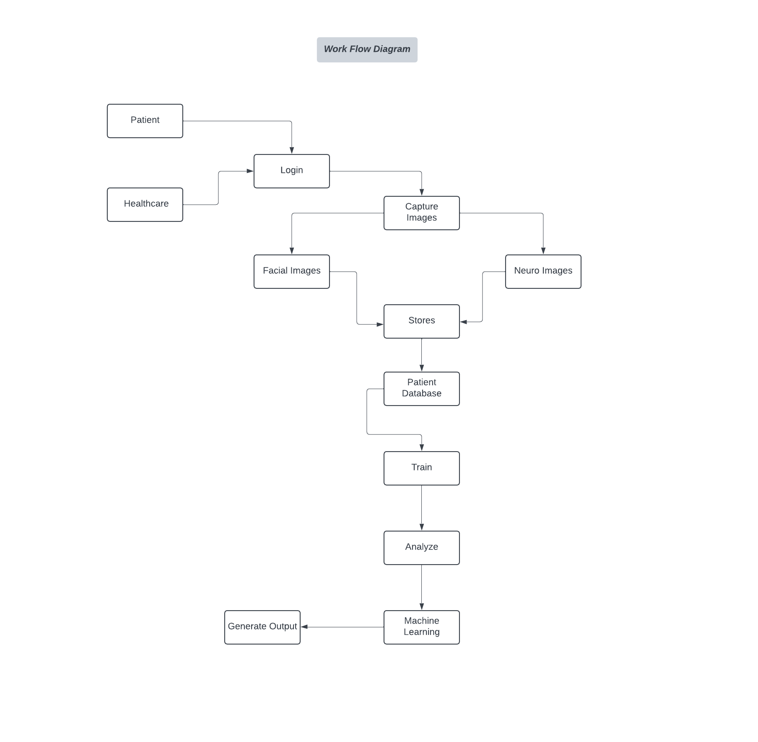
Workflow

Screens

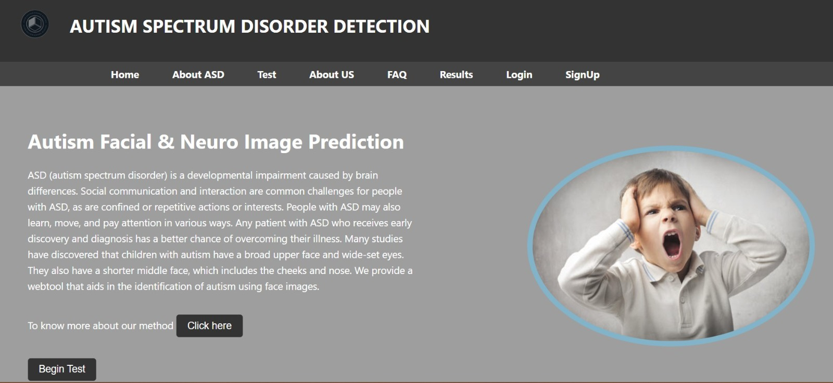

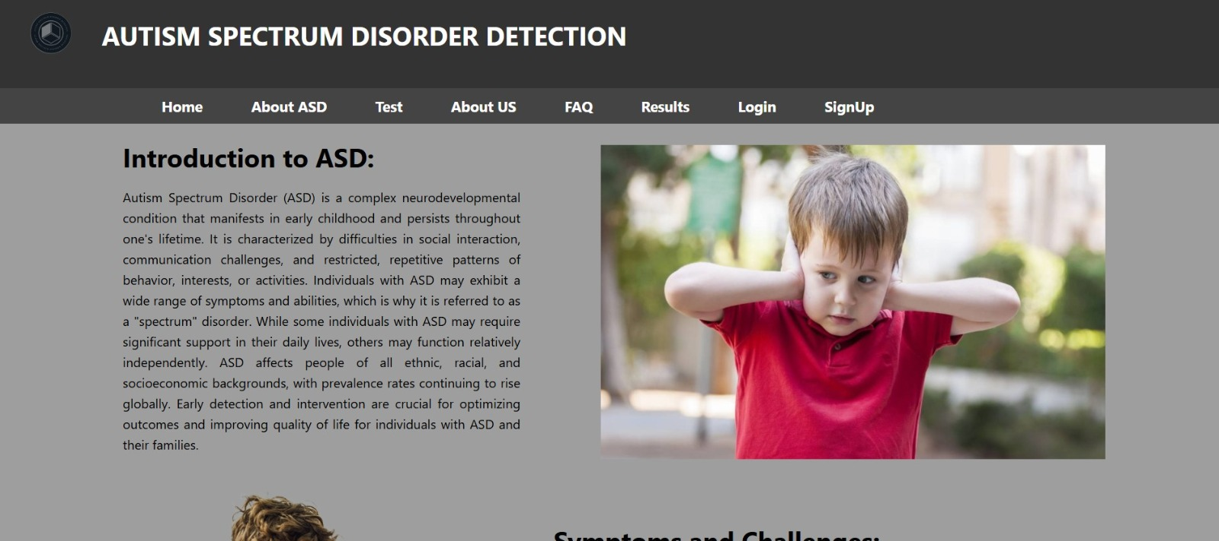

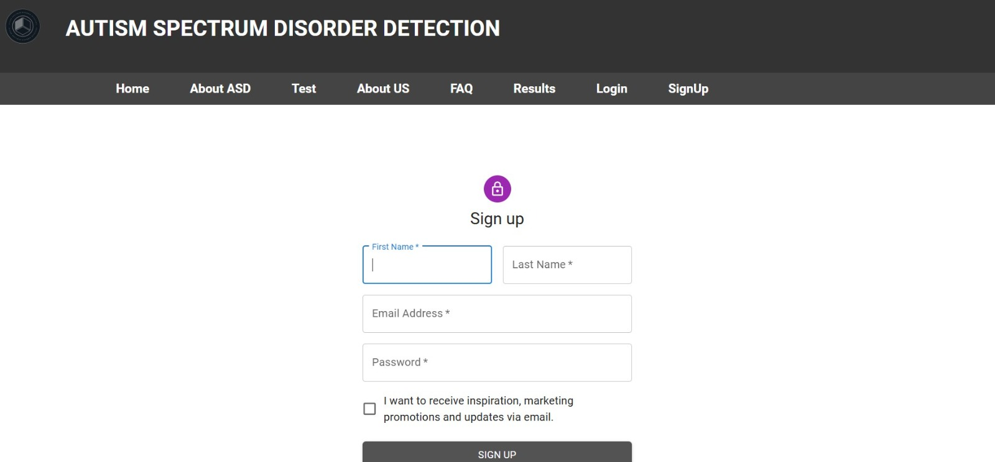

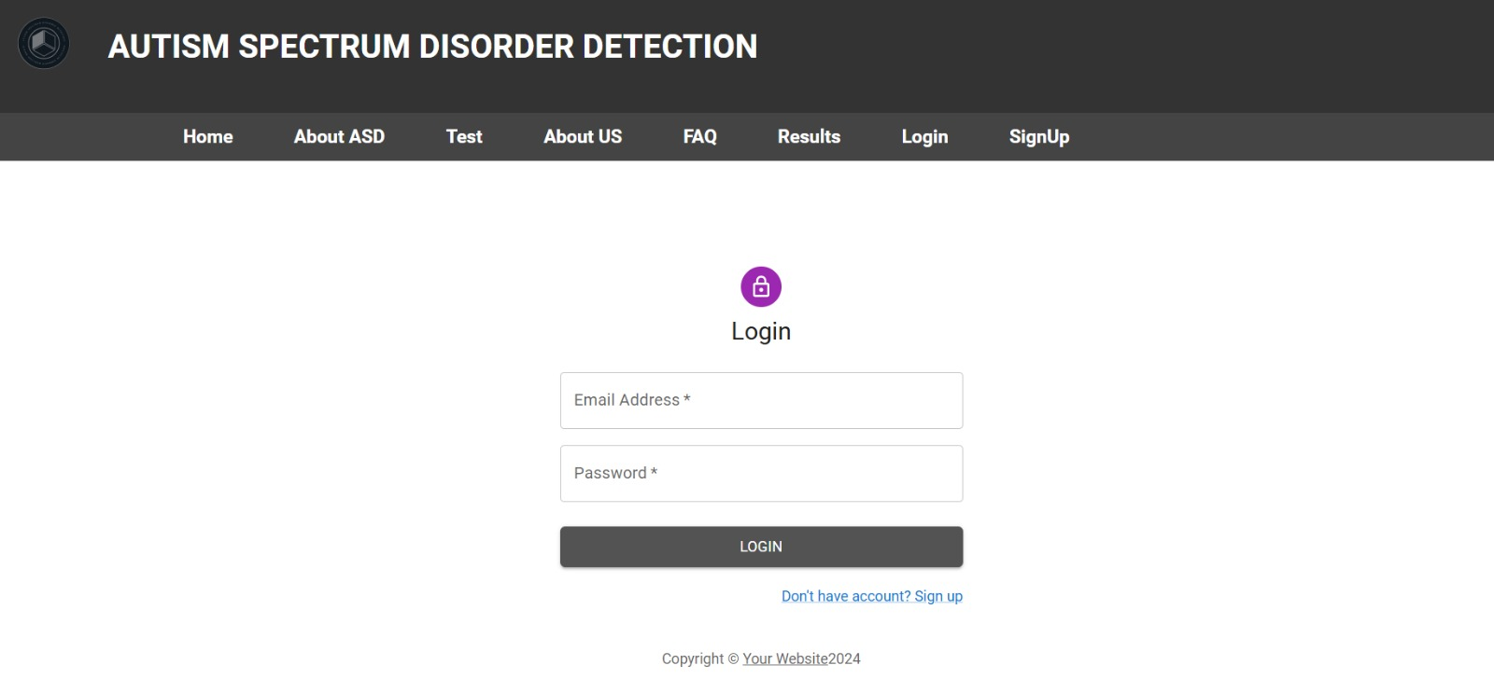

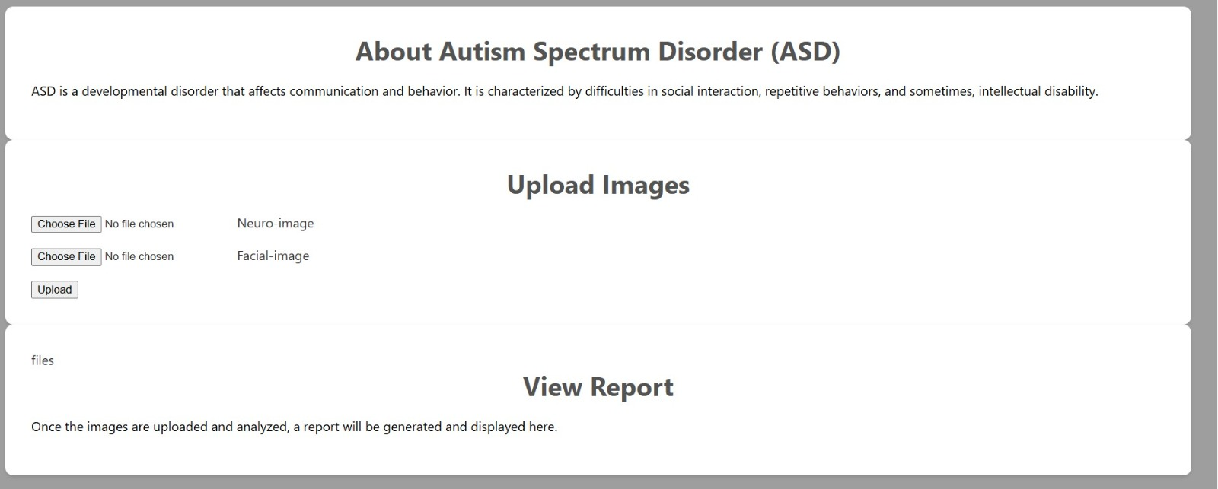

Additional Information
N/A

Other Design Details
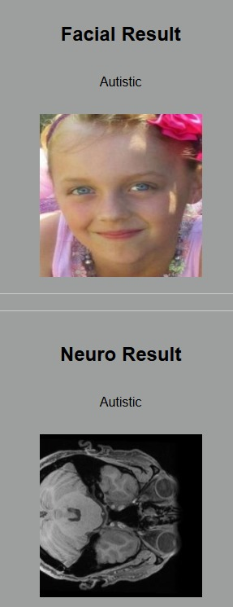

Test Specification and Results

Test Case Specification
Table 6.1: TC-1
Identifier | TC-1
Related requirement(s) | UC-2, SRS Section 3.2.1
Short description | Create new account
Pre-condition(s) | Must have an Email account
Input data | Valid username and password.
Detailed steps | Navigate to the login screen.
Expected result(s) | The user is successfully authenticated and logged into the system.
Post-condition(s) | A user session is established.
Actual result(s) | The user is redirected to the home screen after successful login.

Table 6.2: TC-2
Identifier | TC-2
Related requirement(s) | UC-2, SRS Section 3.2.2
Short description | Verify that user authentication works correctly.
Pre-condition(s) | User account is registered in the system.
Input data | Valid username and password.
Detailed steps | Navigate to the login screen.
Expected result(s) | User is successfully authenticated and logged into the system.
Post-condition(s) | User session is established.
Actual result(s) | User is redirected to the home screen after successful login.

Table 6.3: TC-3
Identifier | TC-3
Related requirement(s) | UC-3, SRS Section 3.2.3
Short description | Verify image upload and processing functionality.
Pre-condition(s) | The patient is registered; the system is online
Input data | Neuro and facial images in acceptable formats.
Detailed steps | 1. Open the image upload section.  2. Select neuro and facial images.
Expected result(s) | 1. The system accepts and processes images.  2. Images are stored in the Data Repository.
Post-condition(s) | Images are processed and stored, ready for analysis
Actual result(s) | The result will be displayed if that person is autistic or not.
Table 6.4: TC-4
Identifier | TC-4
Related requirement(s) | UC-4, SRS Section 3.2.4
Short description | Verify Deep Learning model diagnostic functionality.
Pre-condition(s) | Images are uploaded and processed; system is online
Input data | Processed neuro and facial images.
Detailed steps | 1. Trigger the Deep Learning diagnostic process.  2. Monitor the analysis process.  3. Retrieve the diagnostic result.
Expected result(s) | 1. The system processes the images.  2. The Deep Learning model generates a diagnostic result.  3. The result is stored in the Data Repository.  4. Notification sent to healthcare professional.
Post-condition(s) | Diagnostic result is available for review.
Actual result(s) | The result will be displayed if that person is autistic or not.

Summary of Test Results
Table 6.2: Summary of Test Results
Module Name | Test cases run | Number of defects found | Number of defects corrected so far | Number of defects still need to be corrected
Module 1 (for example Bill Calculation Module, Speech Processing Unit | TC1, TC2 | 2 | 1 | 1
Module 2 | TC-3 | 3 | 2 | 1
Module 3 | TC-4 | 1 | 0 | 1
Complete System | 4 | 6 | 3 | 3

Project Completion Status
Table 7.1: Project Completion Status
Module Name | Status  (Complete, Partially Implemented, Not Implemented)
Module 1 (Facial Images) | Completed
Module 2 (MRI Images) | Completed
Module 3 (Machine /Deep Learning Diagnostics) | Completed
Module 4 (User Interface) | Completed
Complete System | Completed

Table 7.2: Objective(s)/Target(s) Status
Target/Objective | Status  (Completed,  Partially Completed,  Not Completed) | Reason(s)
Objective 1 (Enhance Diagnostic Accuracy) | Completed | Achieved improved accuracy
Objective 2 (Facilitate Early Intervention) | Completed | Real-time processing
Objective 3 (Improve Interface for Healthcare) | Completed | User-friendly interface
Objective 4 (Position as an Innovative Solution) | Completed | Innovative use of Deep Learning demonstrated.
Objective 5 (Contribute to Research and Development) | Partially Completed | Ongoing improvements and updates needed for research integration.
Objective 6 (Compliance with Ethical Standards) | Completed | Implemented strict data privacy measures.

Deployment/Installation Guide

Backend Deployment (EC2)

- Set up EC2 Instance:

- Launch an EC2 instance (Ubuntu) with necessary security group settings.

- Connect and Install Dependencies:

- SSH into your EC2 instance.
- Install Node.js, npm, and any required dependencies.

- Clone and Configure Backend:

- Clone your backend repository from GitHub.
- Set environment variables and configure settings.

- Start Backend Server:

- Run your backend application (Fastapi, python).

Frontend Deployment (Node.js, React, Netify)

- Push to GitHub:

- Push your frontend codebase (React) to a GitHub repository.

- Deploy to Netlify:

- Log in to Netlify, connect your GitHub repository, and configure build settings.

- Set Environment Variables (Optional):

- Configure any necessary environment variables for API endpoints.

- Deploy and Access:

- Trigger a deployment on Netlify and access your hosted frontend via Netlify's generated URL Integration

- API Connection:

- Ensure your frontend communicates with the backend's API (using EC2 instance's public IP or domain).

- Security and Testing:

- Implement HTTPS where necessary and thoroughly test the integration between frontend and backend.

User Manual
N/A

References

Autism_Image_Data (kaggle.com)
https://www.kaggle.com/datasets/dswainsonsujana/autism-preprocessed
https://openneuro.org/datasets/ds002522/versions/1.0.2

https://www.ncbi.nlm.nih.gov/pmc/articles/PMC6154796/table/T1/?report=objectonly
Challenges Surrounding the Diagnosis of Autism in Children - PMC (nih.gov)
Full article: Challenges Surrounding the Diagnosis of Autism in Children (tandfonline.com)
Facial expression recognition as a candidate marker for autism spectrum disorder: how frequent and severe are deficits? | Molecular Autism | Full Text (biomedcentral.com)

Project Summary Form
Name of Project | Autism Spectrum Disorder (ASD)
Project Type | Research-Based (Medical)
Department | FOIT
Start Date | 8/8/23
Completion Date | 27/6/24
Supervisor / Team Leader | Daniyal Ahmed / Ibraheem Shahzad
Team Members (if any) | Shoaib Akhtar  Talha Maqsood
Funding Agency (if any) | None
Amount of Funding (if any) | None
Assign SDGs to Project | SDG 3 and SDG 9.
Motivation of Project | The motivation behind this project is to address the limitations of traditional ASD diagnostic methods which rely heavily on subjective clinical observations. By leveraging Deep Learning and deep learning models, the project aims to create a more accurate and efficient diagnostic tool, enabling earlier and more reliable identification of ASD in children. This can lead to timely interventions and support, significantly improving the quality of life for affected individuals and their families.
Practical / Potential Application | Providing a web-based tool for healthcare professionals to upload and analyze facial and neuroimages for ASD diagnosis.  Facilitating early intervention strategies by offering real-time diagnostic results.  Supporting ongoing research in ASD by contributing valuable data and insights from the diagnostic process.  Enhancing patient engagement and understanding by providing a user-friendly platform for participating in the diagnostic process.
Abstract | Autism Spectrum Disorder (ASD) presents difficulties in early diagnosis, limiting appropriate treatments. This research uses deep learning to improve diagnostic accuracy and efficiency. Conventional approaches rely on subjective judgments and lack standardisation, resulting in delayed diagnosis. The research project intends to overcome this by creating a strong deep-learning model and evaluating various datasets for early ASD identification. Relying on Deep-Learning, and neuroscience, the project incorporates modal data, necessitating skill in feature extraction. The relevance lies in revolutionizing ASD diagnosis, allowing for earlier treatments and individualized assistance. A Deep Learning model for accurate ASD diagnosis is expected to be developed and validated rigorously. The findings help to refine diagnostics and better grasp the complexities of ASD.
Key Technical Features | Integration of advanced Deep Learning algorithms for image analysis.  Real-time processing and interpretation of facial and neuroimages.  User-friendly web interface for easy access and operation by healthcare professionals.  Secure data handling and storage adhering to ethical standards and privacy regulations.
Projects Images / Screenshots

Appendix A: Glossary
ASD: Autism Spectrum Disorder

MVC: Model-View-Controller

HTML: Hypertext Markup Language

CSS: Cascade Style Sheet

Appendix B: IV & V Report
(Independent verification & validation)
IV & V Resource

Name Signature

S# | Defect Description | Origin Stage | Status | Fix Time
 |  |  |  | Hours | Minutes
1 | Integration Issues | Completed | Close | 2 | 00
2 | AWS Deployment | Completed | Close | 10 | 00
Table B.1: List of non-trivial defects

This document has been adapted from the following:
- Previous project templates at UCP
- High-level Technical Design, Centers for Medicare & Medicaid Services. (www.cms.gov)

