Power BI Sales Dashboard

Contents
- Executive Summary
- Dataset Selection
- Data Preparation and Modeling
- Report Development (Pages and Visuals)
- Advanced Features Implemented
- Business Questions Addressed
- Key Insights
- Challenges and Resolutions
- Deliverables
Appendix A. Report Screenshots

Executive Summary

This Power BI project analyzes sales performance against budget targets using a multi-table model. The report enables users to monitor key KPIs, understand trends over time, evaluate performance by channel, product group/category, and salesperson hierarchy, and drill into transaction-level detail for investigation.

Metric (sample view) | Value
Total Sales Amount | 17.91M
Total Budget | 17.27M
Budget Achievement | 1.04 (104%)
Total Orders | 260K
Total Quantity | 6M
Budget Variance (Sales - Budget) | 641.92K (approx.)
The dashboard is designed for straightforward navigation with consistent slicers (Year, Month, Salesperson, Channel), and supports exploration through cross-filtering, drill-through to details, and custom tooltip interactions.

2. Dataset Selection
Dataset name: My Data - Sales & Budget Performance Dataset
Overview: A multi-table dataset designed for sales performance analysis. It combines transactional sales records with product attributes, salesperson hierarchy, and budget targets to evaluate performance across time, channels, products, and people.
Core tables included:
- SalesData (Fact): Transaction-level sales including OrderDate, OrderNumber, ProductKey, SalespersonKey, Channel, Quantity, UnitPrice. Power Query preview indicates 999+ rows; full load meets the 1,000+ row requirement.
- Product (Dimension): Product attributes (name, group, category) including product image URL. - Salesperson (Dimension): Salesperson details with supervisor/manager hierarchy including salesperson image URL.
- Budget (Fact): Budget targets by date and salesperson used for Sales vs Budget comparisons.
Data source and access: Public dataset (link to be added by author).

3. Data Preparation and Modeling

3.1 Power Query - Data Cleaning and Transformation (documented)
- SalesData: promoted headers; corrected data types (OrderDate as Date); removed non-data rows; renamed columns; removed unnecessary columns to keep analysis-ready fields; applied a multiplication step during preparation to support sales amount logic.
- Salesperson: promoted headers; fixed data types; removed duplicates; filtered invalid rows; merged with a supporting query (Salesperson09) to bring in URL; expanded URL field.
- Product: promoted headers; fixed data types; merged with a lookup (Group) to enrich attributes and bring in product image URL; expanded merged columns and kept only key descriptive fields.

3.2 Data Model Design (star schema)
The model uses SalesData as the primary fact table, supported by conformed dimensions (Product, Salesperson, Calendar). Budget is a secondary fact table connected to the same dimensions to enable consistent slicing and variance analysis. Recommended relationship direction is single-direction filtering from dimensions to facts for performance and predictable behavior.
Key relationships:
- SalesData[ProductKey] -> Product[ID] (many-to-one)
- SalesData[SalespersonKey] -> Salesperson[SalespersonKey] (many-to-one)
- SalesData[OrderDate] -> Calendar Table[Date] (many-to-one)
- Budget[SalespersonID] -> Salesperson[SalespersonKey or ID] (many-to-one)
- Budget[Date] -> Calendar Table[Date] (many-to-one)
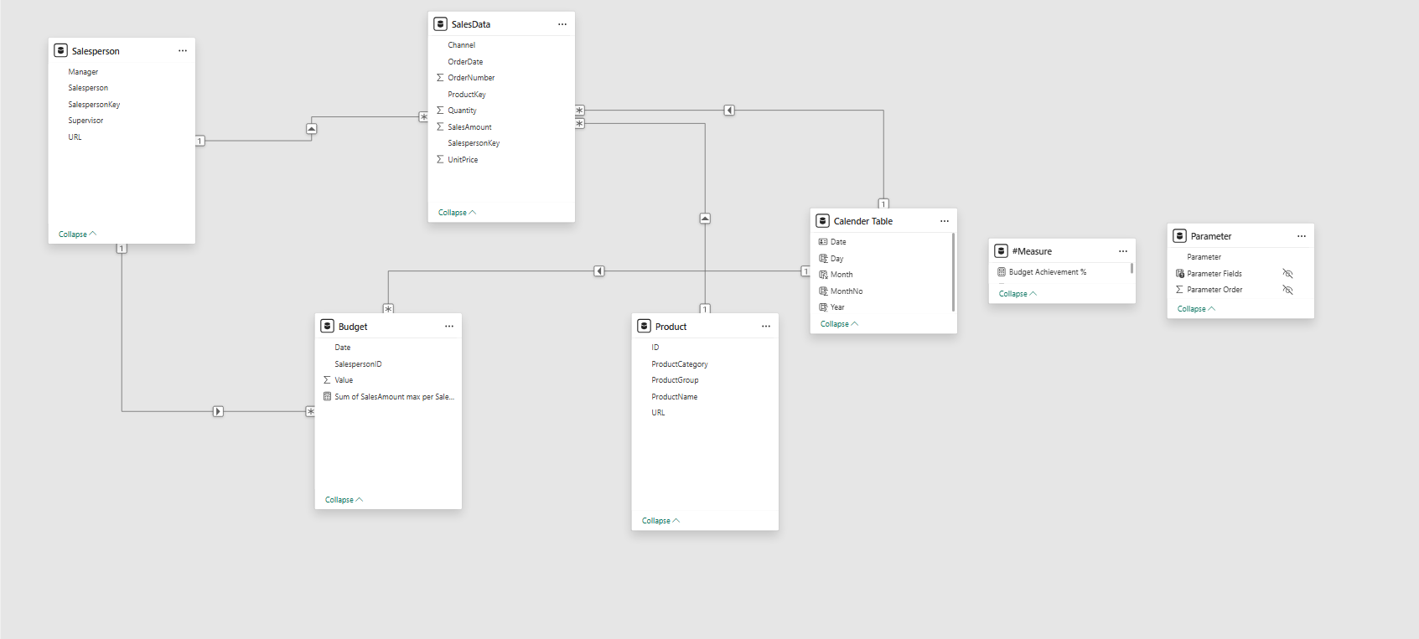

4. Report Development (Pages and Visuals)
The report contains 10 pages, including light and dark theme variants. A dedicated Home page provides button-based navigation to core analysis areas: Sales, Orders, Budget, and Details. Core pages share consistent slicers (Year, Month, Salesperson, Channel) to support easy cross-page analysis.
Page | Purpose | Key visuals (examples)
Home | Navigation hub | Buttons to Sales / Orders / Budget / Details
Sales Overview | Monitor sales and drivers | KPI cards, monthly revenue trend, top salespeople, sales by product group, Key Influencers
Orders Overview | Understand order volume patterns | Daily order trend, orders by channel, word cloud, donuts by group / year / manager / category, toggle buttons
Budget Overview | Budget allocation and performance | Budget trend, budget by supervisor / manager, sales by salesperson, budget vs sales toggle
Detail Overview | Transaction drill-down | KPI cards and detailed table (order-level records)
Theme / Advanced pages | Light/dark variants and additional views | Tooltip pages, what-if / KPI gauge, optional mobile layout

Visual variety and interactivity
Across the report, the design includes a wide variety of visuals (cards, clustered columns, line charts, bar charts, donut charts, tables, word cloud, and the Key Influencers AI visual). Interactivity is provided through slicers, cross-filtering, toggle buttons, custom tooltips, and drill-through to transaction detail.

5. Advanced Features Implemented
- Custom tooltips: hover-based tooltips provide additional context for KPIs and charts without crowding the page.
- Drill-through: users can drill from summary visuals (e.g., salesperson) into the Detail page to view underlying transactions.
- Key Influencers: AI-driven visual used to identify drivers of Sales Amount and highlight segments associated with higher performance.
- Conditional formatting: used to highlight performance outcomes
- Field parameters / dynamic switching: parameter table supports dynamic metric selection
- Light and dark themes: dedicated theme variants support accessibility and presentation use cases.

6. Business Questions Addressed
- How do total sales, orders, quantity, and budget achievement change over time (Year and Month)?- Which channels contribute the most to sales and orders, and how does channel mix differ across periods?
- Which product groups and categories drive the highest revenue and volume?
- Who are the top-performing and under-performing salespeople, supervisors, and managers versusbudget?
- What factors and segments influence Sales Amount (Key Influencers) and where should leadershipfocus for improvement?

7. Key Insights (from report visuals)
- Overall performance is above target: Total Sales (17.91M) exceeds Total Budget (17.27M), implyinga positive variance of about 0.64M and a budget achievement of 104%.
- Revenue trend is seasonal in the sample view: sales rise from early months and peak aroundSep-Oct before easing toward year end.
- Channel contribution in Orders Overview indicates Retail as the largest order source, followed byDistributor and Online.
- Top salespeople are clearly separated: Carla Ferreira leads with 4.7M, followed by Julio Lima (3.3M) and Gustavo Gomes (2.4M).
- Product mix is concentrated: Wheat Flour (4.5M) and Oil (2.9M) are key product groups by sales,with several smaller groups contributing the remainder.

8. Challenges and Resolutions
- Data quality and consistency: addressed by Power Query steps (type fixes, removing non-data rows, de-duplication, filtering invalid records).
- Date intelligence setup: resolved by building a dedicated Calendar Table and marking it as the Date table; Month sorting handled via MonthNo.
- Model clarity and performance: implemented star schema design with single-direction filtering and a measure container table to keep fields organized.
- Usability across many pages: solved with a consistent header, synced slicers, and button-based navigation (Home and section icons).
- Exploration without clutter: achieved using custom tooltips, drill-through, and dynamic metric selection.

Appendix A. Report Screenshots
Key report pages are provided below as supporting evidence of report structure, visuals, and interactivity.
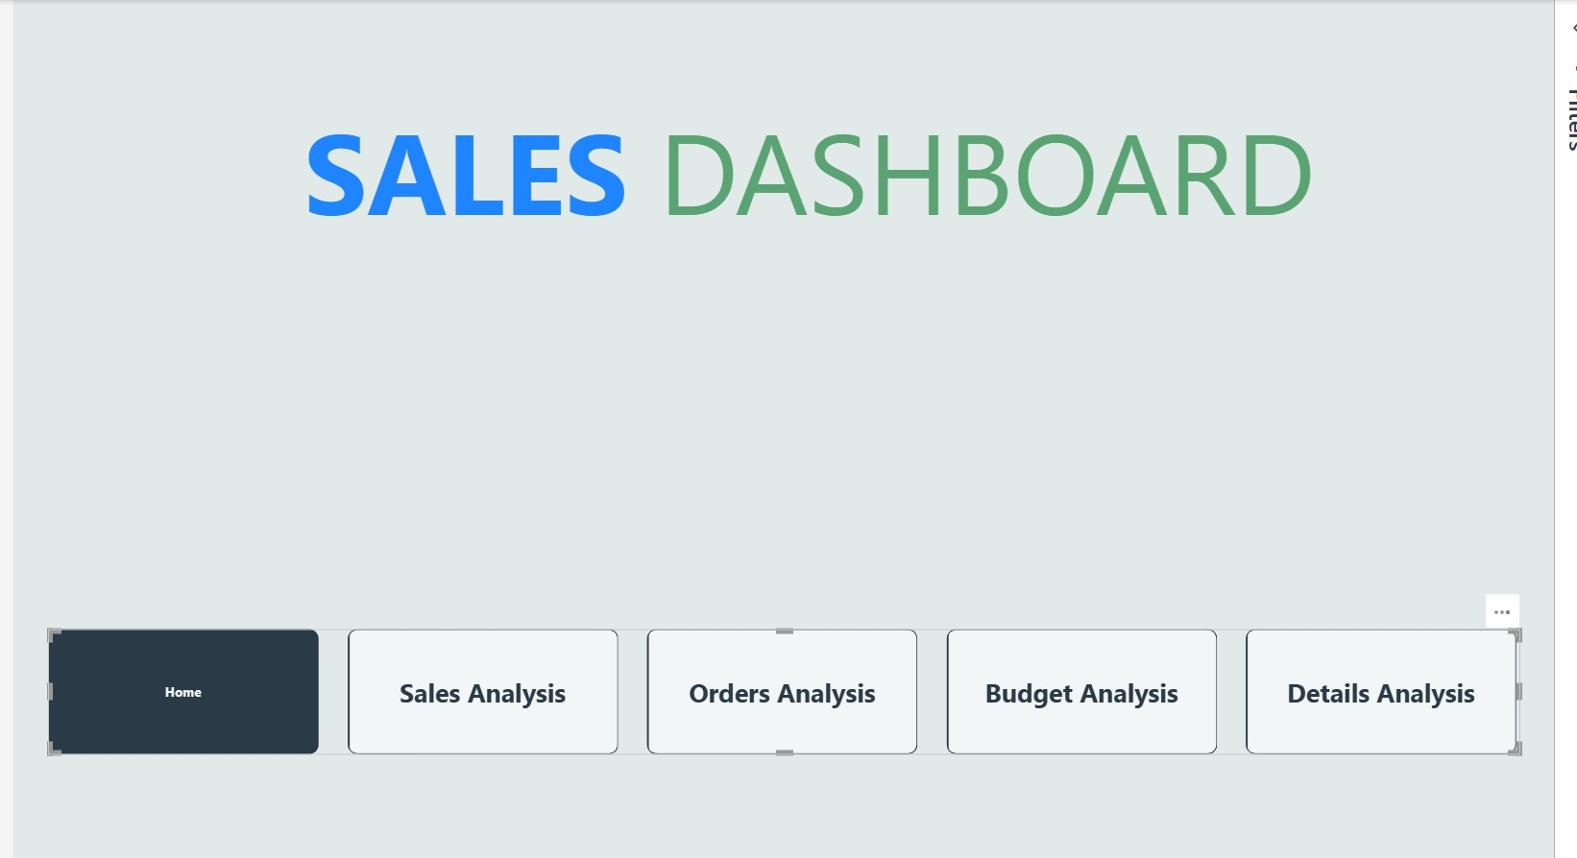
Figure 1. Home page with navigation buttons.
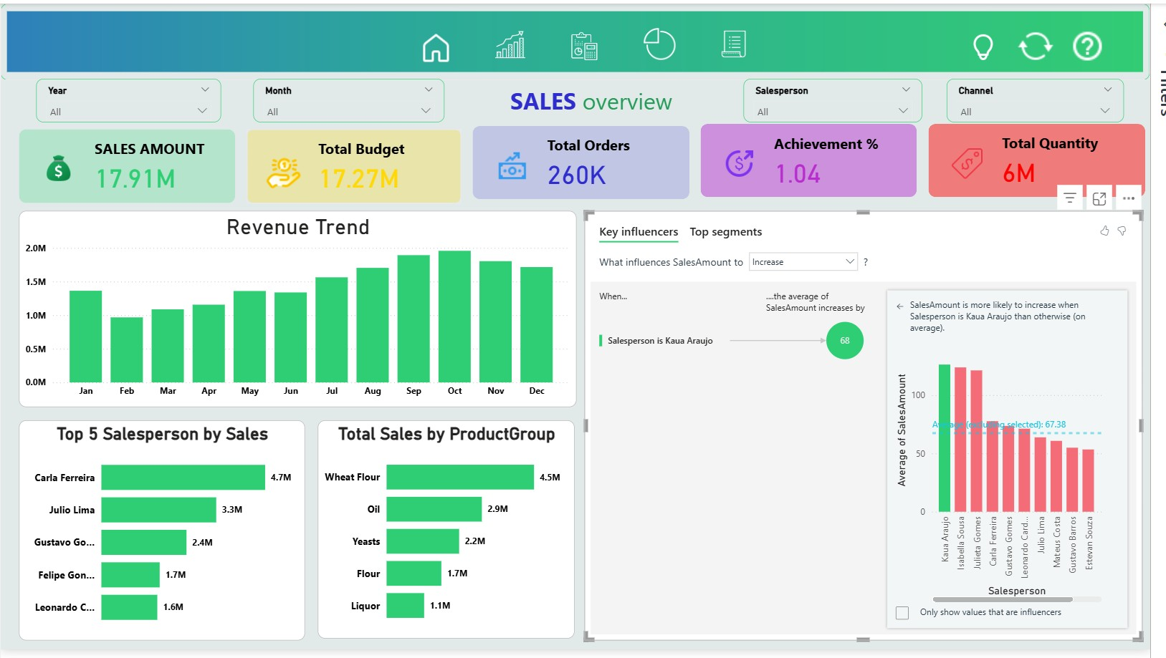
Figure 2. Sales Overview page (KPIs, revenue trend, top performers, key influencers).
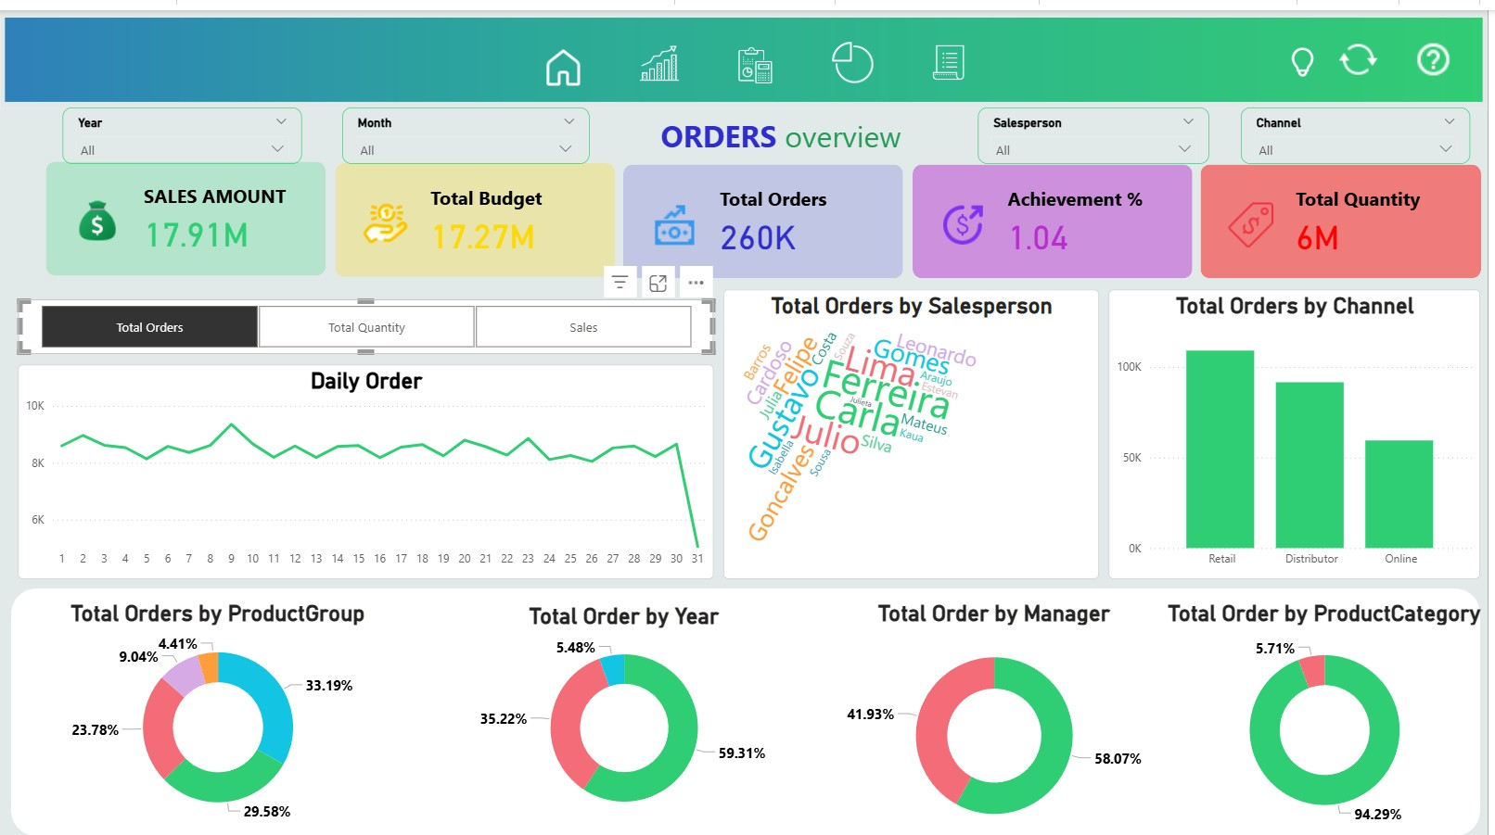
Figure 3. Orders Overview page (daily order trend, channel split, product and management breakdown).
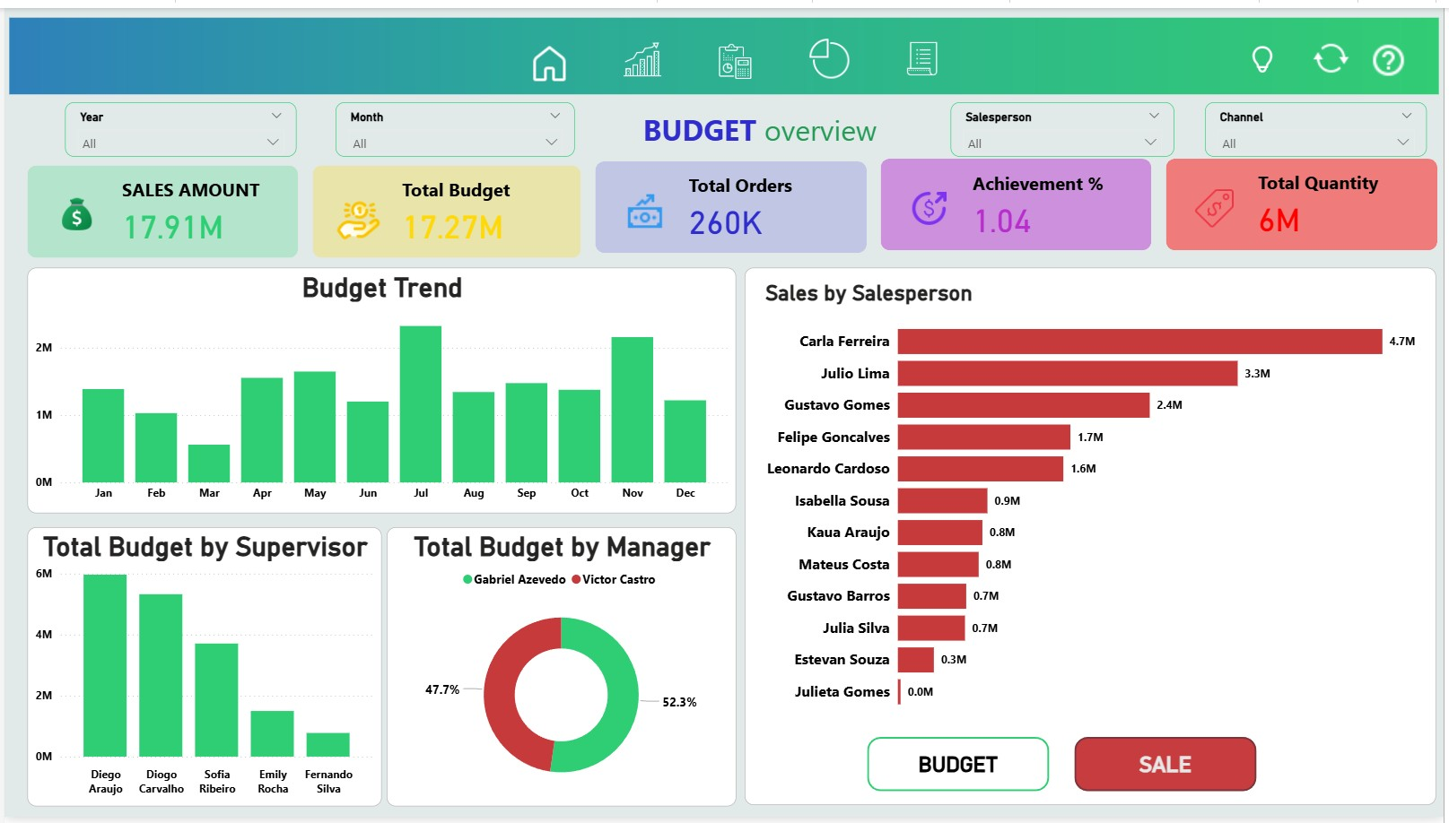
Figure 4. Budget Overview page (budget trend and budget allocation views).
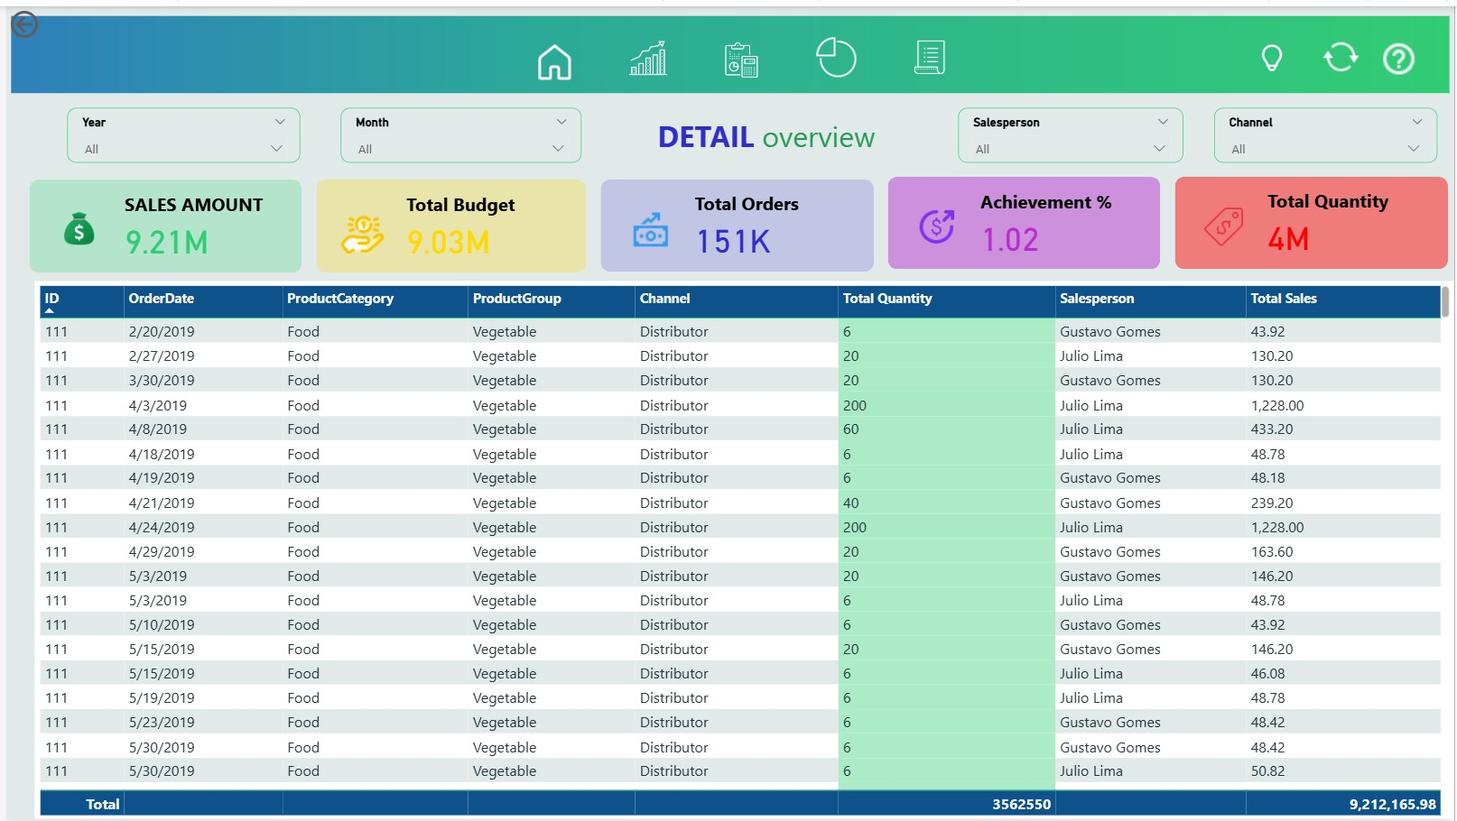
Figure 5. Detail page (drill-through to transaction-level table).
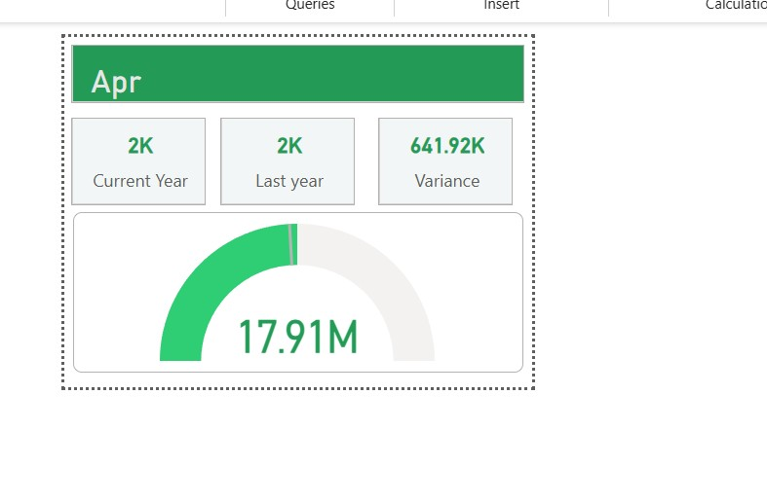
Figure 6. Monthly KPI/gauge view used for variance tracking.

