**THE PROJECT REPORT OF**

##### NAME: Antim Pal

##### REG NO: 1516502

##### ON

# HOTEL MANAGEMENT SYSTEM

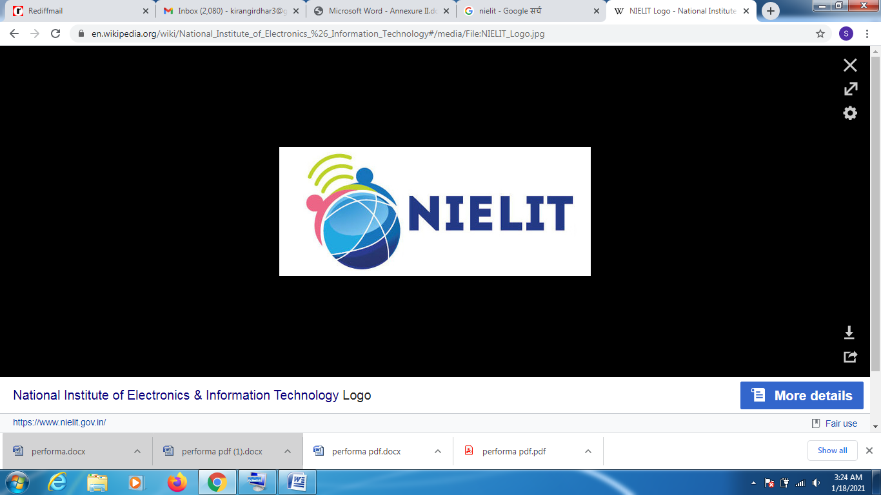

**In partial fulfillment of the requirement for the award of diploma**

**Of**

**'A' Level Project  
To   
NIELIT**

**DECLARATION**

I hereby declare that this project work titled **“Hotel management System”**  is my original work and no part of it has been submitted for any other degree purpose or published in any other from till date.

**NAME: Antim Pal**

**REG NO: 1516502**

**ACKNOWLEDGEMENT**

I hereby take this opportunity to express our sincere gratitude to all the people who have contributed to this project with their knowledge and experience.

I consider myself lucky to work under the guidance of **Mr. Vikas Sharma**. His rare combination of experience in different fields, humbleness, untiring patience and meticulous care has helped this work to acquire the shape of what it is today. This project would have been difficult to complete without his advice, ideas and zeal. He gave me the freedom to explore on my own and at the same time the guidance to recover when my steps faltered. He taught me how to question thoughts and express ideas. I owe an immense intellectual debt to him. It was always a new and unique experience while working with him.

Finally I would like to express my deep appreciation to my family and friends who have been a constant source of inspiration and spiritual support in all aspects of my life. I am eternally grateful to them for always encouraging and being with me wherever and whenever I needed them during the time period of the project.

**NAME: Antim Pal  
REG NO: 1516502**