DOCTORAL RESEARCH — TECHNICAL DOCUMENTATION
DiaFootCare: Design, Development and Evaluation of an On-Device Deep-Learning Platform for Diabetic-Foot-Ulcer Assessment
A patient mobile application, a clinician web dashboard, and a three-model on-device analysis pipeline — design, methods, training, evaluation and deployment.
Version 1.1 · 29 July 2026 · app build 1.1.0 (2)
This document updates and extends the earlier three-model reference (DaiFootCare_Models_Documentation, 2 July 2026) with the full development methodology, the application and dashboard, training figures, and the current deployment and data-collection status.
Abstract
Diabetic foot ulceration is a leading cause of lower-limb amputation, and its outcome depends heavily on frequent, consistent monitoring that is difficult to sustain between clinic visits. This work presents DiaFootCare, an integrated platform that was designed and built to move that monitoring onto the patient’s own phone while keeping a clinician in the loop. Three deep-learning models were developed: a U-Net wound-segmentation network (built on a MobileNetV2 encoder and trained on Kaggle) that produced pixel masks and derived length, width and surface area; a tissue-classification model that, after a from-scratch convolutional network failed to exceed chance, was rebuilt on frozen CLIP embeddings with a support-vector head; and an infection-and-ischaemia model that reused the same frozen backbone. The models were quantised to TensorFlow-Lite and embedded in a Flutter application that runs the full analysis on-device, with an equivalent server pipeline for phones that do not download the models. A Laravel and Vue clinical dashboard was built to supervise the cohort. The mobile tissue model exceeded the historic baseline on F1 (0.733 vs 0.656) while running on-device; the infection and ischaemia model reached AUCs of 0.890 and 0.987; and the segmentation model reached a held-out Dice of 0.818. The platform was deployed and published to the project server, and the research data-collection phase was begun. This document records the methodology and the work done in full.

Contents
1 Introduction and background
2 Aims and objectives
3 Materials — datasets
4 Methodology
4.1 System architecture
4.2 Model 1 — wound segmentation and measurement
4.3 Model 2 — tissue classification
4.4 Model 3 — infection and ischaemia
4.5 Shared image preprocessing
4.6 The mobile application
4.7 The clinical web dashboard and API
5 Results
5.1 Wound segmentation
5.2 Tissue classification
5.3 Infection and ischaemia
5.4 The integrated system
6 Deployment, publication and the onset of data collection
7 Discussion and limitations
8 Future work
9 Conclusion
References
RELEASE STATUS — NOT YET RELEASED TO USERS
DiaFootCare has not yet been released to end users. The build described here was deployed to the project server and made available to the research and clinical team for internal testing and for the beginning of supervised data collection. No public or participant release has taken place, and no real patients are using the app. All dashboard screenshots in this document use fictional demo data.

1 Introduction and background
Diabetic foot ulcers (DFUs) are among the most serious complications of diabetes mellitus. They precede the majority of non-traumatic lower-limb amputations, they heal slowly, and their trajectory can change within days. Because deterioration is often silent — neuropathy blunts the pain that would otherwise prompt a clinic visit — the interval between assessments is itself a risk factor. The clinical need that motivated this project was therefore a way to assess a wound frequently, consistently and objectively between visits, and to surface any deterioration to a clinician early.
The response developed in this work was DiaFootCare, a platform that was designed around three principles. First, the analysis was to run on the patient’s own device, so that a wound photograph need never leave the phone and so that the tool would work without a network. Second, the same analysis was to be available server-side, so that a patient with a low-end phone was not excluded. Third, the results were to be visible to a clinical and research team through a dashboard, so that the app was a monitoring instrument rather than a self-diagnosis toy. The remainder of this document records how the platform was designed, how each model was built and trained, how the software was developed and deployed, and what was measured.

2 Aims and objectives
The overall aim was to design, build and evaluate an integrated, on-device platform for diabetic-foot-ulcer assessment. The specific objectives that structured the work were:
- to develop a wound-segmentation model that produced reliable pixel masks and derived clinical measurements (length, width and surface area) from a single photograph;
- to develop a tissue-classification model able to report the tissue types present in the wound bed, at an accuracy usable on-device;
- to develop a model that estimated the two clinically-validated risk indicators — infection and ischaemia — and combined them into a single risk badge;
- to package all three models for on-device inference and to build a Flutter application around them, with an equivalent server pipeline;
- to build a clinician-facing web dashboard and the API that connects the two; and
- to deploy the platform and to begin collecting the doctor-reviewed data on which further improvement depends.

3 Materials — datasets
Five public and project-specific collections were used across the three models. The role of each differed by model and is detailed in the relevant methodology sections; they are summarised here.
Collection | Used by | Role in this work
DFUTissue / DFUTissueSegNet | Models 1, 2 | Finely annotated wound masks and tissue labels; the precise supervision signal for segmentation.
DFUC 2020 | Models 1, 2 | Weak box-derived masks for segmentation; 810 images later given real six-class doctor labels for tissue.
DFUC 2021 | Models 1, 3 | Representative images for the int8 export; whole-image infection/ischaemia labels for Model 3.
Part B (DFUNet) | Model 3 | Jointly infection- and ischaemia-labelled wounds that lifted the scarce ischaemia and “both” classes.
Doctor-reviewed labels (Source A) | Model 2 | 367 clinician-reviewed images added for this project; part of the gathered data described in §6.

Two facts about the data are worth stating early, because they shaped the methods. The precise wound-mask set was small (approximately 75 images), which forced heavy augmentation and a multi-phase training schedule for Model 1. And the tissue labels were expanded during the project by clinician review — an activity that is itself part of the data-collection effort reported in Section 6.

4 Methodology

4.1 System architecture
The platform was built as three cooperating components: a Flutter mobile application for patients, a Laravel-and-Vue web dashboard for clinicians, and a FastAPI inference service that ran the models server-side. A central architectural decision was that the two classification models (tissue, and infection/ischaemia) shared a single frozen CLIP ViT-B/32 image encoder. The encoder was the only large asset; it was loaded once and executed once per image to produce a 512-dimensional embedding, and each downstream task contributed only a small “head” network. The segmentation model was standalone. This factoring kept the installed application small and kept per-image inference fast, because the expensive encoder pass was amortised across two clinical tasks.

4.2 Model 1 — wound segmentation and measurement
Model 1 located the wound region as a pixel-level mask and converted that mask into clinical measurements. The task was formulated as binary semantic segmentation: every pixel of a 320×320 input was classified as wound or background, producing a per-pixel wound-probability mask.
Architecture. A U-Net decoder was built on a pretrained MobileNetV2 encoder (ImageNet transfer learning), with encoder skip connections taken at input /2, /4, /8 and /16 and the bottleneck at /32. A 320×320 input was chosen over 256×256 to preserve finer wound-boundary detail. The loss combined binary cross-entropy with a Focal-Tversky term (α = 0.3, β = 0.7, γ = 0.75), which penalised missed wound pixels more heavily and concentrated learning on the small wound region.
Training. The model was trained on Kaggle using GPU acceleration (Python 3.11). The training run documented here was executed on 14 May 2026 over 20 epochs; the deployed model followed a multi-phase schedule in which the encoder was first frozen while the decoder was trained, then the top 36 of 155 encoder layers were fine-tuned with batch-normalisation frozen, and finally high-confidence pseudo-labels were added in a self-training phase. ModelCheckpoint (best validation loss), ReduceLROnPlateau and EarlyStopping with best-weight restoration were used throughout, and mixed-precision training was used on the GPU. The precise mask set was oversampled threefold relative to the weak box masks, and strong augmentation (flips, rotations and random cutout) was applied. The training and validation curves for the Kaggle run are shown in Figure 1.
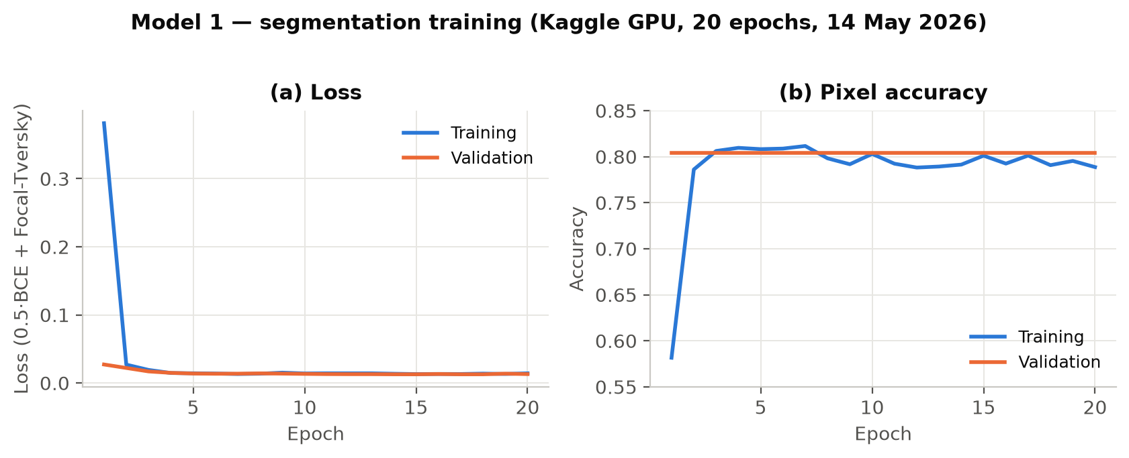
Figure 1. Model 1 segmentation training on Kaggle (20 epochs, 14 May 2026). The loss fell sharply within the first epoch and then converged; training pixel accuracy rose to ≈ 0.81. Validation pixel accuracy was essentially flat at ≈ 0.80 because background pixels dominate the frame — which is why Dice and IoU, not pixel accuracy, were used as the primary segmentation metrics (Section 5.1).
Measurement post-processing. The mask-to-measurement conversion was deterministic and was ported one-to-one from the training notebook into the application’s Dart code, so that on-device measurements matched the reference implementation. The probability mask was binarised, cleaned with a 5×5 morphological opening then closing, and reduced to its largest connected component. Length and width were taken as the extents of the wound’s principal (PCA) axes — the minimum-area rectangle rather than an axis-aligned box — and surface area was the wound-pixel count scaled to cm². Because the application ran without a physical reference object, the measurements were treated as relative: the reliable healing signal was the change in area over time rather than any single absolute figure. Wound depth, which a single two-dimensional photograph cannot recover, was not produced.

4.3 Model 2 — tissue classification
Model 2 identified which tissue types were visible in the wound bed. Because several types can be present at once, the task was formulated as multi-label classification over five classes (epithelial, granulation, necrosis, callus and slough); a sixth class, fibrin, was dropped because the clean evaluation set contained only two positive examples.
A negative result that shaped the method. A from-scratch convolutional network was attempted first. As Figure 2 shows, its validation macro-AUC never departed from chance across sixty-eight epochs, oscillating around 0.50. This negative result was decisive: it established that the small, heterogeneous tissue set could not support a network trained from scratch, and it motivated the move to transfer learning from a large pretrained encoder.
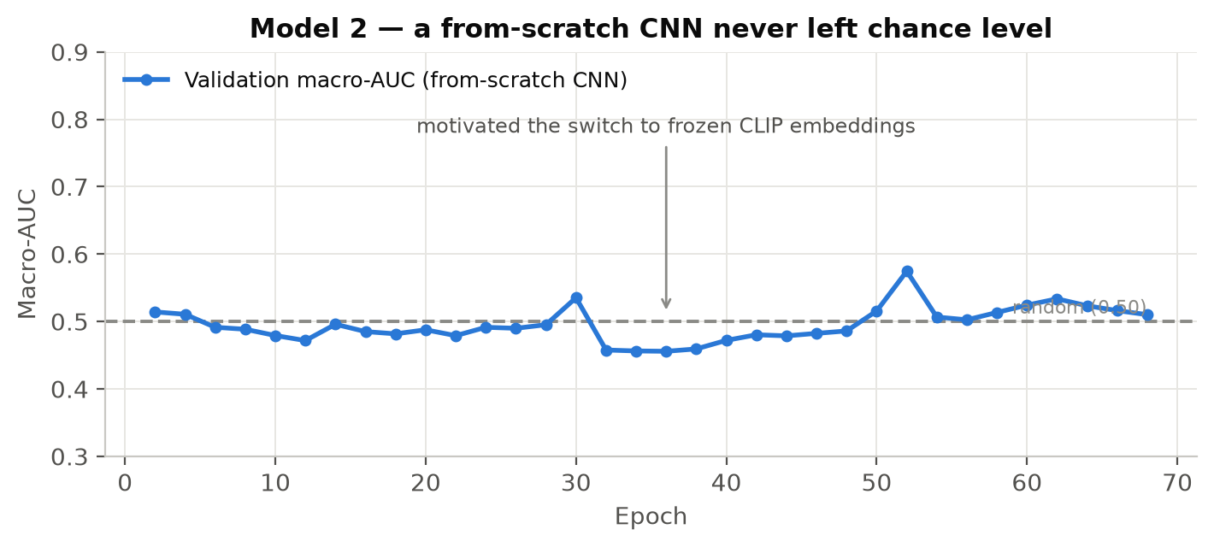
Figure 2. The from-scratch convolutional tissue classifier. Validation macro-AUC remained at chance level (≈ 0.50) throughout training, which motivated the switch to frozen CLIP embeddings.
The deployed approach. Tissue images were instead encoded with a frozen CLIP ViT-B/32 image encoder into 512-dimensional embeddings, on which a per-class radial-basis-function support-vector machine was trained. The CLIP embeddings carried the predictive power that the from-scratch network lacked. For deployment, the support-vector machine was reproduced exactly as TensorFlow operations — a “SVM-as-TFLite” head verified to within 8×10⁻⁶ of the desktop model — so that on-device accuracy equalled the desktop classifier. A research-best desktop variant that rank-averaged CLIP with DINOv2 was also built, but DINOv2 (a ViT-L encoder of roughly 1.2 GB) was impractical on phones, so the deployed mobile build was CLIP-only. The training set was expanded to 1,176 doctor-labelled images by the data-gathering effort of Section 6.

4.4 Model 3 — infection and ischaemia
Model 3 replaced an originally-planned “pus level” output, for which no severity labels existed, with two clinically-validated indicators: infection and ischaemia (blood flow). It was trained as a four-class softmax over {none, infection, ischaemia, both} — the DFUC 2021 label structure — from which the application derived two independent binaries: the probability of infection (infection + both) against a threshold of 0.41, and the probability of impaired blood flow (ischaemia + both) against a threshold of 0.61. This derived-binary formulation handled the rare ischaemia class far better than a direct four-way argmax.
The head reused the same frozen CLIP backbone as Model 2 (verified byte-identical), followed by L2-normalisation, a 256-unit ReLU layer with dropout, and a four-way softmax, trained with label smoothing (0.05) and class-balanced weights. The head was selected through two grouped cross-validation bake-offs: a multi-layer perceptron beat linear logistic regression, and label smoothing then beat weight decay, focal loss and a five-seed ensemble, at no extra deployment size (a single 262 KB head). Cross-validation used StratifiedGroupKFold grouped by wound, so that augmentation and patch-level leakage were eliminated.

4.5 Shared image preprocessing
The preprocessing for Models 2 and 3 had to match CLIP exactly, or classification accuracy collapsed: the image was decoded to RGB, resized so the shorter side was 224 pixels (bicubic), centre-cropped to 224×224, divided by 255, and per-channel normalised with the CLIP mean and standard deviation. Model 1 used its own pipeline (resize to 320×320 and divide by 255; the [−1, 1] rescale for MobileNetV2 was baked into the exported graph). The same preprocessing was implemented identically in Dart and in the server, so that a wound analysed on the phone and on the server produced the same result.

4.6 The mobile application
The application was built with Flutter for Android. The three models were quantised to float16 TensorFlow-Lite and bundled as assets; a single service loaded them, ran Model 1 for measurements, and ran the CLIP backbone once for both classification heads. The app was designed as a daily companion rather than only a scanner: alongside wound capture and analysis it provided blood-glucose logging, medication adherence, a daily foot-care checklist, appointments, reminders, notes, an education library and well-being questionnaires (including the standardised System Usability Scale used by the study). The first-run flow established trust before any feature was used, with plain-language terms, an explicit informed-consent declaration that stated exactly what was collected and that the data were not anonymous, and a choice of on-device or server analysis. Every feature worked offline against a local SQLite store, and registered patients’ records synchronised to the server when connectivity allowed.

4.7 The clinical web dashboard and API
A REST API was built with Laravel 12 (token authentication via Sanctum), and a Vue 3 single-page application was built on top of it for clinicians and the study team. The dashboard presented the cohort’s scans, healing trends, risk alerts, devices and engagement, and allowed the data to be exported as PDF or CSV. For online analysis, the API forwarded the photograph to the FastAPI inference service, relayed the result to the app, and stored it against the patient. The whole stack was deployed to an Ubuntu server under CloudPanel via a push-to-deploy Git remote, with the inference model running as a managed service.

5 Results
The models were evaluated retrospectively on held-out data. Figure 3 summarises the headline result achieved by each model as a bar chart, before the per-model detail that follows.
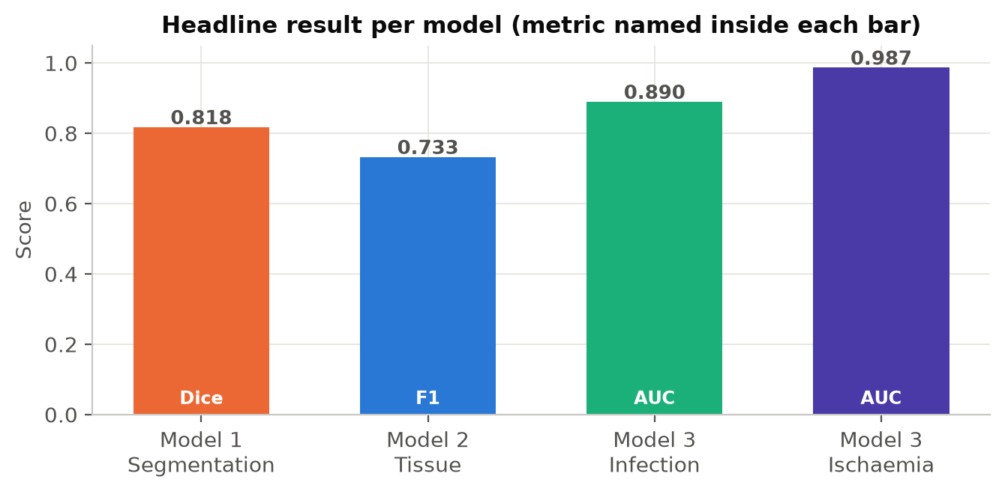
Figure 3. Headline result per model: segmentation Dice, deployed tissue F1, and infection and ischaemia AUC (each metric named inside its bar).

5.1 Wound segmentation
Segmentation quality was reported as Dice and intersection-over-union, computed after the full post-processing pipeline on held-out precise masks, because background pixels dominate the frame and inflate raw pixel accuracy. The held-out test Dice, using eight-view test-time augmentation, was the primary quality figure.
Split | Metric | Value
Validation (per-epoch, Keras) | Soft-Dice | 0.689
Validation (final, post-processed) | Dice | 0.706
Test (held-out, 8-view TTA) | Dice | 0.818
Validation | Best mask threshold | 0.58

A representative measurement output was {length 1.38 cm, width 1.57 cm, area 1.65 cm²}. The training dynamics of the Kaggle run are shown in Figure 1 above, and the Dice scores by evaluation split are shown as a bar chart in Figure 4.
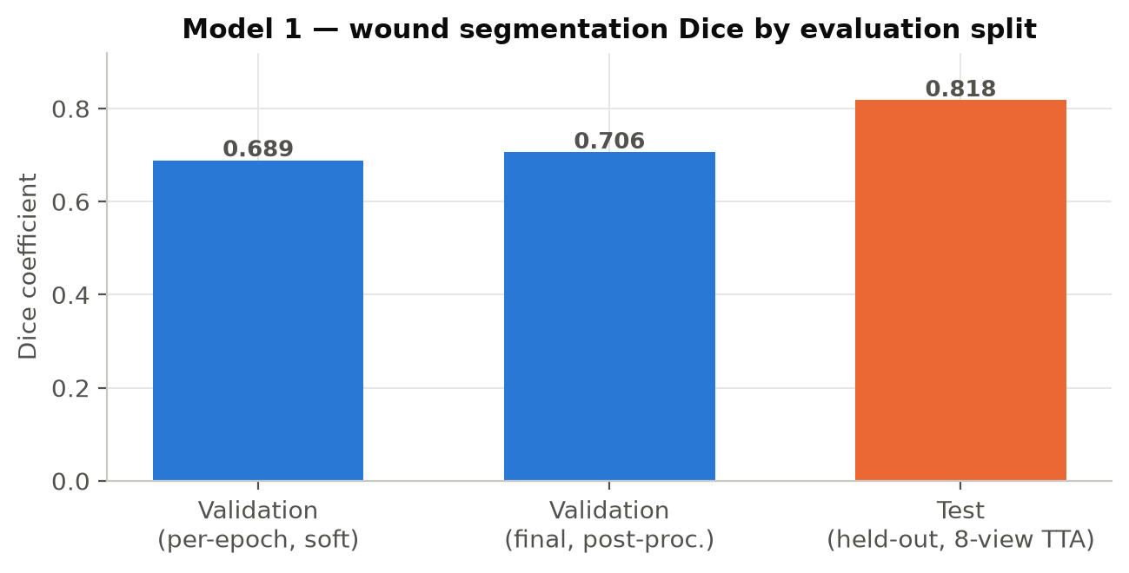
Figure 4. Model 1 wound-segmentation Dice by evaluation split. The held-out test Dice (0.818, eight-view test-time augmentation, shown in orange) was the primary quality figure; validation Dice is shown for reference.

5.2 Tissue classification
On the Source-A evaluation set, the deployed mobile model exceeded the historic baseline on F1 by 0.077 while running entirely on-device, and came within 0.013 AUC of the much larger desktop ensemble (Figure 5). The from-scratch convolutional network, by contrast, never exceeded chance (Figure 2). Models 2 and 3 were developed in the same workspace and share the single frozen CLIP backbone described in Section 4.1.
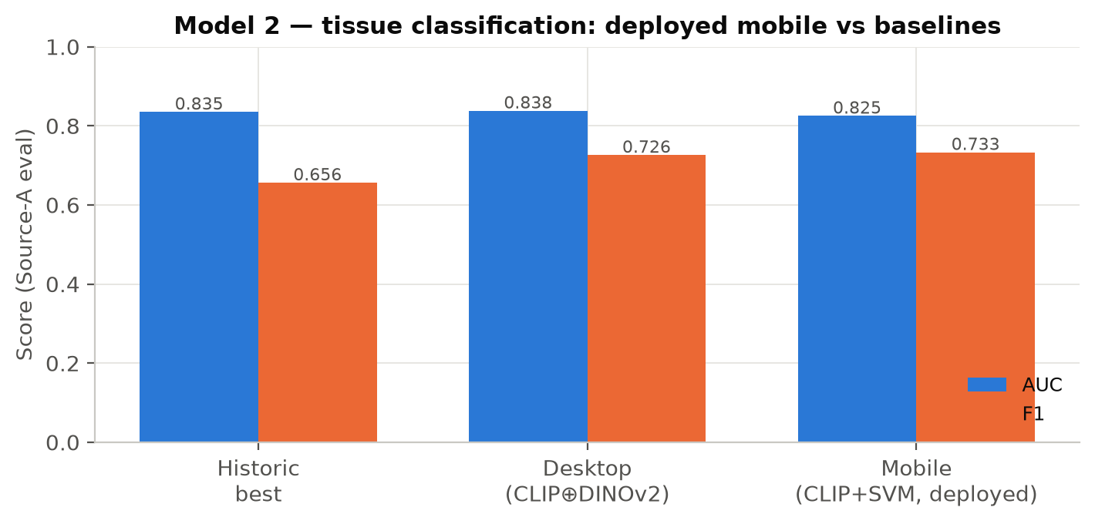
Figure 5. Tissue classification on the Source-A evaluation set. The deployed mobile model (CLIP + SVM-as-TFLite) matched the desktop ensemble on F1 and beat the historic baseline, at a fraction of the size.
The model shipped raw probabilities, and the application applied per-class thresholds read from the exported metadata: epithelial 0.09, granulation 0.43, necrosis 0.60, callus 0.45 and slough 0.63.

5.3 Infection and ischaemia
Under five-fold grouped cross-validation, the two derived binaries reached out-of-fold AUCs of 0.890 (infection) and 0.987 (ischaemia), with F1 scores of 0.829 and 0.872 at their tuned thresholds (Figure 4). The aggregate macro-binary AUC was 0.939 and the macro-F1 was 0.850. Head selection improved every metric monotonically — from linear logistic regression, to a multi-layer perceptron, to the perceptron with label smoothing (Figure 7). Model 3 was developed in the same D:\DF workspace as Model 2 and reused its frozen CLIP backbone unchanged.
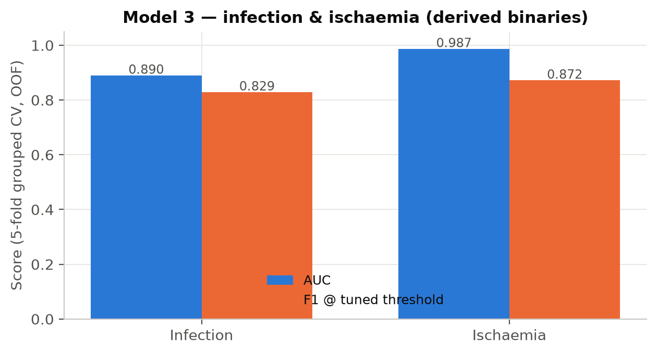
Figure 6. Infection and ischaemia performance (five-fold grouped cross-validation, out-of-fold). Ischaemia detection was near ceiling; infection retained the remaining headroom.
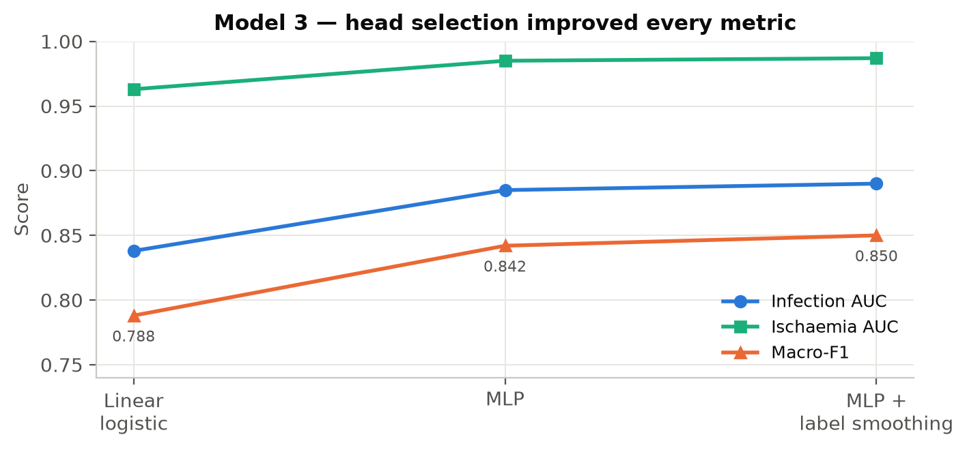
Figure 7. Model 3 head selection. Every metric improved from linear logistic regression to a multi-layer perceptron and again with label smoothing, at no extra deployment size.

5.4 The integrated system
The three models were integrated into the running application and dashboard. Figure 8 shows the patient flow from informed consent through capture to the analysis result and the healing trend; Figure 9 shows the clinician view of the same data. All dashboard data are fictional demo records.
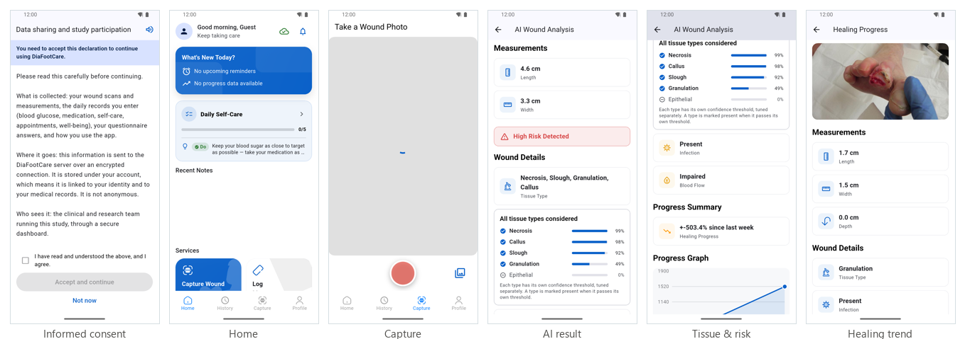
Figure 8. The mobile application in use — informed consent, home, wound capture, the AI result (measurements, tissue and risk), and the healing trend. Captured on app build 1.1.0 (2).
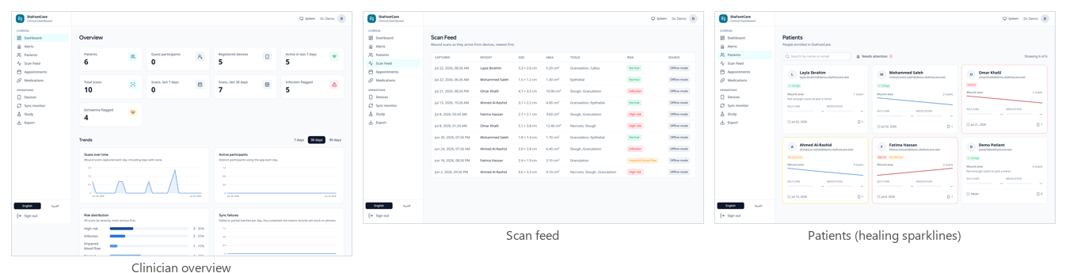
Figure 9. The clinical web dashboard — the cohort overview, the scan feed with colour-coded risk, and the patient list with per-patient healing sparklines (demo data).

6 Deployment, publication and the onset of data collection
The platform was deployed and published to the project server (diafootcare.tech): the web dashboard and API were placed behind TLS on an Ubuntu/CloudPanel host, the inference service was installed as a managed process, and the Android application was made available for download with a machine-readable version manifest that the download page reads. It must be stated plainly that this was a deployment to a staging and testing channel for the research and clinical team, and not a public release to end users.
With the platform in place, the research data-collection phase was begun. The tissue dataset was enlarged by clinician review — 367 doctor-reviewed images were added under the project’s Source-A labels, and 810 DFUC 2020 training images that had previously carried only bounding boxes were given real six-class doctor labels — bringing the pooled gold set to 1,176 doctor-labelled images. This annotation activity was the first stage of the data gathering on which further model improvement depends, and it continues.
The 1.1.0 update. During this phase a maintenance release (build 1.1.0 (2)) was prepared and staged. It added the wound’s surface area to the analysis result alongside length and width, carried end-to-end from the segmentation model through the application, the API and the inference service so that offline and online analyses agreed; and it corrected the Settings screen so that the terms and conditions could be reviewed (read-only) from within the app. The application, API, inference service and download page were updated together, so that a wound analysed on any test phone reported the same measurements and the download page advertised the exact build that was served.
CURRENT STATUS
The platform is deployed, the models are integrated and evaluated, and the doctor-reviewed data collection has commenced. A public release to patients has not yet taken place; the immediate next step is the supervised pilot described in Section 8.

7 Discussion and limitations
The results support the central design choice of transfer learning from a large frozen encoder. The clearest evidence was negative: a convolutional tissue classifier trained from scratch never left chance level (Figure 2), whereas the same data encoded with a frozen CLIP backbone and classified by a support-vector head exceeded the historic baseline. Reusing that one backbone across two tasks also kept the on-device footprint small enough to be practical.
Several limitations were recognised. The precise wound-mask training set was small (≈ 75 images), and although augmentation and weak box masks compensated in part, the segmentation model would benefit from more finely annotated wounds. Absolute centimetre measurements were not reliable without an in-frame reference object, so only the relative area trend should be read as a healing signal; wound depth was deliberately not estimated. Infection reflects broad clinical criteria rather than exudate alone, and neuropathic patients may under-present, so the output is a monitoring aid and not a sole diagnostic basis. Finally, the evaluation reported here is retrospective and cross-validated; the prospective clinical value of the platform remains to be established in the pilot.

8 Future work
- a supervised pilot with recruited patients, to gather prospective, longitudinally-linked wound series and to evaluate the healing-trend signal against clinical outcome;
- enlargement of the precise segmentation set and re-training of Model 1 as more doctor-annotated wounds are collected;
- wound-crop preprocessing (feeding the Model 1 mask into Models 2 and 3) to close the remaining infection-detection headroom;
- preparation of the application for a controlled participant release, including an iOS build and store-readiness; and
- analysis of the engagement and questionnaire data collected through the dashboard.

9 Conclusion
An integrated, on-device platform for diabetic-foot-ulcer assessment was designed, built and evaluated. Three deep-learning models — for segmentation, tissue classification, and infection and ischaemia — were developed, with the tissue and risk models sharing a single frozen CLIP backbone, and were embedded in a Flutter application backed by an equivalent server pipeline and supervised through a clinical web dashboard. The models reached a held-out segmentation Dice of 0.818, a deployed tissue F1 of 0.733 that exceeded the historic baseline while running on-device, and infection and ischaemia AUCs of 0.890 and 0.987. The platform was deployed and published to the project server, and the doctor-reviewed data collection that will drive the next iteration was begun. The work establishes the technical foundation for the prospective clinical study to follow.

References
[1] Ronneberger, O., Fischer, P., Brox, T. (2015). U-Net: Convolutional Networks for Biomedical Image Segmentation. MICCAI 2015, LNCS 9351, 234–241. arXiv:1505.04597.
[2] Sandler, M., Howard, A., Zhu, M., Zhmoginov, A., Chen, L.-C. (2018). MobileNetV2: Inverted Residuals and Linear Bottlenecks. CVPR 2018, 4510–4520. arXiv:1801.04381.
[3] Abraham, N., Khan, N. M. (2019). A Novel Focal Tversky Loss Function with Improved Attention U-Net for Lesion Segmentation. ISBI 2019, 683–687. arXiv:1810.07842.
[4] Radford, A., Kim, J. W., Hallacy, C., et al. (2021). Learning Transferable Visual Models from Natural Language Supervision (CLIP). ICML 2021, PMLR 139, 8748–8763. arXiv:2103.00020.
[5] Oquab, M., Darcet, T., Moutakanni, T., et al. (2023). DINOv2: Learning Robust Visual Features without Supervision. arXiv:2304.07193.
[6] Dhar, M. K., et al. (2024). Wound Tissue Segmentation in Diabetic Foot Ulcer Images Using Deep Learning: A Pilot Study (DFUTissue). arXiv:2406.16012.
[7] Yap, M. H., Kendrick, C., Reeves, N. D., Goyal, M., Pappachan, J. M., Cassidy, B. (2021). Development of Diabetic Foot Ulcer Datasets: An Overview. Diabetic Foot Ulcers Grand Challenge, 1–18. arXiv:2201.00163.
[8] Yap, M. H., Cassidy, B., Pappachan, J. M., O’Shea, C., Gillespie, D., Reeves, N. D. (2021). Analysis Towards Classification of Infection and Ischaemia of Diabetic Foot Ulcers. IEEE BHI 2021, 1–4.
[9] Goyal, M., Reeves, N. D., Rajbhandari, S., Ahmad, N., Wang, C., Yap, M. H. (2020). Recognition of Ischaemia and Infection in Diabetic Foot Ulcers: Dataset and Techniques. Computers in Biology and Medicine, 117, 103616.

Companion document: DaiFootCare_Models_Documentation (the three-model technical reference), which this document updates and extends. Dataset citations [6]–[9] are reproduced as required by the dataset providers and must be cited in any publication using the DFUC collections.

