Imam Mohammad Ibn Saud Islamic University
College of Computer and Information Sciences
Information Systems Department

Course Title: | Application Development
Course Code: | IS1337
Course Instructor(s): | Dr. Prabu Pachiyannan, Dr. Fareeha Anwar ,Dr. Halah Al-Ashaikh,
Exam: | Assignment 1
Semester: | 1st Semester - 202627
Date: | --
Marks: | 5
Privileges: | ☐ Open Book  ☐ Calculator Permitted | ☐ Open Notes  ☐ Laptop Permitted

Students Names (in English): | Ibrahim alsagabi-173 | BADER ALKHARJI-171 | Sultan Batarfi  -173
Students IDs: | 445006914 | 444001683 | 445018502
Section No.:

Instructions:

- A group submission of Maximum 3 Students
- Any Cheating will result in ZERO mark for the assignment.
- Plagiarism penalty will be applied if your answers are similar with any of your colleagues’ answers.
- Write down the complete answers clearly and in your own words.
- Submit only softcopy (in pdf) of the assignment via Blackboard.
- Late submissions are not acceptable.

Official Use Only
Question | Student Marks | Question Marks
1 |  | 5
Total |  | 5

Saudi Green Life
Student Environmental Awareness Website
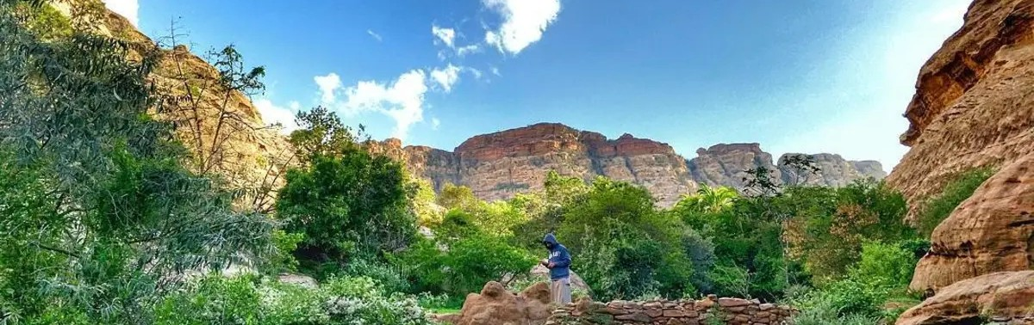

1. Introduction
Saudi Green Life is a student website designed to increase environmental awareness in Saudi Arabia. It introduces visitors to sustainability, responsible use of natural resources, and practical daily habits that support a greener future. The project is inspired by Saudi Vision 2030 and the Saudi Green Initiative.
The website also presents different natural environments in the Kingdom, including marine areas, deserts, mountains, and cities. It is intended for students and the public who want to learn more about environmental protection.
2. Project Objectives
Explain why protecting water, energy, wildlife, and other natural resources is important.
Share simple sustainability tips that visitors can follow in everyday life.
Introduce four different Saudi natural environments and related protection efforts.
Provide sign-up, sign-in, and environmental survey interfaces.
Use a consistent and easy-to-navigate design across the website.
3. Development Tools and Project Structure
The website was developed using HTML5 to organize page content and CSS3 to control the layout, colors, typography, images, spacing, buttons, and hover effects. No JavaScript, PHP, or database was used because this assignment focuses on HTML and CSS.
The project contains five HTML pages: index.html, green-life.html, signup.html, signin.html, and survey.html. It also includes css/style.css and folders for images and videos. These files are organized in one project directory.
4. Main Website Design
All pages share a header with a nature-themed background, university and environmental initiative logos, a navigation bar, and a footer with contact and social-media links. A shared external CSS file maintains the visual style. Internal page links make long environmental content easier to explore.
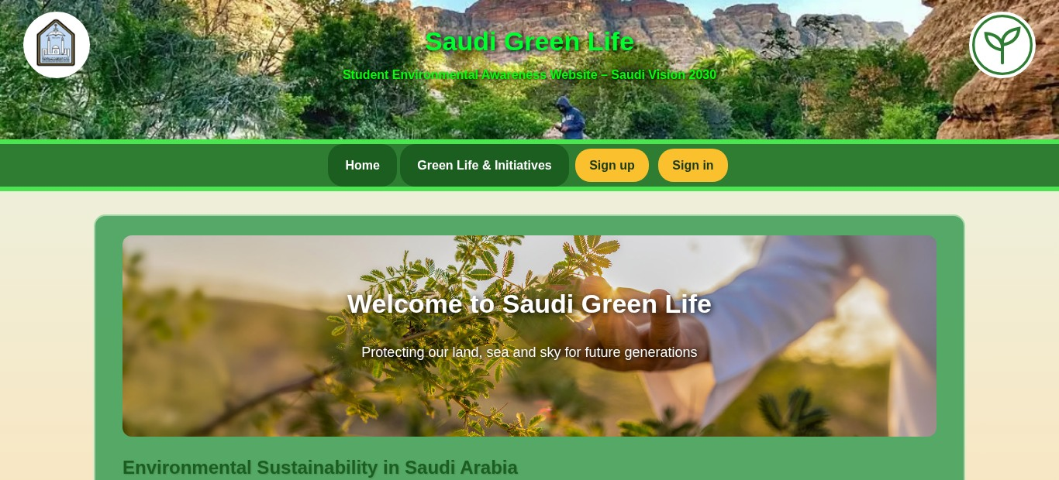
Figure 1. Home page with shared header, navigation, and introductory content (uploaded project version).
5. Website Pages and Features
5.1 Welcome Page (index.html)
The welcome page introduces environmental sustainability in Saudi Arabia. It discusses the value of preserving natural resources and includes three illustrated topics: water, energy, and biodiversity. It also explains the connection between sustainability, Saudi Vision 2030, and the Saudi Green Initiative. Links guide users to the sustainability page or the sign-up form.
5.2 Sustainable Life and Green Initiatives (green-life.html)
This page provides six practical sustainability topics: water conservation, energy saving, recycling, wildlife protection, tree planting, and renewable energy. The Saudi Green Horizons section is divided into four areas: The Marine Horizon, The Desert Horizon, The Mountain Horizon, and The Urban Horizon.
Each horizon contains a short description, a relevant image, and a local video. The page also includes a floating “On this page” menu with internal links to its sections, along with “Back to top” links for easier navigation.
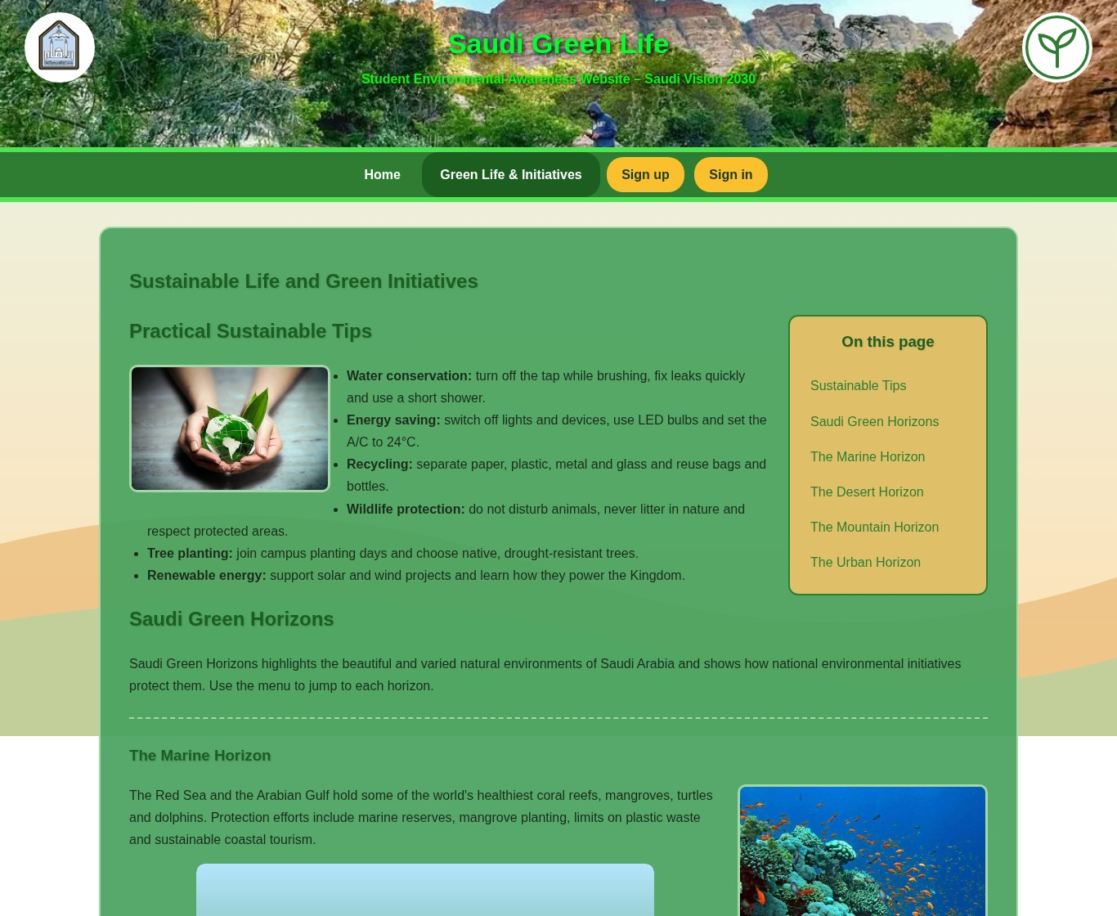
Figure 2. Green Life page showing sustainable tips and the floating internal navigation menu.
5.3 Sign-up Page (signup.html)
The sign-up form asks for full name, date of birth, gender, academic level, college, and home city. It also includes username and password fields, plus checkboxes for recycling, renewable energy, wildlife, and water conservation interests. HTML input types, select lists, radio buttons, and required fields are used to structure the form.
5.4 Sign-in Page (signin.html)
The sign-in form contains a username field and a password field. When the form is submitted, it opens the survey page as a demonstration of the intended user journey. It does not verify an account because the website is a static HTML and CSS project.
5.5 Environmental Awareness Survey (survey.html)
The survey allows visitors to select environmental topics, identify sustainable habits they currently follow, rate their awareness, and write feedback or suggestions. The form uses checkboxes, a drop-down list, and a text area. Submission returns the visitor to the home page; survey responses are not stored.
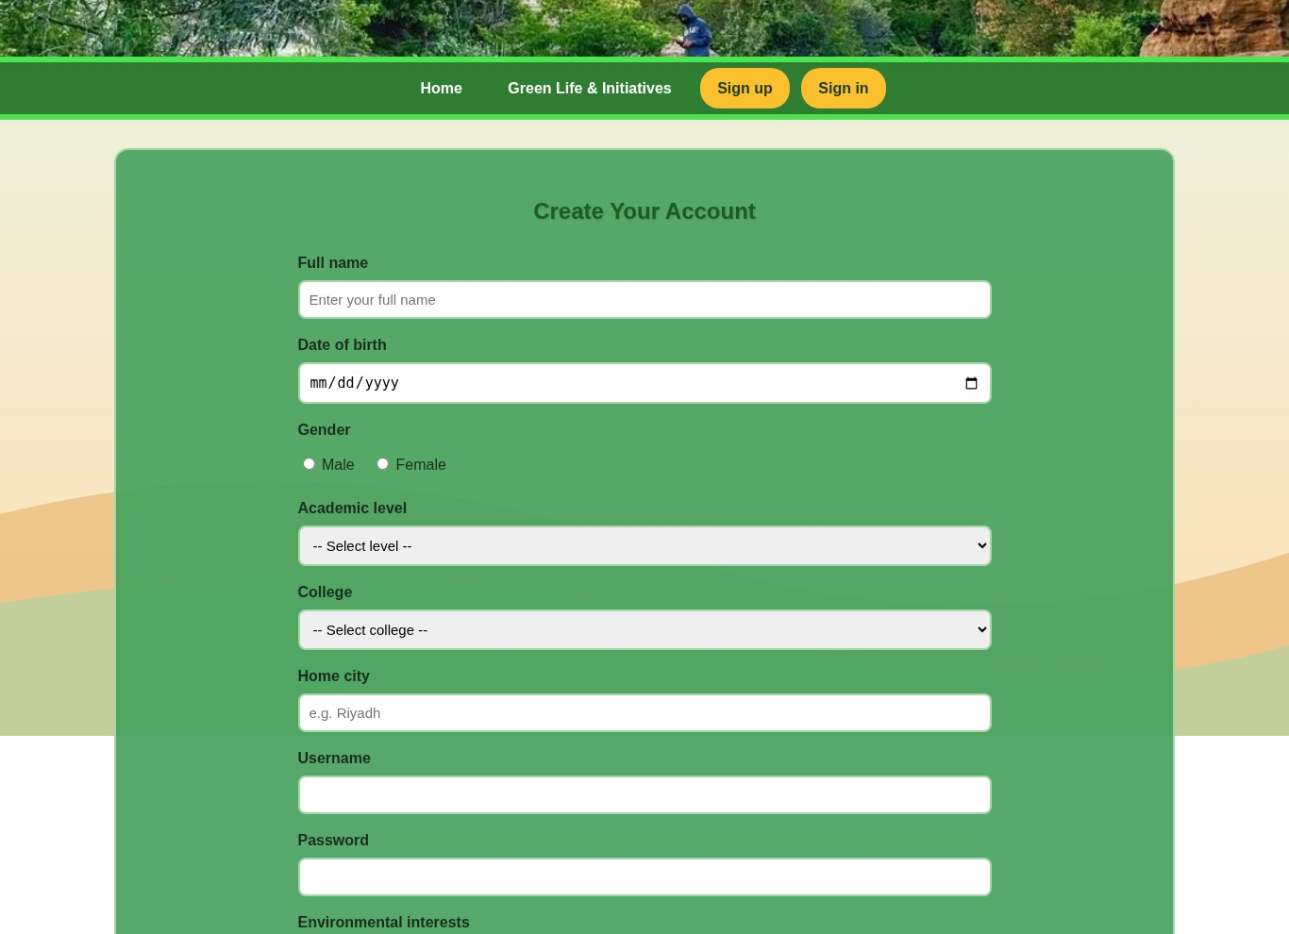  Figure 3. Sign-up form | 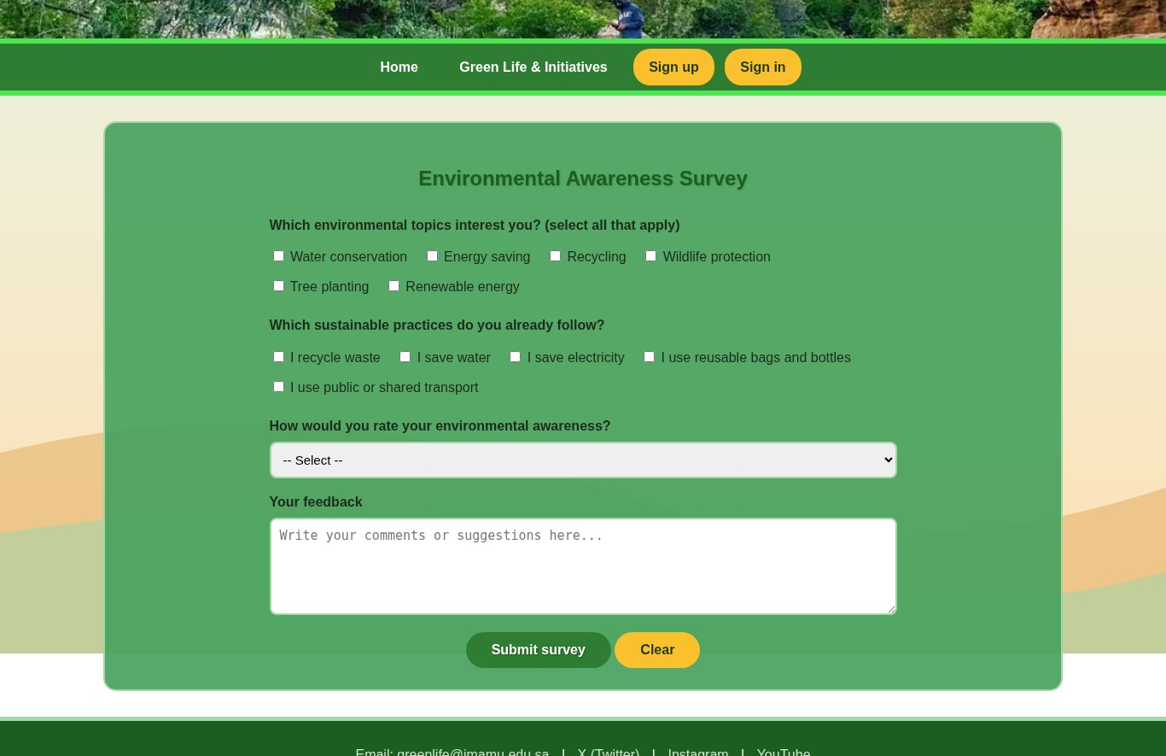  Figure 4. Awareness survey
6. Interface Design and CSS Techniques
The site uses an external CSS stylesheet to keep the appearance consistent across pages. The style rules include element and class selectors, background images, background positioning and sizing, margin and padding, borders and border radius, text alignment, hover effects, width and height, and the float property. The environmental theme is reflected in the use of green colors, nature photographs, and organized content sections.
7. Basic Review and Testing
The uploaded version of the project was reviewed in desktop and narrow-screen layouts. The five pages could be displayed, local image references were available, and the navigation and internal section links were present. The form fields and page destinations were checked by reviewing the HTML code. A final review should be completed after any design changes and before submission.
8. Project Scope and Limitations
Saudi Green Life is a front-end demonstration made with HTML and CSS only. The sign-up form does not create an actual user account, sign-in does not authenticate stored credentials, and survey responses are not saved to a database. These features would require additional programming and data storage beyond the scope of this assignment.
9. Conclusion
This project shows how HTML and CSS can be used to build an organized environmental awareness website. Saudi Green Life combines educational content, images, videos, navigation links, and interactive HTML forms in one consistent design. Through the project, the team practiced page structure, form creation, CSS styling, and linking multiple pages while presenting sustainability topics related to Saudi Arabia.
11. Sources and Media Credits
Course specification: IS1337 – Application Development, Assignment 1 (Semester 1, 2026–2027)

