Project Report: Secure Smart Contract Data Feed (Topic 26)
Team Members: Ibrahem Amar & Nour Raiaheen & Qosay Barmke
Process of the Project Study
This study addresses the "Oracle Problem" in blockchain architectures: how to safely ingest real-world data into an isolated smart contract environment. To eliminate dependencies on high-level, forbidden external packages, this project engineered a custom, zero-trust hybrid cryptographic pipeline from scratch.
The research and development process was divided into three core primitive layers:
- Symmetric Encryption (SM4-GCM): Chosen for fast processing of dynamic data payloads. It deploys the Chinese commercial SM4 standard (32-round generalized Feistel block cipher) wrapped in Galois/Counter Mode (GCM). This transforms the cipher into a stream-like cipher using counter increments $J_{0}$and appends a 16-byte GHASH tag evaluated over a finite field $GF\left(2^{128}\right)$to guarantee data confidentiality and integrity.
- Asymmetric Key Encapsulation (EC El-Gamal): Used to solve the public-key transmission bottleneck. Instead of encrypting large data chunks with asymmetric math, a fresh, random 128-bit SM4 key is generated per transmission and encapsulated via EC El-Gamal using the standard secp256k1 elliptic curve. Koblitz's mapping method was implemented to systematically convert the 128-bit integer key into a valid (x, y) coordinate point on the curve field (P).
- Source Authentication (ECDSA): Integrated over the same secp256k1 curve to ensure identity verification and non-repudiation. The Oracle signs the outbound package using its private scalar key, producing a coordinate verification pair (r, s) anchored in the hardness of the Elliptic Curve Discrete Logarithm Problem (ECDLP). Hashing is handled uniformly via SHA-256.
System Architecture & Project Flow
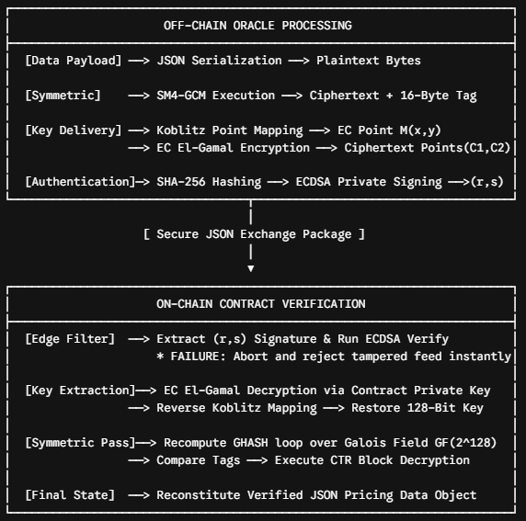
Obtained Results and Evaluation
The system was compiled and validated using an off-chain market ticker object: {'asset': 'ETH/USD', 'price': 3412.75, 'volume_24h': 1234567.89}. Two operational environments were simulated to test the robustness of the custom primitives:
Metric / Scenario | Scenario A: Valid Baseline Pass | Scenario B: Active Tampering Injection
Input Data | Authentic price feed dictionary | Target ciphertext byte inverted (ct_bytes[0] ^= 0xFF)
ECDSA Check | PASSED (Signature matches payload) | FAILED (Payload digest altered in transit)
EC El-Gamal | Successfully derived SM4 key point | Execution aborted prior to key decryption loops
SM4-GCM Tag | Verified via $GF\left(2^{128}\right)$multiplier logic | Processing blocked at edge boundary layer
Final State | Contract successfully recovers pricing payload | Transaction dropped; system state protected
Output Log | [Contract] GCM authentication passed | ValueError: ECDSA signature INVALID - data rejected!
Result Analysis: When an attacker tries to alter data in transit, the modification causes an immediate message digest mismatch. Because the smart contract executes the ECDSA signature check as an initial protective filter, the manipulation is blocked instantly. This defensive structure keeps malicious inputs from reaching the core decryption modules, protecting the contract's resources.
Technical Conclusions
- Architectural Soundness: Combining symmetric block operations (SM4-GCM) with elliptic curve asymmetric components (secp256k1 for El-Gamal and ECDSA) provides a practical solution for data transmission. This framework achieves high performance without compromising cryptographic strength.
- Primitive Autonomy: Building the complete pipeline manually—including Feistel scheduling, Galois Field polynomial reductions, modular inverses using the Extended Euclidean Algorithm, and scalar coordinate tracking—demonstrates that secure, zero-trust pipelines can be built independently of restricted high-level software libraries.
- Production Readiness: The testing phase confirms that the pipeline provides complete confidentiality, mathematically sound source verification, and precise tampering tracking. The multi-tiered validation checks ensure that the consuming interface can ingest external real-world feeds securely and reliably.

