**Tumors**

* **Login Page**

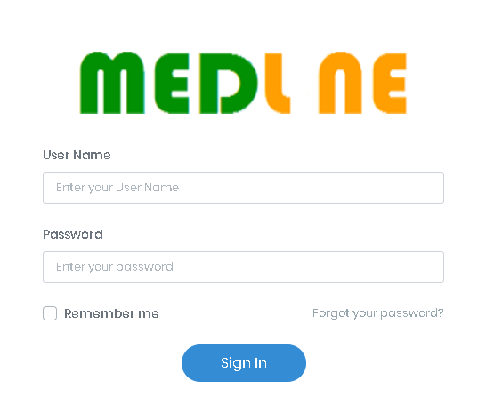

* **Create / Edit cancer type and its subtypes**

1. ICD code
2. Cancer type name

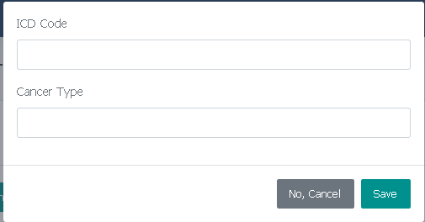

* **Show cancer type and subtypes**

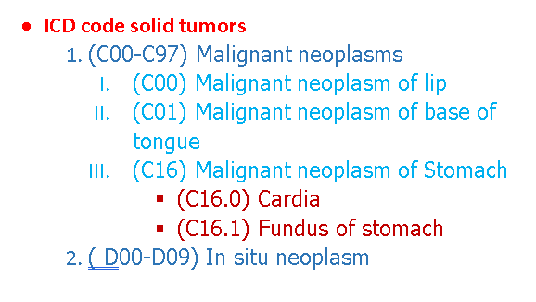

* **Create / Edit Histological or Molecular subtype and their subtypes**

1. Name



* **Show histological subtypes and their subtypes**

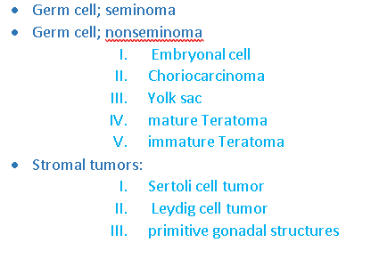

* **Show molecular subtypes and their subtypes**

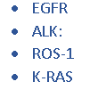

* **Create / Edit T:Tumor size or N:Lymph Node or M:Distant Metastasis**

1. Displayed name
2. Number
3. From
4. To
5. Remarks

* **Create / Edit Stage**

1. Displayed name
2. Number
3. Remarks

* **Assign T, M, N to stage**

1. Select T
2. Select N
3. Select M

* **Show stage matrix**



* **Create / Edit surgery type**

1. Type name

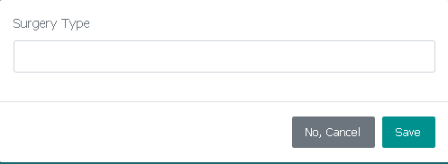

* **Show surgery types**

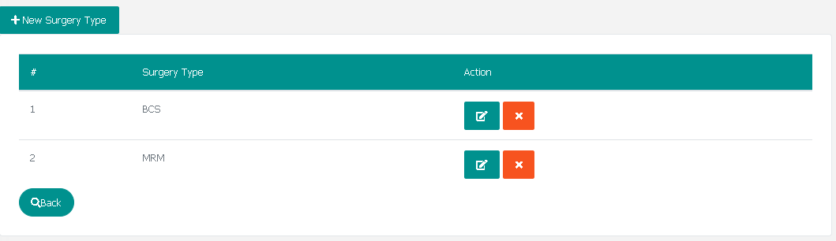

* **Create / Edit treatment type**

1. Type name

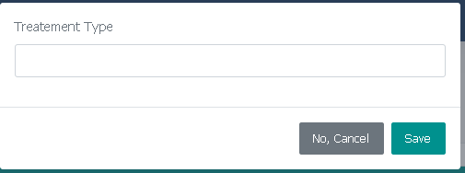

* **Show treatement types**

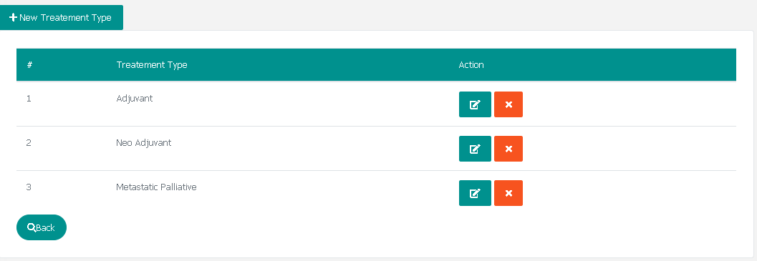

* **Create / Edit patient data**

1. Full Name in Arabic and english
2. Number
3. Birthdate
4. Age
5. Gender
6. Residence
7. National ID
8. contact number
9. occupation
10. Payment method (Insurance, sponsoring company, direct payment) if select sponsor company text field will appear to insert company name
11. first visit date
12. care provider title
13. care provider name

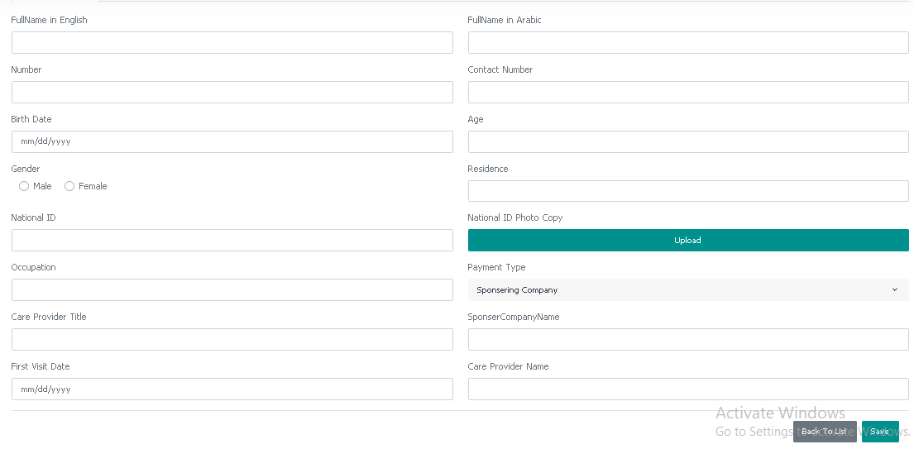

* **show patient list**

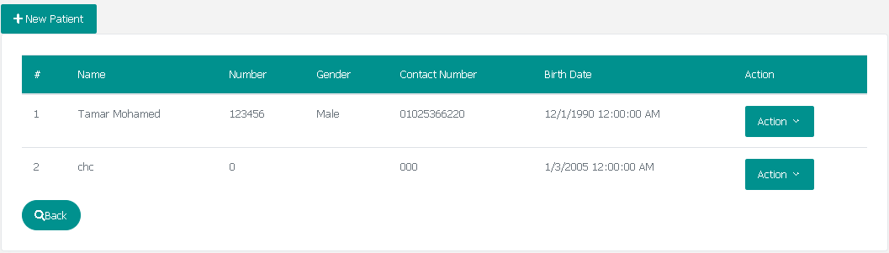

* **Create / Edit patient clinical data**

1. Cancer main type (list)
2. Cancer subtype (list depends on cancer main type)
3. Cancer sub subtype (list depends on cancer sub type)
4. Cancer sub sub subtype (list depends on cancer sub sub type)
5. Cancer side (right or left)
6. Treatment type (list)
7. Histological subtype cancer (list)
8. Histological sub subtype cancer (list depends on Histological subtype cancer)
9. Molecular subtype cancer (list)
10. Molecular sub subtype cancer (list depends on Molecular subtype cancer)
11. Molecular grade (positive or negative)
12. Molecular score
13. Tumor grade (list from 1 to 4)
14. T:Tumor size (list T1, T2, T3, T4a, T4b,…,etc)
15. N :Lymph Node (list N1, N2, N3, …,etc)
16. M :Distant Metastasis (list M0, M1, …, etc)
17. Cancer stage (calculated from T, N, M)
18. CT image
19. PET-CT image
20. Bone scan image
21. Sono-mammography image
22. Had Surgery (yes or no)

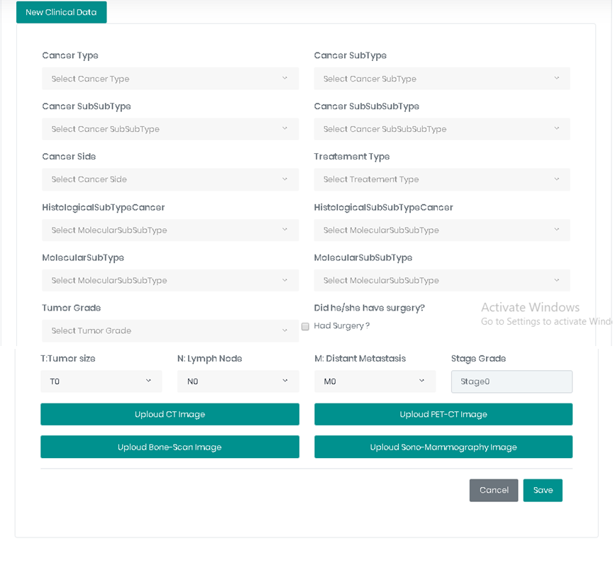

* **Show patient clinical data**

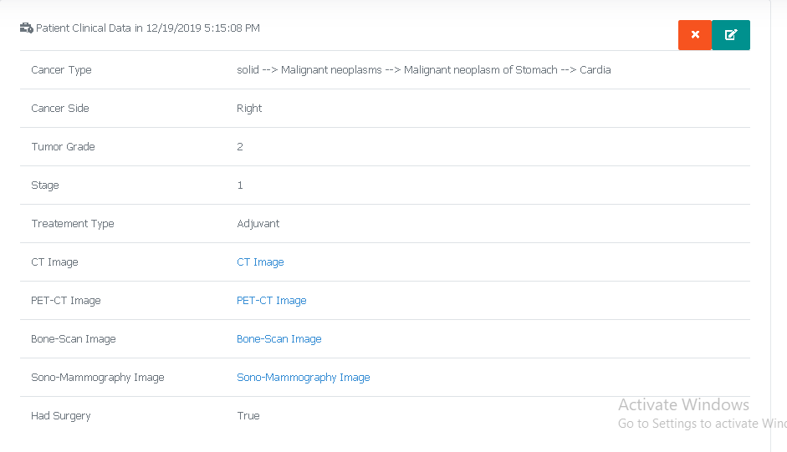

* **Create / Edit patient’s surgery**

1. Surgery type
2. Date of surgery

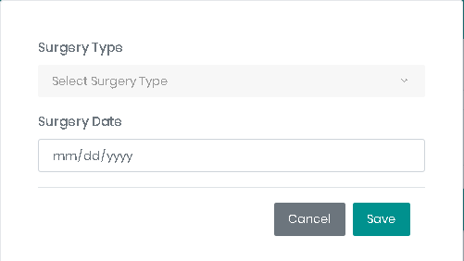

* **Show patient’s surgeries**

