Pharmacy

**Database class project 2022/2023**

|  |  |  |  |  |
| --- | --- | --- | --- | --- |
| Student Name in English | Student Name in Arabic | Student ID | Section | Work percentage |
| Osamah Abdullah | أسامة عبدالله | 12111983 | 3 | 50% |
| Ibrahim Sadi Ahmad Asad | إبراهيم سعدي أحمد أسعد | 12112090 | 3 | 50% |
|  |  |  |  |  |

2022/2023

---------------------------------------------This section is intended for the Instructor---------------------------------------

|  |  |
| --- | --- |
| **Topic** | **Mark** |
| Project Requirements and Modeling |  |
| Correctness of Database mapping |  |
| Functional Dependency and Normalization |  |
| Project Tools |  |
| Project Discussion |  |
| Project Completeness |  |
| Project Output Results or reporting (JasperReport, charts, graphs, etc.) |  |
| Project Administration and Management |  |
| Project Report |  |
| Project Idea |  |
| Project Complexity |  |
| Team work |  |
|  |  |
|  |  |
|  |  |

**D A T A B A S E**

**M A N A G E M E N T S Y S T E M**

**PHARMACY**

**MANEGMENT SYSTEM**

**DATABASE**

202

# Abstract:

# The pharmacy management system is a Java-based application with an Oracle database backend that streamlines and automates various pharmacy operations. It offers features such as inventory management, prescription handling, sales and billing, and user administration. The system's graphical user interface allows for easy management of product inventory, customer prescriptions, and generating bills. With Oracle as the database management system, data storage, retrieval, and manipulation are efficient and secure. The pharmacy management system enhances operational efficiency, accuracy in inventory management, and streamlines sales and billing processes. User authentication and access control ensure secure usage. Overall, this system provides pharmacies with an efficient, user-friendly, and reliable solution for managing their operations.

# TABLE OF

**CONTENTS**

**01 07**

**INTRODUCTION Conclusions**

**02**

**Problem Definition:**

**03**

**Objectives**

**04**

**Secondary objective**

**05**

**Sofrware use**

**06**

**Normalalzation**

**pharmacy database _2023**

# INTRODUCTION

The Pharmacy Management System is a comprehensive software solution designed to streamline and optimize the operations of a pharmaceutical shop. This project focuses on creating a user-friendly interface using Oracle, Maven Java, SQL Developer, Drow.io, and Jaspersoft.

Efficiency, accuracy, and safety are the primary objectives of this system. By maintaining a database of available medicines, the system ensures accurate stock management, reducing errors and improving customer satisfaction. It provides valuable statistics on drug inventory, enabling effective policing and informed decision-making.

The system's functionalities include generating customized reports, printing invoices, bills, and receipts. It also facilitates the recording of supplies received from suppliers. Access to the system is controlled through a login mechanism, with only authorized personnel, specifically the manager, being able to update user information.

One of the core features of the Pharmacy Management System is its ability to handle item updates and additions. Users can easily update stock levels, record purchase bills, and manage sales bills, ensuring seamless inventory management and transaction tracking.

By leveraging the power of Oracle, Maven Java, SQL Developer, Drow.io, and Jaspersoft, this project offers a robust and reliable solution for pharmaceutical shop management. The intuitive interface of the system empowers pharmacy owners and employees to optimize their processes and provide efficient services to customers.

**pharmacy database _**

# DESIGN

Database Design is a collection of processes that facilitate the designing, development, implementation and maintenance of enterprise data management systems.

It helps produce database systems:

* That meet the requirements of the users
* Have high performance.

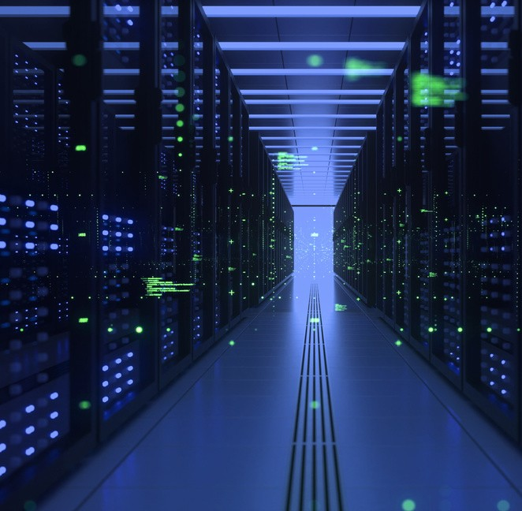

**Divides your information into subject-based tables to reduce redundant data.**

**pharmacy database _2023**

# DESIGN

Architecture Description

The design of a DBMS depends on its architecture. It can be centralized or decentralized or hierarchical. The architecture of a DBMS can be seen as either single tier or multi-tier.

**Database management system**

Connolly and Begg define database management system (DBMS) as a "software system that enables users to define, create, maintain and control access to the database".Examples of DBMS's include MySQL, PostgreSQL, Microsoft SQL Server, Oracle Database, and Microsoft Access.

The DBMS acronym is sometimes extended to indicate the underlying database model, with RDBMS for the relational, OODBMS for the object (oriented) and ORDBMS for the object–relational model. Other extensions can indicate some other characteristics, such as DDBMS for a distributed database management systems.

The functionality provided by a DBMS can vary enormously. The core functionality is the storage, retrieval and update of data. Codd proposed the following functions and services a fully-fledged general purpose DBMS should provide

-Data storage, retrieval and update

* User accessible catalog or data dictionary describing the metadata
* Support for transactions and concurrency

-Facilities for recovering the database should it become damaged

-Support for authorization of access and update of data

-Access support from remote locations

* Enforcing constraints to ensure data in the database abides by certain rules

**pharmacy database _2023**

ER Diagram

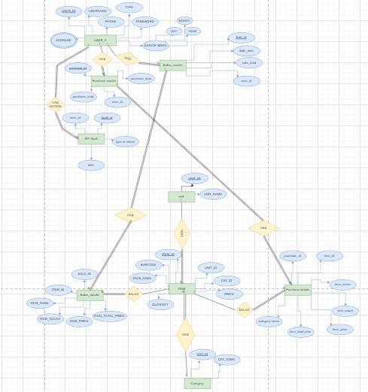

**pharmacy database _2023**

## NEXT STEPS

An entity–relationship model describes interrelated things of interest in a specific domain of knowledge. It is composed of entity types and specifies relationships that can exist between instances of those entity types.

**01 — Relational Schema Diagram**



The model of the Pharmacy Management System ER Diagram is shown in this ER (Entity Relationship) Diagram. It shows all of the database tables.

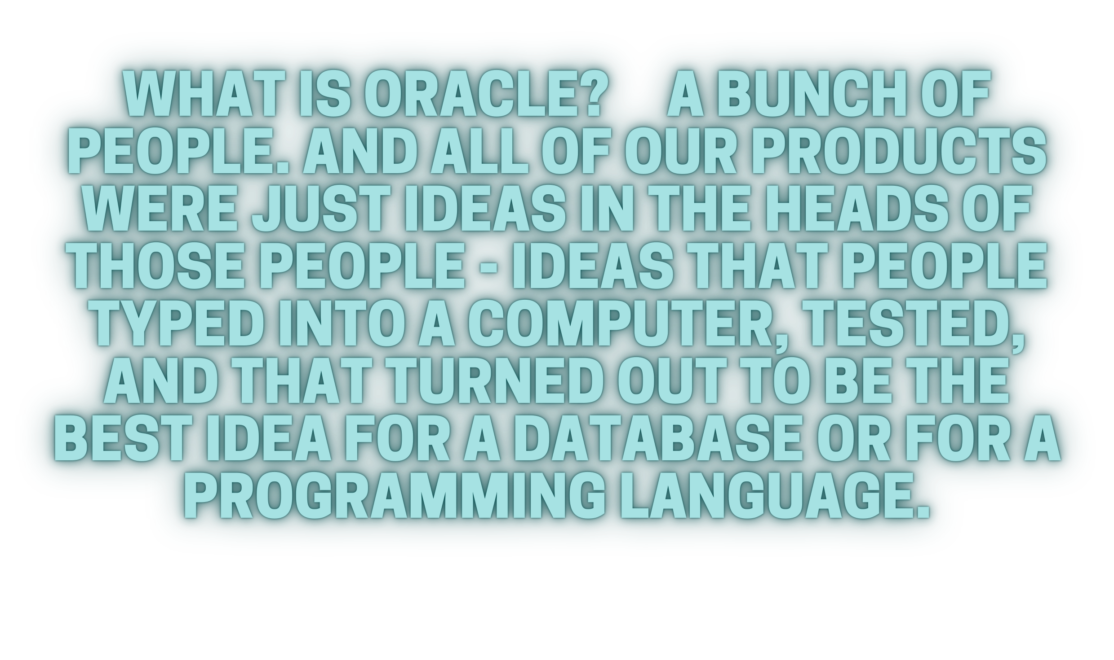It uses structured data and relationships between structured data groups. To define the functions of the Pharmacy Management System. The Pharmacy Management System’s main parts are the Pharmacy, the Medicines, the pharmacist, the customer, the Inventory, and the reports.

**pharmacy database _2022**

## RELATIONAL

SCHEMA DIAGRAM

**pharmacy database _2023**

IMPLEMENTATION

Description on Implementation

The goal of this application is to manage the medicines and various function of the pharmacy.

List of modules:

* Splash screen
* Login page
* Admin window
* User window
* Bills pages
* Purchases
* Sales
* Item/category/unit
* Reports pages

**pharmacy database _2023**

### RESULT AND DISCUSSION

By using SQL& commands and its database this Pharmacy management tends to store all the data received from the users including drugs sales details and the profit made by the owners are all in this data base. This website allows the user to generate invoices for sales, check expiry and quantity remaining of the drugs. It also provides user with options to renew validity and add more drugs into the store and update the database accordingly. By using sql developer these database commands are easily initiated into the database and the ER diagram with relational schema diagrams helps us to make the structure of the database faster and it was easier to make them understand.

**pharmacy database _2023**

### GUI FOR THE PROJECT: -

#### Splash screen

this page is first interface when run the project the page is allow you to go to the next step

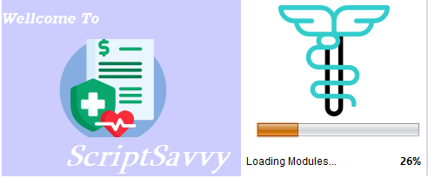

#### Login page

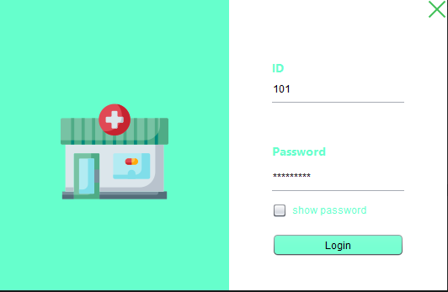this page is first interface after splash screen then you can enter the user_id and password

#### User page

this interface is User window you can click any button you want

#### 

#### 

#### sales page

this interface to add,delete,or upgrade sales you can search by sale id or sales date and you can generate bill

#### Add Purchase

this page is you can add purchase deltails like category price and count

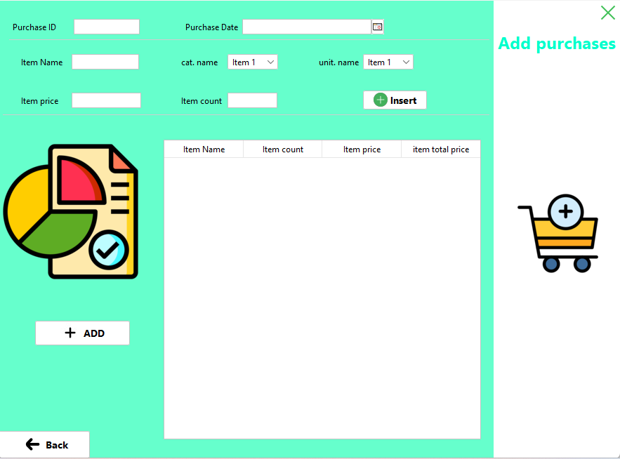

#### 6-Add Item

this page you can add a new item or view all items

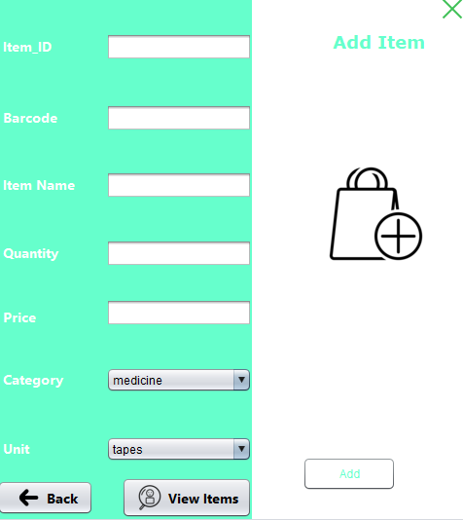

#### 7-Upgrade item page

a page for upgrade any details about any item in database and you can reach category and unit pages from it

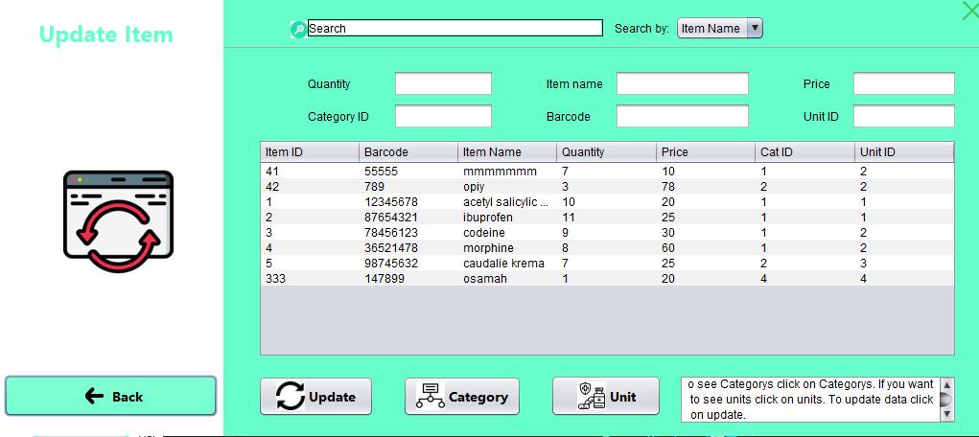

#### 8-Unit page

an interface for adding a new unit type of items like packets ,boxes,plastic bags

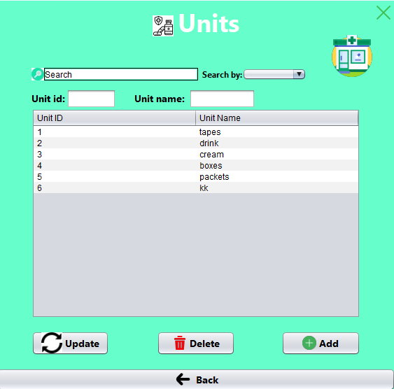

9-Category page

In this page you can add a new category to buy new items and you can delete or upgrade it too

#### Admin page

this interface is for admin can reach everything in data base like home,view users,add item and record.

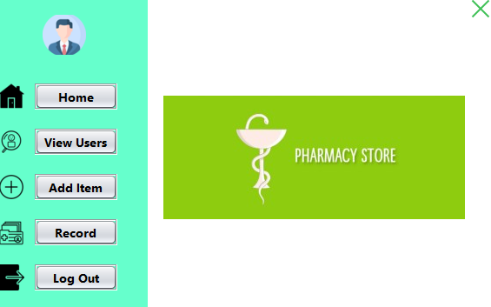

#### Show record page

this page show the administrator who enter the data base and in any time

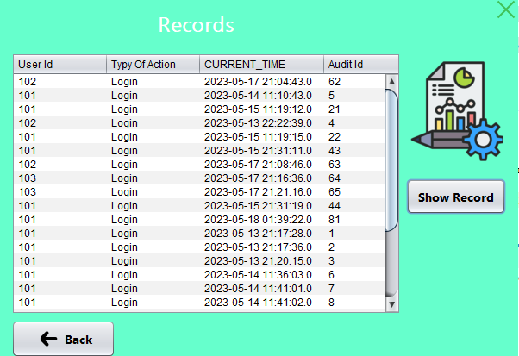

#### 

#### 12-View user page

You can see all users from it and their types

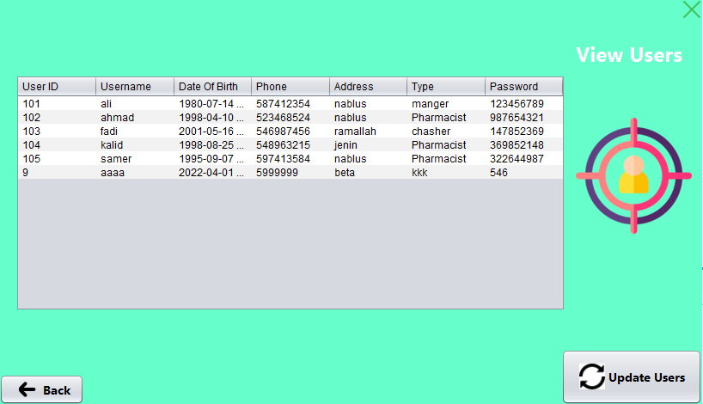

#### 13-View item

on this page , you can see all items in database

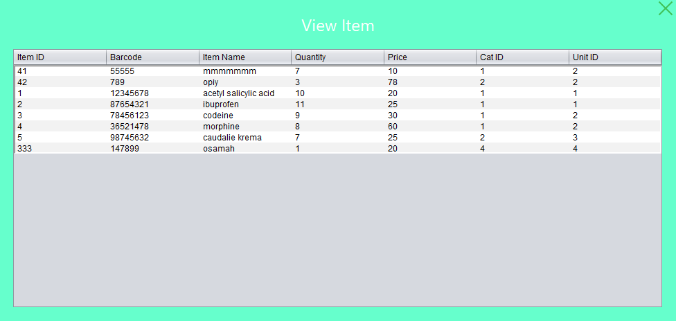

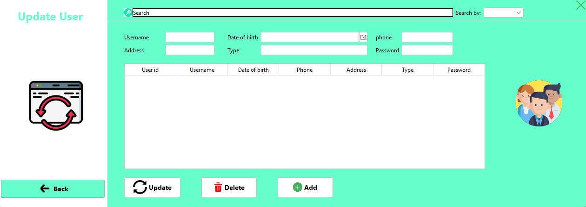14-Update Users:  
you can add or delet or update data on user table this manger can do just.

JasperReport:

Here is the jasper report of the pharmacy it a Sales Bill:

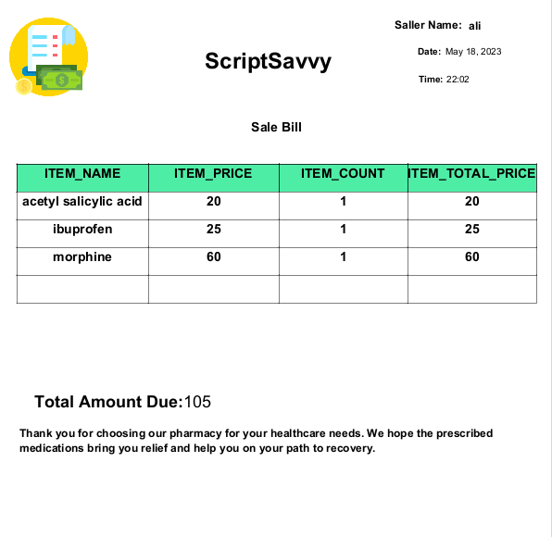

**NORMALAIZATION:**

**USER_0:**

**1st Normalization**

**The intersection of each column and record contain only one value**

**2nd Normalization**

**all the attributes are dependent on the user_ID(Single primary key).**

**3rd Normalization**

**because there is no non-primary key column is transitively dependent on the primary key.**

**BCNF Normalization**

**the primary key(user_ID) Identify the table, and there are no other FDs.**

**Item:**

**1st Normalization**

**The intersection of each column and record contain only one value**

**2nd Normalization**

**all the attributes are dependent on the item_id(Single primary key).**

**3rd Normalization**

**because there is no non-primary key column is transitively dependent on the primary key.**

**BCNF Normalization**

**the primary key(item_ID) Identify the table, and there are no other FDs**

**category:**

**1st Normalization**

**The intersection of each column and record contain only one value**

**2nd Normalization**

**all the attributes are dependent on the cat_ID(Single primary key).**

**3rd Normalization**

**because there is no non-primary key column is transitively dependent on the primary key.**

**BCNF Normalization**

**the primary key(cat_ID) Identify the table, and there are no other FDs**

**unit:**

**1st Normalization**

**The intersection of each column and record contain only one value**

**2nd Normalization**

**all the attributes are dependent on the unit_ID(Single primary key).**

**3rd Normalization**

**because there is no non-primary key column is transitively dependent on the primary key.**

**BCNF Normalization**

**the primary key(unit_ID) Identify the table, and there are no other FDs**

**sales master:**

**1st Normalization**

**The intersection of each column and record contain only one value**

**2nd Normalization**

**all the attributes are dependent on the sale_ID(Single primary key).**

**3rd Normalization**

**because there is no non-primary key column is transitively dependent on the primary key.**

**BCNF Normalization**

**the primary key(sale_ID) Identify the table, and there are no other FDs**

**sales details:**

**1st Normalization**

**The intersection of each column and record contain only one value**

**2nd Normalization**

**all the attributes are dependent on the sale_id and item_id.**

**3rd Normalization**

**because there is no non-primary key column is transitively dependent on the primary key.**

**BCNF Normalization**

**the primary key(sale_ID and item_id) Identify the table, and there are no other FDs**

**purchase master:**

**1st Normalization**

**The intersection of each column and record contain only one value**

**2nd Normalization**

**all the attributes are dependent on the purchase_id(Single primary key).**

**3rd Normalization**

**because there is no non-primary key column is transitively dependent on the primary key.**

**BCNF Normalization**

**the primary key(purchase_ID) Identify the table, and there are no other FDs**

**purchase details:**

**1st Normalization**

**The intersection of each column and record contain only one value**

**2nd Normalization**

**all the attributes are dependent on the purchase_ID and item_id.**

**3rd Normalization**

**because there is no non-primary key column is transitively dependent on the primary key.**

**BCNF Normalization**

**the primary key(purchase_ID and item_id) Identify the table, and there are no other FDs**

**audit:**

**1st Normalization**

**The intersection of each column and record contain only one value**

**2nd Normalization**

**all the attributes are dependent on the audi_id(Single primary key).**

**3rd Normalization**

**because there is no non-primary key column is transitively dependent on the primary key.**

**BCNF Normalization**

**the primary key(audit_ID) Identify the table, and there are no other FDs**

### CONCLUSIONS AND

FUTURE SCOPE

DETAILED INFORMATION GATHERING HAS TO BE DONE. WITHOUT THAT THE PURPOSE FOR USING THE SOFTWARE WON’T BE SATISFIED PROPERLY. O HOWEVER, IT CAN GIVE GOOD PROFITS IN THE LONG RUN.

O IMPLEMENTING THE SOFTWARE REQUIRES CHANGE IN THE BUSINESS PRACTICES.

O EFFICIENT ORGANIZATION OF ALL KNOWLEDGE IS THE ANALYSIS COMPANY AND EASY ANALYSIS ACCESS AND RETRIEVAL OF INFORMATION IS POSSIBLE.

O IN THIS PROJECT WE CAN ALSO INCLUDE BAR CODE FACILITY USING THE BAR CODE READER, WHICH WILL DETECT THE EXPIRY DATE AND THE OTHER INFORMATION ABOUT THE RELATED MEDICINES.

O COMPANY USING THIS SOFTWARE WILL ALWAYS BE ABLE TO PLAN IN FUTURE AND ALWAYS BE AWARE OF THEIR FINANCIAL POSITION IN THE MARKET.

O IT LEADS TO EASE IN FUNCTIONING OF BUSINESS PROCESSES.

O THE PROJECT CAN BE MADE MORE ROBUST BY INCLUDING BIOMETRIC VERIFICATION.

O THERE IS ALSO A SCOPE TO EXPAND BY IMPLEMENTING NEWER TECHNOLOGIES LIKE CLOUD ETCETERA.

**Contact**

**Osamah Abdullah**

**Ibrahim asad**

Palestine