Web downloader:

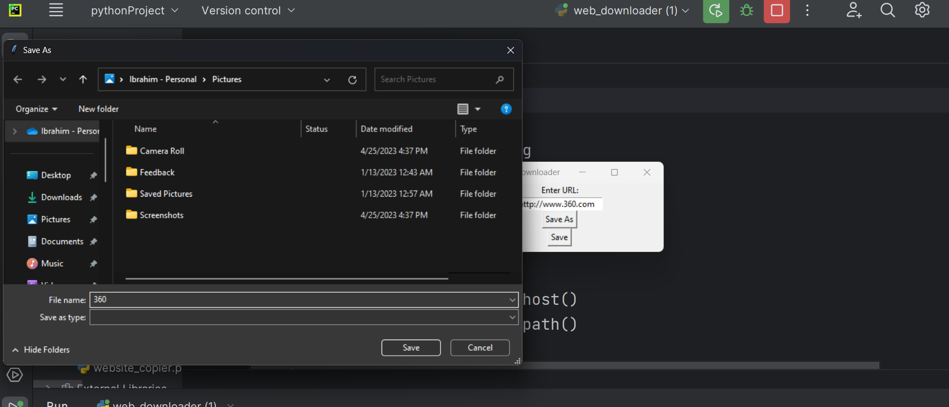

Img transfere:

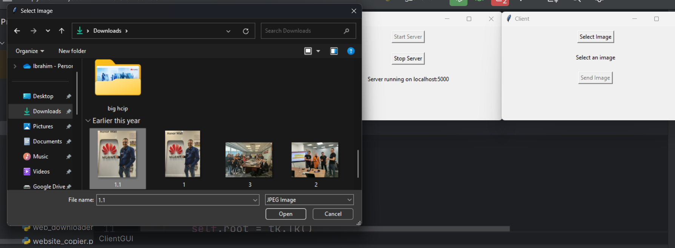

FTP:

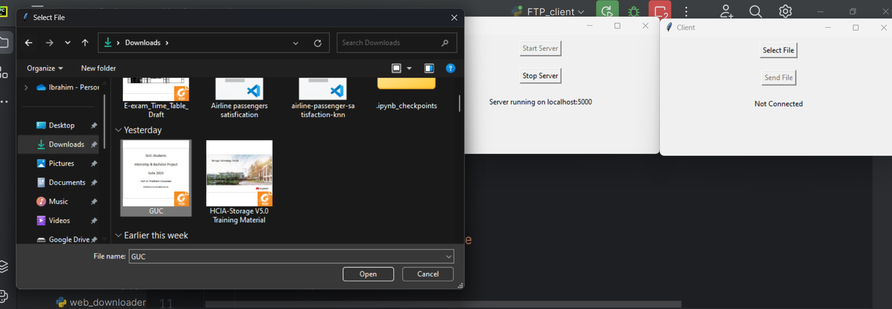

Chat room:



