TECHNICAL DATA DOCUMENTATION

Airbnb Analytics Platform
Implementation Guide

Data Pipeline, Modeling & Dashboard Design

Prepared By
Ibrahim Hegazi

Track
Data Engineering & Analytics

Date
August 2026



Table of Contents

Chapter 1: Executive Summary 3
Chapter 2: Business Understanding 5
Chapter 3: Data Overview 6
Chapter 4: Project Phases & Architecture 7
Chapter 5: Data Profiling Before & After EDA & Data Quality Framework 14
Chapter 6: EDA & Data Quality Framework 19
Chapter 7: Data Cleansing & Remediation 21
Chapter 8: Data Modeling 23
Chapter 9: Dataflow Gen 2 to Implement the Physical Data Model 25
Chapter 10: Semantic Layer 29
Chapter 11: SMART Questions 35
Chapter 12: Visualization Using PowerBI 37
Chapter 1: Executive Summary

1.1 Summary

The enterprise analytics architecture documented herein was engineered to process 48,895 rows of short-term rental listing telemetry from the 2019 New York City Airbnb market. Ingested via Delta Lake (Bronze layer) from raw CSV source file (downloaded from Kaggle), the source payload represents uncurated, unindexed listing endpoints that required rigorous data quality validation and structural conformity before any analytical deployment could occur. The core enterprise objective is the systematic detection of data quality anomalies and the identification of market patterns across the borough, neighborhood, and host network.

By engineering a multi-tiered Business Intelligence pipeline, raw listing rows are transformed into an authoritative analytical semantic model, enabling operational stakeholders to preemptively identify pricing anomalies, availability gaps, outlier hosts, and market concentration risks before reporting decisions are made.

This technical blueprint outlines the end-to-end design, modeling, and deployment of a robust Enterprise Data Warehouse (EDW) and an interactive BI ecosystem. Utilizing a Microsoft-centric technology stack — Microsoft Fabric (Lakehouse), PySpark, and Power BI — augmented with Python for exploratory data analysis and statistical profiling, the solution achieves enterprise-grade reporting while bypassing traditional OLTP query bottlenecks through dimensional modeling (Star Schema with one fact table and five conformed dimensions).

1.2 Architectural Governing Principle

The deployed framework adheres to strict layer isolation across the ingestion pipeline (Bronze → Silver → Gold), ensuring fault tolerance, auditability, and data quality validation at every stage across the entire ETL orchestration life cycle.

Layer | Purpose | Technology
Bronze | Raw ingestion, schema-on-read, immutable source copy | Delta Lake, Spark
Silver | Data quality checks, cleansing, standardization, deduplication | PySpark, DQ Framework
Gold | Dimensional modeling, Star Schema, semantic layer | Spark SQL, Power BI

1.3 Solution Pillar

Solution Pillar | Delivered Capability
Data Engineering | Layered Medallion Architecture (Bronze→Silver→Gold) with 29-point data quality framework, and error detection catalog
Data Quality | 9-category DQ framework: Format, Validity, Completeness, Uniqueness, Consistency, Accuracy, Domain, Referential Integrity, Timeliness — 29 issues detected, 9 actual errors fixed
Data Modeling | Star Schema with 1 fact table (`FactListing`) and 5 conformed dimensions (`DimDate`, `DimHost`, `DimListing`, `DimNeighborhood`, `DimRoomType`)
Analytics | Executive Power BI portal with 7 interactive SMART analysis pages, 37 DAX measures/KPIs, and synchronized cross-page filtering
Profiling | Comprehensive column-level profiling with logical validation, outlier detection, skewness analysis, and IQR-based anomaly identification
Governance | Bronze→Silver→Gold, error catalog with classification (Actual Error / Business Anomaly / Edge Case), and stakeholder escalation framework

Chapter 2: Business Understanding

2.1 The Business Problem

The New York City short-term rental market represents a complex and rapidly evolving ecosystem with significant implications for housing policy, tourism economics, and neighborhood dynamics. As platforms like Airbnb scale exponentially, traditional siloed operational systems fail to provide the multidimensional analytical visibility required to understand market concentration, pricing anomalies, and the shifting balance between individual hosts and commercial operators. Current institutional limitations include fragmented data lacking referential integrity, unacceptable data quality issues in raw listings, and an inability to correlate neighborhood-level supply dynamics with pricing and availability patterns.

2.2 Strategic Objectives & Target Audience

The imperative for a centralized, dimensional analytics repository is driven by the need to answer complex business questions instantaneously. The primary audiences for this deployment are:

- Executive Leadership & Policy Makers — requiring macro-level market concentration metrics, borough-level supply distribution assessments, and systemic pricing trends across room types.
- Market Analysts & Real Estate Strategists — requiring granular, slice-and-dice capabilities to isolate high-demand neighborhoods, pinpoint pricing outliers and anomalies, and identify host concentration risks (commercial operators vs individual hosts).
- Operational Teams & Data Governance — requiring daily operational intelligence regarding data quality metrics, pipeline health, and listing completeness across the medallion architecture.

Chapter 3: Data Overview

3.1 Executive Ingestion Summary

The enterprise pipeline ingests an exhaustive 48,895-record payload originating from the Kaggle New York City Airbnb 2019 repository. Extracted from flat CSV files, this data represents high-fidelity short-term rental telemetry spanning all five NYC boroughs and 221 distinct neighborhoods. The ingestion objective centers on capturing discrete listing data points and mapping them accurately into analytical dimensions to reveal underlying market dynamics, pricing patterns, and host concentration risks.

3.2 Professional Data Dictionary

The following structural metadata map assigns each of the 16 raw source columns to explicit logical domains, establishing the blueprint for the downstream Star Schema topology.

Attribute | Logical Domain | Analytical Purpose
id | Listing Core | Unique deterministic identifier per listing; maps to the Fact table primary business key
name | Listing Core | Free-text listing title; cleaned for whitespace, newlines, and null variations during Silver transformation
host_id | Host Profile | Primary business key for the host; tracks host concentration and multi-listing behavior
host_name | Host Profile | String descriptor of the host; standardized for capitalization inconsistencies during cleansing
neighbourhood_group | Geography | NYC borough classification (5 values); primary geographic aggregation axis for pricing and supply analysis
neighbourhood | Geography | Granular neighborhood identifier (221 values); supports localized market clustering and hotspot detection
latitude | Geography | Spatial vector enabling geographic visualization and neighborhood boundary validation
longitude | Geography | Spatial vector enabling geographic visualization and neighborhood boundary validation
room_type | Listing Profile | Categorical classification (Entire home/apt, Private room, Shared room); drives pricing segmentation and demand analysis
price | Listing Core | Continuous financial metric representing nightly rate; primary analytical target for market pricing decomposition
minimum_nights | Listing Profile | Integer constraint representing minimum stay requirement; used for booking feasibility and outlier detection
number_of_reviews | Review Core | Cumulative review count; primary engagement metric correlated with listing popularity and demand velocity
last_review | Review Core | Date timestamp of most recent review; parsed for time-series analysis and temporal gap detection
reviews_per_month | Review Core | Continuous metric representing review velocity; critical for high-demand listing identification
calculated_host_listings_count | Host Profile | Declared total listings per host; validated against actual row count for consistency and host categorization
availability_365 | Listing Profile | Days available in the calendar year (0-365); drives occupancy analysis and inactive listing detection

Source: Kaggle — New York City Airbnb Open Data (dgomonov/new-york-city-airbnb-open-data) | Rows: 48,895 | Columns: 16

Chapter 4: Project Phases & Architecture

4.1 Project Phases

The enterprise analytics solution was executed across twelve distinct phases, following a structured lifecycle from environment setup to final documentation.

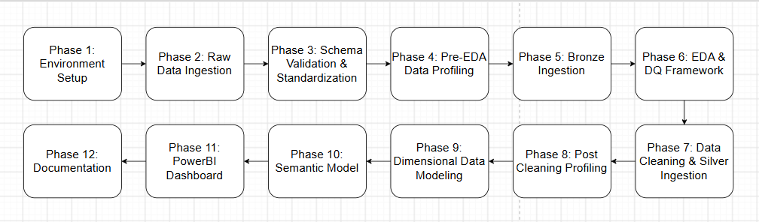

Phase | Name | Activities | Deliverables
Phase 1 | Environment Setup | Creation of Fabric Lakehouse and Warehouse, establishment of Bronze/Silver/Gold schemas, workspace configuration | Lakehouse, Warehouse, 3-tier schema architecture
Phase 2 | Raw Data Ingestion | Manual upload of `AB_NYC_2019.csv` into Lakehouse file section | Raw CSV file in Fabric OneLake
Phase 3 | Schema Validation & Schema Standardization | Checking if each row contain only the 16 columns in the raw dataset. | Notebook 1: Schema Validator, Notebook 2: Cleaner/Normalizer
Phase 4 | Pre-EDA Data Profiling | Comprehensive column-level profiling, column classification (16 columns) statistical analysis, unique sample extraction | Notebook 3: Profiling report, column classifications, initial statistics
Phase 5 | Bronze Ingestion | Delta table creation from validated CSV, schema-on-read, immutable source preservation | Notebook 4: `Bronze.AB_NYC_2019` table
Phase 6 | EDA & Data Quality Framework | 9-category DQ framework execution (Format, Validity, Completeness, Uniqueness, Consistency, Accuracy, Domain, Referential Integrity, Timeliness), univariate/bivariate visualization, error detection | Notebook 5: 29 detected issues, error catalog, classification matrix, stakeholder escalation framework
Phase 7 | Data Cleaning & Silver Ingestion | Resolution of 9 actual errors: whitespace trimming, newline removal, null standardization, capitalization correction | Notebook 6: `Silver.AB_NYC_2019` table, 4 cleansing operations applied
Phase 8 | Post-Cleaning Profiling | Validation profiling to verify all fixes applied, residual issue detection, before/after comparison | Notebook 7: Post-clean profile, remaining whitespace detection, quality verification
Phase 9 | Dimensional Data Modeling | Conceptual, logical, and physical schema design in Draw.io and Oracle SQL Developer Data Modeler, Star Schema implementation via Data Flow Gen2, Gold layer population in Warehouse | 5 dimension tables, 1 fact table, ERD diagrams, Data Flow Gen2 pipelines
Phase 10 | Semantic Model | Power BI semantic model creation, table relationships, DAX measure engineering (37 KPIs), derived column creation (4 calculated columns) | Semantic model with 6 tables, 37 measures, 4 calculated columns
Phase 11 | Power BI Dashboard | 7-page SMART dashboard development with synchronized filtering, answering 10 core business questions | Executive dashboard: Market Overview, Pricing Intelligence, Neighborhood Deep Dive, Host Analysis, Review & Demand, Availability & Booking Gaps, Price Deep Dive
Phase 12 | Documentation | Technical architecture blueprint, executive summary, data dictionary, error catalog, stakeholder recommendations | Complete project documentation package

4.2 Architecture Diagram
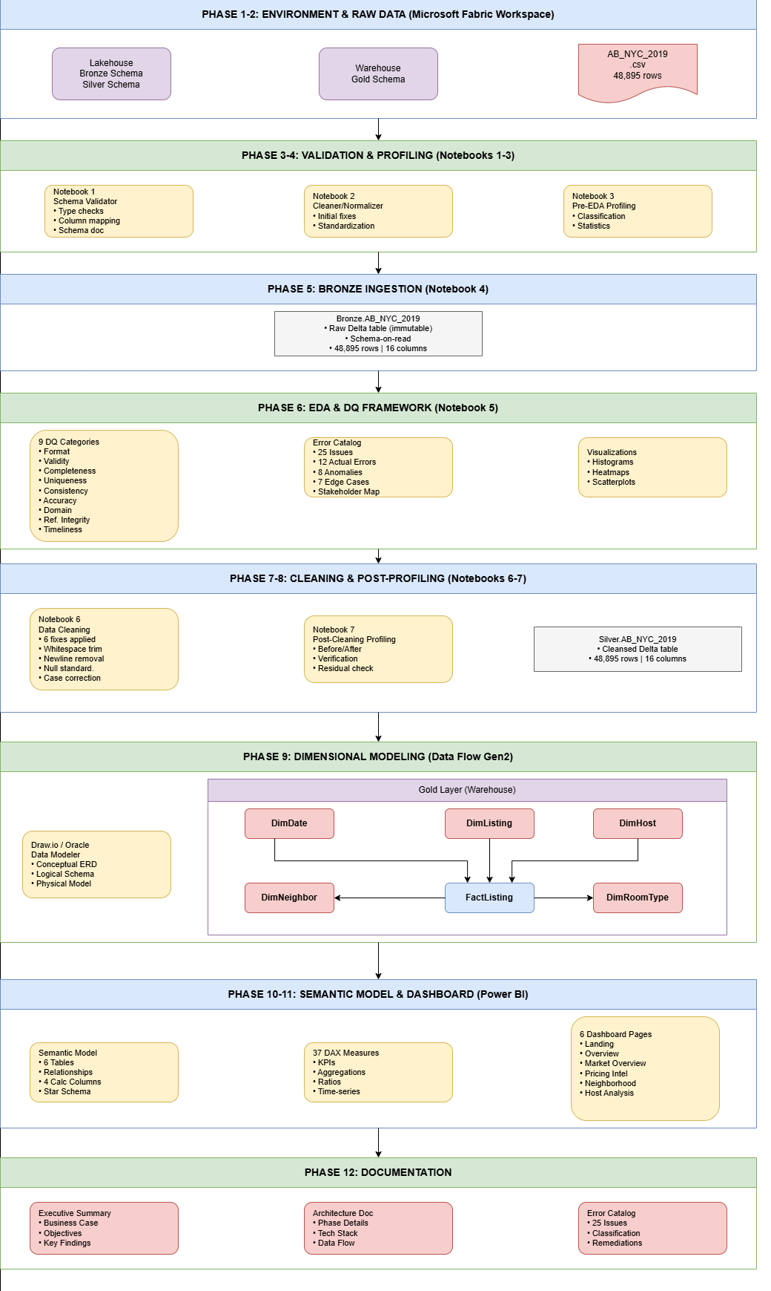

4.3 Medallion Architecture Summary

Layer | Storage | Table | Row Count | Purpose | Key Operations
Bronze | Lakehouse | `Bronze.AB_NYC_2019` | 48,895 | Raw, immutable source copy | CSV-to-Delta conversion, schema inference
Silver | Lakehouse | `Silver.AB_NYC_2019` | 48,895 | Cleansed, validated data | 6 cleansing fixes applied
Gold | Warehouse | `FactListing` | 48,895 | Analytical fact table | Surrogate key mapping, dimensional joins
Gold | Warehouse | `DimDate` | 3,196 | Date dimension | Calendar generation (2011-2019)
Gold | Warehouse | `DimHost` | 37,457 | Host dimension | Deduplication, host categorization
Gold | Warehouse | `DimListing` | 48,895 | Listing dimension | Name extraction
Gold | Warehouse | `DimNeighborhood` | 221 | Neighborhood dimension | Borough-neighborhood mapping
Gold | Warehouse | `DimRoomType` | 3 | Room type dimension | Static lookup values

4.4 Technology Stack

Component | Technology | Purpose
Data Lakehouse | Microsoft Fabric Lakehouse | Unified storage for Bronze & Silver layers
Data Warehouse | Microsoft Fabric Warehouse | Gold layer dimensional model storage
Data Integration | Fabric Data Flow Gen2 | Low-code ETL for dimension/fact loading
Ingestion & Transformation | PySpark Notebooks (7 total) | Schema validation, profiling, DQ checks, cleansing
Data Quality | Python/PySpark | 42-point DQ framework across 9 categories
Profiling | PySpark, Matplotlib, Seaborn | Statistical profiling, visualizations, heatmaps
Data Modeling | Draw.io, Oracle Data Modeler | Conceptual, logical, physical Schemas
Visualization | Power BI | 37 DAX measures, 6-page dashboard
Orchestration | Fabric Pipelines (future) | Automated Bronze→Silver→Gold execution
Governance | Fabric OneLake, Power BI Lineage (future) | Unified lineage, data catalog, access control

Chapter 5: Data Profiling Before & After (EDA and Data Cleaning)

5.1 Before EDA Profiling Summary

The pre-EDA profiling revealed a raw dataset with 49,079 rows and significant structural issues requiring immediate remediation before any analytical work could begin.

5.1.1 Critical Issues Identified

Issue | Description | Affected Columns | Impact
Universal String Typing | All 16 columns ingested as strings regardless of logical type | All except availability_365 | No numeric operations possible
Schema Drift | neighbourhood_group contained 77 unique values (vs expected 5 NYC boroughs) | neighbourhood_group, neighbourhood, room_type | Invalid categorical values from column misalignment
Invalid Category Values | room_type contained 86 values including numbers (200, 138, 69) instead of 3 expected types | room_type | Category corruption
Systematic Null Pattern | 185 rows with missing values across 11 columns | Multiple | Row-level schema drift
Whitespace Contamination | 287 values with leading/trailing whitespace in name, 9 in id, 4 in host_id | name, id, host_id | Join failures, duplicate grouping
Data Type Errors | Latitude, longitude, price, minimum_nights all stored as strings | 7 numeric columns | No aggregation, calculation, or geospatial analysis
Missing Values | 10,234 nulls in last_review, 10,215 in reviews_per_month | last_review, reviews_per_month | 20.9% review data missing

5.1.2 Before Profiling - Column Classification Errors

Column | Expected Type | Actual Type | Distinct Values | Notes
id | Integer Identifier | String | 49,066 | Whitespace issues present
host_id | Integer Identifier | String | 37,484 | 185 nulls, whitespace issues
latitude | Double Coordinate | String | 19,172 | String type, 185 nulls
longitude | Double Coordinate | String | 14,696 | String type, 185 nulls
price | Integer Count | String | 687 | String type, 185 nulls
minimum_nights | Integer Count | String | 134 | String type, 185 nulls
number_of_reviews | Integer Count | String | 464 | String type, 205 nulls
neighbourhood_group | Categorical (5 values) | String | 77 | Column misalignment
room_type | Categorical (3 values) | String | 86 | Contains numeric values
availability_365 | Integer Count | Integer | 366 | Only correctly typed column

5.2 After EDA and Cleaning Profiling Summary

Post-EDA and cleansing profiling was executed against the Silver layer (`Silver.AB_NYC_2019`) with 48,895 rows and 16 columns, all correctly typed and structurally validated.

5.2.1 Key Improvements Achieved

Metric | Before | After | Improvement
Total Rows | 49,079 | 48,895 | 184 malformed rows removed
Correctly Typed Columns | 1/16 (6%) | 16/16 (100%) | All columns properly typed
neighbourhood_group Values | 77 (corrupted) | 5 (correct) | Column realigned
room_type Values | 86 (corrupted) | 3 (correct) | Column realigned
Name Whitespace Issues | 287 | 1 | 99.7% reduction
Missing Value Rate | Up to 20.9% | 0-20.6% | Nulls properly handled
ID Uniqueness | 100% | 100% | No duplicates

5.2.2 After Profiling - Column Classification Summary

Column | Classification | Data Type | Unique Values | Key Statistics
id | IDENTIFIER | Integer | 48,895 (100%) | Range: 2,539 - 36,487,245
name | FREE_TEXT | String | 47,893 (98%) | 17 nulls, Avg length: 36.91
host_id | IDENTIFIER | Integer | 37,457 (76.6%) | 1,525 IQR outliers
host_name | CATEGORICAL | String | 11,428 (23.4%) | 21 nulls, Avg length: 6.12
neighbourhood_group | CATEGORICAL | String | 5 (0.01%) | Clean NYC boroughs
neighbourhood | CATEGORICAL | String | 221 (0.5%) | Valid neighborhoods
latitude | COORDINATE | Double | 19,048 (39%) | Range: 40.50 - 40.91
longitude | COORDINATE | Double | 14,718 (30.1%) | Range: -74.24 - -73.71
room_type | CATEGORICAL | String | 3 (0.01%) | Clean categories
price | COUNT | Integer | 674 (1.4%) | Mean: $152.72, Skew: 19.12
minimum_nights | COUNT | Integer | 109 (0.2%) | Mean: 7.03, Skew: 21.83
number_of_reviews | COUNT | Integer | 394 (0.8%) | Mean: 23.27, 10,052 zeros
last_review | DATETIME | Date | 1,764 (3.6%) | Range: 2011-03-28 to 2019-07-08
reviews_per_month | CONTINUOUS | Double | 937 (1.9%) | Mean: 1.37, Skew: 3.13
calculated_host_listings_count | COUNT | Integer | 47 (0.1%) | Mean: 7.14, Skew: 7.93
availability_365 | COUNT | Integer | 366 (0.7%) | Mean: 112.78, 17,533 zeros

5.3 Before vs After Comparison

Column | Before (Bronze) | After (Silver) | Resolution
id | String, 9 whitespace issues | Integer, clean | Type cast, whitespace trim
name | String, 32 nulls, 287 whitespace | String, 17 nulls, 1 whitespace | Whitespace trim, newline removal, null standardization
host_id | String, 185 nulls | Integer, 0 nulls | Type cast, row removal
host_name | String, 206 nulls | String, 21 nulls | Row removal, case correction
neighbourhood_group | 77 values (corrupted) | 5 values (correct) | Column realignment from schema drift
neighbourhood | 382 values | 221 values | Column realignment
room_type | 86 values (corrupted) | 3 values (correct) | Column realignment
latitude | String | Double | Type cast
longitude | String | Double | Type cast
price | String, 185 nulls | Integer, 0 nulls | Type cast
minimum_nights | String | Integer | Type cast
number_of_reviews | String | Integer | Type cast
last_review | String, 10,234 nulls | Date, 10,052 nulls | Type cast, date parsing
reviews_per_month | String, 10,215 nulls | Double, 10,052 nulls | Type cast
calculated_host_listings_count | String | Integer | Type cast
availability_365 | Integer, 342 nulls | Integer, 0 nulls | Already correct type

Chapter 6: EDA & Data Quality Framework

6.1 Framework Overview

A comprehensive 9-category Data Quality framework was designed and executed against the Bronze layer dataset to systematically detect, classify, and catalog all data anomalies before cleansing. The framework is detection-only — no modifications occur during this phase, preserving complete audit trail and lineage.

6.2 Framework Architecture

The DQ framework is organized into nine distinct check categories, each targeting a specific dimension of data quality. Checks execute sequentially with results logged for downstream remediation.

6.3 Category Descriptions

1 Format/Value Standardization: Detects inconsistent formats, representations, and value encodings including categorical variations, numeric format violations, date inconsistencies, whitespace issues, boolean encoding conflicts, non-standard null representations, embedded escape characters, and multiple consecutive whitespaces.

2 Validity: Verifies data conforms to expected formats, types, and domains including data type violations, invalid categories, pattern mismatches, range violations, and format consistency issues.

3 Completeness: Measures and understands missing data through per-column null percentages, per-row missing counts, missing data pattern analysis (MCAR/MAR/MNAR), and missing value correlation checks.

4 Uniqueness: Ensures no duplicate data exists through duplicate row detection, duplicate ID verification, and unique value distribution analysis.

5 Consistency: Validates logical relationships across columns including cross-column validation, logical contradiction detection, dependency violations, value range logic, category mapping consistency, and foreign key consistency.

6 Accuracy: Identifies statistical anomalies through outlier detection, distribution analysis, business rule violation checks, and impossible value detection.

7 Domain Validation: Checks business-specific domain constraints including geographic validation, reference data validation, value range enforcement, and business calendar alignment.

8 Referential Integrity: Ensures valid table relationships through orphan record detection, invalid foreign key checks, and missing parent record identification.

9 Timeliness: Monitors data freshness via age analysis, load timestamp consistency, source-to-target latency measurement, temporal logic validation, and gap detection in time-series data.

---

6.4 Execution Summary

The framework executed 42 total checks across 9 categories, detecting 25 issues across the 9 categories. 2categories (Uniqueness, Referential Integrity) yielded no issues, the latter due to single-table scope. Results were cataloged by severity, classification, and affected rows, forming the foundation for Chapter 7 remediation.

Chapter 7: Data Cleansing & Remediation

7.1 Approach

Chapter 6 cataloged 25 issues across 9 DQ categories with 12 classified as Actual Errors. This chapter details remediation for the 6 auto-fix errors directly resolved in the Silver layer. All transformations preserve the Bronze source intact and are logged for audit trail. The remaining 6 Actual Errors and 8 Business Anomalies are flagged for stakeholder review or deferred.

7.2 Remediation Strategy by Classification

Classification | Count | Strategy
Actual Error (Auto-Fix) | 12 | Resolved programmatically in Silver layer
Actual Error (Flagged) | 6 | Escalated for manual review
Business Anomaly | 8 | Requires stakeholder input
Edge Case | 7 | Accepted as-is, documented

7.3 Auto-Fix Execution

Issue | Description | Remediation | Affected Rows
Trailing Whitespace in Listing Names | 236 listing names contain trailing spaces, causing join mismatches and inconsistent grouping | Trim trailing whitespace from the name column | 236 (0.48%)
Host Name Capitalization Typos | 24 host name groups contain casing errors (e.g., MIchele, FLora), indicating data entry issues | Apply correction mapping for obvious typos; flag remainder for manual review | 24 groups (0.05%)
Non-Standard Null Representation | A single row uses '.' as a null placeholder in the name column, counted as valid data | Replace '.' with null | 1 (0.002%)
Embedded Newline Characters | 168 listing names contain \n characters, risking parsing failures during export | Replace all newline characters with spaces | 168 (0.34%)
Multiple Consecutive Whitespaces | Several listing names contain double or triple spaces between words | Collapse multiple consecutive spaces into single spaces | 3+ (<0.01%)

7.5 Flagged Issues Awaiting Stakeholder Input

Issue # | Description | Severity | Affected Rows | Question
7 | reviews_per_month >30 | Low | 1 | Data error or legitimate outlier?
9 | 15 rows with 3 missing values | Medium | 15 | Investigate root cause
11 | Isolated MCAR missing values | Low | 37 | Accept or impute?
14 | Entire home/apt at $0 | High | 2 | Data error requiring correction
17 | Host IDs without host name | Medium | 21 | Complete missing host data

7.6 Silver Layer Output Summary

Metric | Before | After
Trailing whitespace rows | 236 | 0
Newline characters | 168 rows | 0
Non-standard nulls (.) | 1 | 0
Multi-space instances | 3+ | 0
Host name typos corrected | — | 24 groups
Flagged issues pending | — | 6
Bronze integrity | Preserved | Unmodified

Chapter 8: Data Models

8.1 Model Types Defined

Conceptual Model: A high-level representation of business entities and their relationships, independent of any technology or implementation detail. It defines what the system contains from a business perspective, using plain business terminology understood by stakeholders.

Logical Model: A detailed, technology-agnostic specification of data structures, attributes, data types, keys, and relationships. It defines how data is organized with normalization rules applied, but remains independent of any specific database system.

Physical Model: The implementation-specific schema design tailored to a particular database technology. It defines how data is stored, including table structures, indexes, partitions, data types, and performance optimizations for the target platform.

8.2 Conceptual Model

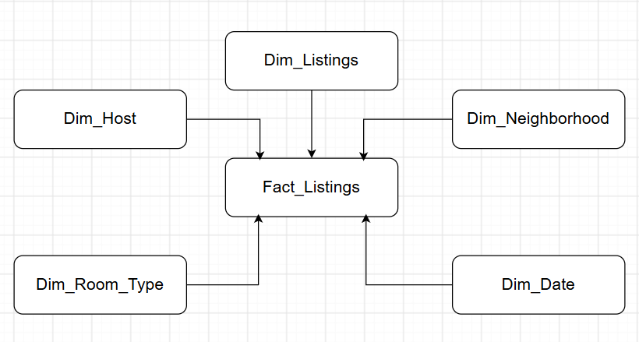

8.3 Logical Model

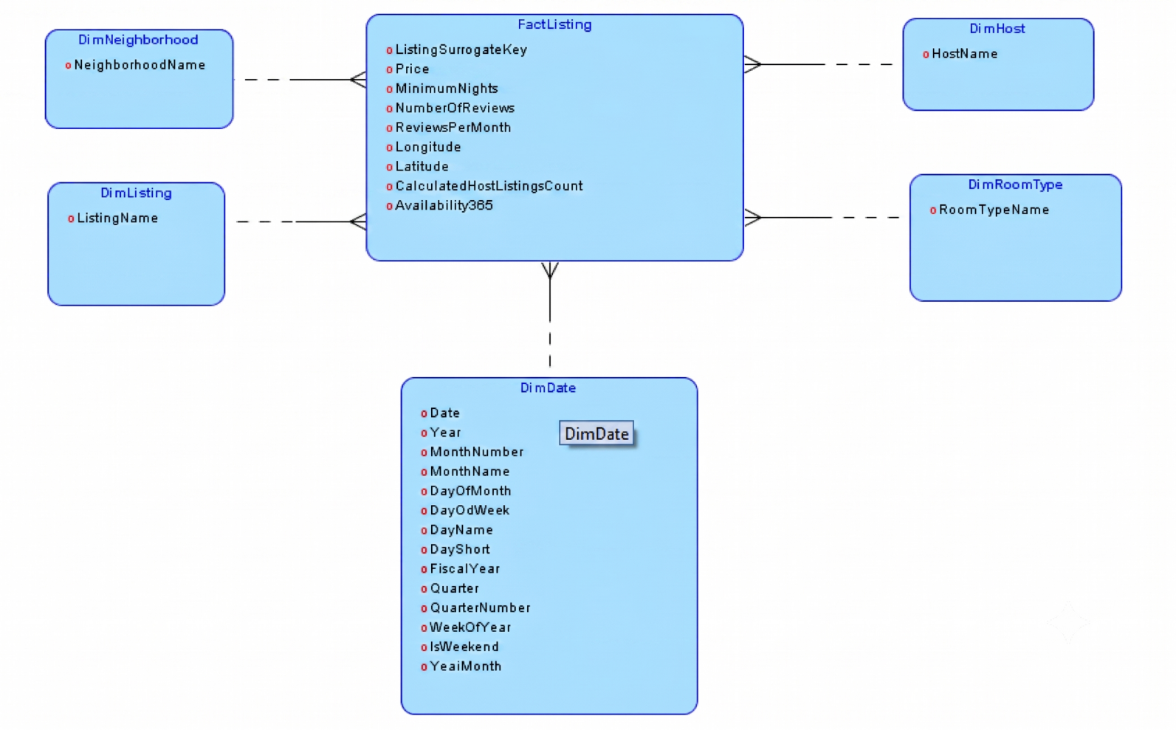

8.4 Physical Model
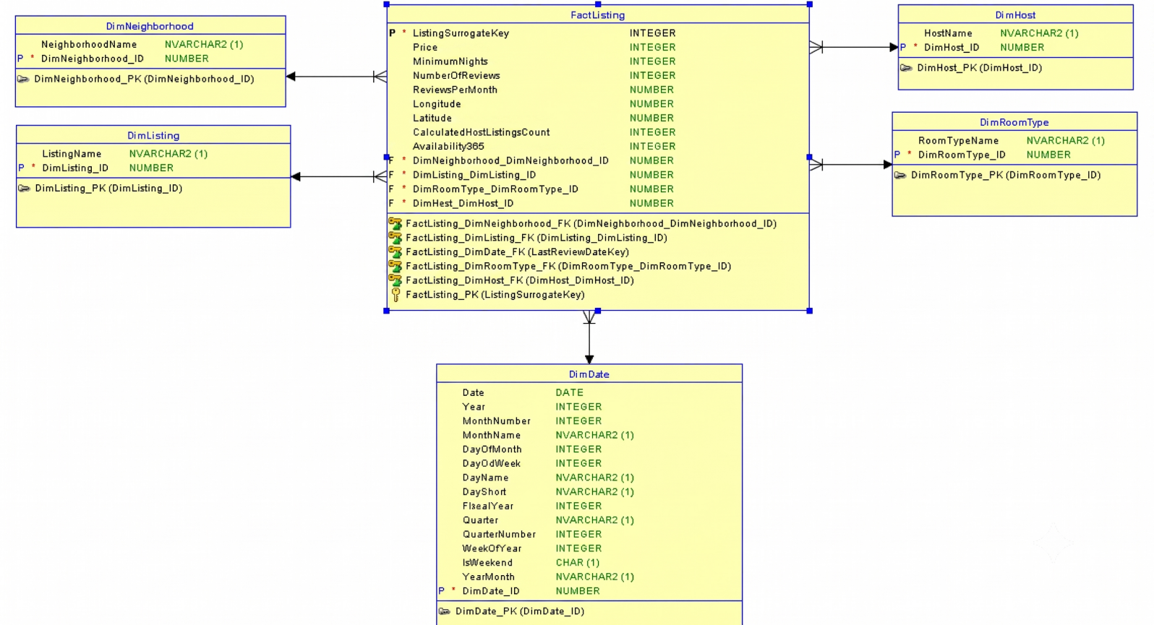
Chapter 9: Physical Data Model Implementation

9.1 Overview

The physical data model is implemented in Microsoft Fabric using Dataflow Gen2, transforming cleaned data from the Silver layer into a fully modeled Gold layer star schema. Dataflow Gen2 provides a low-code, Power Query-based ETL experience with visual transformation logic and automated orchestration, enabling efficient data preparation for analytics.

9.2 Architecture

Silver (Cleaned Data) ──▶ Dataflow Gen2 ──▶ Gold (Modeled Data)

9.3 Dimension Tables

Dimension | Description | Columns | Grain
DimDate | Calendar date dimension with fiscal calendar support | Date, DateKey, Year, MonthNumber, MonthName, MonthShort, DayOfMonth, DayOfWeek, DayName, DayShort, FiscalYear, Quarter, QuarterNumber, WeekOfYear, IsWeekend, YearMonth | Per date
DimHost | Host attributes with calculated categories | HostID (bigint), HostName (varchar), Host Category (varchar) | Per host_id
DimListing | Listing reference details | ListingID (bigint), ListingName (varchar) | Per listing_id
DimNeighborhood | Location hierarchy for NYC boroughs | NeighborhoodID (bigint), NeighborhoodName (varchar), NeighborhoodGroup (varchar) | Per neighborhood
DimRoomType | Room type reference | RoomTypeID (bigint), RoomTypeName (varchar) | Per room_type

DimDate is generated programmatically to cover the full date range present in the dataset, with fiscal year logic (July-June) implemented for business reporting.

9.4 Fact Table

Table | Description | Key Columns | Measures
FactListing | Listing-level fact containing performance metrics and dimension foreign keys | ListingSurrogateKey, ListingID, HostID, NeighborhoodID, RoomTypeID, LastReviewDateKey | Price, MinimumNights, NumberOfReviews, ReviewsPerMonth, CalculatedHostListingsCount, Availability365, Price Tier, Is High Demand, Booking Potential, Price per Month

The fact table includes materialized derived columns for analytical convenience:
- Price Tier: Free / Budget (<$100) / Mid-Range (<$300) / Premium (<$500) / Luxury
- Is High Demand: 1 if NumberOfReviews > 50 AND ReviewsPerMonth > 3
- Booking Potential: Not Available (0 days) / Low (<30) / Medium (<180) / High
- Price per Month: Price × 30 (estimated monthly revenue)

9.5 Data Types Summary

All Gold layer tables use optimized data types for storage and query performance:

Data Type | Usage | Columns
bigint | Surrogate keys, IDs, counts | HostID, ListingID, DateKey, Year, MonthNumber
int | Numeric measures | Price, MinimumNights, NumberOfReviews, Availability365
float | Geospatial coordinates | Latitude, Longitude
decimal(18,2) | Monetary values | Price per Month
varchar | Text attributes | HostName, MonthName, Quarter, Price Tier
date | Calendar dates | Date

Important: All `varchar` columns use `varchar` instead of `nvarchar` due to Fabric Warehouse compatibility requirements.

9.6 Dataflow Gen2 Implementation Steps

1. Source Connection: Connect to Silver layer delta tables in the Fabric Lakehouse Files section
2. Dimension Builds:
- Extract distinct dimension values from fact data
- Deduplicate and assign surrogate keys
- Generate `DimDate` for complete date range
3. Fact Build:
- Join staged data with dimensions to resolve foreign keys
- Apply derived column calculations (Price Tier, Is High Demand, etc.)
4. Destination: Write output tables to Gold layer Warehouse

9.7 Star Schema Output

Table | Type | Grain | Surrogate Key
DimDate | Dimension | Per date | DateKey
DimHost | Dimension | Per host_id | HostID
DimListing | Dimension | Per listing_id | ListingID
DimNeighborhood | Dimension | Per neighborhood | NeighborhoodID
DimRoomType | Dimension | Per room_type | RoomTypeID
FactListing | Fact | Per listing | ListingSurrogateKey

9.8 Notes on Implementation

- Surrogate Keys: All dimension keys are natural keys (not generated), maintaining referential integrity with source data
- Derived Columns: Five materialized columns were added to FactListing for analytical convenience, reducing DAX complexity in the semantic layer

9.9 Pictures From DataFlow Gen2

DimNeighborhood
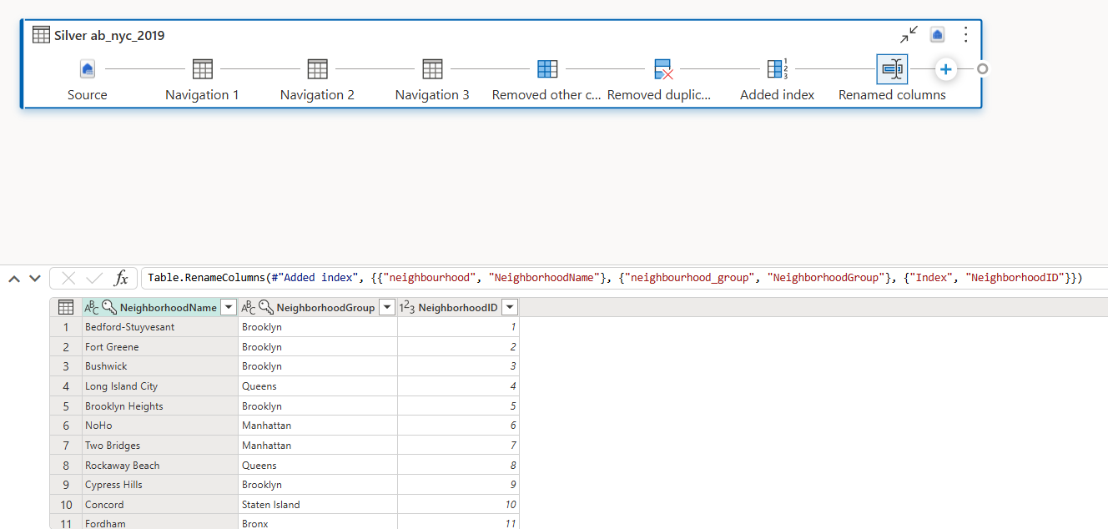

FactListing
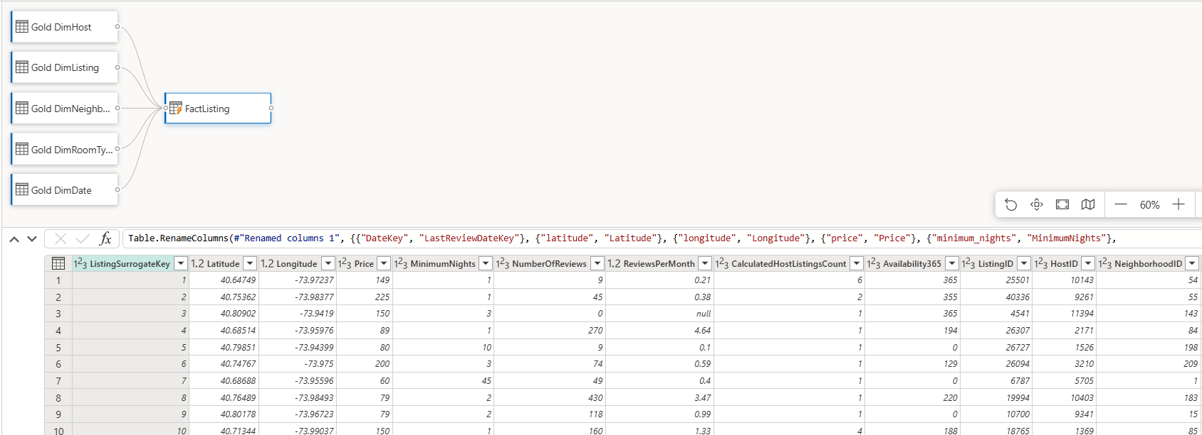

Chapter 10: Semantic Layer

10.1 Overview

The semantic layer connects the Silver dimensional model to end-user reporting by defining KPIs, calculated columns, and business logic. Due to Fabric privilege restrictions preventing calculated column creation in the data model, SQL scripts were used to materialize derived columns directly in the Gold layer tables, while DAX measures were defined in the Power BI model for dynamic aggregations.

10.2 Architecture

Silver Layer ──▶ Gold Layer (Materialized Columns via SQL) ──▶ Power BI Model (DAX Measures) ──▶ Reports

10.3 Core KPIs

# | Measure | DAX Formula | Description
1 | Total Listings | COUNTROWS('Gold FactListing') | Total number of listings
2 | Avg Price | AVERAGE('Gold FactListing'[Price]) | Mean listing price
3 | Median Price | MEDIAN('Gold FactListing'[Price]) | Median listing price
4 | Total Hosts | DISTINCTCOUNT('Gold FactListing'[HostID]) | Unique host count
5 | Avg Reviews | AVERAGE('Gold FactListing'[NumberOfReviews]) | Mean reviews per listing
6 | Avg Availability | AVERAGE('Gold FactListing'[Availability365]) | Mean available days
7 | Total Reviews | SUM('Gold FactListing'[NumberOfReviews]) | Sum of all reviews
8 | Occupancy Rate | DIVIDE([Avg Availability], 365, 0) | Ratio of available days to year

10.4 Price Analysis

# | Measure | DAX Formula
9 | Min Price | MIN('Gold FactListing'[Price])
10 | Max Price | MAX('Gold FactListing'[Price])
11 | Price Range | [Max Price] - [Min Price]
12 | Listings Under 100 | CALCULATE([Total Listings], 'Gold FactListing'[Price] < 100)
13 | Listings 100-300 | CALCULATE([Total Listings], 'Gold FactListing'[Price] >= 100 && 'Gold FactListing'[Price] < 300)
14 | Listings Over 300 | CALCULATE([Total Listings], 'Gold FactListing'[Price] >= 300)
15 | Pct Under 100 | DIVIDE([Listings Under 100], [Total Listings], 0)

10.5 Room Type Analysis

# | Measure | DAX Formula
16 | Entire Home Count | CALCULATE([Total Listings], 'Gold DimRoomType'[RoomTypeName] = "Entire home/apt")
17 | Private Room Count | CALCULATE([Total Listings], 'Gold DimRoomType'[RoomTypeName] = "Private room")
18 | Shared Room Count | CALCULATE([Total Listings], 'Gold DimRoomType'[RoomTypeName] = "Shared room")
19 | Avg Price by Room | AVERAGE('Gold FactListing'[Price])

10.6 Neighborhood & Borough Analysis

# | Measure | DAX Formula | Usage
20 | Listings by Borough | [Total Listings] | Use with NeighborhoodGroup
21 | Avg Price by Borough | [Avg Price] | Use with NeighborhoodGroup
22 | Listings Count | [Total Listings] | Visual filter, Top N = 10

10.7 Host Analysis

# | Measure | DAX Formula
23 | Super Host Threshold | 10 (constant)
24 | Avg Listings per Host | DIVIDE([Total Listings], [Total Hosts], 0)
25 | Single Listing Hosts | COUNTROWS(FILTER(SUMMARIZE('Gold FactListing', 'Gold FactListing'[HostID], "Count", COUNTROWS('Gold FactListing')), [Count] = 1))
26 | Multi Listing Hosts | [Total Hosts] - [Single Listing Hosts]

10.8 Review Analysis

# | Measure | DAX Formula
27 | Listings with Reviews | CALCULATE([Total Listings], 'Gold FactListing'[NumberOfReviews] > 0)
28 | Listings without Reviews | CALCULATE([Total Listings], 'Gold FactListing'[NumberOfReviews] = 0)
29 | Pct with Reviews | DIVIDE([Listings with Reviews], [Total Listings], 0)
30 | Avg Reviews per Month | AVERAGE('Gold FactListing'[ReviewsPerMonth])

10.9 Time-Based Measures

# | Measure | DAX Formula | Usage
35 | Reviews by Year | SUM('Gold FactListing'[NumberOfReviews]) | Use with DimDate[Year]
36 | Listings by Review Year | [Total Listings] | Use with DimDate[Year]

10.10 Materialized Columns (SQL Implementation)

Due to Fabric privilege restrictions, calculated columns were materialized directly in Gold layer tables using SQL scripts instead of DAX calculated columns.

Gold.FactListing Columns Added:

Column | Logic
Price Tier | Free / Budget (<$100) / Mid-Range (<$300) / Premium (<$500) / Luxury
Is High Demand | 1 if NumberOfReviews > 50 AND ReviewsPerMonth > 3
Booking Potential | Not Available (0 days) / Low (<30) / Medium (<180) / High
Price per Month | Price × 30

Gold.DimHost Column Added:

Column | Logic
Host Category | Single Listing (1) / Small Host (≤5) / Medium Host (≤20) / Large Host

10.11 SQL Implementation Script

‘’’
-- Add columns
ALTER TABLE Gold.FactListing
ADD [Price Tier] VARCHAR(50), [Is High Demand] INT,
[Booking Potential] VARCHAR(50), [Price per Month] DECIMAL(18,2);

ALTER TABLE Gold.DimHost
ADD [Host Category] VARCHAR(50);

-- Populate FactListing
UPDATE Gold.FactListing
SET [Price Tier] = CASE
WHEN Price = 0 THEN 'Free' WHEN Price < 100 THEN 'Budget'
WHEN Price < 300 THEN 'Mid-Range' WHEN Price < 500 THEN 'Premium'
ELSE 'Luxury' END,
[Is High Demand] = CASE WHEN NumberOfReviews > 50 AND ReviewsPerMonth > 3 THEN 1 ELSE 0 END,
[Booking Potential] = CASE
WHEN Availability365 = 0 THEN 'Not Available' WHEN Availability365 < 30 THEN 'Low'
WHEN Availability365 < 180 THEN 'Medium' ELSE 'High' END,
[Price per Month] = Price * 30;

-- Populate DimHost
WITH HostListingCounts AS (
SELECT HostID, COUNT(*) AS ListingCount FROM Gold.FactListing GROUP BY HostID
)
UPDATE Gold.DimHost
SET [Host Category] = CASE
WHEN hlc.ListingCount = 1 THEN 'Single Listing'
WHEN hlc.ListingCount <= 5 THEN 'Small Host'
WHEN hlc.ListingCount <= 20 THEN 'Medium Host'
ELSE 'Large Host' END
FROM Gold.DimHost dh
INNER JOIN HostListingCounts hlc ON dh.HostID = hlc.HostID;
‘’’

10.12 Measure Summary

Category | Measures
Core KPIs | 8
Price Analysis | 7
Room Type | 4
Borough | 3
Host | 4
Reviews | 4
Time-Based | 2
Total Measures | 32
Materialized Columns | 5

10.13 Picture of the Semantic Model

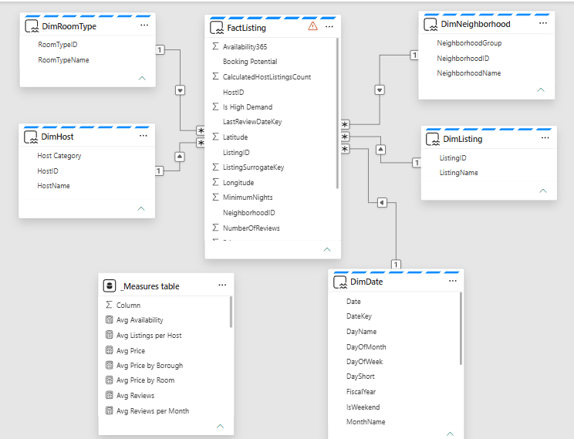

Chapter 11: SMART Questions

Smart Question 1: What is the current state of the NYC Airbnb market in 2019?

Specific: Quantify the total listings, hosts, average price, and availability across all NYC boroughs.

Measurable: Tracked via 5 core KPIs — Total Listings, Average Price, Total Hosts, Average Reviews, Occupancy Rate.

Achievable: Data is complete for all 48,895 listings across 5 boroughs with 16 attributes per listing.

Relevant Provides macro-level market snapshot for executive stakeholders and policy makers.

Time-bound: Represents 2019 calendar year snapshot with review activity spanning 2011-2019.

Smart Question 2: How does pricing vary by room type and neighborhood, and where are the outliers?

Specific: Analyze price distribution across room types and neighborhoods to identify premium areas and pricing anomalies.

Measurable: Avg Price by Room Type, Avg Price by Borough, Price Tier Distribution, Top 10 Most Expensive Neighborhoods, Price Outlier Count.

Achievable: 674 distinct price points across 3 room types and 221 neighborhoods.

Relevant: Enables market analysts to identify pricing strategy opportunities and anomalous listings.

Time-bound: 2019 pricing snapshot with 388 statistical outliers identified (3σ above $873 mean).

Smart Question 3: Which neighborhoods offer the best balance of availability, price, and reviews?

Specific: Identify neighborhoods that optimize the trade-off between affordability, bookability, and demand signals.

Measurable: Listings Count by Neighborhood, Avg Price, Avg Availability, Avg Reviews, Booking Potential classification.

Achievable: 221 neighborhoods with complete pricing, availability, and review metrics.

Relevant: Supports real estate strategists and travelers in identifying high-value market segments.

Time-bound: 2019 data with availability ranging 0-365 days and reviews spanning 2011-2019.

Smart Question 4: Who are the power hosts, and how is the market split between individuals and commercial operators?

Specific: Identify multi-listing hosts, categorize host types, and measure market concentration.

Measurable: Total Hosts, Single Listing Hosts, Multi Listing Hosts, Avg Listings per Host, Host Category Distribution, Top 10 Hosts by Listing Count.

Achievable: 37,457 unique hosts with listing counts ranging from 1 to 327.

Relevant: Reveals market concentration risk and the balance between casual individuals and professional operators.

Time-bound: 2019 host snapshot with calculated host listing counts validated against actual row counts.

Chapter 12: Visualization Using PowerBI

12.0 Landing Page


12.1 Overview Page
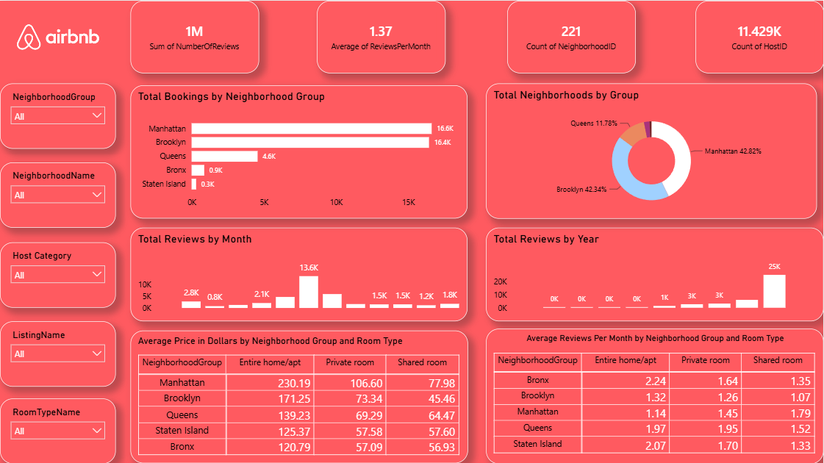

12.2 Market Analysis
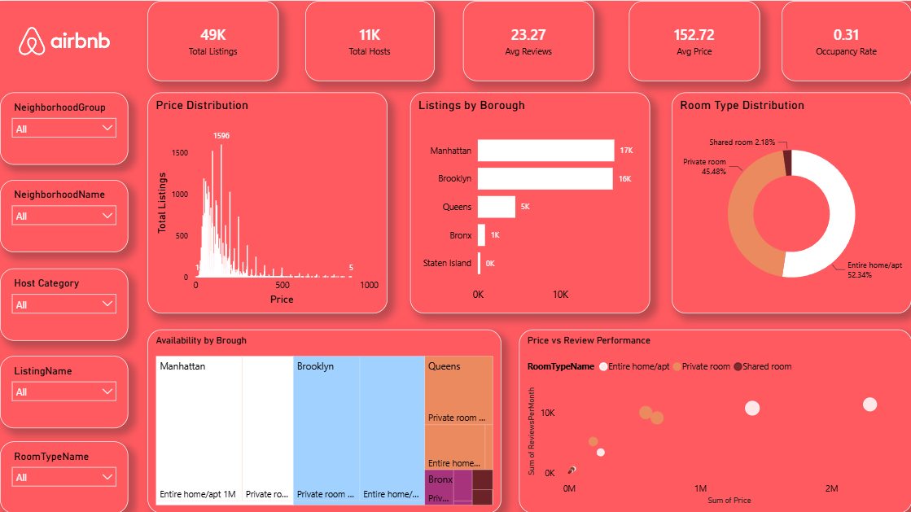

12.3 Pricing Intelligence Page
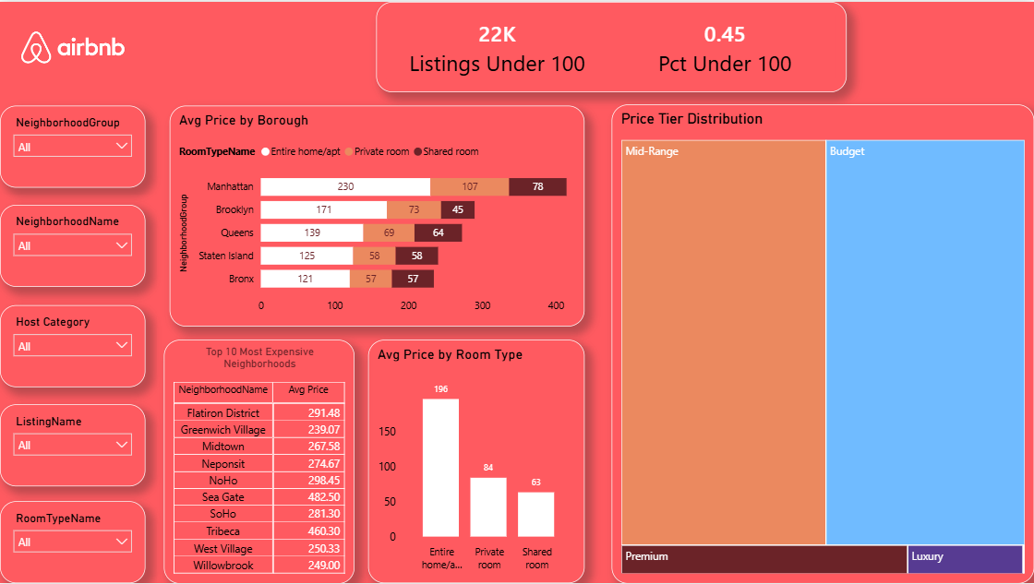

12.4 Neighborhood Deep Dive Page
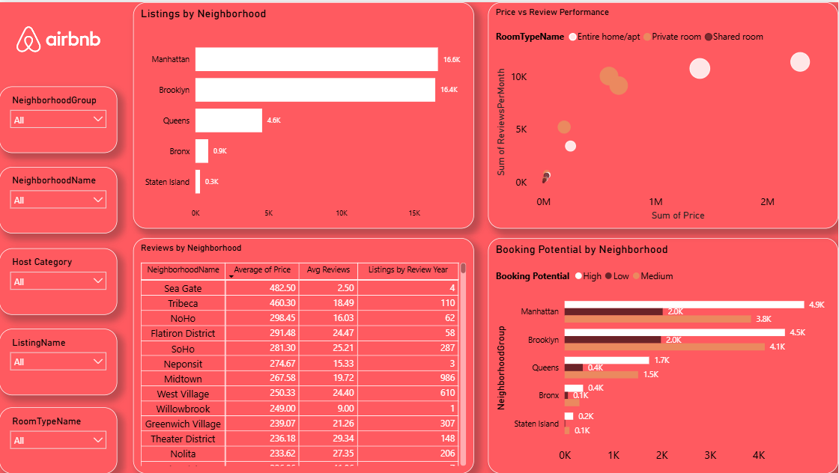

12.5 Host Analysis Page

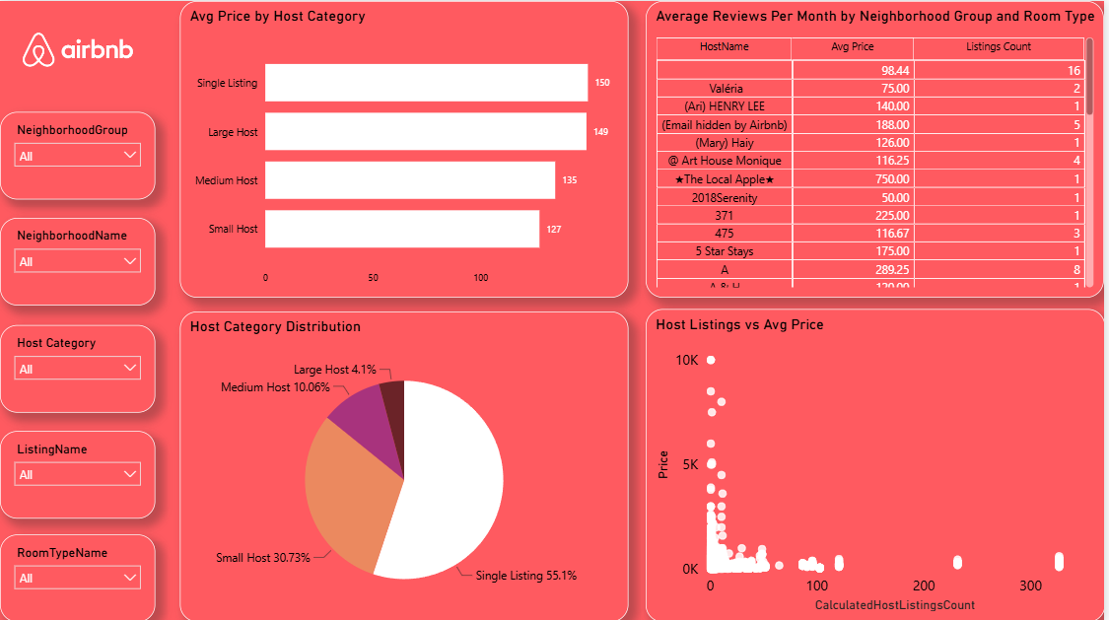

THANK YOU

