Page | 1

**Full Name : IBRAHIM HOSSAIN**

Address : Purbo Hazipara, Rampura, Dhaka 1219, Cell Phone : +8801957225457

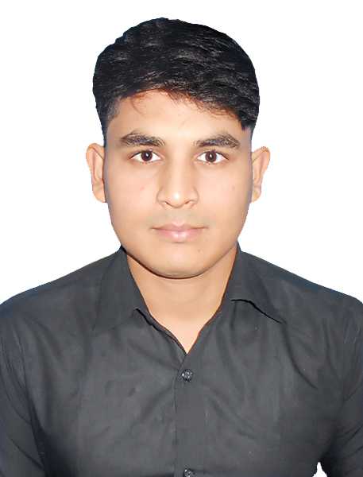

Email : [ibrahimhossaincse@gmail.com](mailto:ibrahimhossaincse@gmail.com)

**Career Objective:**

* To obtain a position in the information technology field where I can work in a challenging environment and gain expertise in working as part of a team to research and develop new software products.
* To choose a career that involves challenges and opportunity for self-development.
* To develop career in a private organization and large working group.
* Willing to utilize conceptual and analytical skills to pursue a long-term career in any organization to convey personal gratification.

**Employment History:**

# Divine IT Limited

**Trainee Software Engineer Duration:** 8 Months

**A & I Group**

**IT Executive**

Department: Information Technology

**Duration:** 6Months

**Educational Qualification:**

|  |  |  |  |  |  |
| --- | --- | --- | --- | --- | --- |
| **Exam Title** | **Concentration** | **Institute** | **Result** | **Pass year** | **Board** |
| BSC in CSE | Computer Science &  Engineering | Uttara University (UU) | CGPA: 3.66  out of 4 | 2022 |  |
| Diploma in Engineering | Computer Technology | BCMC Collage of Engineering & Technology | CGPA: 3.38  out of 4 | 2017 | Bangladesh Technical  Education Board |
| S.S.C | Humanities | Sharatala Secondary School | GPA: 3.75  (5.00) | 2013 | Jashore |

**Training Summary:**

|  |  |  |  |
| --- | --- | --- | --- |
| **Training Title** | **Topic** | **Institute** | **Duration** |
| **Java** |  | **javatpoint.com** | **8 Months** |
| **Spring-Boot** |  | **Udemy.com** | **3 Months** |
| **MySQL** |  | **Online** | **8 Months** |
| **React Js** |  | **Udemy.com** | **11 Months** |
| **Redux** |  | **Divine-it-ltd** | **8 Months** |
| **React-Redux** |  | **Divine-it-ltd** | **8 Months** |
| **Redux-saga** |  | **Divine-it-ltd** | **8 Months** |
| **Reselect** |  | **Divine-it-ltd** | **8 Months** |
| **Primereact** |  | **Divine-it-ltd** | **8 Months** |
| **Immutable** |  | **Divine-it-ltd** | **8 Months** |
| **PrimeFlex** |  | **Divine-it-ltd** | **8 Months** |
| **C, C++** |  | **Book** | **2 Year** |
| **Data Structure & Algorithm** |  | **Udemy.com** | **1 Year** |
| **jQuery** |  | **Youtube.com** | **3 Months** |
| **Development Tool** | **Agile/Scrum** | **UU Dhaka** | **1 Week** |
| **JavaScript ES6** |  | **Pirple.com** | **1 Year** |
| **HTML5** | **HTML**  **Course** | **Sololearn.com** | **1 Months** |
| **SEIP Course** | **Professional**  **Back Office Services** | **ISSL Uttara Dhaka** | **3 Months** |
| **CSS** |  | **MDN** | **1 Year** |
| **SASS** |  | **Youtube.com** | **6 Months** |
| **Bootstrap** |  | **RR Foundation** | **1 Year** |
| **Adobe PS CC** | **Web UI** | **Youtube.com** | **1 Year** |
| **Git** | **Git (GitHub)** | **Udemy.com** | **2 Week** |
| **Microsoft Office** | **Outlook, Excel, word, PowerPoint** | **BCMC College of Engineering & Technology** | **6 Months** |

Page | 2

Page | 3

**Live projects:**

[www.ibd.net.bd](http://www.ibd.net.bd/)

[www.netzonedb.net](http://www.netzonedb.net/)

**Contributed project at Divine IT Ltd:**

[https://pro.edumanbd.com/#/login](https://pro.edumanbd.com/%23/login) https://github.com/Ibrahim-Hossain-Jewel/redux-saga_CRUD

**Reactjs projects:**

<https://ibrahim-hossain-jewel.github.io/monsters-rolodex/> <https://github.com/Ibrahim-Hossain-Jewel/crwn-clothing.git>

**Hand Scratch web UI/UX for a university:**

https://github.com/Ibrahim-Hossain-Jewel/University-UI-UX.git

**Web UI by adobe photoshop CC:**

[Digital Marketing Website UI on Behance](https://www.behance.net/gallery/92752065/Digital-Marketing?tracking_source)

[Architecture, Developer Website UI on Behance](https://www.behance.net/gallery/92751161/Architecture-Developer?tracking_source=project_owner_other_projects)

[Digital-Agency-company website UI on Behance](https://www.behance.net/gallery/92751841/Digital-Agency-company?tracking_source=project_owner_other_projects)

**Raw JavaScript project:**

[To do web application with multiple user panel](https://github.com/Ibrahim-Hossain-Jewel/to-do-app-with-multiple-user-Project-)

**Stackoverflow.com**

user:15852900 [ibrahimHossainpersonalwebsite](https://ibrahim-hossain-jewel.github.io/Personal-website/index.html)

**Personal website**

**Language Proficiency:**

|  |  |  |  |
| --- | --- | --- | --- |
| **Language** | **Medium** | **Good** | **Excellent** |
| **Bangla** |  |  | **Excellent** |
| **English** |  |  | **Excellent** |



**Hobby:**

|  |  |
| --- | --- |
| **Travelling** | **International news** |

Page | 4

**Personal Details:**

Father`s Name : Mofizur Rahman Mother`s Name : Momena Khatun Date of Birth : October 16, 1997

Gender : Male

Marital Status : Single

Nationality : Bangladeshi (By birth).

National ID 19974119034000041

Passport No : EJ 0158006

Religion : Islam

Blood group : B+

Permanent Address : Village: Gokorno, Post-office: Pakshia Bazar, Thana : Sharsha District : Jashore

**Reference (S):**

**Reference:01**

Engr. Md. Shaheen Akter

Associate Professor & Department Head BCMC College of Engineering & Technology Jashore.

**Reference:02**

Associate Professor & Director, Dept. of Computer Science and Engineering, IT Division at UTTARA UNIVERSITY Phone : +88 01795379956

* + I thereby, declare that each of the information cited above is true and any intentionally made mistake will result me in disqualification.

# ------------------------------

**Signature**