Following Hyperion Dev:-

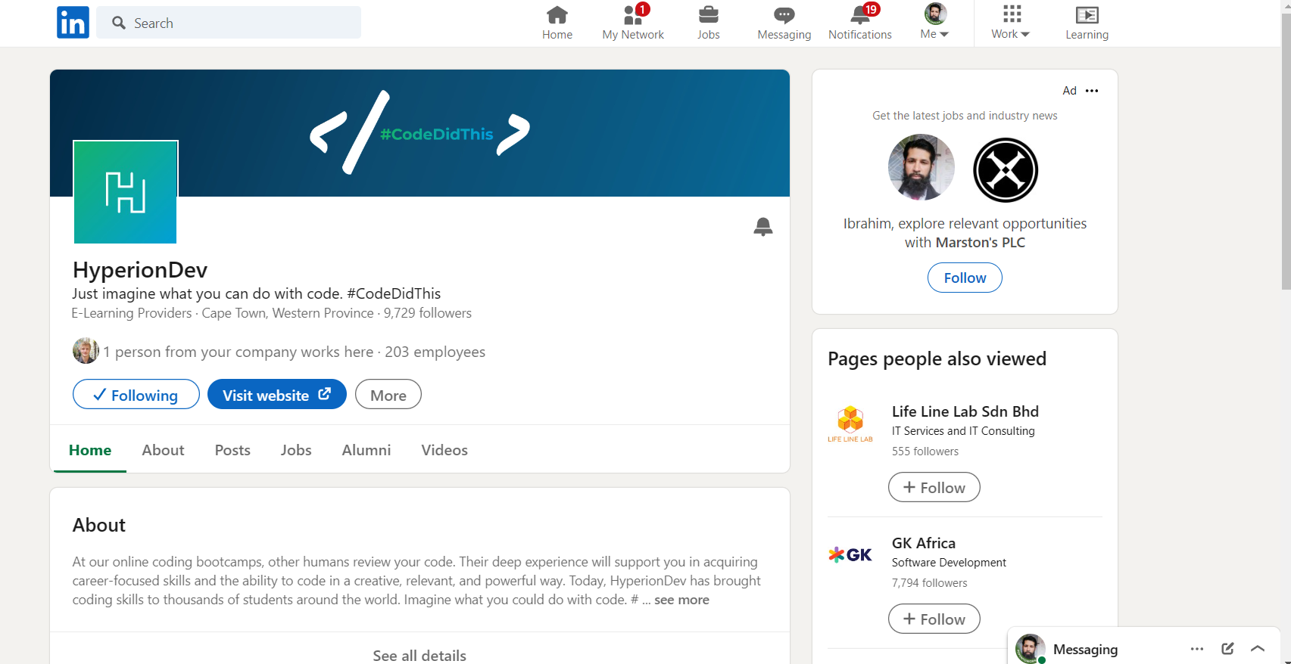
LinkedIn Profile Updated Education:-
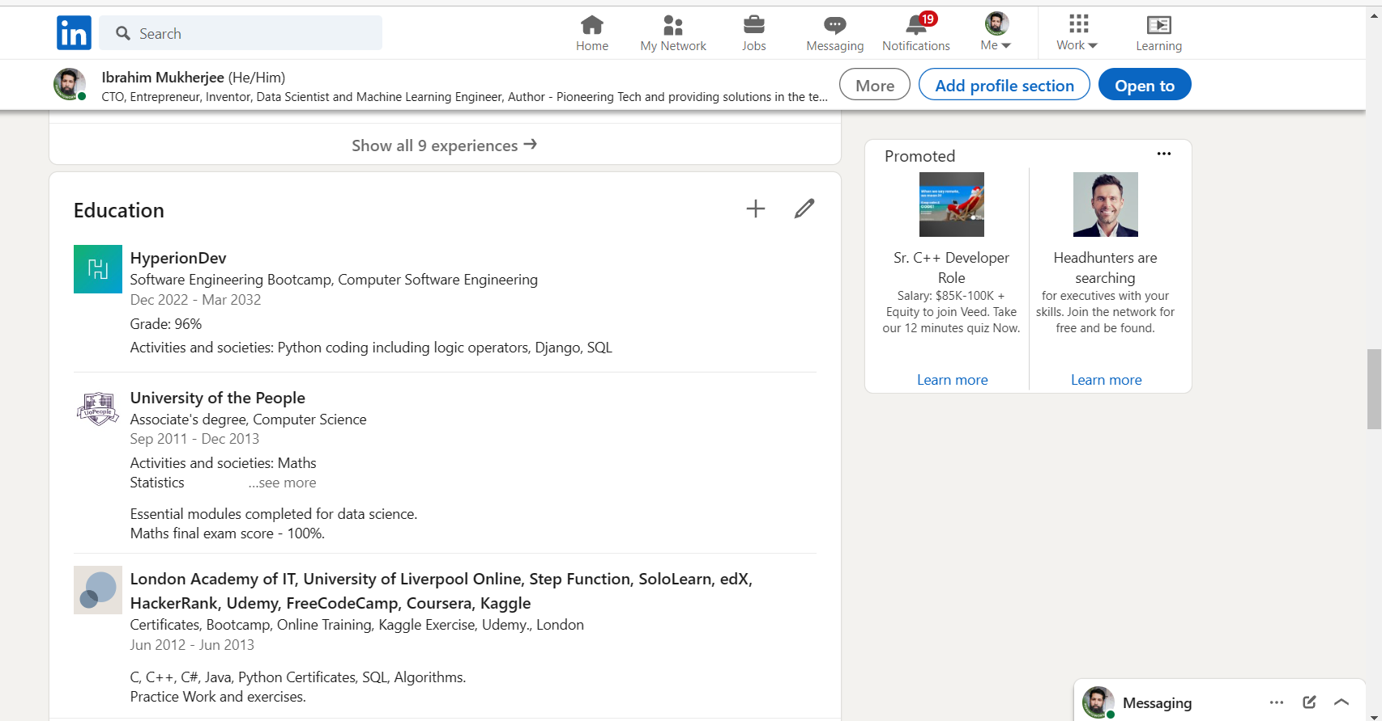
LinkedIn Profile Updated:-

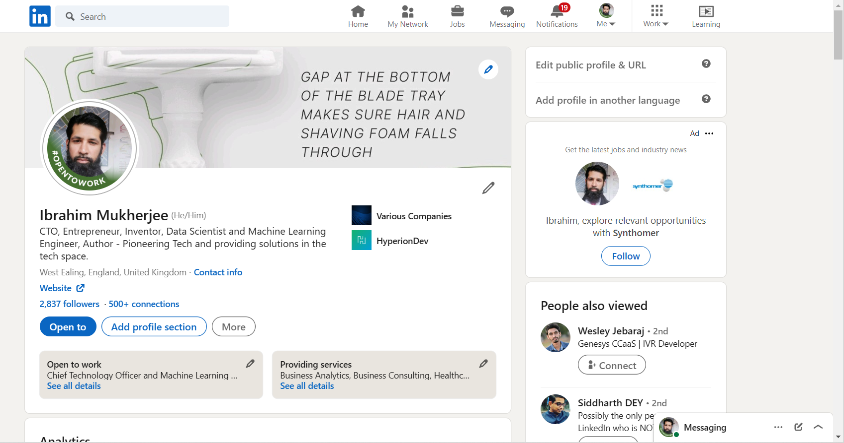
CV Updated with LinkedIn Profile Link :-

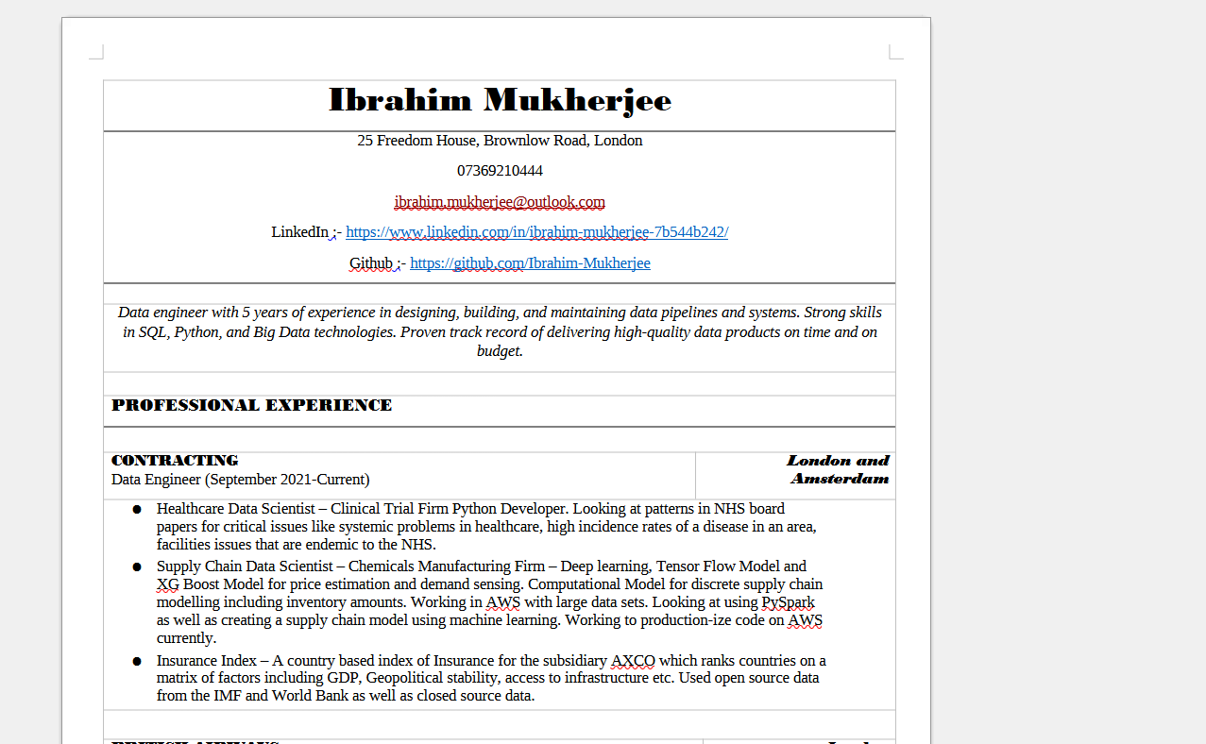
Compulsory Task 3:-

Applied for 5 Jobs on LinkedIn. Reached out to recruiters directly including Jessica at Client Server with new copy of CV + Cover Letter, as well as other contacts in Recruitment.

Overall 50+ applications made. Have updated with final stage interviews coming up.

Job Applications Recorded:-

