TAAM WEB-3 WHITE PAPER

Website:- https://taam-web3.crd.co

Github:- https://github.com/Ibrahim-Mukherjee/TAAM/tree/main

Discord:- https://discord.com/invite/tAt65m473k

Telegram:- https://t.me/+LOqQvz1D0kk2ODA8

X/Twitter:- @Taam_Coin_Web3

Contact for Corporate Partnerships or CVs for new developers:- ibrahim-taam@proton.me

For Large Tenders of Coins to buy from TAAM directly:- ibrahim-taam@proton.me



Introduction
TAAM-WEB3 is an Open Source Software Development Foundation. The code is provided open source under the MIT license. Developer are paid in TAAM tokens which are available on the Stellar Network. Some code is kept closed source, and TAAM works with established companies in the field of self-driving AI, Robotics, Cybersecurity and Digital Biometrics. The scope of the Open Source Foundation may change as work develops.

A DAO will be formed where a voting mechanism is established based on the number of coins each party has and are encouraged to vote on outstanding issues including development of the project and marketing of the project.

TAAM’s main purpose is to develop open-source functional code and interface with established companies similar to the Linux Foundation. TAAM’s company structure is decentralized where the company is abstracted to a collection of individual or corporate asset holders contributing to the DAO which is run by the founder Ibrahim Mukherjee.

TAAM was initiated by Ibrahim Mukherjee who launched the project and minted 900 billion TAAM tokens on the Stellar Blockchain. Assets are allocated to all members on a fair basis based on clear lines and incentive structures as below:-

Incentive System Design

PLEASE NOTE FOR ALL CONTRIBUTORS:-

!!!THE COIN ALLOCATION WILL CHANGE AS THE PROJECT GAINS GROUND AND THE VALUE OF THE TAAM COIN INCREASES – MANAGEMENT WILL CONTINUOUSLY REVIEW THE ASSET PRICE TO PROVIDE FAIR ALLOCATION AND JUST REWARD FOR ALL WORK DEPENDING ON ASSET PRICE AND VOLATILITY ON A REGULAR BASIS.!!!

BY WORKING ON TAAM YOU EXPLICITLY FORGO THE RIGHT TO TAKE MANAGEMENT TO COURT IF YOU ARE NOT SATISFIED WITH THE ALLOCATION.


The project's incentive system is designed to reward contributors with TAAM tokens for their work in various roles and contributions to the project. The incentive structure is as follows:

Software Developers:-

Code Commit – They receive 1000 coins for every 10 lines of audited secure code they write.

Bounties – Bounties receive 1,000,000 coins each irrespective of the number of lines of code.

The code areas include cybersecurity, self-driving technology, alternatives to blockchain, control systems for drones, robots, and other humanoid systems, artificial general intelligence, battery management, renewable energy management, bitcoin tracing through transactions, face detection for AR/VR, development of SLM's for use in devices, and development of drivers for IoT devices.

Academics:-



They receive 10,000 coins for pre-print paper such as ArXiv committed to TAAM after audit, any white paper beneficial for TAAM.

1,000,000 coins for audited secure code they write for new papers on ArXiv or established journals. Academics can choose to get 100,000 coins for executing papers or choose 1000 coins per line of audited code at their discretion.

Social Media Managers:-

They are awarded coins on an hourly basis for their work. The current rate set is 100 coins per hour of work.

Content Creation:-

Coins are distributed per post on Twitter, Instagram, and TikTok based on audited work. 10 coins are given per post on Twitter, Instagram, Tiktok. Facebook. TAAM does not work on Threads, Truth Social or any of these other channels. Management will review social media outlets based on popularity, prevalence of false information and assess this list regularly.

!!!ALL ASSETS POSTED MUST BE OFFICIAL ASSETS OF TAAM-WEB3 FROM THE CONTENT CREATORS ON DISCORD!!! NO UNAUTHORIZED POSTS ARE ALLOWED OR MAKING OUTLANDISH CLAIMS ON SOCIAL MEDIA. ONLY USE APPROVED MATERIAL FROM THE DISCORD CHANNEL TO MAKE POSTS.

Reposts from Official TAAM Twitter Handle:-

Reposts from the official twitter Handle of TAAM-web3 on X get 10 coins.

Graphic Designers:-

They receive 100 coins asset made. This includes posters, videos, white paper design.

Videos exceeding 5 second and after quality is checked can be awarded up to 10,000 coins.

High quality eye-popping posters can be awarded up to 10,000 coins.

White Papers by Economists or Finance Professions (PhD, Qualified Chartered Accountatants, Qualified CFA or Qualified Actuaries only):-

Authors of white papers are given 10,000 coins, while academics writing pre-print code or executing existing papers are awarded 100,000 coins each.
The allocation of coins is based on the area of contribution, the importance of the code to the final project, and the quality of the code.

Blockchain Developers and Exchange Management:-

Blockchain developers working to create new wallets for Taam-Web3, develop infrastructure around the TAAM project on the Stellar Blockchain, interface with MEXC, Kraken or other exchanges are given up to 1,000,000 coins based on project scope or 1,000 coins per 10 lines of code whichever is higher.

Why TAAM is on the Stellar Foundation:-

TAAM tokens are integrated with the Stellar Network, chosen for its ability to make cash exchangeable and its collaboration with organizations like UNHCR. TAAM tokens can be purchased by investors directly on the Stellar Chain or through regular coin drops. The Stellar Development Foundation (SDF) is a nonprofit organization focused on creating equitable access to the global financial system through blockchain technology.

Collaboration with General Ai Co.:-
TAAM-Web3 collaborates with the General Ai Co., SanRa, Sy6 and other companies to provide services in cybersecurity, machine learning, and other use cases. Contact:- ibrahim-taam@proton.me for large corporations who want to invest in the TAAM project and participate in the DAO to direct future development and provide “bounties” for work.

Project Overview
TAAM is an open-source project dedicated to the development of Web3 and AI technologies, which are considered crucial for humanity today. The project operates under the premise that open-source code is robust, auditable, and beneficial to humanity, contrasting with the pitfalls of closed source code development

Open Source Code Benefits
Open-source software offers numerous advantages, such as cost-efficiency, flexibility, agility, enhanced security, and the power of community collaboration. It attracts talent and allows for the sharing of maintenance costs. Open-source projects like TAAM can lead to innovation and are considered a good investment in the future of technology

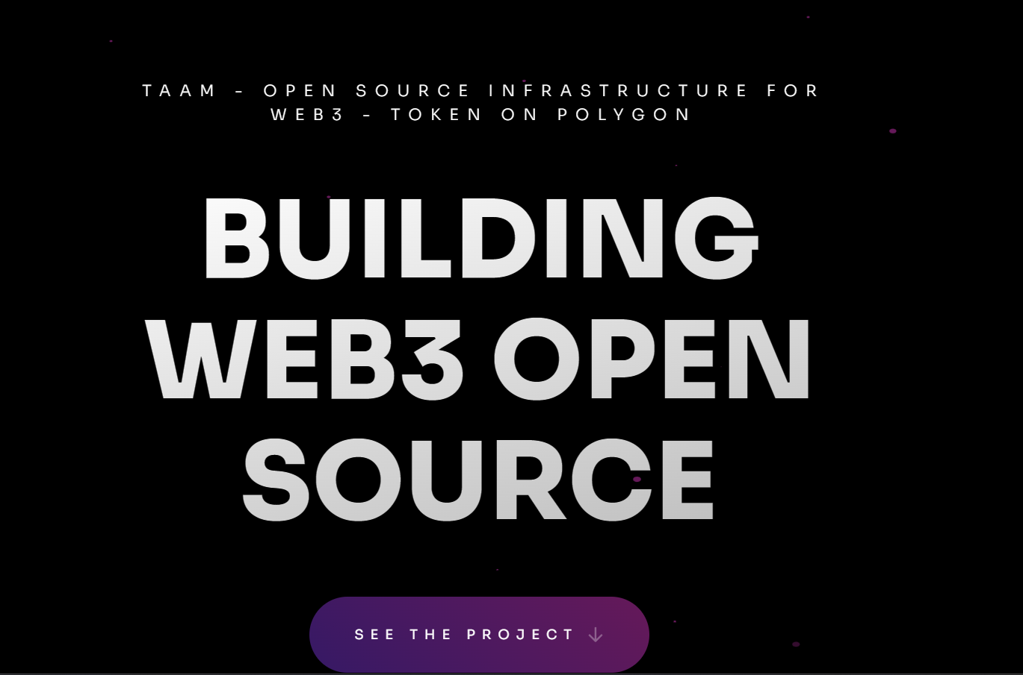
Visit the website at:- https://taam-web3.crd.co

TAAM PARTNERS:-

Taam is on the Stellar Blockchain.

SanRa – Cybersecurity.

The General Ai Co. - AI and Machine Learning.

