Readme:

BudgetBuddy

> Developed by Rayhaan (ST10214465), Ibrahim (ST10062630), and Ryan (ST10171205)

Github Link: https://github.com/VCSTDN2024/prog7313-part3-poe-team-15.git

Youtube Link: https://youtu.be/tlakbjHgmrQ

Purpose of the App:

**BudgetBuddy** is a smart and user-friendly mobile application designed to help individuals track their expenses, set budget goals, and gain control over their personal finances. Our goal is to empower users with the tools and insights needed to manage their money effectively.

This app supports users by:
- Allowing registration and login for personalized budget tracking.
- Managing expense categories.
- Logging expenses with optional photo attachments.
- Setting monthly budget goals.
- Receiving budgeting tips generated by the app.
- Tracking budgeting progress visually with a dynamic character and progress bar.
- Generating visual reports for better financial insight.

Design Considerations:

Iterative Improvements:

The current version of BudgetBuddy has evolved significantly from its initial prototype and Part 2 submission. Key improvements include:

Navigation Overhaul: Fixed issues with the navigation bar for smoother user experience.
Colour Scheme Redesign: Updated to create a more cohesive and visually pleasing interface.
Enhanced UX/UI: Reorganized screens for better usability and interaction.

Feature Highlights:

Registration & Login Flow:
- Users start at the login screen.
- New users can register accounts.
- Upon logging in, they gain full access to the app's features.

Category Management:
- Add, view, and manage expense categories.

Expense Logging:
- Enter expense amount and description.
- Attach photos for better expense documentation.
- Save data for easy retrieval.

Budget Goal Setting:
- Define monthly budget goals.
- Save and update these goals as needed.

Own Feature 1 - Budget Tips Generator:
- Located on the budget goals screen.
- Provides simple, dynamic tips to help users stay on budget.

Own Feature 2 - Interactive Character Feedback:
- A character on the home screen reflects the user's budgeting status:
- 🟢 Green = Within budget.
- 🔴 Red = Over/Under budget.
- Visual and motivational feedback based on goal adherence.

Progress Bar Tracker:
- Tracks the user's financial activity.
- Dynamically updates as expenses are logged.
- Provides a clear indication of budgeting progress.

Expense Report Page:
- Users can select a period to generate a detailed financial report.
- Graphs display:
- Total spent per category.
- Min/Max budget goals.
- Visual insight into budgeting behavior and trends.

We made several design improvements and refinements since the prototype (Part 1) and Part 2 submission:

- Redesigned the navigation bar for improved stability.
- Harmonized the colour scheme for a more appealing and readable interface.
- Added interactive visual feedback (e.g., character color, progress bar).
- Improved responsiveness and layout consistency across all screens.

Version Control with GitHub:

- All source code, assets, and documentation are version-controlled via GitHub.
- Team collaboration was maintained through branches, commits, and pull requests.
- Issues and project boards were used for task tracking and progress monitoring.

Tech Stack:

- Framework: Android Studio (Java / Kotlin)
- Database: FireBase
- UI Design: XML Layouts, Material Components
- Version Control: GitHub

Developer Setup Instructions (Android Studio):

Follow these steps to get the project running on your local development environment:

1. Clone the Repository
```bash
git clone https://github.com/your-username/BudgetBuddy.git
cd BudgetBuddy
- Open the Project in Android Studio
  - Launch Android Studio.
  - Click on "Open" and select the cloned BudgetBuddy folder.
- Sync Gradle Files
  - Android Studio will prompt you to sync Gradle.
  - Click "Sync Now" to download dependencies.
- Set Up Emulator or Device
  - Connect a physical Android device or set up an emulator.
  - Ensure developer mode is enabled on your device.
- Build and Run the App
  - Click the green run button.
  - Select your device or emulator.
- Permissions
  - Ensure you allow the necessary permissions (storage/camera) when prompted during app usage.

Summary:

BudgetBuddy is more than a budgeting tool—it's a financial companion. Through continuous development and user-centered design, we’ve crafted an app that not only meets the requirements of our POE but exceeds expectations with added features and polished functionality. The journey from prototype to polished product has involved solving technical and design challenges while maintaining a consistent focus on user experience.

Screenshots:
App icon:
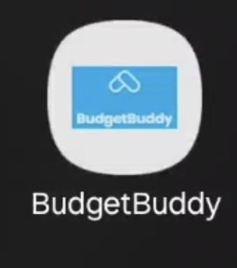
Login:
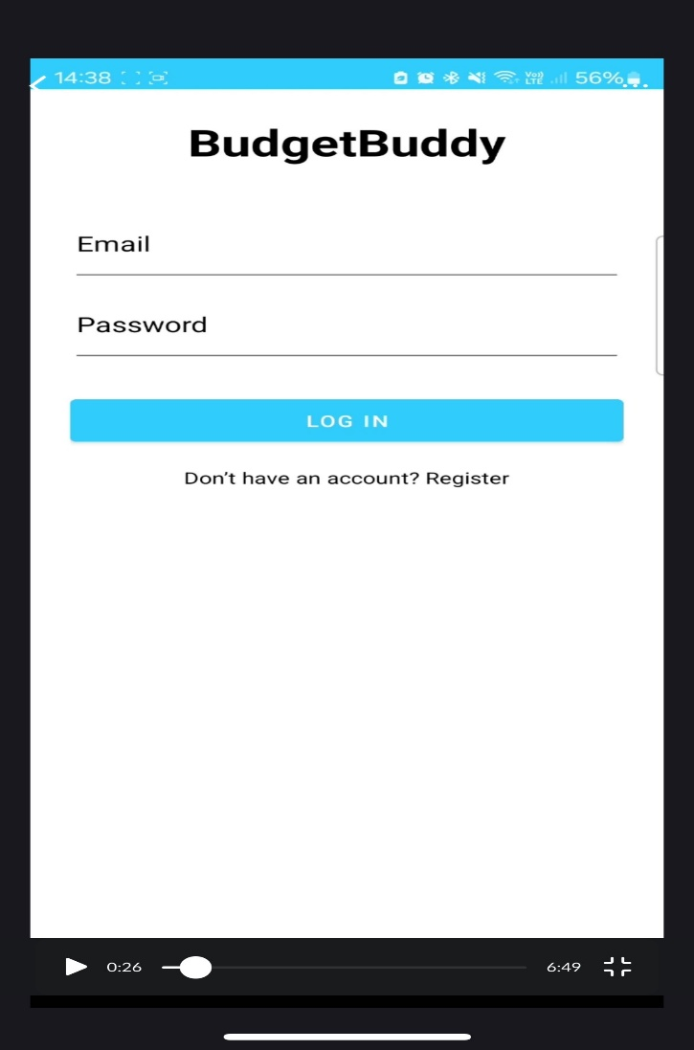
Register:
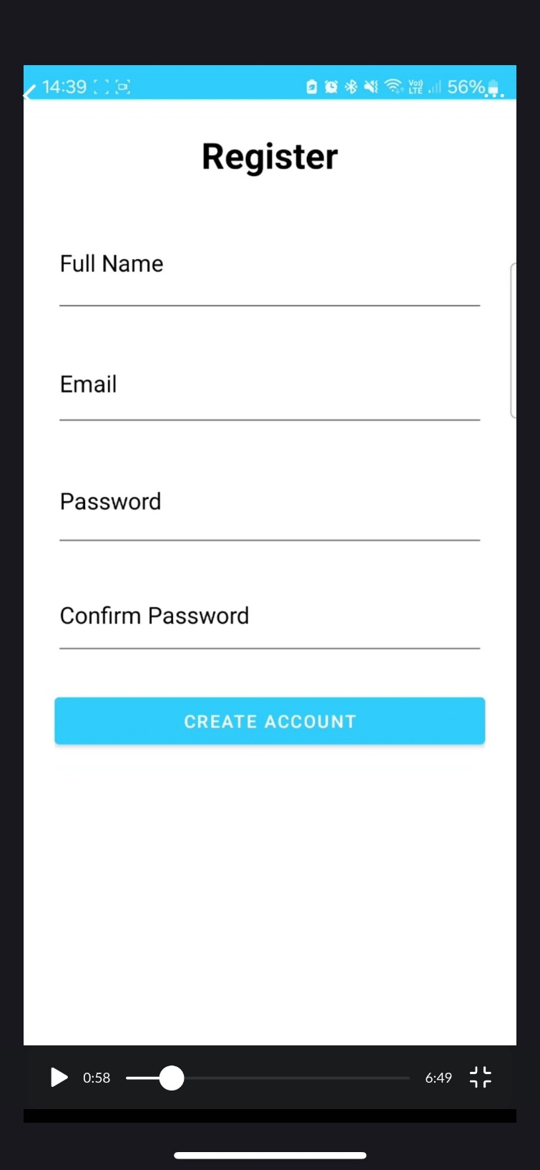

Home Page:
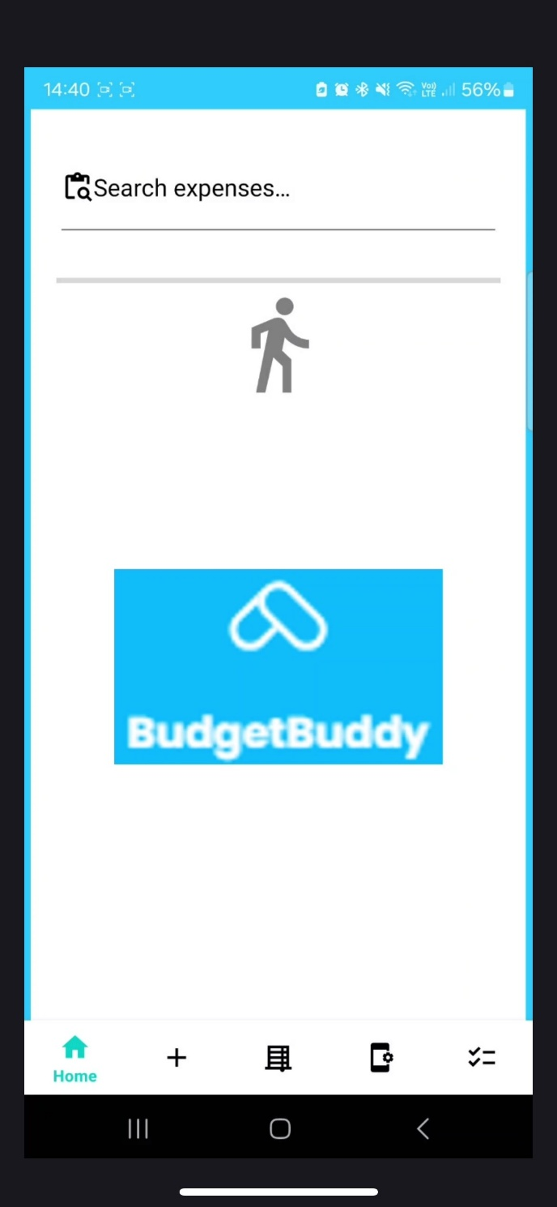

Categories :
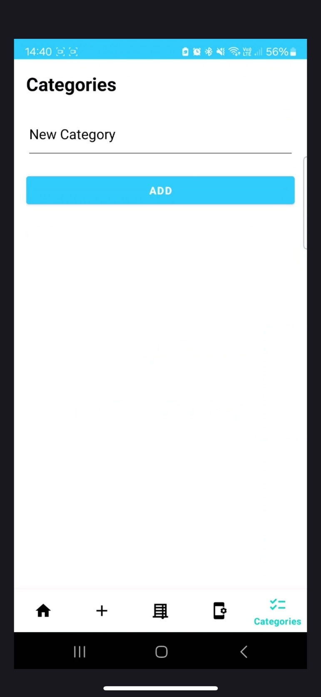

Expense(s):
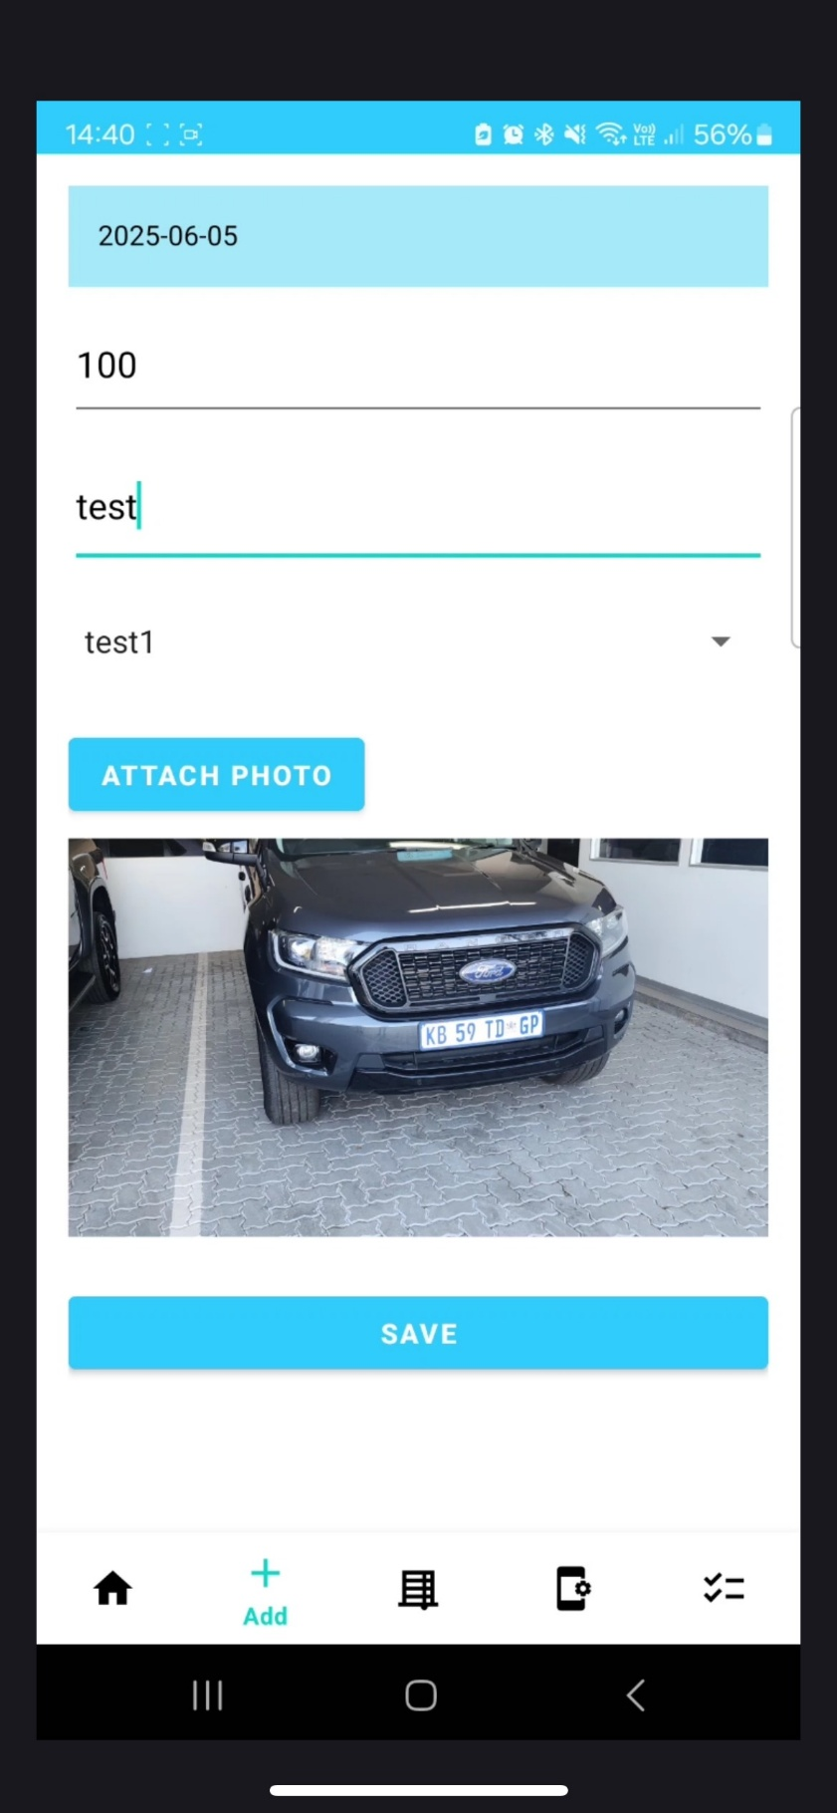
Budget Goals:
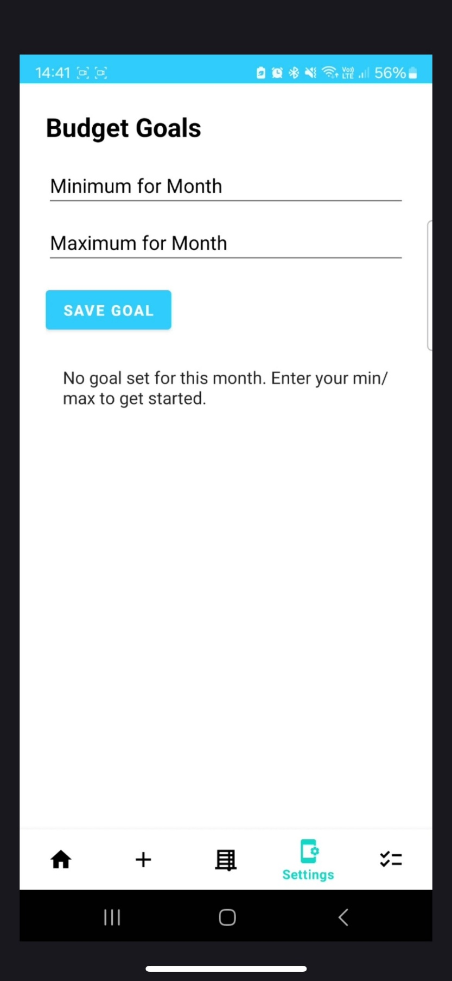

Within Budget:
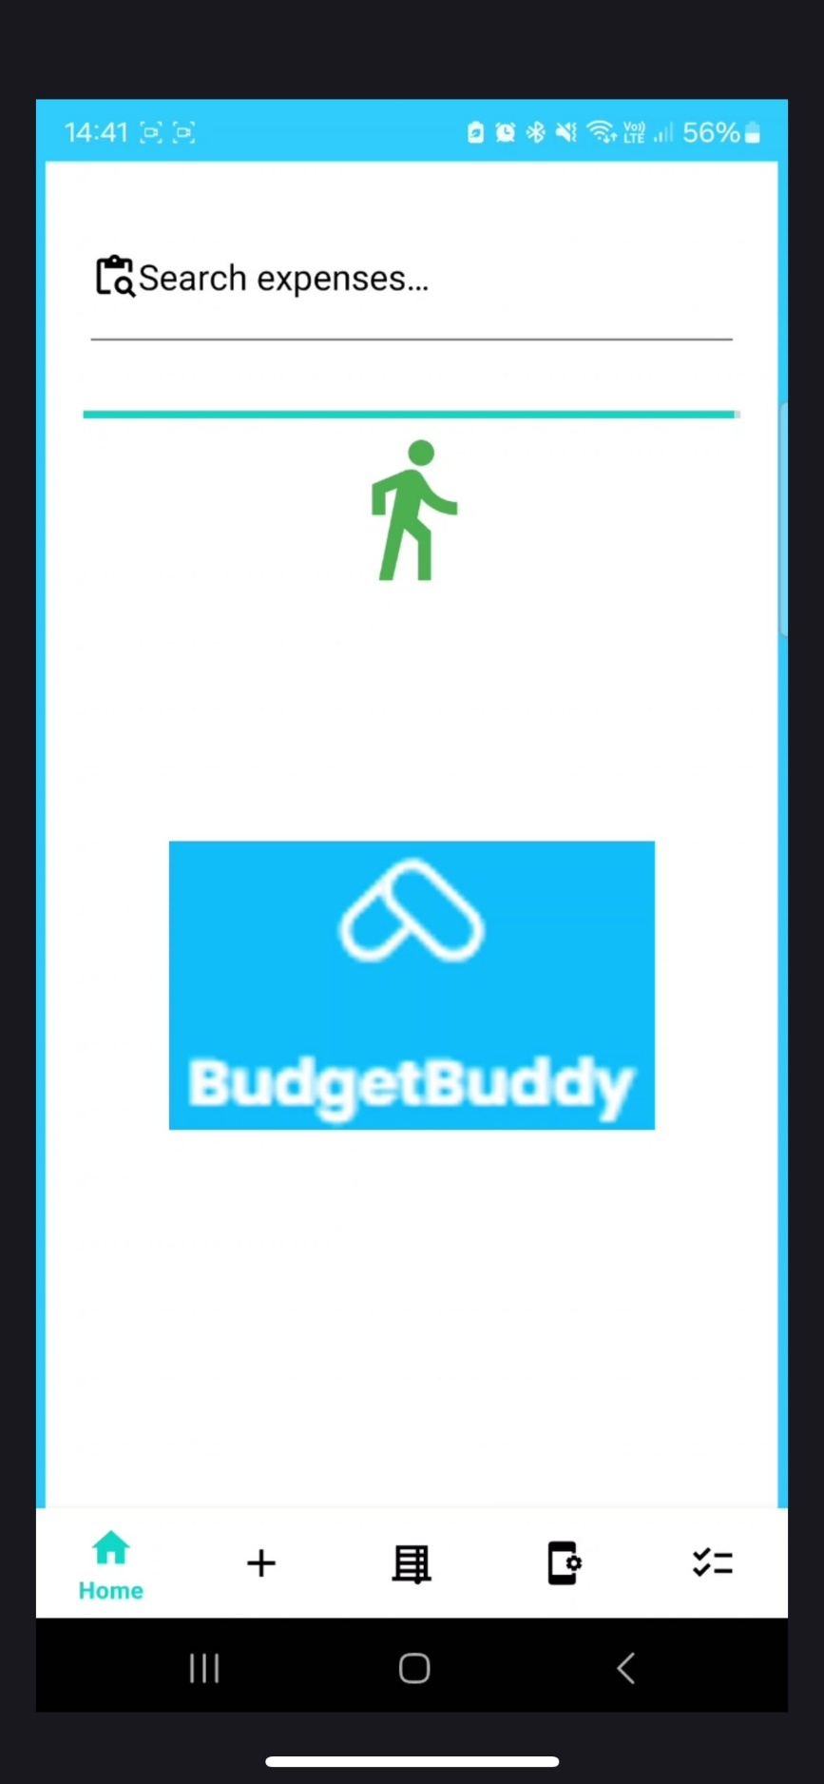
Out of Budget:
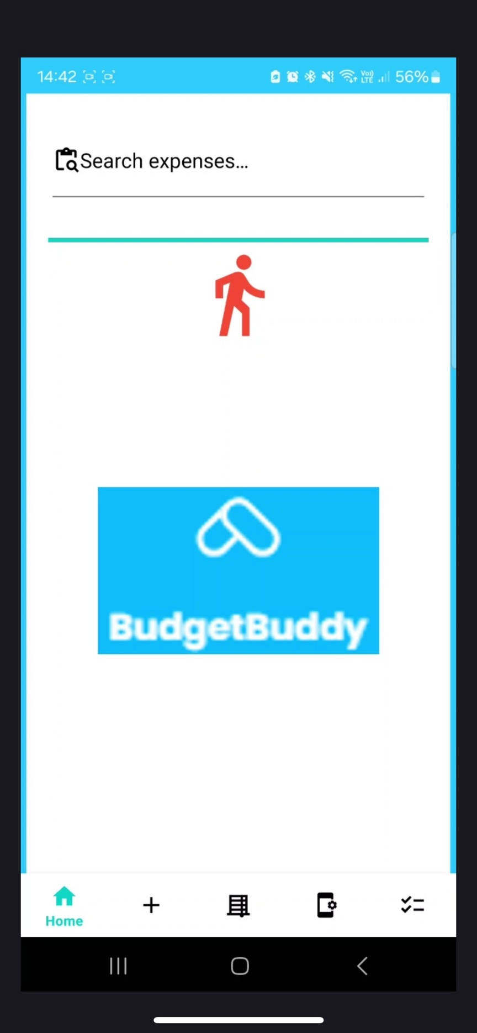
Report:
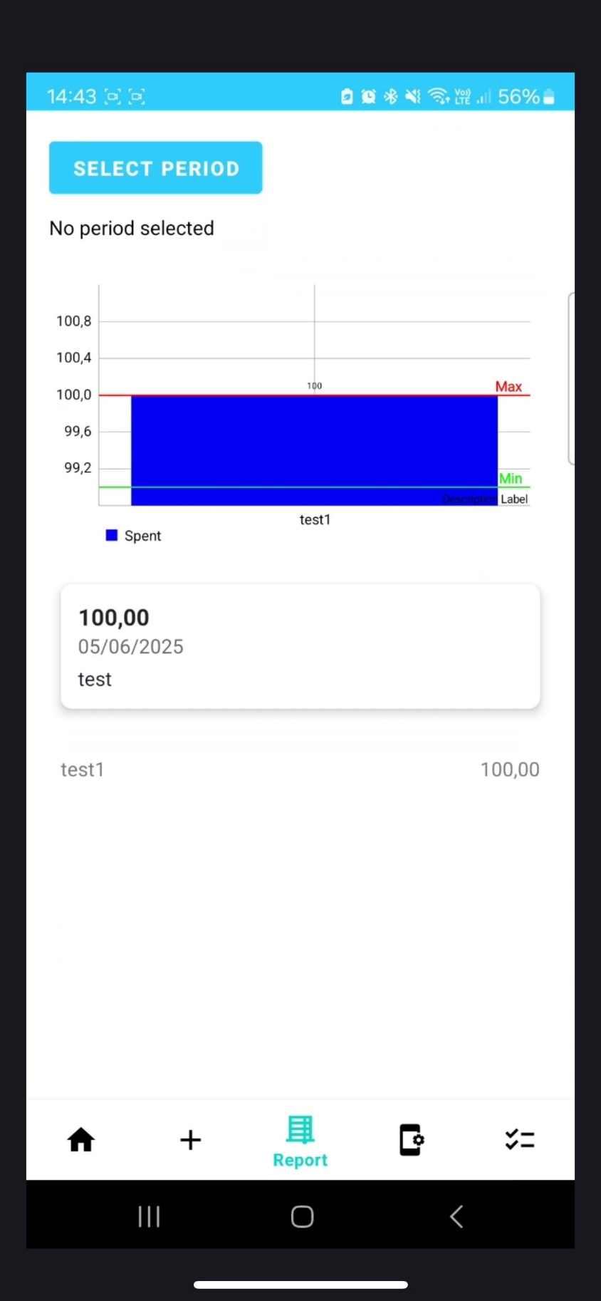
Database / Cloud:
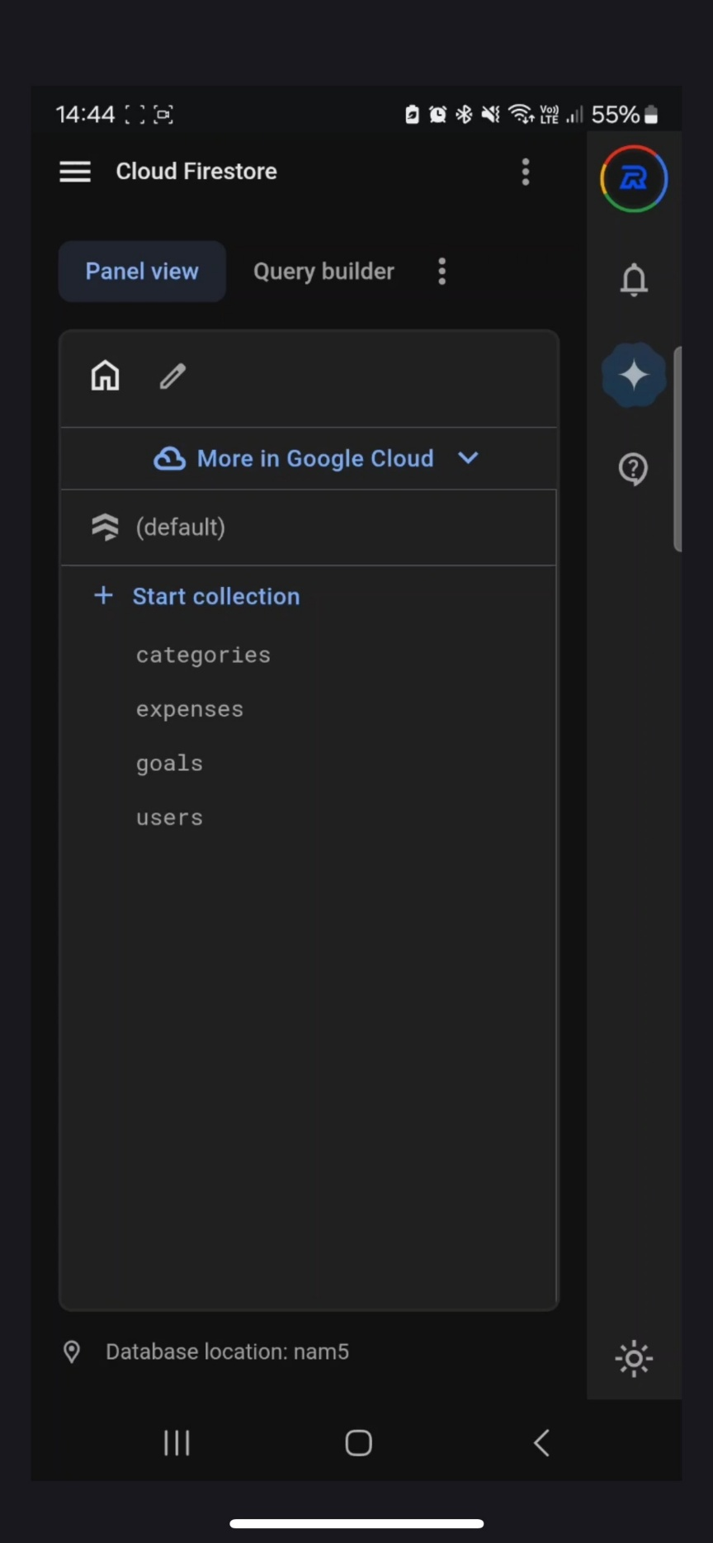

Reference List:
- Du Plooy-Cilliers, F., Davis, C. and Bezuidenhout, R., 2014. Research matters. 1st ed. Cape Town: Juta.
- Firebase, 2024. Get started with Firebase Authentication on Android. [online] Available at: https://firebase.google.com/docs/auth/android/start [Accessed 5 June 2025].
- Firebase, 2024. Cloud Firestore Security Rules. [online] Available at: https://firebase.google.com/docs/firestore/security/get-started [Accessed 5 June 2025].
- Firebase, 2024. Add Firebase to your Android project. [online] Available at: https://firebase.google.com/docs/android/setup [Accessed 5 June 2025].
- GitHub Marketplace, 2024. Automated Build Android App with GitHub Action. [online] Available at: https://github.com/marketplace/actions/automated-build-android-app-with-github-action [Accessed 5 June 2025].
- YouTube, 2025. BudgetBuddy App Demonstration. [video online] Available at: https://youtu.be/tlakbjHgmrQ [Accessed 5 June 2025].
- GitHub, 2025. BudgetBuddy GitHub Repository. [online] Available at: https://github.com/VCSTDN2024/prog7313-part3-poe-team-15.git [Accessed 5 June 2025].
- GeeksforGeeks, 2024. Android App Development with Kotlin. [online] Available at: https://www.geeksforgeeks.org/kotlin-android-tutorial [Accessed 5 June 2025].
- W3Schools, 2024. Kotlin Tutorial. [online] Available at: https://www.w3schools.com/kotlin/ [Accessed 5 June 2025].

