Convolutional Neural Networks for Skin Disease Analysis and Treatment Decision Support System

Kerem Selçuk
Department of Software Engineering
Firat University
Elazığ, Türkiye
240541055@firat.edu.tr
Aybüke Türk
Department of Software Engineering
Firat University
Elazığ, Türkiye
240541115@firat.edu.tr
Ibrahim Taşkıran
Department of Software Engineering
Firat University
Elazığ, Türkiye
230541049@firat.edu.tr
Muhammet Baykara
Department of Software Engineering
Firat University
Elazig, Türkiye
mbaykara@firat.edu.tr
Mhd Hadi Said Alkaddour
Department of Software Engineering
Firat University
Elazig, Türkiye
250541627@firat.edu.tr

Abstract— Skin diseases are among the common health issues that directly affect people’s quality of life. In recent years, there has been a marked increase in both the number and severity of dermatological cases. Environmental factors such as climate change, increased UV radiation, and air pollution have a direct negative impact on the skin barrier. The combination of sunlight and pollution causes the skin’s collagen structure to break down much faster than normal. This situation sets the stage for various skin problems to arise in different age groups. In addition to these issues, there has been a significant increase in the use of cosmetic products available on the market. Cosmetic products used to repair damage caused by environmental factors, or used incorrectly, can actually worsen existing skin damage and lead to new problems. In addition, incorrect treatment methods administered as a result of the skin condition not being properly diagnosed further exacerbate the damage. The time-consuming nature of traditional dermatological evaluation processes delays access to treatment, thereby further exacerbating the disease burden. In this study which was conducted for these reasons, an automatic skin disease diagnosis system based on Convolutional Neural Networks (CNN) was developed to address these issues. The system is built on the EfficientNet CNN architecture and has been trained on an image dataset covering six different skin disease categories. The developed model achieved an 84% verification accuracy. One of the study original contributions is that this CNN model has been integrated into a smartphone-based mobile app called “DermAI” enabling real-time classification. Users can get real-time health diagnoses by uploading images through the app. The system also functions as a decision support mechanism. This approach clearly demonstrates the clinical applicability of CNN-based artificial intelligence in dermatology by providing a fast and reliable preliminary diagnostic tool in settings where access to specialists is limited.
Keywords— Skin disease classification, Decision support system, Deep learning, Convolutional neural networks

Introduction (Heading 1)
Skin diseases, such as eczema, acne, and actinic keratosis, are one of the most common health problems worldwide, affecting hundreds of millions of people annually. No age group is immune to these conditions; everyone from infants to the elderly is at risk. Skin diseases, which cause both physical and psychological effects, can profoundly impact an individual's daily life. In the US, it is known that more than 31.6 million people are affected by eczema [1] ; in a study of 102,353 children under the age of 17, this rate was found to be 10.7% [2].

Access to dermatological expertise is severely unequal worldwide. In many developing regions, the patient-dermatologist ratio exceeds 50,000:1 making timely diagnosis and treatment difficult. Delayed diagnosis in malignant lesions such as actinic keratosis and basal cell carcinoma significantly worsens prognosis [3]. The complex structure of the skin and the apparent similarity of diseases further complicate accurate diagnosis. This problem is exacerbated by the fact that traditional skin assessments take a long time.

The proliferation of smartphone cameras and advancements in CNN architectures have opened a new door for AI-powered diagnostic tools. The combined use of image processing and deep learning methods makes automatic detection of skin diseases possible. Studies in this field,
where users can obtain disease predictions from their own images using mobile application-based systems, are included in the literature [4]. Hybrid models using different CNN architectures together have been shown to exhibit higher performance compared to other approaches [5], [6].When examined on a disease basis; in eczema detection, Nisar et al. [7] achieved 84.43% accuracy with SVM architecture using features such as color, size and texture. Balaji et al. [8] achieved 72.7% diagnostic accuracy with a dynamic cropping and Bayesian classifier-based approach. In a study on rosacea and acne detection, 93.1% accuracy, 92.8% specificity and 94.9% sensitivity were obtained on 2624 images using sparse coding, deep residual network and support vector machine [9]. The transfer learning-based SeResNext50 architecture gave an accuracy rate of 95.76% in the skin sensitivity model, while the SeResNext101 architecture gave an accuracy rate of 85.11% in the acne intensity model [10].

However, the vast majority of current studies focus only on classification performance; meaningful feedback to the user, clinical guidance and integration into practical life are not adequately addressed [5], [6]. This clearly highlights the need for systems that can provide real guidance to the user beyond just making accurate predictions.

Developed to fill this gap, DermAI is a mobile-based expert system that classifies six dermatological categories with its
EfficientNet-B0 CNN architecture, achieving 84% validation accuracy. The system offers an integrated application running on the Android platform, a FastAPI-based RESTful API, and a clinical decision support mechanism. This study proposes a concrete solution to the vital need for accurate and timely diagnosis of lesions in the treatment process to improve patient outcomes through enhanced diagnostic accuracy. The remaining sections of this article are organized as follows: Section II deals with preprocessing techniques and CNN architecture; Section III addresses Android implementation and decision support mechanisms; Section IV discusses performance metrics; and Section V presents overall results and future research trends.

RELATED STUDIES
In the study by Esteva et al. [11], 129450 clinical images were used and the CNN trained on these images achieved a level of success in classifying skin cancer comparable to that of certified dermatologists. Subsequent studies within the scope of the ISIC competition have led to comparable datasets and protocols for lesion segmentation and classification [12].
The EfficientNet architecture developed by Tan and Le [13] offers a composite scaling method by scaling the network depth, width, and resolution with a fixed set of coefficients. The EfficientNet-B0 architecture, considered a basic variant of EfficientNet, achieved higher accuracy using fewer parameters over the ImageNet set when compared to architectures such as ResNet-50 and DenseNet-121. With this result, EfficientNet is a suitable architecture for constrained environments.
Systems like SkinVision [14], which use CNN-based approaches relying on cloud inference, must transmit data to third-party cloud providers for inference. This is a necessity and also causes latency. At this point, DermaAI performs inference with local servers rather than third-party cloud providers. This reduces latency.
Mobile systems using local server AI have been studied in many contexts, from diabetic retinopathy screening [15] to tuberculosis detection [16], and common challenges include processing heterogeneous images from inputs, managing model size constraints, and preventing latency for a responsive user experience. With DermaAI, these challenges are addressed by combining server-side single-sample inference detection and client-side image optimization.

METHOD

Overview
A system was developed that predicts and explains specific skin diseases using a Convolutional Neural Network (CNN) framework. Search engines were used with techniques appropriate to academic output to obtain information. The research was done by reviewing research articles, studies on artificial intelligence in healthcare and medical journals. The recent application of deep learning architectures for the diagnosis of skin diseases has given access to the resources for this study. The research was prioritized by accessing and obtaining information from recently published sources. The aim of reviewing academic references was not only for the artificial intelligence to predict but also to explain these predictions using medical data. The research and development process began with researching IEEE Xplore, ScienceDirect, Google Scholar, Medline and scientific journals, prioritized by date. The keywords used in the research were “skin diseases and artificial intelligence”, “skin diseases and deep learning”, “eczema and deep learning”, and “acne-rosacea and CNN”. The obtained information was sorted, detailed, and classified, thus transforming it into data usable in the system.
Open-source platforms were used to obtain disease data. The data obtained from these platforms were filtered according to formats that the system could use. Relevant studies were examined to determine the most accurate technique that could be used based on the data and methods.

Data Set Description
The data used in the study were the “Skin Diseases CNN” [17] and “Skin diseases image dataset” [18] datasets from the Kaggle platform . These datasets are collections of images of dermatological disorders in general.

Data Sizing
In the diagnosis of skin diseases, preserving the morphological characteristics (shape, border arrangement, geometry) of lesions is of critical importance. Standard image resizing processes increase the risk of false positives by distorting clinical anomalies through stretching. To prevent this risk, the "Aspect Ratio Preserving Black Padding" technique was applied to the system. In this method, dynamic zero padding (black areas) is added to the edges while preserving the proportions of the original image, thus allowing the lesions to be resized to 224x224 pixels without distorting their clinical geometry. This method is shown in Figure 1.

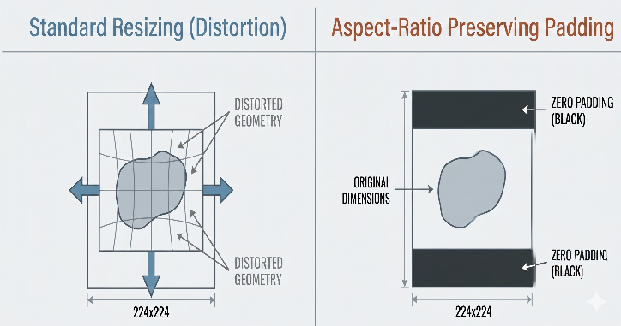
Fig. 1. Comparison of standard resizing and black fill method

To prevent an unbalanced data distribution in the dataset and to ensure the model does not show bias towards diseases with a large number of data points, the number of data points for each disease was limited to 500 images. Diseases with a statistically weak accuracy rate (less than 250 images) were classified as a whole and grouped under the heading "other diseases". The disease distributions are shown in Figure 2.

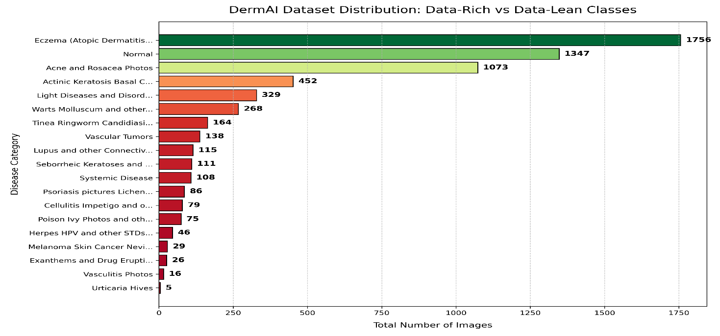

Fig. 2. Distribution of DermAI Dataset

Model Architecture and Training Strategy

This study utilized the EfficientNet-B0 transfer learning architecture, which provides parameter efficiency and advantages while also offering high accuracy. With this architecture, the model detected features in skin lesions in a two-dimensional spatial plane and achieved a success rate of over 57.6%. CUDA and GPU-accelerated parallel computation was used for performance optimization during the training process. In the subsequent work, the system transitioned from a 1D smoothed array (150,528 vector) Scikit-Learn architecture to a 2D Spatial Tensor (224x224x3) supported architecture that provides high performance at the production level for the prototype phase. The OneCycleLR strategy was applied for model convergence optimization.

Memory Management and Disaster Recovery
To reduce the impact of high-resolution datasets on system performance and memory (RAM), an "out-of-core" training strategy was implemented. Instead of processing data individually, it was processed in groups of 32. To prevent possible system crashes, a "Checkpoint" system (saving as a .pkl file) was installed at the end of each period. Thanks to this "Checkpoint," the continuity and reliability of training were ensured. This is a positive approach in terms of training large datasets with limited hardware limitations [19].

Clinical Decision Support Database and Dynamic Data Structure
In addition to being a classification tool, the system offers a character support mechanism to provide an efficient and user-friendly infrastructure. For this purpose, a JSON database separate from the main code structure has been designed. A data pool has been created, prepared by examining more than 25 academic references in IEEE format, and providing risk level, clinical descriptions, care recommendations, and disease warnings for each diagnosis

result. The JSON-based nature of the data provides a dynamic system where findings and revisions that may be added during the process can be integrated without changing the main code structure.

System Integration and Mobile Application Development

Kotlin and Java 21 languages ​​were used for the native Android infrastructure. A smooth workflow was achieved with a user experience designed in accordance with Material Design 3 standards. The system aims to deliver the analysis results in less than 3 seconds (NFR) under average network conditions. Furthermore, to protect the user privacy and security, the image selection and analysis processes are handled through secure data paths. The Sequence Diagram showing the interaction between the actors in the system is shown in Figure 3.
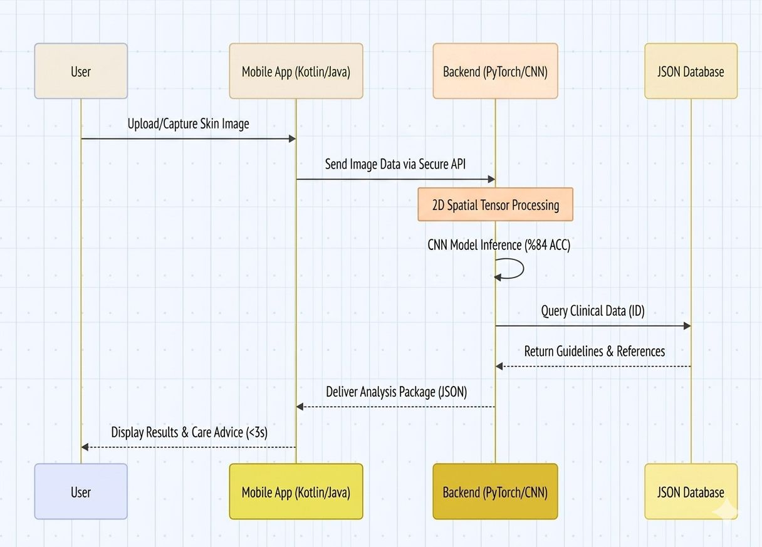
Fig. 3. Sequence Diagram showing user interaction and data flow between system components

Findings

Artificial Intelligence Model
In this study, EfficientNet-B0, pre-trained on ImageNet, was used as the backbone network. The final classification layer was reconfigured to correspond to six disease classes; the total number of trainable parameters was kept at approximately 4.01 million.
The aspect ratio was preserved in image processing using the letterboxd approach. Random rotation, color jitter correction, and horizontal/vertical flipping optimization techniques were used throughout the training. The model was trained in 20 epochs using the AdamW optimizer and the OneCycleLR timer.

Table I. Model training configuration
Hyperparameter | Value
Backbone | EfficientNet-B0
Optimizer | AdamW
Learning Rate Scheduler | OneCycleLR  (max. 1e-3)
Number of Periods / Group Size | 20 / 32
Loss Function | CrossEntropyLoss

System Components
The backend consists of a REST API server built on FastAPI and Uvicorn With a server operating on a single architecture and a checkpoint initially loaded into RAM once, each request is responded to using the same model instance. The incoming image is validated at the primary endpoint, POST/predict. The result is returned as JSON with the three highest prediction confidence scores.
The mobile application was developed using Kotlin and Jetpack Compose. It supports both shooting from the camera and selecting from the gallery via the Retrofit HTTP client and the CameraX library. The content:// URI change introduced with Android 13+ was resolved using ContentResolver.openInputStream().

Model Performance
The model was evaluated on a test set of 526 images. Overall accuracy was 84%, and the macro F1 score was 0.81. Figure 4 presents the complexity matrix, Figure 5 shows the distribution of F1 scores by disease, and Figure 6 presents the comprehensive metric report.

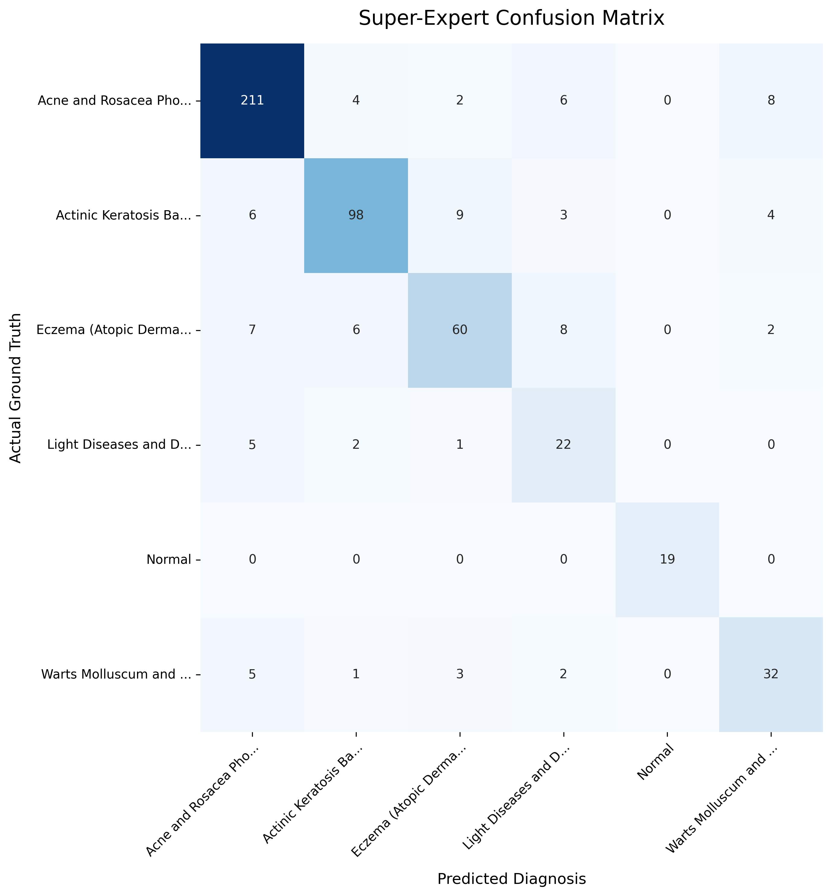
Fig. 4. Complexity Matrix — Rows show actual diagnoses, columns show model predictions

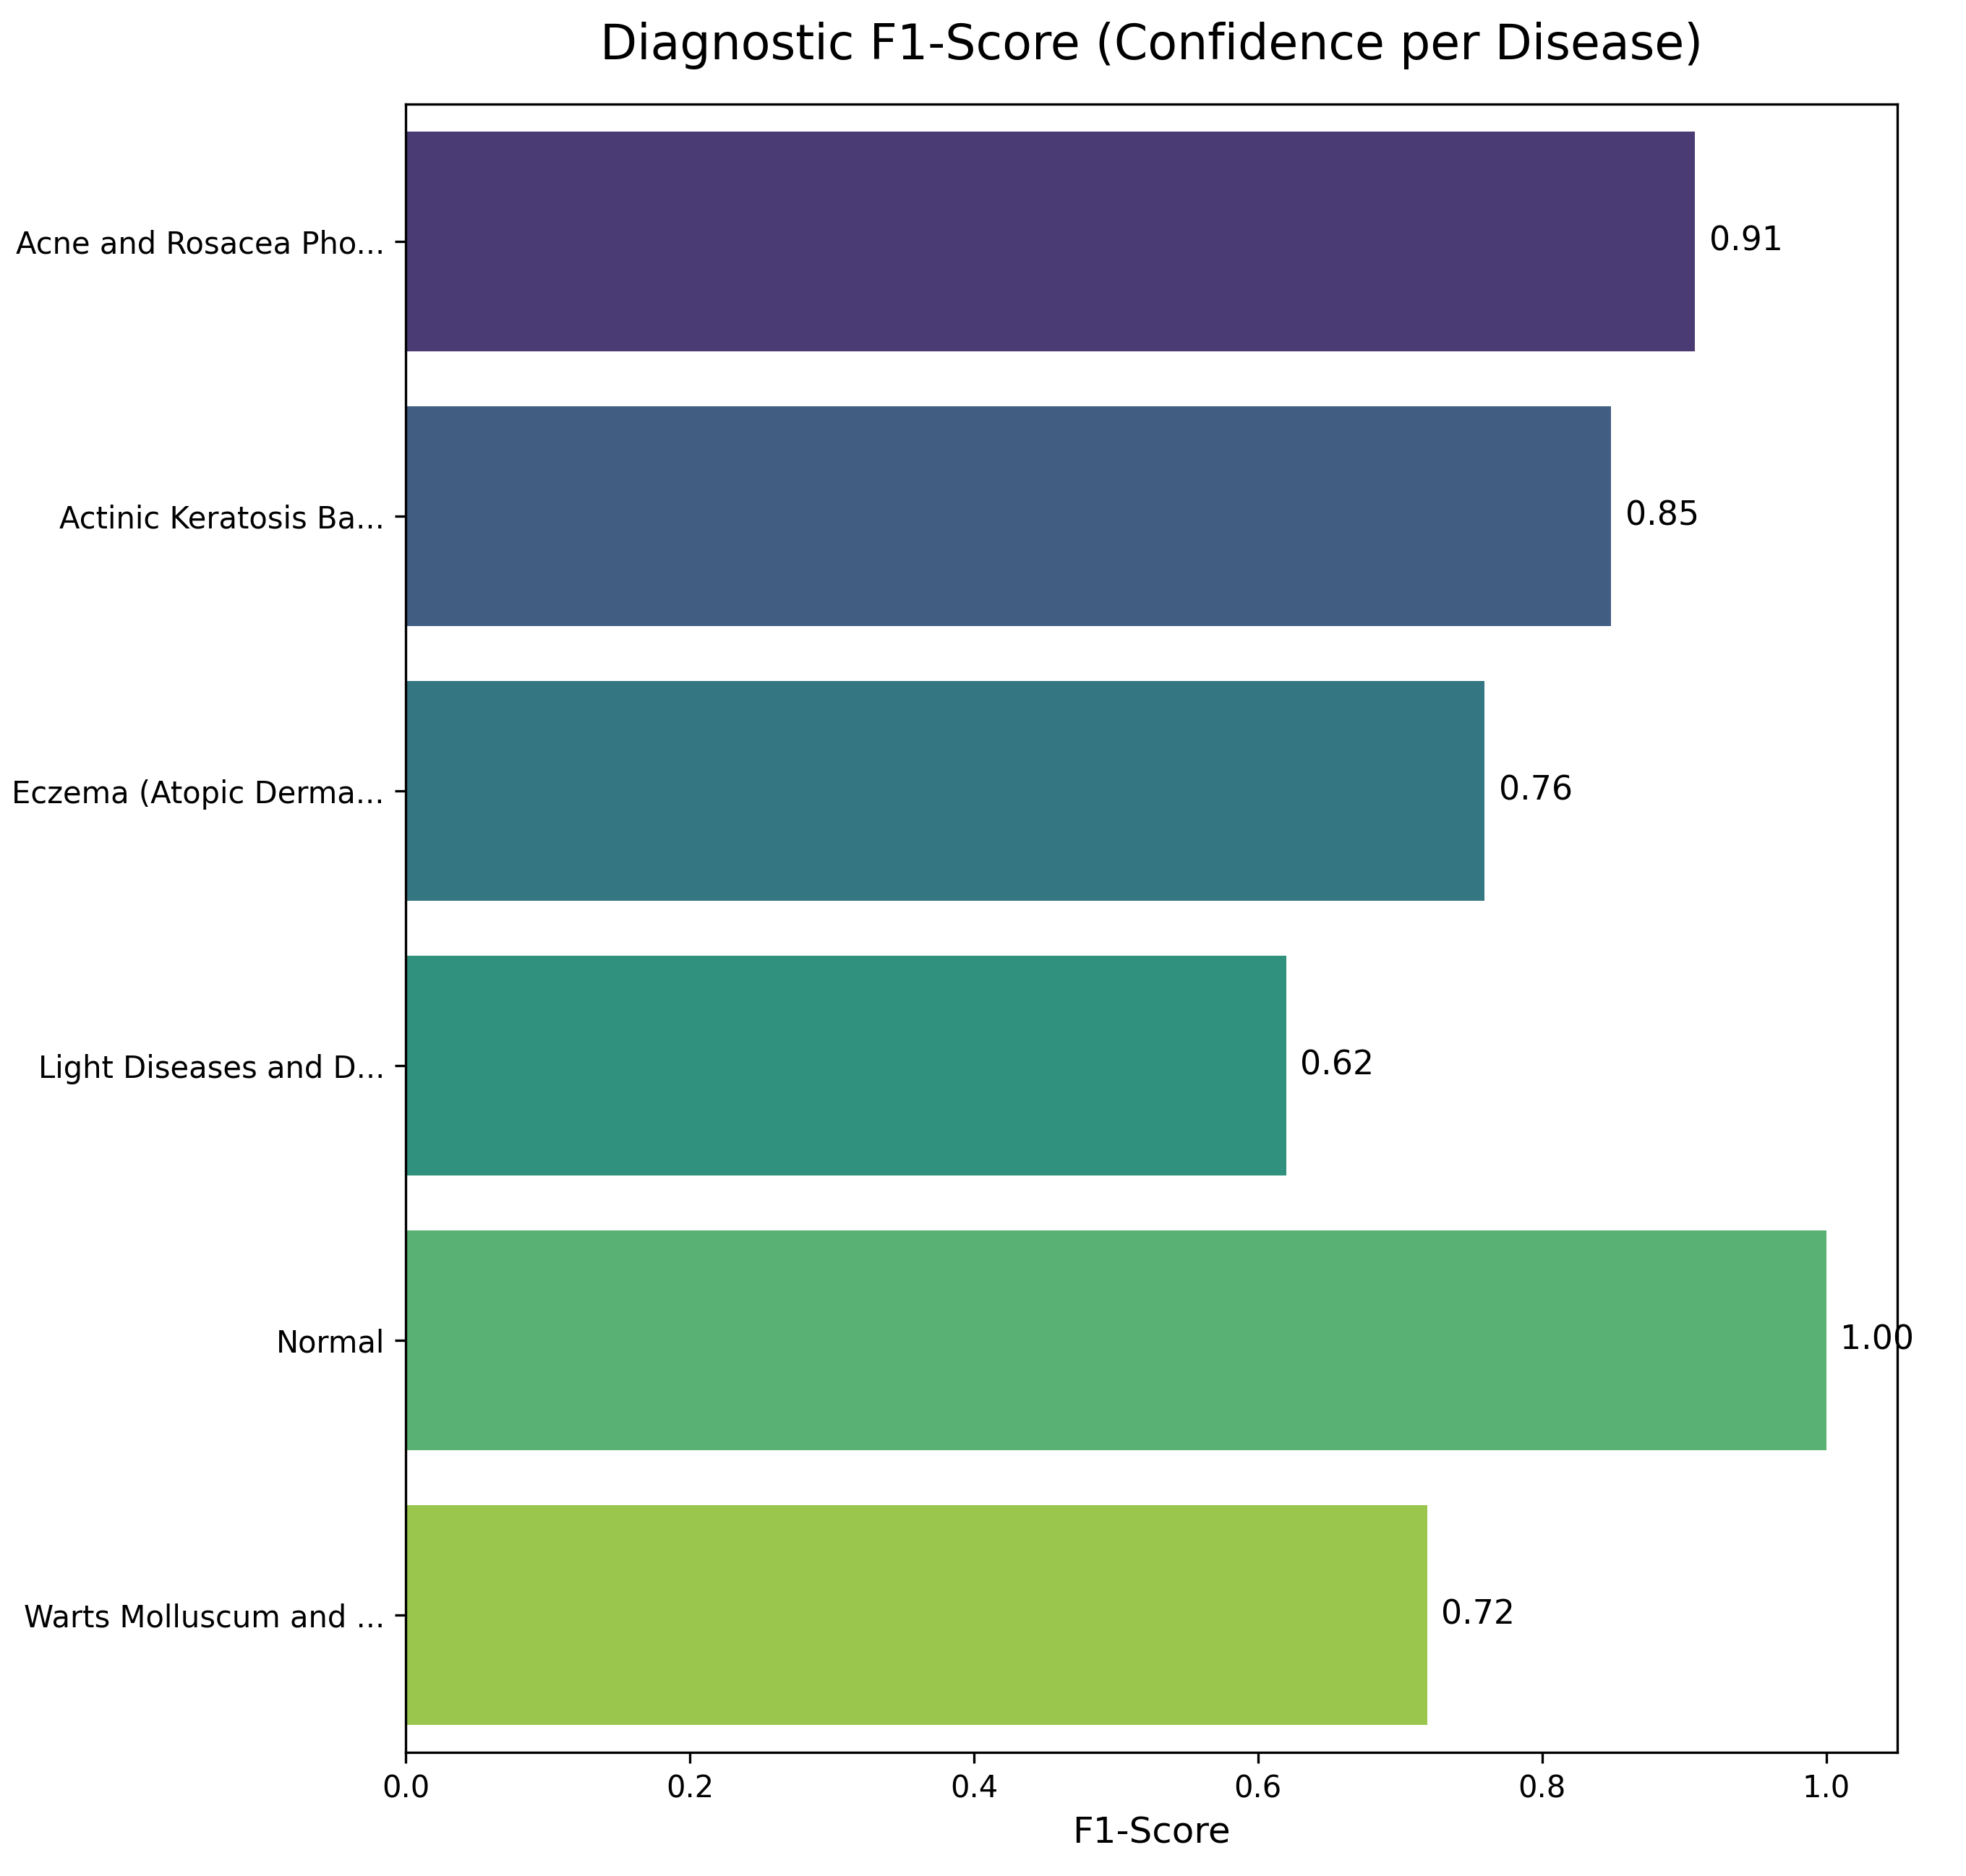
Fig. 5. Distribution of F1 scores by disease

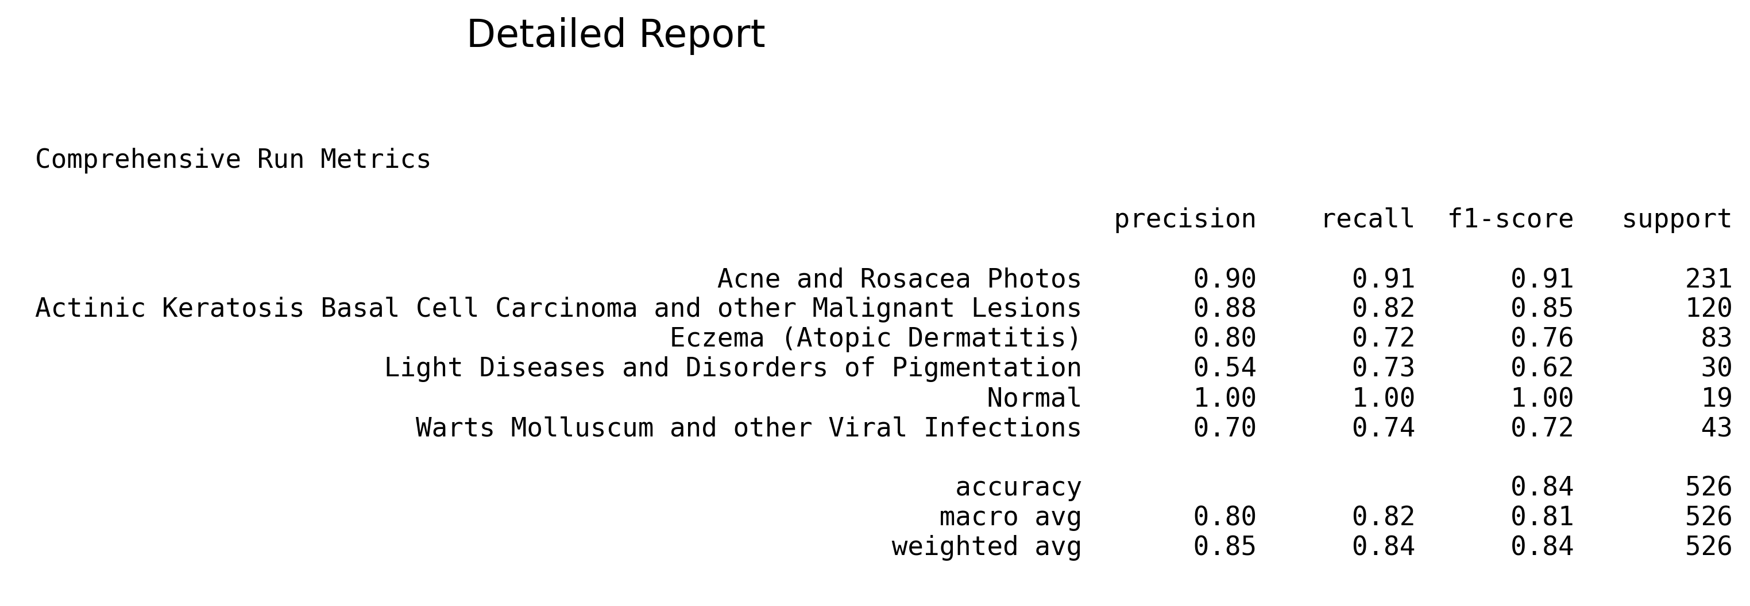
Fig. 6. Comprehensive performance report of the test set (n=526)

Looking at the complexity matrix, the Acne and Rosacea and Normal skin classes show the highest success rate: 211 out of 231 samples (91%) in the Acne and Rosacea class were correctly predicted, and all 19 samples in the Normal class were correctly predicted. The Eczema class was the category with the most confusion; only 60 out of 83 samples were correctly classified, with the remainder being confused with other inflammatory classes, primarily Light-Related Diseases. This is due to the morphological similarity of chronic inflammatory lesions.
The Light Disorders and Pigmentation Disorders class received the lowest F1 score at 0.62. The small sample size in this class and the visual variety of lesions such as vitiligo, hyperpigmentation indicate that this result remains within an expected range.

Table II. Performance metrics by class (test set, n=526)
Disease Class | Precision | Recall | F1 Score | n
Acne and Rosacea | 0.90 | 0.91 | 0.91 | 231
Actinic Keratosis / Malignant Lesion | 0.88 | 0.82 | 0.85 | 120
Eczema (Atopic Dermatitis) | 0.80 | 0.72 | 0.76 | 83
Light-induced disease / Pigmentation disorder. | 0.54 | 0.73 | 0.62 | 30
Normal | 1.00 | 1.00 | 1.00 | 19
Warts / Viral Infections | 0.70 | 0.74 | 0.72 | 43

Discussion and Conclusion

This study developed a CNN-based system for the real-time diagnosis of skin diseases in a mobile environment. The most significant problem encountered during the development process was the imbalance in the dataset. 14 out of 20 disease classes had fewer than 250 data points; this threatened the overall accuracy of the model, so these classes were removed from training. For the remaining 6 classes, each class was limited to 500 images. Test results confirmed that this decision improved the model's accuracy and learning quality.
The prototyping stage of the design architecture based on Scikit-Learn led to a 57.6% accuracy in the 1D approach. The main reason for that was the loss of spatial information due to the flattening of the image. When the switch was made to EfficientNet-B0, the model could process the shape and texture features of the lesions in a two-dimensional plane, where the accuracy increased to 84% and the macro F1 score increased to 0.81. When examined on a class basis, the Normal Skin and Acne-Rosacea classes performed above expectations. While the F1 score of 1.00 for Normal Skin is encouraging, it should be considered that only 19 samples were used in the test. On the other hand, the F1 score of 0.62 in the Light Disorders class was an expected result. Reliable learning with only 30 samples in this class is already difficult; the visual variations of vitiligo and hyperpigmentation further complicate the classification.
Compared to similar studies in the literature, DermAI can be said to hold an important position. While Nisar et al. achieved 84.43% accuracy with SVM in eczema detection [7], DermAI remained in a similar range with an F1 score of 0.76 in the eczema class.Although studies focusing on rosacea detection report accuracy above 93% [9], these studies are systems working on a single disease. The DermAI system, however, examines 6 skin lesions.
One of the most important contributions of the study is the superior decision support mechanism of the classification. The JSON-based database, which utilizes more than 25 academic reference reviews, adds a risk level, care recommendation, and medical warning to each diagnosis. This feature supports the practical use of the system, especially in regions where access to dermatologists is limited.
Some limitations of the study should also be clearly stated. The test set consists of 526 images, and the sample size in some classes may not be statistically reliable. Also, the dataset consists only of images from Kaggle, and validation with real patient data from clinical settings has not been performed. The performance of the model has not yet been tested in different skin tones and geographic populations. Future studies plan to expand the dataset and apply data enhancement techniques for less represented classes. A comparative evaluation of the model with dermatologists in a clinical setting is also among the priority goals. Furthermore, there are plans to port the system to the iOS platform and reach a wider user base with multilingual interface support. In conclusion, despite being an academic project developed with limited resources, DermAI offers performance and usability close to real-world use. This study concretely demonstrates that dermatological artificial intelligence systems should not only be accurate but also designed to provide meaningful guidance to the user.

Data and Code Accessibility

All source code used in the study including the CNN model and application code has been released as open source: https://github.com/Ibrahim-Taskiran/DermAI

REFERENCES
[1] JM Hanifin, ML Reed, and Eczema Prevalence and Impact Working Group, “A population-based survey of eczema prevalence in the United States,” Dermat. Contact Atopic Occup. drug, c. 18, p. 2, pp. 82-91, Jun. 2007, doi: 10.2310/6620.2007.06034.
[2] TE Shaw, GP Currie, CW Koudelka, and EL Simpson, “Eczema Prevalence in the United States: Data from the 2003 National Survey of Children's Health,” J. Invest. Dermatol. c. 131, p. 1, pp. 67-73, Jan. 2011, doi: 10.1038/jid.2010.251.
[3] MM Ali, M. Raj, A. Farid, MY Minhaj, P. Umang, and S. Patel, “Deep Learning in Dermatology: Convolutional Neural Network-Based Classification of Skin Diseases and Cancer,” in 2024 Second International Conference on Microwave, Antenna and Communication (MAC), Oct. 2024, pp. 1-7. doi: 10.1109/MAC61551.2024.10837323.
[4] M. Chowdhury, S. Sultana, TA Ridi, AF Chowdhury, W. Alam, and F. Amin, “Elegant: A Skin and Haircare Assistant Mobile Application with Beauty Salon Search, Skin Disorder Check, Dermatologist Booking Features,” in 2025 International Conference on Computing and Communication Technologies (ICCCT), Apr. 2025, pp. 1-6. doi: 10.1109/ICCCT63501.2025.11019494.
[5] S. Mehta and A. Aneja, “Hybrid AI Models for Dermatology: Combining CNN and RF for Skin Lesion Classification,” in 2024 5th International Conference on Data Intelligence and Cognitive Informatics (ICDICI), Nov. 2024, pp. 431-436. doi: 10.1109/ICDICI62993.2024.10810876.
[6] Z. Wu et al, “Studies on Different CNN Algorithms for Facial Skin Disease Classification Based on Clinical Images”, IEEE Access, vol. 7, pp. 66505-66511, 2019, doi: 10.1109/ACCESS.2019.2918221.
[7] H. Nisar, YK Ch'ng, and YK Ho, “Automatic Segmentation and Classification of Eczema Skin Lesions Using Supervised Learning,” in 2020 IEEE Conference on Open Systems (ICOS), Nov. 2020, pp. 25-30. doi: 10.1109/ICOS50156.2020.9293657.
[8] VR Balaji, ST Suganthi, R. Rajadevi, V. Krishna Kumar, B. Saravana Balaji, and S. Pandiyan, “Skin disease detection and segmentation using dynamic graph cut algorithm and classification through Naive Bayes classifier,” Measurement, vol. 163, p. 107922, Oct. 2020, doi: 10.1016/j.measurement.2020.107922.
[9] S. Park, AL Chien, B. Lin, and K. Li, “FACES: A Deep-Learning-Based Parametric Model to Improve Rosacea Diagnoses,” Appl. Sci., c. 13, p. 2, p. 970, Jan. 2023, doi: 10.3390/app13020970.
[10] RKMS K Karunanayake, WGM Dananjaya, MS Y Peiris, BRIS Gunatileka, S. Lokuliyana, and A. Kuruppu, “CURETO: Skin Diseases Detection Using Image Processing and CNN,” in 2020 14th International Conference on Innovations in Information Technology (IIT), Nov. 2020, pp. 1-6. doi: 10.1109/IIT50501.2020.9299041.
[11] Esteva et al. Esteva, A., Kuprel, B., Novoa, R. A., Ko, J., Swetter, S. M., Blau, H. M., & Thrun, S. (2017). Dermatologist-level classification of skin cancer with deep neural networks. Nature, 542(7639), 115–118. https://doi.org/10.1038/nature21056 Cited by: 18,943
[12] Codella et al. Codella, N. C., Gutman, D., Celebi, M. E., Helba, B., Marchetti, M. A., Dusza, S. W., ... & Halpern, A. (2018). Skin lesion analysis toward melanoma detection: A challenge at the 2017 International Symposium on Biomedical Imaging (ISBI). arXiv preprint arXiv:1710.05006.
[13] Tan & Le Tan, M., & Le, Q. V. (2019). EfficientNet: Rethinking model scaling for convolutional neural networks. International Conference on Machine Learning, 6105–6114. https://doi.org/10.48550/arxiv.1905.11946 Cited by: 37,460

[14] Udrea et al. Udrea, A., Mitra, G. D., Costicheanu, D., Noels, E. C., Wakkee, M., Siegel, D. M., ... & Nijsten, T. E. (2020). Accuracy of a smartphone application for triage of skin lesions. British Journal of Dermatology, 183(3), 548–553. https://doi.org/10.1111/bjd.18931
[15] Gulshan et al. Gulshan, V., Peng, L., Coram, M., Stumpe, M. C., Wu, D., Narayanaswamy, A., ... & Webster, D. R. (2016). Development and validation of a deep learning algorithm for detection of diabetic retinopathy in retinal fundus photographs. JAMA, 316(22), 2402–2410. https://doi.org/10.1001/jama.2016.17216 Cited by: 9,590
[16] Lakhani & Sundaram Lakhani, P., & Sundaram, B. (2017). Deep learning at chest radiography: Automated classification of pulmonary tuberculosis by using convolutional neural networks. Radiology, 284(2), 574–582. https://doi.org/10.1148/radiol.2017162326 Cited by: 2,371
[17] “Skin Diseases CNN”. Accessed: 06 May 2026. [Online]. Available at: https://kaggle.com/code/mpwolke/skin-diseases-cnn
[18] “Skin diseases image dataset”. Accessed: 06 May 2026. [Online]. Available at: https://www.kaggle.com/datasets/ismailpromus/skin-diseases-image-dataset
[19] DP Kingma and M. Welling, “Auto-Encoding Variational Bayes,” 10 December 2022, arXiv: arXiv:1312.6114. doi: 10.48550/arXiv.1312.6114.

