# Water portability

## DNN

# Water level prediction

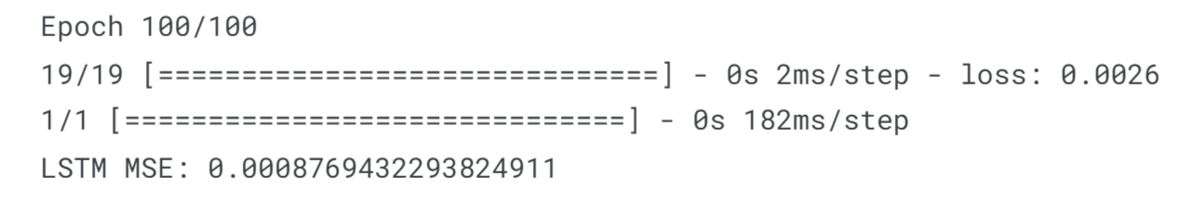

# Water Treatment

## DNN

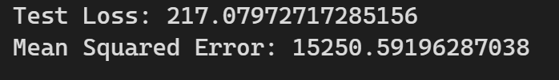

# Water Leak

***Acceleromter:***

Branched: Dnn

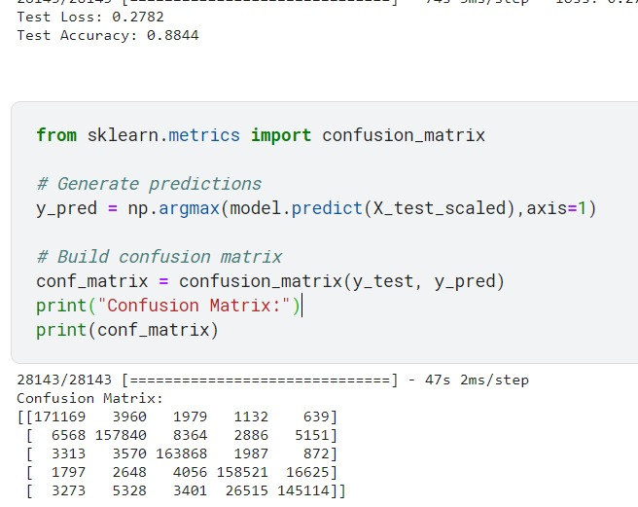

Looped: Dnn



***Hydrophone:***

Branched: Dnn

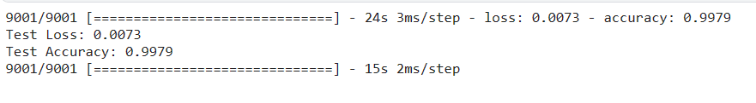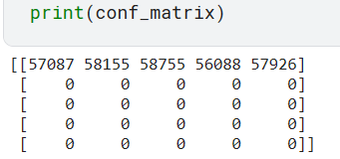

Looped: Dnn

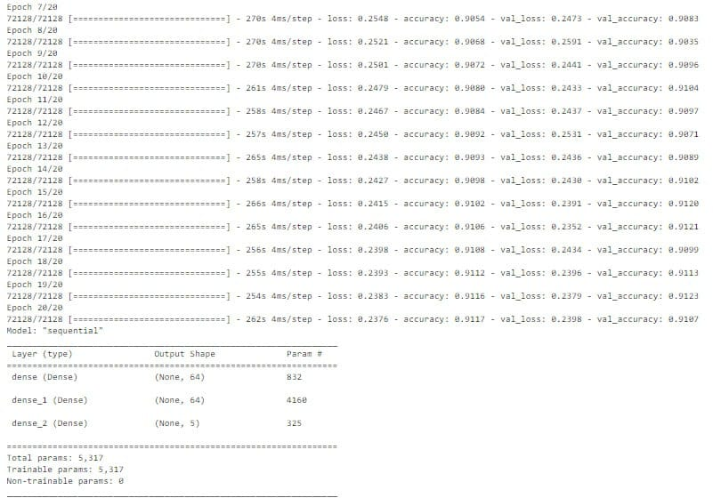

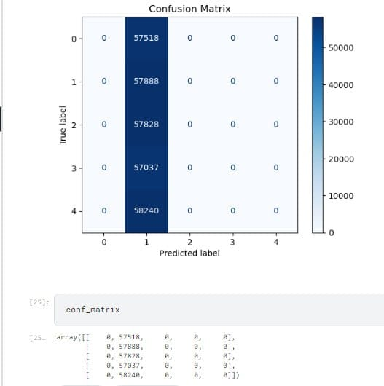

***Pressure:***

Branched: Rnn

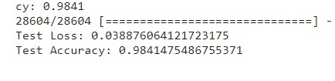

Looped: Dnn

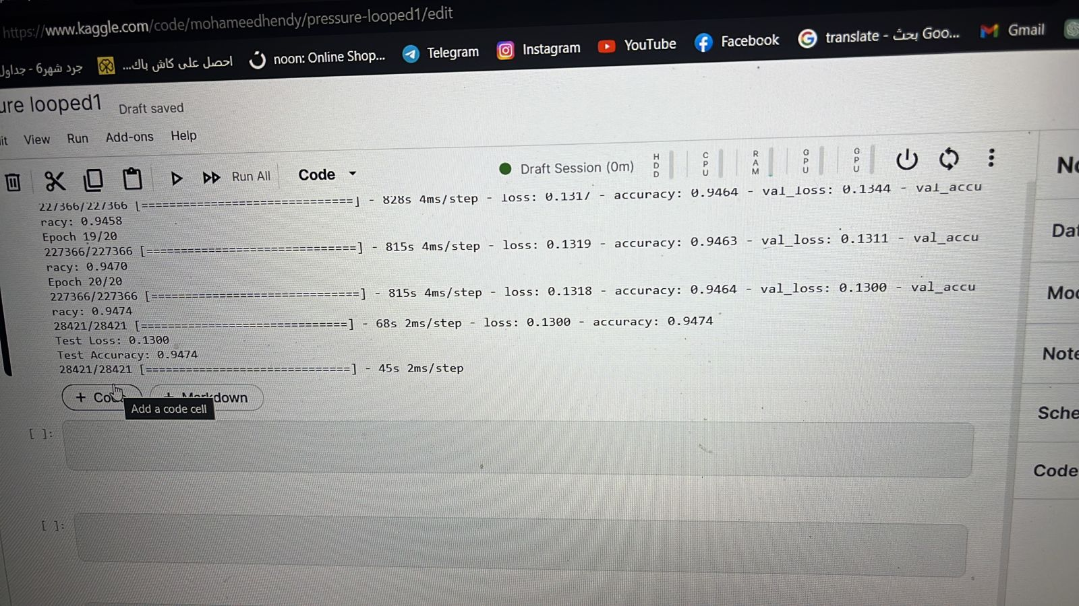

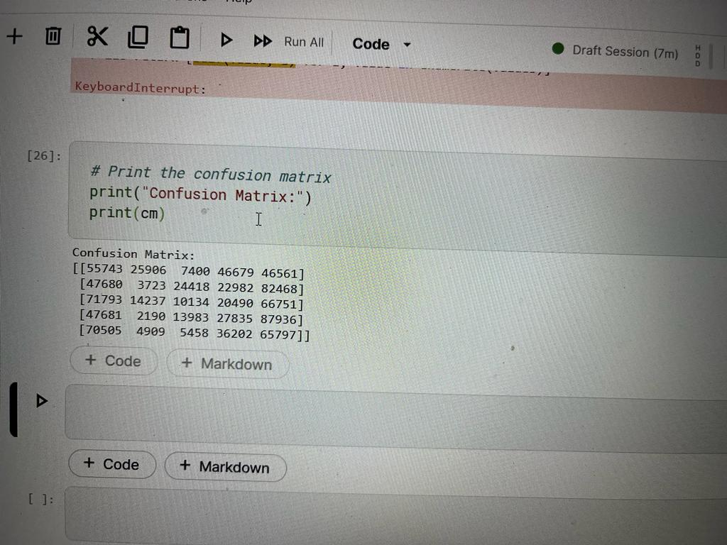

# Predict Water Consumption

## Tank 1: LSTM



## Tank 2: LSTM

