Resume of
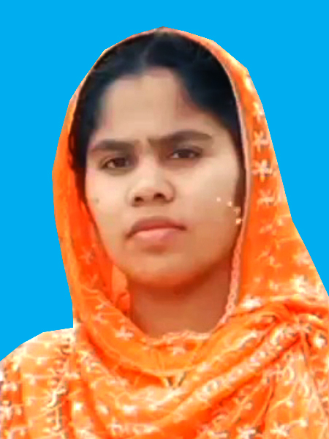
MST. MOHSENA KHATUN
Phone 01722-603141

Academic Information
Masters
University : National University
Major : History
CGPA : 2.94 (out of 4.00 scales)
Passing Year : 2019.
B/A PASS CORUS
University : National University
Major : B.S.S
CGPA : 2nd Class
Passing Year : 2015.
Alim
Institution : Golerhat Fazil B/A Madrasha
Board : Madrasha
Group : Humanities
GPA : 4.08(out of 5.00 scales)
Passing Year : 2012.
Dakhil
Institution : Kachakata Bazar Dakhil Madrasha
Board : Dhaka
Group : Humanities
GPA : 4.31(Out of 5.00 scales)
Passing Year : 2010

LANGUAGE PROFICIENCY
Bengali : Excellent listening, speaking, reading and Writing abilities.
English : Fair listening, speaking, reading and Writing abilities.

PERSONAL INFORMATION

Father’s Name : Md. Mofizar Rahman
Mother’s Name : Hazra Begum
Date of Birth : 10 June 1995
Present Address : Village: Sarkartari, post. S.P Madargonj, Upazila: Nageshwari, District:
Kurigram.

Permanent Address : Village: Sarkartari, post. S.P Madargonj, Upazila: Nageshwari, District:
Kurigram.

Nationality : Bangladeshi.
National ID NO : 1487350447
Religion : Islam.
Marital Status : Married.
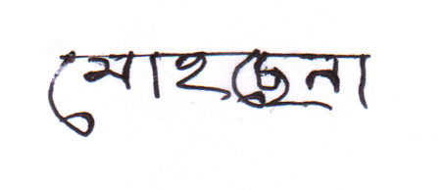

MST. MOHSENA KHATUN

