**Numerical dataset**

**ANN:**

**Hyperparameters:**

**Before: epoch = 5**

**Accuracy = 96.4 %**

**Loss curve:**

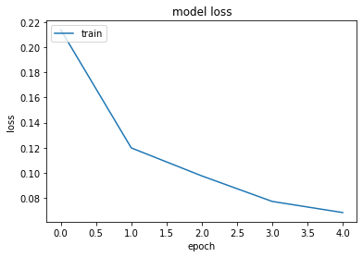

**Confusion matrix:**

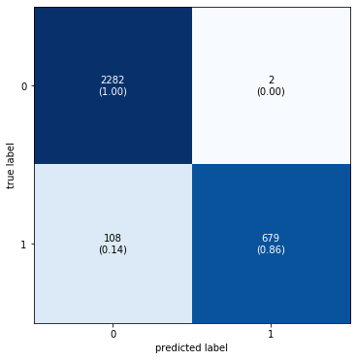

**ROC**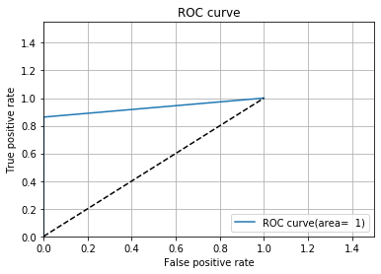

**After: epoch = 10**

**Accuracy : 99.3%**

**

**

**SVM:**

**Before:**

**Hyperparameters**

**C = 0.5**

**Kernel = ‘sigmoid’**

**Degree = 3**

**Gamma = 5**

**Result:**

**Accuracy = 69.6 %**

**Confusion matrix:**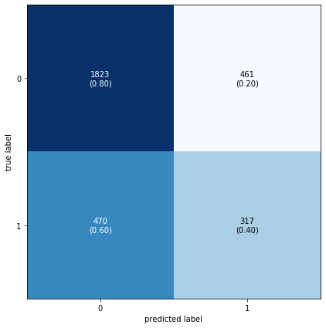

**ROC:**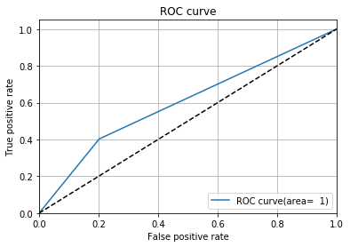

**Learning curve:**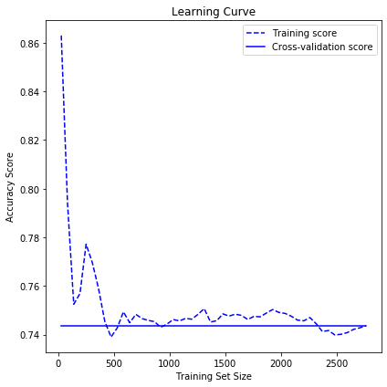

**After :**

**Hyper-parameters**

**Kernel: sigmoid**

**Gamma: auto**

**Degree: 3**

**C: 0.1**

**Result :**

**

**accuracy: 97.3 %**

**confusion matrix:**

**Images dataset**

**ANN:**

**Before:**

**Hyperparameters:**

**Optimizer : ‘adam’**

**Epoch = 5**

**Result :**

**Accuracy = 71.67 %**

**Loss curve:**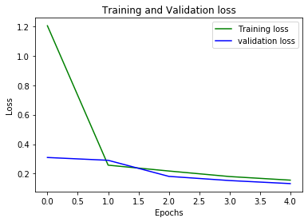

**Confusion matrix:**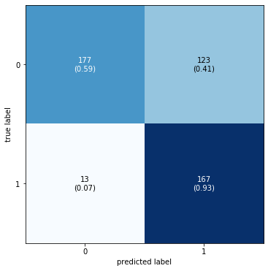

**ROC:**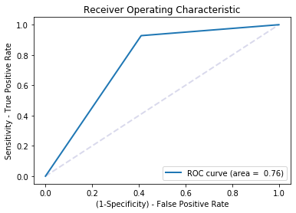

**After :**

**Hyper-parameters**

**Initial learning :32*32**

**Optimizer: ‘adam’**

**Epoch :10**

**Result :**

**Loss curve:**

**SVM:**

**Before :**

**Hyperparameters:**

**Optimizer : ‘rbf’**

**Max iteration : 950**

**C = 1**

**Result :**

**Accuracy : 94.72%**

**Learning curve:**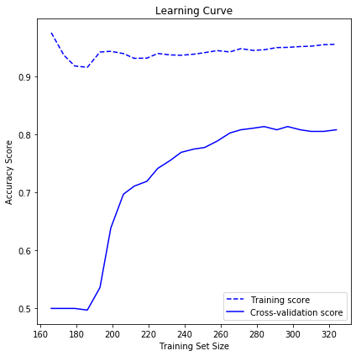

**Confusion matrix:**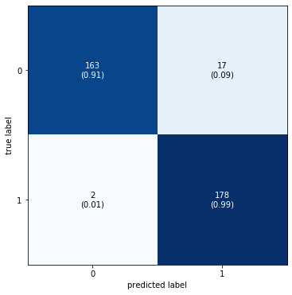

**ROC:**

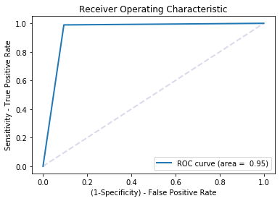

**After :**

**Hyper-parameters**

**Optimizer : ‘rbf’**

**Max iteration : 950**

**C = 10**

**Result :**

**Accuracy :98.06%**

