

Faculty of Computers and Artificial Intelligence

Computer Science Department

2021/2022

**CS 396 Selected Topics in CS-2**

**Research Project**

Report Submitted for Fulfillment of the Requirements for Selected Topics in CS-2 course

Team No. 15

|  |  |  |  |
| --- | --- | --- | --- |
|  | ID | Name | Grade |
|  | 201900270 | حسنين شوقى حسنين على |  |
|  | 201900280 | خالد زكريا رمزي ابراهيم |  |
|  | 201900026 | احمد خالد احمد ابو العلا |  |
|  | 201900005 | ابراهيم السيد محمد حنور |  |
|  | 201900086 | احمد محمد امام احمد |  |
|  | 201900292 | رامي عماد يعقوب جدالله |  |
|  | 201900281 | خالد عادل محمد شكر |  |

Delivered to:

**Dr. Wessam El-Behaidy**

**Paper details**:

* **Authors**: Hareem Kibriya1 & Momina Masood1 & Marriam Nawaz1 & Tahira Nazir2.
* **Paper name**: Multiclass classification of brain tumors using a novel CNN architecture
* **Publisher name:** [Springer Link](https://link.springer.com/)
* **Accepted for publication on 27 March 2022**

**In the paper they used brain tumors dataset contain 3 classes (**glioma, pituitary, and meningioma**)**

* Implementation algorithm:

* Results:

Project Description Document:

* General Information:
* We used chest [**x-ray**](https://www.kaggle.com/datasets/paultimothymooney/chest-xray-pneumonia) dataset, the data contain 5815, dimension of images are different, the classes in data are (PNEUMONIA, NORMAL)
* Implementation details:
  + Training: 3489 (60%)
  + Validation: 1163 (20%)
  + Testing: 1163 (20%)
* Block diagram:

for the model:

**\* 4**

* **Hyper-parameters**

**Learning rate: 0.001**

**Optimizer: “Adam”**

**Epoch : 1000**

**Batch size: 10**

Models Results:

Accuracy curve:

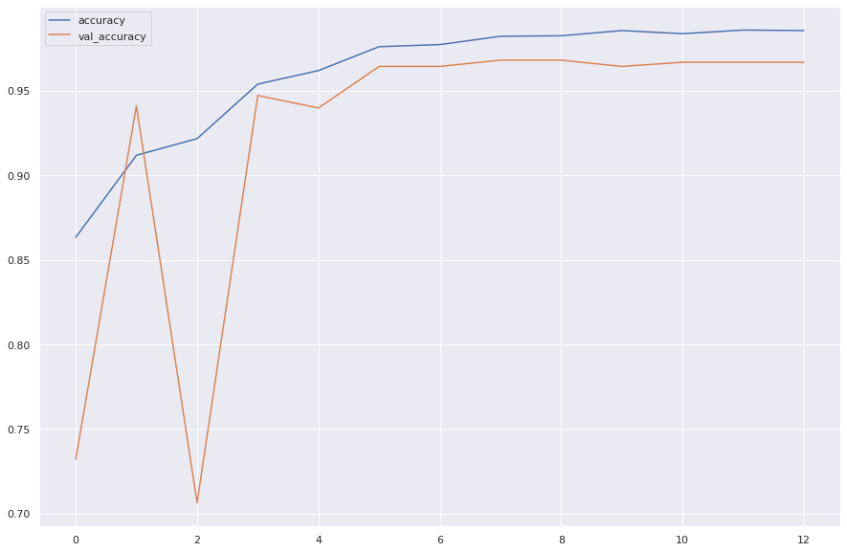

Loss curve: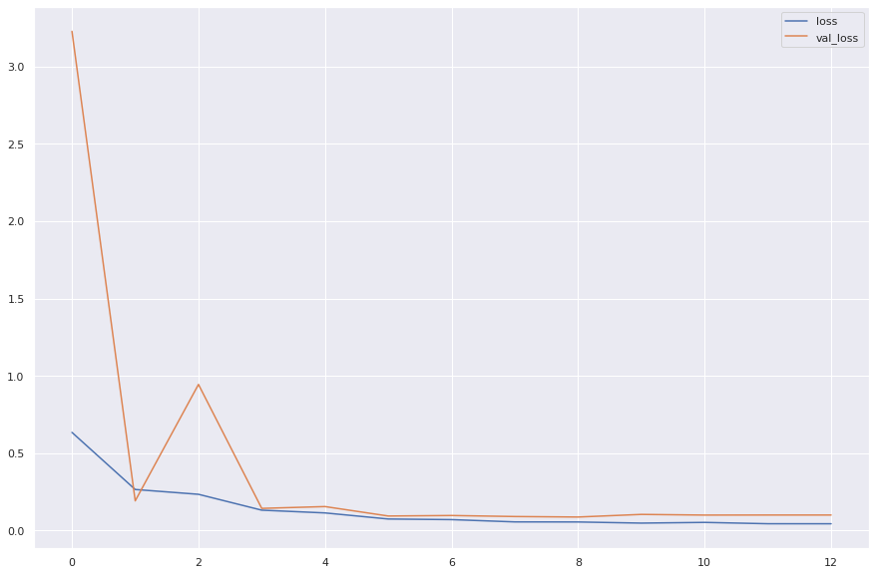

Confusion matrix:

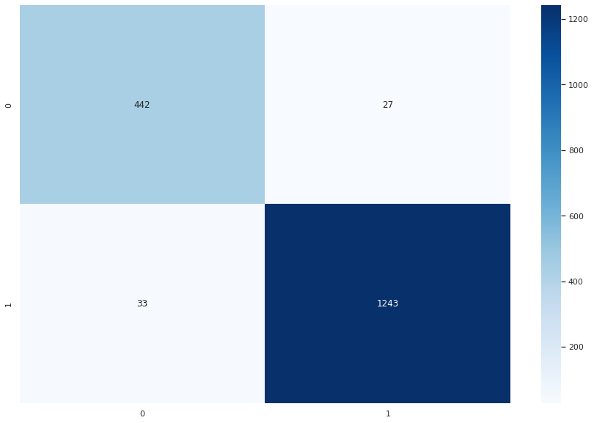

Classification report:

