Assignment#2
Name: Ibrahim Khan
Department: AI

Screenshot of pika package installation:
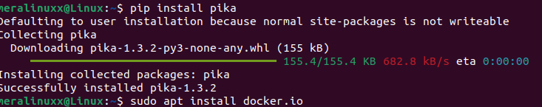

Screenshot of the docker:
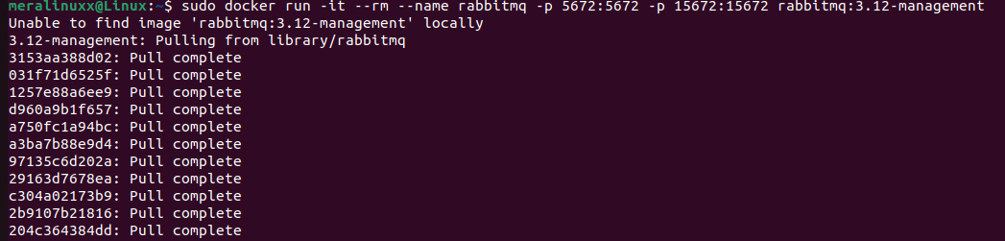

Screenshot of the send.py file:
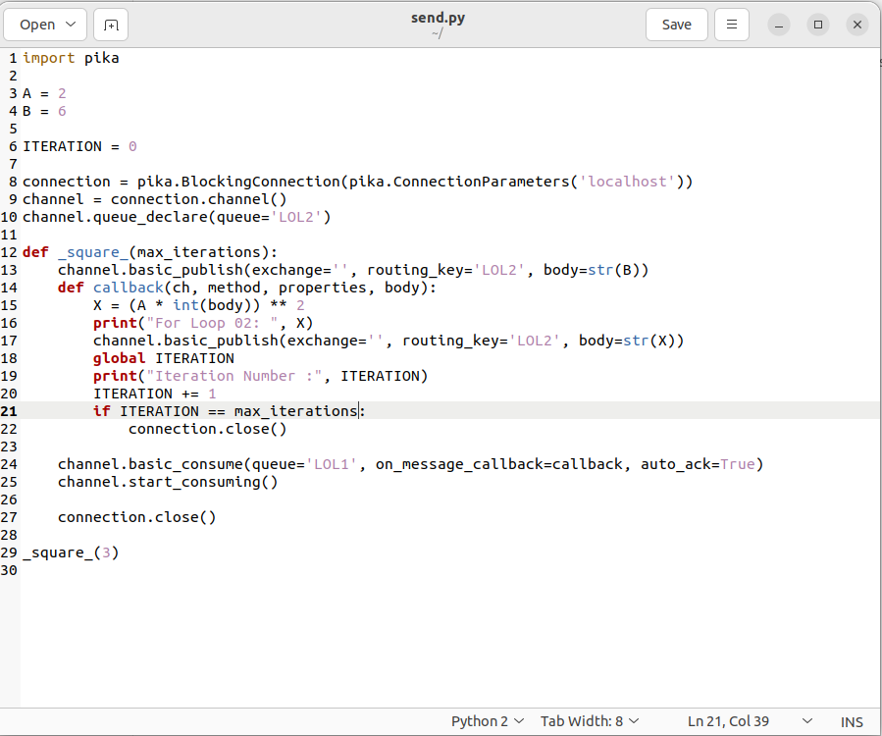

Screenshot of receive.py:
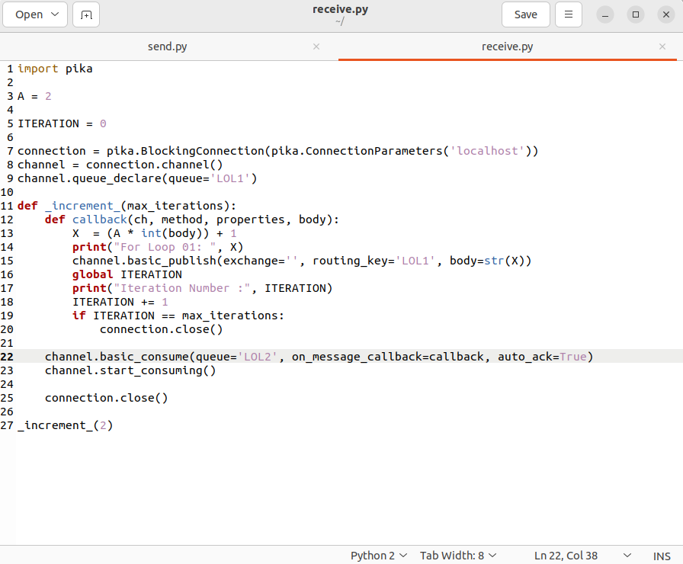

Screenshot of the final results:
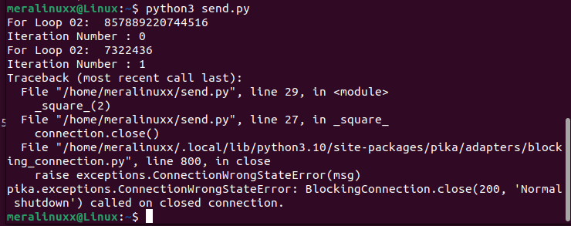

Screenshot of the final results:
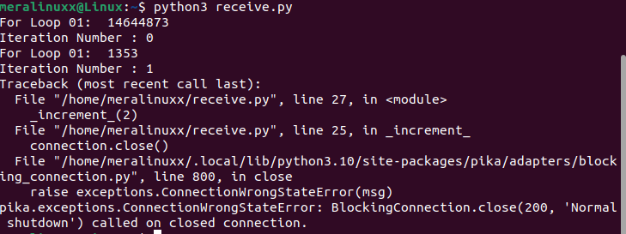

Screenshot of the final results:
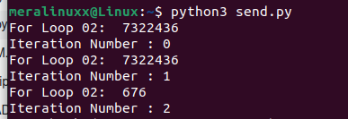

Screenshot of the final results
