Analysis of DataCo Supply chain

Ibrahim & Karthik

2023-04-11

#Load the required libraries

library(ggplot2)  
library(dplyr)

## Warning: package 'dplyr' was built under R version 4.2.3

##   
## Attaching package: 'dplyr'

## The following objects are masked from 'package:stats':  
##   
## filter, lag

## The following objects are masked from 'package:base':  
##   
## intersect, setdiff, setequal, union

library(tidyr)  
library(RColorBrewer)  
library(plotrix)  
library(lattice)

#Read CSV file and load it in a data frame We can see top elements of the data

#Reading the dataset  
supply_chain = read.csv('C:/Users/Lenovo/OneDrive/Documents/directory files/DataCoSupplyChainDataset.csv')  
  
head(supply_chain)

## Type Days.for.shipping..real. Days.for.shipment..scheduled.  
## 1 DEBIT 3 4  
## 2 TRANSFER 5 4  
## 3 CASH 4 4  
## 4 DEBIT 3 4  
## 5 PAYMENT 2 4  
## 6 TRANSFER 6 4  
## Benefit.per.order Sales.per.customer Delivery.Status Late_delivery_risk  
## 1 91.25 314.64 Advance shipping 0  
## 2 -249.09 311.36 Late delivery 1  
## 3 -247.78 309.72 Shipping on time 0  
## 4 22.86 304.81 Advance shipping 0  
## 5 134.21 298.25 Advance shipping 0  
## 6 18.58 294.98 Shipping canceled 0  
## Category.Id Category.Name Customer.City Customer.Country Customer.Email  
## 1 73 Sporting Goods Caguas Puerto Rico XXXXXXXXX  
## 2 73 Sporting Goods Caguas Puerto Rico XXXXXXXXX  
## 3 73 Sporting Goods San Jose EE. UU. XXXXXXXXX  
## 4 73 Sporting Goods Los Angeles EE. UU. XXXXXXXXX  
## 5 73 Sporting Goods Caguas Puerto Rico XXXXXXXXX  
## 6 73 Sporting Goods Tonawanda EE. UU. XXXXXXXXX  
## Customer.Fname Customer.Id Customer.Lname Customer.Password Customer.Segment  
## 1 Cally 20755 Holloway XXXXXXXXX Consumer  
## 2 Irene 19492 Luna XXXXXXXXX Consumer  
## 3 Gillian 19491 Maldonado XXXXXXXXX Consumer  
## 4 Tana 19490 Tate XXXXXXXXX Home Office  
## 5 Orli 19489 Hendricks XXXXXXXXX Corporate  
## 6 Kimberly 19488 Flowers XXXXXXXXX Consumer  
## Customer.State Customer.Street Customer.Zipcode Department.Id  
## 1 PR 5365 Noble Nectar Island 725 2  
## 2 PR 2679 Rustic Loop 725 2  
## 3 CA 8510 Round Bear Gate 95125 2  
## 4 CA 3200 Amber Bend 90027 2  
## 5 PR 8671 Iron Anchor Corners 725 2  
## 6 NY 2122 Hazy Corner 14150 2  
## Department.Name Latitude Longitude Market Order.City Order.Country  
## 1 Fitness 18.25145 -66.03706 Pacific Asia Bekasi Indonesia  
## 2 Fitness 18.27945 -66.03706 Pacific Asia Bikaner India  
## 3 Fitness 37.29223 -121.88128 Pacific Asia Bikaner India  
## 4 Fitness 34.12595 -118.29102 Pacific Asia Townsville Australia  
## 5 Fitness 18.25377 -66.03705 Pacific Asia Townsville Australia  
## 6 Fitness 43.01397 -78.87907 Pacific Asia Toowoomba Australia  
## Order.Customer.Id order.date..DateOrders. Order.Id Order.Item.Cardprod.Id  
## 1 20755 1/31/2018 22:56 77202 1360  
## 2 19492 1/13/2018 12:27 75939 1360  
## 3 19491 1/13/2018 12:06 75938 1360  
## 4 19490 1/13/2018 11:45 75937 1360  
## 5 19489 1/13/2018 11:24 75936 1360  
## 6 19488 1/13/2018 11:03 75935 1360  
## Order.Item.Discount Order.Item.Discount.Rate Order.Item.Id  
## 1 13.11 0.04 180517  
## 2 16.39 0.05 179254  
## 3 18.03 0.06 179253  
## 4 22.94 0.07 179252  
## 5 29.50 0.09 179251  
## 6 32.78 0.10 179250  
## Order.Item.Product.Price Order.Item.Profit.Ratio Order.Item.Quantity Sales  
## 1 327.75 0.29 1 327.75  
## 2 327.75 -0.80 1 327.75  
## 3 327.75 -0.80 1 327.75  
## 4 327.75 0.08 1 327.75  
## 5 327.75 0.45 1 327.75  
## 6 327.75 0.06 1 327.75  
## Order.Item.Total Order.Profit.Per.Order Order.Region Order.State  
## 1 314.64 91.25 Southeast Asia Java Occidental  
## 2 311.36 -249.09 South Asia Rajast\xe1n  
## 3 309.72 -247.78 South Asia Rajast\xe1n  
## 4 304.81 22.86 Oceania Queensland  
## 5 298.25 134.21 Oceania Queensland  
## 6 294.98 18.58 Oceania Queensland  
## Order.Status Order.Zipcode Product.Card.Id Product.Category.Id  
## 1 COMPLETE NA 1360 73  
## 2 PENDING NA 1360 73  
## 3 CLOSED NA 1360 73  
## 4 COMPLETE NA 1360 73  
## 5 PENDING_PAYMENT NA 1360 73  
## 6 CANCELED NA 1360 73  
## Product.Description Product.Image Product.Name  
## 1 NA http://images.acmesports.sports/Smart+watch Smart watch   
## 2 NA http://images.acmesports.sports/Smart+watch Smart watch   
## 3 NA http://images.acmesports.sports/Smart+watch Smart watch   
## 4 NA http://images.acmesports.sports/Smart+watch Smart watch   
## 5 NA http://images.acmesports.sports/Smart+watch Smart watch   
## 6 NA http://images.acmesports.sports/Smart+watch Smart watch   
## Product.Price Product.Status shipping.date..DateOrders. Shipping.Mode  
## 1 327.75 0 02-03-2018 22:56 Standard Class  
## 2 327.75 0 1/18/2018 12:27 Standard Class  
## 3 327.75 0 1/17/2018 12:06 Standard Class  
## 4 327.75 0 1/16/2018 11:45 Standard Class  
## 5 327.75 0 1/15/2018 11:24 Standard Class  
## 6 327.75 0 1/19/2018 11:03 Standard Class

#View(supply_chain)

### Check the structure of the data frame

We can see that the data is mix of Int and Chars.

str(supply_chain)

## 'data.frame': 180519 obs. of 53 variables:  
## $ Type : chr "DEBIT" "TRANSFER" "CASH" "DEBIT" ...  
## $ Days.for.shipping..real. : int 3 5 4 3 2 6 2 2 3 2 ...  
## $ Days.for.shipment..scheduled.: int 4 4 4 4 4 4 1 1 2 1 ...  
## $ Benefit.per.order : num 91.2 -249.1 -247.8 22.9 134.2 ...  
## $ Sales.per.customer : num 315 311 310 305 298 ...  
## $ Delivery.Status : chr "Advance shipping" "Late delivery" "Shipping on time" "Advance shipping" ...  
## $ Late_delivery_risk : int 0 1 0 0 0 0 1 1 1 1 ...  
## $ Category.Id : int 73 73 73 73 73 73 73 73 73 73 ...  
## $ Category.Name : chr "Sporting Goods" "Sporting Goods" "Sporting Goods" "Sporting Goods" ...  
## $ Customer.City : chr "Caguas" "Caguas" "San Jose" "Los Angeles" ...  
## $ Customer.Country : chr "Puerto Rico" "Puerto Rico" "EE. UU." "EE. UU." ...  
## $ Customer.Email : chr "XXXXXXXXX" "XXXXXXXXX" "XXXXXXXXX" "XXXXXXXXX" ...  
## $ Customer.Fname : chr "Cally" "Irene" "Gillian" "Tana" ...  
## $ Customer.Id : int 20755 19492 19491 19490 19489 19488 19487 19486 19485 19484 ...  
## $ Customer.Lname : chr "Holloway" "Luna" "Maldonado" "Tate" ...  
## $ Customer.Password : chr "XXXXXXXXX" "XXXXXXXXX" "XXXXXXXXX" "XXXXXXXXX" ...  
## $ Customer.Segment : chr "Consumer" "Consumer" "Consumer" "Home Office" ...  
## $ Customer.State : chr "PR" "PR" "CA" "CA" ...  
## $ Customer.Street : chr "5365 Noble Nectar Island" "2679 Rustic Loop" "8510 Round Bear Gate" "3200 Amber Bend" ...  
## $ Customer.Zipcode : int 725 725 95125 90027 725 14150 725 33162 725 94583 ...  
## $ Department.Id : int 2 2 2 2 2 2 2 2 2 2 ...  
## $ Department.Name : chr "Fitness" "Fitness" "Fitness" "Fitness" ...  
## $ Latitude : num 18.3 18.3 37.3 34.1 18.3 ...  
## $ Longitude : num -66 -66 -122 -118 -66 ...  
## $ Market : chr "Pacific Asia" "Pacific Asia" "Pacific Asia" "Pacific Asia" ...  
## $ Order.City : chr "Bekasi" "Bikaner" "Bikaner" "Townsville" ...  
## $ Order.Country : chr "Indonesia" "India" "India" "Australia" ...  
## $ Order.Customer.Id : int 20755 19492 19491 19490 19489 19488 19487 19486 19485 19484 ...  
## $ order.date..DateOrders. : chr "1/31/2018 22:56" "1/13/2018 12:27" "1/13/2018 12:06" "1/13/2018 11:45" ...  
## $ Order.Id : int 77202 75939 75938 75937 75936 75935 75934 75933 75932 75931 ...  
## $ Order.Item.Cardprod.Id : int 1360 1360 1360 1360 1360 1360 1360 1360 1360 1360 ...  
## $ Order.Item.Discount : num 13.1 16.4 18 22.9 29.5 ...  
## $ Order.Item.Discount.Rate : num 0.04 0.05 0.06 0.07 0.09 ...  
## $ Order.Item.Id : int 180517 179254 179253 179252 179251 179250 179249 179248 179247 179246 ...  
## $ Order.Item.Product.Price : num 328 328 328 328 328 ...  
## $ Order.Item.Profit.Ratio : num 0.29 -0.8 -0.8 0.08 0.45 ...  
## $ Order.Item.Quantity : int 1 1 1 1 1 1 1 1 1 1 ...  
## $ Sales : num 328 328 328 328 328 ...  
## $ Order.Item.Total : num 315 311 310 305 298 ...  
## $ Order.Profit.Per.Order : num 91.2 -249.1 -247.8 22.9 134.2 ...  
## $ Order.Region : chr "Southeast Asia" "South Asia" "South Asia" "Oceania" ...  
## $ Order.State : chr "Java Occidental" "Rajast\xe1n" "Rajast\xe1n" "Queensland" ...  
## $ Order.Status : chr "COMPLETE" "PENDING" "CLOSED" "COMPLETE" ...  
## $ Order.Zipcode : int NA NA NA NA NA NA NA NA NA NA ...  
## $ Product.Card.Id : int 1360 1360 1360 1360 1360 1360 1360 1360 1360 1360 ...  
## $ Product.Category.Id : int 73 73 73 73 73 73 73 73 73 73 ...  
## $ Product.Description : logi NA NA NA NA NA NA ...  
## $ Product.Image : chr "http://images.acmesports.sports/Smart+watch " "http://images.acmesports.sports/Smart+watch " "http://images.acmesports.sports/Smart+watch " "http://images.acmesports.sports/Smart+watch " ...  
## $ Product.Name : chr "Smart watch " "Smart watch " "Smart watch " "Smart watch " ...  
## $ Product.Price : num 328 328 328 328 328 ...  
## $ Product.Status : int 0 0 0 0 0 0 0 0 0 0 ...  
## $ shipping.date..DateOrders. : chr "02-03-2018 22:56" "1/18/2018 12:27" "1/17/2018 12:06" "1/16/2018 11:45" ...  
## $ Shipping.Mode : chr "Standard Class" "Standard Class" "Standard Class" "Standard Class" ...

colnames(supply_chain) # column names

## [1] "Type" "Days.for.shipping..real."   
## [3] "Days.for.shipment..scheduled." "Benefit.per.order"   
## [5] "Sales.per.customer" "Delivery.Status"   
## [7] "Late_delivery_risk" "Category.Id"   
## [9] "Category.Name" "Customer.City"   
## [11] "Customer.Country" "Customer.Email"   
## [13] "Customer.Fname" "Customer.Id"   
## [15] "Customer.Lname" "Customer.Password"   
## [17] "Customer.Segment" "Customer.State"   
## [19] "Customer.Street" "Customer.Zipcode"   
## [21] "Department.Id" "Department.Name"   
## [23] "Latitude" "Longitude"   
## [25] "Market" "Order.City"   
## [27] "Order.Country" "Order.Customer.Id"   
## [29] "order.date..DateOrders." "Order.Id"   
## [31] "Order.Item.Cardprod.Id" "Order.Item.Discount"   
## [33] "Order.Item.Discount.Rate" "Order.Item.Id"   
## [35] "Order.Item.Product.Price" "Order.Item.Profit.Ratio"   
## [37] "Order.Item.Quantity" "Sales"   
## [39] "Order.Item.Total" "Order.Profit.Per.Order"   
## [41] "Order.Region" "Order.State"   
## [43] "Order.Status" "Order.Zipcode"   
## [45] "Product.Card.Id" "Product.Category.Id"   
## [47] "Product.Description" "Product.Image"   
## [49] "Product.Name" "Product.Price"   
## [51] "Product.Status" "shipping.date..DateOrders."   
## [53] "Shipping.Mode"

### checking NA values

There are 336201 NA values in Product Description and Order Zipcode columns.

#colSums(is.na(supply_chain))  
sum(is.na(supply_chain))

## [1] 336201

#Deleting null values

supply_chain <- supply_chain[, -which(names(supply_chain) %in% c("Order.Zipcode", "Product.Description"))]  
#supply_chain

#Checking null values

#colSums(is.na(supply_chain))  
sum(is.na(supply_chain))

## [1] 3

#Order Item Discount Distribution

ggplot(supply_chain, aes(x = Order.Item.Discount)) +  
 geom_histogram(binwidth = 1, fill = "blue", color = "black") +  
 labs(title = "Order Item Discount Distribution",  
 x = "Order Item Discount",  
 y = "Count")

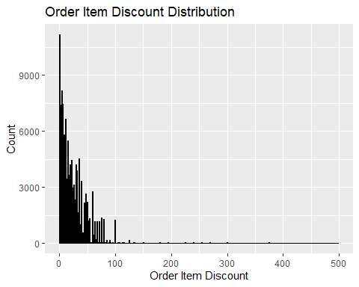

#Count of mode of transaction

type_count <- table(supply_chain$Type)  
type_count

##   
## CASH DEBIT PAYMENT TRANSFER   
## 19616 69295 41725 49883

#Pie chart on Count of mode of transaction

pie(type_count)  
title(main = "Count of Mode of Transaction" )

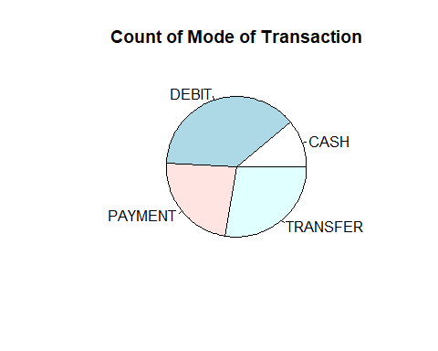

#Taking only 10000 values to generate graphs quickly

supply_chain_sample <- sample_n(supply_chain, 1000)  
#supply_chain_sample

#Calculating Avg. number of days to deliver

mean(supply_chain$Days.for.shipping..real.) #average time to delivery is 3-4 days

## [1] 3.497654

#Showing average time delivery in a plot

bwplot(~Days.for.shipping..real. , data=supply_chain)

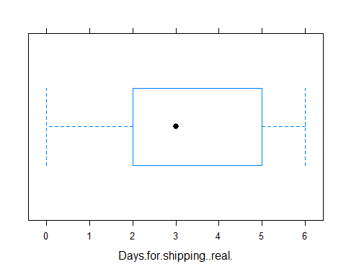

#title(main = "Avg. number of days to deliver")

#Bar graph on Order Status

ggplot(data = supply_chain, aes(x = Order.Status)) +  
 geom_histogram(stat = "count", fill = "steelblue", color = "black") +  
 ggtitle("Order Status") +  
 xlab("Order Status") +  
 ylab("Frequency")

## Warning in geom_histogram(stat = "count", fill = "steelblue", color = "black"):  
## Ignoring unknown parameters: `binwidth`, `bins`, and `pad`

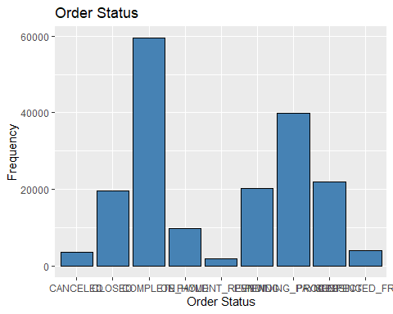 #Number of Orders from different product categories between shipping modes

# Subset data for each shipping mode  
first_class_department <- subset(supply_chain, Shipping.Mode == "First Class")  
second_class_department <- subset(supply_chain, Shipping.Mode == "Second Class")  
standard_class_department <- subset(supply_chain, Shipping.Mode == "Standard Class")  
same_day_department <- subset(supply_chain, Shipping.Mode == "Same Day")  
  
# Aggregate data for each department  
department <- aggregate(cbind(number = Delivery.Status) ~ Department.Name, data = supply_chain, FUN = function(x) length(x))  
first_class_department <- aggregate(cbind(number = Delivery.Status) ~ Department.Name, data = first_class_department, FUN = function(x) length(x))  
second_class_department <- aggregate(cbind(number = Delivery.Status) ~ Department.Name, data = second_class_department, FUN = function(x) length(x))  
standard_class_department <- aggregate(cbind(number = Delivery.Status) ~ Department.Name, data = standard_class_department, FUN = function(x) length(x))  
same_day_department <- aggregate(cbind(number = Delivery.Status) ~ Department.Name, data = same_day_department, FUN = function(x) length(x))  
  
# Create plot  
fig <- ggplot() +  
 geom_line(data = department, aes(x = Department.Name, y = number, group = 1), size = 1) +  
 labs(title = "Total number of orders from different product categories",  
 x = "Department Name",  
 y = "Number of Orders") +  
 theme(axis.text.x = element_text(angle = 90, hjust = 1)) +  
 facet_wrap(~ "", nrow = 1)

## Warning: Using `size` aesthetic for lines was deprecated in ggplot2 3.4.0.  
## ℹ Please use `linewidth` instead.  
## This warning is displayed once every 8 hours.  
## Call `lifecycle::last_lifecycle_warnings()` to see where this warning was  
## generated.

# Example of using group aesthetic in geom_line()  
fig2 <- ggplot() +  
 geom_line(data = first_class_department, aes(x = Department.Name, y = number, color = "First Class", group = 1), size = 1) +  
 geom_line(data = second_class_department, aes(x = Department.Name, y = number, color = "Second Class", group = 1), size = 1) +  
 geom_line(data = standard_class_department, aes(x = Department.Name, y = number, color = "Standard Class", group = 1), size = 1) +  
 geom_line(data = same_day_department, aes(x = Department.Name, y = number, color = "Same Day", group = 1), size = 1) +  
 labs(title = "Number of Orders from different product categories between shipping modes",  
 x = "Department Name",  
 y = "Number of Orders",  
 color = "Shipping Mode") +  
 theme(axis.text.x = element_text(angle = 90, hjust = 1)) +  
 facet_wrap(~ "", nrow = 1) +  
 scale_color_manual(values = c("First Class" = "blue", "Second Class" = "green", "Standard Class" = "red", "Same Day" = "purple"))  
  
print(fig2)

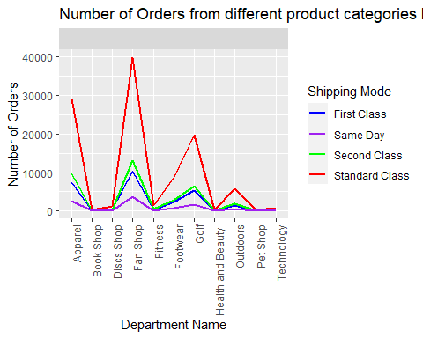

# Display plots  
print(fig)

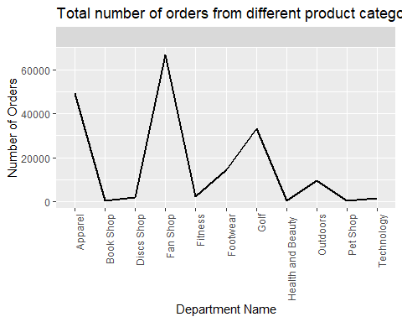

#print(fig2)

summary(supply_chain)

## Type Days.for.shipping..real. Days.for.shipment..scheduled.  
## Length:180519 Min. :0.000 Min. :0.000   
## Class :character 1st Qu.:2.000 1st Qu.:2.000   
## Mode :character Median :3.000 Median :4.000   
## Mean :3.498 Mean :2.932   
## 3rd Qu.:5.000 3rd Qu.:4.000   
## Max. :6.000 Max. :4.000   
##   
## Benefit.per.order Sales.per.customer Delivery.Status Late_delivery_risk  
## Min. :-4274.98 Min. : 7.49 Length:180519 Min. :0.0000   
## 1st Qu.: 7.00 1st Qu.: 104.38 Class :character 1st Qu.:0.0000   
## Median : 31.52 Median : 163.99 Mode :character Median :1.0000   
## Mean : 21.98 Mean : 183.11 Mean :0.5483   
## 3rd Qu.: 64.80 3rd Qu.: 247.40 3rd Qu.:1.0000   
## Max. : 911.80 Max. :1939.99 Max. :1.0000   
##   
## Category.Id Category.Name Customer.City Customer.Country   
## Min. : 2.00 Length:180519 Length:180519 Length:180519   
## 1st Qu.:18.00 Class :character Class :character Class :character   
## Median :29.00 Mode :character Mode :character Mode :character   
## Mean :31.85   
## 3rd Qu.:45.00   
## Max. :76.00   
##   
## Customer.Email Customer.Fname Customer.Id Customer.Lname   
## Length:180519 Length:180519 Min. : 1 Length:180519   
## Class :character Class :character 1st Qu.: 3258 Class :character   
## Mode :character Mode :character Median : 6457 Mode :character   
## Mean : 6691   
## 3rd Qu.: 9779   
## Max. :20757   
##   
## Customer.Password Customer.Segment Customer.State Customer.Street   
## Length:180519 Length:180519 Length:180519 Length:180519   
## Class :character Class :character Class :character Class :character   
## Mode :character Mode :character Mode :character Mode :character   
##   
##   
##   
##   
## Customer.Zipcode Department.Id Department.Name Latitude   
## Min. : 603 Min. : 2.000 Length:180519 Min. :-33.94   
## 1st Qu.: 725 1st Qu.: 4.000 Class :character 1st Qu.: 18.27   
## Median :19380 Median : 5.000 Mode :character Median : 33.14   
## Mean :35921 Mean : 5.443 Mean : 29.72   
## 3rd Qu.:78207 3rd Qu.: 7.000 3rd Qu.: 39.28   
## Max. :99205 Max. :12.000 Max. : 48.78   
## NA's :3   
## Longitude Market Order.City Order.Country   
## Min. :-158.03 Length:180519 Length:180519 Length:180519   
## 1st Qu.: -98.45 Class :character Class :character Class :character   
## Median : -76.85 Mode :character Mode :character Mode :character   
## Mean : -84.92   
## 3rd Qu.: -66.37   
## Max. : 115.26   
##   
## Order.Customer.Id order.date..DateOrders. Order.Id   
## Min. : 1 Length:180519 Min. : 1   
## 1st Qu.: 3258 Class :character 1st Qu.:18057   
## Median : 6457 Mode :character Median :36140   
## Mean : 6691 Mean :36222   
## 3rd Qu.: 9779 3rd Qu.:54144   
## Max. :20757 Max. :77204   
##   
## Order.Item.Cardprod.Id Order.Item.Discount Order.Item.Discount.Rate  
## Min. : 19.0 Min. : 0.00 Min. :0.0000   
## 1st Qu.: 403.0 1st Qu.: 5.40 1st Qu.:0.0400   
## Median : 627.0 Median : 14.00 Median :0.1000   
## Mean : 692.5 Mean : 20.66 Mean :0.1017   
## 3rd Qu.:1004.0 3rd Qu.: 29.99 3rd Qu.:0.1600   
## Max. :1363.0 Max. :500.00 Max. :0.2500   
##   
## Order.Item.Id Order.Item.Product.Price Order.Item.Profit.Ratio  
## Min. : 1 Min. : 9.99 Min. :-2.7500   
## 1st Qu.: 45131 1st Qu.: 50.00 1st Qu.: 0.0800   
## Median : 90260 Median : 59.99 Median : 0.2700   
## Mean : 90260 Mean : 141.23 Mean : 0.1206   
## 3rd Qu.:135390 3rd Qu.: 199.99 3rd Qu.: 0.3600   
## Max. :180519 Max. :1999.99 Max. : 0.5000   
##   
## Order.Item.Quantity Sales Order.Item.Total Order.Profit.Per.Order  
## Min. :1.000 Min. : 9.99 Min. : 7.49 Min. :-4274.98   
## 1st Qu.:1.000 1st Qu.: 119.98 1st Qu.: 104.38 1st Qu.: 7.00   
## Median :1.000 Median : 199.92 Median : 163.99 Median : 31.52   
## Mean :2.128 Mean : 203.77 Mean : 183.11 Mean : 21.98   
## 3rd Qu.:3.000 3rd Qu.: 299.95 3rd Qu.: 247.40 3rd Qu.: 64.80   
## Max. :5.000 Max. :1999.99 Max. :1939.99 Max. : 911.80   
##   
## Order.Region Order.State Order.Status Product.Card.Id   
## Length:180519 Length:180519 Length:180519 Min. : 19.0   
## Class :character Class :character Class :character 1st Qu.: 403.0   
## Mode :character Mode :character Mode :character Median : 627.0   
## Mean : 692.5   
## 3rd Qu.:1004.0   
## Max. :1363.0   
##   
## Product.Category.Id Product.Image Product.Name Product.Price   
## Min. : 2.00 Length:180519 Length:180519 Min. : 9.99   
## 1st Qu.:18.00 Class :character Class :character 1st Qu.: 50.00   
## Median :29.00 Mode :character Mode :character Median : 59.99   
## Mean :31.85 Mean : 141.23   
## 3rd Qu.:45.00 3rd Qu.: 199.99   
## Max. :76.00 Max. :1999.99   
##   
## Product.Status shipping.date..DateOrders. Shipping.Mode   
## Min. :0 Length:180519 Length:180519   
## 1st Qu.:0 Class :character Class :character   
## Median :0 Mode :character Mode :character   
## Mean :0   
## 3rd Qu.:0   
## Max. :0   
##