Thesis Results Guide
Hybrid Machine Learning Framework for Detection of Depression and its Severity in Cancer Patients using Fear of Cancer Recurrence (FCR)
MS Bioinformatics thesis, NUST. A plain-language companion to the figures and tables in thesis_outputs/.
Generated 19 October 2026 from git commit 9bafade-dirty. Every number in this document is read from the analysis result files; to update it, re-run python -m thesis_analysis.run_all --stage report.
How to use this guide
- Part 1 tells the whole story on one page — read it first.
- Parts 2–5 explain each result in simple words and name the figure or table to cite in the thesis.
- Part 6 explains how to read every figure; Part 7 is a glossary of the technical terms.
- Parts 8–9 list the limitations and the decisions to agree with your supervisor before submission.
- Unless stated otherwise, results are for 'All rows' (n = 1530), the primary analysis.

1. The study in one page
Research question. Can fear of cancer recurrence (FCR), together with basic demographic and clinical information, detect depression and estimate its severity in people with cancer?
Data. 1530 participants answered the BDI depression questionnaire and the FCRI fear-of-recurrence questionnaire, plus questions on gender, age, province, cancer type, time since diagnosis, cancer status, treatment and medication. A BDI total of 11 or more was counted as depressed; the BDI total was also split into six severity classes.
What was done. (1) cleaned and scored the data; (2) tested statistically how FCR relates to depression; (3) trained machine-learning models with and without the depression questions, adding a feature-selection step and combining models into ensembles (the 'hybrid' framework); (4) measured performance honestly with repeated nested cross-validation and explained the final models with SHAP.
The answer in brief
- Fear of recurrence and depression rise together strongly (Spearman ρ = 0.85).
- Without seeing any depression questions, the hybrid model (Boruta (RF) + Soft Voting) detected depression with macro F1 0.88: it found 98% of depressed participants and correctly cleared 82% of non-depressed participants (ROC-AUC 0.96).
- Estimating the exact severity class is harder: macro F1 0.60, but most mistakes are near misses (quadratic weighted κ 0.86).
- The FCRI answers carry the signal. FCRI alone performed about the same as FCRI + demographic + clinical (binary macro F1 0.875 vs 0.872), while demographic + clinical information alone reached only 0.634.
- Feature selection made the model simpler but did not make it significantly better than the same ensemble without it (difference +0.010, p = 0.865).
- Caution: when the 561 rows that match a mock-data generator are removed, binary macro F1 falls to 0.63 and severity to 0.46. Which rows are real must be settled before submission.

2. The data
All analyses were run twice, on two versions of the dataset:
- All rows (n = 1530). Every cleaned response. This is the primary analysis.
- Excluding generator-matched rows (n = 969). 561 rows have a name and all 21 BDI answers identical to the output of a mock-data generator found in the project's history, so they may not be real participants. This version leaves them out.
 | All rows | Excluding generator-matched rows
Participants | 1530 | 969
Depressed (BDI ≥ 11) | 1411 | 950
Not depressed (BDI < 11) | 119 | 19
Normal (BDI 0–10) | 119 | 19
Mild mood disturbance (BDI 11–16) | 133 | 47
Borderline clinical depression (BDI 17–20) | 138 | 58
Moderate depression (BDI 21–30) | 424 | 253
Severe depression (BDI 31–40) | 317 | 225
Extreme depression (BDI 41–63) | 399 | 367
Mean BDI total (SD) | 29.7 (13.0) | 34.2 (11.6)
Mean FCRI total (SD) | 78.5 (34.7) | 96.5 (28.0)

What this means. Most participants are depressed; only 119 are not. Classes this unequal make the 'not depressed' group hard to learn, which is why the main score is macro F1 (it gives each class equal weight) and why class weights are used. See Figure 4.1 and Table 4.2.
Reliability. Both questionnaires are internally consistent (Cronbach's α: BDI 0.91, FCRI 0.97; Table 4.4).

Data problems found
- 717 answers to BDI items 6 and 7 had been scored wrongly by the original parser ("I don't feel ..." was scored as a symptom). They were corrected here; the saved app models in models/ were trained before this fix.
- 19 men report ovarian or cervical cancer and 5 women report prostate cancer.
- 68 participants are under 18 years old.
- 26 participants gave the same answer to all 21 BDI questions.
- Duplicate responses found: 0. 54 participants had a few missing FCRI answers, which were filled with their own subscale average.
These are listed in Table 4.1. They were kept in the analysis but should be discussed with your supervisor (Part 9).

3. What was done, in plain words
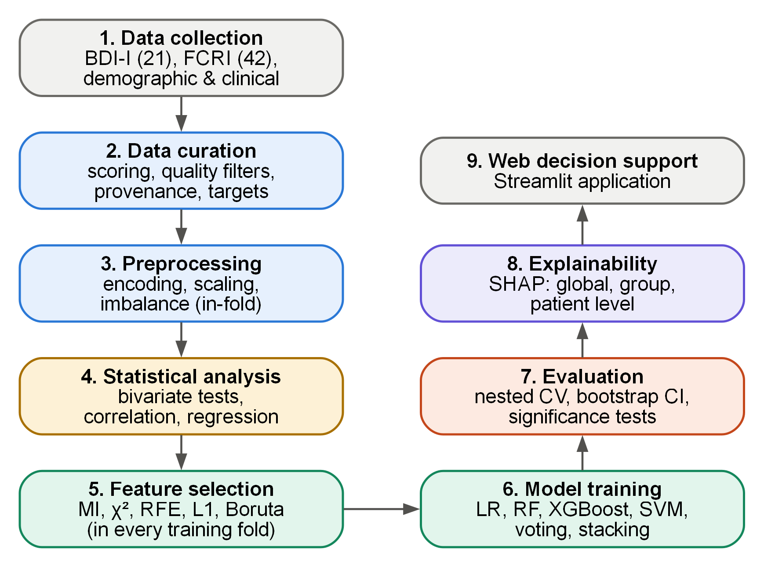
Figure 3.1. Overall research methodology of the hybrid machine-learning framework.

Step 1 — Two targets from one score
The BDI total decides both things the model must predict: depressed if BDI ≥ 11 (binary), and a severity class (Normal 0–10, Mild mood disturbance 11–16, Borderline clinical depression 17–20, Moderate depression 21–30, Severe depression 31–40, Extreme depression 41–63). See Figure 3.3.

Step 2 — Four feature sets, to avoid fooling ourselves
Because the labels are calculated from the BDI answers, a model that sees those answers simply adds them up again; this is called leakage. Four sets of inputs were therefore compared:
Set | Inputs | Why it is there
A | BDI + FCRI + demographic + clinical | Upper bound only — contains the answer (leakage).
B | FCRI + demographic + clinical | The honest test of the thesis claim. Main set.
C | FCRI only | Does fear of recurrence alone carry the signal?
D | Demographic + clinical | What can be done without any questionnaire?

Step 3 — The hybrid framework
For every training split the pipeline (1) one-hot encodes categories and scales answers to 0–1, (2) chooses the most useful inputs with one of five feature-selection methods (mutual information, χ², RFE, L1 logistic regression, Boruta), (3) tunes four learners (logistic regression, random forest, XGBoost, SVM) and (4) combines them by soft voting or stacking. The best feature-selection method + best ensemble on set B is the hybrid model. See Figure 3.5 and Table 3.3.

Step 4 — Honest testing with nested cross-validation
The data were split into 5 parts; each part in turn was the test set and the rest the training set, and this was repeated 5 times with different splits (25 test results per model). Inside each training set a second 3-fold loop tuned the settings, so the test part was never used for any decision. Every step that learns from data (scaling, SMOTE, feature selection) was re-done inside each training split. See Figure 3.6 and Figure 3.4. A separate hold-out test set was not used because the 'not depressed' group is too small to split off reliably.

Step 5 — Explaining the model
The final hybrid models were explained with SHAP, which shows how much each answer pushed each prediction towards or away from depression.

4. The results, one at a time

4.1 Fear of recurrence is strongly linked with depression
Key numbers
- Spearman correlation between FCRI total and BDI total: ρ = 0.85 (p < 0.001).
- 15 of 16 comparisons between depressed and non-depressed participants were significant after Holm correction.
- The multivariable logistic regression has 3.61 'not depressed' cases per model parameter — below the usual minimum of 10, so its odds ratios are unstable; report them with care.

Cite Figure 4.5, Figure 4.3, Figure 4.4, Table 4.5 and Table 4.11.
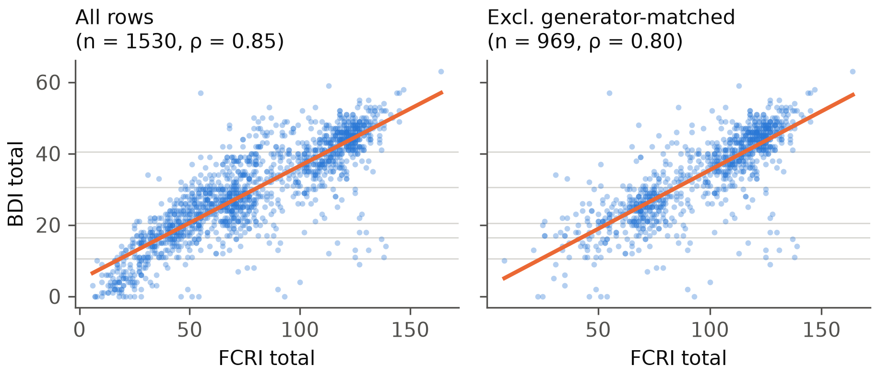
Figure 4.5. Relationship between FCRI total and BDI total scores.

4.2 Which information matters? (feature sets A–D)
Data | Task | A (with BDI) | B (FCRI + info) | C (FCRI only) | D (info only)
All rows | Binary | 0.95 | 0.88 | 0.88 | 0.63
 | Severity | 0.86 | 0.60 | 0.61 | 0.32
Excluding generator-matched rows | Binary | 0.94 | 0.63 | 0.58 | 0.57
 | Severity | 0.80 | 0.47 | 0.46 | 0.33

Best macro F1 for each feature set (mean over 25 outer test folds; for set B this is the hybrid model).
What it shows
- Set A is high because the model can add up the BDI answers again — it is not a fair test (leakage).
- Set B minus set C (effect of adding demographic + clinical to FCRI): -0.003 for binary (p = 0.865) and -0.008 for severity (p = 1.000).
- Set B minus set D (effect of the FCRI answers): +0.238 for binary (p < 0.001) and +0.285 for severity (p < 0.001).
- Plain meaning: almost all of the predictive information comes from the FCRI answers; demographic and clinical details add little.

These comparisons use the same ensemble without feature selection on both sides, so only the inputs differ. Cite Figure 4.7 and Table 4.17.
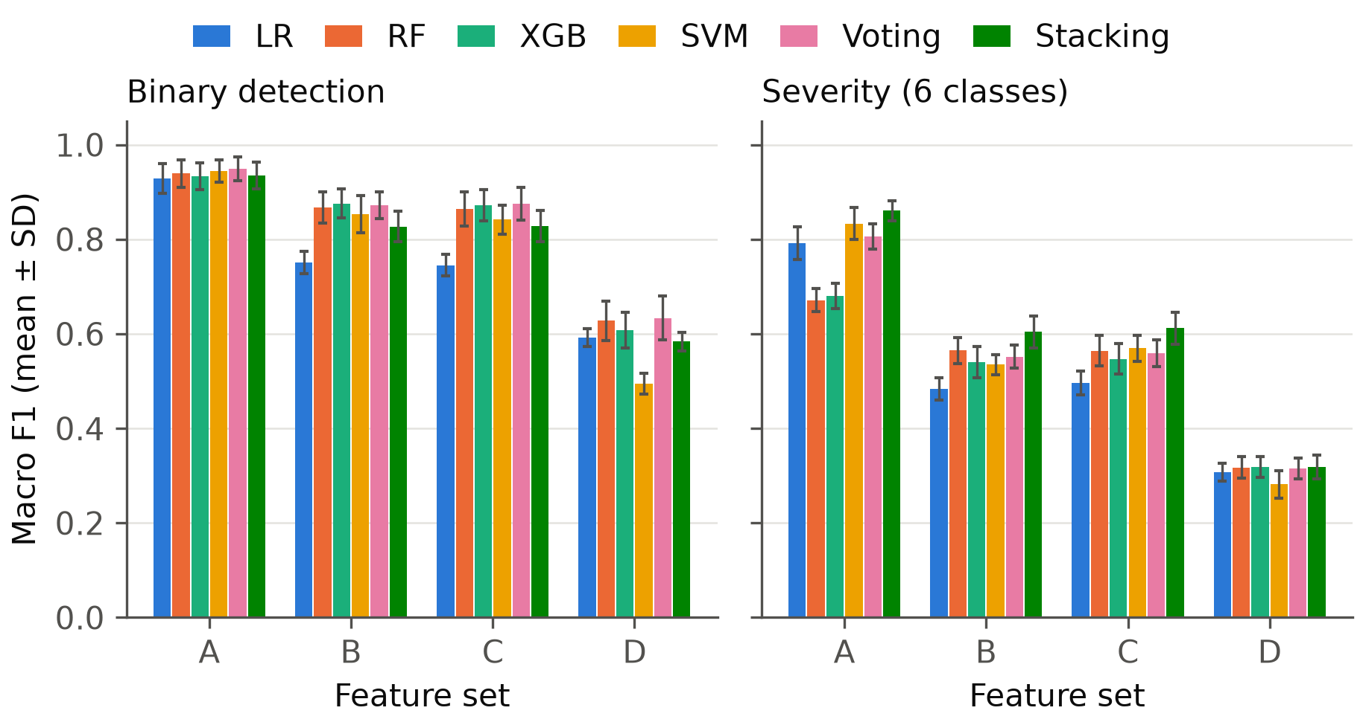
Figure 4.7. Macro F1 of every model on feature sets A-D (mean ± SD over 25 outer folds).

4.3 How well does the hybrid model work?
Feature set B (no BDI answers). Values are the mean over 25 outer test folds; the 95% confidence interval is in brackets.

Binary: depressed or not
 | All rows | Excluding generator-matched rows
Hybrid model | Boruta (RF) + Soft Voting | Chi-square + Soft Voting
Macro F1 (main score) | 0.88 (0.85–0.91) | 0.63 (0.53–0.73)
Balanced accuracy | 0.90 (0.86–0.93) | 0.64 (0.53–0.74)
Sensitivity — depressed found | 98% (97%–99%) | 99% (97%–100%)
Specificity — non-depressed cleared | 82% (74%–89%) | 29% (6%–50%)
ROC-AUC | 0.96 (0.92–0.98) | 0.91 (0.83–0.95)
MCC | 0.77 (0.69–0.83) | 0.26 (0.07–0.47)
Brier score (lower = better) | 0.033 (0.027–0.039) | 0.025 (0.017–0.033)

Severity: six classes
 | All rows | Excluding generator-matched rows
Hybrid model | Boruta (RF) + Stacking (LR meta) | L1 logistic regression + Stacking (LR meta)
Macro F1 (main score) | 0.60 (0.57–0.64) | 0.46 (0.41–0.50)
Balanced accuracy | 0.61 (0.58–0.64) | 0.49 (0.43–0.55)
Quadratic weighted κ | 0.86 (0.83–0.88) | 0.69 (0.63–0.74)
Macro ROC-AUC | 0.89 (0.88–0.90) | 0.86 (0.82–0.88)

What it shows
- The model finds 98% of depressed participants and correctly clears 82% of the non-depressed — the small group is the harder one.
- Severity: easiest class 'Normal' (F1 0.79), hardest class 'Borderline clinical depression' (F1 0.29). The middle classes cover narrow BDI ranges, so small differences in answers move a participant across a boundary.
- 83% of severity mistakes were only one class away from the true class.
- Misclassified participants sat close to the BDI cut-off (median distance 4.0 points vs 19.5 for correctly classified ones) — the model struggles mostly with borderline cases.

Cite Table 4.18, Table 4.20, Table 4.22, Figure 4.9, Figure 4.11, Figure 4.12 and Figure 4.16.
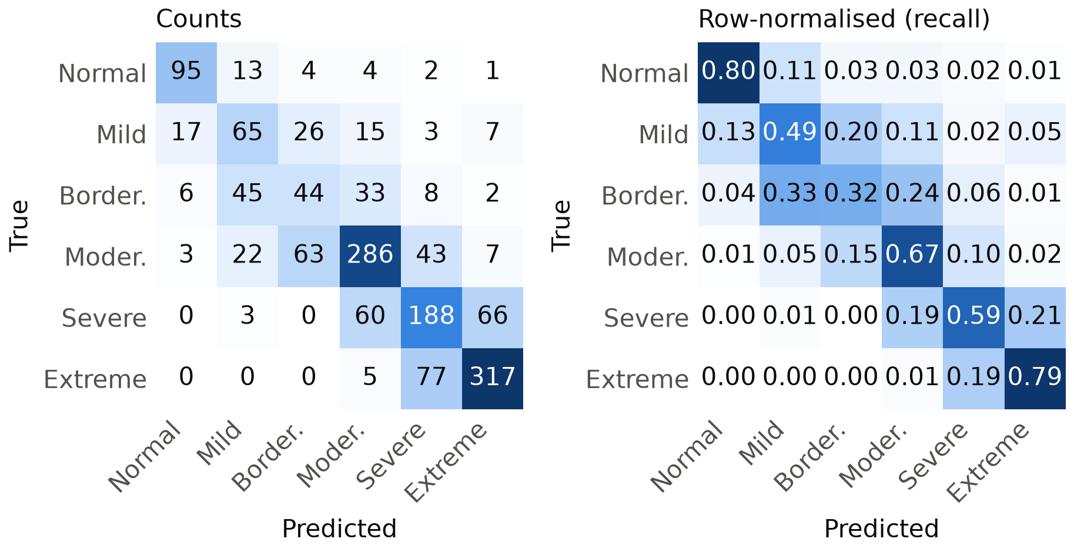
Figure 4.12. Confusion matrices (counts and row-normalised) of the hybrid model for severity classification.

4.4 Is the hybrid better than simpler models?
What it shows
- Binary detection: average ranks (1 = best) — Voting 1.64; XGB 2.42; RF 2.90; SVM 3.68; Stacking 4.36; LR 6.00. Friedman p < 0.001; models whose ranks differ by less than 1.51 are not significantly different.
- Severity (6 classes): average ranks (1 = best) — Stacking 1.40; Voting 3.04; RF 3.16; SVM 3.20; XGB 4.24; LR 5.96. Friedman p < 0.001; models whose ranks differ by less than 1.51 are not significantly different.
- Binary: hybrid vs the same ensemble without feature selection: macro F1 0.882 vs 0.872 (p = 0.865).
- Severity: hybrid vs the same ensemble without feature selection: macro F1 0.604 vs 0.604 (p = 1.000).

Plain meaning: the ensembles rank at the top, but feature selection did not raise the score significantly; its benefit is a smaller, more interpretable set of inputs. Describe it as 'comparable performance with fewer inputs', not as an improvement.
Cite Figure 4.13, Table 4.24 and Table 4.26.

4.5 What happens when parts are removed? (ablation)
Each row removes or changes one thing and shows the change in macro F1 compared with the hybrid set-up (2 repeats of 5-fold CV, primary data).
Change | Binary Δ | Severity Δ
Without demographic variables | +0.001 | -0.006
Without clinical variables | -0.007 | -0.005
Without medication variable | -0.015 | +0.005
Without FCRI items 19 & 26 (mood overlap) | +0.002 | +0.002
Without Min-Max scaling | -0.002 | -0.002
Label (ordinal) encoding instead of one-hot | -0.003 | +0.002
Without feature selection | -0.017 | +0.004
SMOTE instead of class weights | -0.006 | -0.014
No imbalance handling | -0.008 | -0.016
FCRI items only (set C) | -0.013 | +0.004
Without FCRI items (set D) | -0.250 * | -0.283 *
Set D without medication variable | -0.275 * | -0.308 *

* significant after Holm correction (p < 0.05). Negative Δ = worse without it.
What it shows
- 2 of 12 changes made a significant difference in at least one task: Without FCRI items (set D); Set D without medication variable.
- Only removing the FCRI answers hurts. Removing demographic, clinical or medication variables, the mood-overlap FCRI items, or scaling, and swapping class weights for SMOTE, made no significant difference.

Cite Figure 4.17, Table 4.29, Table 4.28 and Table 4.30.

Other choices tested (sensitivity analyses)
- All rows: with the stricter cut-off BDI ≥ 17, best binary macro F1 = 0.84.
- All rows: merging the two lowest classes (five classes), best severity macro F1 = 0.63.
- Excluding generator-matched rows: with the stricter cut-off BDI ≥ 17, best binary macro F1 = 0.67.
- Excluding generator-matched rows: merging the two lowest classes (five classes), best severity macro F1 = 0.55.

4.6 Which questions matter most? (SHAP)
The five questions with the largest influence on the binary hybrid model:
1. FCRI 14: In your opinion, are you at risk of having a cancer recurrence?
2. FCRI 9: I am worried or anxious about the possibility of cancer recurrence
3. FCRI 1: Television shows or newspaper articles about cancer or illness
4. FCRI 16: How much time per day do you spend thinking about the possibility of cancer recurrence?
5. FCRI 13: I believe that I am cured and that the cancer will not come back
What it shows
- In the main model (set B) FCRI answers account for 100% of the model's reasoning, demographic variables 0% and clinical variables 0%.
- This is because the Boruta (RF) feature-selection step kept only FCRI questions in the final model.
- When BDI answers are allowed (set A) they take 67% of the reasoning — another sign of leakage.
- Read the full wording of the top items above before writing the discussion: they describe how the participant sees their risk of recurrence and how much they worry about it.

Cite Figure 4.19, Figure 4.20, Figure 4.21, Figure 4.22, Figure 4.23 and Table 4.34 (which compares SHAP with the statistical tests and feature-selection frequency).
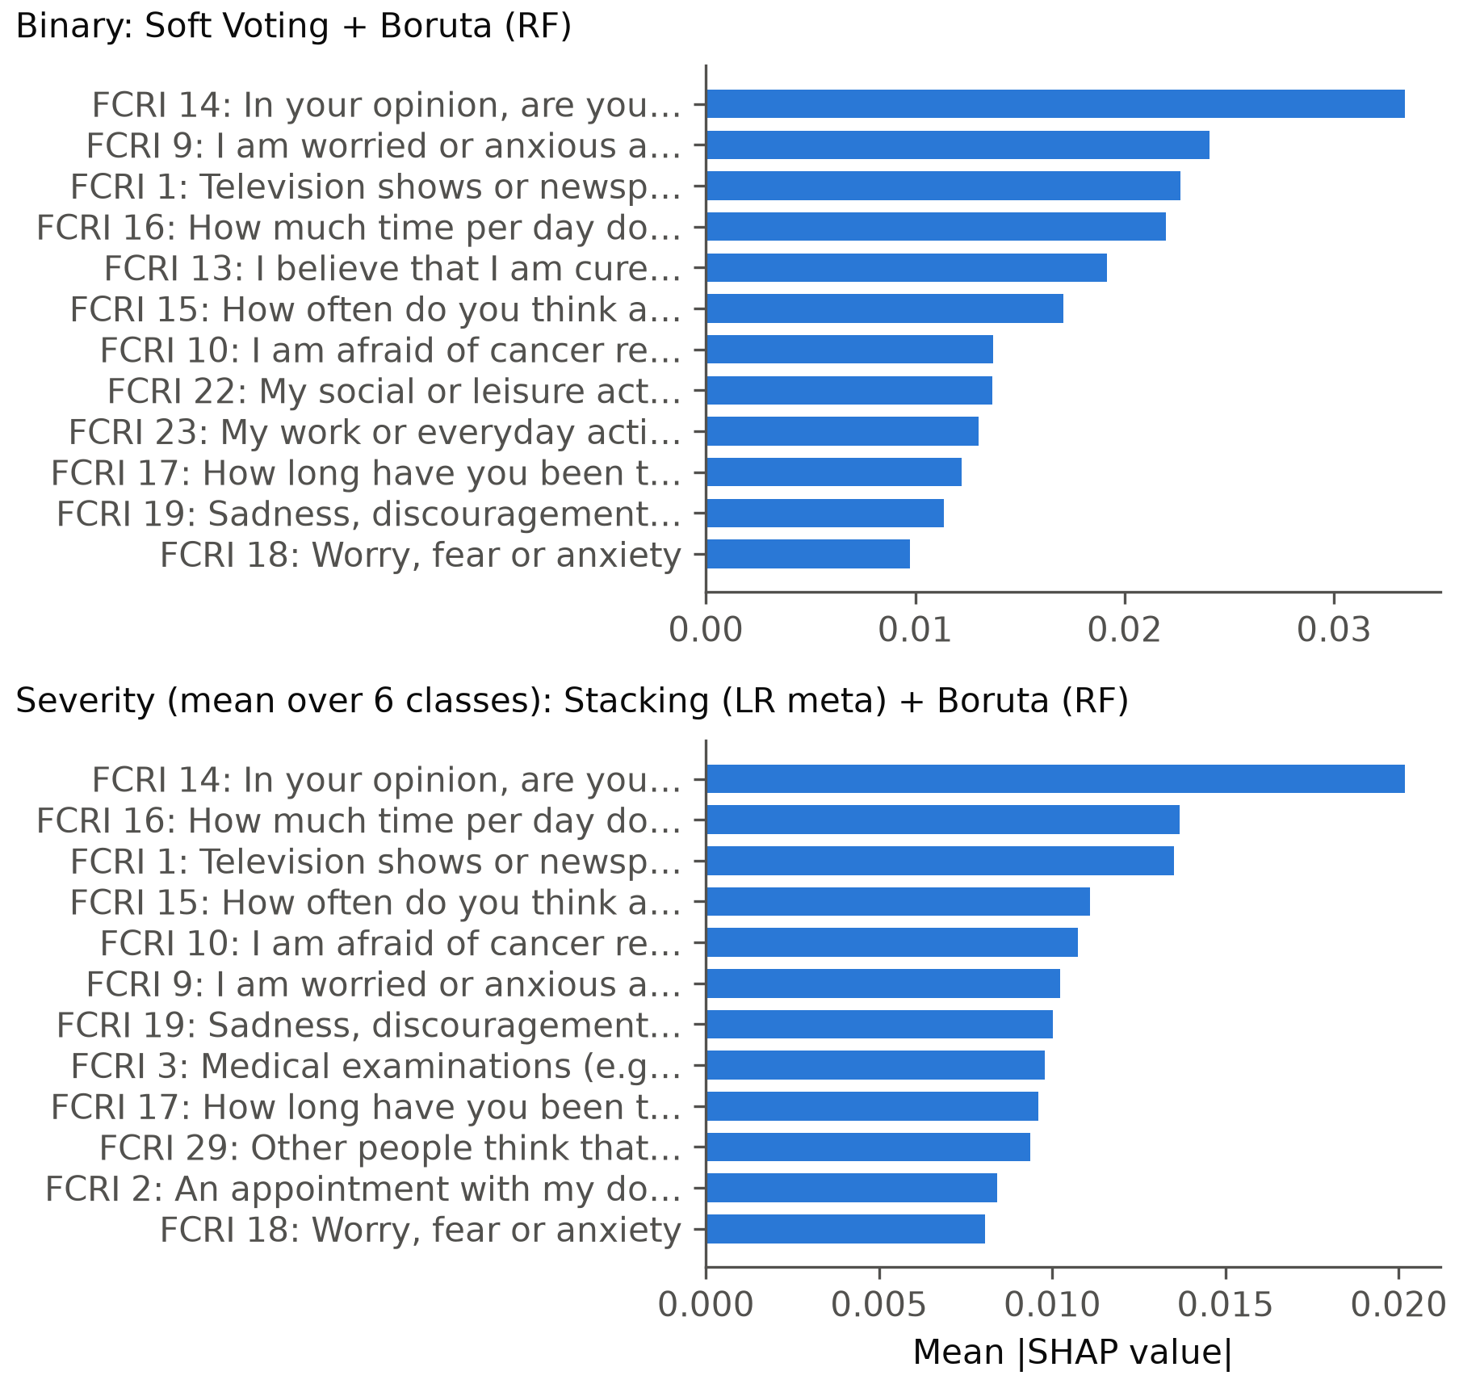
Figure 4.20. Mean absolute SHAP values of the top features (binary and severity models, feature set B).

4.7 Can the probabilities be trusted, and would more data help?
What it shows
- Brier score of the binary hybrid: 0.033 (0 = perfect).
- Binary detection: macro F1 went from 0.83 with 244 training participants to 0.88 with 734 and 0.88 with 1224 (-0.001 over the second half), so the curve has levelled off and more data of the same kind would add little.
- Severity (6 classes): macro F1 went from 0.49 with 244 training participants to 0.60 with 734 and 0.61 with 1224 (+0.016 over the second half), so it is still rising slowly and more data would probably help a little.

Cite Figure 4.14 and Figure 4.15.

5. Why the two versions of the data give different answers
 | All rows | Excluding generator-matched rows
Binary macro F1 | 0.88 | 0.63
Binary specificity | 82% | 29%
Binary ROC-AUC | 0.96 | 0.91
Binary MCC | 0.77 | 0.26
Severity macro F1 | 0.60 | 0.46
Severity QWK | 0.86 | 0.69
Not-depressed participants | 119 | 19
FCRI–BDI correlation ρ | 0.85 | 0.80

- Without the generator-matched rows only 19 participants are not depressed, so the model has very few examples of that class and specificity drops sharply.
- The generator-matched rows may follow an artificial pattern that is easier to learn, which would make the all-rows results look better than real-world performance.
- Until the origin of these rows is confirmed, report both versions and state clearly which one is primary (see Part 9).
Appendix figures in thesis_outputs/figures/appendix/ repeat the main figures for this version.

6. How to read each figure
No. | What it is | What to look for
Figure 3.1 | Overall research methodology of the hybrid machine-learning framework. | The whole study on one page: data → curation → statistics and machine learning → explanation → web app. Use it to introduce Chapter 3.
Figure 3.2 | Participant flow from the raw form export to the analysis datasets. | How many responses were removed at each cleaning step and why.
Figure 3.3 | Mapping of the BDI total score to the binary target and the six severity classes. | How a BDI total score becomes 'depressed / not depressed' and one of six severity classes.
Figure 3.4 | Data preprocessing pipeline; steps inside the dashed box are re-fitted on every training fold. | Which steps are done once per participant (scoring) and which are re-learned inside every training fold (encoding, scaling, SMOTE, feature selection) so no test information leaks.
Figure 3.5 | Architecture of the proposed hybrid framework (feature selection followed by ensemble learning). | The proposed model: a feature-selection step chooses the inputs, four base learners are tuned, and their predictions are combined by voting or stacking.
Figure 3.6 | Repeated stratified nested cross-validation scheme used for tuning and evaluation. | Two loops: the inner loop tunes settings, the outer loop measures performance on data the model never saw.
Figure 3.7 | Architecture of the web-based decision-support system. | How the Streamlit app, the saved models and the questionnaire fit together.
Figure 4.1 | Distribution of the binary depression target and the six BDI severity classes. | How unequal the classes are. Few 'not depressed' participants means that class is hard to learn and its results are less certain.
Figure 4.2 | Distributions of BDI total and FCRI total scores (dashed lines: BDI severity cut-offs). | The spread of BDI and FCRI totals; dashed lines are the severity cut-offs.
Figure 4.3 | FCRI total and subscale scores across BDI severity classes. | Whether fear of recurrence rises from the 'Normal' to the 'Extreme' class. A steady rise supports the link between FCR and depression.
Figure 4.4 | Spearman correlations between BDI total, FCRI total and FCRI subscales. | Darker cells = stronger correlation. Look at the BDI row: which FCRI subscales move most with depression?
Figure 4.5 | Relationship between FCRI total and BDI total scores. | Each dot is a participant. A tight upward cloud means high FCR goes with high BDI.
Figure 4.6 | Adjusted odds ratios (95% CI) of being classified as depressed (multivariable logistic regression). | Odds ratios to the right of 1 raise the odds of depression, to the left lower them. Lines crossing 1 are not significant. Very wide lines mean too little data.
Figure 4.7 | Macro F1 of every model on feature sets A-D (mean ± SD over 25 outer folds). | The key leakage figure. Set A (with BDI items) is high because the label is made from those items. Compare B, C and D to see what FCR and patient details add.
Figure 4.8 | Macro F1 of models and feature-selection methods on feature set B. | Each cell is a model + feature-selection method; darker = better. Find the best combination (the hybrid).
Figure 4.9 | ROC curves of all models for binary depression detection (feature set B, pooled out-of-fold predictions). | Curves closer to the top-left corner separate depressed from not depressed better (higher AUC).
Figure 4.10 | Precision-recall curves for binary depression detection (feature set B). | Precision-recall for the rare 'not depressed' class; compare each curve with the dashed chance line.
Figure 4.11 | Confusion matrices (counts and row-normalised) of the hybrid model for binary detection. | Rows are the true class, columns the prediction. Off-diagonal cells are mistakes.
Figure 4.12 | Confusion matrices (counts and row-normalised) of the hybrid model for severity classification. | Most mistakes should sit next to the diagonal (one class away), which is less serious than a big jump.
Figure 4.13 | Critical-difference diagrams (Friedman + Nemenyi) comparing models on feature set B. | Models further left rank better. Models joined by a thick bar are not significantly different.
Figure 4.14 | Calibration curve of the best binary model (out-of-fold predictions). | If the curve follows the diagonal, a predicted probability of 0.8 really means about 80% are depressed.
Figure 4.15 | Learning curves of the hybrid models. | If the validation line is still rising at the right, more participants would help. A big gap to the training line means over-fitting.
Figure 4.16 | Misclassification rate by distance of the BDI total from the nearest class boundary. | Errors are most common for participants whose BDI score lies close to a cut-off, i.e. the borderline cases.
Figure 4.17 | Effect of imbalance handling and of removing feature groups / preprocessing steps. | Bars show how much macro F1 changes when something is removed or changed. Only bars marked significant matter.
Figure 4.18 | Selection frequency of the most frequently selected features across outer folds. | How often each feature was chosen across training folds; 1.0 = chosen every time.
Figure 4.19 | SHAP summary (beeswarm) plot of the hybrid binary model on feature set B. | Each dot is a participant. Dots to the right push the prediction towards depression; the colour shows whether the answer on that item was high or low.
Figure 4.20 | Mean absolute SHAP values of the top features (binary and severity models, feature set B). | The average importance of each feature for the final model.
Figure 4.21 | SHAP dependence plots of the five most important features (binary model, feature set B). | How the effect of one item changes as the answer goes from 0 to 4.
Figure 4.22 | SHAP waterfall plots explaining individual predictions for three participants. | Why the model made one specific prediction: each bar pushes the probability up or down.
Figure 4.23 | Share of total mean |SHAP| contributed by each feature group (feature sets A and B). | Share of the model's reasoning that comes from BDI, FCRI, demographic and clinical variables.

Files: thesis_outputs/figures/<name>.png (300 dpi, for Word) and .svg (vector). All are at most 16 cm wide, so they can be inserted at 100% size.

7. Glossary
Term | Meaning in simple words
BDI | Beck Depression Inventory: 21 questions, each scored 0–3. The total (0–63) defines both targets.
FCRI | Fear of Cancer Recurrence Inventory: 42 questions, each scored 0–4, in seven subscales.
FCR | Fear of cancer recurrence: worry that the cancer will come back or spread.
Target / label | What the model tries to predict: depressed yes/no (binary) or one of six severity classes.
Feature | An input given to the model, e.g. one FCRI answer, age group or cancer type.
Leakage | When the model is given information that already contains the answer. Here: BDI items, because the label is calculated from them.
Feature selection (FS) | A step that keeps only the most useful inputs (methods: mutual information, χ², RFE, L1, Boruta).
Ensemble | Several models combined. Soft voting averages their probabilities; stacking trains a small logistic-regression model on top of their predictions.
Hybrid model | The best feature-selection method + the best ensemble, chosen by macro F1 on feature set B.
Cross-validation (CV) | Split the data into 5 parts, train on 4 and test on 1, rotate, and repeat with different splits.
Nested CV | CV inside CV: the inner loop tunes the model's settings, the outer loop gives an honest score.
Class weights / SMOTE | Two ways to stop the model ignoring small classes: give their errors more weight, or create synthetic examples of them.
Macro F1 | Main score (0–1). F1 balances precision and recall; 'macro' averages it over classes so the small classes count equally.
Sensitivity (recall) | Share of truly depressed participants the model finds.
Specificity | Share of truly not-depressed participants the model correctly clears.
ROC-AUC | Chance that the model ranks a random depressed participant above a random non-depressed one (0.5 = guessing, 1 = perfect).
MCC | Matthews correlation coefficient, −1 to 1 (0 = guessing); fair under class imbalance.
Quadratic weighted κ (QWK) | Agreement for ordered classes; a near miss is penalised less than a big miss.
Brier score | Average squared error of the predicted probabilities; lower is better.
Mean ± SD | Average over the outer test folds ± how much it varied between folds.
95% CI | Range that very likely contains the true value (from bootstrap resampling of participants).
p-value / Holm | p < 0.05 = unlikely to be chance. Holm adjusts p-values when many tests are run at once.
Spearman ρ | Rank correlation from −1 to 1; above 0.7 is usually called strong.
Cronbach's α | Internal consistency of a questionnaire; above 0.7 is acceptable, above 0.9 excellent.
Ablation | Remove one thing (e.g. demographic variables) and see whether performance drops.
SHAP | A method that shows how much each input pushed a prediction up or down. It explains the model, not cause and effect.
Nogueira stability | 0–1; how similar the selected features are across training folds.

8. Limitations to mention in the thesis
- Data origin. 561 of 1532 rows match mock-generator output; the rest could not be verified from the repository alone.
- Small 'not depressed' group. Specificity and other results for this group have wide confidence intervals.
- Label comes from the BDI. Both targets are calculated from the BDI, so models that see BDI answers only re-compute the label; only sets B–D test real prediction.
- Overlapping questions. Some FCRI items (19 sadness, 26 mood) resemble depression symptoms; the ablation shows how much they matter.
- Self-report, one time point, one form. Both questionnaires were filled in together online, which can inflate their correlation; there is no external validation group.
- Regression power. Only 3.61 events per parameter in the multivariable logistic regression; its odds ratios are unstable.
- Instrument version. The BDI wording and cut-offs used are those of the first-edition BDI (0–10 normal … 41–63 extreme), not the BDI-II.
- SHAP is not causation. It shows what the model relies on, not what causes depression.

9. Decisions to agree with your supervisor
1. Which rows are genuine participants, and therefore which data version is primary in the thesis.
2. Whether the binary cut-off stays at BDI ≥ 11 or moves to ≥ 17.
3. Whether six severity classes are reported, or the two lowest classes are merged (five classes).
4. Whether participants under 18 and the inconsistent gender/cancer-type answers are excluded.
5. Whether the instrument is described as BDI-I/BDI-IA instead of BDI-II in the methodology.
6. Whether the BDI items 6/7 scoring fix is applied to the app and the saved models are retrained.
7. Whether the Streamlit app should switch to an FCRI-based hybrid model.

10. Where everything is
What | Where
Figures for the thesis | thesis_outputs/figures/ (appendix versions in figures/appendix/)
All tables, formatted for Word | thesis_outputs/tables/thesis_tables.docx
Tables as spreadsheets | thesis_outputs/tables/*.csv
Detailed summary + draft methodology text | thesis_outputs/RESULTS_SUMMARY.md
This guide | thesis_outputs/THESIS_GUIDE.docx
Cleaned dataset | thesis_outputs/data/curated_dataset.csv
Run logs (settings, versions, git commit) | thesis_outputs/logs/
Re-run everything | python -m thesis_analysis.run_all --stage all

