**IoT-Based Smart Traffic Management System**

**1. Introduction**

Traffic congestion and road safety are two major concerns in urban cities. Traditional traffic management systems lack real-time adaptability, leading to inefficiencies and increased accident risks. This project aims to develop an **IoT-Based Smart Traffic Management System** to enhance traffic flow, prioritize emergency vehicles, and provide real-time environmental monitoring using embedded systems and IoT technologies. Additionally, the system integrates accident detection, fire safety mechanisms, and remote monitoring.

**2. Objectives**

The main objectives of this project are:

* **Adaptive Traffic Control:** Dynamically adjust traffic signals based on vehicle presence and emergency situations.
* **Pedestrian Crossing System:** Ensure safe pedestrian movement with a dedicated crossing feature.
* **Emergency Vehicle Priority:** Utilize RFID sensors to detect ambulances and extend green light timing.
* **Environmental Monitoring:** Display real-time temperature data on an LCD screen.
* **Smart Street Lighting:** Automatically control street lamps based on time.
* **Traffic Awareness Messages:** Display safety-related messages on an LCD for drivers and pedestrians.
* **Fire Sprinkler Activation:** Detect accidents and activate fire sprinklers for enhanced safety.
* **24-Hour CCTV Monitoring:** Implement webcam surveillance for real-time footage storage and analysis.
* **Server Integration:** Store all collected data for remote monitoring and record-keeping.

**3. Literature Review**

**Existing Systems**

Traditional traffic management relies on pre-set timers, leading to inefficiencies. Modern solutions use **Artificial Intelligence (AI)** and **IoT** to optimize traffic based on real-time data.

**IoT Integration in Traffic Management**

IoT has significantly improved smart city infrastructure by enabling real-time data collection from various sensors like RFID, temperature sensors, motion detectors and smoke detectors.

**4. System Components & Methodology**

**Hardware Components**

* **MCU-PT (Arduino) Controllers:** Handles traffic light logic and smart street lighting.
* **RFID Sensors:** Detects emergency vehicles for priority passage.
* **LCD Display:** Shows real-time temperature, time, date, and traffic messages.
* **Temperature Sensor (A0):** Monitors environmental conditions.
* **Street Lamps (D0, D1):** Automatically turn on/off based on time.
* **Buzzer (A0, A3):** Alerts for pedestrian crossing and emergency vehicles.
* **Fire Sprinkler System:** Activates automatically in case of an accident.
* **Smoke Detector:** Detects unsafe air conditions and triggers an alarm at fuel stations.
* **Webcam:** Provides 24-hour CCTV footage for traffic and pedestrian monitoring.
* **Remote Server:** Collects and stores all sensor and surveillance data for analysis.

**Software & Logic Implementation**

The system operates using **MCU programming (JavaScript & Python)** inside Cisco Packet Tracer. The core logic includes:

* **RFID-Based Traffic Light Control:** If an emergency vehicle is detected, the green light extends by **30 seconds**.
* **Pedestrian Crossing Feature:** When the speaker is on in that lane, pedestrians can then move safely across the crossing.
* **LCD-Based Messaging System:** Displays traffic safety tips, time, and real-time temperature.
* **Street Light Automation:** Streetlights turn **ON after 6 PM** and **OFF at 6 AM**.
* **Accident Detection & Fire Safety:** If an accident is detected, fire sprinklers are activated automatically.
* **Smoke Detection:** If smoke levels surpass a threshold at a fuel station, a siren alert is triggered.
* **Remote Monitoring & CCTV:** A webcam captures real-time footage, which is stored on a remote server for review.

**5. Implementation**

**Arduino 1 (Traffic Light & RFID Integration)**

This Arduino manages the traffic signals and RFID-based emergency vehicle detection.

* RFID detection instantly extends green light for emergency vehicles.
* Traffic lights cycle through green, yellow, and red phases dynamically.
* Pedestrian crossing feature ensures safe walking intervals.

**Arduino 2 (Street Lighting & LCD Display)**

This Arduino handles environmental monitoring and automated lighting.

* Displays time, temperature, and safety messages on an LCD.
* Controls street lamps based on time.

**Traffic Server**

* Webcam captures footage for real-time monitoring and record-keeping.
* Monitors smoke levels and triggers alarms at fuel stations.
* Activates fire sprinklers in case of an accident.

**6. Results & Discussion**

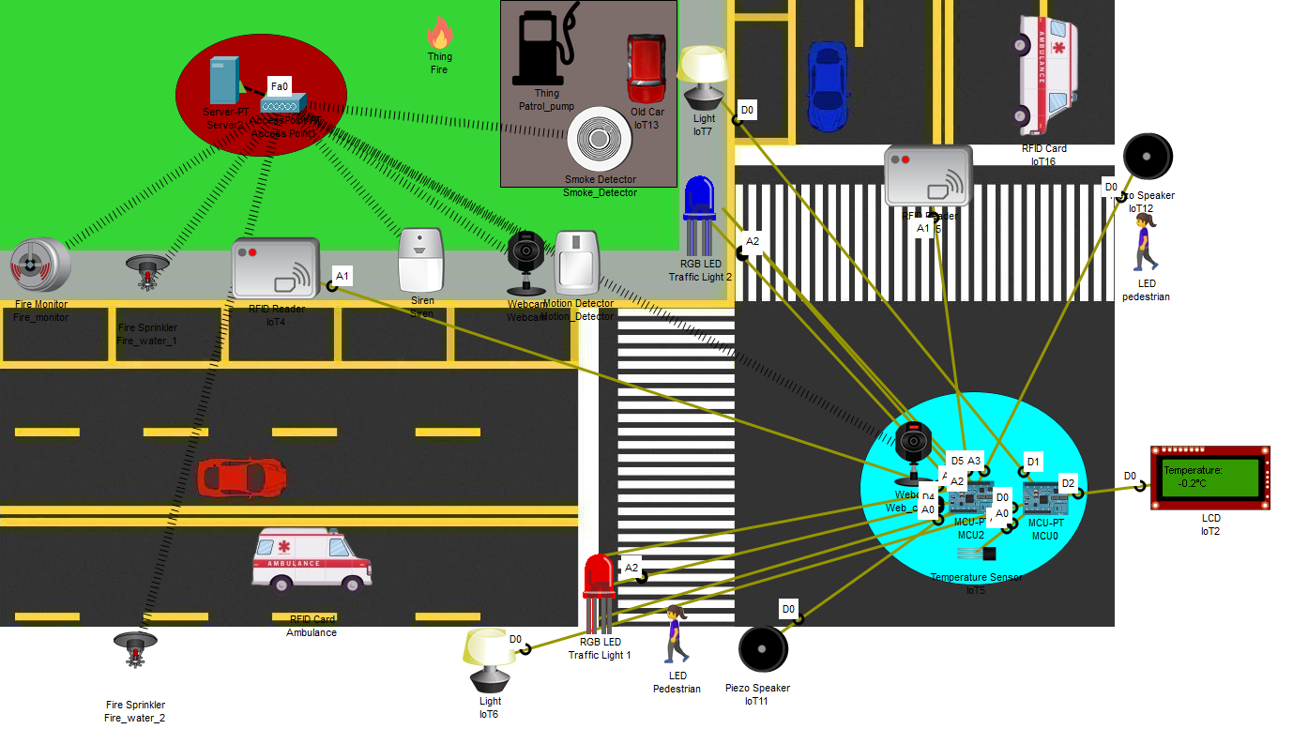

**Observations**

* **Real-time Emergency Vehicle Detection:** Successfully extends green light timing upon detecting an RFID-tagged ambulance.
* **Adaptive Street Lighting:** Lights turn on and off based on preset timing.
* **Traffic Awareness Messages:** The LCD cycles through messages every **5 seconds**, keeping drivers informed.
* **Pedestrian Safety:** The pedestrian feature effectively halts traffic to allow safe crossing.
* **Smoke & Accident Detection:** Smoke levels at fuel stations are accurately detected, triggering sirens. Accidents activate fire sprinklers immediately.
* **Remote Data Storage:** A remote server successfully collects and stores traffic and environmental data.

**Limitations & Challenges**

* **Lack of Real-Time Clock in MCU:** Time simulation was manually implemented.
* **Limited Sensor Range in PT:** Cisco Packet Tracer does not allow external sensors, requiring simulated inputs.
* **Webcam Simulation Constraints:** Cisco Packet Tracer does not fully support real-time CCTV functionality, requiring external integration for complete implementation.

**7. Conclusion & Future Scope**

The IoT-Based Smart Traffic Management System successfully integrates RFID-based emergency detection, smart street lighting, pedestrian safety mechanisms, accident response systems, smoke detection, and real-time CCTV surveillance to optimize urban traffic control.

**Future Enhancements**

* **Integration with AI:** Use AI-based traffic prediction for real-time optimizations.
* **Cloud-Based Monitoring:** Store and analyze traffic data using cloud platforms.
* **Mobile App for Users:** Develop an app to provide real-time traffic conditions and alerts.
* **Congestion-Based Traffic Lighting** – Adaptive signal control based on real-time traffic density, which could not be implemented due to Cisco Packet Tracer’s lack of IR sensors and other limitations.
* **Enhanced CCTV System:** Implement a fully operational real-time surveillance system with AI-based analysis for better security monitoring.