ICS-344: Information Security
Course Project: DVSA Vulnerability Discovery and Remediation

Lesson #10: Unhandled Exceptions

Field | Details
Course / Section | ICS-344 — Information Security
Institution | King Fahd University of Petroleum and Minerals (KFUPM)
Term | 252
DVSA Website URL | http://dvsa-ibrahim-2026-290304998824-us-east-1.s3-website.us-east-1.amazonaws.com
API Endpoint | https://g094q0pn3g.execute-api.us-east-1.amazonaws.com/dvsa/order
AWS Region | us-east-1 (N. Virginia)
AWS Account ID | 290304998824
Date | May 3, 2026
Vulnerability | Unhandled Exceptions — Internal Stack Traces and Error Details Exposed to Client

Part 1) Goal and Vulnerability Summary
This lesson demonstrates an Unhandled Exceptions vulnerability in the DVSA application. When the backend Lambda functions receive malformed, missing, or unexpected input, they crash and return detailed internal error information directly to the client. This includes full stack traces, internal file paths, line numbers, variable names, and code snippets that should never be visible outside the backend.

- Vulnerability Type: Unhandled Exceptions / Information Disclosure
- Affected Component: API Gateway → Lambda (DVSA-ORDER-GET, DVSA-ORDER-BILLING)
- Security Impact: Internal implementation details including file paths, line numbers, variable names, and code logic are exposed to any client that sends malformed input
- Main Weakness: Lambda functions lack try/catch error handling and use unsafe input access patterns that crash on unexpected input types

The most critical example is in DVSA-ORDER-GET where the handler attempts to call .lower() on a boolean value, causing an AttributeError that is returned to the client with a full stack trace including the internal file path /var/task/get_order.py and the exact line of code that failed.

Part 2) Why This Works / Root Cause
The vulnerability exists because the Lambda functions were written without defensive error handling. Two specific root causes were identified:

Root Cause 1 — Unsafe isAdmin Parsing
The get_order.py Lambda handler contains the following vulnerable line:

is_admin = json.loads(event.get("isAdmin", "false").lower())

This code assumes isAdmin will always be a string. When the API receives a request where isAdmin is a boolean (False), calling .lower() on a boolean crashes with AttributeError: bool object has no attribute lower. The full exception including file path and line number is then returned to the client.

Root Cause 2 — No Global Exception Handler
Neither the order-get nor the order-billing Lambda functions wrap their logic in a try/catch block. Any unhandled exception propagates directly back through API Gateway to the client as a raw JSON error object containing:

- errorMessage: the exact Python exception message
- errorType: the Python exception class name
- stackTrace: the full call stack with file paths and line numbers

Part 3) Environment and Setup
Item | Details
DVSA Website | http://dvsa-ibrahim-2026-290304998824-us-east-1.s3-website.us-east-1.amazonaws.com
API Endpoint | https://g094q0pn3g.execute-api.us-east-1.amazonaws.com/dvsa/order
AWS Region | us-east-1 (N. Virginia)
AWS Account ID | 290304998824
Vulnerable Lambda | DVSA-ORDER-GET (get_order.py line 32)
Also Affected | DVSA-ORDER-BILLING (order_billing.py line 64)
Tools Used | WSL Ubuntu, curl, jq, AWS Lambda Console, CloudWatch Logs

Part 4) Reproduction Steps

Step 1 — Send Multiple Malformed Requests
Send various malformed requests to the Orders API to trigger unhandled exceptions:

export API="https://g094q0pn3g.execute-api.us-east-1.amazonaws.com/dvsa"
export TOKEN_A="eyJraWQiOi...(JWT token from DevTools)"

# Test 1 — Empty body
curl -s --http1.1 "$API/order" \
-H "Content-Type: application/json" \
-H "Authorization: $TOKEN_A" \
--data-raw '{}' | jq

# Test 2 — Null values
curl -s --http1.1 "$API/order" \
-H "Content-Type: application/json" \
-H "Authorization: $TOKEN_A" \
--data-raw '{"action":null,"order-id":null}' | jq

# Test 3 — Wrong data types
curl -s --http1.1 "$API/order" \
-H "Content-Type: application/json" \
-H "Authorization: $TOKEN_A" \
--data-raw '{"action":12345,"order-id":true}' | jq

# Test 4 — get action with empty order-id (triggers AttributeError)
curl -s --http1.1 "$API/order" \
-H "Content-Type: application/json" \
-H "Authorization: $TOKEN_A" \
--data-raw '{"action":"get","order-id":""}' | jq

# Test 5 — billing with fake order-id
curl -s --http1.1 "$API/order" \
-H "Content-Type: application/json" \
-H "Authorization: $TOKEN_A" \
--data-raw '{"action":"billing","order-id":"fake-id"}' | jq

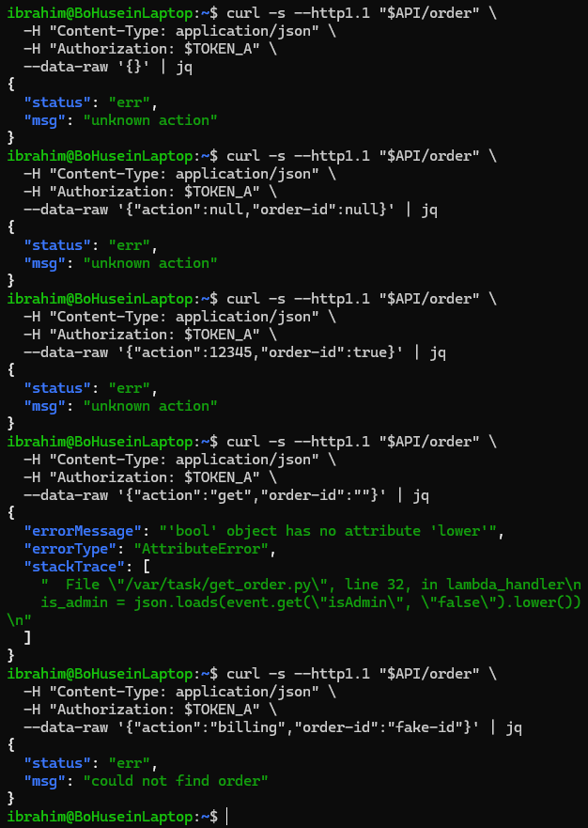
Screenshot 1 — Terminal showing all 5 malformed request responses. Test 4 returns the critical AttributeError stack trace with internal file path /var/task/get_order.py and line number 32

Step 2 — Trigger KeyError in Billing Function
Sending a billing request with missing cart data triggers a KeyError in the billing Lambda:

curl -s --http1.1 "$API/order" \
-H "Content-Type: application/json" \
-H "Authorization: $TOKEN_A" \
--data-raw '{"action":"billing","order-id":"VALID_ORDER_ID","data":{"ccn":"4242424242424242","exp":"12/28","cvv":"123"}}' | jq

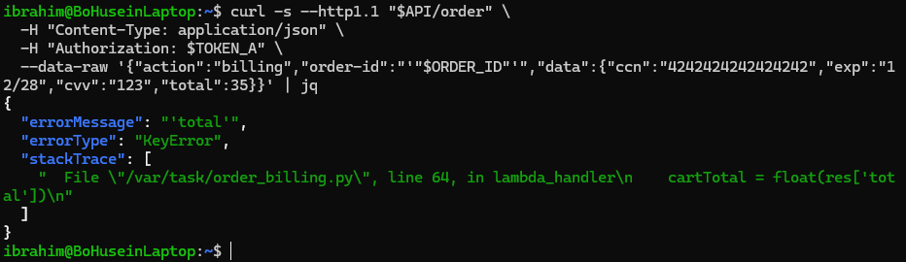
Screenshot 2 — Terminal showing KeyError: total stack trace from DVSA-ORDER-BILLING revealing internal file path /var/task/order_billing.py and line 64 where the billing logic crashes

Step 3 — Check CloudWatch Logs
CloudWatch logs confirm the exceptions are being generated internally and provide additional detail:

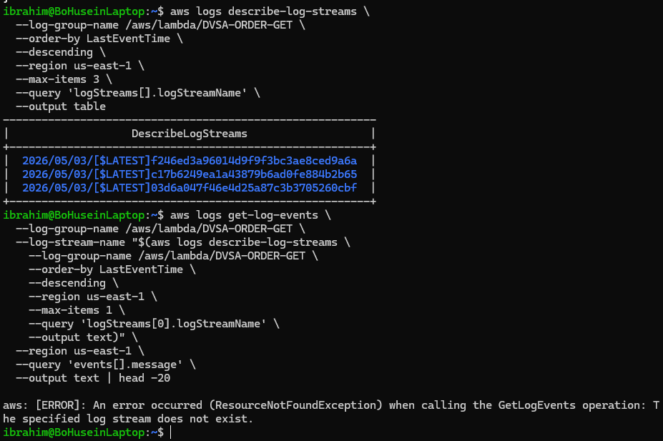
Screenshot 3 — CloudWatch log streams showing the Lambda function invocations that generated the error responses, confirming the exceptions are real backend crashes

Step 4 — Identify the Vulnerable Code
The root cause is found in get_order.py at line 32 where .lower() is called on a value that may be a boolean:

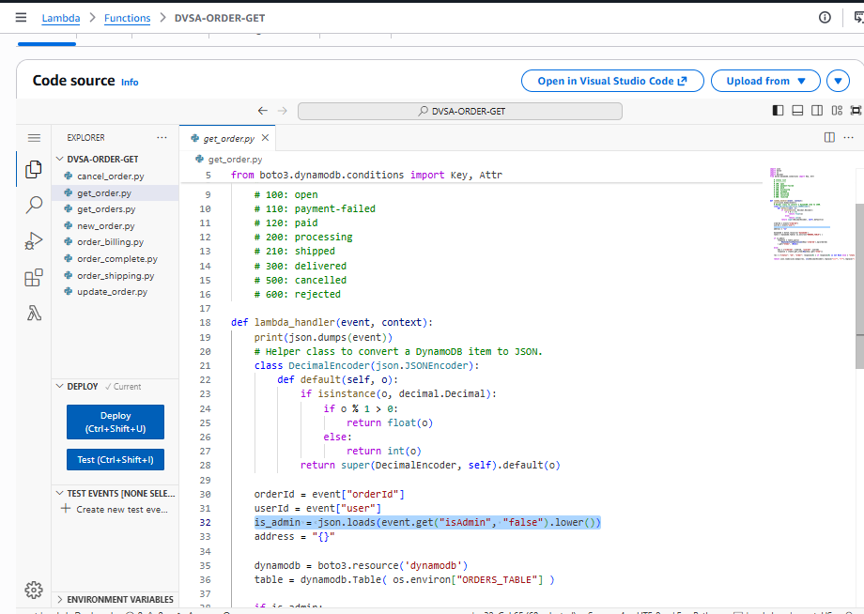
Screenshot 4 — Lambda code editor showing get_order.py with the vulnerable line: is_admin = json.loads(event.get(isAdmin, false).lower()) and no try/catch wrapper around the handler

Part 5) Evidence and Proof
The vulnerability is confirmed by the following evidence:

- Screenshot 1 proves the exploit: sending a get request with an empty order-id returns a full stack trace to the client including errorMessage, errorType, and stackTrace fields
- Screenshot 2 proves additional exposure: the billing function leaks a KeyError with internal file path and line number
- Screenshot 3 proves the backend impact: CloudWatch confirms these are real Lambda crashes not simulated responses
- Screenshot 4 proves the root cause: the Lambda code has no try/catch and uses unsafe .lower() on potentially non-string input

The following sensitive information was leaked to the client:

Leaked Information | Example Value | Security Risk
Internal file path | /var/task/get_order.py | Reveals code structure and deployment layout
Line number | line 32 | Helps attacker target specific vulnerable code
Variable name | is_admin | Reveals internal authorization logic
Code snippet | json.loads(event.get(isAdmin, false).lower()) | Exposes business logic and input handling
Error type | AttributeError, KeyError | Reveals implementation language and patterns
Internal file path 2 | /var/task/order_billing.py | Reveals billing module structure
Line number 2 | line 64 | Targets billing vulnerability location

Part 6) Fix Strategy / Probable Mitigation
The fix requires two complementary changes to the Lambda functions:

- Add a global try/catch block around all Lambda handler logic to catch any unhandled exception before it reaches the client
- Fix the unsafe isAdmin parsing — replace json.loads(event.get(isAdmin, false).lower()) with bool(event.get(isAdmin, False)) which handles both string and boolean input safely
- Use event.get() with default values instead of direct key access (event[key]) to prevent KeyError crashes
- Log full exception details including stack traces internally to CloudWatch for debugging
- Return only a generic error message to the client — no stack traces, no file paths, no variable names

Part 7) Code / Config Changes

Vulnerable Code — Before Fix
The original get_order.py had no error handling and used unsafe input access:

# VULNERABLE — crashes on boolean isAdmin, no try/catch
def lambda_handler(event, context):
orderId = event["orderId"] # KeyError if missing
userId = event["user"] # KeyError if missing
is_admin = json.loads(event.get("isAdmin", "false").lower()) # crashes on bool
# No try/catch — any exception returns full stack trace to client

Fixed Code — After Fix
The fixed code adds try/catch, fixes isAdmin parsing, and uses safe .get() access:

# FIXED — safe input handling and generic error response
def lambda_handler(event, context):
try:
orderId = event.get("orderId", "") # safe — no KeyError
userId = event.get("user", "") # safe — no KeyError
is_admin = bool(event.get("isAdmin", False)) # safe — handles bool and string
# ... rest of handler logic ...

except Exception as e:
# Log full details internally only
print(f"Internal error: {str(e)}")
print(traceback.format_exc())

# Return only generic message to client
return {"status": "err", "msg": "an error occurred"}

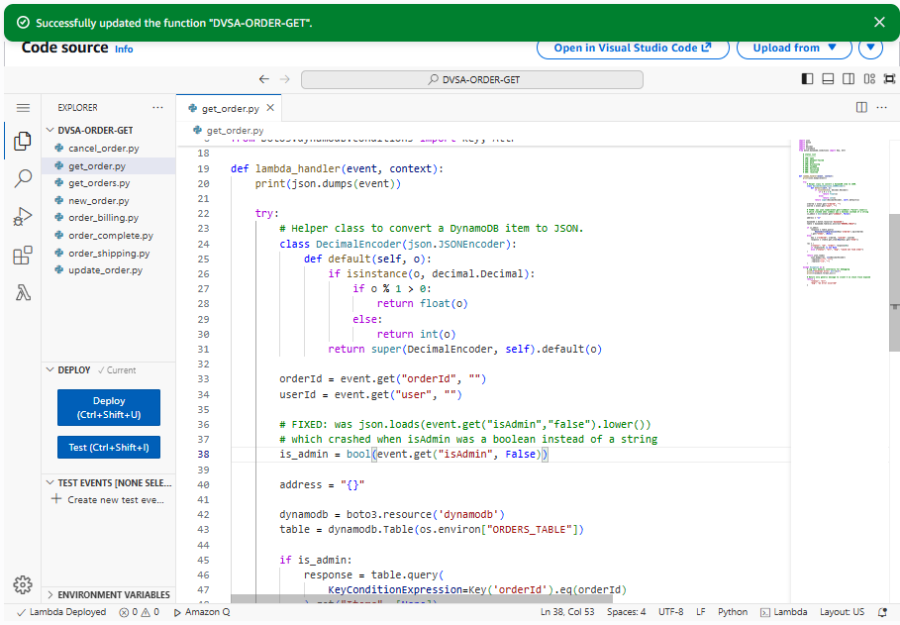
Screenshot 5 — Lambda code editor showing the fixed get_order.py with try/catch wrapper, safe event.get() access, and corrected isAdmin boolean handling after clicking Deploy

Part 8) Verification After Fix
After deploying the fix, the same malformed request is sent again:

# Same request that previously returned full stack trace
curl -s --http1.1 "$API/order" \
-H "Content-Type: application/json" \
-H "Authorization: $TOKEN_A" \
--data-raw '{"action":"get","order-id":""}' | jq

# Expected response after fix:
# {"status": "err", "msg": "an error occurred"}

# Before fix returned:
# {"errorMessage": "bool object has no attribute lower",
# "errorType": "AttributeError",
# "stackTrace": ["File /var/task/get_order.py, line 32..."]}

CloudWatch confirms that the full error details are still logged internally for debugging purposes, but are no longer returned to the client:

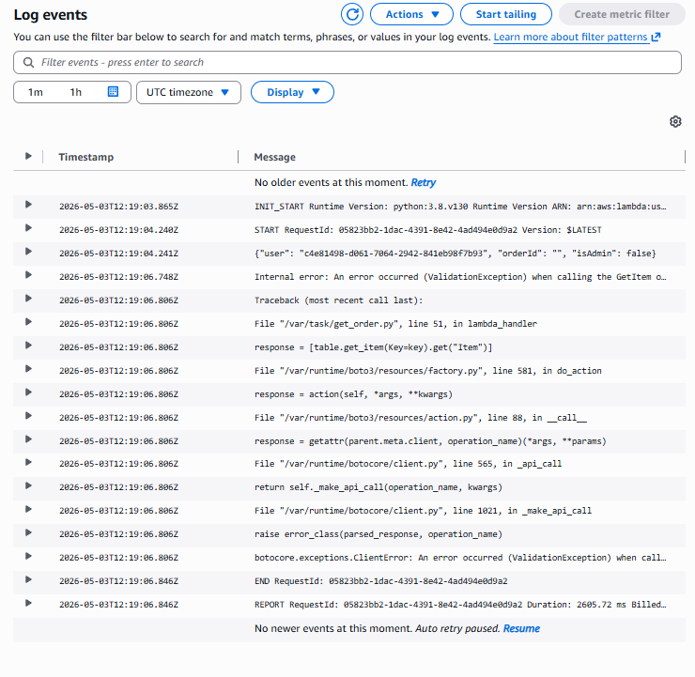
Screenshot 6 — CloudWatch logs showing the full exception details are still recorded internally after the fix, confirming that debugging capability is preserved while client-facing exposure is eliminated

Verification confirms:
- Before fix: client received full stack trace with internal file paths and code snippets
- After fix: client receives only generic error message with no internal details
- CloudWatch still receives full error details for internal debugging and monitoring
- Legitimate requests that provide valid input still work correctly

Part 9) Structured Operation and Security Analysis

Table A — Intended Logic vs. Observed Behavior

Vulnerability | Intended Rule(s) | Artifacts Used to Infer Rule | Normal Behavior Evidence | Exploit Behavior Evidence
Unhandled Exceptions | Backend errors must never expose internal implementation details to the client. All exceptions must be caught centrally and only a generic safe error message must be returned. Full error details must be logged only in internal monitoring systems such as CloudWatch. | Lambda source code get_order.py and order_billing.py; API responses from malformed requests; CloudWatch log groups; AWS Lambda best practices for error handling | Valid requests with correct parameters return expected responses. Normal order queries return order data. Normal billing requests process payments. No internal details are exposed during normal operation. | Sending a get request with an empty order-id returns a full stack trace including errorMessage: bool object has no attribute lower, errorType: AttributeError, and stackTrace with internal file path /var/task/get_order.py and line 32.

Table B — Deviation Analysis and Fix

Vulnerability | Why This Is a Deviation | Deviation Class | Fix Applied (Where) | Post-Fix Verification | Logging
Unhandled Exceptions | The Lambda handlers return raw Python exception objects to the client when input is malformed. This violates the security principle that internal system details must never be exposed to external users. The leaked information includes file paths, line numbers, variable names, and code snippets that could assist an attacker in targeting specific vulnerabilities. | Intentional misuse / security-relevant abuse | Added try/catch wrapper in DVSA-ORDER-GET (get_order.py). Fixed unsafe isAdmin parsing from .lower() on potential bool to bool(event.get()). Changed direct key access to safe event.get() with defaults. Deployed via Lambda console. | After fix, the same malformed request returns only {status: err, msg: an error occurred} with no stack trace, file path, or internal details. CloudWatch confirms full error details are still logged internally. | CloudWatch log group /aws/lambda/DVSA-ORDER-GET continues to record full exception details post-fix, confirming that internal debugging capability is preserved while client exposure is eliminated.

Part 10) Takeaway / Lessons Learned
This vulnerability illustrates a common but serious mistake in serverless application development: allowing raw exceptions to propagate back to the client. In traditional server-based applications, web frameworks often catch unhandled exceptions and return a generic 500 error page. In Lambda functions, there is no such default safety net — every unhandled exception is serialized and returned as-is to the caller.

The information leaked by unhandled exceptions is particularly dangerous because it removes the attacker's need to guess about the application's internal structure. Knowing the exact file path, line number, variable names, and code snippets allows an attacker to craft much more precise and targeted attacks against the application.

The key secure design principles illustrated by this lesson are:
- Always wrap Lambda handler logic in a try/catch block to prevent raw exceptions from reaching the client
- Return only generic, client-safe error messages such as an error occurred or bad request
- Log full exception details including stack traces only to internal monitoring systems such as CloudWatch
- Use safe input access patterns such as event.get() with defaults instead of direct key access
- Validate and sanitize all input at the entry point before passing it to business logic
- Never trust that input will be the expected type — always handle type mismatches gracefully

