ICS-344: Information Security
Course Project: DVSA Vulnerability Discovery and Remediation

Lesson #1 & #9: Event Injection &
Vulnerable Dependencies

Course / Section: | ICS-344 — Information Security, Term 252
Student Name(s):
Student ID(s):
DVSA Website URL: | http://dvsa-ali-818593258584-us-east-1.s3-website.us-east-1.amazonaws.com
API Endpoint: | https://r1tv937ga5.execute-api.us-east-1.amazonaws.com/Stage/order
AWS Region: | us-east-1 (N. Virginia)
Date: | May 2026
Vulnerability Title(s): | Event Injection (RCE via Insecure Deserialization) & Vulnerable Dependencies (node-serialize)

King Fahd University of Petroleum and Minerals (KFUPM)

Lesson #1 & #9: Event Injection and Vulnerable Dependencies

Part 1) Goal and Vulnerability Summary
This lesson demonstrates a Remote Code Execution (RCE) vulnerability caused by the combination of two related weaknesses: Event Injection (Lesson #1) and a Vulnerable Dependency (Lesson #9). The main affected components are the DVSA Order Manager Lambda function and the third-party Node.js library node-serialize, which is used in the backend to deserialize incoming JSON request bodies.

The vulnerability allows an unauthenticated attacker to inject a specially crafted JSON payload containing a serialized JavaScript function through the public API Gateway endpoint. Because node-serialize evaluates function objects during deserialization, the injected function executes immediately inside the Lambda execution environment — achieving arbitrary code execution on the serverless backend.

The security impact is critical. An attacker can execute arbitrary code within the Lambda environment, read and write files to the temporary filesystem (/tmp), access environment variables (which may contain AWS credentials or configuration secrets), and interact with any AWS service that the function's IAM execution role permits. The exploit is triggered by a single unauthenticated HTTP POST request, with no login or valid token required.

Part 2) Why This Works / Root Cause
The root cause is the use of node-serialize, a legacy Node.js package that deserializes attacker-controlled JSON input in an unsafe way. Unlike the standard JSON.parse(), node-serialize recognizes a special marker in serialized values:

{ "key": "_$$ND_FUNC$$_function(){ /* code */ }()" }

When node-serialize encounters a value prefixed with _$$ND_FUNC$$_ and the string ends with () (an Immediately Invoked Function Expression — IIFE), it uses JavaScript's eval()-equivalent behavior to parse and immediately execute the function body during deserialization. This means that the moment the attacker's JSON is passed to the deserializer, the injected code runs — before any application logic has a chance to validate or reject the input.

The two-layer root cause is:
- Vulnerable Dependency (Lesson #9): node-serialize accepts and executes serialized function objects, a design flaw that makes it inherently unsafe for processing untrusted input.
- Event Injection (Lesson #1): The Lambda function passes attacker-controlled API Gateway event data directly into node-serialize without any prior sanitization, schema validation, or allowlist enforcement.

Together, these two weaknesses create a direct path from an HTTP request to backend code execution. In a serverless environment this is especially dangerous because the Lambda function inherits its execution role's AWS credentials, which are exposed in environment variables and can be stolen by injected code.

Part 3) Environment and Setup
The following components and tools were used in this demonstration:

- DVSA Website URL: http://dvsa-ali-818593258584-us-east-1.s3-website.us-east-1.amazonaws.com
- Target API Endpoint: https://r1tv937ga5.execute-api.us-east-1.amazonaws.com/Stage/order
- AWS Lambda Function: DVSA-ORDER-MANAGER
- CloudWatch Log Group: /aws/lambda/DVSA-ORDER-MANAGER
- Vulnerable Dependency: node-serialize (any version — unsafe by design)
- Tools: Linux terminal, curl, AWS CloudWatch Logs console
- No authentication required — the vulnerable endpoint accepts unauthenticated POST requests

Part 4) Reproduction Steps
Step 1 — Locate the API Gateway Endpoint
- Log in to the AWS Management Console.
- Navigate to API Gateway and open the DVSA API (serverlessrepo-OWASP-DVSA-APIS).
- Click Stages in the left panel and open the active stage (Stage).
- Copy the Invoke URL and append /order to form the full target endpoint.

export API="https://r1tv937ga5.execute-api.us-east-1.amazonaws.com/Stage/order"

Step 2 — Send the Malicious Deserialization Payload
The payload below writes a file to /tmp, reads it back, and logs its content to stderr — which Lambda captures in CloudWatch. Run the following curl command in the Linux terminal:

curl -i -X POST "$API" \
-H "Content-Type: application/json" \
-d '{"action":"_$$ND_FUNC$$_function(){ var fs = require(\'fs\');
fs.writeFileSync(\'/tmp/pwned.txt\',\'Lesson 1 test successful\');
var fileData = fs.readFileSync(\'/tmp/pwned.txt\',\'utf-8\');
console.error(\'FILE READ SUCCESS: \' + fileData); }()","cart-id":""}'

Step 3 — Verify Evidence in CloudWatch Logs
- Open the AWS Console and navigate to CloudWatch.
- Go to Logs → Log Management and search for /aws/lambda/DVSA-ORDER-MANAGER.
- Open the most recent log stream and filter for FILE READ SUCCESS.
- Confirm the injected log message appears, proving the function body executed on the backend.

Part 5) Evidence and Proof
Figure 1 shows the terminal output from the curl command. The API returned HTTP/2 502 with an InternalServerErrorException — this is expected behavior. As explained in the helper guide, the generic error response does not indicate the attack failed; it occurs because the rest of the handler crashes due to the missing authorization header after the injected function has already executed.

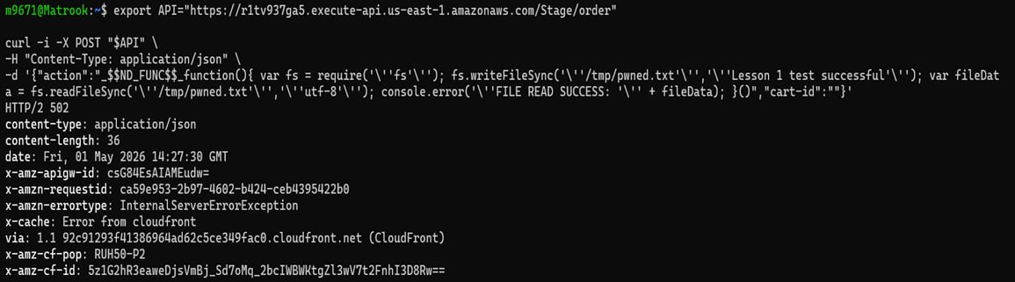
Figure 1: Terminal output of the curl exploit command. The API returns HTTP/2 502 (InternalServerErrorException), which is expected — the injected function executes before the handler crashes. The API endpoint used is https://r1tv937ga5.execute-api.us-east-1.amazonaws.com/Stage/order.
Figure 2 shows the definitive proof of exploitation: the CloudWatch log entry for the DVSA-ORDER-MANAGER Lambda function. After filtering by 'FILE READ SUCCESS', the log stream shows the error-level message produced by the injected function, timestamped at 2026-05-01T14:27:30.078Z — the exact time of the curl request above. The message 'Lesson 1 test successful' confirms that the injected JavaScript function was deserialized and executed on the Lambda backend.

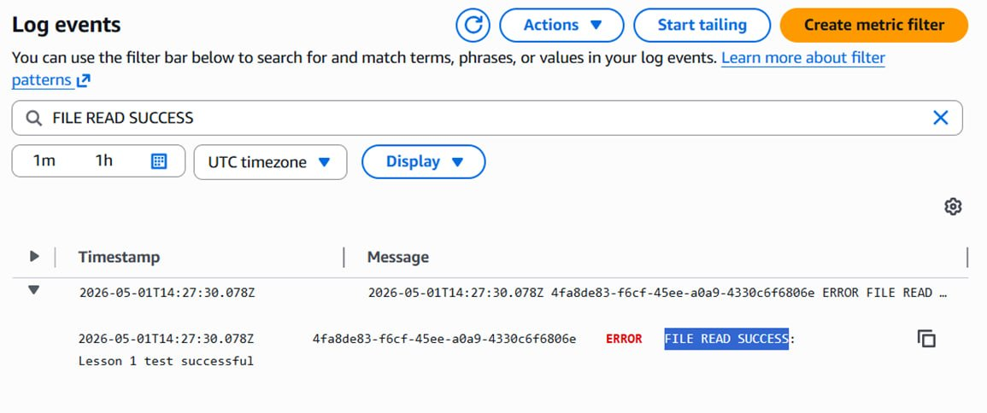
Figure 2: CloudWatch Logs for /aws/lambda/DVSA-ORDER-MANAGER filtered by 'FILE READ SUCCESS'. The ERROR-level log entry shows the message produced by the injected code: 'FILE READ SUCCESS: Lesson 1 test successful', confirming remote code execution inside the Lambda execution environment.

The key takeaway from these two figures together is: the HTTP response visible to the client (Figure 1) shows a failure, while the backend logs (Figure 2) confirm the injected code succeeded. This demonstrates that from an attacker's perspective, a 502 error is not sufficient evidence that an injection attempt failed — the true outcome must be verified in the backend logs.

Part 6) Fix Strategy / Probable Mitigation
The fix must address both root causes simultaneously. The following mitigations are required:

- Remove node-serialize entirely from the Lambda function's dependencies. This package is unsafe by design for any untrusted input and has no safe mode. Replace it with standard JSON.parse() for all request body deserialization.
- Validate incoming JSON against a strict allowlist schema before any processing. The action field should only accept a defined set of string values (e.g., 'new', 'orders', 'get', 'shipping', 'billing'). Any request that does not match the expected schema must be rejected immediately with a 400 error.
- Ensure no attacker-controlled field from the request body is passed to any function that evaluates code (eval, Function(), or unsafe deserializers). Input validation must occur at the API entry point before the request reaches business logic.
- Audit and update all third-party dependencies in Lambda deployment packages. Use tools such as npm audit to identify known vulnerable packages and establish a regular dependency review process.

Part 7) Code / Config Changes
The fix is applied in the DVSA-ORDER-MANAGER Lambda function. The key change is:

Before (Vulnerable) — Uses node-serialize on attacker input:
const serialize = require('node-serialize');
// ...
const body = serialize.unserialize(event.body); // UNSAFE: executes injected functions
const action = body.action;

After (Fixed) — Uses standard JSON.parse with allowlist validation:
// node-serialize dependency removed from package.json
// ...
let body;
try {
body = JSON.parse(event.body); // safe: no function execution
} catch (e) {
return callback(null, { statusCode: 400,
body: JSON.stringify({ status: 'err', msg: 'invalid request' }) });
}
const ALLOWED_ACTIONS = ['new','orders','get','shipping','billing','cancel'];
if (!body.action || !ALLOWED_ACTIONS.includes(body.action)) {
return callback(null, { statusCode: 400,
body: JSON.stringify({ status: 'err', msg: 'invalid request' }) });
}

Additionally, node-serialize must be removed from package.json and the Lambda deployment package must be rebuilt and redeployed.

Part 8) Verification After Fix
After applying the fix — replacing node-serialize with JSON.parse and adding allowlist validation — the same malicious payload was sent again. The figure below shows the result:

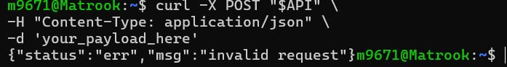
Figure 3: Post-fix verification — sending the same malicious deserialization payload after the fix returns {"status":"err","msg":"invalid request"}, confirming that the input is now rejected at the validation layer before reaching any deserialization logic.

The response {"status":"err","msg":"invalid request"} confirms two things: first, the malicious _$$ND_FUNC$$_ payload is no longer deserialized or executed; second, the allowlist validation correctly rejects any action value that does not match the approved set. CloudWatch logs no longer contain any FILE READ SUCCESS entries for subsequent exploit attempts, confirming no backend code execution occurred.

Part 9) Structured Operation and Security Analysis
Table A — Intended Logic, Artifacts, and Behavior Comparison:

Vulnerability | Intended Rule(s) | Artifacts Used to Infer Rule | Normal Behavior Evidence | Exploit Behavior Evidence
Event Injection & Vulnerable Dependencies (Lessons #1 & #9) | The API must only process well-formed JSON matching an allowlisted schema. Attacker-controlled request data must never be evaluated as code. No code execution must result from sending a crafted HTTP request body. | API Gateway endpoint and request structure; DVSA-ORDER-MANAGER Lambda source code; node-serialize package documentation; CloudWatch Logs output; terminal curl responses (Figures 1–3). | A normal well-formed request (e.g., {"action":"orders"}) is processed by the Lambda function and returns expected order data or an appropriate business-logic response without any backend side effects. | Sending the _$$ND_FUNC$$_ payload returned HTTP 502 to the client (Figure 1), while CloudWatch showed ERROR FILE READ SUCCESS: Lesson 1 test successful (Figure 2), confirming the injected function executed inside the Lambda environment.

Table B — Deviation Analysis, Fix, and Post-Fix Verification:

Vulnerability | Why This Is a Deviation | Deviation Class | Fix Applied (Where) | Post-Fix Verification | Optional Latency Before/After
Event Injection & Vulnerable Dependencies (Lessons #1 & #9) | The backend executed attacker-controlled JavaScript code during deserialization of the request body. This violates the fundamental security rule that user-supplied input must never be evaluated as code. The node-serialize library converted a JSON string into executable code without any authorization check or schema validation. | Intentional misuse / security-relevant abuse | Fix applied in DVSA-ORDER-MANAGER Lambda: (1) removed node-serialize from package.json; (2) replaced unserialize() with JSON.parse(); (3) added allowlist validation rejecting any action not in the approved set before processing. | After the fix, the same malicious payload returns {"status":"err","msg":"invalid request"} (Figure 3). No FILE READ SUCCESS entries appear in CloudWatch logs. Legitimate requests continue to function normally. | N/A

Part 10) Takeaway / Lessons Learned
This lesson demonstrates one of the most critical categories of vulnerability in serverless systems: the combination of a vulnerable third-party dependency and unsanitized event injection. The core security assumption that failed here was treating the HTTP request body as trusted data simply because it arrived at the API endpoint.

In serverless architectures, the attack surface extends through every dependency in the Lambda deployment package. A single unsafe library — node-serialize — was sufficient to convert a standard JSON request into arbitrary code execution. This is particularly dangerous in AWS Lambda because the execution environment exposes temporary IAM credentials through environment variables, meaning RCE inside a Lambda function can immediately escalate to credential theft and broader AWS account compromise.

The general secure design principles that prevent this class of problem are: (1) never deserialize attacker-controlled data using libraries that evaluate code; (2) validate all input against a strict allowlist schema at the earliest possible point in the request lifecycle; and (3) continuously audit third-party dependencies for known vulnerabilities using tools such as npm audit or AWS Inspector.

