ICS-344: Information Security
Course Project: DVSA Vulnerability Discovery and Remediation

Lesson #3: Sensitive Data Exposure

Field | Details
Course / Section | ICS-344 — Information Security
Institution | King Fahd University of Petroleum and Minerals (KFUPM)
Term | 252
DVSA Website URL | http://dvsa-ibrahim-2026-290304998824-us-east-1.s3-website.us-east-1.amazonaws.com
AWS Region | us-east-1 (N. Virginia)
Date | May 3, 2026
Vulnerability | Sensitive Data Exposure — Internal Token Leaked in API Response

Part 1) Goal and Vulnerability Summary
This lesson demonstrates a Sensitive Data Exposure vulnerability in the DVSA Orders API. The backend returns an internal order token field that is not required for normal user functionality and should never be exposed to the client.

- Vulnerability Type: Sensitive Data Exposure / Information Disclosure
- Affected Component: API Gateway → Lambda (DVSA-USER-ORDERS)
- Security Impact: Internal order tokens are exposed to any authenticated user, potentially enabling unauthorized access to receipts
- Main Weakness: The API response includes the confirmationToken field without any filtering or access restriction

The application returns a token field in every order response. This token is an internal identifier linked to receipt functionality and should be treated as sensitive data. Instead, it is freely returned to any authenticated user who queries their orders.

Part 2) Why This Works / Root Cause
The vulnerability exists because the Lambda function that handles order queries does not filter its response before returning data to the client. Specifically:

- The Orders API response includes a confirmationToken field for each order
- This token is an internal identifier used in receipt-related workflows
- No server-side filtering removes internal fields before the response is sent to the client
- No authorization check verifies whether the requesting user should have access to this token

This violates the principle of least exposure, which states that an API should return only the minimum data required for the client to function correctly. By returning the internal token, the backend unnecessarily expands the attack surface.

Part 3) Environment and Setup
Item | Details
DVSA Website | http://dvsa-ibrahim-2026-290304998824-us-east-1.s3-website.us-east-1.amazonaws.com
API Endpoint | https://g094q0pn3g.execute-api.us-east-1.amazonaws.com/Stage/order
AWS Region | us-east-1 (N. Virginia)
AWS Account ID | 290304998824
Lambda Function | DVSA-USER-ORDERS
Tools Used | Browser DevTools (Network tab), curl (WSL Ubuntu), jq
User Context | Normal authenticated user (non-admin)

Part 4) Reproduction Steps

Step 1 — Login and Place an Order
- Open the DVSA website in the browser
- Register and log in as a normal user
- Add an item to the cart and place an order
- Note the order confirmation ID from the confirmation page

Step 2 — Capture Authorization Token from DevTools
- Press F12 to open Developer Tools
- Navigate to the Network tab and select Fetch/XHR filter
- Click Orders in the DVSA navigation menu
- Click on one of the order requests in the Network panel
- Under the Headers tab, locate the Authorization header and note the Request URL

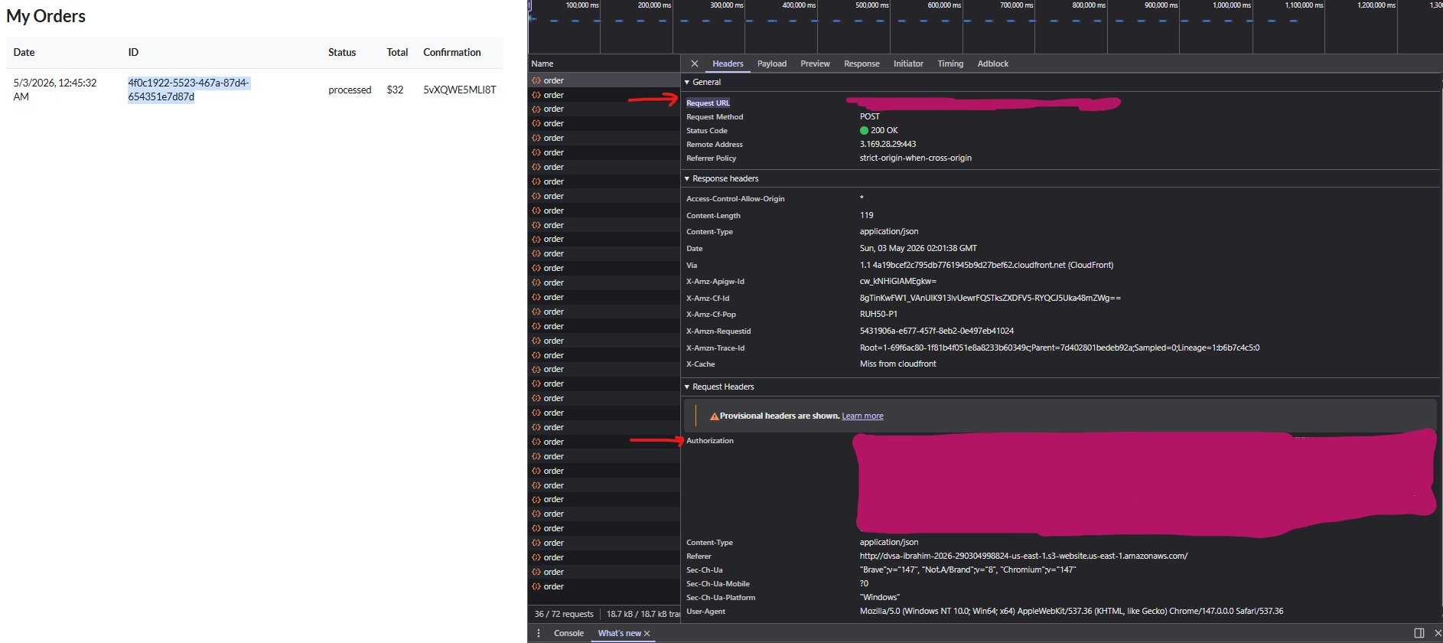
Screenshot 1 — Browser DevTools showing the authenticated order request with Authorization header and Request URL visible

Step 3 — Call the Orders API from Terminal
export API="https://g094q0pn3g.execute-api.us-east-1.amazonaws.com/Stage"
export TOKEN_A="eyJraWQiOi...(JWT token from DevTools)"

curl -s "$API/order" \
-H "content-type: application/json" \
-H "authorization: $TOKEN_A" \
--data-raw '{"action":"orders"}' | jq

Step 4 — Observe the Exposed Token in Response
The response reveals the internal token field alongside normal order data:

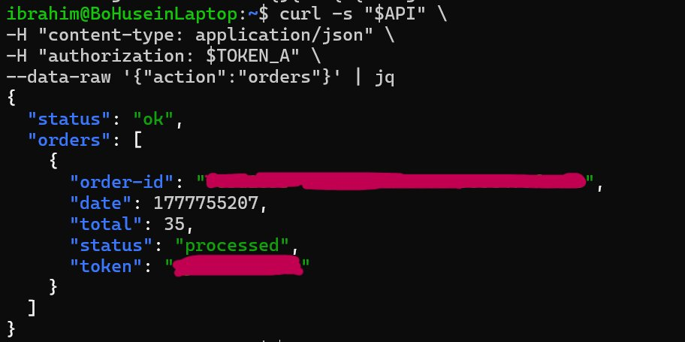
Screenshot 2 — Terminal showing the API response before fix, with the sensitive token field clearly visible in the orders response

Part 5) Evidence and Proof
The vulnerability is confirmed by the presence of the token field in the API response shown in Screenshot 2 above. When a normal authenticated user calls the Orders API, the backend returns:

{
"status": "ok",
"orders": [
{
"order-id": "[redacted]",
"date": 1777755207,
"total": 35,
"status": "processed",
"token": "[redacted]" <-- SENSITIVE DATA EXPOSED
}
]
}

The token field is an internal identifier linked to receipt functionality. This field:
- Is not required for normal order display in the frontend
- Is exposed to any authenticated user without restriction
- Is linked to receipt-related backend operations
- Violates the principle of least exposure

Part 6) Fix Strategy / Probable Mitigation
- Remove the token field from the Orders API response before sending to the client
- Apply response filtering in the Lambda function to strip internal fields
- Only expose fields required by the frontend: order-id, date, total, and status
- If receipt access is needed, use a separate authenticated endpoint that verifies ownership
- Ensure all internal identifiers are never included in public API responses

The fix must be applied at the backend Lambda response layer, not at the client side, as client-side filtering cannot be trusted for security.

Part 7) Code / Config Changes

Vulnerable Code — Before Fix
The Lambda function returned the full order object including the internal token field:

item = {
"order-id": i["orderId"],
"date": i["paymentTS"],
"total": i["totalAmount"],
"status": human_status[status],
"token": i["confirmationToken"] # <-- VULNERABLE: exposes internal token
}

Fixed Code — After Fix
The token field is removed from the response construction in both loops:

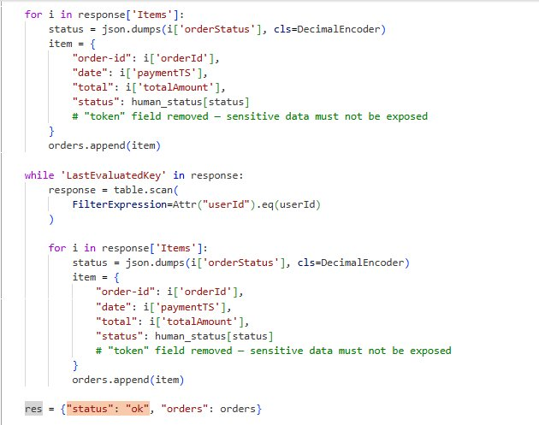
Screenshot 3 — Fixed Lambda code showing the token field removed from the response in both order processing loops, with comment explaining the security rationale

The key change applied in file DVSA-USER-ORDERS (Python):
- Removed: "token": i["confirmationToken"] from the first for loop
- Removed: "token": i["confirmationToken"] from the while loop
- Added comment: # token field removed — sensitive data must not be exposed

Part 8) Verification After Fix

Before Fix — Token Visible in Response

Screenshot 4 — Terminal output before fix showing the token field present in the API response (TOKEN_A used)

After Fix — Token Removed from Response
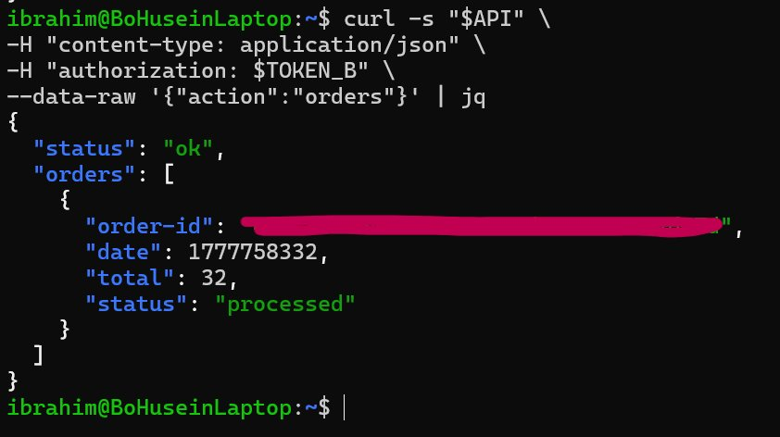
Screenshot 5 — Terminal output after fix showing the token field is no longer present in the API response (TOKEN_B used to verify)
Verification confirms:
- The token field is no longer visible in the API response after the fix
- Sensitive internal data is protected from client exposure
- Normal order display functionality still works correctly — order-id, date, total, and status are all returned
- The fix does not break any legitimate user workflow

Part 9) Structured Operation and Security Analysis

Table A — Intended Logic vs. Observed Behavior

Vulnerability | Intended Rule(s) | Artifacts Used to Infer Rule | Normal Behavior Evidence | Exploit Behavior Evidence
Sensitive Data Exposure | The Orders API must return only the minimum data required for display. Internal tokens and backend identifiers must never be exposed to the client. | DVSA order workflow; DevTools network capture; JWT Authorization header; curl terminal output; Lambda source code (DVSA-USER-ORDERS) | User logs in and views orders. The frontend displays order-id, date, total, and status. No internal token is needed or shown in the UI. | When the Orders API is called with action 'orders', the JSON response includes a token field (confirmationToken) that is transmitted to the client in plaintext, as shown in Screenshot 2.

Table B — Deviation Analysis and Fix

Vulnerability | Why This Is a Deviation | Deviation Class | Fix Applied (Where) | Post-Fix Verification | Logging
Sensitive Data Exposure | The backend returns the confirmationToken field in every order response. This token is not required by the client and violates the principle of least exposure, unnecessarily expanding the attack surface. | Intentional misuse / security-relevant abuse | Removed token field from response in DVSA-USER-ORDERS Lambda function (both for loop and while loop). Deployed fix via AWS Lambda console. | After fix, the token field no longer appears in the API response. Order display still works normally. Confirmed with curl using both TOKEN_A and TOKEN_B. | CloudWatch logs confirm normal Lambda execution post-fix with no errors.

Part 10) Takeaway / Lessons Learned
This vulnerability highlights a fundamental principle of secure API design: an application should never return more data than the client strictly needs. Even when data is not immediately exploitable on its own, exposing internal identifiers and tokens increases the attack surface and can serve as a stepping stone for more serious attacks.

In a serverless architecture, this problem is especially common because Lambda functions often directly serialize and return full database objects without applying any response filtering. Developers may add fields to the database schema for internal use and forget that those fields are also being returned by existing query functions.

The key secure design principles illustrated by this lesson are:
- Apply the principle of least exposure in every API response
- Never return internal tokens, identifiers, or backend-specific fields to the client
- Use explicit response schemas that define exactly which fields are returned
- Treat any data not required by the frontend as sensitive and exclude it by default
- Regularly audit API responses to ensure no unintended data is being disclosed

