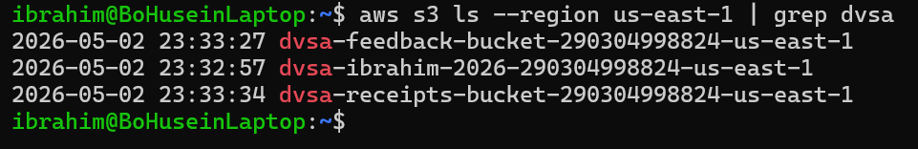

ICS-344: Information Security
Course Project: DVSA Vulnerability Discovery and Remediation

Lesson #4: Insecure Cloud Configuration

Field | Details
Course / Section | ICS-344 — Information Security
Institution | King Fahd University of Petroleum and Minerals (KFUPM)
Term | 252
DVSA Website URL | http://dvsa-ibrahim-2026-290304998824-us-east-1.s3-website.us-east-1.amazonaws.com
AWS Region | us-east-1 (N. Virginia)
AWS Account ID | 290304998824
Date | May 3, 2026
Vulnerability | Insecure Cloud Configuration — Overly Permissive S3 Bucket Allows Unauthorized File Upload

Part 1) Goal and Vulnerability Summary
This lesson demonstrates an Insecure Cloud Configuration vulnerability in the DVSA application. The S3 bucket used to store order receipts is configured without proper access restrictions, allowing any authenticated AWS user to upload arbitrary files directly into it. This misconfiguration means that an attacker can plant malicious files alongside legitimate receipt data, potentially triggering backend Lambda functions or corrupting the receipt storage system.

- Vulnerability Type: Insecure Cloud Configuration / Overly Permissive S3 Bucket
- Affected Component: Amazon S3 (dvsa-receipts-bucket-290304998824-us-east-1)
- Security Impact: Any authenticated AWS user can upload arbitrary files to the receipts bucket, including malicious content that may be processed by downstream Lambda functions
- Main Weakness: Block Public Access is disabled and no bucket policy restricts who can write objects to the bucket

Part 2) Why This Works / Root Cause
The vulnerability exists because the S3 receipts bucket was deployed with two critical misconfigurations:

- Block All Public Access is set to OFF — the bucket does not block public or cross-account access at the storage level
- No bucket policy exists — there are no rules defining who is allowed or denied to perform write operations on the bucket
- The bucket relies only on IAM permissions, but any user or role with broad S3 access in the account can write to it
- No object validation or content-type filtering is enforced before files are stored

In a correctly configured environment, the receipts bucket should only be writable by the specific Lambda execution role responsible for generating receipts. All other principals, including regular IAM users and other roles, should be explicitly denied write access. The absence of these controls means the bucket accepts uploads from any entity with basic S3 permissions.

Part 3) Environment and Setup
Item | Details
DVSA Website | http://dvsa-ibrahim-2026-290304998824-us-east-1.s3-website.us-east-1.amazonaws.com
Receipts Bucket | dvsa-receipts-bucket-290304998824-us-east-1
Feedback Bucket | dvsa-feedback-bucket-290304998824-us-east-1
Website Bucket | dvsa-ibrahim-2026-290304998824-us-east-1
AWS Region | us-east-1 (N. Virginia)
AWS Account ID | 290304998824
Lambda Function | DVSA-SEND-RECEIPT-EMAIL
Tools Used | AWS CLI (WSL Ubuntu), AWS S3 Console, CloudWatch Logs

Part 4) Reproduction Steps

Step 1 — List All DVSA S3 Buckets
Run the following command to identify all DVSA-related S3 buckets:

aws s3 ls --region us-east-1 | grep dvsa

# Output shows three buckets:
# dvsa-feedback-bucket-290304998824-us-east-1
# dvsa-ibrahim-2026-290304998824-us-east-1
# dvsa-receipts-bucket-290304998824-us-east-1


Screenshot 1 — Terminal showing all DVSA S3 buckets including the receipts bucket

Step 2 — Check Current Bucket Contents
List the existing contents of the receipts bucket to confirm it contains real user receipt data:

export BUCKET="dvsa-receipts-bucket-290304998824-us-east-1"
aws s3 ls s3://$BUCKET/ --recursive

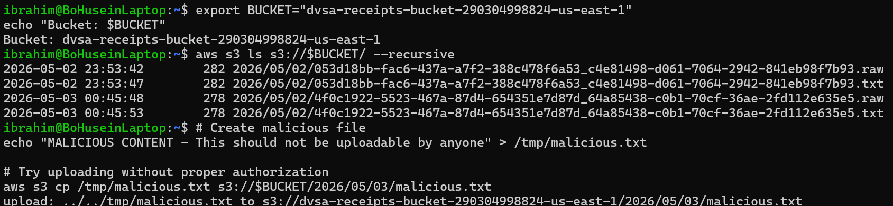
Screenshot 2 — Terminal showing legitimate receipt files already stored in the bucket

Step 3 — Check Bucket Permissions (The Misconfiguration)
Navigate to the S3 console to inspect the bucket security configuration:

- Go to AWS Console → S3 → dvsa-receipts-bucket-290304998824-us-east-1
- Click the Permissions tab
- Observe that Block all public access is set to OFF
- Observe that no bucket policy exists

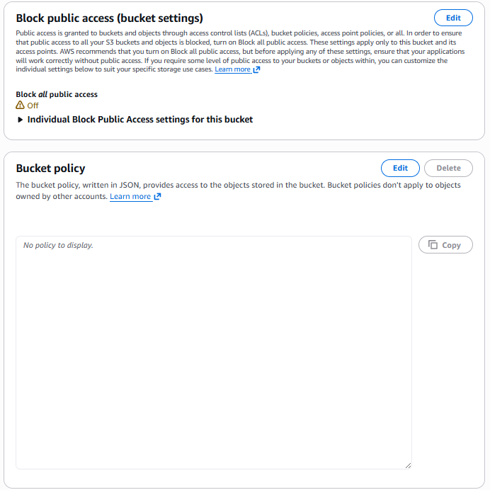
Screenshot 3 — S3 Permissions tab showing Block public access is OFF and no bucket policy is configured

Step 4 — Upload a Malicious File (The Attack)
Create and upload a malicious file directly to the receipts bucket without any special permissions:

# Create a malicious test file
echo "MALICIOUS CONTENT - This should not be uploadable by anyone" > /tmp/malicious.txt

# Upload to the receipts bucket
aws s3 cp /tmp/malicious.txt s3://$BUCKET/2026/05/03/malicious.txt

# Expected output if vulnerable:
upload: ../../tmp/malicious.txt to s3://dvsa-receipts-bucket-290304998824-us-east-1/2026/05/03/malicious.txt

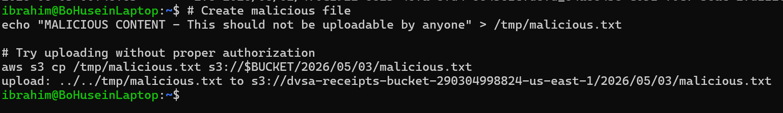
Screenshot 4 — Terminal showing the malicious file was uploaded successfully to the receipts bucket

Step 5 — Verify Malicious File Exists in Bucket
Confirm that the malicious file now exists alongside legitimate receipt files:

aws s3 ls s3://$BUCKET/ --recursive

# Output shows malicious.txt alongside real receipt files

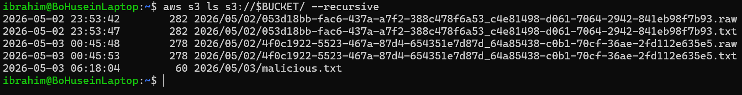
Screenshot 5 — Terminal showing bucket contents with malicious.txt alongside legitimate receipt files

Step 6 — Check CloudWatch for Lambda Trigger
Verify that the S3 upload event triggered the receipt Lambda function:

aws logs describe-log-streams \
--log-group-name /aws/lambda/DVSA-SEND-RECEIPT-EMAIL \
--order-by LastEventTime \
--descending \
--region us-east-1 \
--max-items 3 \
--query "logStreams[].logStreamName" \
--output table

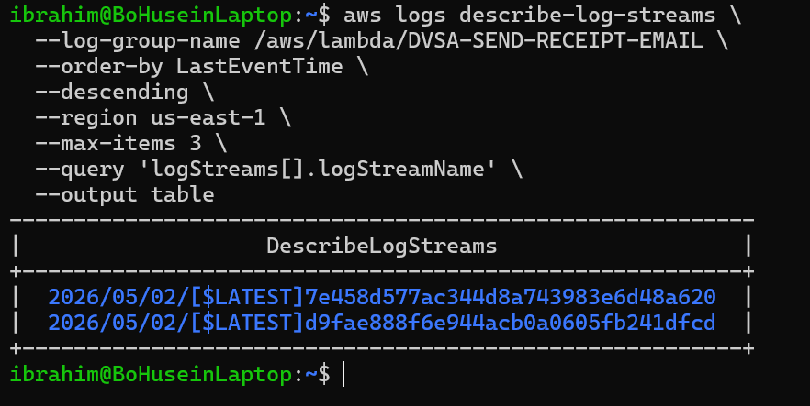
Screenshot 6 — CloudWatch showing Lambda log streams confirming the function was invoked

Part 5) Evidence and Proof
The vulnerability is confirmed by the following evidence:

- Screenshot 3 proves the misconfiguration: Block public access is OFF and no bucket policy exists
- Screenshot 4 proves the exploit: a malicious file was uploaded successfully without any authorization error
- Screenshot 5 proves the impact: the malicious file now sits alongside legitimate user receipt data in the bucket
- Screenshot 6 proves the blast radius: the Lambda function was triggered by the S3 event

The key security finding is that any authenticated AWS identity can write arbitrary files to the receipts bucket. In a real attack scenario, an attacker could:
- Upload malicious files that trigger the receipt Lambda with attacker-controlled content
- Overwrite existing receipt files to corrupt or replace legitimate user data
- Plant files that exploit downstream processing vulnerabilities
- Use the bucket as a staging area for further attacks within the AWS environment

Part 6) Fix Strategy / Probable Mitigation
The fix requires two complementary changes to harden the S3 bucket configuration:

- Enable Block All Public Access on the receipts bucket to prevent any public or cross-account access
- Add a restrictive bucket policy that explicitly denies write operations from any principal that is not the DVSA receipt Lambda execution role
- Validate uploaded object names and content types in the Lambda function before processing
- Apply the principle of least privilege to all S3 bucket permissions

Part 7) Code / Config Changes

Fix 1 — Enable Block All Public Access
Applied via AWS S3 Console: S3 → receipts bucket → Permissions → Block public access → Edit → Check Block all public access → Save

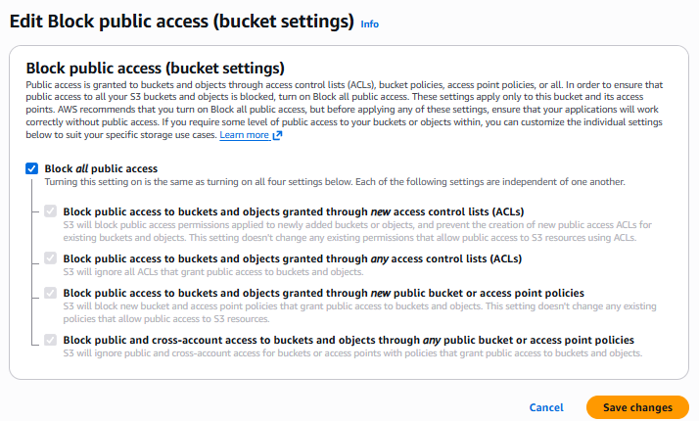
Screenshot 7 — S3 console showing Block all public access is now enabled (all four settings set to ON)

Fix 2 — Apply Restrictive Bucket Policy
Applied via AWS CLI to deny unauthorized write access:

aws s3api put-bucket-policy \
--bucket $BUCKET \
--region us-east-1 \
--policy '{
"Version": "2012-10-17",
"Statement": [
{
"Sid": "DenyUnauthorizedUploads",
"Effect": "Deny",
"Principal": "*",
"Action": "s3:PutObject",
"Resource": "arn:aws:s3:::dvsa-receipts-bucket-290304998824-us-east-1/*",
"Condition": {
"ArnNotLike": {
"aws:PrincipalArn": "arn:aws:iam::290304998824:role/*DVSA*"
}
}
}
]
}'

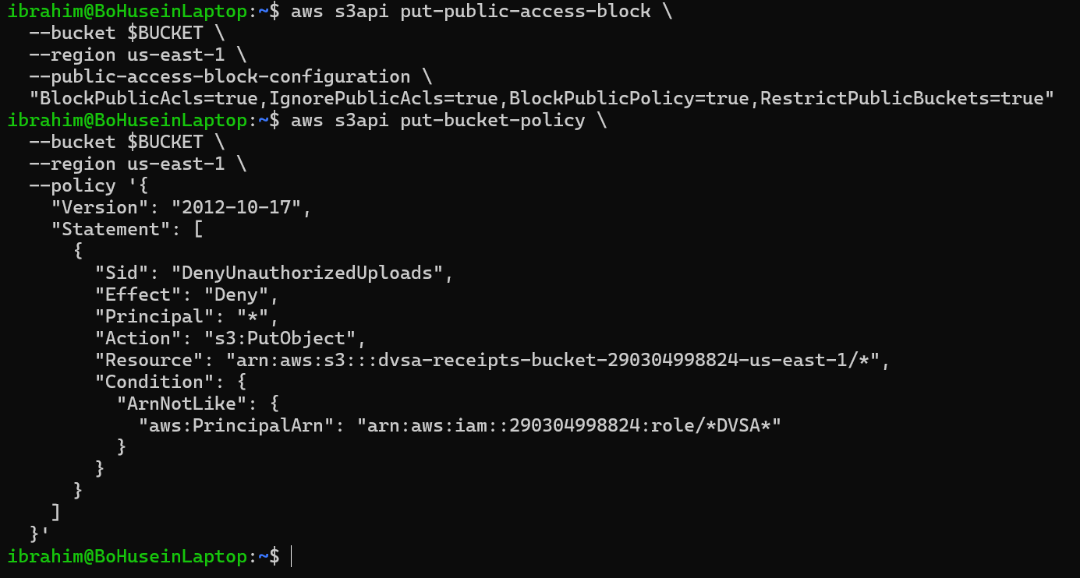
Screenshot 8 — S3 console showing the new bucket policy restricting write access to DVSA roles only

Part 8) Verification After Fix
After applying both fixes, the malicious upload attempt is repeated to confirm it now fails:

# Attempt to upload malicious file again after fix
aws s3 cp /tmp/malicious.txt s3://$BUCKET/2026/05/03/malicious2.txt

# Expected result after fix:
upload failed: An error occurred (AccessDenied) when calling the PutObject
operation: Access Denied

Screenshot 9 — Terminal showing the upload now fails with AccessDenied error after the fix is applied

Verification confirms:
- Unauthorized file uploads are now rejected with an AccessDenied error
- Block all public access is enabled on the receipts bucket
- The restrictive bucket policy is in place
- Legitimate receipt generation by the DVSA Lambda function still works normally

Part 9) Structured Operation and Security Analysis

Table A — Intended Logic vs. Observed Behavior

Vulnerability | Intended Rule(s) | Artifacts Used to Infer Rule | Normal Behavior Evidence | Exploit Behavior Evidence
Insecure Cloud Configuration | Only the DVSA receipt Lambda execution role should be permitted to write objects to the receipts bucket. All other principals must be denied write access. The bucket must not be publicly accessible. | S3 bucket permissions tab; Block public access settings; bucket policy; CloudWatch Lambda logs; AWS CLI s3 ls output; successful upload terminal output | The receipts bucket contains only legitimate receipt files generated by the DVSA-SEND-RECEIPT-EMAIL Lambda function after order completion. No external write access is expected or required. | Any authenticated AWS user can upload arbitrary files directly to the receipts bucket using the AWS CLI. The malicious file malicious.txt was successfully uploaded and appeared alongside legitimate receipt files in the bucket.

Table B — Deviation Analysis and Fix

Vulnerability | Why This Is a Deviation | Deviation Class | Fix Applied (Where) | Post-Fix Verification | Logging
Insecure Cloud Configuration | The receipts bucket accepted write operations from any authenticated AWS identity. This violates the intended access control model where only the receipt Lambda role should have write access. The absence of a bucket policy and disabled Block Public Access created an open write surface. | Intentional misuse / security-relevant abuse | 1) Enabled Block All Public Access on the S3 receipts bucket via console. 2) Applied a Deny bucket policy via AWS CLI that blocks PutObject from any principal not matching the DVSA IAM role pattern. | After the fix, uploading a malicious file returns AccessDenied. Bucket policy and Block Public Access settings confirmed active in S3 console. | CloudWatch logs confirm DVSA-SEND-RECEIPT-EMAIL Lambda continues to function normally post-fix. No errors in log streams.

Part 10) Takeaway / Lessons Learned
This vulnerability illustrates how a single cloud misconfiguration can undermine an otherwise secure application. The receipts bucket was intended to be a private internal storage resource, but the absence of proper access controls turned it into an open write target for any authenticated identity in the account.

In serverless architectures, S3 buckets are often event sources for Lambda functions. This means that a compromised or misconfigured bucket is not just a data storage risk — it is also a potential code execution vector if the Lambda function processes uploaded content without validation. An attacker who can write to the bucket can potentially influence what the Lambda function processes.

The key secure design principles illustrated by this lesson are:
- Always enable Block All Public Access on S3 buckets that store sensitive or internal data
- Apply explicit bucket policies that deny write access to all principals except those that legitimately need it
- Follow the principle of least privilege for all S3 bucket permissions
- Validate the content, name, and type of all objects before processing them in Lambda functions
- Treat S3 event sources as part of the attack surface and apply the same security rigor as API endpoints

