ICS-344: Information Security
Course Project: DVSA Vulnerability Discovery and Remediation

Lesson #5: Broken Access Control

Course / Section: | ICS-344 — Information Security, Term 252
Student Name(s):
Student ID(s):
DVSA Website URL: | http://dvsa-ali-818593258584-us-east-1.s3-website.us-east-1.amazonaws.com
AWS Region: | us-east-1 (N. Virginia)
Date: | May 2026
Vulnerability Title: | Broken Access Control — Unauthorized Order Modification via Missing Role-Based Authorization

King Fahd University of Petroleum and Minerals (KFUPM)

Lesson #5: Broken Access Control

Part 1) Goal and Vulnerability Summary
This lesson demonstrates a Broken Access Control vulnerability in the DVSA application. The affected component is the Order Manager Lambda function (DVSA-ORDER-MANAGER), which handles order-related API requests through Amazon API Gateway. The vulnerability allows a regular authenticated user to invoke a privileged 'update' action on any order — an operation that should be restricted to administrators or the internal order management workflow only.

In the normal intended flow, a user places an order through the frontend, proceeds through shipping and billing, and the system records the final order state. Order item modifications after order creation should not be permitted through a direct API call by a regular user. However, the API exposes an 'update' action that accepts a new item list and applies it to any order referenced by its order-id, without verifying whether the requesting user has the role or permission to perform such an update.

The security impact is significant: an attacker can manipulate any order's item list after the order has been created and potentially after payment has been processed. This can be used to change what items are recorded as purchased, alter the order state, or corrupt backend data — all without completing a legitimate payment or holding any administrative role. This constitutes a direct violation of the principle of least privilege and object-level authorization.

Part 2) Why This Works / Root Cause
The root cause is the absence of server-side role-based access control (RBAC) on the 'update' action in the Order Manager Lambda function. The vulnerable code checks only that a valid JWT is present (i.e., the user is authenticated), but does not verify:

- Whether the requesting user holds an administrator role.
- Whether the order being modified belongs to the requesting user.
- Whether the order is in a state that permits modification (e.g., it has not yet been billed).
- Whether the 'update' action is intended to be accessible from the public-facing API at all.

Because API Gateway routes all actions through the same Lambda endpoint and the function dispatches based on the action field without enforcing per-action authorization rules, any authenticated user can invoke 'update' simply by crafting a JSON request body with the correct structure. Authentication (proving who you are) is present, but authorization (proving what you are allowed to do) is entirely missing for this action.

Part 3) Environment and Setup
- DVSA Website URL: http://dvsa-ali-818593258584-us-east-1.s3-website.us-east-1.amazonaws.com
- API Endpoint: the /dvsa/order or /Stage/order endpoint captured from DevTools (stored in $API)
- AWS Services involved: API Gateway → Lambda (DVSA-ORDER-MANAGER) → DynamoDB (DVSA-ORDERS-DB)
- One regular non-admin user account with a valid JWT (stored in $TOKEN)
- One order placed through the DVSA frontend (order-id stored in $ORDER_ID)
- Tools: DVSA web browser interface, DevTools (to capture order-id and JWT), Linux terminal, curl, jq

Part 4) Reproduction Steps
Step 1 — Place an Order and Capture the Order ID
- Log in to the DVSA website as a regular (non-admin) user.
- Add a product to the cart (e.g., Rampage for $40) and proceed to checkout.
- Open DevTools (F12), go to the Network tab, and filter by Fetch/XHR.
- Click Checkout and observe the POST request to the /order endpoint.
- In the Response tab, copy the returned order-id.
- Export the API endpoint and JWT token:

export API="https://<api-id>.execute-api.us-east-1.amazonaws.com/dvsa/order"
export TOKEN="<paste your authorization token here>"
export ORDER_ID="5d20be58-7bc7-4b17-bc99-c06ccb15bf2b"

Step 2 — Retrieve the Order State (Baseline)
Fetch the order details to confirm the initial state before any modification:

curl -s "$API" \
-H "content-type: application/json" \
-H "authorization: $TOKEN" \
--data-raw '{"action":"get","order-id":"$ORDER_ID"}' | jq

Step 3 — Attempt to Update the Order Item List (The Exploit)
Send an 'update' action as a regular user to modify the order's item list:

curl -s "$API" \
-H "content-type: application/json" \
-H "authorization: $TOKEN" \
--data-raw '{"action":"update","order-id":"$ORDER_ID","items":{"1":1}}' | jq

Step 4 — Verify the Order Was Modified
Re-fetch the order details to confirm the item list was changed by the unauthorized update:

curl -s "$API" \
-H "content-type: application/json" \
-H "authorization: $TOKEN" \
--data-raw '{"action":"get","order-id":"$ORDER_ID"}' | jq

Part 5) Evidence and Proof
Figure 1 shows the DVSA frontend at the moment of order creation. The browser DevTools Response panel confirms the API returned a successful order creation response with status 'ok', message 'order created', and the order-id 5d20be58-7bc7-4b17-bc99-c06ccb15bf2b. This establishes the starting point for the exploit demonstration.

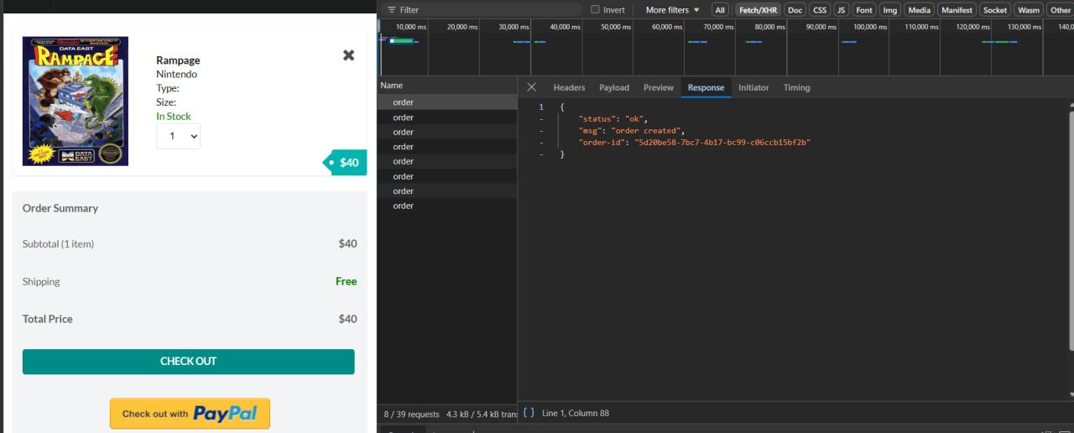
Figure 1: DVSA frontend showing the Rampage game ($40) in the cart with the DevTools Response panel confirming successful order creation (order-id: 5d20be58-7bc7-4b17-bc99-c06ccb15bf2b).
Figure 2 shows the baseline GET request for the newly created order. Key fields confirm the initial state: itemList shows item '1014' with quantity 1 (the Rampage game), orderStatus is 100, and totalAmount is 0 — indicating a freshly created, unprocessed order. This is the state before any unauthorized modification.

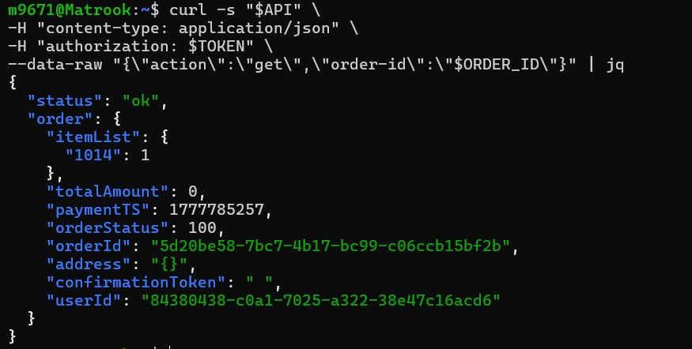
Figure 2: Baseline GET order response confirming the initial order state — itemList: {"1014":1}, orderStatus: 100, totalAmount: 0, orderId: 5d20be58-7bc7-4b17-bc99-c06ccb15bf2b.
Figure 3 is the core exploit evidence. A regular authenticated user sends an 'update' action directly to the API with a new items payload ({"1":1}). The API responds with status 'ok' and message 'cart updated' — confirming that the backend accepted and applied the unauthorized order modification without any role or privilege check.

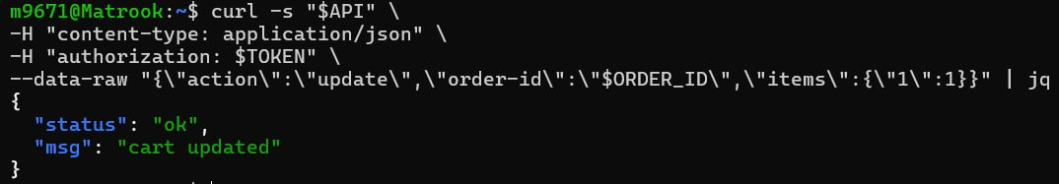
Figure 3: Exploit confirmed — the 'update' action sent by a regular non-admin user returns {"status":"ok","msg":"cart updated"}, proving the backend applied the modification without any authorization check.
Figure 4 confirms the persistent impact of the exploit. A second GET request after the unauthorized update shows that itemList has changed from {"1014":1} (Rampage game, item 1014) to {"1":1} (item 1), proving the attacker successfully overrode the original order contents. The order record in DynamoDB was permanently modified by the unauthorized API call.

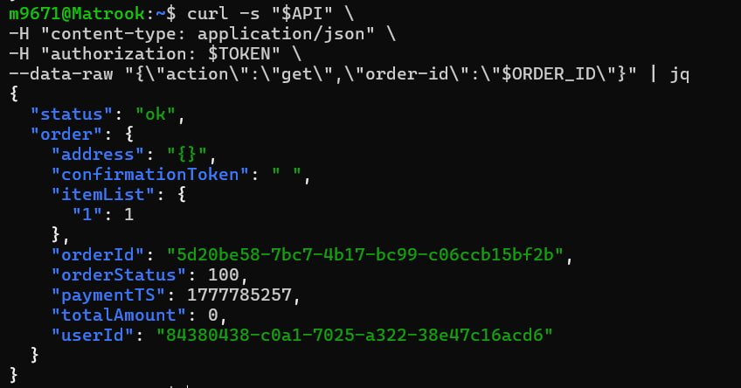
Figure 4: Post-exploit GET order response showing the modified state — itemList has changed from {"1014":1} to {"1":1}, confirming the unauthorized update was persisted in the DynamoDB orders table.

Part 6) Fix Strategy / Probable Mitigation
The fix must enforce server-side authorization checks before the 'update' action is processed. The following mitigations are required:

- Restrict the 'update' action to admin users only: before processing an update, verify that the requesting user's JWT contains an admin role claim. If the user is not an admin, return 401 Unauthorized immediately.
- Alternatively, remove the 'update' action from the public-facing API entirely and route order modifications only through internal Lambda-to-Lambda invocations that do not pass through API Gateway.
- Enforce order state transition validation: once an order has been created, its item list should only be modifiable in specific states (e.g., before shipping). The backend must validate the current orderStatus before allowing any modification.
- Apply object-level authorization: even for admin users, validate that the order being modified belongs to the correct workflow context and that the modification is legitimate.

Part 7) Code / Config Changes
File changed: DVSA-ORDER-MANAGER Lambda function (order-manager.js)

Before (Vulnerable) — No authorization check on 'update':
case 'update':
// No role check — any authenticated user can reach this
updateOrder(orderId, items, callback);
break;

After (Fixed) — Admin role check enforced before update:
case 'update':
// Verify the requesting user is an admin before allowing order update
if (!isAdmin) {
return callback(null, {
statusCode: 401,
body: JSON.stringify({ status: 'err', msg: 'unauthorized update' })
});
}
updateOrder(orderId, items, callback);
break;

The isAdmin flag is derived from the verified JWT claims (set earlier in the handler after signature verification). Only tokens with an admin-role claim will have isAdmin set to true. All other authenticated users receive a 401 response without any order modification taking place.

Part 8) Verification After Fix
After applying the fix, two verification tests were performed to confirm both that the exploit is blocked and that legitimate admin-restricted behavior is preserved.

Test 1 — Admin-Orders Action Still Correctly Blocked for Non-Admin Users
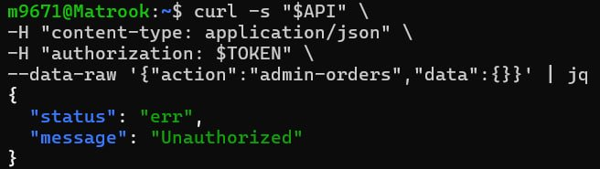
Figure 5: The 'admin-orders' action returns {"status":"err","message":"Unauthorized"} for a non-admin token, confirming that admin-level actions remain properly protected and the authorization layer is functioning.

Test 2 — Update Action Now Blocked for Regular Users
Figure 6: Post-fix verification — the same 'update' action that previously returned {"status":"ok","msg":"cart updated"} now returns {"status":"err","msg":"unauthorized update"}, confirming that the admin role check is now enforced before any order modification is permitted.

The fix is confirmed effective: regular authenticated users can no longer invoke the 'update' action to modify order contents. The response has changed from the vulnerable 'cart updated' (Figure 3) to the correct 'unauthorized update' (Figure 6). The order data in DynamoDB is no longer modifiable by unauthorized users through direct API calls.

Part 9) Structured Operation and Security Analysis
Table A — Intended Logic, Artifacts, and Behavior Comparison:

Vulnerability | Intended Rule(s) | Artifacts Used to Infer Rule | Normal Behavior Evidence | Exploit Behavior Evidence
Broken Access Control (Lesson #5) | Only administrators may invoke the 'update' action to modify an order's item list. A regular authenticated user must not be able to alter order contents after order creation. Order state transitions must follow the intended workflow: create → ship → bill. | DVSA frontend order creation flow (Figure 1); baseline GET order response confirming initial itemList (Figure 2); exploit UPDATE response (Figure 3); post-exploit GET confirming item list change (Figure 4); JWT claims (isAdmin flag); DVSA-ORDER-MANAGER Lambda source code. | A normal user places an order and receives order-id. Fetching the order with GET shows the correct item (itemList: {"1014":1}). The user cannot change the item list; only shipping, billing, and cancellation actions are available in the intended workflow. | Sending action:'update' with a new items payload as a regular non-admin user returned {"status":"ok","msg":"cart updated"} (Figure 3). A subsequent GET confirmed the itemList changed from {"1014":1} to {"1":1} (Figure 4), proving unauthorized persistent modification of the order record.

Table B — Deviation Analysis, Fix, and Post-Fix Verification:

Vulnerability | Why This Is a Deviation | Deviation Class | Fix Applied (Where) | Post-Fix Verification | Optional Latency Before/After
Broken Access Control (Lesson #5) | The backend processed an order update request from a non-admin user without any role or privilege check. This violates the intended access control rule that order item modification is an administrative operation. Authentication was present (valid JWT), but authorization was entirely absent for the 'update' action, allowing any logged-in user to overwrite order data. | Intentional misuse / security-relevant abuse | Fix applied in DVSA-ORDER-MANAGER Lambda (order-manager.js): added an isAdmin check in the 'update' action handler. If the requesting user's JWT does not carry an admin role claim, the handler immediately returns HTTP 401 with {"status":"err","msg":"unauthorized update"} before any order modification is attempted. | After the fix, the same update request from a non-admin user returns {"status":"err","msg":"unauthorized update"} (Figure 6). The admin-orders action also correctly returns Unauthorized for non-admin tokens (Figure 5). Order data in DynamoDB can no longer be modified by regular users via direct API calls. | N/A

Part 10) Takeaway / Lessons Learned
This lesson illustrates a fundamental distinction in web security: authentication and authorization are not the same thing. The DVSA application correctly required users to log in (authentication) but failed to enforce what logged-in users are allowed to do (authorization). A valid JWT proves identity but does not automatically grant permission to every API action.

In serverless architectures, broken access control is especially impactful because Lambda functions often serve as a combined handler for many actions. If the dispatch logic does not enforce per-action privilege checks, a single misconfiguration exposes all privileged operations to every authenticated user. The blast radius extends directly to the persistence layer — in this case, DynamoDB records were permanently modified.

The general secure design principle that prevents this class of problem is: enforce authorization at the server side for every sensitive action, every time. Role-based access control (RBAC) must be applied as close to the data modification point as possible, and the API must never rely on the client to limit which actions it requests. Every privileged operation — especially those that modify persistent state — must independently verify that the requesting identity holds the required role before proceeding.

