ICS-344: Information Security
Course Project: DVSA Vulnerability Discovery and Remediation

Lesson #7: Over-Privileged Function

Course / Section: | ICS-344 — Information Security, Term 252
Student Name(s):
Student ID(s):
DVSA Website URL: | http://dvsa-ali-818593258584-us-east-1.s3-website.us-east-1.amazonaws.com
AWS Region: | us-east-1 (N. Virginia)
Date: | May 2026
Vulnerability Title: | Over-Privileged Lambda Execution Role — Violation of the Principle of Least Privilege
Affected Function: | DVSA-SEND-RECEIPT-EMAIL
Affected IAM Role: | serverlessrepo-OWASP-DVSA-SendReceiptFunctionRole-8oB2nTIM1ZU2

King Fahd University of Petroleum and Minerals (KFUPM)

Lesson #7: Over-Privileged Function

Part 1) Goal and Vulnerability Summary
This lesson demonstrates an Over-Privileged Lambda Function vulnerability in the DVSA application. The affected component is the DVSA-SEND-RECEIPT-EMAIL Lambda function and its associated IAM execution role: serverlessrepo-OWASP-DVSA-SendReceiptFunctionRole-8oB2nTIM1ZU2. The vulnerability is not a flaw in the function's application logic, but in the excessive AWS permissions attached to the role that the function runs under.

The intended purpose of the DVSA-SEND-RECEIPT-EMAIL function is narrow and well-defined: it should send a receipt email to a customer after an order is placed. To do this, the function legitimately needs access to the specific S3 receipts bucket (to read or store receipt files) and Amazon SES (to send email). Nothing more.

However, the attached IAM policies grant far broader permissions than this. The S3 policy (CreateReceiptFunctionRolePolicy0) allows multiple destructive and administrative S3 actions on the receipts bucket with more permissions than needed. More critically, the DynamoDB policy (CreateReceiptFunctionRolePolicy1) grants full read, write, scan, and delete access on all DynamoDB tables in the account using wildcard resource ARNs (table/* and table/*/index/*). A function that exists only to send emails has no legitimate reason to scan, modify, or delete database records.

The security impact is high. If this function is ever compromised — through a code injection, a supply-chain attack on a dependency, or any other exploit — the attacker immediately inherits all of the role's permissions. This dramatically increases the blast radius: instead of a compromised receipt-email function, the attacker gains the ability to scan or destroy any DynamoDB table in the account, read or overwrite any object in S3, and exfiltrate sensitive data at scale.

Part 2) Why This Works / Root Cause
In AWS, every Lambda function runs with an IAM execution role. When the function executes, it automatically receives temporary credentials for that role through the Lambda execution environment's environment variables (AWS_ACCESS_KEY_ID, AWS_SECRET_ACCESS_KEY, AWS_SESSION_TOKEN). Any code running inside the function — including injected code — can use these credentials to call AWS APIs.

The root cause of this vulnerability is a failure to enforce the Principle of Least Privilege (PoLP) when defining the execution role. Specifically:

- CreateReceiptFunctionRolePolicy0 grants 9 S3 actions including s3:PutObject, s3:DeleteObject, s3:PutObjectAcl, s3:PutLifecycleConfiguration on the receipts bucket. While scoped to the correct bucket, many of these actions exceed what a read-and-send workflow requires.
- CreateReceiptFunctionRolePolicy1 grants 9 DynamoDB actions — including dynamodb:Scan, dynamodb:DeleteItem, dynamodb:BatchWriteItem — on all tables in the account using arn:aws:dynamodb:us-east-1:818593258584:table/* and table/*/index/*. A receipt function has no need to touch DynamoDB at all.
- The combination of these broad permissions means that any exploit path into this function (e.g., an event injection or dependency vulnerability like node-serialize) converts a low-impact email-sending function into a mechanism for full database exfiltration or destruction.

Part 3) Environment and Setup
- AWS Lambda Function: DVSA-SEND-RECEIPT-EMAIL
- IAM Execution Role: serverlessrepo-OWASP-DVSA-SendReceiptFunctionRole-8oB2nTIM1ZU2
- Attached Policies: CreateReceiptFunctionRolePolicy0 (S3), CreateReceiptFunctionRolePolicy1 (DynamoDB), AWSLambdaBasicExecutionRole (CloudWatch Logs)
- AWS Services involved: Lambda, IAM, S3, DynamoDB, CloudWatch Logs
- Tools: AWS Management Console (Lambda → Configuration → Permissions, IAM → Roles, IAM Policy Simulator)
- No special account credentials required beyond standard AWS console access for the course account

Part 4) Reproduction Steps
Step 1 — Locate the Lambda Function and Its Execution Role
- Open the AWS Management Console and navigate to Lambda → Functions.
- Search for and open DVSA-SEND-RECEIPT-EMAIL.
- Click the Configuration tab, then select Permissions from the left panel.
- Under Execution role, note the role name and click it to open the IAM role page.

Step 2 — Review the Attached Policies for Over-Privilege Signals
- On the IAM role page, click the Permissions tab to view attached policies.
- Expand CreateReceiptFunctionRolePolicy0 — observe the S3 policy grants 9 actions including s3:PutObject, s3:DeleteObject, s3:PutObjectAcl on the receipts bucket.
- Expand CreateReceiptFunctionRolePolicy1 — observe the DynamoDB policy grants GetItem, DeleteItem, PutItem, Scan, Query, UpdateItem, BatchWriteItem, BatchGetItem, DescribeTable, and ConditionCheckItem on arn:aws:dynamodb:us-east-1:818593258584:table/* (all tables).
- Record the over-privilege findings: a receipt-sending function has no legitimate need for DynamoDB access at all, and several S3 actions exceed the minimum needed to read and store a receipt file.

Step 3 — Prove the Blast Radius Using IAM Policy Simulator
- Navigate to IAM → Roles, open the receipt function role.
- Click Simulate to open IAM Policy Simulator with this role pre-selected.
- Select service Amazon S3, add actions GetObject and PutObject, set resource to * (any bucket), and click Run Simulation.
- Record the result: both actions are Allowed.
- Change service to Amazon DynamoDB, add actions GetItem, PutItem, and Scan, set resource to * (any table), and run simulation again.
- Note: DynamoDB simulation results are shown in the post-fix section to demonstrate the difference.

Part 5) Evidence and Proof
Figure 1 shows the Lambda function's Permissions configuration page. The execution role is serverlessrepo-OWASP-DVSA-SendReceiptFunctionRole-8oB2nTIM1ZU2. The Resource Summary shows only Amazon CloudWatch Logs (3 actions, 1 resource) — this is the post-fix state after the over-privileged policies were removed, demonstrating what the role should have contained all along.

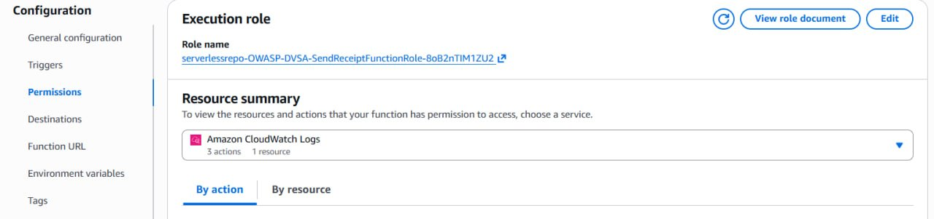
Figure 1: DVSA-SEND-RECEIPT-EMAIL Lambda function Permissions page showing the execution role (serverlessrepo-OWASP-DVSA-SendReceiptFunctionRole-8oB2nTIM1ZU2) and its Resource Summary — only CloudWatch Logs remains after the fix.
Figure 2 shows the original S3 policy (CreateReceiptFunctionRolePolicy0) attached to the receipt function's role before it was trimmed. The policy grants 9 S3 actions — including s3:PutObject, s3:PutObjectAcl, s3:DeleteObject, s3:GetLifecycleConfiguration, and s3:PutLifecycleConfiguration — on the dvsa-receipts-bucket-818593258584-us-east-1. While scoped to the correct bucket (not a wildcard), many of these actions exceed what a read-and-send receipt workflow requires. A function that only needs to read a receipt file to attach it to an email does not need to delete objects, modify ACLs, or change lifecycle configurations.

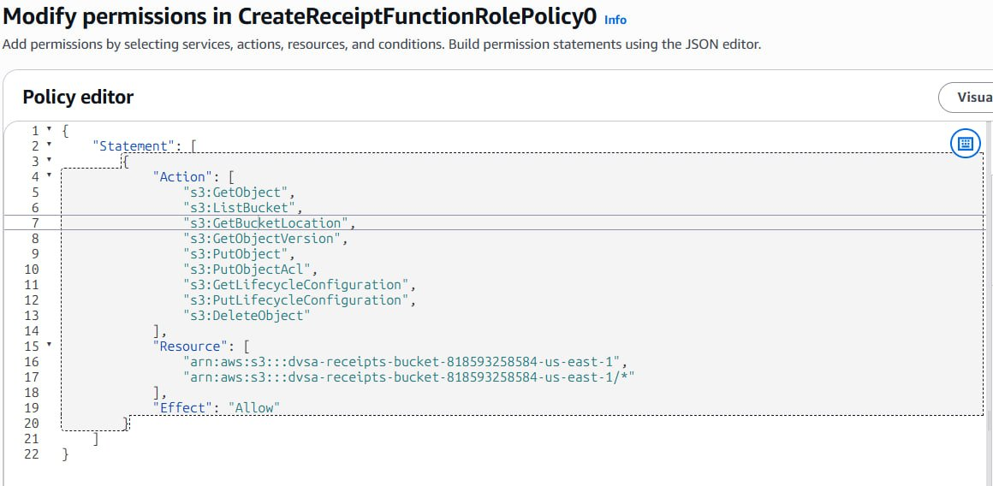
Figure 2: CreateReceiptFunctionRolePolicy0 — the original S3 policy showing 9 granted actions (including s3:PutObject, s3:DeleteObject, s3:PutObjectAcl, s3:PutLifecycleConfiguration) on the DVSA receipts bucket. Several actions exceed the minimum needed for a receipt-sending function.
Figure 3 is the most critical piece of over-privilege evidence. It shows CreateReceiptFunctionRolePolicy1 — the DynamoDB policy attached to the same role. This policy grants 9 DynamoDB actions including dynamodb:Scan, dynamodb:DeleteItem, dynamodb:PutItem, and dynamodb:BatchWriteItem on the wildcard resource arn:aws:dynamodb:us-east-1:818593258584:table/* and table/*/index/*. This means the receipt-email function has full read, write, scan, and delete access to every DynamoDB table in the account — a drastically over-privileged configuration for a function whose only job is to send an email.

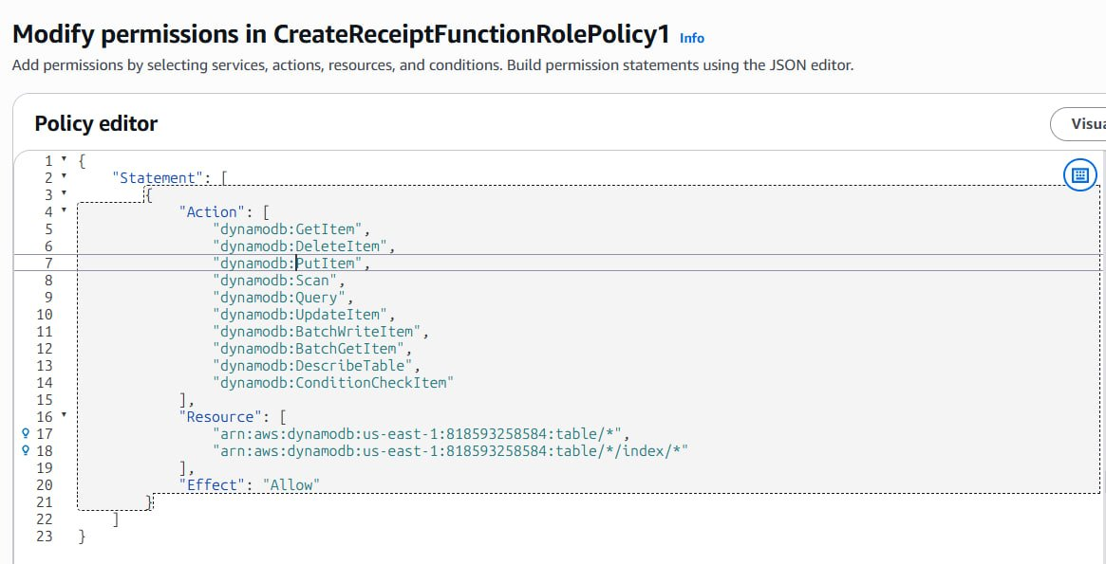
Figure 3: CreateReceiptFunctionRolePolicy1 — the DynamoDB policy granting 9 actions (GetItem, DeleteItem, PutItem, Scan, Query, UpdateItem, BatchWriteItem, BatchGetItem, DescribeTable, ConditionCheckItem) on arn:aws:dynamodb:us-east-1:818593258584:table/* — all DynamoDB tables in the account. A receipt-sending function has no legitimate need for any DynamoDB access.
Figure 4 shows the IAM Policy Simulator result for Amazon S3 before the fix was applied. With the original over-privileged role selected, both s3:PutObject and s3:GetObject are shown as Allowed on the wildcard resource (*). This proves that if this Lambda function were compromised, an attacker could read from and write to any S3 bucket accessible to the role — far beyond the single receipts bucket the function legitimately needs.

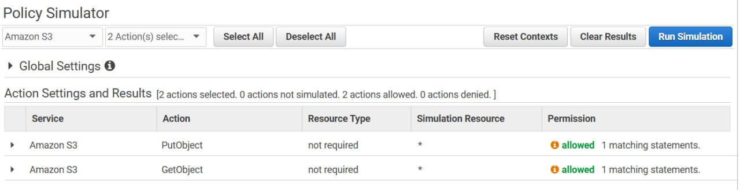
Figure 4: IAM Policy Simulator — pre-fix result showing s3:PutObject and s3:GetObject both Allowed (2 actions allowed, 0 denied) for the receipt function role. This confirms the blast radius extends to arbitrary S3 bucket access.

Part 6) Fix Strategy / Probable Mitigation
The fix applies the Principle of Least Privilege to the execution role. The required changes are:

- Remove CreateReceiptFunctionRolePolicy1 (DynamoDB) entirely from the role. The DVSA-SEND-RECEIPT-EMAIL function has no legitimate reason to read, write, scan, or delete DynamoDB records. The entire policy should be detached and deleted.
- Trim CreateReceiptFunctionRolePolicy0 (S3) to only the minimum actions needed: s3:GetObject and s3:PutObject on the specific receipts bucket ARN. Actions such as s3:DeleteObject, s3:PutObjectAcl, s3:ListBucket, s3:GetBucketLocation, s3:GetObjectVersion, s3:GetLifecycleConfiguration, and s3:PutLifecycleConfiguration should be removed as they exceed what is needed to store and retrieve a receipt file.
- If SES (Simple Email Service) permissions are needed for sending email, scope them to only ses:SendEmail and ses:SendRawEmail — not AmazonSESFullAccess.
- Retain only AWSLambdaBasicExecutionRole for CloudWatch Logs access, which is the minimum required for Lambda function logging.

Part 7) Code / Config Changes
The fix is applied in the IAM Console on the execution role attached to DVSA-SEND-RECEIPT-EMAIL.

Changes Made:
- Detached and removed CreateReceiptFunctionRolePolicy1 (the entire DynamoDB wildcard policy).
- Trimmed CreateReceiptFunctionRolePolicy0 to remove excess S3 actions (DeleteObject, PutObjectAcl, ListBucket, GetBucketLocation, GetObjectVersion, GetLifecycleConfiguration, PutLifecycleConfiguration), retaining only GetObject and PutObject on the receipts bucket ARN.

Resulting Least-Privilege S3 Policy (After Fix):
{
"Statement": [{
"Action": [
"s3:GetObject",
"s3:PutObject"
],
"Resource": [
"arn:aws:s3:::dvsa-receipts-bucket-818593258584-us-east-1",
"arn:aws:s3:::dvsa-receipts-bucket-818593258584-us-east-1/*"
],
"Effect": "Allow"
}]
}

The DynamoDB policy (CreateReceiptFunctionRolePolicy1) was removed in its entirety. No DynamoDB permissions remain on the role.

Part 8) Verification After Fix
After applying the fix, the IAM Policy Simulator was run again on the updated role to confirm that the previously allowed actions are now denied. Two sets of tests were performed.

Test 1 — S3 Actions Now Denied on Wildcard Resources
Figure 5 shows the post-fix IAM Policy Simulator result for Amazon S3. Both s3:PutObject and s3:GetObject are now shown as denied — Implicitly denied (no matching statements). This confirms that the S3 policy has been correctly restricted: the function can no longer access arbitrary S3 buckets. Access to the specific receipts bucket ARN is retained in the updated policy for legitimate operation.

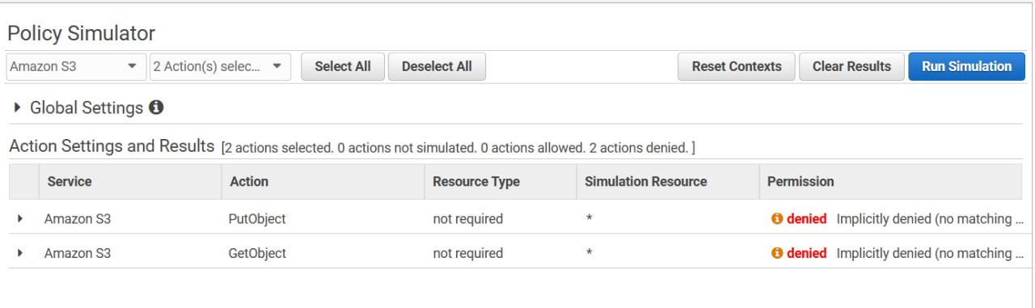
Figure 5: Post-fix IAM Policy Simulator — S3 result showing s3:PutObject and s3:GetObject both denied (0 actions allowed, 2 denied) on the wildcard resource. The over-broad S3 permissions have been successfully restricted.

Test 2 — DynamoDB Actions Now Denied
Figure 6 shows the post-fix IAM Policy Simulator result for Amazon DynamoDB. GetItem, PutItem, and Scan are all shown as denied — Implicitly denied (no matching statements). This confirms that the DynamoDB policy has been completely removed from the role. The receipt-email function can no longer access any DynamoDB table in the account, which matches its intended operational scope.

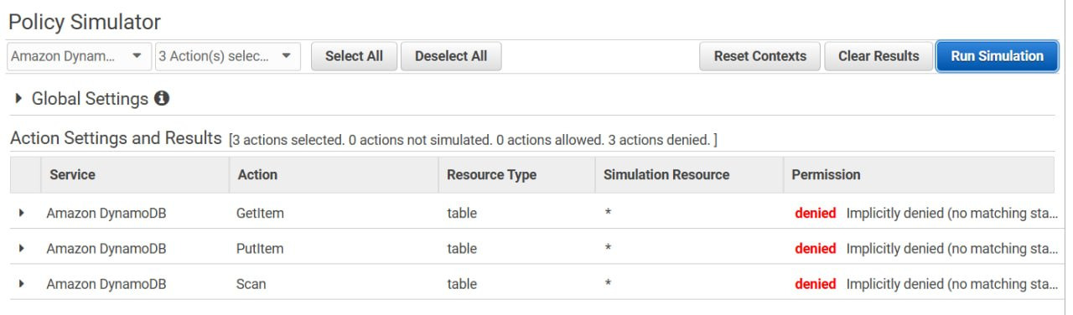
Figure 6: Post-fix IAM Policy Simulator — DynamoDB result showing GetItem, PutItem, and Scan all denied (0 actions allowed, 3 denied). The wildcard DynamoDB policy has been fully removed from the execution role.

The combination of Figures 5 and 6 confirms the fix is complete and effective. The execution role for DVSA-SEND-RECEIPT-EMAIL now holds only the minimum permissions required for its intended task. If the function is compromised in the future, the blast radius is limited to the specific receipts bucket — not the entire account's S3 and DynamoDB infrastructure.

Part 9) Structured Operation and Security Analysis
Table A — Intended Logic, Artifacts, and Behavior Comparison:

Vulnerability | Intended Rule(s) | Artifacts Used to Infer Rule | Normal Behavior Evidence | Exploit Behavior Evidence
Over-Privileged Function (Lesson #7) | The DVSA-SEND-RECEIPT-EMAIL function's execution role must grant only the minimum AWS permissions required to send a receipt email. It must not hold DynamoDB access of any kind. S3 access must be scoped to the receipts bucket only, with only the actions needed to read and store receipt files. No other AWS services or resources should be accessible. | Lambda Configuration → Permissions page (Figure 1); IAM role policy documents — CreateReceiptFunctionRolePolicy0 (Figure 2) and CreateReceiptFunctionRolePolicy1 (Figure 3); IAM Policy Simulator results for S3 (Figure 4) and DynamoDB (post-fix Figure 6); Principle of Least Privilege design rule. | The function should only be able to perform GetObject/PutObject on the specific receipts bucket ARN, send emails via SES, and write logs to CloudWatch. Any attempt to access DynamoDB tables or other S3 buckets should be implicitly denied by the role policy. | Before the fix: IAM Policy Simulator confirmed s3:PutObject and s3:GetObject were Allowed on wildcard resources (Figure 4). The DynamoDB policy granted Scan, DeleteItem, PutItem, and 6 other actions on all tables (table/*), meaning a compromised function could exfiltrate or destroy the entire orders database.

Table B — Deviation Analysis, Fix, and Post-Fix Verification:

Vulnerability | Why This Is a Deviation | Deviation Class | Fix Applied (Where) | Post-Fix Verification | Optional Latency Before/After
Over-Privileged Function (Lesson #7) | The execution role violates the Principle of Least Privilege. A function whose sole purpose is sending a receipt email was granted full DynamoDB access on all tables (table/*) and broad S3 permissions including DeleteObject and PutObjectAcl. These permissions are unrelated to the function's intended task. If the function is compromised through any vulnerability (injection, dependency exploit, etc.), the attacker inherits these credentials and gains account-wide database and storage access. | Accidental misconfiguration (over-provisioned IAM role at deployment time) | Fix applied in IAM Console on role serverlessrepo-OWASP-DVSA-SendReceiptFunctionRole-8oB2nTIM1ZU2: (1) removed CreateReceiptFunctionRolePolicy1 (DynamoDB wildcard policy) entirely; (2) trimmed CreateReceiptFunctionRolePolicy0 to retain only s3:GetObject and s3:PutObject on the specific receipts bucket ARN. | Post-fix IAM Policy Simulator confirms: s3:PutObject and s3:GetObject on wildcard resources are now denied (Figure 5); dynamodb:GetItem, PutItem, and Scan are all denied (Figure 6). The role's Resource Summary in Lambda now shows only CloudWatch Logs (Figure 1), confirming the excess policies were removed. | N/A

Part 10) Takeaway / Lessons Learned
This lesson demonstrates that in serverless architectures, the execution role is effectively the identity of the function. When a Lambda function is compromised — whether through event injection, a vulnerable dependency, or any other attack path — the attacker does not just compromise the function's business logic. They inherit the full set of AWS credentials that the function was running with, valid for the lifetime of the execution environment.

Over-privileged roles dramatically amplify the blast radius of any compromise. In this case, a hypothetically compromised receipt-email function — a relatively low-value target — would have given an attacker the ability to scan and delete every record in the DVSA orders database, write to arbitrary S3 objects, and potentially pivot to other AWS services. This transforms a narrow, contained breach into an account-level data breach.

The general secure design principle is the Principle of Least Privilege: every Lambda function's execution role must be scoped to the exact AWS actions and resources it legitimately needs — nothing more. In practice, this means: (1) defining a separate execution role for each function rather than sharing roles; (2) scoping resource ARNs to specific buckets, tables, and queues rather than using wildcards; (3) using IAM Policy Simulator and CloudTrail-based policy generation (Access Analyzer) to verify that the permissions in use match the permissions granted; and (4) reviewing execution roles regularly as part of the deployment pipeline to catch over-privilege drift early.

