ICS-344: Information Security
Course Project: DVSA Vulnerability Discovery and Remediation

Lesson #9: Vulnerable Dependencies

Course / Section: | ICS-344 — Information Security, Term 252
Student Name(s):
Student ID(s):
DVSA Website URL: | http://dvsa-ali-818593258584-us-east-1.s3-website.us-east-1.amazonaws.com
AWS Region: | us-east-1 (N. Virginia)
Date: | May 2026
Vulnerability Title: | Vulnerable Dependencies — Remote Code Execution via node-serialize (Insecure Deserialization)
Affected Function: | DVSA-ORDER-MANAGER (order-manager.js)
Vulnerable Package: | node-serialize (any version — unsafe by design for untrusted input)

King Fahd University of Petroleum and Minerals (KFUPM)

Lesson #9: Vulnerable Dependencies

Part 1) Goal and Vulnerability Summary
This lesson demonstrates a Vulnerable Dependencies vulnerability in the DVSA application. The affected component is the DVSA-ORDER-MANAGER Lambda function, specifically its use of the third-party Node.js package node-serialize to process incoming HTTP request bodies from API Gateway.

The vulnerability arises because node-serialize is an inherently unsafe library that can deserialize JavaScript function objects embedded in JSON strings. When the library encounters a value prefixed with the special marker _$$ND_FUNC$$_ followed by a function definition ending in (), it evaluates and executes the function body using JavaScript's eval() mechanism during the deserialization process. Because the Lambda function passes attacker-controlled request body data directly into serialize.unserialize() without any prior validation, an attacker can inject a serialized function payload through the public API Gateway endpoint and achieve arbitrary Remote Code Execution (RCE) inside the Lambda execution environment.

The security impact is critical. Any code injected through this vector executes with the full privileges of the Lambda execution role, has access to the function's environment variables (including temporary AWS credentials), and can interact with the filesystem and network. This makes the vulnerable dependency a direct entry point for credential theft, data exfiltration, and lateral movement within the AWS account.

Part 2) Why This Works / Root Cause
The node-serialize package extends JSON serialization to support JavaScript functions by encoding them as strings with a special prefix. During deserialization, the library detects this prefix and reconstructs the function using JavaScript's eval()-equivalent behavior. If the serialized value ends with () — forming an Immediately Invoked Function Expression (IIFE) — the function is also called immediately at the moment of deserialization.

The vulnerable payload structure is:

{"action":"_$$ND_FUNC$$_function(){ <malicious code> }()"}

The two-layer root cause is:

- Vulnerable Dependency: node-serialize is unsafe by design for processing untrusted input. It was never intended to be used as a general-purpose JSON parser for user-supplied data. Any version of this library will execute functions embedded in attacker-controlled input.
- Missing Input Validation: The order-manager.js handler passes event.body directly into serialize.unserialize() on line 10 without any schema validation, type checking, or allowlist enforcement. The application trusts the raw HTTP request body as if it were safe, structured data.

These two weaknesses together create a direct path: an HTTP POST request to the API Gateway /order endpoint triggers the Lambda handler, which immediately deserializes the attacker-controlled body — executing the injected function before any business logic runs.

Part 3) Environment and Setup
- DVSA Website URL: http://dvsa-ali-818593258584-us-east-1.s3-website.us-east-1.amazonaws.com
- Target API Endpoint: the /Stage/order or /dvsa/order endpoint (stored in $API environment variable)
- Affected Lambda Function: DVSA-ORDER-MANAGER
- Affected Source File: order-manager.js (lines 1 and 10 in the vulnerable version)
- Vulnerable Package: node-serialize (required on line 1, used on line 10)
- CloudWatch Log Group: /aws/lambda/DVSA-ORDER-MANAGER
- Tools: VS Code / Lambda console (for source code inspection), Linux terminal, curl, AWS CloudWatch Logs console
- No authentication required — the vulnerable endpoint processes unauthenticated POST requests before any auth check

Part 4) Reproduction Steps
Step 1 — Inspect the Vulnerable Source Code
- Open the DVSA-ORDER-MANAGER Lambda function in the AWS Console.
- Navigate to the Code tab and open order-manager.js.
- Observe line 1: const serialize = require('node-serialize'); — this imports the unsafe library.
- Observe line 10: var req = serialize.unserialize(event.body); — this passes the raw attacker-controlled request body directly into the unsafe deserializer without any prior validation.

Step 2 — Send the Malicious Deserialization Payload
Craft and send a POST request containing an IIFE payload in the action field. The injected function calls console.error('PWNED') — a safe proof-of-concept that logs to CloudWatch without causing damage:

curl -X POST "$API" \
-H "Content-Type: application/json" \
-d '{"action":"_$$ND_FUNC$$_function(){console.error(\"PWNED\")}()"}'

The API will return a generic error response. This is expected — as the helper guide explains, the generic error does not indicate the attack failed. The injected function executes before the handler crashes, and the evidence must be verified in CloudWatch.

Step 3 — Verify RCE in CloudWatch Logs
- Open the AWS Console and navigate to CloudWatch → Logs → Log Management.
- Search for the log group /aws/lambda/DVSA-ORDER-MANAGER.
- Open the most recent log stream and filter by the keyword PWNED.
- Confirm that ERROR PWNED entries appear — these were produced by the injected function running inside the Lambda execution environment.

Part 5) Evidence and Proof
Figure 1 shows the vulnerable source code of order-manager.js as viewed in the Lambda Code editor. Line 1 is highlighted in yellow: const serialize = require('node-serialize') — the unsafe library import. Line 10 is also highlighted: var req = serialize.unserialize(event.body) — the direct deserialization of the raw, unvalidated HTTP request body. This code pattern is the direct root cause of the vulnerability: any JSON value with the _$$ND_FUNC$$_ prefix in the request body will be evaluated as JavaScript during this call.

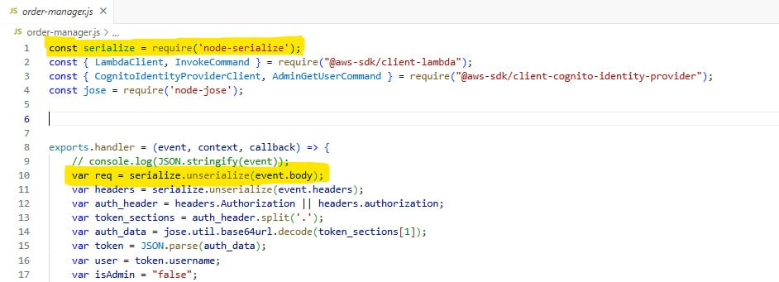
Figure 1: Vulnerable order-manager.js source code. Line 1 (highlighted) imports node-serialize. Line 10 (highlighted) passes event.body directly into serialize.unserialize() without any input validation — the direct cause of the RCE vulnerability.
Figure 2 shows the terminal output of the curl exploit command. The API returned {"message":"Internal server error"} — a generic 500-class error. As explained in the helper guide, this response does not indicate the attack failed. The injected function executes during deserialization before the rest of the handler runs. The handler subsequently crashes due to the missing authorization header, and API Gateway surfaces a generic error. The true evidence of execution is in the backend logs.

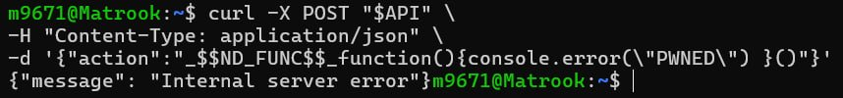
Figure 2: Terminal output showing the curl exploit command sending the _$$ND_FUNC$$_ payload to the API. The returned {"message":"Internal server error"} is expected behavior — the injected function already executed on the backend before the handler crashed.
Figure 3 provides definitive proof of Remote Code Execution. CloudWatch Logs for /aws/lambda/DVSA-ORDER-MANAGER, filtered by the keyword PWNED, shows four separate log entries all at the ERROR level, timestamped on 2026-05-04 at 14:04, 14:19, 14:24, and 14:25 UTC. Each entry corresponds to a separate exploit invocation. The presence of these ERROR PWNED log lines confirms that the injected console.error('PWNED') function call was executed inside the Lambda execution environment — proving that attacker-controlled JavaScript ran on the backend serverless infrastructure.

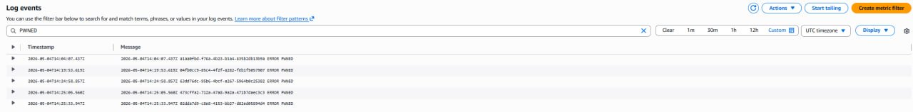
Figure 3: CloudWatch Logs for /aws/lambda/DVSA-ORDER-MANAGER filtered by 'PWNED'. Four ERROR-level log entries confirm that the injected JavaScript function executed inside the Lambda environment on multiple exploit attempts — definitive proof of Remote Code Execution via the vulnerable node-serialize dependency.

Part 6) Fix Strategy / Probable Mitigation
The fix addresses both layers of the root cause simultaneously:

- Remove node-serialize entirely from the Lambda deployment package. The package.json dependency entry must be deleted, and the node_modules folder must be rebuilt without it. This package is unsafe by design for any untrusted input and has no safe configuration mode.
- Replace serialize.unserialize(event.body) with the safe standard library call JSON.parse(event.body). JSON.parse() only parses data — it never evaluates or executes code, regardless of what the input contains.
- Add input validation after parsing: verify the action field against a strict allowlist of permitted values before dispatching to any handler. Any request with an unrecognized or missing action must be rejected with a 400 error before further processing.
- Add a safe header parsing fallback: replace serialize.unserialize(event.headers) with a conditional check — if event.headers is a string, parse it with JSON.parse(); otherwise use it directly as an object. This handles API Gateway's variable header serialization without reintroducing unsafe deserialization.
- Continuously audit all Lambda dependencies using npm audit and AWS Inspector, and pin reviewed dependency versions in package-lock.json to prevent unintended upgrades to vulnerable versions.

Part 7) Code / Config Changes
File changed: order-manager.js (DVSA-ORDER-MANAGER Lambda function)

Before (Vulnerable):
Line 1 — Vulnerable package import:

const serialize = require('node-serialize'); // UNSAFE DEPENDENCY

Line 10 — Unsafe deserialization of attacker-controlled input:

var req = serialize.unserialize(event.body); // EXECUTES INJECTED FUNCTIONS

Line 11 — Also uses unsafe deserialization for headers:

var headers = serialize.unserialize(event.headers);

After (Fixed):
Line 1 — node-serialize removed; only safe dependencies remain:

// const serialize = require('node-serialize'); -- REMOVED

Line 9 — Safe JSON parsing replaces unsafe deserialization:

var req = JSON.parse(event.body); // SAFE: no code execution

Lines 11–13 — Safe conditional header parsing:

var headers = typeof event.headers === 'string'
? JSON.parse(event.headers)
: event.headers;

Figure 4 shows the fixed order-manager.js source code as viewed in the Lambda Code editor. The node-serialize import is gone from line 1 (lines 1–3 now show only safe AWS SDK imports). Line 9 uses JSON.parse(event.body) highlighted in yellow. Lines 11–13 show the safe conditional header parsing pattern, also highlighted. The function no longer contains any reference to node-serialize.

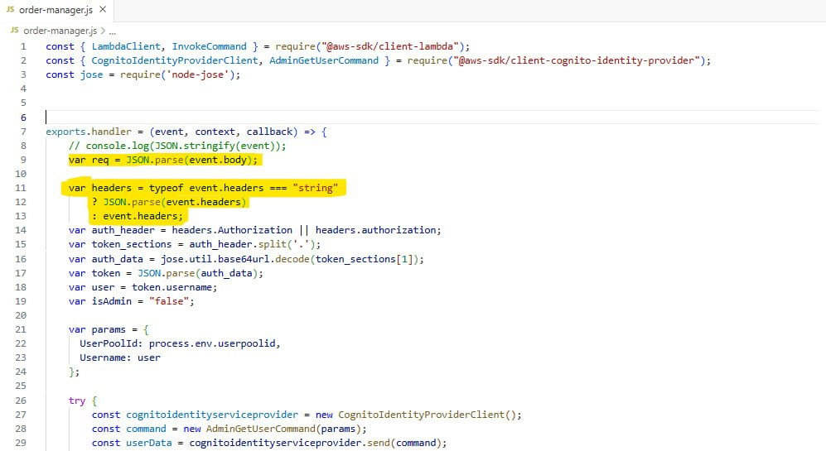
Figure 4: Fixed order-manager.js source code. node-serialize has been removed from imports (line 1 now starts with LambdaClient). Line 9 uses JSON.parse(event.body) and lines 11–13 implement safe conditional header parsing — both highlighted in yellow. No unsafe deserialization remains.

Part 8) Verification After Fix
After deploying the patched Lambda, the same exploit payload was sent again using curl. CloudWatch Logs were then filtered by PWNED to verify whether the injected function executed.

Figure 5: Post-fix CloudWatch Logs for /aws/lambda/DVSA-ORDER-MANAGER filtered by 'PWNED' — showing 'No events found'. The injected function no longer executes after the fix, confirming that replacing node-serialize with JSON.parse() completely eliminates the RCE vulnerability.

The result is conclusive: CloudWatch shows 'No events found' when filtering for PWNED after the fix was applied. Compare this directly with Figure 3, where the same filter returned four ERROR-level entries before the fix. The injected console.error('PWNED') no longer runs because JSON.parse() only parses data and never evaluates code — regardless of what the _$$ND_FUNC$$_ payload contains, it is treated as a plain string value and cannot cause code execution.

Part 9) Structured Operation and Security Analysis
Table A — Intended Logic, Artifacts, and Behavior Comparison:

Vulnerability | Intended Rule(s) | Artifacts Used to Infer Rule | Normal Behavior Evidence | Exploit Behavior Evidence
Vulnerable Dependencies — node-serialize RCE (Lesson #9) | The Lambda function must parse request body data using a safe method that never evaluates code. Attacker-controlled HTTP request data must only be treated as structured data — never as executable content. Third-party dependencies used to process untrusted input must not have code-evaluation behavior. | order-manager.js source code (Figures 1 & 4) showing the require() and unserialize() calls; node-serialize package documentation describing the _$$ND_FUNC$$_ behavior; curl exploit command (Figure 2); CloudWatch Logs before fix (Figure 3) and after fix (Figure 5). | Under normal operation, a well-formed JSON request body is parsed and the action field is dispatched to the appropriate handler. No side effects occur from parsing. A request with an invalid action returns an error response without any backend code execution. | Sending the _$$ND_FUNC$$_ payload returned a generic error to the client (Figure 2), while CloudWatch showed four ERROR PWNED entries confirming that the injected JavaScript function executed inside the Lambda environment (Figure 3). Execution occurred during deserialization, before any auth or validation logic ran.

Table B — Deviation Analysis, Fix, and Post-Fix Verification:

Vulnerability | Why This Is a Deviation | Deviation Class | Fix Applied (Where) | Post-Fix Verification | Optional Latency Before/After
Vulnerable Dependencies — node-serialize RCE (Lesson #9) | The backend executed attacker-controlled JavaScript code injected through the HTTP request body. This violates the fundamental security rule that user input must be treated as data, never as code. The use of node-serialize to process untrusted input converted a routine JSON parsing step into arbitrary code execution, bypassing all authentication and authorization logic that follows. | Intentional misuse / security-relevant abuse (enabled by accidental use of an unsafe dependency) | Fix applied in order-manager.js (DVSA-ORDER-MANAGER Lambda): (1) removed node-serialize from require() statements and package.json; (2) replaced serialize.unserialize(event.body) with JSON.parse(event.body) on line 9; (3) replaced serialize.unserialize(event.headers) with safe conditional JSON.parse on lines 11–13. Lambda redeployed after changes. | Post-fix CloudWatch Logs filtered by PWNED show 'No events found' (Figure 5), compared to four ERROR PWNED entries before the fix (Figure 3). The injected function no longer executes. Legitimate well-formed requests continue to be processed normally by the handler. | N/A

Part 10) Takeaway / Lessons Learned
This lesson demonstrates that a single vulnerable third-party dependency can undermine every other security control in an application. The DVSA application had multiple layers of logic — authentication checks, authorization dispatch, business logic — but none of them mattered because the vulnerable dependency executed attacker code before any of those layers were reached. The attack surface began at the moment the request body was passed to serialize.unserialize().

In serverless architectures this is especially impactful because Lambda functions are self-contained deployment packages that include all their dependencies. If a dependency is unsafe, every invocation of the function is potentially exploitable. Unlike traditional servers where dependency updates can be patched centrally, each Lambda function must be individually audited, updated, and redeployed.

The comparison between Figure 3 (pre-fix: four PWNED entries) and Figure 5 (post-fix: no events found) visually captures the entire lesson: the same exploit payload, the same API endpoint, the same Lambda function — but after replacing one unsafe library call with a safe one, the attack is completely neutralized. This illustrates the core principle: choose dependencies carefully, audit them regularly with npm audit, and never use libraries that evaluate code when processing untrusted input. Safe parsing (JSON.parse) and unsafe deserialization (serialize.unserialize) are not equivalent — one is always data, the other can be code.

