
Course Name : Software Engineering
Project Title : Employee Management System
Team Members :
 | Name | Group | Id
1 | Ibrahim Abdelsattar Abdelsattar | G1 | 107061
2 | Ahmed Zayed Kamel Mohammed | G1 | 105893
3 | Esraa Hussein Abdelrazek | G1 | 106788
4 | Ahmed Tamer Elhanafy | G1 | 105252
5 | Ahmed Mohamed Ahmed | G1 | 107276
Dr. Hesham Eldeeb
T.A. Abeer Raafat
T.A. Rahma Mohamed

Table of Contents
1. Project Overview 3
1.1 Executive Summary 3
1.2 Key Platform Characteristics 3
1.3 Project Identity and Baseline Specifications 3
2. System Architecture 4
2.1 Five-Layer Clean Architecture 4
2.2 Component and Layer Diagram 4
3. Functional Modules 5
4. Security and Access Control 6
4.1 Role-Based Access Control and Role Personas 6
4.2 Server-Side Security and Confidentiality Guarantees 6
5. Static Models 7
5.1 Use Case Diagram 7
5.2 Domain Class Diagram 8
5.3 Database Schema and Entity-Relationship Diagram 9
6. Dynamic Models 10
6.1 Activity Diagrams 10
6.2 Sequence Diagrams 13
6.3 State Machine Diagrams 16
7. Deployment Architecture 19
7.1 Runtime and Database Topology 19
7.2 Idempotent Bootstrapping 19
8. Testing and Verification 20
8.1 Automated Domain Unit Tests 20
8.2 Full-Stack and Mobile Responsiveness Acceptance 20
8.3 Commands for Local Execution and Verification 20

1. Project Overview
This document presents the formal software engineering documentation of NexaHR, an enterprise employee management system. It describes the system architecture, functional modules, security model, database design, the complete UML specification, the deployment topology, and the verification results.

1.1 Executive Summary
NexaHR is a full-stack, production-grade Human Resource Information System (HRIS) developed for NexaWorks Technologies SAE, headquartered in New Cairo, Egypt. The platform unifies employee lifecycle records, leave management based on the Egyptian labor calendar, shift-based attendance with grace-period evaluation, Kanban task execution, weighted OKR performance reviews, and confidential payroll governance in Egyptian pounds (EGP).

1.2 Key Platform Characteristics
- Bilingual RTL/LTR and mobile-first user experience: The application opens in Egyptian Arabic (ar-EG, right-to-left) by default and can be switched instantly to English (left-to-right). The “NexaHR” brand identity is preserved in both languages, and responsive layouts support screen widths from 375 px to 1440 px, with a quick-navigation bottom bar on mobile devices.
- Relational persistence and pure domain engine: The system is backed by 26 normalized PostgreSQL tables hosted on Google Cloud SQL (europe-west2) and managed through Drizzle ORM. It is paired with a decoupled domain rule engine (src/domain/rules.ts) that is fully unit-tested.

1.3 Project Identity and Baseline Specifications
Table 1 summarizes the identity of the platform and the baseline configuration of the implemented production system.
Table 1 – Project identity and baseline specifications
Specification | Implemented Configuration
Platform Brand and Tagline | NexaHR – “People, Performance, Possibilities.” (the brand is always rendered as NexaHR)
Default Organization | NexaWorks Technologies SAE (headquartered in New Cairo, Cairo Governorate, Egypt)
Regional Baseline | Timezone: Africa/Cairo (UTC+2); Currency: EGP; Weekend: Friday and Saturday; Date format: DD/MM/YYYY
Default Language and Direction | Egyptian Arabic (ar-EG, dir="rtl") by default, with full English (en, dir="ltr") support
Frontend and Motion Stack | React 19, TypeScript, Tailwind CSS v4, Motion (motion/react), Recharts, Lucide Icons
Backend and Database Stack | Node.js, Express REST API, Drizzle ORM, Google Cloud SQL for PostgreSQL (26 tables)
Seeded Enterprise Dataset | 25 employees (active, onboarding, and archived), 5 departments, 14 job titles, 4 role personas

2. System Architecture

2.1 Five-Layer Clean Architecture
The system follows a strict separation of concerns across five layers: Presentation, Application State, Pure Domain Rules, API Controllers, and Cloud SQL persistence. Table 2 lists each layer together with its principal source files and core engineering responsibility.
Table 2 – Architecture layers, source files, and responsibilities
Architecture Layer | Source Files | Core Engineering Responsibility
1. Presentation Layer | src/features/*, AppShell.tsx | Responsive RTL/LTR user interface, landing page simulator, 12 workspace views, mobile bottom navigation and drawer
2. Application Layer | AuthContext.tsx, LanguageContext.tsx | Session token lifecycle, /api/bootstrap synchronization, role switching, and ar-EG/en localization
3. Domain Layer | src/domain/rules.ts, rules.test.ts | Pure business logic: RBAC matrix, circular manager check, working-day calculation, attendance metrics, and EGP payroll
4. Data Access and API Layer | server.ts, src/middleware/auth.ts | Express REST routes, HMAC token verification, server-side RBAC guards, audit trail, and notifications
5. Persistence Layer | src/db/schema.ts, src/db/seed.ts | 26 normalized PostgreSQL tables with foreign-key constraints and an idempotent 25-employee Cairo seed

2.2 Component and Layer Diagram
Figure 1 presents the UML component diagram of the five-layer architecture, from the Presentation layer through the Application, Domain, and API layers to Cloud SQL.
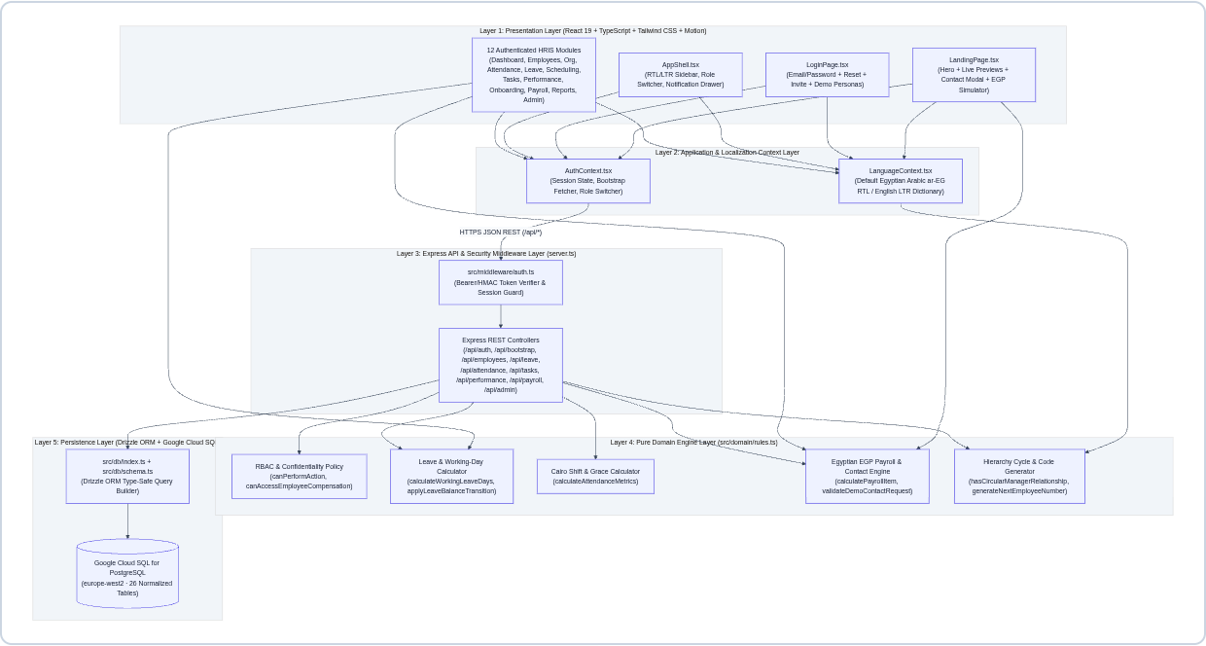
Figure 1 – UML component and five-layer clean architecture diagram

3. Functional Modules
The platform comprises a public landing page (M00) and fourteen functional modules (M01–M14), providing end-to-end coverage of the HRIS domain. Table 3 lists each module with its route and principal implemented capabilities.
Table 3 – Functional modules catalog
ID | Module | Route | Key Implemented Capabilities and Validations
M00 | Interactive Landing Page | / | Animated hero section, live attendance/payroll/leave preview, EGP payroll simulator, demo booking modal
M01 | Authentication and Activation | /login | Email/password sign-in, password reset, invite-token activation (INV-XXXXXX), one-click role cards
M02 | Role-Scoped Dashboard | /dashboard | Tailored KPIs for Admin, HR, Department Manager, and Employee roles; live UTC check-in/out; workforce charts
M03 | Employee Directory | /employees | 360° profiles, search and filtering, CSV export, automatic NW-EMP-XXX code generation, circular-hierarchy guard, archiving
M04 | Organization and Hierarchy | /organization | Department CRUD, active-staff archive guard, EGP salary bands, interactive collapsible organization chart
M05 | Attendance and Punctuality | /attendance | Server-side UTC check-in/out, duplicate-session guard, Cairo 09:00 start with 15-minute grace calculation, attendance corrections
M06 | Leave and Entitlements | /leave | Excludes Friday/Saturday and Cairo public holidays, date-overlap guard, pending/used quota transitions, approvals
M07 | Shifts and Holidays | /scheduling | Morning (09:00), Flex (10:00), and Night (22:00) shifts; employee shift assignments; holiday calendar
M08 | Tasks and Kanban Board | /tasks | Five-column Kanban board (TODO, IN_PROGRESS, IN_REVIEW, COMPLETED, BLOCKED), progress slider, and comments
M09 | Performance and OKRs | /performance | Weighted competency matrix (1.0–5.0), automatic rating category, DRAFT → PUBLISHED → ACKNOWLEDGED workflow
M10 | Onboarding and Offboarding | /onboarding | Automated IT/HR/Finance/Manager clearance tasks with live recalculation of the employee onboarding percentage
M11 | EGP Payroll and Compensation | /payroll | Monthly EGP payroll cycles (for example, PAY-2026-10), unpaid-leave deduction engine, strict RBAC confidentiality
M12–M14 | Reports, Notifications, and Administration | /reports,  /admin | Header notification bell, CSV exports, RBAC role assignment with self-demotion lock, audit log viewer

4. Security and Access Control
NexaHR enforces permissions on the server for every Express endpoint and every PostgreSQL query, so that access control never depends on the client.

4.1 Role-Based Access Control and Role Personas
Table 4 describes the four role personas provisioned for NexaWorks and the operational scope authorized for each. All demonstration accounts use the seeded password NexaHR@2026.
Table 4 – Provisioned role personas and authorized scope
RBAC Role | Demo Persona | Email | Authorized Operational Scope
SYSTEM_ADMIN | Eng. Tarek El-Masry (CTO) | admin@nexaworks.eg | Full organization settings, RBAC role management, immutable audit logs, and all HR and payroll modules
HR_MANAGER | Laila Hassan (Head of People) | hr@nexaworks.eg | Employee create/read/update/archive, departments, onboarding, leave overrides, EGP payroll and compensation
DEPARTMENT_MANAGER | Eng. Omar Abdelrahman (VP Engineering) | manager@nexaworks.eg | Attendance and leave approvals for direct reports, team Kanban tasks, and OKR reviews (no access to team salaries)
EMPLOYEE | Eng. Nour El-Din (Senior Engineer) | employee@nexaworks.eg | Self-service check-in/out, leave requests, assigned tasks, review sign-off, and personal EGP payslip

4.2 Server-Side Security and Confidentiality Guarantees
- Compensation and payroll isolation: Enforced through canAccessEmployeeCompensation() in src/domain/rules.ts and in server.ts (/api/bootstrap). Department Managers are blocked at the API layer from viewing other employees’ base salaries, allowances, or payroll registers.
- Self-approval and scope guards: Enforced through canApproveLeaveForEmployee(). A Department Manager may approve leave requests or attendance corrections only for direct reports or employees within the managed department, and may never approve their own requests.
- Administrator self-demotion lock and audit redaction: The endpoint PATCH /api/admin/users/:profileId/role prevents System Administrators from revoking their own SYSTEM_ADMIN role. The logAudit() function automatically removes password, passwordHash, and token fields before records are persisted to audit_logs.

5. Static Models
This chapter presents the static models of the system: the use case model, the domain class model, and the relational database schema.

5.1 Use Case Diagram
The use case model captures four actor tiers, role generalization (inheritance), 14 functional use cases, and «include» security subroutines.
- Actor generalization hierarchy: Department Manager and HR Manager inherit all Employee self-service capabilities (UC-01 through UC-11A). The System Administrator inherits the operational capabilities of the HR Manager and adds UC-13 (RBAC Governance) and UC-14 (Security Audit Inspection).
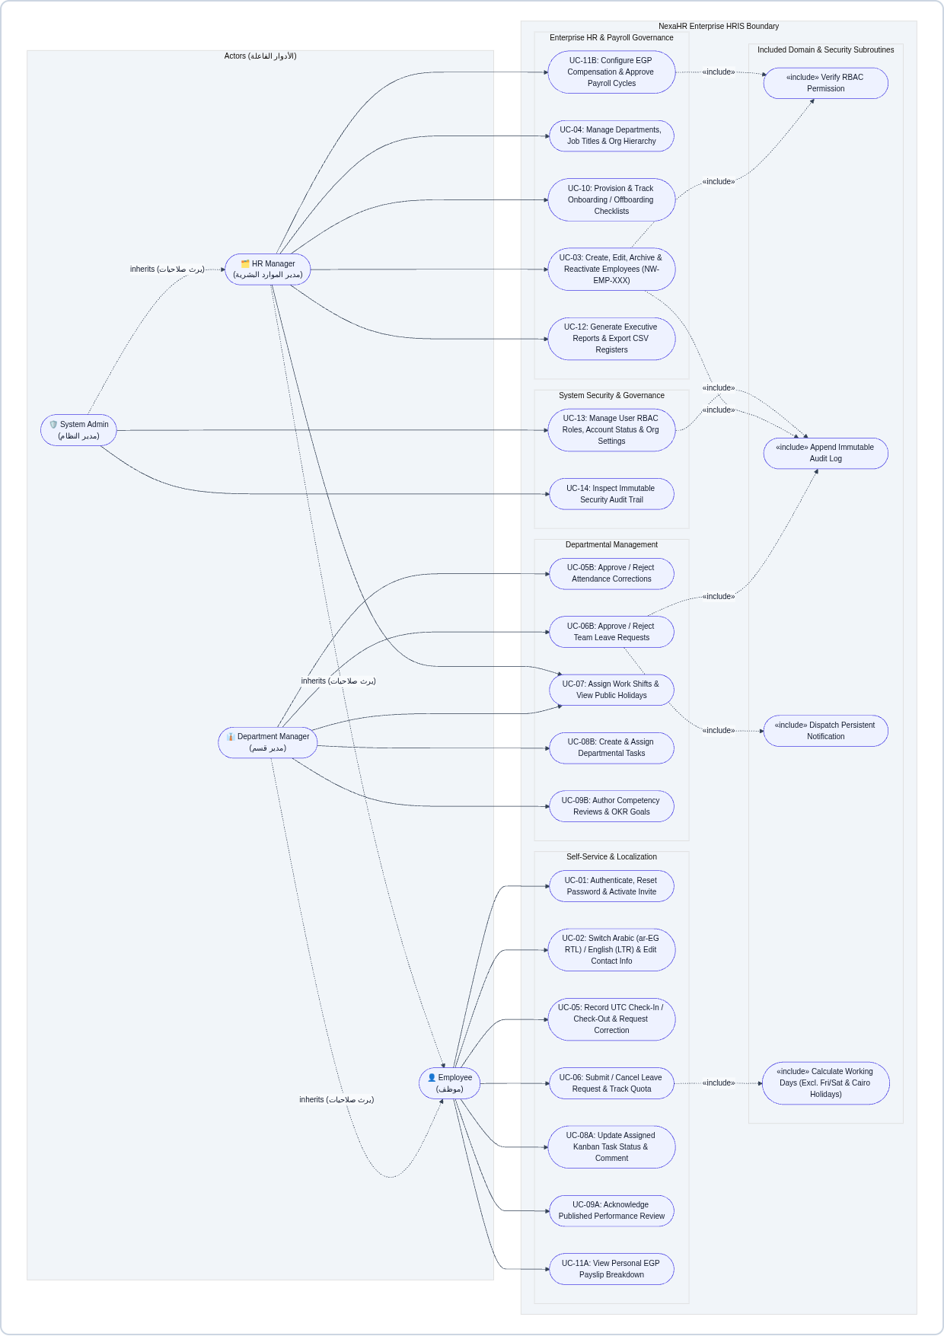
Figure 2 – UML use case diagram across the NexaHR enterprise HRIS system boundary

5.2 Domain Class Diagram
The class model captures the core domain classes, their encapsulated business operations, and the multiplicity of associations across the HRIS domain.
- Pure domain service layer (`NexaHRDomainRules`): Encapsulates deterministic, side-effect-free domain operations, including validateEmployeeInput(), hasCircularManagerRelationship(), generateNextEmployeeNumber(), calculateWorkingLeaveDays(), applyLeaveBalanceTransition(), calculateAttendanceMetrics(), and calculatePayrollItem().
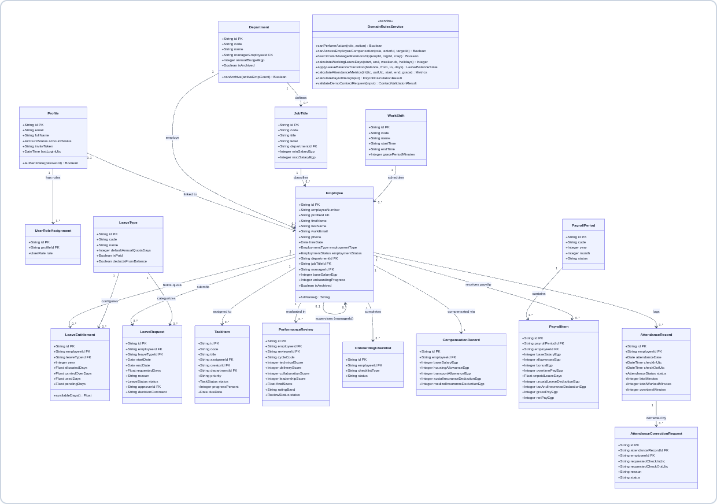
Figure 3 – UML domain class diagram showing core entities, attributes, methods, and multiplicities

5.3 Database Schema and Entity-Relationship Diagram
The persistence layer consists of 26 normalized PostgreSQL tables defined in src/db/schema.ts, with strict foreign-key integrity and audit history. Table 5 groups the tables by schema domain, and Figure 4 presents the entity-relationship diagram in crow’s foot notation.
Table 5 – PostgreSQL schema domains and relational integrity rules
Schema Domain Group | PostgreSQL Tables | Key Relational Integrity Rules
Identity and RBAC (4) | profiles, user_roles, role_permissions, audit_logs | One-to-many relationship between profile and roles; immutable, append-only audit_logs with JSON metadata
Organization and Directory (6) | organization_settings, departments, job_titles, employees, employee_status_history, employee_documents | Self-referencing employees.manager_id (acyclic); non-destructive ARCHIVED status
Attendance and Leave (7) | work_shifts, shift_assignments, attendance_records, attendance_correction_requests, leave_types, leave_entitlements, leave_requests, public_holidays | One open attendance session per employee; transactional allocated/used/pending leave quotas
Tasks, OKRs, and Lifecycle (6) | tasks, task_comments, performance_goals, performance_reviews, onboarding_checklists, onboarding_tasks | Task progress and checklist completion automatically recalculate the employee onboarding percentage
Payroll and Notifications (3) | compensation_records, payroll_periods, payroll_items, notifications | Historical salary versioning (is_current); EGP payroll items linked to payroll periods

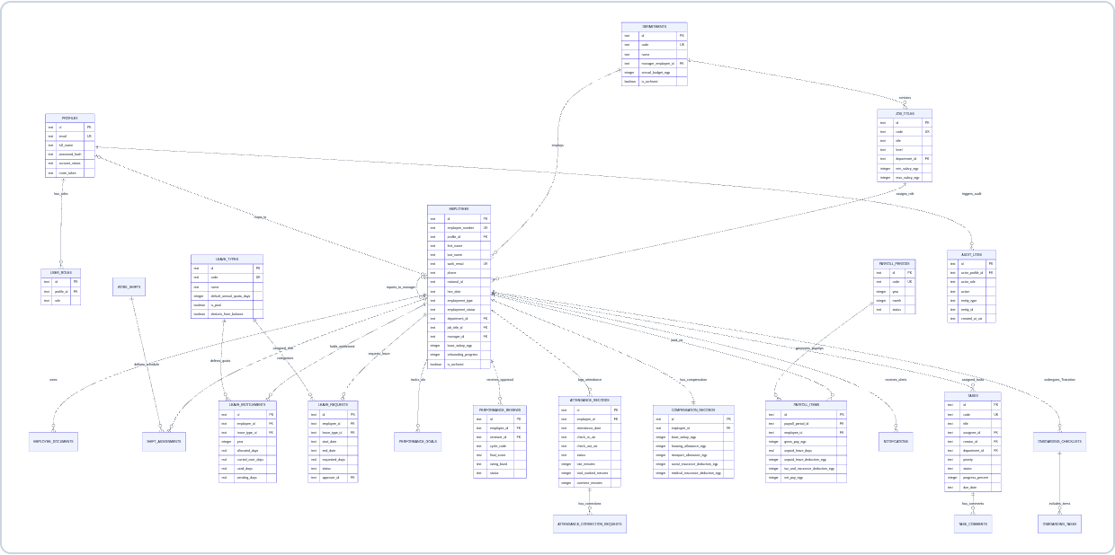
Figure 4 – Crow’s foot entity-relationship (ER) diagram of the normalized PostgreSQL database

6. Dynamic Models
This chapter presents the dynamic behavior of NexaHR through UML activity diagrams, sequence diagrams, and state machine diagrams.

6.1 Activity Diagrams

6.1.1 Leave Request and Approval Workflow
This activity diagram models the exclusion of Egyptian weekends and holidays, overlap prevention, pending-quota reservation, and the manager decision branches.
- Transactional quota state machine: Submitting a paid leave request immediately reserves pending_days. Approval moves the reserved days from pending_days to used_days, whereas rejection or cancellation by the employee restores the days to the available balance.
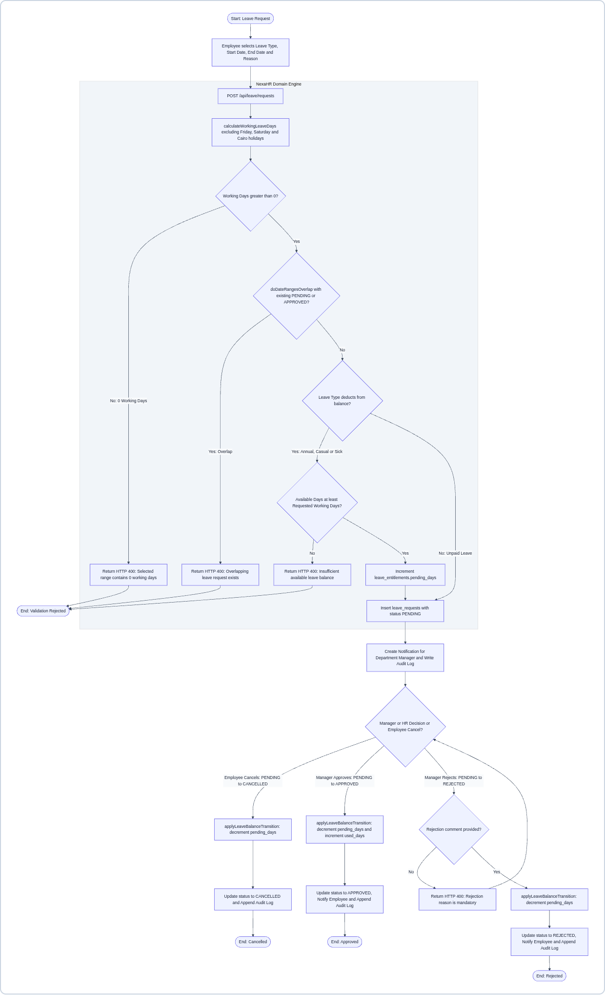
Figure 5 – UML activity diagram: leave submission, domain validation, and approval, rejection, or cancellation

6.1.2 Attendance and Punctuality Workflow
This activity diagram models server-authoritative UTC check-in and check-out, evaluation of punctuality in the Cairo timezone (09:00 start with a 15-minute grace period), and the attendance correction workflow.
- Grace period and worked-hours calculation: The system evaluates checkInUtc against the shift start time (09:00 Africa/Cairo) plus a 15-minute grace window (until 09:15). At check-out it computes the total workedMinutes and overtimeMinutes, and employees may submit correction requests for manager review.
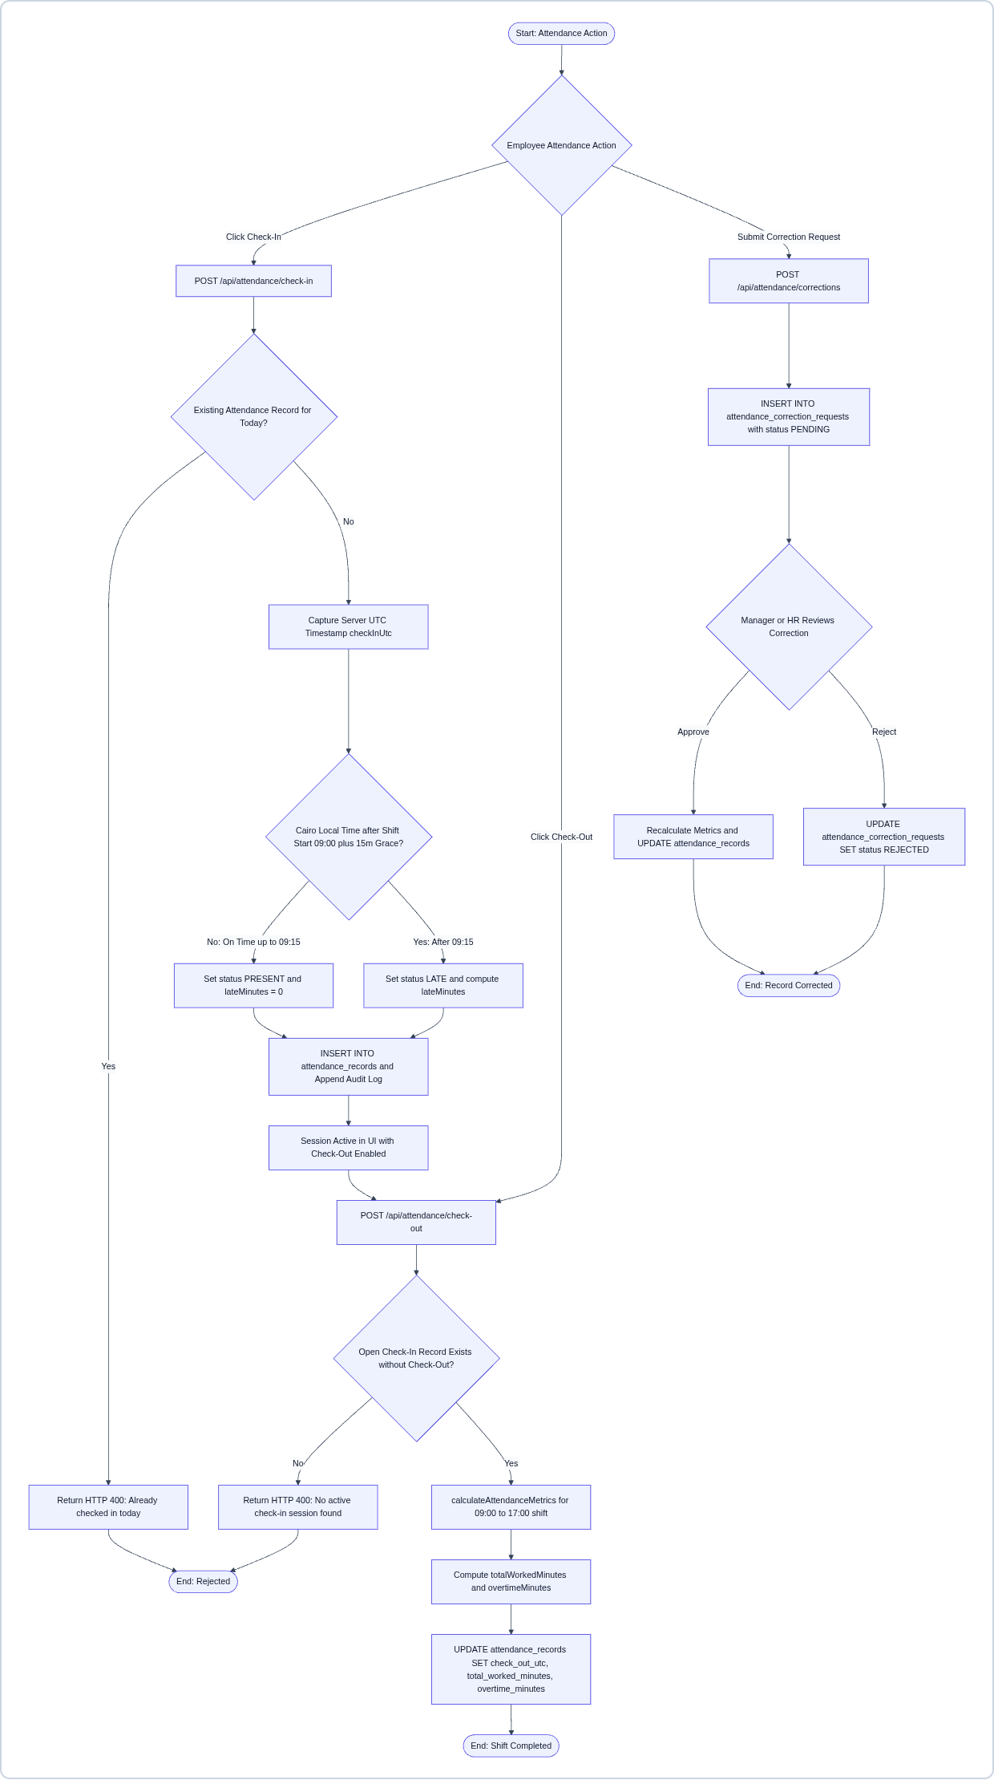
Figure 6 – UML activity diagram: daily check-in, check-out, grace-period evaluation, and attendance correction

6.1.3 Employee Creation and Auto-Provisioning
This activity diagram models the multi-table transactional provisioning that is triggered when an HR Manager or Administrator creates a new employee through POST /api/employees.
- Automated multi-table provisioning: After verifying RBAC permissions, field rules, and the acyclic manager hierarchy (hasCircularManagerRelationship), the server generates the next sequential NW-EMP-XXX code and, in parallel, provisions the 2026 leave quotas, the EGP compensation record, and four onboarding clearance tasks.
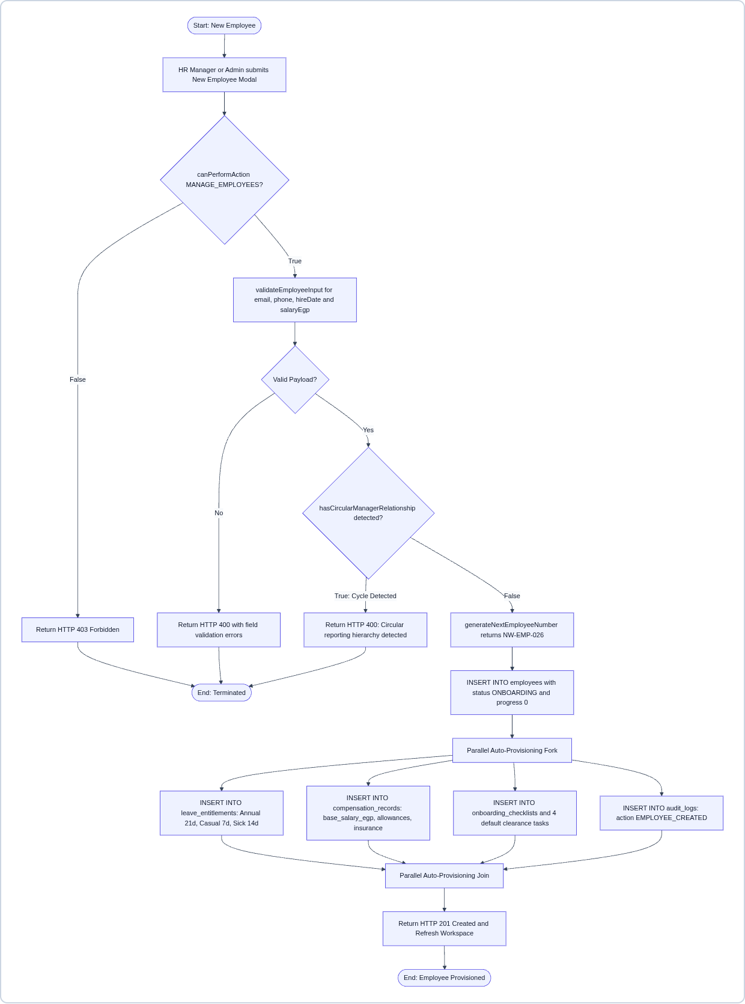
Figure 7 – UML activity diagram: employee creation, circular-hierarchy guard, and parallel auto-provisioning

6.2 Sequence Diagrams

6.2.1 Leave Submission and Manager Approval
This sequence diagram shows time-ordered lifelines across the Employee, Department Manager, LeavePage UI, Express API, Domain Rules, and Cloud SQL.
- End-to-end message traceability: The diagram illustrates both the validation-failure alternative frame (HTTP 400 Bad Request) and the transactional commit path (HTTP 201 Created), followed by the Department Manager approval through PATCH /api/leave/requests/:id/decision.
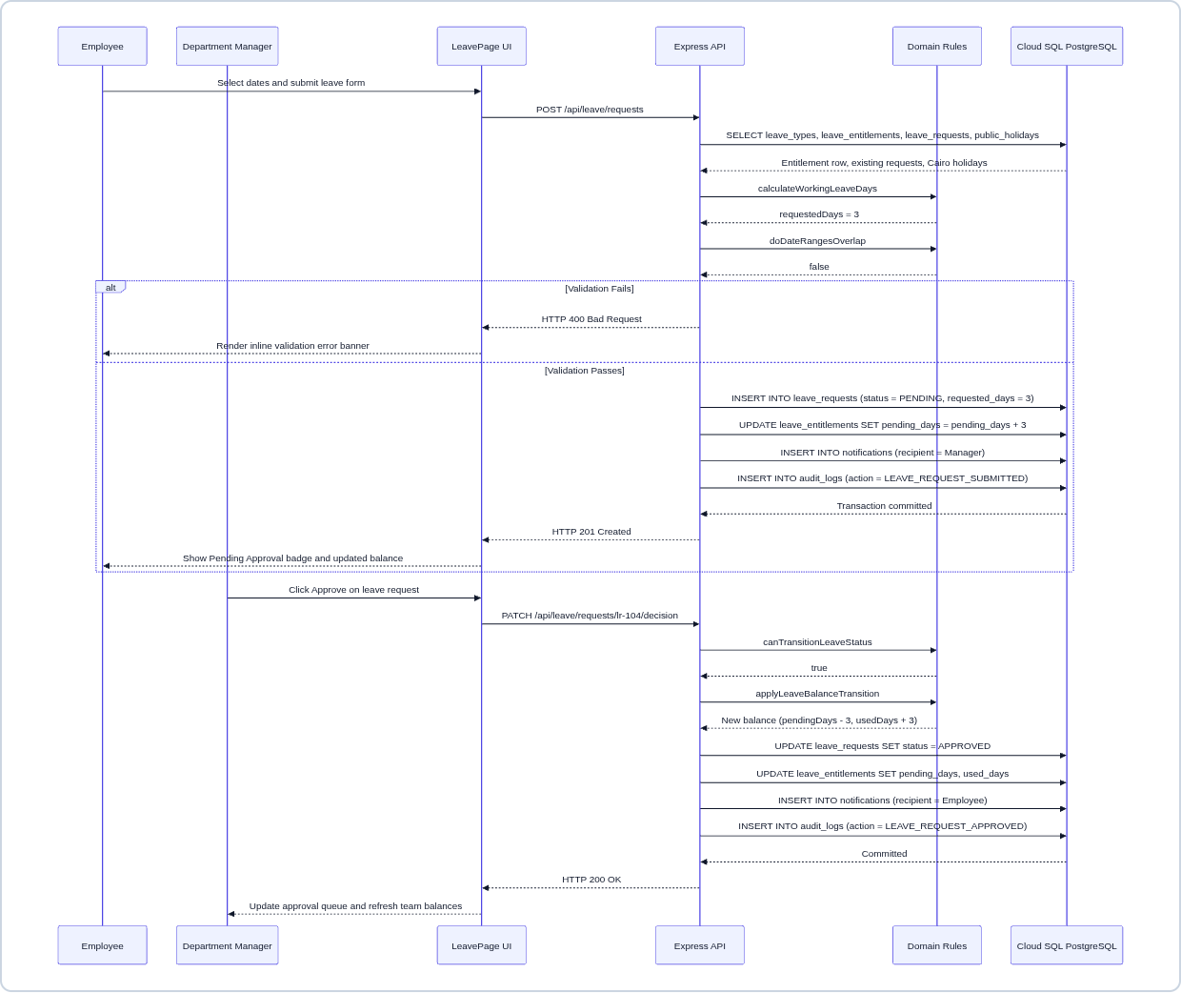
Figure 8 – UML sequence diagram: leave request submission (POST) and manager approval decision (PATCH)

6.2.2 Employee Auto-Provisioning
This sequence diagram shows the HR Manager submitting the New Employee modal, followed by circular-hierarchy validation, generation of the sequential code NW-EMP-026, and the multi-table PostgreSQL inserts.
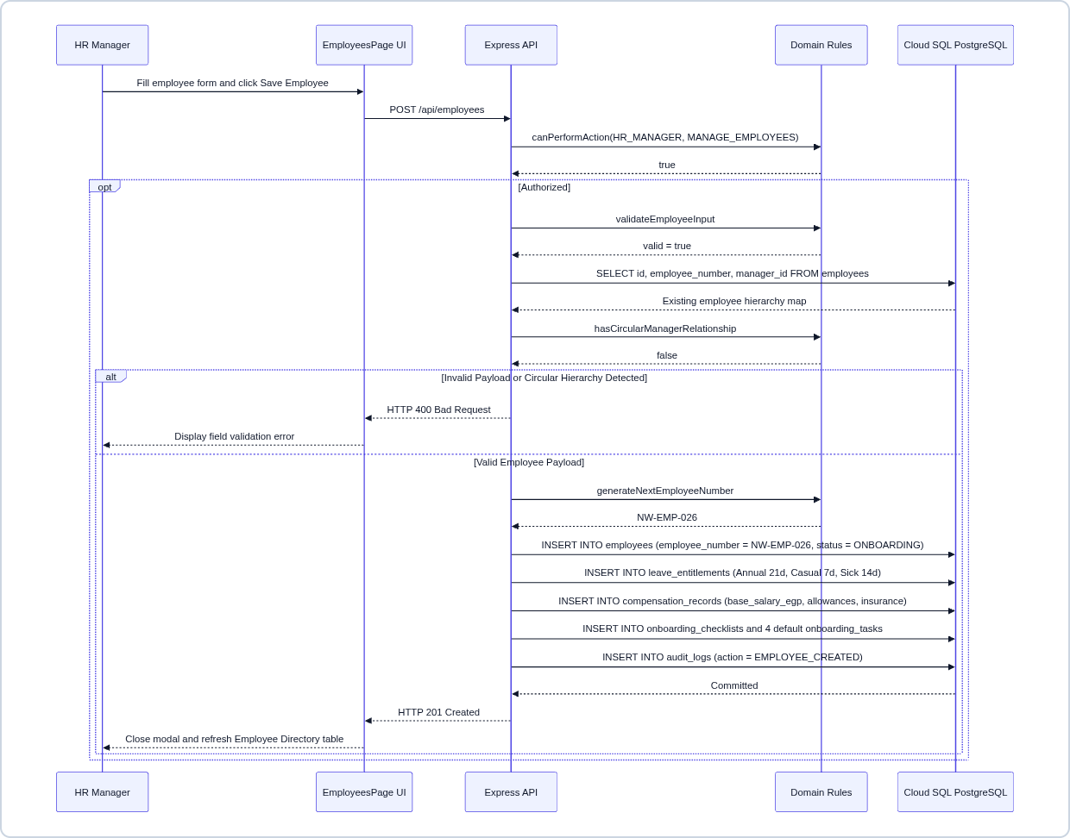
Figure 9 – UML sequence diagram: employee creation and provisioning

6.2.3 Authentication and Arabic RTL Bootstrap
This sequence diagram shows LanguageContext initializing the default ar-EG right-to-left locale, POST /api/auth/login issuing a signed HMAC token, and GET /api/bootstrap filtering confidential records according to the RBAC role.
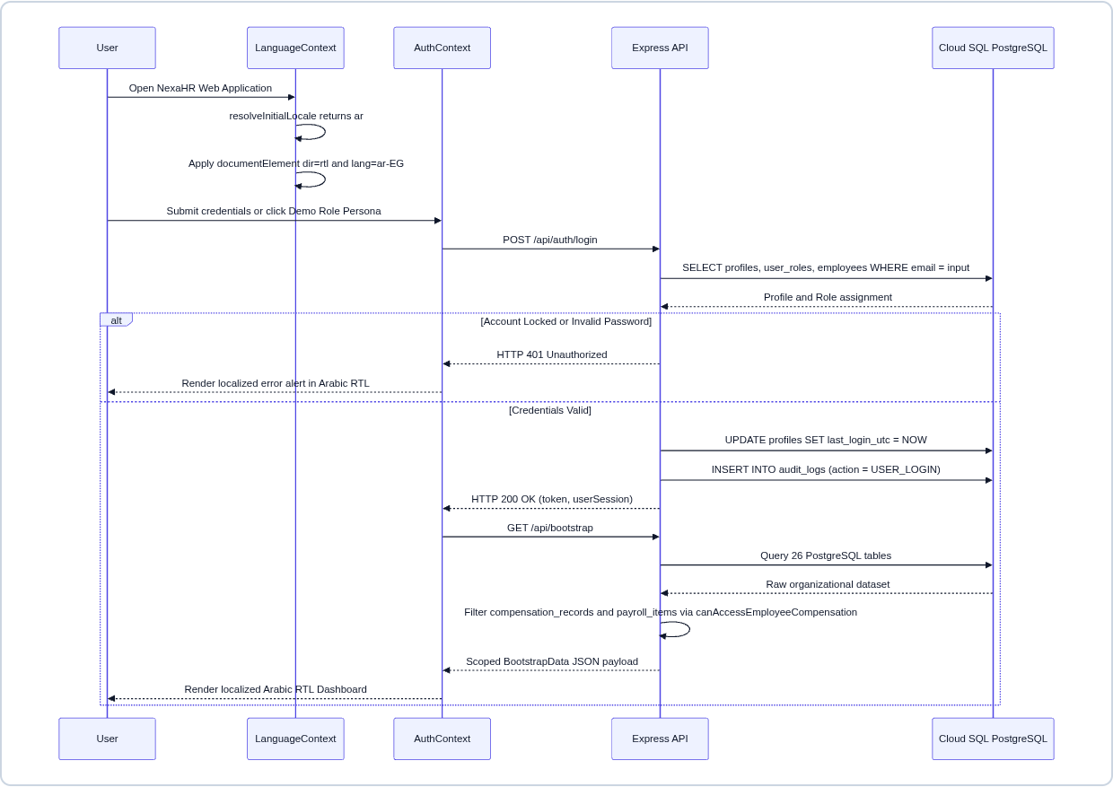
Figure 10 – UML sequence diagram: authentication, RBAC, and Arabic RTL bootstrap

6.2.4 EGP Payroll Calculation
This sequence diagram models the Egyptian EGP payroll calculation, the payroll cycle approval, and the RBAC confidentiality guard.
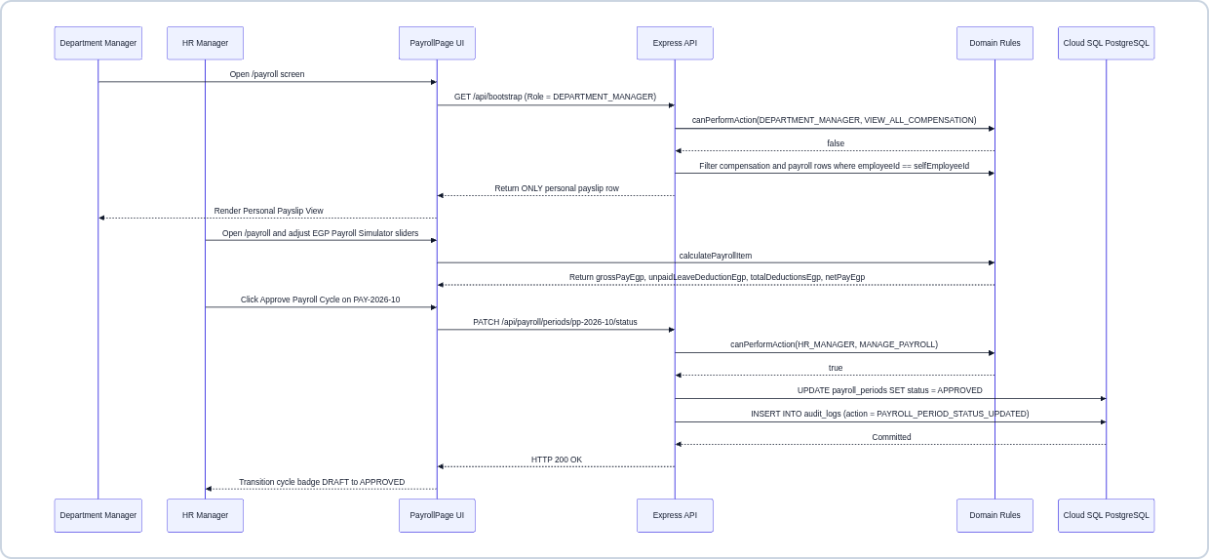
Figure 11 – UML sequence diagram: EGP payroll calculation, cycle approval, and RBAC confidentiality guard

6.3 State Machine Diagrams

6.3.1 Leave Request Lifecycle
This state machine models the lifecycle of a leave request (PENDING, APPROVED, REJECTED, and CANCELLED) and the quota adjustments applied on each transition.
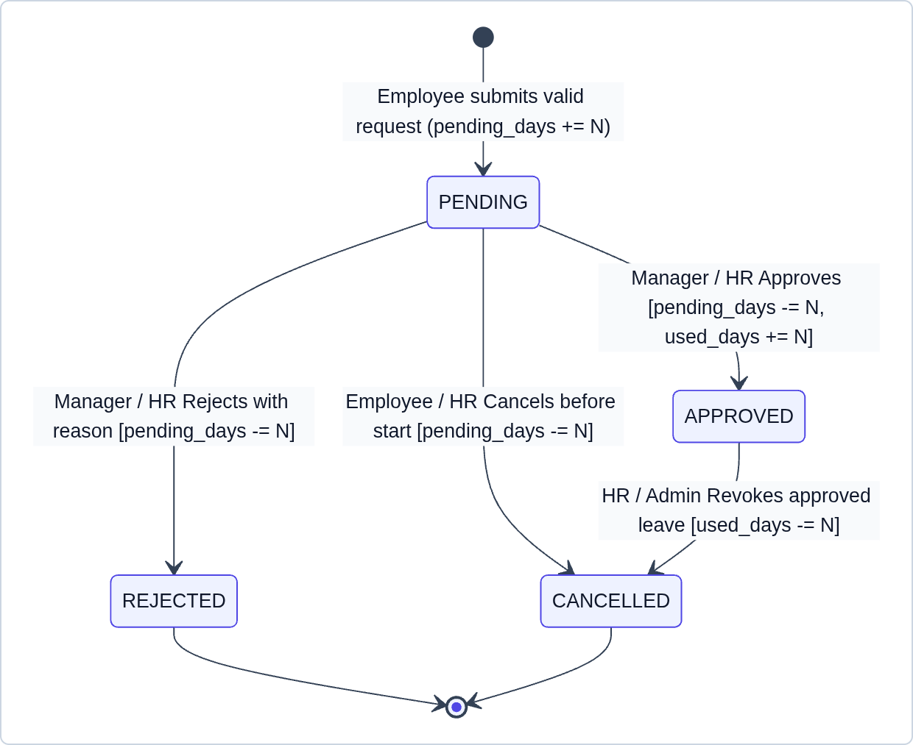
Figure 12 – UML state machine: leave request lifecycle

6.3.2 Task (Kanban) Lifecycle
This state machine models the lifecycle of a Kanban task through the states TODO, IN_PROGRESS, IN_REVIEW, COMPLETED, and BLOCKED, driven by the task progress value.
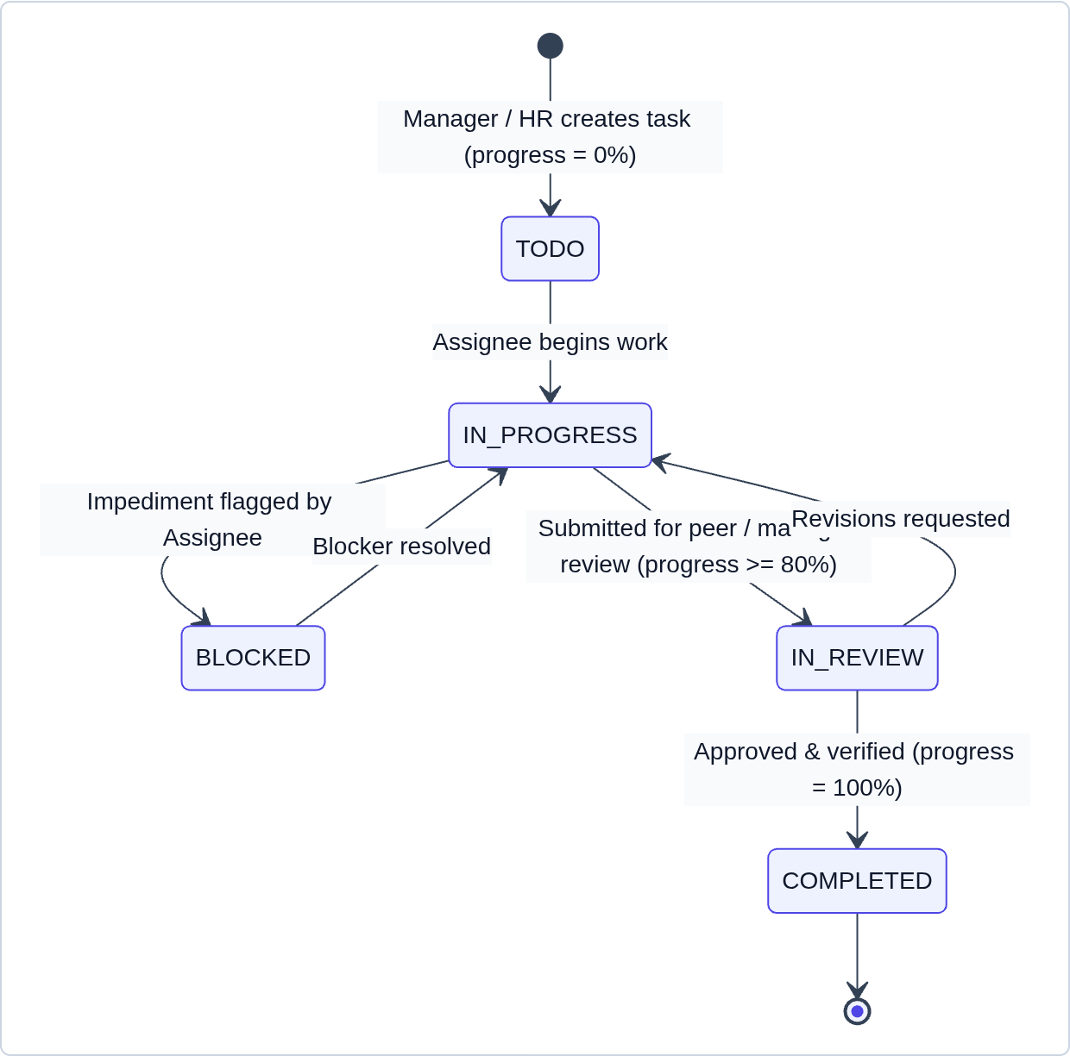
Figure 13 – UML state machine: task (Kanban) lifecycle

6.3.3 Performance Review and Payroll Period Lifecycles
These state machines model the multi-stage performance review lifecycle (DRAFT, PUBLISHED, ACKNOWLEDGED) and the payroll period lifecycle (PAY_DRAFT, PAY_APPROVED, PAID).
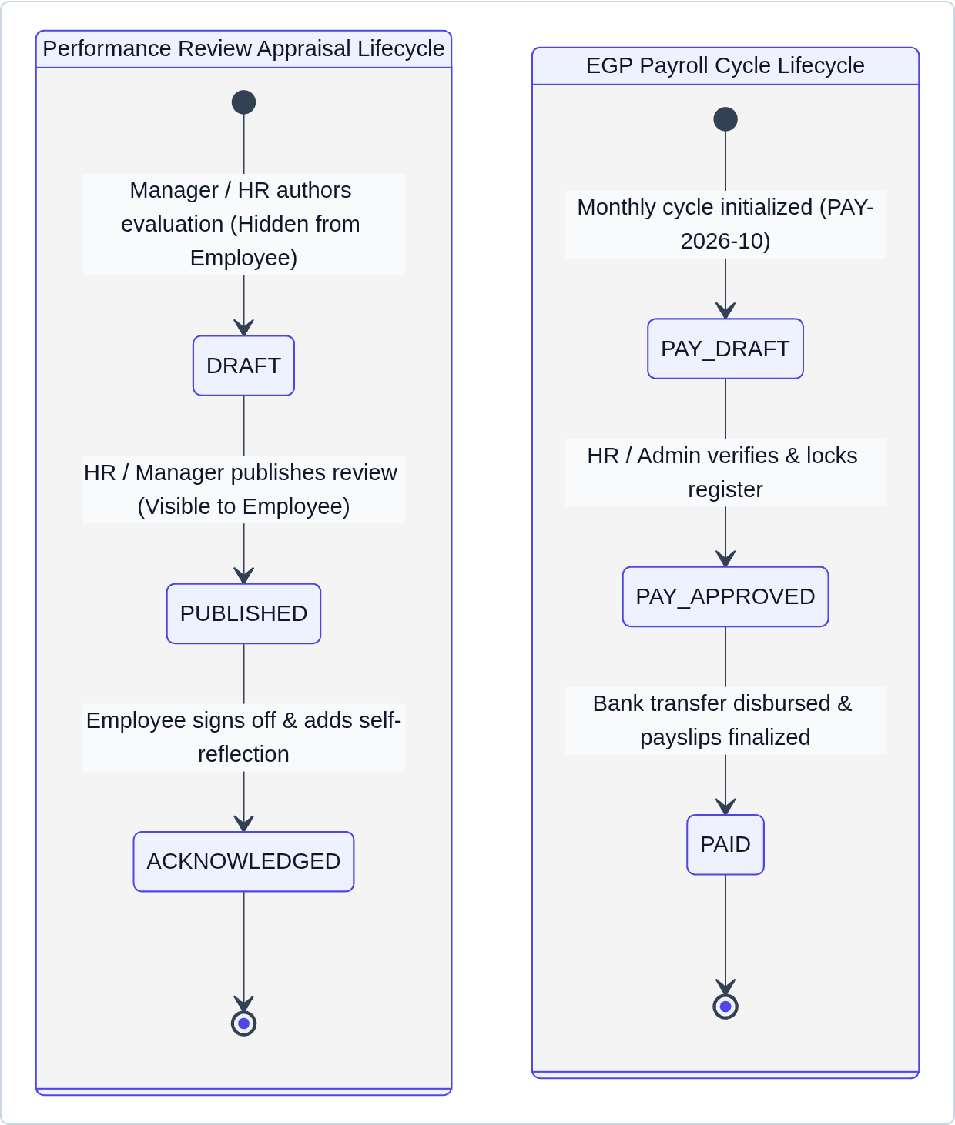
Figure 14 – UML state machines: performance review and payroll period lifecycles

7. Deployment Architecture

7.1 Runtime and Database Topology
A containerized Node.js 22 application (Express with the bundled Vite SPA) is deployed on Google Cloud Run (port 3000, HTTPS) and connects through an encrypted TLS connection pool to Google Cloud SQL for PostgreSQL 16 in europe-west2. Figure 15 presents the UML deployment diagram of the production cloud infrastructure.
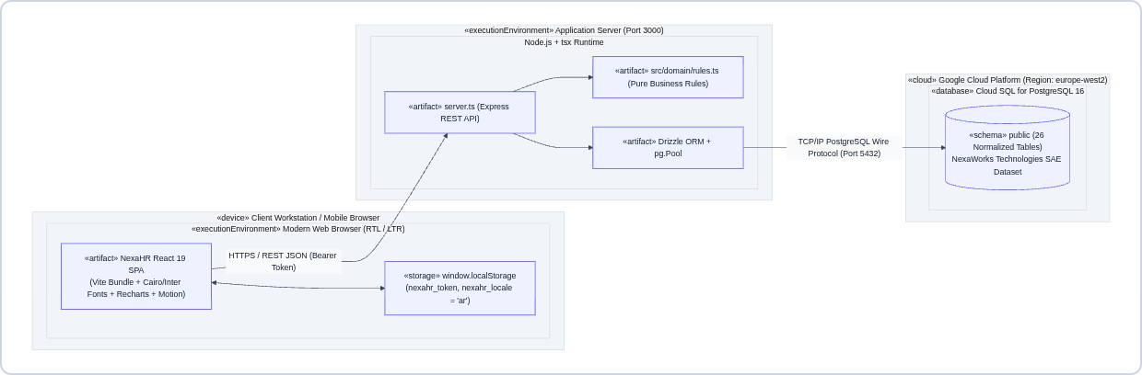
Figure 15 – UML deployment and cloud infrastructure diagram

7.2 Idempotent Bootstrapping
On startup, server.ts executes ensureNexaWorksSeeded() to verify that all 26 PostgreSQL tables exist and to seed the 25-employee Cairo dataset when the database is empty. This makes deployment and restarts zero-downtime and idempotent.

8. Testing and Verification
Verification combines pure domain unit tests (node:test), TypeScript compilation, and mobile and desktop browser checks.

8.1 Automated Domain Unit Tests
The test suite in src/domain/rules.test.ts contains 10 test cases, all of which pass. Table 6 maps each test to the domain rule it verifies in src/domain/rules.ts.
Table 6 – Domain unit test results
Test Case ID | Verified Domain Rule | Status
TEST-01 and TEST-02 | Employee field validation, EGP salary bounds, self-reporting guard, and circular manager loop detection | PASS
TEST-03 | Sequential employee code generator (generateNextEmployeeNumber → NW-EMP-026) | PASS
TEST-04 and TEST-05 | Working leave days calculator (excludes Friday/Saturday and Cairo holidays) and overlapping date range detection | PASS
TEST-06 | Transactional leave state machine and balance transitions (SUBMIT, APPROVE, REJECT, CANCEL) | PASS
TEST-07 | Attendance worked/late/overtime calculator with 15-minute grace period and overnight shift support | PASS
TEST-08 | Egyptian EGP payroll formula (Gross = Base + Allowances, unpaid-leave deduction, Net Pay) | PASS
TEST-09 | Strict four-role RBAC permission matrix and compensation confidentiality enforcement | PASS
TEST-10 | Egyptian Arabic (ar-EG RTL) localization and bilingual demo contact request validation | PASS

8.2 Full-Stack and Mobile Responsiveness Acceptance
- Zero horizontal overflow on mobile phones (375×812): Verified across /, /login, /dashboard, /employees, /organization, /attendance, /leave, /tasks, /performance, and /payroll, in both Egyptian Arabic (RTL) and English (LTR), with document.documentElement.scrollWidth <= window.innerWidth.

8.3 Commands for Local Execution and Verification
Table 7 – Local execution and verification commands
Purpose | Command
Install dependencies | npm install
Run the full-stack server | npm run dev (http://localhost:3000)
Run the domain unit tests | npx tsx --test src/domain/rules.test.ts
Type-check and build | npm run lint && npm run build

