SLIDE 01 / 15 | NexaHR — Enterprise Employee Management System — منصة NexaHR للموارد البشرية
Formal Software Engineering II Project Documentation & Complete UML Specification Deck (15 Slides)
"People, Performance, Possibilities." | «الكوادر، الأداء، وآفاق المستقبل.»
- Executive Summary: NexaHR is a full-stack, production-grade Human Resource Information System (HRIS) engineered for NexaWorks Technologies SAE (New Cairo, Egypt). It unifies employee lifecycle records, Egyptian labor calendar leave rules, shift grace-period attendance, Kanban task execution, weighted OKR performance reviews, and confidential EGP payroll governance.
- Bilingual RTL/LTR & Mobile-First UX: Opens in Egyptian Arabic (ar-EG RTL) by default with instant switching to English (LTR), preserving the English "NexaHR" brand identity and responsive mobile layouts (375px–1440px) with a quick-navigation bottom bar.
- Relational Persistence & Pure Domain Engine: Backed by 26 normalized PostgreSQL tables on Google Cloud SQL (europe-west2) managed via Drizzle ORM, paired with a decoupled, 100% unit-tested domain rule engine in src/domain/rules.ts.
Project Identity & Baseline Specifications
Specification Dimension | Implemented Production Configuration
Platform Brand & Tagline | NexaHR — "People, Performance, Possibilities." (Brand always rendered as NexaHR)
Default Organization | NexaWorks Technologies SAE (Headquartered in New Cairo, Cairo Governorate, Egypt)
Regional Baseline | Timezone: Africa/Cairo (UTC+2) | Currency: EGP | Weekend: Friday & Saturday | Date: DD/MM/YYYY
Default Language & Direction | Egyptian Arabic (ar-EG, dir="rtl") default + Full English (en, dir="ltr") support
Frontend & Motion Stack | React 19, TypeScript, Tailwind CSS v4, Motion (motion/react), Recharts, Lucide Icons
Backend & Database Stack | Node.js, Express REST API, Drizzle ORM, Google Cloud SQL for PostgreSQL (26 Tables)
Seeded Enterprise Dataset | 25 Active/Onboarding/Archived Employees, 5 Departments, 14 Job Titles, 4 Role Personas
SLIDE 02 / 15 | 5-Layer Clean Architecture & Component Model — المعمارية الهندسية خماسية الطبقات
Strict separation of concerns across Presentation, Application State, Pure Domain Rules, API Controllers, and Cloud SQL
Architecture Layer | Source Files | Core Engineering Responsibility
1. Presentation Layer | src/features/*, AppShell.tsx | Responsive RTL/LTR UI, Landing Page simulator, 12 workspace views, mobile bottom nav & drawer
2. Application Layer | AuthContext.tsx, LanguageContext.tsx | Session token lifecycle, /api/bootstrap synchronization, role switching, ar-EG/en localization
3. Domain Layer | src/domain/rules.ts, rules.test.ts | Pure business logic: RBAC matrix, circular manager check, working days, attendance & EGP payroll
4. Data Access & API | server.ts, src/middleware/auth.ts | Express REST routes, HMAC token verification, server-side RBAC guards, audit trail & notifications
5. Persistence Layer | src/db/schema.ts, src/db/seed.ts | 26 normalized PostgreSQL tables with FK constraints and idempotent 25-employee Cairo seed
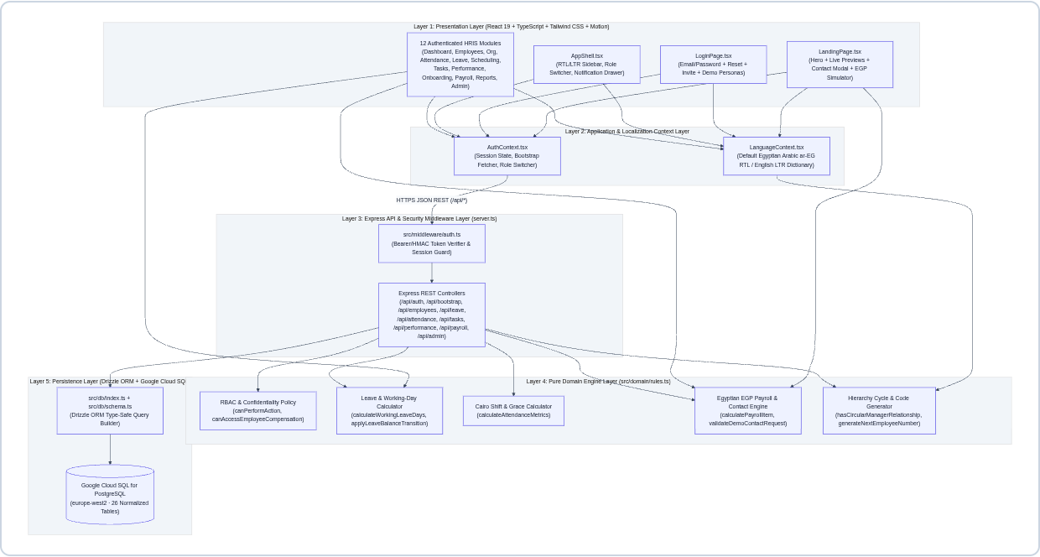
Figure 2.1 — UML Component & 5-Layer Clean Architecture Diagram (Presentation → Application → Domain → API → Cloud SQL)
SLIDE 03 / 15 | Implemented Functional Modules Catalog — وحدات النظام الوظيفية المتكاملة
End-to-end functional coverage across the public Landing Page, Authentication Portal, and 14 core HRIS modules
Module ID & Name | Route / Scope | Key Implemented Capabilities & Domain Validations
M00: Interactive Landing Page | / | Smooth motion hero, live Attendance/Payroll/Leave preview, EGP Payroll Simulator, Demo Booking Modal
M01: Auth & Activation | /login | Email/password sign-in, password reset, invite token activation (INV-XXXXXX), 1-click role cards
M02: Role-Scoped Dashboard | /dashboard | Tailored KPIs for Admin, HR, Dept Manager, and Employee; live UTC check-in/out & workforce charts
M03: Employee Directory | /employees | 360° profiles, search/filter, CSV export, auto NW-EMP-XXX code, circular hierarchy guard, archive
M04: Organization & Hierarchy | /organization | Department CRUD, active-staff archive guard, EGP salary bands, interactive collapsible Org Chart
M05: Attendance & Punctuality | /attendance | Server UTC check-in/out, duplicate session guard, Cairo 09:00 + 15m grace calculation, corrections
M06: Leave & Entitlements | /leave | Excludes Fri/Sat & Cairo holidays, date-overlap guard, pending/used quota transitions, approvals
M07: Shifts & Holidays | /scheduling | Morning (09:00), Flex (10:00) & Night (22:00) shifts, employee shift assignments, holiday calendar
M08: Tasks & Kanban Board | /tasks | 5-column Kanban (TODO, IN_PROGRESS, IN_REVIEW, COMPLETED, BLOCKED), progress slider & comments
M09: Performance & OKRs | /performance | Weighted competency matrix (1.0–5.0), auto rating category, DRAFT → PUBLISHED → ACKNOWLEDGED
M10: Onboarding & Offboarding | /onboarding | Automated IT/HR/Finance/Manager clearance tasks with live employee onboarding % recalculation
M11: EGP Payroll & Comp | /payroll | Monthly EGP payroll cycles (PAY-2026-10), unpaid leave deduction engine, strict RBAC confidentiality
M12–M14: Reports, Notifs, Admin | /reports, /admin | Header notification bell, CSV exports, RBAC role assignment with self-demotion lock, audit log viewer
SLIDE 04 / 15 | Role-Based Access Control (RBAC) & Security Governance — مصفوفة الصلاحيات والأمان (RBAC)
Server-authoritative permission enforcement on every Express endpoint and PostgreSQL query
1. Provisioned NexaWorks Role Personas
RBAC Role | Arabic Title | Demo Persona | Email (Pass: NexaHR@2026) | Authorized Operational Scope
SYSTEM_ADMIN | مدير النظام | Eng. Tarek El-Masry (CTO) | admin@nexaworks.eg | Full org settings, RBAC role management, immutable audit logs, all HR & payroll modules
HR_MANAGER | مدير الموارد البشرية | Laila Hassan (Head of People) | hr@nexaworks.eg | Employee CRUD/archive, departments, onboarding, leave overrides, EGP payroll & compensation
DEPARTMENT_MANAGER | مدير إدارة / قسم | Eng. Omar Abdelrahman (VP Eng) | manager@nexaworks.eg | Direct reports attendance/leave approvals, team Kanban tasks & OKR reviews (No team salary access)
EMPLOYEE | موظف | Eng. Nour El-Din (Sr. Engineer) | employee@nexaworks.eg | Self-service check-in/out, leave requests, assigned tasks, review sign-off, personal EGP payslip
2. Server-Side Security & Confidentiality Guarantees
- Compensation & Payroll Isolation: Enforced via canAccessEmployeeCompensation() in src/domain/rules.ts and server.ts (/api/bootstrap). Department Managers are strictly blocked at the API layer from viewing other employees’ base salaries, allowances, or payroll registers.
- Self-Approval & Scope Guards: Enforced via canApproveLeaveForEmployee(). A Department Manager can only approve leave or attendance corrections for direct reports or employees inside their managed department, and can never self-approve.
- Admin Self-Demotion Lock & Audit Redaction: PATCH /api/admin/users/:profileId/role blocks System Admins from revoking their own SYSTEM_ADMIN role. logAudit() automatically strips password, passwordHash, and token fields before persisting to audit_logs.
SLIDE 05 / 15 | System Actors & UML Use Case Specification — مخطط حالات الاستخدام (Use Case Diagram)
Models the 4 actor tiers, role generalization (inheritance), 14 functional use cases, and «include» security subroutines
- Actor Generalization Hierarchy: Department Manager and HR Manager inherit all Employee self-service capabilities (UC-01 through UC-11A). System Administrator inherits HR Manager operational capabilities while adding UC-13 (RBAC Governance) and UC-14 (Security Audit Inspection).
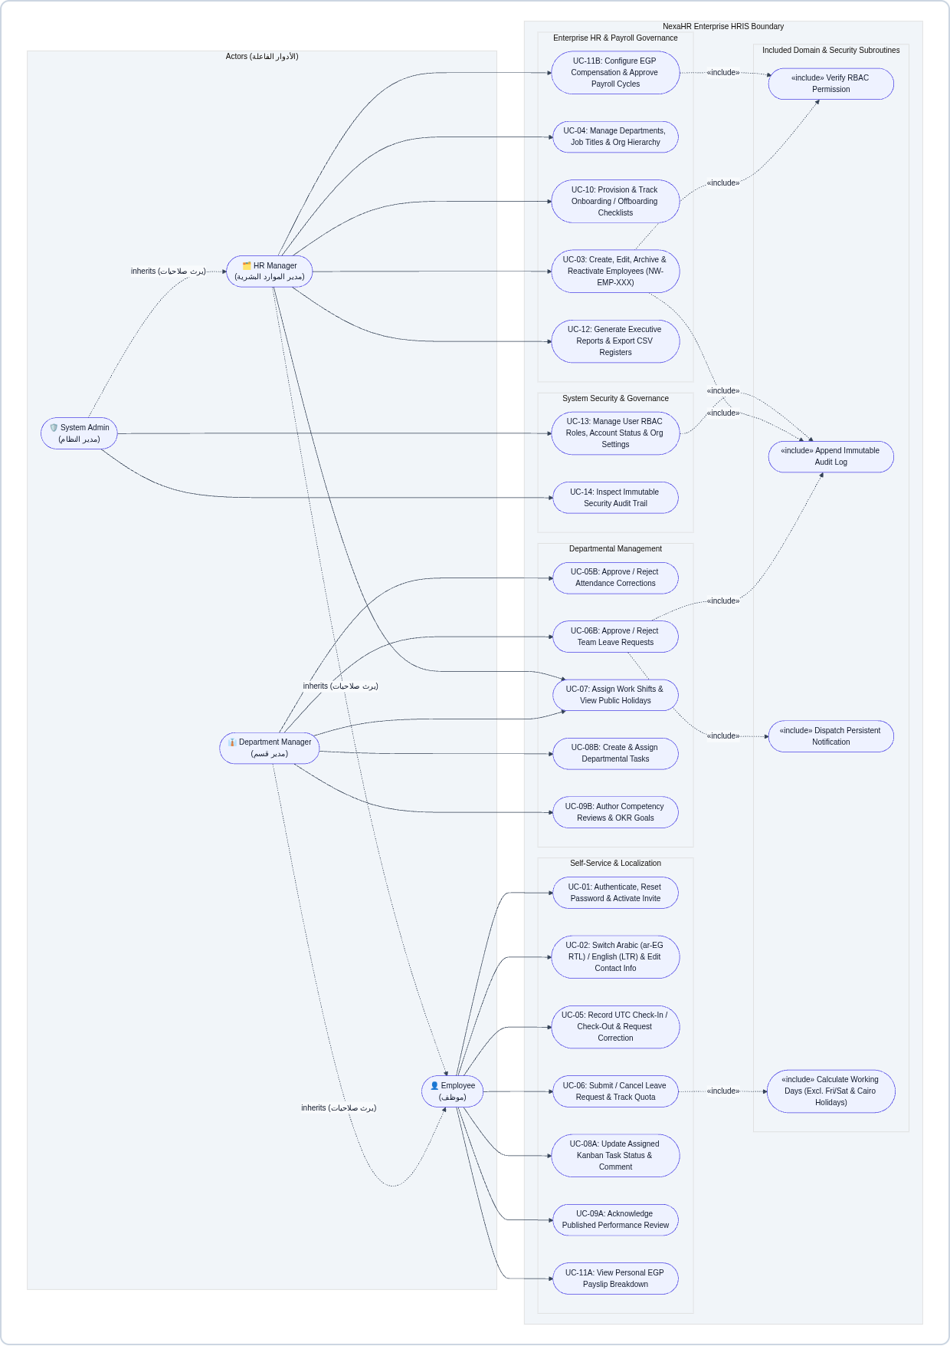
Figure 5.1 — Complete UML Use Case Diagram across the NexaHR Enterprise HRIS System Boundary
SLIDE 06 / 15 | Enterprise Domain Model & UML Class Diagram — مخطط الفئات والكائنات (Class Diagram)
Core domain classes, encapsulated business operations, and multiplicity associations across the HRIS domain
- Pure Domain Service Layer (NexaHRDomainRules): Encapsulates deterministic, side-effect-free domain operations including validateEmployeeInput(), hasCircularManagerRelationship(), generateNextEmployeeNumber(), calculateWorkingLeaveDays(), applyLeaveBalanceTransition(), calculateAttendanceMetrics(), and calculatePayrollItem().
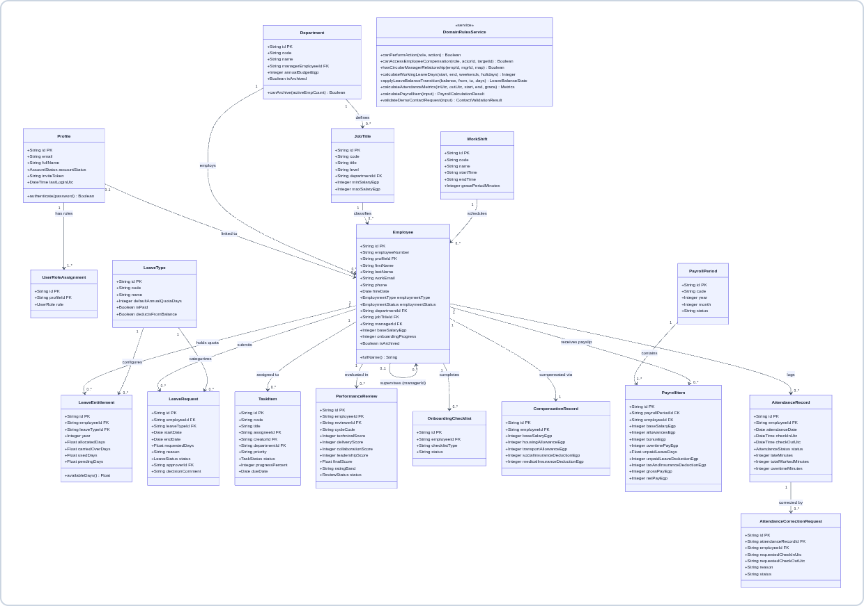
Figure 6.1 — UML Domain Class Diagram showing core entities, attributes, methods, and multiplicities
SLIDE 07 / 15 | PostgreSQL Relational Schema & Crow’s Foot ER Diagram — مخطط علاقات قاعدة البيانات (ERD)
26 normalized PostgreSQL tables defined in src/db/schema.ts with strict foreign-key integrity and audit history
Schema Domain Group | PostgreSQL Tables (26 Total) | Key Relational Integrity Rules
Identity & RBAC (4) | profiles, user_roles, role_permissions, audit_logs | 1:N profile-to-roles; immutable append-only audit_logs with JSON metadata
Org & Directory (6) | organization_settings, departments, job_titles, employees, employee_status_history, employee_documents | Self-referencing employees.manager_id (acyclic); non-destructive ARCHIVED status
Attendance & Leave (7) | work_shifts, shift_assignments, attendance_records, attendance_correction_requests, leave_types, leave_entitlements, leave_requests, public_holidays | Unique open session per employee; transactional allocated/used/pending leave quotas
Tasks, OKRs & Lifecycle (6) | tasks, task_comments, performance_goals, performance_reviews, onboarding_checklists, onboarding_tasks | Task progress & checklist completion auto-recalculate employee onboarding %
Payroll & Notifications (3) | compensation_records, payroll_periods, payroll_items, notifications | Historical salary versioning (is_current); EGP payroll items linked to periods
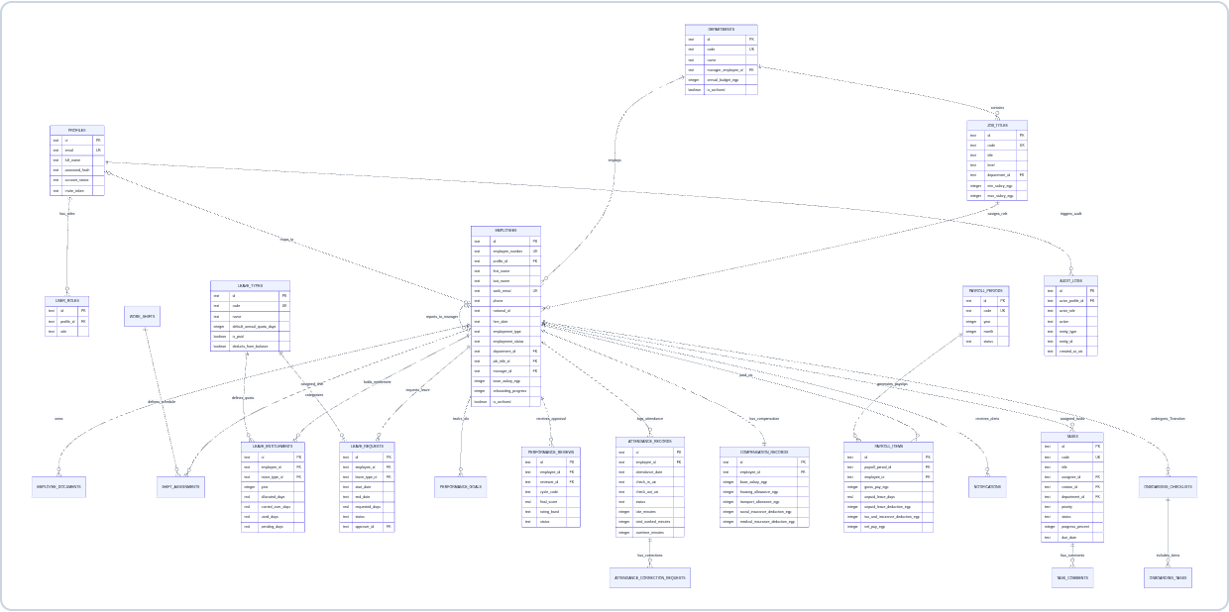
Figure 7.1 — Crow’s Foot Entity-Relationship (ER) Diagram of the Normalized PostgreSQL Database
SLIDE 08 / 15 | UML Activity Diagram — Leave Request & Approval Workflow — مخطط النشاط لدورة الإجازات والأرصدة
Models Egyptian weekend/holiday exclusion, overlap prevention, pending quota reservation, and manager decision branches
- Transactional Quota State Machine: Submitting a paid leave request reserves pending_days immediately. Approval moves pending_days to used_days; Rejection or Employee Cancellation restores pending_days back to available balance.
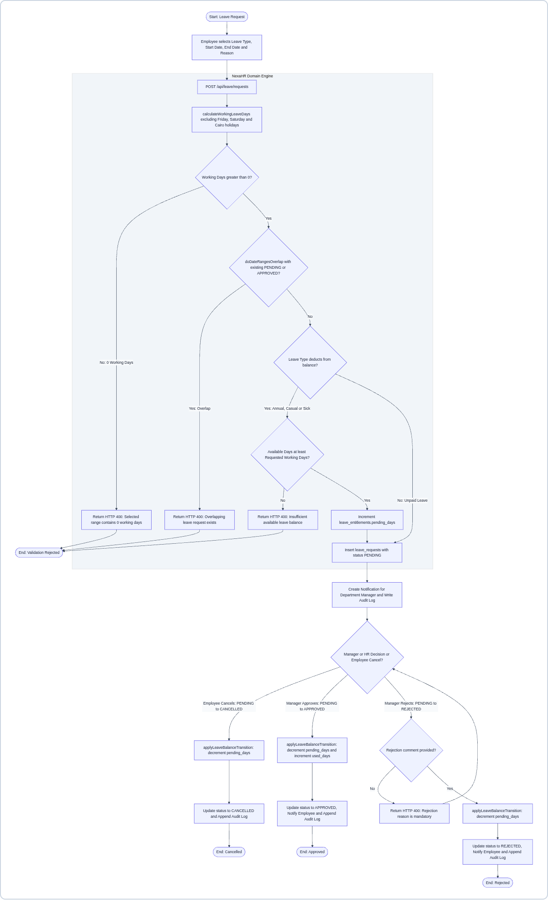
Figure 8.1 — UML Activity Diagram: Leave Submission, Domain Validation, and Approval/Rejection/Cancellation
SLIDE 09 / 15 | UML Activity Diagram — Attendance & Punctuality Workflow — مخطط النشاط للحضور والانصراف وتصحيح البصمة
Server-authoritative UTC check-in/out, Cairo timezone (09:00 + 15m grace) punctuality evaluation, and correction workflow
- Grace Period & Worked Hours Formula: Evaluates checkInUtc against shift start (09:00 Africa/Cairo) + 15-minute grace window (09:15). Check-out computes total workedMinutes and overtimeMinutes, while allowing employees to submit manager-reviewed correction requests.
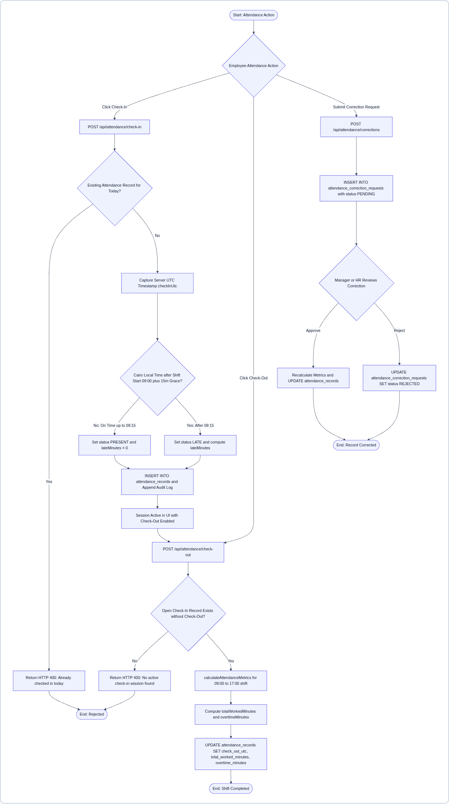
Figure 9.1 — UML Activity Diagram: Daily Check-In, Check-Out, Grace Period Evaluation & Attendance Correction
SLIDE 10 / 15 | UML Activity Diagram — Employee Creation & Auto-Provisioning — مخطط النشاط لإضافة موظف والتجهيز التلقائي
Multi-table transactional provisioning triggered when HR or Admin creates a new employee in POST /api/employees
- Automated Multi-Table Provisioning: After verifying RBAC permissions, field rules, and acyclic manager hierarchy (hasCircularManagerRelationship), the server generates the next sequential NW-EMP-XXX code and provisions 2026 leave quotas, EGP compensation, and 4 onboarding clearance tasks in parallel.
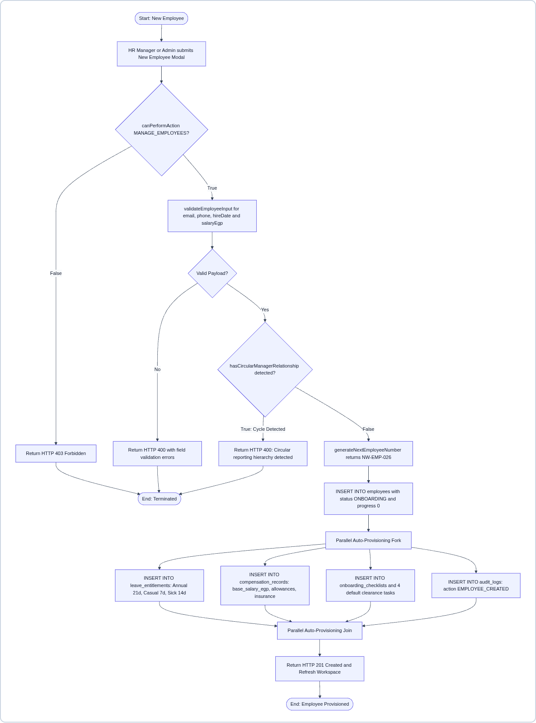
Figure 10.1 — UML Activity Diagram: Employee Creation, Circular Hierarchy Guard & Parallel Auto-Provisioning
SLIDE 11 / 15 | UML Sequence Diagram — Leave Submission & Manager Approval — مخطط التتابع لتقديم واعتماد الإجازات
Time-ordered lifelines across Employee, Department Manager, LeavePage UI, Express API, Domain Rules, and Cloud SQL
- End-to-End Message Traceability: Illustrates both the validation failure alt-frame (HTTP 400 Bad Request) and the transactional commit path (HTTP 201 Created), followed by the Department Manager PATCH /api/leave/requests/:id/decision approval sequence.
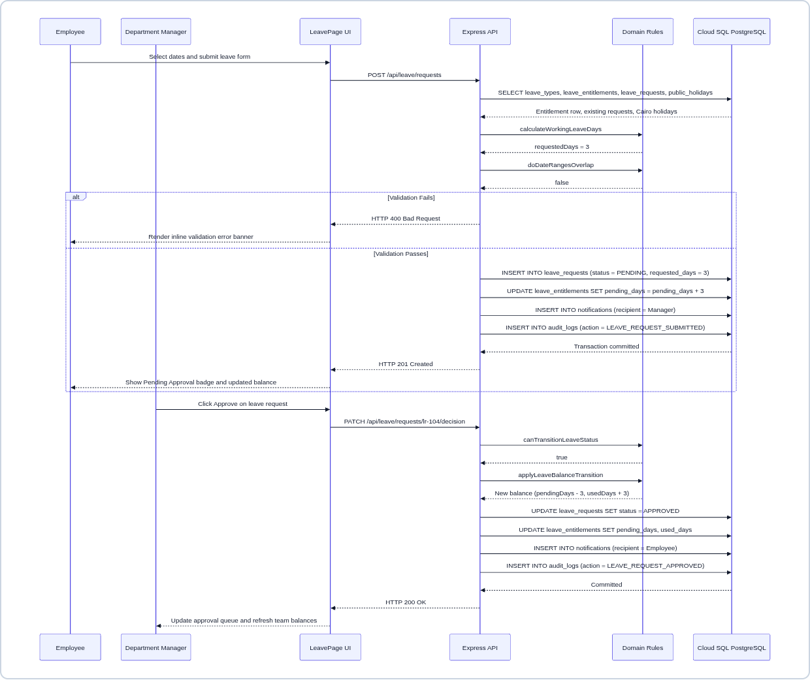
Figure 11.1 — UML Sequence Diagram: Leave Request Submission (POST) & Manager Approval Decision (PATCH)
SLIDE 12 / 15 | UML Sequence Diagrams — Auto-Provisioning & Auth/RTL Bootstrap — مخططات التتابع للتعيين والمصادقة وتهيئة اللغة العربية
Detailed interaction lifelines for (A) Employee Auto-Provisioning and (B) Authentication + Egyptian Arabic RTL Bootstrap
- Left Sequence (4.6 — Employee Auto-Provisioning): Shows HR Manager submitting New Employee Modal → circular hierarchy validation → sequential NW-EMP-026 generation → multi-table PostgreSQL inserts.
- Right Sequence (4.7 — Auth & Egyptian Arabic RTL Bootstrap): Shows LanguageContext initializing ar-EG RTL default → POST /api/auth/login issuing signed HMAC token → GET /api/bootstrap filtering confidential records by RBAC role.
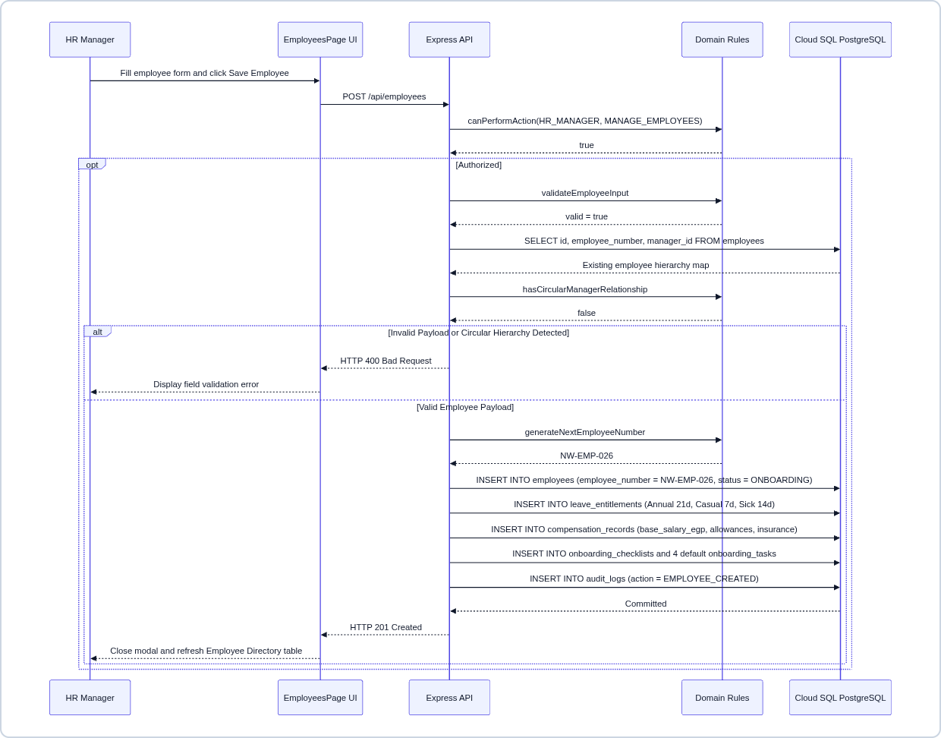  Figure 12.1 — Sequence: Employee Creation & Provisioning | 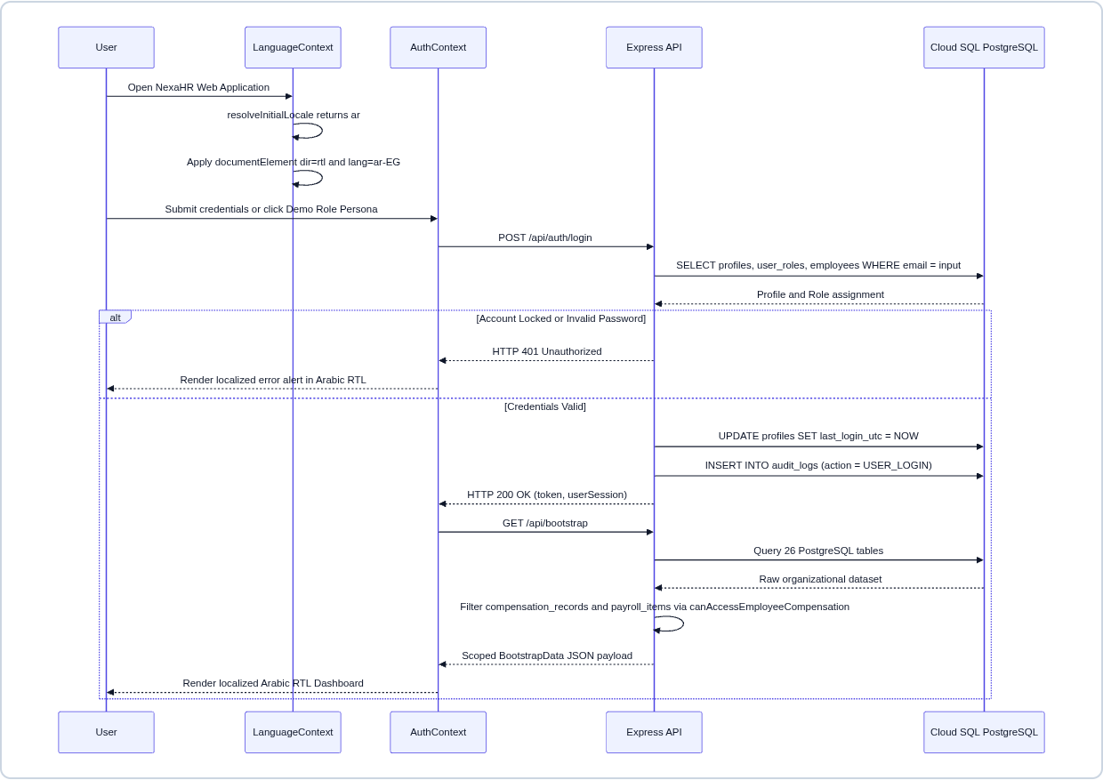  Figure 12.2 — Sequence: Auth, RBAC & Arabic RTL Bootstrap
SLIDE 13 / 15 | EGP Payroll Sequence & Leave / Task Lifecycle State Machines — تتابع مسير المرتبات ومخططات الحالة للإجازات والمهام
Models the Egyptian EGP payroll calculation sequence alongside formal UML State Machines for Leave and Kanban Tasks
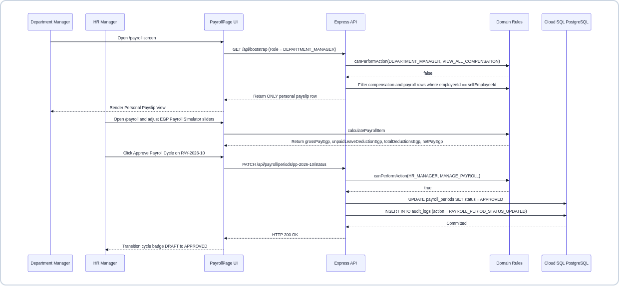
Figure 13.1 — UML Sequence Diagram: EGP Payroll Calculation, Cycle Approval & RBAC Confidentiality Guard
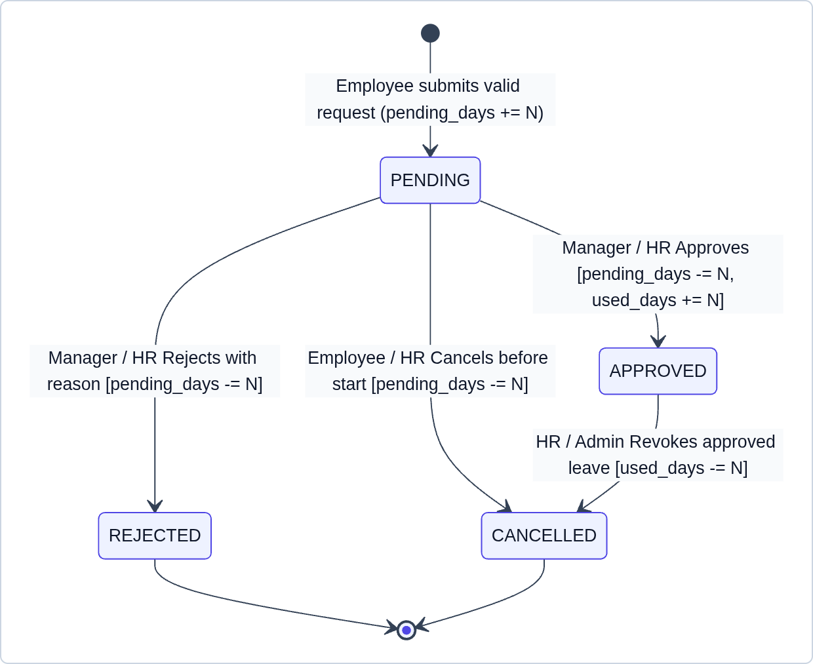  Figure 13.2 — Leave Request Lifecycle State Machine | 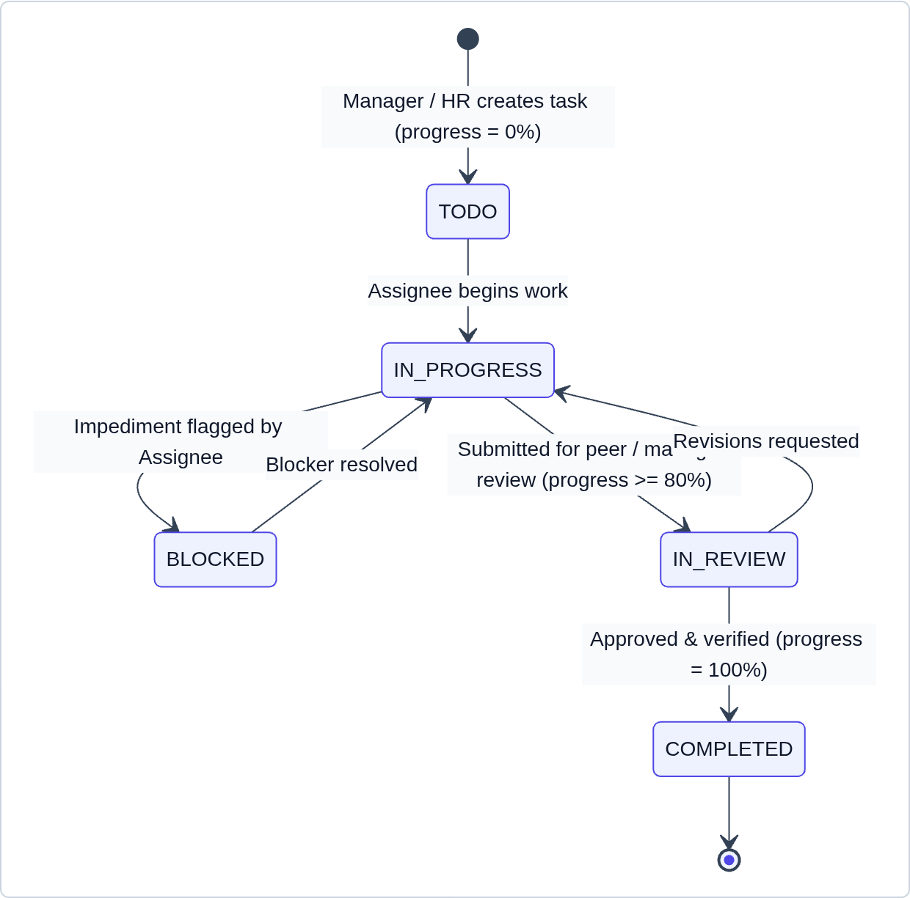  Figure 13.3 — Task (Kanban) Lifecycle State Machine
SLIDE 14 / 15 | Appraisal / Payroll State Machines & Cloud Deployment Topology — مخططات الحالة للأداء والمرتبات ومعمارية النشر السحابي
Multi-stage performance review & payroll period state transitions and production Cloud Run + Cloud SQL deployment
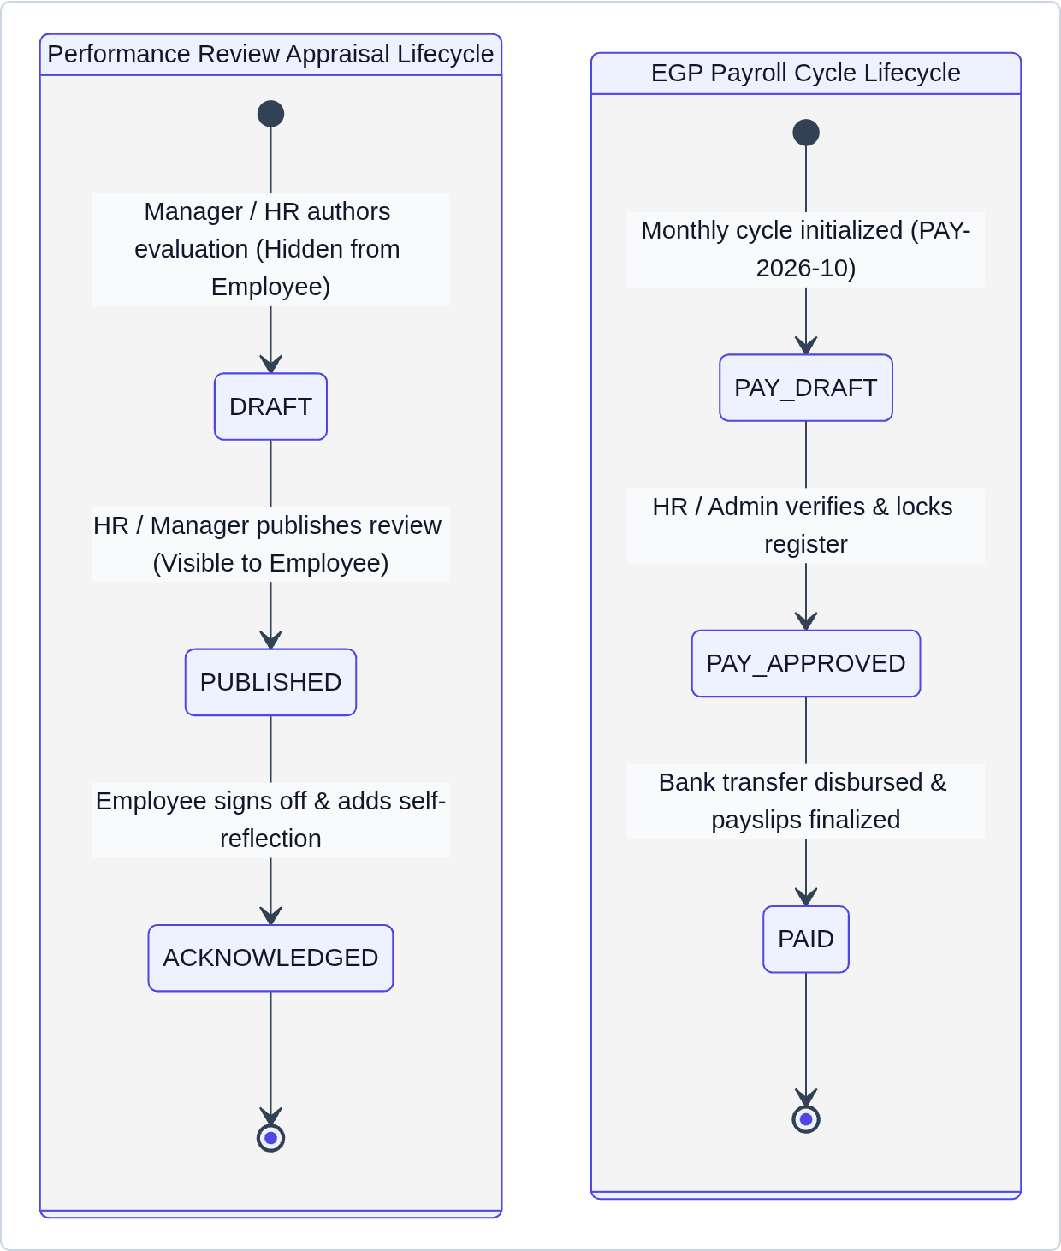  Figure 14.1 — Performance Review & Payroll Period State Machines | 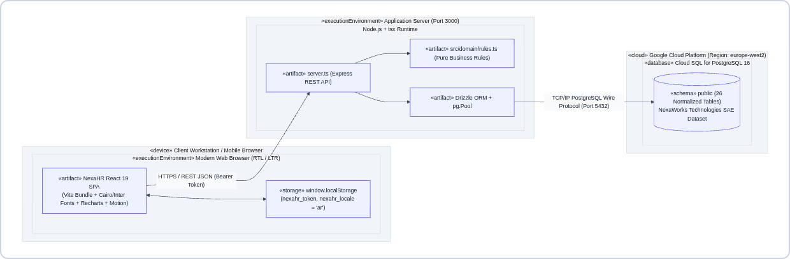  Figure 14.2 — UML Deployment & Cloud Infrastructure Diagram
Production Cloud Infrastructure Summary
- Runtime & Database Topology: Containerized Node.js 22 + Express + Vite SPA bundle deployed on Google Cloud Run (Port 3000, HTTPS), connected via encrypted TLS pool to Google Cloud SQL for PostgreSQL 16 in europe-west2.
- Zero-Downtime Idempotent Bootstrapping: On startup, server.ts executes ensureNexaWorksSeeded() to verify all 26 PostgreSQL tables and seed the 25-employee Cairo dataset if empty.
SLIDE 15 / 15 | Requirements Traceability, Automated Testing & Verification — مصفوفة التتبع والاختبارات الآلية والتحقق الهندسي
End-to-end verification across pure domain unit tests (node:test), TypeScript compilation, and mobile/desktop browser checks
1. Automated Domain Unit Test Suite (src/domain/rules.test.ts — 10 / 10 Passing)
Test Case ID | Verified Domain Rule in src/domain/rules.ts | Status
TEST-01 & 02 | Employee field validation, EGP salary bounds, self-reporting guard & circular manager loop detection | PASS (ok)
TEST-03 | Sequential employee code generator (generateNextEmployeeNumber → NW-EMP-026) | PASS (ok)
TEST-04 & 05 | Working leave days calculator (excludes Fri/Sat & Cairo holidays) & overlapping date range detection | PASS (ok)
TEST-06 | Transactional leave state machine & balance transitions (SUBMIT, APPROVE, REJECT, CANCEL) | PASS (ok)
TEST-07 | Attendance worked/late/overtime calculator with 15-minute grace period & overnight shift support | PASS (ok)
TEST-08 | Egyptian EGP Payroll formula (Gross = Base + Allowances, Unpaid Leave Deduction, Net Pay) | PASS (ok)
TEST-09 | Strict 4-role RBAC permission matrix & compensation confidentiality enforcement | PASS (ok)
TEST-10 | Egyptian Arabic (ar-EG RTL) localization & bilingual demo contact request validation | PASS (ok)
2. Full-Stack & Mobile Responsiveness Acceptance Summary
- Zero Horizontal Overflow on Mobile Phones (375×812): Verified across /, /login, /dashboard, /employees, /organization, /attendance, /leave, /tasks, /performance, and /payroll in both Egyptian Arabic (RTL) and English (LTR) with document.documentElement.scrollWidth <= window.innerWidth.
- Commands for Local Execution & Verification: Install: npm install | Run Full-Stack Server: npm run dev (http://localhost:3000) | Run Domain Unit Tests: npx tsx --test src/domain/rules.test.ts | Typecheck & Build: npm run lint && npm run build.

