**Students Stress Analysis**

**Abilities related to mental health of students**

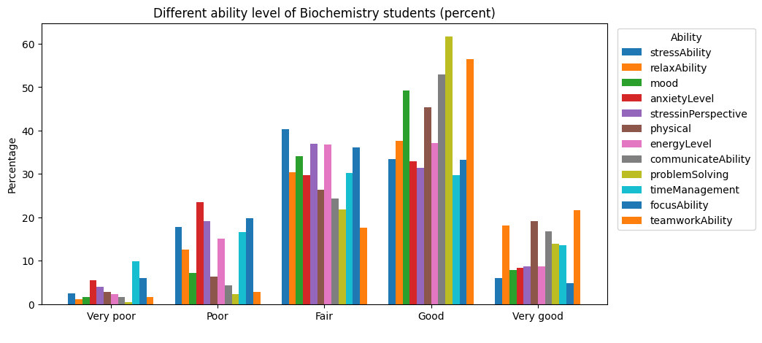

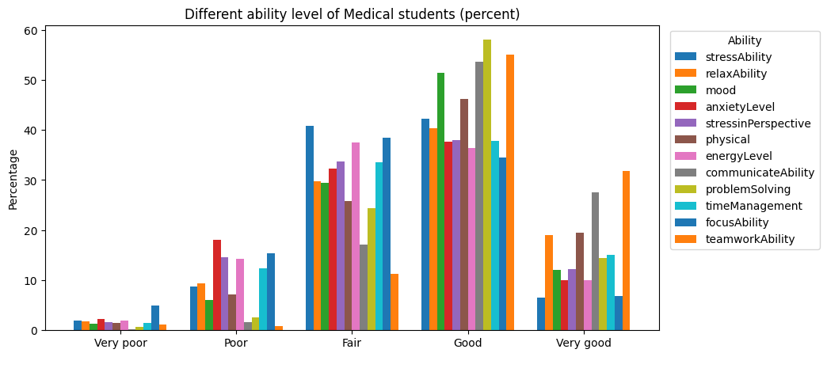

# Activities of students in leisure time

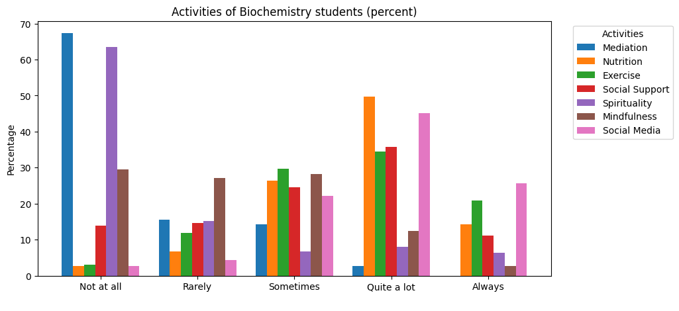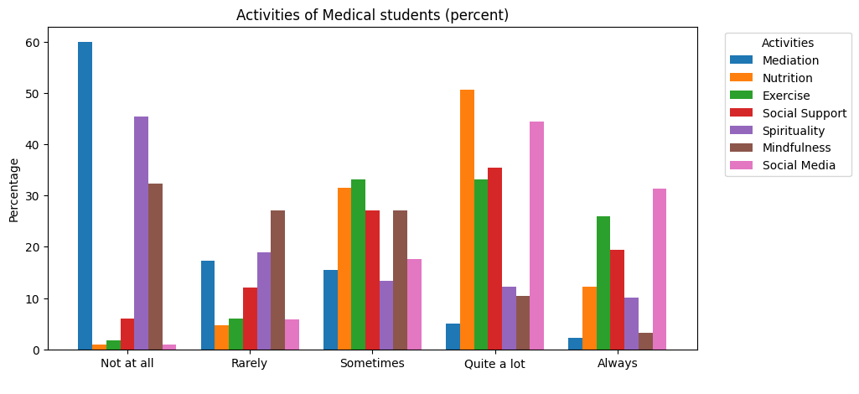

# Most effective stress relieving activities according to students

# Medical students:

|  |  |
| --- | --- |
| Activity | Percentage |
| Mediation | 3.026 |
| Nutrition | 0.908 |
| Exercise | 35.703 |
| Social Support | 26.172 |
| Spirituality | 6.203 |
| Mindfulness | 2.874 |
| Social Media | 2.874 |

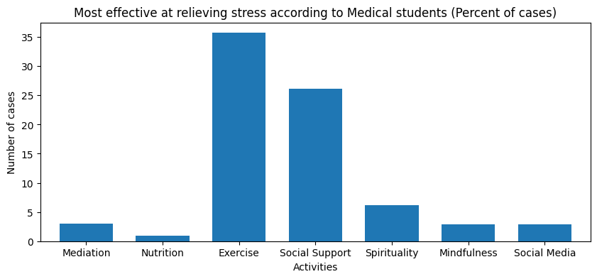

Most of the Medical students thinks that 'Exercise' (35.70%) and 'Social Support Activities' (26.17%) are effective on stress relieve.

# Biochemistry students:

|  |  |
| --- | --- |
| Activity | Percentage |
| Mediation | 0.787 |
| Nutrition | 3.150 |
| Exercise | 33.465 |
| Social Support | 13.780 |
| Spirituality | 4.331 |
| Mindfulness | 0.787 |
| Social Media | 3.543 |

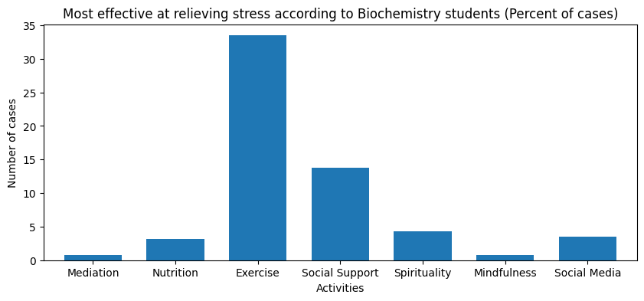

Most of the Medical students thinks that 'Exercise' (33.46%) and 'Social Support Activities' (13.78%) are effective on stress relieve.

# Analysing students stress score

Five number summary of stress score of whole data:

Count 876.00

Mean 25.96

Std 4.34

Min 12.00

25% 23.00

50% 26.00

75% 29.00

Max 37.00

## **Difference of mean score between Medical and Biochemistry students**

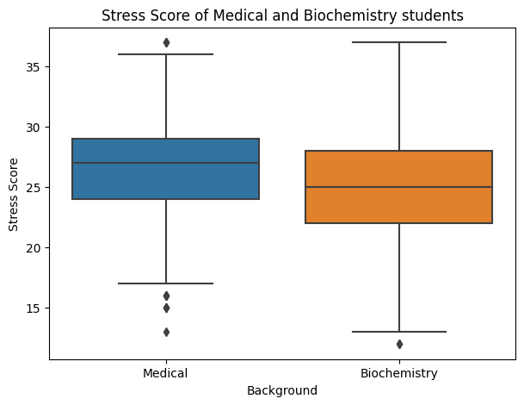

We suspect a difference of score in the graph between tow cohort. We will do a two samples independent t-test to clarify the doubt.

## **Hypothesis testing:**

**Summary of Score in different degree**

|  |  |  |
| --- | --- | --- |
|  | Medical | Biochemistry |
| count | 647 | 229 |
| mean | 26.44 | 24.62 |
| std | 4.14 | 4.60 |
| min | 13.00 | 12.00 |
| 25% | 24.00 | 22.00 |
| 50% | 27.00 | 25.00 |
| 75% | 29.00 | 28.00 |
| max | 37.00 | 37.00 |

t-Statistic = 5.565

p-Value = 3.496 x 10-8

As p-value is less than 0.05. We may reject the null hypothesis. There is a significant difference between two samples.

So, it is now clear that Medical students have significantly higher score and Biochemistry students have less.

## **Difference of mean score between students of different year**

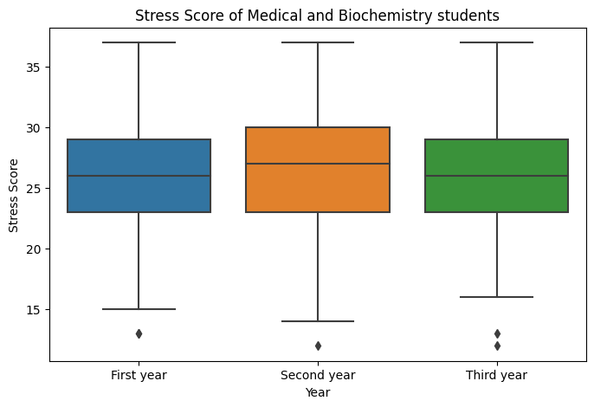

Mean stress score of different year student seems equal. We can predict this by the graph shown above. Let's check if the prediction is right. There would be three sample in the test. So a one way ANOVA test may be suitable for this.

|  |  |  |  |  |
| --- | --- | --- | --- | --- |
|  | **SS** | **df** | **F** | **PR(>F)** |
| Year | 18.665 | 2 | 0.495 | 0.61 |
| Residual | 16469.23 | 873 |  |  |

Here, p-value>0.05. So we may not reject the H0. So, mean of scores are equal in each year of students.

## **Relation between stress score and social media usage**

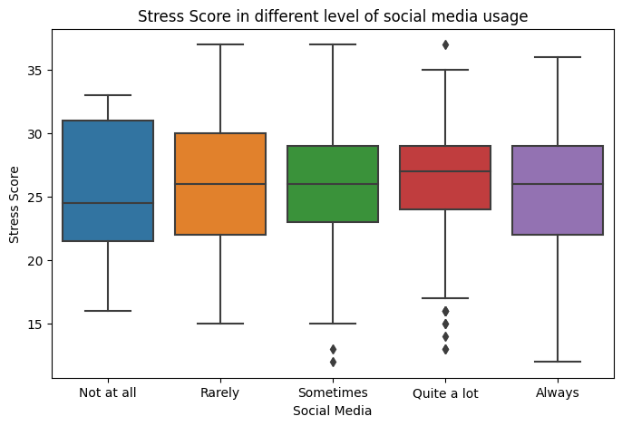

|  |  |  |  |  |
| --- | --- | --- | --- | --- |
|  | **SS** | **df** | **F** | **PR(>F)** |
| Year | 18.665 | 2 | 0.495 | 0.61 |
| Residual | 16469.23 | 873 |  |  |

Here, p-value>.05. So, we may not reject the H0. So, means of score are equal in each level of social media usage. So, it is unnecessary to check individual groups. (eg: Medical, Biochemistry)

# Last month mental condition

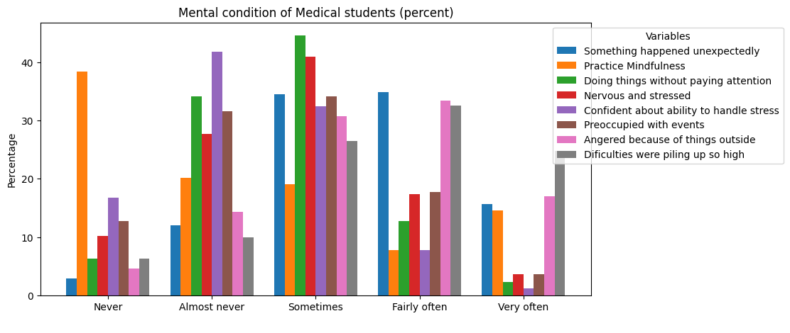

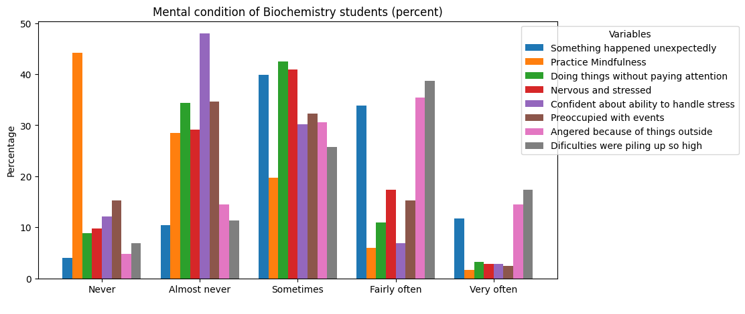

# Relationship between Social Media and Stress of Medical students

|  |  |  |  |  |
| --- | --- | --- | --- | --- |
|  | Chi Square | p-value | alpha=5% | alpha=10% |
| Something happened unexpectedly | 20.08304 | 0.216504 | FALSE | FALSE |
| Practice Mindfulness | 14.09983 | 0.591277 | FALSE | FALSE |
| Doing things without paying attention | 32.24927 | 0.009278 | TRUE | TRUE |
| Nervous and stressed | 42.36836 | 0.000348 | TRUE | TRUE |
| Confident about ability to handle stress | 25.10356 | 0.06802 | FALSE | TRUE |
| Preoccupied with events | 25.11878 | 0.067759 | FALSE | TRUE |
| Angered because of things outside | 25.45379 | 0.062215 | FALSE | TRUE |
| Difficulties were piling up so high | 19.49524 | 0.243819 | FALSE | FALSE |

TRUE = Associated with social media

FALSE = Not associated with social media

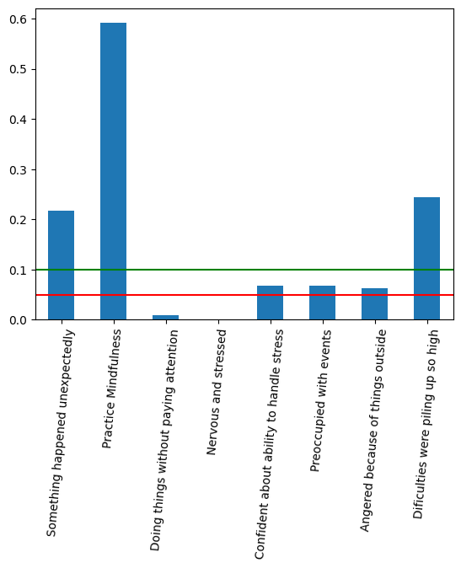

This graph shows different variables p-value of Chi-square test with Social media for medical students. We can see 'Social Media' usage of Medical students is associated with 'Doing things without paying attention' and 'Nervous and stressed'. At 5% level of significance.

## **Heatmap plot for significant pairs (Percent of cases)**

Let's visualise the association with the help of heatmap plot.

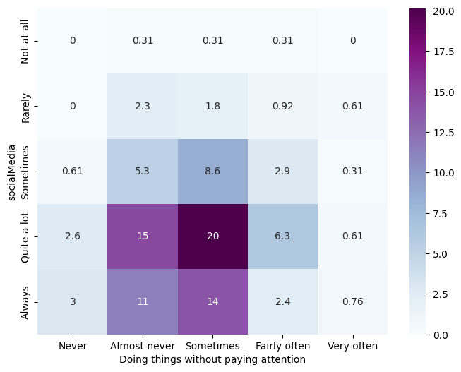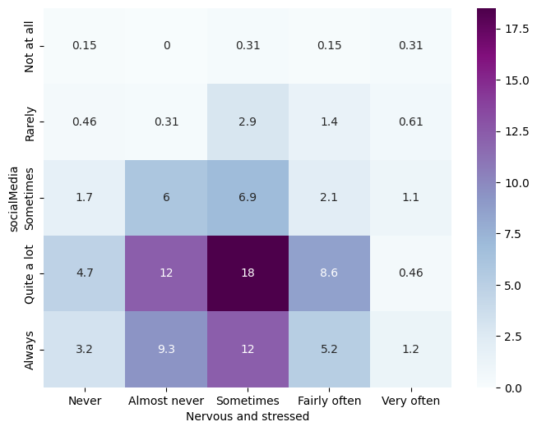

# Relationship between Social Media and Stress of Biochemistry students

|  |  |  |  |  |
| --- | --- | --- | --- | --- |
|  | Chi Square | p-value | alpha=5% | alpha=10% |
| Something happened unexpectedly | 20.08304 | 0.216504 | FALSE | FALSE |
| Practice Mindfulness | 14.09983 | 0.591277 | FALSE | FALSE |
| Doing things without paying attention | 32.24927 | 0.009278 | TRUE | TRUE |
| Nervous and stressed | 42.36836 | 0.000348 | TRUE | TRUE |
| Confident about ability to handle stress | 25.10356 | 0.06802 | FALSE | TRUE |
| Preoccupied with events | 25.11878 | 0.067759 | FALSE | TRUE |
| Angered because of things outside | 25.45379 | 0.062215 | FALSE | TRUE |
| Difficulties were piling up so high | 19.49524 | 0.243819 | FALSE | FALSE |

TRUE = Associated with social media

False = Not associated with social media

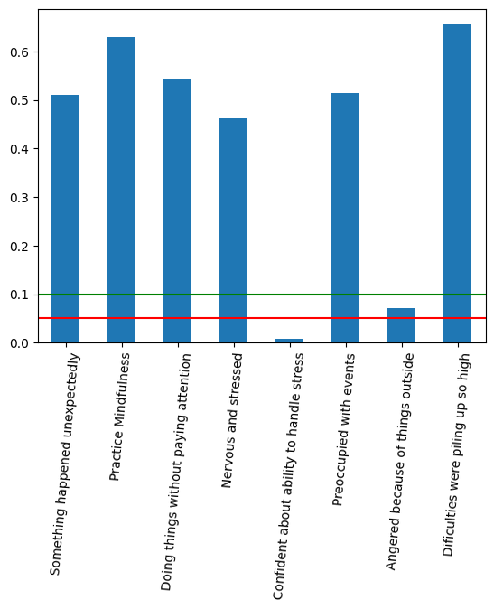

This graph shows different variables p-value of Chi-square test with Social media for Biochemistry students. We can see 'Social Media' usage of Medical students is associated with Confident about ability to handle stress '. At 5% level of significance.

## **Heatmap plot for significant pairs (Percent of cases)**

Let's visualise the association with the help of heatmap plot.

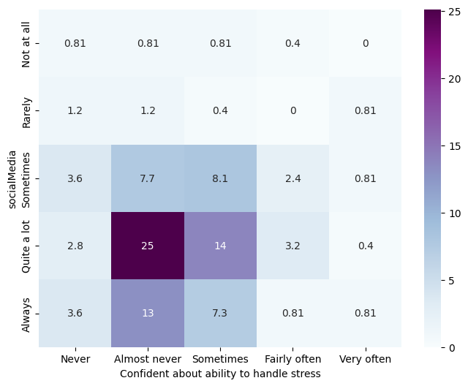

# Cause of stress

|  |  |
| --- | --- |
| Activity | Percentage |
| Finance | 13.767 |
| Course workload | 51.74 |
| Personal Relationships | 37.519 |
| Moving to university | 25.567 |
| Social/Recreational | 6.808 |
| Health | 5.144 |

**Medical students**

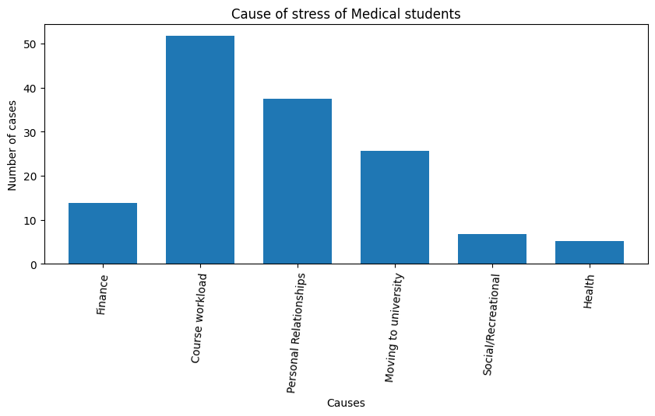

Most of the Medical students thinks that ' Course workload' (51.74%) and Personal Relationships' (37.51%) are crucial cause of their stress.

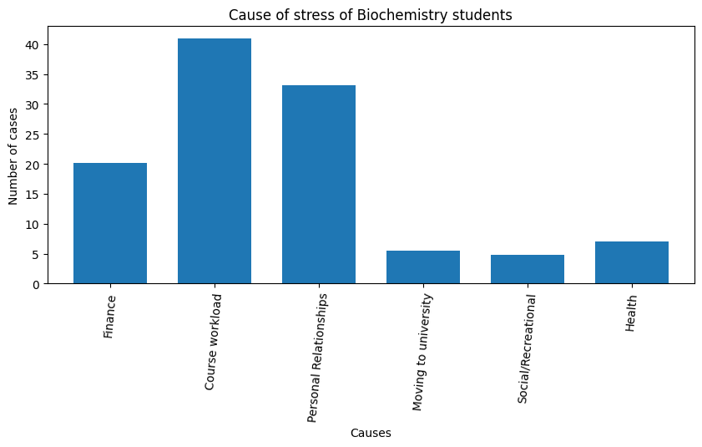**Biochemistry students**

|  |  |
| --- | --- |
| **Activity** | **Percentage** |
| Finance | 20.079 |
| Course workload | 40.945 |
| Personal Relationships | 33.071 |
| Moving to university | 5.512 |
| Social/Recreational | 4.724 |
| Health | 7.087 |

Most of the Biochemistry students thinks that 'Course workload' (40.95%) and Personal Relationships' (33.07%) are crucial cause of their stress.

# Relationship between Exercise and Stress of Medical students

|  |  |  |  |  |
| --- | --- | --- | --- | --- |
|  | Chi Square | p-value | alpha=5% | alpha=10% |
| Something happened unexpectedly | 25.23 | 0.065874 | FALSE | TRUE |
| Practice Mindfulness | 23.192 | 0.108702 | FALSE | FALSE |
| Doing things without paying attention | 9.8771 | 0.87297 | FALSE | FALSE |
| Nervous and stressed | 23.572 | 0.099266 | FALSE | TRUE |
| Confident about ability to handle stress | 27.135 | 0.040005 | TRUE | TRUE |
| Preoccupied with events | 14.924 | 0.530247 | FALSE | FALSE |
| Angered because of things outside | 23.347 | 0.104761 | FALSE | FALSE |
| Difficulties were piling up so high | 25.539 | 0.060874 | FALSE | TRUE |

TRUE = Associated with social media

FALSE = Not associated with social media

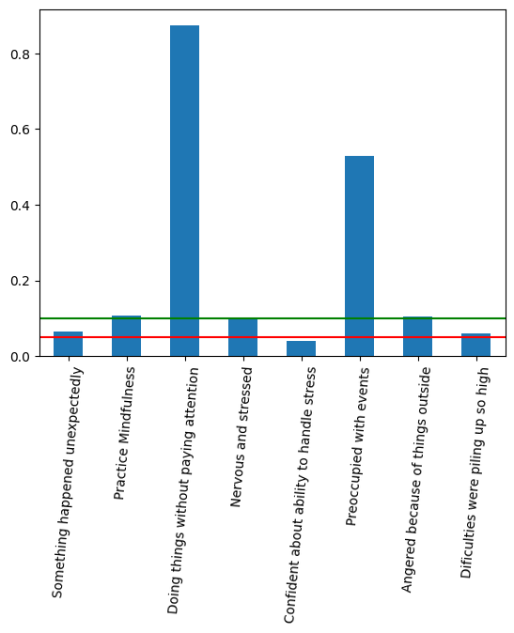

For 10% tolerance 'Exercise' is associated with 'Something happened unexpectedly', 'Nervous and stressed', 'Confident about ability to handle stress' and 'Difficulties were piling up so high'.

## **Heatmap plot for significant pairs (Percent of cases)**

Let’s see associated pairs visually.

# Relationship between Exercise and Stress of Biochemistry students

|  |  |  |  |  |
| --- | --- | --- | --- | --- |
|  | Chi Square | p-value | alpha=5% | alpha=10% |
| Something happened unexpectedly | 30.113 | 0.017424 | True | TRUE |
| Practice Mindfulness | 20.348 | 0.204950 | False | False |
| Doing things without paying attention | 9.6148 | 0.885955 | False | False |
| Nervous and stressed | 19.576 | 0.239936 | False | False |
| Confident about ability to handle stress | 32.058 | 0.009827 | True | TRUE |
| Preoccupied with events | 14.691 | 0.547398 | False | False |
| Angered because of things outside | 14.879 | 0.533548 | False | False |
| Difficulties were piling up so high | 29.393 | 0.021416 | True | TRUE |

TRUE = Associated with social media

FALSE = Not associated with social media

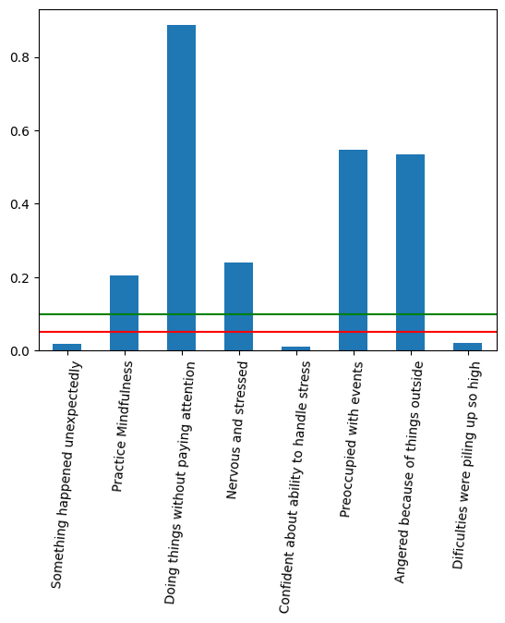

For 5% tolerance 'Exercise' is associated with 'Something happened unexpectedly', 'Confident about ability to handle stress' and 'Difficulties were piling up so high' Let's have a look on heatmap.

## **Heatmap plot for significant pairs (Percent of cases)**

Let’s see associated pairs visually.

## 

