**Introduction**

**Executive Summary**

**LMS** learning management system is a software application for the administration, documentation, tracking, reporting and delivery of educational courses or training programs or learning and development programs. The learning management system concept emerged directly from e-Learning. The system offers sign up for students and teacher. LMS offer students track their grades, attendance, assignments, course materials and offer online delivery of their assignments and communication with their instructors. LMS also offers to instructors to introduce their material, assign students to their class, put tasks and assignments, update their attendance, grades and make analysis on them, take reports and feedback about their progress.

**Document Overview**

This document introduces Learning Management System product study plan. It introduces general description, constraints on the system, functional requirements of the system, domain requirements of the system, working system and user interfaces.

**System Description**

**Introduction**

**LMS** learning management system deals with all kind of student details, academic related reports, college details, department details, exam mark details, section details and graph details too. It tracks all the details of a student from the day one to the end of his course which can be used for all reporting purpose, tracking of attendance, mark details, percentage calculations, completed semesters years, exam details, cycle test1, cycle test2, cycle test3, model exam, university result etc. To maintain the information of students (Attendance, personal and academics) To generate the reports in various ways (pdf, excel). To made retrieval of data easier.

**System Architecture**



**Users**

The system is divided into two parts one can accessed by Teaching staff and the other can be accessed by students.

**Modules**

**The system consists of following modules:**

**Storage:** LMS uses different types of storage:

• Core storage for student modules and user interaction

• Core storage for education materials and time table module

• Archive storage for historical changes, deleted contents and old logs

• System storage for system configuration, user’s information and fresh logs

• Indexing storage to support full text search engines

• Analytics storage(s) to store the outcomes of data analytics module

**Data Processing**

Data processing module is responsible on providing all data related services like data modeling, data transformation, data classifier and multimedia processing.

**Data Analytics**

LMS System holds huge amount of contents which includes students information, user interaction and logs, Attendance Module, Time Table Module, Student Analytic Module and assignments module.

**Indexing**

This module is responsible on indexing textual contents to allow internal full text search queries.

**Security**

Security module is responsible on user authentication and communications security.

**General User Area**

This module provides user with main system activities like accessing the attendance module, accessing the assignment module, pursuing his grades and the time tables.

**Attendance Module**

Instructors and teaching assistants can use the Attendance activity to record student attendance.

**Assignment handle Module**

The assignment module allows teachers to collect work from students, review it and provide feedback including grades.

**Time Table Module**

Timetable Generation is one of the most complicated and time-consuming tasks for every school/ institution as each class has a unique time table with specified subjects and teachers.

**Student Analytic Module**

Student analytic module is responsible for doing some mathematical function on student’s grades

**System Administration Area**

This module is dedicated for system administrators

**System Modules**

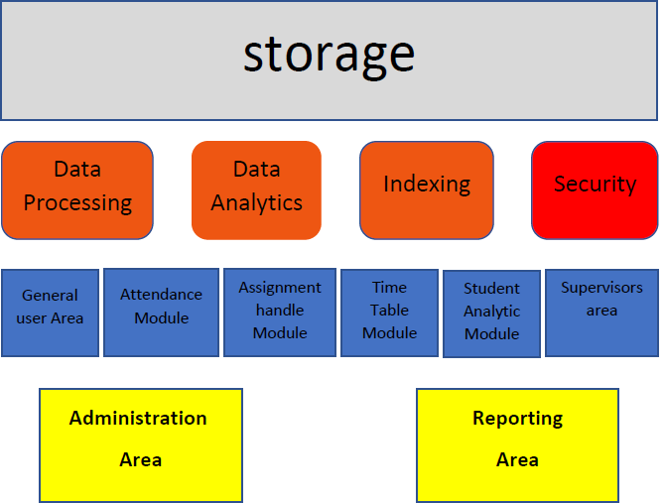

**Storage**

LMS uses different types of storage:

• Core storage for student modules and user interaction

• Core storage for education materials and time table module

• Archive storage for historical changes, deleted contents and old logs

• System storage for system configuration, user’s information and fresh logs

• Indexing storage to support full text search engines

• Analytics storage(s) to store the outcomes of data analytics module

Core storage uses NOSQL unstructured database installed over distributed infrastructure. Unstructured scheme allows flexible data definition and allow future extension of question types. NOSQL database speed up the queries compared with raw data storage format. Cloud infrastructure offer high availability and instant recovery of data. Archive storage uses JSON data format stored directly over distributed storage. JSON allow flexible access of data attributes. Distributed storage allows fast access of data items and offer expandable storage. Data replication is configured to minimum which full data availability and data recovery needs of archiving information.

System storage uses traditional structured database which provide better queries and data processing over structured contents.

**Data Processing**

Data processing module is responsible on providing all data related services like data modeling, data transformation, data classifier and multimedia processing.

Data modeling is required to understand the textual material based on the related language model, this will allow better revision and improve the quality of education information. Data transformation is required to allow import and export of different data format. The system supports common data formats supported by common data processors applications. Multimedia processing is required to enhance the quality of multimedia contents like images, audio and video. It converts multimedia contents to unified format. Also, this service is required to detect some features required by data classifier service. Data classifier is required to classify the contents which is important to avoid non-appropriate material. The classifier uses information retrieved by data modeling and image and video processing services.

**Data Analytics**

LMS System holds huge amount of contents which includes students information, user interaction and logs, Attendance Module, Time Table Module, Student Analytic Module and assignments module. This module is important to study the contents and produce very useful result. Basically, this module support following data analytics.

Similarity analysis to determine similar examination contents. This analysis is important to avoid generating exams having similar questions.

Quality analysis to study the correctness of examination contents based on user interaction. High quality contents will be published to all users. Low quality questions are used only by their authors and related users. Security analysis to study user behavior to avoid future attacks. Basically, this analysis users logs to study user behavior.

Statistical analysis to produce a set of statistical studies regarding contents and user’s interaction. For example, this analysis can study the distribution of student information contents vs. time or region or language

**Indexing**

This module is responsible on indexing textual contents to allow internal full text search queries. Full text search is used by final users to find certain contents. Also, it used by other modules like data processing to locate contents in a fixed time regardless the overall contents size.

**Security**

Security module is responsible on user authentication and communications security. User can register/login using internal accounts or via their phones or common social accounts. The portal access is made using https protocol in order to secure the communication.

Security module also responsible on managing the permissions and roles. Users are either guests, logged users, school books authority owners, supervisors.

Security module also, responsible on detecting the threats and preventing data theft. The system is tested against common attacks using known penetration testing tools. Data theft is prevented using various data protection techniques as described in "IMS Process Security” feature.

**General Use Area**

This module provides user with main system activities like accessing the attendance module, accessing the assignment module, pursuing his grades and the time tables.

In online exams, users can view results after examiner approval. Users can view examination history and achieved results.

In additions, users can browse and find courses topics also, users can edit their profiles and view other user’s profiles.

General system support martial are published to help users. However, users can communication with system operators to report issues or to get a direct support.

**Attendance Module**

Instructors and teaching assistants can use the Attendance activity to record student attendance. Each mark (e.g., Present, Late, Excused, Absent) is assigned a point value, and the aggregate score for each student appears in a single column in the LMS gradebook. Students can also view their own attendance record and any instructor comments in the Attendance activity itself.

**Assignment handle module**

The assignment module allows teachers to collect work from students, review it and provide feedback including grades. The work students submit is visible only to the teacher and not to the other students unless a group assignment is selected.

Students can submit any digital content (files), including, for example, word-processed documents, spreadsheets, images, audio and video clips. Assignments don't necessarily have to consist of file uploads. Alternatively, teachers can ask students to type directly into a text field in the website. Or they can ask student to do both, upload a file or files and type text directly into the website. An assignment activity can also be set up to not accept any student submissions and serve as a reminder to students of a 'real-world' assignment they need to complete and to record grades in Moodle for activities that don't have an online component.

An assignment has an 'available from' date before which no students can submit anything, and a due date, after which teachers can choose not to accept submissions any more.

Markers can choose to be notified every time a student submits an assignment, or only for late submissions. Markers can choose to give students feedback in the form of text or uploaded files.

This module let the students to know the assignment required to deliver and the deadline of those assignments, students can upload those assignment and know their grades after supervisors check them.

**Timetable Module**

Timetable Generation is one of the most complicated and time-consuming tasks for every school/ institution as each class has a unique time table with specified subjects and teachers. This Timetable Software generate teachers time schedule easily and quickly. This software provides best solution in creation of timetable in a very simple way and avoids time conflicts in adjustments.

• option for one-week or two-week timetables.

• Manual (standard) or automatic (optional) timetable creation using pre-defined parameters.

• Full integration with the Staff and Attendance Modules as well as the online Portals.

• Setting of individual timetable parameters for each year group.

• Creation of multiple timetables for each year group.

• Individual student timetable printouts.

• Period locking - ideal for registration times or fixed tutorial sessions.

• Easy location of staff and students by using the staff and student finder function.

• Flexible staff planning by allocating preferred periods and identifying part-time staff.

• Ability to manage Staff Cover and identify available teachers.

• Timetable print options in formats suitable for form rooms, staff rooms or school notice boards.

**Student Analytic module**

Student analytic module is responsible for doing some mathematical function on student’s grades.

For each student it is responsible for calculating the GPA, and all student it is responsible to classifying the students based on the aspherical order in the student’s name-sheet, calculating the maximum, the average grades, and classifying all the students ranks based on their degrees.

**Supervisors area**

This module is dedicated for system operators. System operators are responsible on managing the system operation and contents. System operators, can access all system contents, view statistical reports, and provide direct support to users.

**System Administration Area**

This module is dedicated for system administrators. System administrators responsible on system management, configuration, backup and solving technical issues. System administrator can view system status, data status, online sessions, logs and other system status and measures.

**System Users**

**Teachers**

• Teacher can access his courses and related materials.

• Teacher can access the course attendance and edit it.

• Teacher can access the course assignments and make one.

• Teacher can put the course timetable.

• Teacher can view his students’ grades and analysis them.

**Students**

• student can access his courses and related materials.

• student can access his attendance and grades.

• student can access his assignments and submit.

• student can access his timetable.

**System Models**

**Use Case Diagrams**

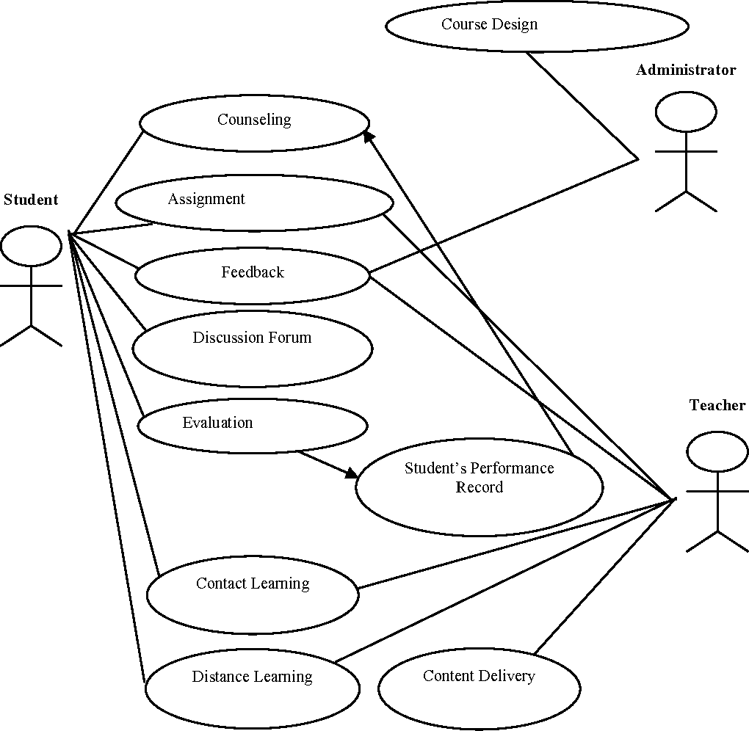

Case diagram describes how the user uses the system, show a graphical overview of the functionality of the learning management system in terms of actors , their goals as use cases and dependencies between use cases.

**Sequence Diagrams**

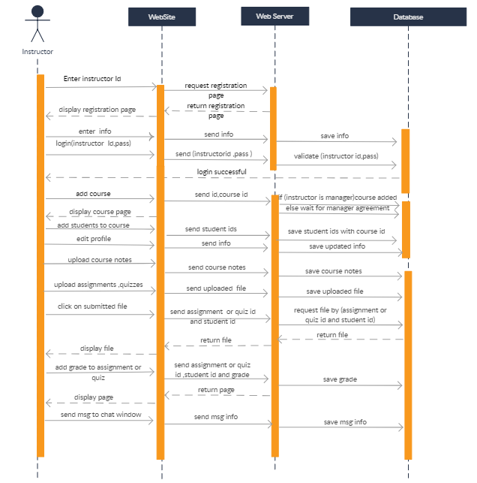

Sequence diagrams describe interactionsamong different between classes and modules in terms of an exchange of message, demonstrate when and how tasks are completed in a system, especially as those tasks relate to use cases.

**Non-Functional Requirements**

**Security Requirements**

* Students' data is invisible to other students
* Teachers are allowed to view students data in courses they teach
* Student shall been forced to change their password the next time they log in if they have not changed it within the length of time established as password expiration duration.
* The system must provide configurable role-based authentication.
* The system shall protect the user’s privacy

**Usability Requirements**

* The system must support Mobility (e.g., phones and tablets).
* The system must support all current versions and any previous supported versions of modern web browsers including Internet Explorer, Firefox, Chrome and Safari.
* The system shall have a single login to access all content
* The system shall have a consistent UI (in all the views and dialogs, the UI elements behave and are placed in a similar way)

**Performance Requirements**

**Technology Requirements**

LMS will be developed using open source tools, languages and servers. Commercial tools will be used in case there is no open source alternative

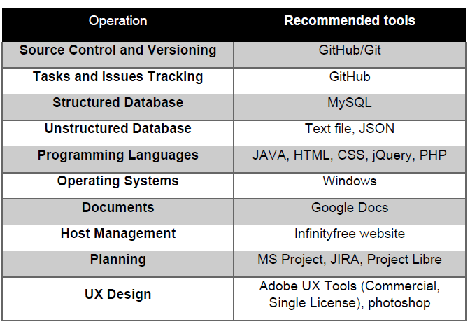

**System Modules**

## LOGIN/AUTHENTICATION MODULE

A Login/Authentication module is a plug-in that collects user information such as a user ID and password, and compares the information against entries in a database. If a user provides information that meets the authentication criteria, the user is validated and, assuming the appropriate policy configuration, granted access to the requested resource. If the user provides information that does not meet the authentication criteria, the user is not validated and denied access to the requested resource.

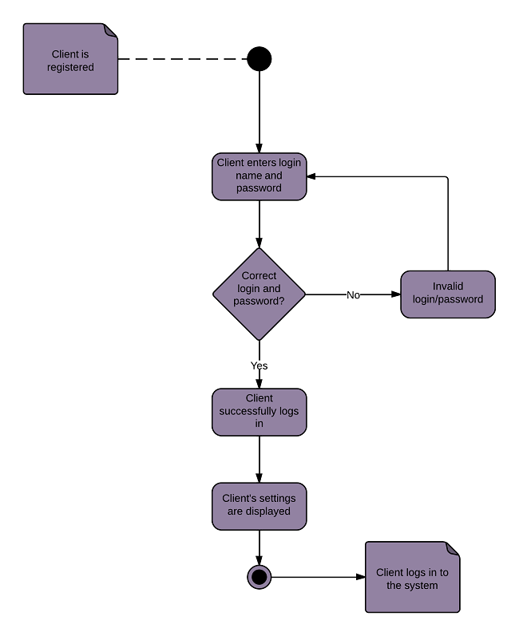

## INSERT/UPDATE/DELETE MODULE

In this module an admin can insert the new data of a student, he/she can update the data of any student and can delete the data of any student.

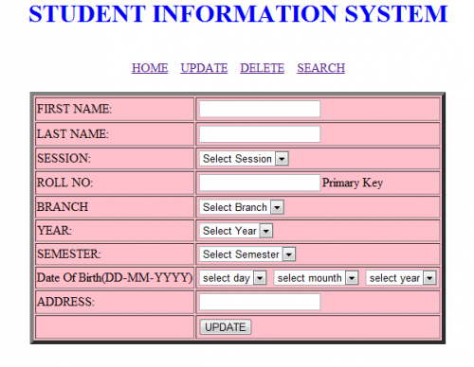

**STUDENT FEES MODULE**

Student fees module, It is also called **student Fees management System**. Admin can manage fee details of students, like how much fee is pending of a student or is there any changes in fee, policy  admin can control all these things.

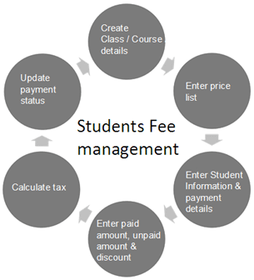

**ATTENDANCE MODULE**

 An admin can control the attendance records of the students, like what is the status of attendance status of a student. Admin will also be responsible for permission granting to teacher and other stuff who can access the attendance of students.

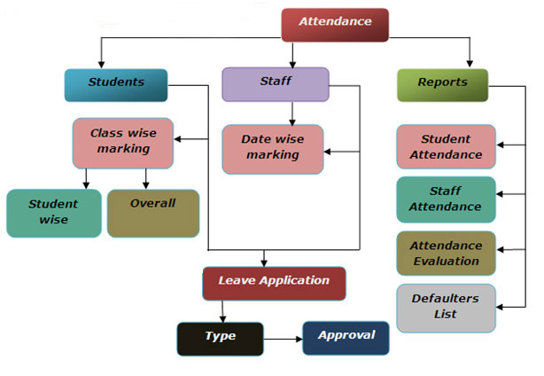

**TIME TABLE module**

A very essential module in student management is Time Table Generator for student, Because managing a lot of students' time table is hard task.

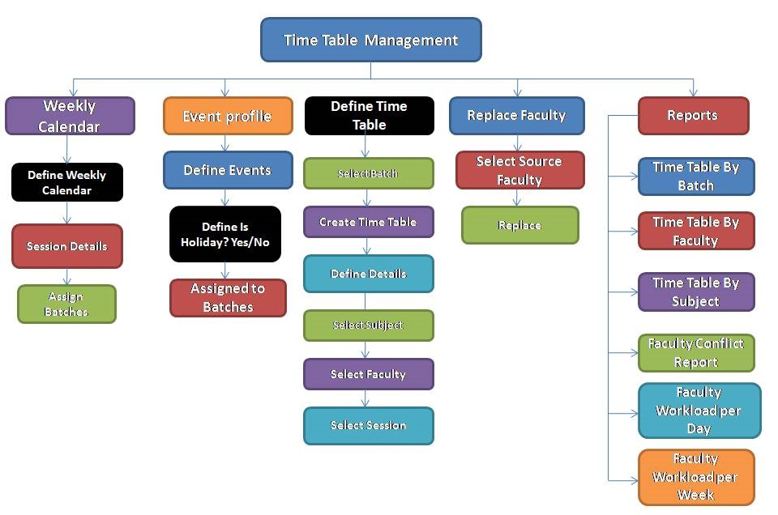

**STUDENT ANALYTIC MODULE**

 An admin can make the analytics of students like analytics of the result, analytics of the attendance, analytics of fee, analytics of the admissions etc.  
You can add so many other functions in admin module of student information system according to your requirement.

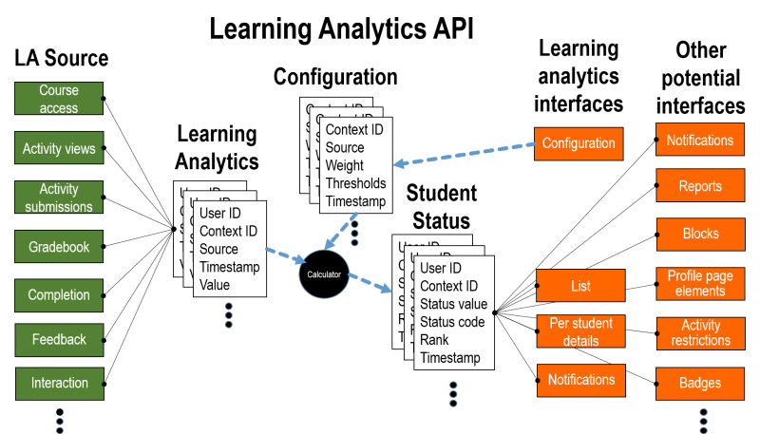

**System Functions**

**STUDENT MODULE**

**LOGIN FUNCTION**

**Description** : Admin will provide an unique id and password to each student by which he/she can enter in the system for accessing the information according to their authority.

**Inputs** :ID & password

**Outputs** :

**Pre-conditions** :

**Post-conditions** :

**PROFILE VIEW FUNCTION**

**Description** :  An student can view their profile from this function. Here an admin can provide some authority to update the profile like he/she can change their mobile number, email address but he/she can not change their parental information like parents contact detail, address etc, these restriction can be set by the admin according to their policy.

**Inputs** :

**Outputs** :

**Pre-conditions** :

**Post-conditions** :

**ATTENDANCE VIEW FUNCTION**

**Description** : An student can view their attendance status from this function. You can see here attendance alert system here like if attendance is very less then it will show in red color, if attendance is fine then it will show in blue color.

**Inputs** :

**Outputs** :

**Pre-conditions** :

**Post-conditions** :

**RESULT/MARKS VIEW FUNCTION**

**Description** :  From this function an student can see internal marks and result. Here you can put an function of print result, so if any student want to print result he/she can do that.

**Inputs** :

**Outputs** :

**Pre-conditions** :

**Post-conditions** :

**FEE DETAIL VIEW FUNCTION**

**Description** :  A student can check their fee status from this function. he/she can check their pending fee from this function, you can add print fee slip and fee alert feature in this function.

**Inputs** :

**Outputs** :

**Pre-conditions** :

**Post-conditions** :

**TIME TABLE FUNCTION**

**Description** : A student can check their regular class time table and examination seating plan from this function.

**Inputs** :

**Outputs** :

**Pre-conditions** :

**Post-conditions** :

**NOTIFICATION/NEWS FUNCTION**

**Description** : In this function students can check the notification and news which is delivered by the administrator.

**Inputs** :

**Outputs** :

**Pre-conditions** :

**Post-conditions** :

**STUDENT FORUM**

**Description** : You can add student forum in student information system project, here students can put their issue publicly and discuss with each other.

**Inputs** :

**Outputs** :

**Pre-conditions** :

**Post-conditions** :