AI SMART GLASSES
Engineering Reference & Co-op Handoff Summary

Prepared by: Ibrahim Ayoub | SINRG Lab, Northeastern University |
This document summarizes the AI Smart Glasses project as it stands today. It walks through every subsystem: firmware, the mobile app, mechanical design, the PCB, performance testing, and ongoing display research.

1. GENERAL DESCRIPTION
The AI Smart Glasses project is a wearable voice-and-vision assistant built around a custom ESP32-based hardware platform paired with a companion Android application. The glasses capture audio and, on the current hardware revision, still images and short video as well, streaming everything over Bluetooth Low Energy to a phone running the AIglasses app. The app transcribes speech, generates a reply through OpenAI's language and vision models, synthesizes that reply as audio, and streams it back to the glasses for playback through the onboard speaker. There is no dedicated backend server: all language and vision processing runs through cloud APIs reached directly from the phone.
The project began in February 2026 and has since moved through two hardware generations (ESP32-C6, then ESP32-S3), several mechanical design revisions, a custom two-board PCB layout, and an instrumented performance-testing program. This document captures where each of those threads stands as of this revision and points to the folders and files where the underlying work lives, so a new team member can get oriented without having to read the full git history.

2. SYSTEM ARCHITECTURE
Two data paths run between the glasses and the phone, both carried over a single custom BLE GATT service:
- Voice path: press-and-hold the PTT button to record. The glasses capture audio through an INMP441 I2S microphone, stream it to the phone, which transcribes it (gpt-4o-transcribe), generates a reply (gpt-4o-mini), converts the reply to speech (tts-1), and streams the resulting audio back for playback through the MAX98357A amplifier and speaker.
- Vision path: a quick double-tap of the PTT button switches to vision mode. The onboard OV3660 camera captures a still image or short video clip, the firmware streams the JPEG to the phone over a dedicated image channel, and the phone sends it to gpt-4o for description.
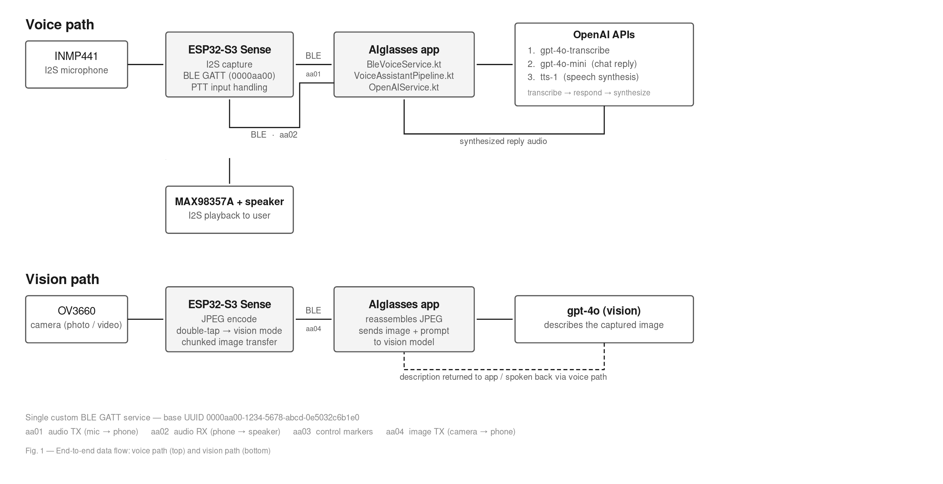
Fig. 1: End-to-end data flow : voice path and vision path over the BLE GATT service

Communication runs over a custom BLE GATT service (base UUID 0000aa00-1234-5678-abcd-0e5032c6b1e0) with four characteristics:
Characteristic | UUID suffix | Direction | Purpose
Audio TX | aa01 | glasses → phone | streamed microphone audio (NOTIFY)
Audio RX | aa02 | phone → glasses | synthesized reply audio for playback (WRITE)
Control | aa03 | bidirectional | single-byte session markers: start/end of capture, image markers, etc.
Image TX | aa04 | glasses → phone | camera JPEG, sent in chunks (NOTIFY)

3. HARDWARE PLATFORM
The project has run on two microcontroller boards. The ESP32-C6 was the original target; the ESP32-S3 is the current and active platform.
 | ESP32-C6 (early build, retired) | ESP32-S3 Sense (current)
Board | Seeed XIAO ESP32-C6 | Seeed XIAO ESP32-S3 Sense
I2S peripherals | 1 (mic and speaker time-share the same bus) | 2 (independent mic and speaker, no mode-switch delay)
Camera | none | OV3660, still photo and video
BLE write mode | WRITE_WITH_RESPONSE (acknowledged, slow) | WRITE_NR (no response, much higher throughput)
Measured BLE throughput | ~14 KB/s | ~49 KB/s
Status | superseded; kept for reference only | active development target

The move from C6 to S3 was driven directly by measurement, not preference. The C6's single I2S peripheral forces the firmware to tear down and reinstall the I2S driver every time it switches between recording and playback (about 50 ms per switch), and BLE transfer under WRITE_WITH_RESPONSE consumed 64% of total round-trip latency in testing. The S3 removes both bottlenecks in hardware and adds the camera the project now depends on for vision mode.
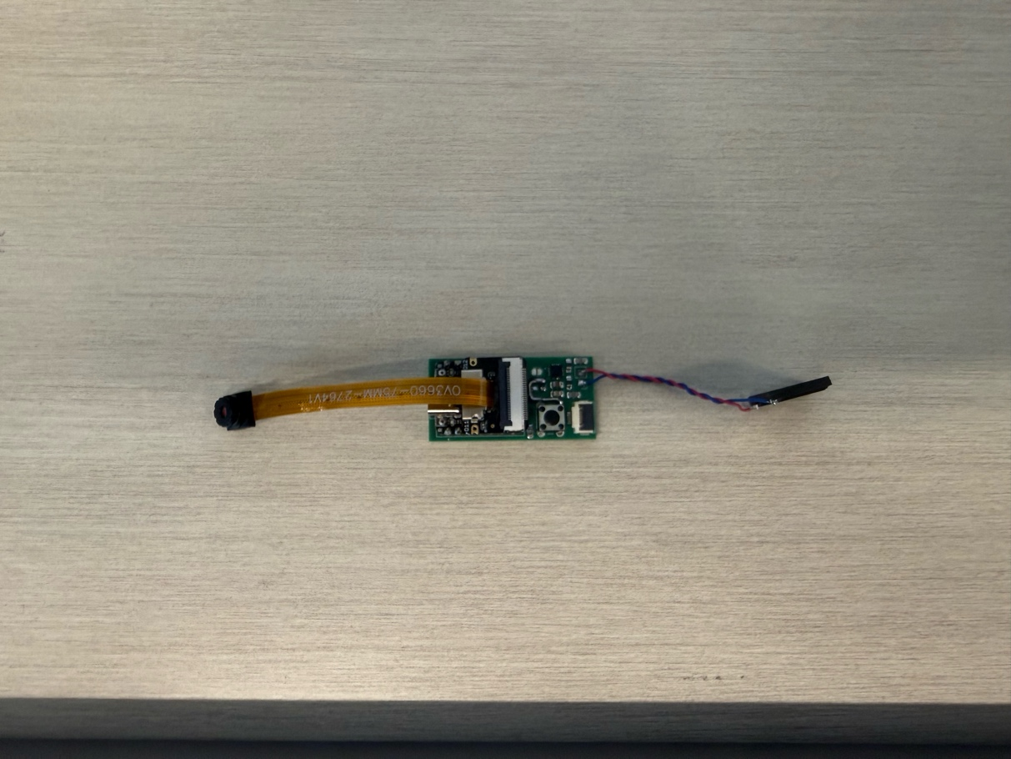

4. FIRMWARE
The firmware handles I2S audio capture and playback, camera capture and JPEG encoding, the BLE GATT service and packet fragmentation, and PTT button handling, including the tap-pattern detection that distinguishes a press-and-hold (voice) from a quick double-tap (vision).
Earlier in the project, the C6 code was refactored from a single large monolithic sketch into a modular library structure (separate managers for I2S, audio, and BLE) so the hardware abstraction could be reused across boards. The S3 firmware follows the same structure and adds two things the C6 build did not have: a 160 KB PSRAM-backed ring buffer for streaming audio playback (the C6 instead used a flat static buffer that came within 0.05% of overflowing during testing; see Section 10), and the camera/vision-mode logic.
An early prototype streamed microphone audio over Wi-Fi to a Mac running a local Whisper server through an ngrok tunnel. This route was tested and deliberately dropped in favor of BLE: it was harder to set up and less reliable for day-to-day use. It is kept purely as a historical reference.

5. MOBILE APPLICATION (AIGLASSES, ANDROID)
File / area | Responsibility
BleVoiceService.kt | scans for and connects to the glasses, negotiates the BLE MTU, and listens on the audio, image, and control notification channels
OpenAIService.kt | wraps the OpenAI calls: transcription, chat, text-to-speech, and vision
VoiceAssistantPipeline.kt | coordinates the record → transcribe → respond → synthesize → play sequence
ui/screens/ | five Compose screens: Home, Live View, Gallery, Features, and Developer (debug/telemetry view)

Stage | Model | Purpose
Speech-to-text | gpt-4o-transcribe | converts recorded speech to text
Chat response | gpt-4o-mini | generates the assistant's reply
Text-to-speech | tts-1 | synthesizes the spoken reply
Vision | gpt-4o | describes images captured in vision mode

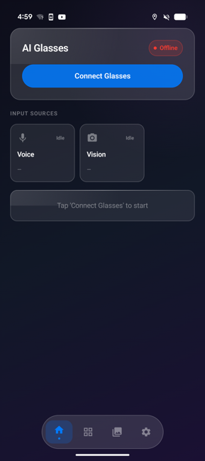 | 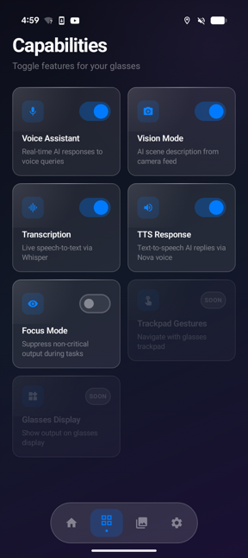 | 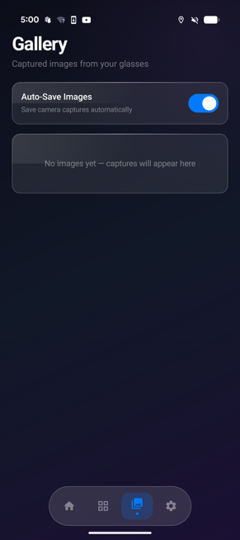 | 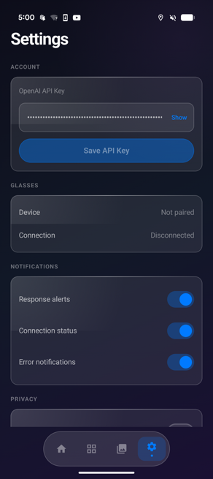 | 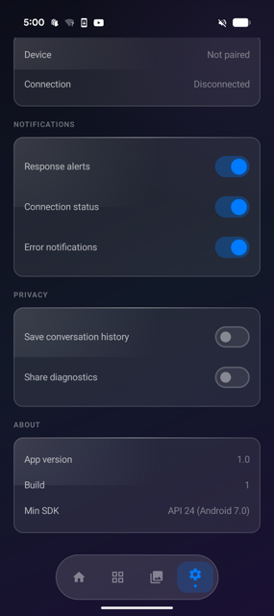

6. INPUT METHODS
Primary input is a physical push-to-talk (PTT) button: a press-and-hold records a voice query, and a quick double-tap (within roughly 600 ms) switches to vision mode for a photo-plus-question interaction.
A second input method, capacitive touch, has been prototyped separately. A standalone firmware sketch proved out swipe-gesture detection on six TK43-TP223 capacitive pads wired to an external ESP32-S3 dev board (see Fig. 2 for the pad layout and gesture map: left/right swipes across the two rows, up/down across the three columns). That sketch was a firmware proof-of-concept only: the same gesture-detection logic is now being ported to run directly on the ESP32-S3’s native capacitive-touch GPIOs and built into the new PCB as an onboard trackpad, rather than wired to an external sensor module. This is part of the left-side PCB design currently underway (Section 8).
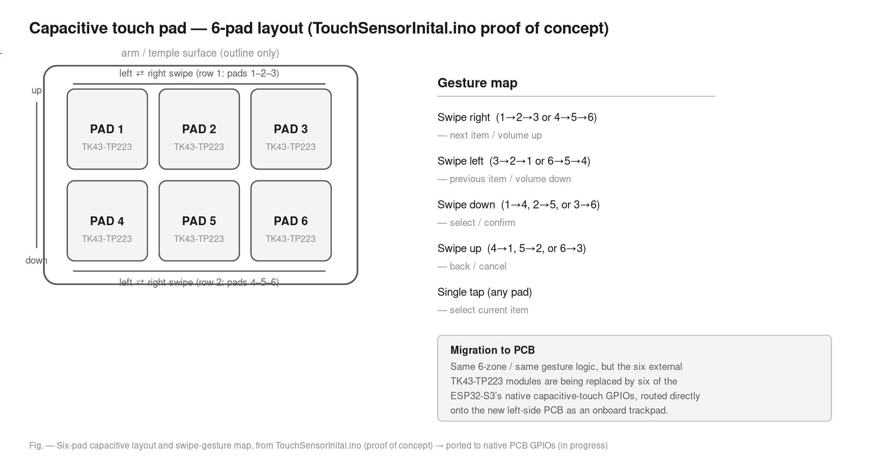
Fig. 2: Six-pad capacitive layout and swipe-gesture map, being ported to native PCB GPIOs

7. MECHANICAL DESIGN (CAD)
Revision | Approx. date | Notes
V1 | Mar 2026 | first printable frame; straight arm geometry
Glasses 3D Design 1 / 2 | Mar–Apr 2026 | dimensional refinement: initial frame summary documented
Glassesv3 | May 2026 | exploded-view studies; early camera-placement experiments
Glasses Vision | May 2026 | revision focused on the camera housing
V2 (current) | Jun 2026 | finalized right-side geometry, matched to the fabricated PCB

Design changes carried into V2, per the most recent progress report: the arm ends were straightened to properly seat the battery, “Northeastern” / “Sinrg Lab” branding was added to the left and right arms respectively, the front frame was thinned for a more discreet fit, and the camera cutout was corrected after the original dimensions were found to be based on a different ESP32 camera module than the OV3660 actually being used.
Status: the right arm and frame are finalized and print-ready, and slicer-ready export files for both Prusa and Ultimaker are on hand. The left side is the active design effort: it needs to additionally route a connector for the camera and host the new capacitive trackpad.

8. PCB
The right-side board has been fabricated, assembled, and is functioning as expected: it carries the ESP32-S3, microphone, amplifier, and supporting circuitry directly inside the arm in place of loose hand-wiring. The left-side board is the active design task: beyond mirroring the right side’s core circuitry, it needs to add the camera connector and the capacitive-touch trackpad described in Section 6.

9. DISPLAY (RESEARCH AND FUTURE WORK)
This is the newest area of investigation and does not yet have a hardware implementation or a place in the current frame design; it is being evaluated as an addition on top of everything described above. The goal is a heads-up visual output, which the design currently lacks entirely.
The primary reference point is Brilliant Labs’ Halo glasses, which project a UI into the wearer’s peripheral vision using a 0.2-inch color micro-OLED display and an optical combiner, and pair it with bone-conduction audio rather than speakers. The component family under evaluation comes from GZOT (Nanjing Guozhao Optoelectronics), which manufactures silicon-based micro-OLED display modules in the same size class (roughly 0.2″–1.2″) used in headsets like Halo.
Adding a display would be a significant step beyond the current audio-and-vision design. It introduces new constraints (optical alignment, additional power draw, and finding physical space for the module in a frame that is already tightly packed) that don’t exist anywhere else in the project yet. Treat this as a research track that runs in parallel with the rest of the build, not a near-term integration target.

10. PERFORMANCE TESTING
I instrumented the firmware with [PERF-Mxx] markers (roughly M1 through M21) to directly measure round-trip latency, BLE throughput, memory headroom, audio buffer fill, camera capture time, and battery draw, rather than estimating these from first principles.
Metric | C6 result (measured) | Notes
End-to-end round trip | 16.5 s | full voice-query cycle
BLE TX duration | 10.6 s | 64% of total round-trip; the dominant bottleneck
OpenAI pipeline total | 7.75 s | Whisper + chat + TTS, run sequentially
BLE throughput | 14 KB/s | limited by WRITE_WITH_RESPONSE
Battery life (300 mAh) | ~2.6 h | no power management active

These results directly motivated the move to the S3 platform and produced a concrete punch list: switch to WRITE_WITHOUT_RESPONSE, stream TTS playback instead of waiting for the full clip to arrive, move the audio buffer to dynamic / PSRAM allocation, and add CPU-frequency scaling plus amplifier shutdown-pin gating to extend battery life.
The S3 summary is currently a predictions-and-setup document: instrumentation has been written into the firmware, but the live capture sessions that would fill in the real numbers are still in progress. A second full round of S3 testing is underway now (the first C6 round surfaced enough issues that a more rigorous repeat was judged worthwhile); results will replace the placeholder values once complete and be shared with the team.

11. COMPONENT REFERENCE
Component | Part | Function | Reference
MCU | Seeed XIAO ESP32-S3 Sense | main controller, Wi-Fi/BLE, camera, audio I/O | wiki.seeedstudio.com/xiao_esp32s3_getting_started
Microphone | InvenSense INMP441 | I2S digital MEMS microphone | Farnell datasheet DS-1824785
Audio amplifier | Maxim MAX98357A | I2S Class-D amplifier driving the speaker | Analog Devices / Maxim datasheet
Speaker | Same Sky CMS-151103-088SP | 8 Ω, 700 mW, 100 Hz–20 kHz | DigiKey part #10821316
Camera | OV3660 (onboard XIAO Sense) | still photo and video capture | -
Touch sensor (proof of concept) | TK43-TP223 × 6 | capacitive swipe-gesture detection | see TouchSensorInital.ino header
Display (under research) | GZOT micro-OLED family | candidate heads-up display module | gzot.com/en/product_details/22

